**The Energy Enhancement Siddhi Program Book Number One**

**Wonder Words**

Hello this is Earl Nightingale, and I’d like to tell you about the amazing word. The experts call it the most important word—as far as the results we get from life are concerned—in this or any other language. This amazing word is ATTITUDE.

The definition of Attitude is “the position or bearing as indicating action, feeling, or mood.” And it is our actions—feelings—or moods—which determine the actions, feelings, or moods of others toward us, and which control, to a surprising extent, our success or failure.

Here is where we have the first opportunity to add some real heat to this powerful program. Consider this: you live simultaneously on three planes ...

1) you are a spiritual being; 2) you have a marvelous mind; and 3) you live in a physical body.

1. SPIRITUAL - THOUGHT ENERGY NON PHYSICAL

2. INTELLECTUAL IDEAS

3. PHYSICAL THINGS OR RESULTS

Earl Nightingale explained that attitude is our “position or bearing as indicating action, feeling or mood.”

Think of what he said ... attitude is ACTION, FEELING or MOOD. That would indicate attitude is expressed by both your mind and your body.

Now, we THINK in pictures or images ... we certainly have an image of our BODY, but we do not have one for our MIND. No one has ever seen the mind ... and where there is no image there is confusion. The image is what brings order to the mind. This is why Solomon said, “Where there is no vision, the people will perish.”

It was after years of serious study that I stumbled upon this beautiful truth. Without an image of the mind, your understanding of attitude will very likely be distorted. However, that does not mean you will not be successful in life. You could have a great attitude and become highly successful ... yet, not understand exactly what attitude is and how it has affected your success in life. A person in this position is frequently referred to as an unconscious competent. When this is the case, a person’s success would be non-transferable. Since their success has its foundation in their attitude and since they do not have a clear understanding of what attitude is, they would be unable to explain their cause of success to another person... possibly even a loved one. Situations like this are not uncommon.

Before we help you in forming an image of the mind, let’s continue with Earl Nightingale’s description of the amazing word.

It is, then, our attitude toward life which will determine life’s attitude toward us.

Now, what does this mean exactly? Everything operates on the law of cause and effect. Everything we say or do will cause some effect. Now, we’re charged with producing causes ... the effects, or the rewards of our actions, will always take care of themselves.

That’s why I say success can be guaranteed, and will come to us every time if we live in a certain way. Good attitude—good results. Fair attitude—fair results. Bad attitude—bad results.

Earl explained, “Everything operates on the law of cause and effect.” That was correct, however, we are going to expand upon that.

Dr. Wernher von Braun who is considered the father of space exploration stated, “The natural laws of the universe are so precise that we have no difficulty building a spaceship that we can send to the moon, and we can time the landing with the precision of a fraction of a second. He also said these laws must have been set by someone. Everything in life is controlled by law. Cause and Effect is just one of the laws.

Earl Nightingale recognized that everything was controlled by law. In the final lesson he quotes Ralph Waldo Emerson who said, “Let him learn a prudence of a higher strain. Let him learn that everything in nature, even dust and feathers go by law and not by luck ...”

The law has been described as the uniform and orderly method of the omnipotent God. In other words, the law is God’s modus operandi. There are seven laws. I found it amazing how well Earl Nightingale included all of the laws in “The Energy Enhancement Siddhi Program.” As we come to them, they will be brought to your attention ... which will heighten your level of understanding and give you greater control over your life.

As we return to “The Energy Enhancement Siddhi Program,” that is exactly what Earl Nightingale is suggesting.

You see, each of us shapes their own life. And the shape of it is determined by our attitude, the attitude we hold most of the time!

Only as we remove our bad habit Energy Blockages can we change our attitude and increase our Energy. This is Energy Enhancement!

Sounds simple, doesn’t it? But, it’s not quite that easy. For most of us, learning this new habit takes time. But once it’s mastered, our daily lives will become as changed as if we walked out of a dark tunnel into the bright clear light of day.

A person with a poor attitude toward learning, for example, in school or afterward, isn’t going to learn very much until they change their attitude. I know you can think of examples of this in your own life. If we take the attitude that we cannot do something, we generally will not do it. An attitude of failure—and we’re whipped before we start!

So, we know, then, that what we receive from life, what we accomplish, or fail to accomplish, is due in large measure to our overall attitude.

William James of Harvard said the greatest discovery of his generation was that “HUMAN BEINGS CAN ALTER THEIR LIVES BY ALTERING THEIR ATTITUDES OF MIND.”

In virtually every seminar you attend and every self-help book you read, William James is quoted.

“HUMAN BEINGS CAN ALTER THEIR LIVES BY ALTERING THEIR ATTITUDES OF MIND.”

That sounds pretty simple doesn’t it? However, it is not very easy, it can’t be ... otherwise more people would do it. Why don’t they?

The answer is obvious, they don’t know how.

James was right, a change in attitude will change your life. However ... teachers tell that to students... doctors tell it to patients... sales managers tell salespeople and counselors tell couples who are having trouble... just a change in attitude is all you require.

The person in question will agree and they desperately want the good that is promised to them. What is the problem? Attitude is a mind/body thing, and we were given no image of the mind.

What I am going to share with you now, I found after nine years of searching. It has been the single most valuable concept I have ever learned ... for me, it brought all the pieces of the puzzle together. It is an image of the mind. It was originated by Dr. Thurman Fleet (circa 1934) in an attempt to show patients how they could heal their body by controlling the activities of the mind.

This drawing will eliminate confusion and give you a model to begin working with as you proceed through this program. To help you personalize this image, permit the large circle... the mind, to be your head, and the smaller one to be your body. Mind is movement and as such, is in every cell of your body. However, you must have an image to have order. So, your head will represent your mind.

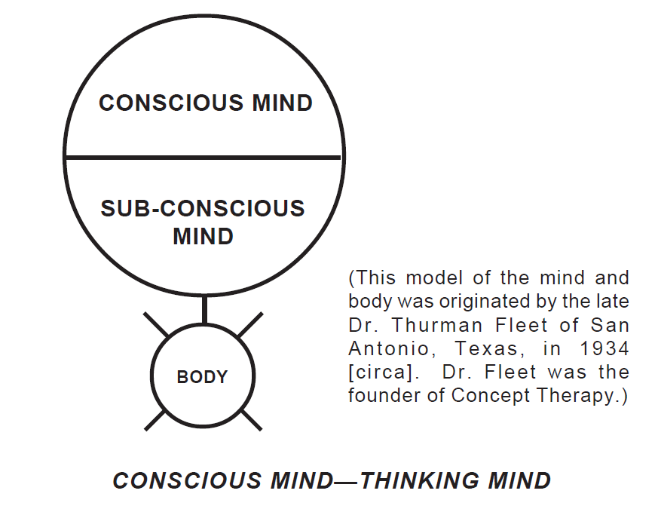

(This model of the mind and body was originated by the late Dr. Thurman Fleet of San Antonio, Texas, in 1934 [circa]. Dr. Fleet was the founder of Concept Therapy.)

CONSCIOUS MIND—THINKING MIND

The conscious mind is the part of you that thinks. Visualize the top half of your head as your conscious mind. Your free will lies in this part of your mind. You can accept or reject any idea. No person or circumstance can cause you to think about thoughts or ideas you do not choose. This is important because the thoughts you choose will eventually determine your results in life. As you accept a thought, it is impressed upon your Sub-Conscious mind.

SUB-CONSCIOUS MIND— CONDITIONED MIND

This part of you functions in every cell of your body. However, for our image, the bottom half of your head will represent your sub-conscious mind. Every thought or word your conscious mind chooses to accept, this part must accept... it has no ability to reject.

This part of you operates in an orderly manner. “By Law” it expresses itself through you in feelings and actions. Any thought you continuously impress upon your subconscious over, and over, any implant Energy Blockage implanted in your Energy Body becomes fixed in this part of your personality.

Energy Blockages will then continue to express themselves without any conscious assistance until they are grounded, transmuted and replaced. (Energy Blockages are more commonly referred to as “Bad habits.”)

BODY—INSTRUMENT OF THE MIND

The body is the most visible part of you. The body is the physical presentation of you, the material medium; it is merely the instrument of the mind, or the house you live in. The thoughts or images that are consciously chosen and impressed upon the sub-conscious, must move your body into action. The actions in which you are involved determine your results.

No. 1—Thoughts,

No. 2—Feelings,

No. 3— Actions,

No. 4—Results.

To change results— change thoughts, feelings and actions. Keep it simple.

To develop a good attitude toward the world in general—each of us must first develop a good attitude toward ourselves. We can’t give to others something we don’t have, so it’s the attitude we take toward ourselves which determines our attitude toward others—which radiates to the world around us.

When you see someone with a poor attitude toward others, you can be sure they have a poor attitude toward themselves. They don’t like themselves. They’re unhappy about something. A happy person reflects their happiness in their attitude. A person with a poor attitude most of the time is lacking in energy, unhappy and frustrated most of the time ... and they’re a human magnet for unpleasant experiences, karma.

When karma comes, as it must because of their attitude— it reinforces their poor attitude, thereby bringing more problems and so on. (That person becomes a self-generating, doom-fulfilling cycle.) But for the person with a good attitude, the same principle holds true in reverse. Expecting the best—that’s what they get most of the time.

Now, why would a person persist in a poor attitude... expecting the worst?

Well they have never been told they can change their attitude. They have never been taught techniques to change their attitude!

We’re so familiar with ourselves that we tend to take ourselves for granted; we tend to minimize what we can accomplish—the goals we can reach—and for some equally strange reason, we believe others can reach heights which we cannot! We tend to overlook the fact that there is enormous undeveloped potential within each of us— a great reserve of talent and ability which we habitually fail to use.

There are millions of human beings living narrow, darkened, frustrated lives—living defensively—simply because they take a defensive—doubtful attitude toward themselves and, as a result, toward life in general.

Attitude is the reflection of a person. (What’s going on on the inside shows on the outside.) One’s attitude is incalculably powerful. It can bring about marvelous results for us. But we must train it, patiently, day by day.

We train it by removing our bad habits and by energizing and potentising good attitudes within us by grounding, transmutation, by Mantra, or much more rapidly by the Energy Enhancement Seven Step process from the Energy Enhancement Five Level Meditation Course.

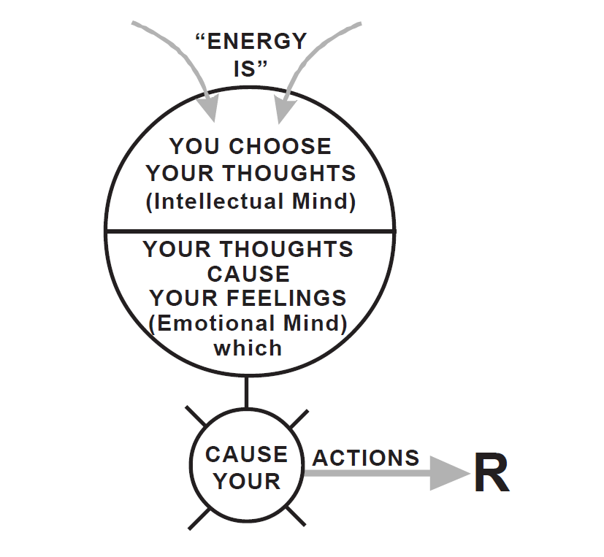

Now, for just a minute, let’s talk about people— successful people—who go sailing through life from one success to another and who, when they occasionally fail at something, shrug it off, and head right out again.

No matter what a person does—whenever you find a person doing an outstanding job and getting outstanding results, you’ll find a person with a good attitude. These people take the attitude toward themselves that they can accomplish what they set out to accomplish; that achievement is the natural order of things; that there’s no good reason on earth why they can’t be competent—successful. They have a healthy attitude toward themselves ... and as a natural result ... toward life and the things they want to accomplish.

Because of this, they achieve some remarkable things and come to be called successful, outstanding, brilliant, lucky and so on. They are quite frequently no more brilliant or talented than the majority of the people by whom they’re surrounded ... but they have the right attitude. They find their accomplishments not too difficult simply because it seems so few others are really trying ... really believe in themselves.

Successful people come in all sizes, shapes and colors, and in widely varying degrees of intelligence, background, and education.

But they have one thing in common, they expect more good out of life than bad; they expect to succeed more often than they fail — and they do.

The Positive Attitude created by the lack of Energy Blockages allows them to channel more Energy from God, from the chakras above the head, and this maximization of Energy causes the positive result.

When you want something worthwhile, take the attitude that there are a lot more reasons why you can have it, than why you can’t. Set out to earn it — go after it —work at it —ask for it —and nine times out of ten, you’ll get it.

Now, think about this.

Our environment, the world we’ve created around ourselves, is really a mirror of our attitudes. If we don’t like our environment, we can change it by changing our attitudes.

The world plays no favorites; it’s impersonal. It doesn’t care who succeeds and who fails; nor does it care whether we change or not. Our attitude toward life doesn’t affect the world and the people in it nearly as much as it affects us.

It would be impossible to even estimate the number of jobs which have been lost, promotions or good grades missed, sales not made, marriages ruined by poor attitudes. But you can number in the millions the jobs which are held though hated, the marriages which are tolerated but unhappy, the parents and children who fail to understand one another.

All because of people who are waiting for the world and others to change toward them, before they’ll change, instead of being big enough and wise enough to at least make a test which will prove where most of the trouble lies ... in our own poor attitudes.

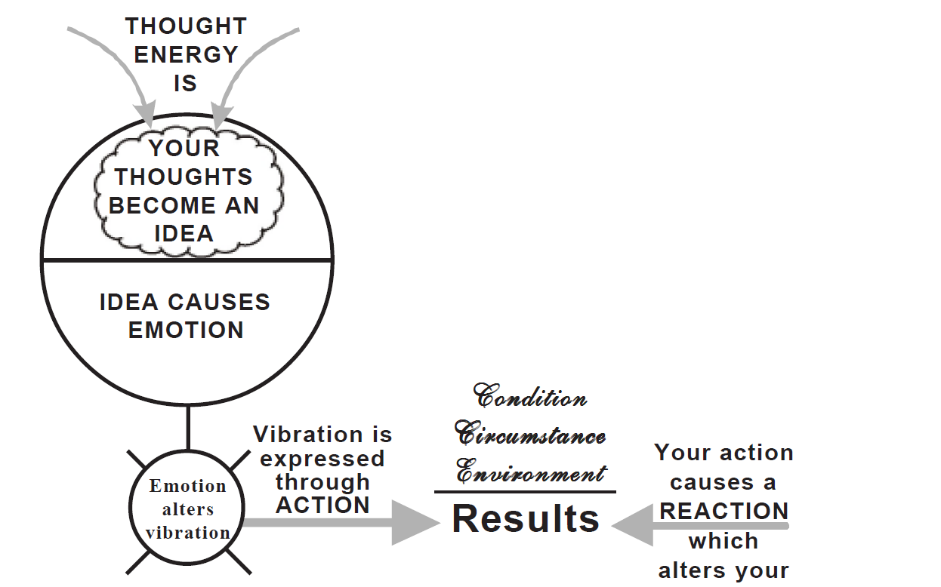

All right, so a successful attitude will help to bring us the success we seek. But just how does a person get this kind of attitude?

The easiest and most effective means of forming a good attitude habit is to begin conducting yourself as though you have a good, positive, expectant attitude toward life. Eliminate the negative. Accentuate the positive. If you’ve never tried it, you’ll be amazed at what happens.

Remember that actions can trigger negative feelings, negative emotions, and negative emotions are always triggered by Energy Blockages.

These negative emotions trigger negative actions. And so it goes.

The only solution is the removal of energy blockages and the energization - potentization of positive attitudes.

Not long ago, I read a line which went: “Life is dull only to dull people!” This is true. It could also have read: “Life is interesting only to interesting people.” Or, “Life is successful only to successful people.”

You must first become mentally ... from an attitude standpoint ... the person you wish to be.

A famous restaurateur was asked by a newspaper reporter one time: “When did you become successful?”

And he replied, “I was successful when I was sleeping on park benches. I knew what I wanted to do, and I knew that I’d do it.” You see, his attitude had been one of success, of expecting success, long before the material, the tangible rewards of success had been earned.

The great German philosopher Goethe put it this way:

**“BEFORE YOU CAN DO SOMETHING, YOU MUST FIRST BE SOMETHING.”**

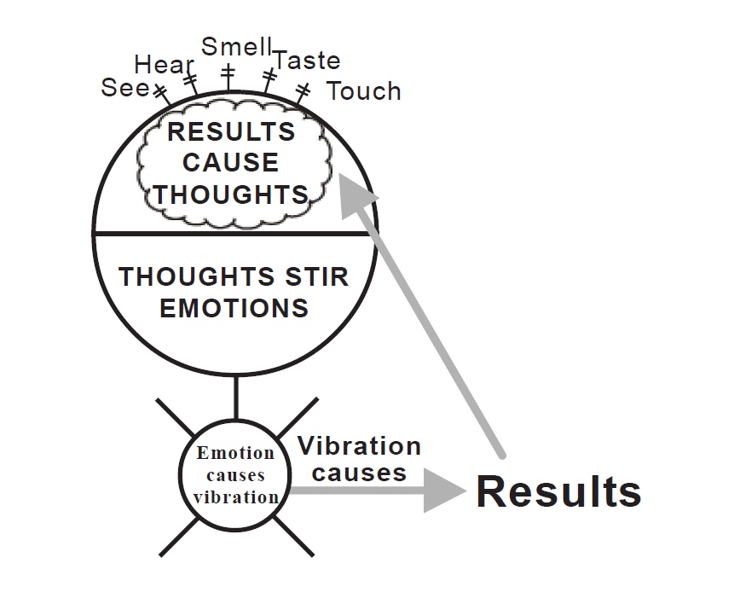

 Chances are you know people who seem to be what others call “lucky.” All kinds of wonderful things happen to them—and they give the impression of happily sailing through life having a wonderful time and accomplishing more in a year than most people do in five.

If you will conscientiously go about the test I’m going to recommend, and concentrate on it every day, you’ll find yourself beginning to join this small, happy, and extremely productive group of people. You’ll find yourself becoming “lucky,” as they say, and most of your problems will take care of themselves.

Of this you can be sure—the results will be nothing short of amazing. Now, here’s the test.

Act toward the world—everything and everyone, with an attitude calculated to produce the results you want. That is, if the result you want is more success in what you’re doing, act as though you are already in possession of that success. If you want others to treat you with admiration and respect, treat others with admiration and respect ... first.

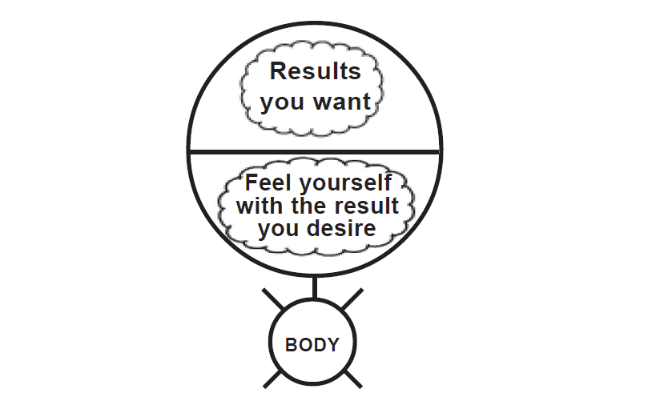

**TREAT EVERY PERSON AS THE MOST IMPORTANT PERSON ON EARTH.**

**Do this for three excellent reasons:**

1. As far as a person is concerned, he or she is the most important person on earth.

2. Because this is the way human beings ought to treat each other.

3. By treating everyone this way, we form an important positive habit.

There’s nothing in the world that men, women and children want and need more than self-esteem, the feeling that they’re important, that they’re needed, that they’re respected, that they are the sons and daughters of God.

They will give their love, their affection, their respect—and their support—to the person who fills this need.

Have you ever noticed that the higher you go in any organization of value, the nicer the people seem to become? You see, the bigger the person, the easier it is to talk to them— to get along with them—and to work with them.

Do you know why? It’s because they have a good attitude, and the people with the best attitudes just naturally rise to the top.

They don’t have a good attitude because of their position.

They have a position as a result of their attitude.

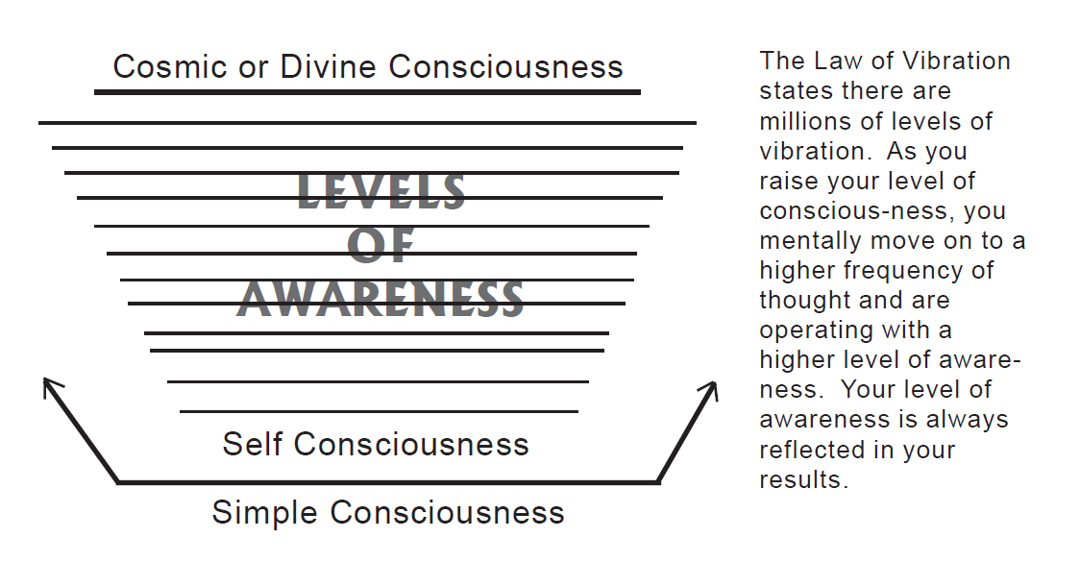

The Law of Vibration states there are millions of levels of vibration. These levels of vibration are the chakras above the head.

As you raise your level of conscious-ness through Energy Enhancement meditation channeling the energy of the chakras above the head using the Kundalini Kriyas, you mentally move on to a higher frequency of thought and are operating with a higher level of awareness.

Your level of awareness is always reflected in your results.

The people with the best attitudes have removed their Energy Blockage bad habits and thus are clear of any obstruction to channeling the infinite energy of the chakras above the head, the energy of the divine.

You are a child of God.

You are made in the image of God.

Imago Dei..

And thus using the Kundalini Kriyas of Energy Enhancement Meditation through channeling the infinite energy of the chakras above the head you can operate with an Infinitely high level of awareness.

As you focus on contacting and channeling the Infinite energies of the chakras above the head.

As you remove bad habit energy blockages which prevent this Infinite energy flowing to and through you.

As you implant and absorb Angel Wonder Words like Attitude into your subconscious system through mantra repetition, through sutra repetition and the Energy Enhancement Seven Step Process.

So you can achieve anything you want to achieve.

You can achieve that which you were born to achieve.

You can become that which you were born to become.

Think of it this way, science and theology are the only points of reference to which you can go, in search of information with respect to your true potential.

Both of these areas clearly indicate that nothing is either created or destroyed, which would indicate all the knowledge there ever was or ever will be is 100% evenly present in all places at the same time.

All the power there ever was or ever will be is 100% evenly present in you, in all places at the same time. In other words, the way to fly an airplane has always been here. The Wright brothers merely became aware of the principles governing flight. Edison merely developed a higher degree of awareness when he created the incandescent light. It was awareness that took us out of a cave and put us in a condominium.

We are talking about accessing the Quantum Leap energies of the higher chakras.

An animal operates with a simple consciousness. The animal knows and yet knows not.

They have senses: they can see, hear, smell, taste and touch. They’re aware of their objective world but not their subjective world.

The next level of consciousness is self-consciousness, and then God consciousness, the Infinite Energy of the chakras above the head consciousness As Gurdjieff put it, Being meditation.

That’s where you and I should operate. We not only have sensory factors to deal with our objective world, we have intellectual and imagination factors that permit us to deal with our subjective world.

Then you have the higher level that theology would refer to as “Divine” consciousness, “Christ” consciousness or possibly “Krishna” consciousness, depending upon your religious persuasion. Science might refer to this level of consciousness as “Cosmic” consciousness.

As a person raises their level of conscious awareness, it’s expressed in their behavior and results. Individuals who work for $25,000 per year, are not necessarily working for $25,000 because they want $25,000, they’re working for $25,000 because they’re not aware of how to earn $50,000.

People suffer from headaches because they’re not aware they can eliminate the headache: it’s their head, they made it ache, and they can make it stop. Individuals with a lower level of consciousness react to conditions or circumstances; those with a higher level of awareness would respond.

The higher the level of consciousness, the greater the energy and the greater the awareness of the laws that govern the universe. They know that the thought energy they send into the universe dictates what will return.

Act toward others and the world at large in exactly the same manner that you want the world, and others, to act toward you. For example, treat the members of your family as the persons they really are: the most important people in your life. Carry out into the world each morning the kind of attitude you’d have if you were the most successful person on earth. And notice how quickly it develops into a habit.

Almost immediately, a change will be noticed. Irritations that use to frustrate and annoy disappear. When some less informed person gives you a bad time, stay on the track.

When someone cuts in front of you with their car, or acts in any other manner that shows their ignorance and lack of courtesy, don’t permit yourself to drop to their emotional, mental, energy level.

Don’t let their unhappiness make you unhappy.

Like water off a duck’s back.

When you begin to develop better attitudes, you should realize you’ve already placed yourself on the road to what you seek. You are well on your way to joining the top two percent of the people. You’ve prepared the ground and planted the seed—you have made of yourself an embodiment of that which you seek.

Now in summing up, here are a few points to keep in mind:

First, it’s our positive, can-do attitude at the beginning of a task which, more than anything else, will bring about its successful outcome.

Second, our attitudes toward others determine their attitude toward us. We’re interdependent. The success we achieve in life will depend largely on how well we relate to others.

Third, before you can achieve the kind of life you want, you must THINK, ACT, TALK AND CONDUCT YOURSELF IN ALL OF YOUR AFFAIRS as would the person you wish to become.

Fourth, the higher you go in any worthwhile organization, the better the attitudes you’ll find. Attitudes are not the result of success. Success is the result of good attitudes.

And, finally, the deepest craving of human beings is for self-esteem; to be needed, to feel important, to be appreciated. When you treat every person you meet as the most important person in the world, both of you will benefit.

To make these important principles a habit-knit part of your life, here are some suggestions.

Since your mind can hold only one thought at a time, focus on connecting with the infinite energy of the chakras above the head, twenty-four hours a day, to make those thoughts constructive and positive.

Look for the best in people and ideas. Be constantly alert for new ideas you can put to use in your life.

Don’t waste time being a Poor Me, talking about your problems, or your poor health—unless you’re talking to your doctor. It probably won’t help you. It cannot help others.

Radiate the energy – channel the energy of the Chakras above the head and the attitude of well-being and confidence, the attitude of the person who knows where they’re going.

You’ll find good things happening to you right away.

Lastly, treat everyone with whom you come in contact as the most important person on earth.

Start this habit, practice it consistently, and you’ll do it the rest of your life.

**THE GOAL**

¨There are lots of fires in this world, and lots of people running around trying to put them out with buckets of petrol¨ - Swami Satchidanand

What this means is that the buckets of petrol are our paradigms, our Energy Blockages, our ego.

And it is these paradigms, Energy Blockages, and egos which get in the way of the natural functioning of our Soul. It is our Soul Path, Soul Task, Soul Destiny – our happiness – which is destroyed by these paradigms, Energy Blockages, and egos.

Therefore our happiness and the happiness of the World is determined by how successful we are at removing our paradigms, Energy Blockages, and egos and the paradigms, Energy Blockages, and egos of all the people in the World!

Now Earl Nightingale, in his audio program Lead the Field, defines success this way:

“Success is the progressive realization of a worthy goal.”

“It means that anyone who’s on course toward the fulfillment of a goal is successful. Now, success doesn’t lie in the achievement of a goal, although that is what the world considers success. It lies in the journey toward the goal.

We’re successful as long as we’re working towards something we want to bring about in our lives. That’s when the human being is at his or her best.”

But I beg to differ.

There is a world of difference between a professional goal, a worldly goal, a worthy goal to which Earl Nightingale refers, and an existential goal, a Spiritual Goal, a goal which will solve every ill on this Planet.

THE Goal!

So, although we are learning how to, “get what we want” I want to enlighten you about the price we have to pay to achieve a bad goal.

“The Lord have mercy on those who get what they want” – Hindu saying

Instead we need a worthy goal.

A goal where no-one gets hurt and at least one person benefits, and if one person benefits, then that person could even be you!

More, a Soul Goal!

"I am the master of my fate: I am the captain of my soul." by William Ernest Henley best known for his poem " Invictus " (1875).

But before you can become Captain, you have to spend years before the Mast, an able seaman apprentice!

**THREE STEPS TO ACHIEVING YOUR IDEAL GOAL**

**STEP 1: GET CLEAR**

If you are to be successful in setting and reaching worthy goals, there are two things you must know:

(1) where you want to go and

(2) where you are.

Along with these pieces of information, there are certain principles that you must weld into your subconscious, into your personality.

Integrity is one of these Angel Wonder Word principles.

Integrity means honesty and truth.

A famous line in Hamlet put it best:

“And this above all, to thine own self be true. And it must follow as the night the day – thou canst not then be false to any man.”

If we are true to ourselves, to our Soul, to our Higher Self, we cannot be false to anyone else.

If we live by integrity, we have what we need in a pinch, our sleep is untroubled, and we’re respected wherever we go.

This kind of truth is essential to establish where you are now. Because if you’re not completely honest with where you are, it won’t matter where you’re going because you won’t know in which direction to start moving or what changes you have to make.

When you choose a goal you seriously want (setting the right goal) and then make an irrevocable decision to follow the directions outlined in Step 2, something beautiful happens:

At a time that will be determined by natural law, you will enjoy in your material world the physical replica of what your imagination first presented to your consciousness.

**STEP 2: PAY THE PRICE**

“When I examined myself and my methods of thought, I came to the conclusion that the gift of fantasy has meant more to me than my talent for absorbing positive knowledge.” - Albert Einstein

Everything that was ever created by humans began in the form of a fantasy, imagination and projection.

However, you must take the time to crystallize the image of your chosen goal and then paint that image in Wonder Words so crystal clear that a child would understand it.

Mantra repetition, sutra repetition and the Energy Enhancement Seven Step Process will weld your aim into your subconscious.

Once you complete that picture—down to the last detail, you must answer, in the affirmative, the following two questions before your fantasy truly qualifies as a goal:

Am I able to cause this image to move into form?

Am I willing to pay the price that must be paid to turn this image into physical form?

**STEP 3: COMMIT**

Although you may take the time right now to go through Steps 1 and 2, if there is no firm and irrevocable commitment to carry through with all of your plans, a year from now, everything will be much the same as it is right now.

Irrevocable Commitment is the creation of Will-Power.

Many excellent writings convey the necessity and the power of commitment, including the following words from W. H. Murray:

“Until one is committed, there is hesitancy, the chance to draw back, always ineffectiveness. Concerning all acts of initiative (and creation), there is one elementary truth, the ignorance of which kills countless ideas and splendid plans: that the moment one definitely commits oneself, then Providence moves too. All sorts of things occur to help one that would never otherwise have occurred. A whole stream of events issues from the decision, raising in one’s favor all manner of unforeseen incidents and meetings and material assis- tance, which no man could have dreamt would have come his way.”

Goals are essential to living the life you really want.

Use this three-step process to exercise your imagination and Will as conscious, deliberate tools to take you out of the ordinary and propel you into the extraordinary.

“THE” GOAL

Therefore our happiness and the happiness of the World is determined by how successful we are at removing our paradigms, Energy Blockages, and egos and the paradigms, Energy Blockages, and egos of all the people in the World!

Top Down

Now, positivity and the implantation of positive goals from the conscious into the unconscious and the Heart, the subconscious through Mantra repetition and visualization, as we are learning on this course, is a top down methodology.

Bottom Up

However, it totally ignores the Methodology of Energy Enhancement Alchemical VITRIOL and the Energy Enhancement Seven Step Process to transmute and remove the Energy Blockages preventing the implantation of the Goal. Energy Enhancement destroys trauma and fear, anger and sadness, manicism and depression. Energy Enhancement is bottom up.

Speed and efficiency in achieving the goal comes from the combination of Top Down and Bottom Up.

**THE DECISION**

**DECISION, THE MASTERY OF PROCRASTINATION**

**By Napoleon Hill**

ACCURATE analysis of over 25,000 men and women who had experienced failure, disclosed the fact that LACK OF DECISION was near the head of the list of the 30 major causes of FAILURE. This is no mere statement of a theory--it is a fact.

PROCRASTINATION, the opposite of DECISION, is a common enemy which practically every man must conquer.

You will have an opportunity to test your capacity to reach quick and definite DECISIONS when you finish reading this book, and are ready to begin putting into ACTION the principles which it describes.

**Analysis of several hundred people who had accumulated fortunes well beyond the million dollar mark, disclosed the fact that every one of them had the habit of REACHING DECISIONS PROMPTLY, and of changing these decisions SLOWLY, if, and when they were changed. People who fail to accumulate money, without exception, have the habit of reaching decisions, IF AT ALL, very slowly, and of changing these decisions quickly and often.**

**REACHING DECISIONS PROMPTLY** Carnegie measured how long Napoleon Hill took to reach his decision to publicise the Secret of Dale Carnegie’s success. It took him 29 seconds to decide to invest twenty years of his life in the project! If he had taken longer, Carnegie would have rejected him!

**It is easy to change a decision, the more you practise, the easier it is!**

The majority of people who fail to accumulate money sufficient for their needs, are, generally, easily influenced by the "opinions" of others. They permit the newspapers and the "gossiping" neighbors to do their "thinking" for them. "Opinions" are the cheapest commodities on earth. Everyone has a flock of opinions ready to be wished upon anyone who will accept them. If you are influenced by "opinions" when you reach DECISIONS, you will not succeed in any undertaking, much less in that of transmuting YOUR OWN SOUL DESIRE into reality.

If you are influenced by the opinions of others, you will have no DESIRE of your own.

Keep your own counsel, when you begin to put into practice the principles described here, by reaching your own decisions and following them. Take no one into your confidence, EXCEPT the members of your "Master Mind" group, and be very sure in your selection of this group, that you choose ONLY those who will be in COMPLETE SYMPATHY AND HARMONY WITH YOUR PURPOSE.

Close friends and relatives, while not meaning to do so, often handicap one through "opinions" and sometimes through ridicule, which is meant to be humorous. Thousands of men and women carry inferiority complexes with them all through life, because some well-meaning, but ignorant person destroyed their confidence through "opinions" or ridicule.

You have a brain and mind of your own. USE IT, and reach your own decisions. If you need facts or information from other people, to enable you to reach decisions, as you probably will in many instances; acquire these facts or secure the information you need quietly, without disclosing your purpose.

It is characteristic of people who have but a smattering or a veneer of knowledge to try to give the impression that they have much knowledge. Such people generally do TOO MUCH talking, and TOO LITTLE listening. Keep your eyes and ears wide open--and your mouth CLOSED, if you wish to acquire the habit of prompt DECISION. Those who talk too much do little else. If you talk more than you listen, you not only deprive yourself of many opportunities to accumulate useful knowledge, but you also disclose your PLANS and PURPOSES to people who will take great delight in defeating you, because they envy you.

Remember, also, that every time you open your mouth in the presence of a person who has an abundance of knowledge, you display to that person, your exact stock of knowledge, or your LACK of it! Genuine wisdom is usually conspicuous through modesty and silence.

**Keep it secret. Keep it safe!! Do not tell anyone of your decision until you have it.**

Keep in mind the fact that almost every person with whom you associate is against you in some way. They are jealous, afraid or competitive. If you talk about your plans too freely, you may be surprised when you learn that some other person has beaten you to your goal by PUTTING INTO ACTION AHEAD OF YOU, the plans of which you talked unwisely.

Let one of your first decisions be to KEEP A CLOSED MOUTH AND OPEN EARS AND EYES.

As a reminder to yourself to follow this advice, it will be helpful if you copy the following epigram in large letters and place it where you will see it daily.

"TELL THE WORLD WHAT YOU INTEND TO DO, BUT FIRST SHOW IT."

This is the equivalent of saying that "deeds, and not words, are what count most."

**Once you have made a decision. Don't change the decision.**

Millions of people look at the achievements of Henry Ford, after he has arrived, and envy him, because of his good fortune, or luck, or genius, or whatever it is that they credit for Ford's fortune. Perhaps one person in every hundred thousand knows the secret of Ford's success, and those who do know are too modest, or too reluctant, to speak of it, because of its simplicity. A single transaction will illustrate the "secret" perfectly.

A few years back, Ford decided to produce his now famous V-8 motor. He chose to build an engine with the entire eight cylinders cast in one block, and instructed his engineers to produce a design for the engine. The design was placed on paper, but the engineers agreed, to a man, that it was simply impossible to cast an eight cylinder gas engine block in one piece.

Ford said, "Produce it anyway." "But," they replied, "it's impossible!"

"Go ahead," Ford commanded, "and stay on the job until you succeed no matter how much time is required."

The engineers went ahead. There was nothing else for them to do, if they were to remain on the Ford staff. Six months went by, nothing happened. Another six months passed, and still nothing happened. The engineers tried every conceivable plan to carry out the orders, but the thing seemed out of the question; "impossible!"

At the end of the year Ford checked with his engineers, and again they informed him they had found no way to carry out his orders.

"Go right ahead," said Ford, "I want it, and I'll have it."

They went ahead, and then, as if by a stroke of magic, the secret was discovered.

The Ford DETERMINATION had won once more!