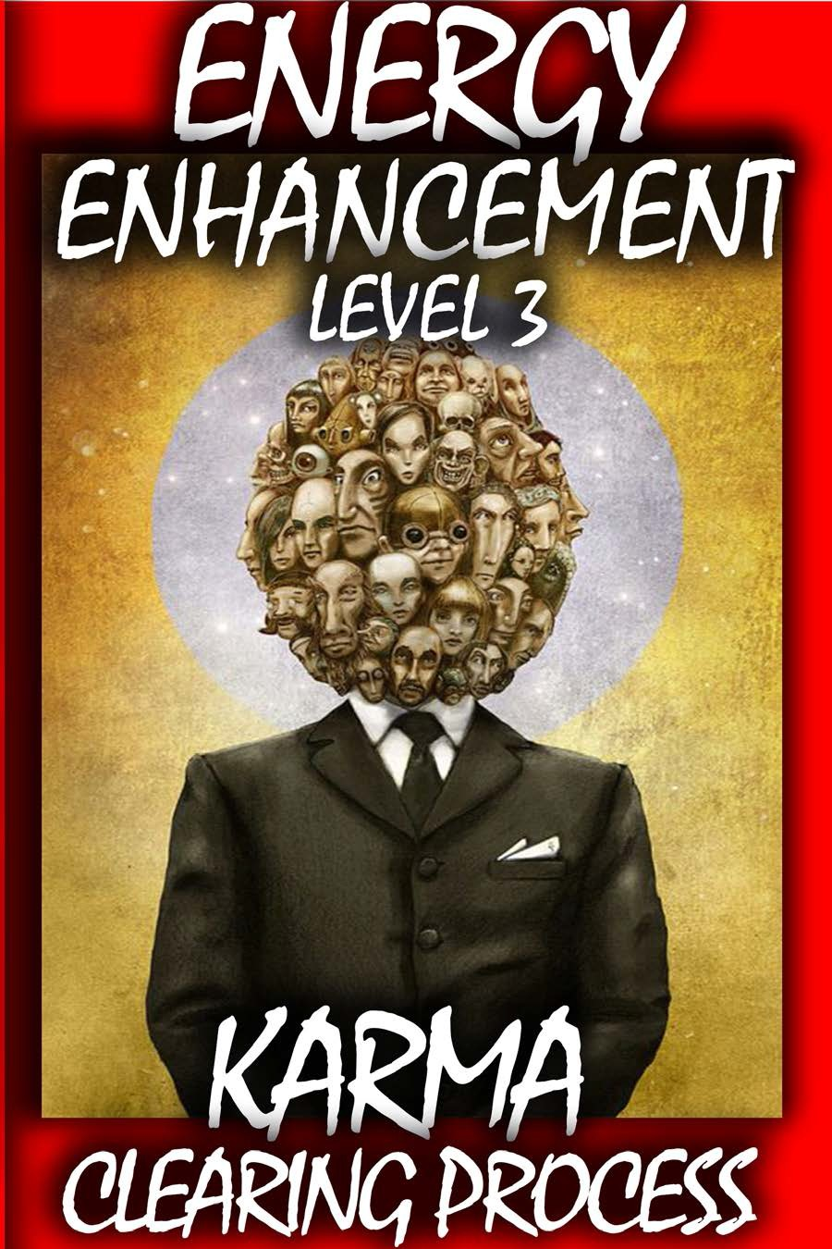

DEDICATION

With all Thanks, Love and Gratitude to Swami Devi Dhyani and all the Energy Enhancement book editor, Prema PraShakti who make these books possible.
With all Thanks, Love and Gratitude to my Mother and Father and to all my other Teachers, Theos Bernard, Sri Yogendra, Eric Berne, Gurdjieff, Father Bede Griffiths, Osho, Zen Master Hogen, Swami Sivananda, Swami Satchitananda, and all the other giants upon whose shoulders I stand - who made me able to be what… I AM – Swami Satchidanand
Copyright © 2018

[Energy Enhancement Synthesis of Light Limited (SOL)] All rights reserved. This publication may not be reproduced in whole or in part, by any person,
without written permission of: Swami Satchidanand
sol@energyenhancement.org www.energyenhancement.org

“THERE CAN ONLY BE ONE!!”

Table of Contents
ENERGY ENHANCEMENT COURSE APPRENTICE LEVEL3 12 THOMAS BLAIR'S ENERGY EXPERIENCES!!! 24
Reincarnation, Immortality and the Removal of Karma 25
Philip Chester Course Report 52
ENERGY ENHANCEMENT IS THE REAL TRUTH Karma
Clearing Process of Energy Enhancement Meditation Including the Kundalini Kriyas + Alchemy Today I sat in a chair and listened to the heart chant initiation 1 for the first time 55
FIFTEEN YEARS OF FANTASTIC TESTIMONIALS MAKES ENERGY ENHANCEMENT THE COURSE TO COME ON!! 74 REPORT FROM HIROMI FROM JAPAN ON THE DVD COURSE 94
What we feel 116
Our Deepest Fear 117
WHAT DON MINIHANE SAYS OF HIS MEDITATIONAL EXPERIENCES ON THE JANUARY 2007 COURSE 121
Energy Enhancement APPRENTICE LEVEL 3. Initiation 1. 127
CLEANING THE AKASHIC RECORDS - THE ENERGY ENHANCEMENT KARMA CLEANING PROCESS 130
TRANSMUTE BAD LUCK TO GOOD LUCK 156
Meditation Energy Enhancement and Gurdjieff 157
Energy Enhancement APPRENTICE LEVEL 3 Initiation 4 159
Energy Enhancement Meditation Course Level 3 - Initiation 5 162 The Aloof Strategy. 167
The Poor me Strategy, 168
The Interrogator Strategy 175
The Violator Strategy 175
The Don Juan, Seductor, Succubus/Incubus, Lilith or Vamp Strategy 179
Pleaser Strategy 180
The Critic Strategy 181
The Tyrant Strategy 181
The Self Destructor Strategy 181
Manic Depression 182
THE TRI-STRATEGIES 183
The Cuckoo and the Soul-Infused Personality 187
MONKEYS ARE ENERGY VAMPIRES 191

THE LUST ARCHETYPE OF THE THOTH TAROT AND ENLIGHTENMENT 193
SUB-PERSONALITY ENERGY BLOCKAGES AND THE BHAGAVAD GITA 197
Energy Enhancement APPRENTICE LEVEL 3. Initiation 5. THE KARMA CLEANING PROCESS Removing the Strategies 200
STRATEGIES 201
The Correct use of the Strategies 203
STRATEGIES 209
Part I: How Psychic Vampirism Works 210
Part II: Effects of psychic vampirism 215
Part III: How to Protect yourself and recover from psy-vamp attacks 217
Part IV: How to Perceive Energy 221
Part V: Other Tips, advice and suggestions for psy-vampires...222 Energy Enhancement APPRENTICE LEVEL 3. Initiation 6 THE SEVEN STEP PURIFICATION OF TRAUMA-FORMED NEGATIVE KARMIC MASS IN TALENTS AND THE CREATION AND INCREASE OF TALENTS OR ANGEL TALENT COLONIES IN LEVEL THREE OF ENERGY ENHANCEMENT 223
THE TALENTS 235
Energy Enhancement APPRENTICE LEVEL 3. Initiation 7 239
REMOVING VOWS FROM THIS LIFE AND ALL YOUR PAST LIVES 241
Some Of The Subconscious Past-Life Vows 244
KARMA CLEARING, SOUL SPLITS AND ENERGY ENHANCEMENT 253
ENERGY ENHANCEMENT WORK WITH ENERGY BLOCKAGES 258
THE OUCH!! LIST 258
Energy Enhancement APPRENTICE LEVEL 3. Initiation 8 274
THE ENERGY ENHANCEMENT PATH OF PLEASURE, SAMADHI, SAMYAMA, ENLIGHTENMENT 278
What is Energy Enhancement Reiki? 299
Energy Enhancement Meditation Course Level 1 307
Energy Enhancement Meditation Course Level 2 310
Energy Enhancement Meditation Course Level 3 312
Energy Enhancement Meditation Course Level 4 314

ENERGY ENHANCEMENT APPRENTICE LEVEL 3

"Traditional forms of meditation are designed to fail!!"

FIND ALL THE INCREDIBLE MEDITATION TECHNIQUES AND MEDITATION PRACTISES REMOVED FROM TRADITIONAL MEDITATIONS AND TAUGHT IN THE ENERGY ENHANCEMENT STREAMING VIDEO MEDITATION COURSE AND LIVE MEDITATION RETREATS IN BRAZIL AND INDIA

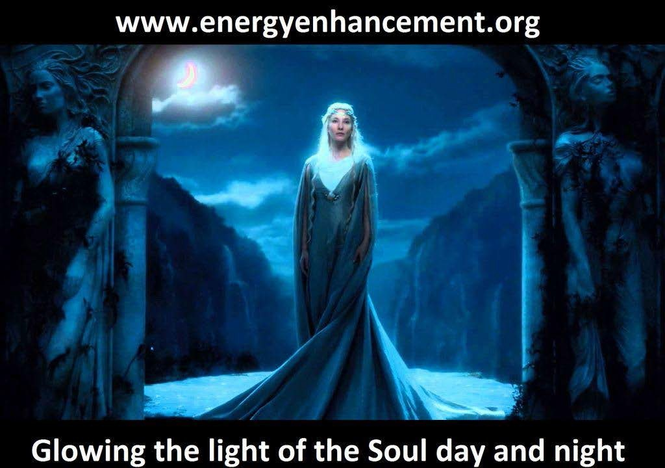

5

"WE PUT BACK WHAT THE OTHERS TOOK OUT!!"

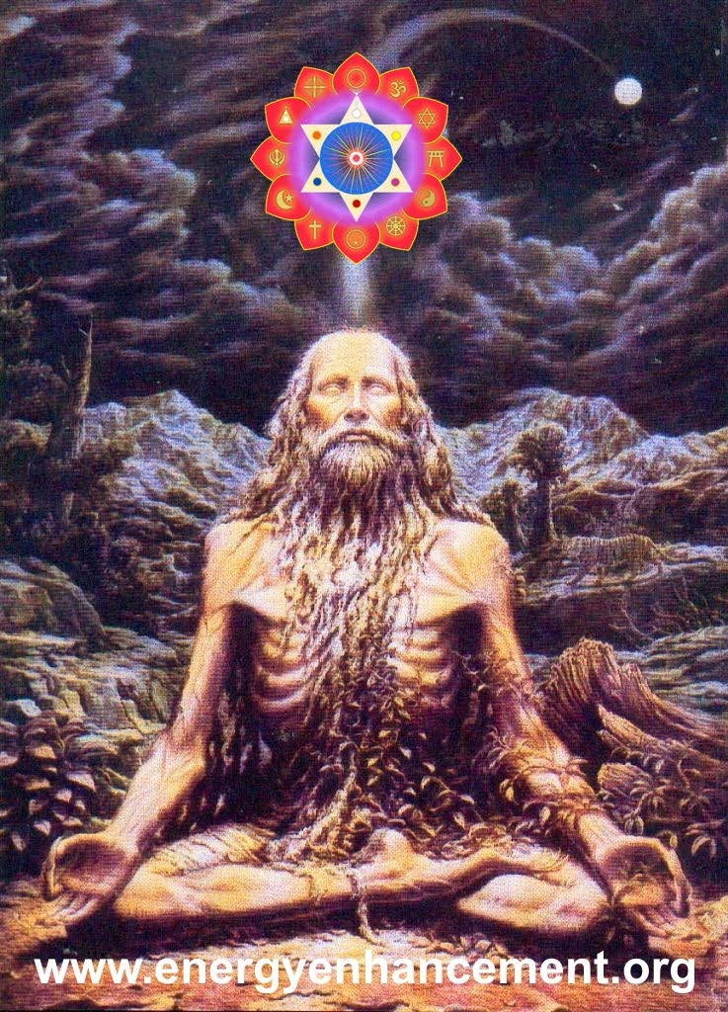

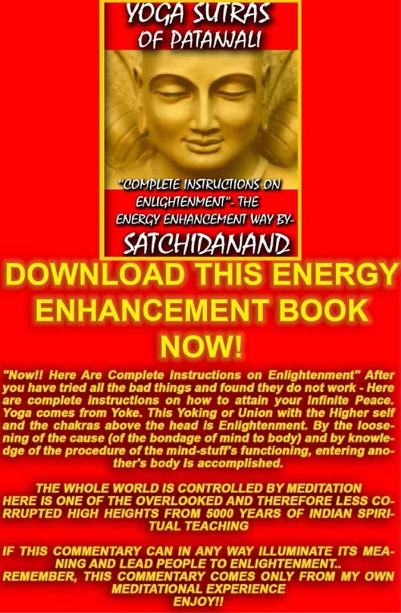

THE YOGA SUTRAS OF PATANJALI BY SWAMI SATCHIDANAND - CLICK HERE..
http://www.energyenhancement.org/Sacr ed-Energy/yoga-sutras-of-patanjali- book/Energy-Enhancement-Yoga-Sutras- of-Patanjali.pdf

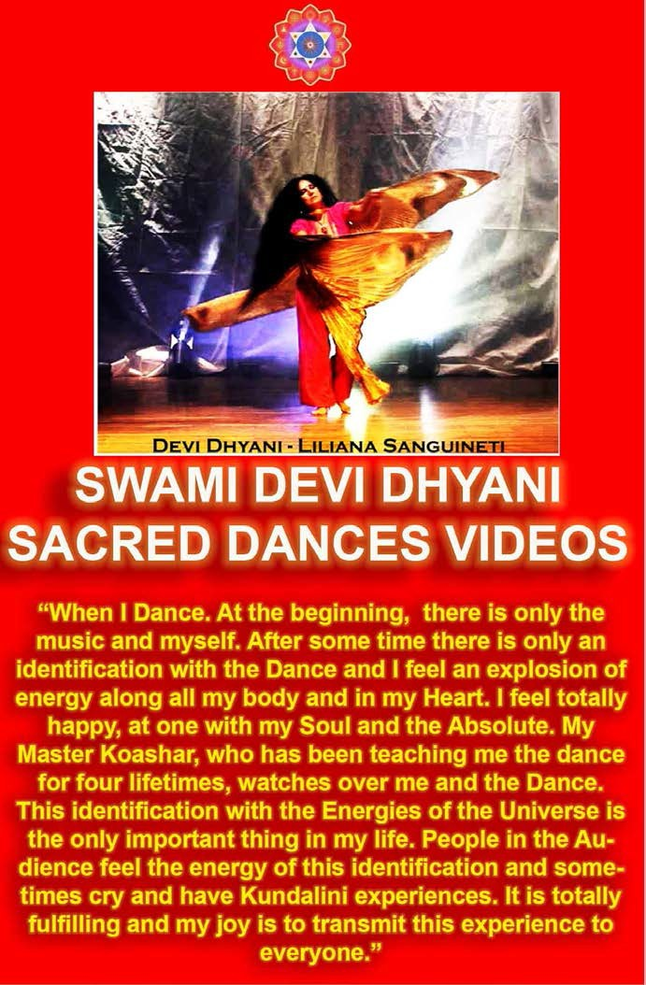

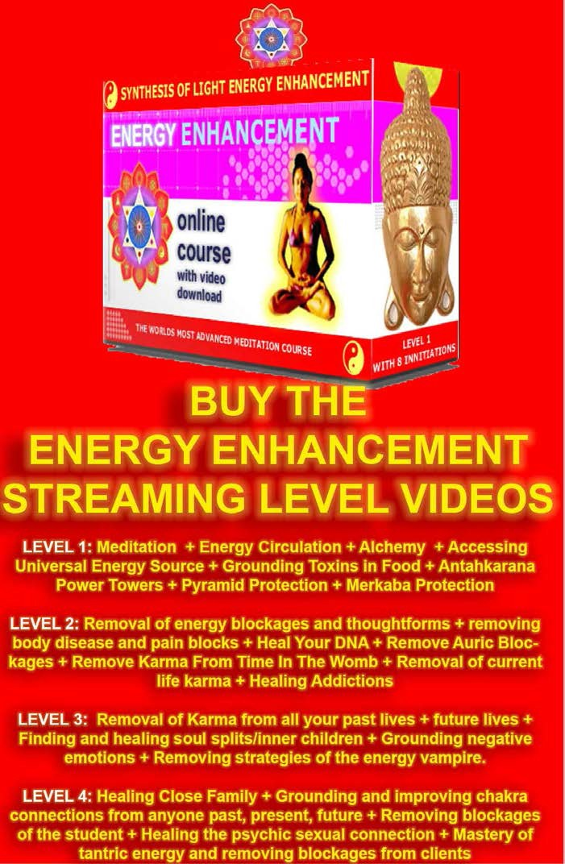

YES, WITH ENERGY ENHANCEMENT, LEARN HOW TO REMOVE ALL YOUR ENERGY BLOCKAGE KARMA!!

REMOVE ALL YOUR BAD LUCK AND TROUBLE

REMOVE ALL YOUR INNER SABOTAGE, ATTITUDES, HABITS WHICH PREVENT SUCCESS IN LIFE

- REMOVE KARMA, FOLLOW DHARMA

YES, EACH ENERGY BLOCKAGE IS THIS LIFE, PAST LIFE KARMA

ONCE KARMA IS REMOVED THEN IT IS EASY TO FIND YOUR DHARMA, YOUR SOUL PATH, "THE PATH WITH HEART"

REMOVING EVEN DEEPER BLOCKAGES

THE KARMA CLEARING PROCESS

"Waste no more time arguing what a good person should be.. Be One" - Marcus Aurelius

"REMOVING ALL YOUR ENERGY BLOCKAGES IS A REALLY GOOD THING TO DO" - SATCHIDANAND

ENERGY ENHANCEMENT IS THE NEWEST AND MOST HIGH SPIRITUAL IMPULSE ON THIS PLANET

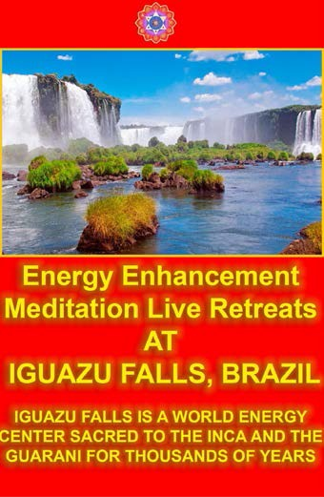

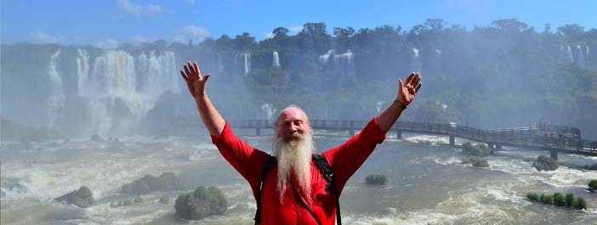

SATCHIDANAND - IGUAZU FALLS

Read Amara Atma's Energy Enhancement Report at Iguazu Falls..

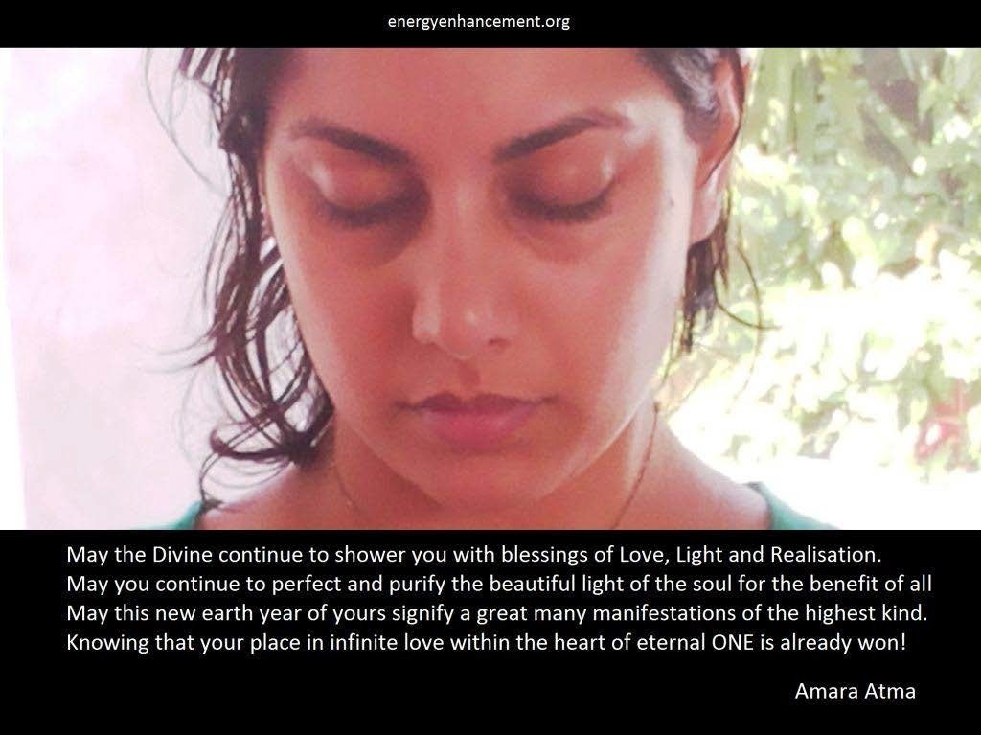

ENERGY ENHANCEMENT COURSE APPRENTICE LEVEL3

KARMA CLEANING PROCESS, CLEAN THE KARMA FROM PAST LIVES, CLEAN THE KARMA FROM YOUR FUTURE LIFE, CLEAN THE KARMA FROM YOUR FUTURE LIFETIMES,

SOUL FRAGMENTATION INTEGRATION AND RETRIEVAL, HOW TO STOP PSYCHOPATHIC ENERGY VAMPIRES, INTEGRATE INNER CHILDREN, HEAL AND INTEGRATE SELFISH EGO SUB PERSONALITIES, LIFE DESTROYING STRATEGIES, THE ALOOF, THE INTERROGATOR, THE VIOLATOR, THE SELFISH COMPETITIVE STAR, THE VAMP OR DON JUAN, THE PLEASER, THE BLAMER, THE CRITIC, THE KING, THE SELF DESTRUCTOR, REMOVE ALL THE DESTRUCTIVE VOWS FROM THIS AND PAST LIFETIMES, THE CREATION OF SELF LOVE, LOVE AND SERVICE.

If you are serious about self-improvement, growth, change, enlightenment! Then the Energy Enhancement Course is for you.

JEAN, EE STUDENT

ENERGY ENHANCEMENT APPRENTICE LEVEL 3

SOUL SPLIT RETRIEVAL THIS LIFE TRAUMA CLEARING

PAST LIFE KARMA CLEARING

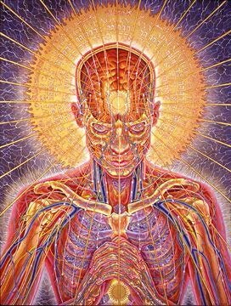
Energy Enhancement is the fastest way to Enlightenment..

Yoga is good but Pranayama is 10 times faster at releasing Energy Blockages whiMeditation Courses The Energy Enhancement Meditation Course Symbol from

the Synthesis of Light- Satchidanandch stop the Enlightenment process.

Pranayama is good but Meditation is 10 times faster than even that at releasing Energy Blockages which stop the Enlightenment process.

Meditation is good but Samyama is 10 times faster than even that at releasing Energy Blockages which stop the Enlightenment process.

Yoga, Pranayama, Meditation and Samyama are part of the Eight Limbs of Yoga in the Yoga Sutras of Patanjali and Samyama is talked about from over 5000 years ago in the THIRD AND FOURTH Chapter of The Yoga Sutras of Patanjali.

And Samyama IS Energy Enhancement, 1000 times faster on the Path of Enlightenment.

You cannot afford NOT to try it!! Love and Light,
Satchidanand

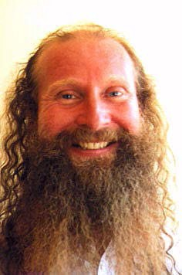

THE MEDITATION ENERGY ENHANCEMENT SEVEN STEP PROCESS OF LEVEL TWO IS THE ONLY PROCESS ON ANY PATH WHICH TEACHES HOW TO TOTALLY REMOVE THE PARADIGM - ALL THE NEGATIVE ENERGY BLOCKAGES OF THE EGO!!

"All of our students report on their personal success in eliminating their own Energy Blockages by themselves"

"The Technique of the Energy Enhancement Seven Step Process is the only Enlightenment process outside of expensive Scientology which can dissolve Energy

Blockages. Without it Buddhism, Hinduism, Ramana Maharshism, Ekhard Tollism, Sri Niscardattaism, any other Enlightenment process depends on the Master to remove the energy blockages.

In Energy Enhancement, we help but we give full instructions to our students on how to Eliminate the Energy Blockages of the Angry, Painful, Selfish, Competitive, Fearful, Desire filled Ego and all of our students report on their personal success in eliminating their own Energy Blockages by themselves.

IN THIS WAY, WITH ENERGY ENHANCEMENT, NEW MASTERS ARE VERY EASILY FORMED

The rate of evolution of humanity needs to increase. The old ways of the Master doing all the work of removing the energy blockages of the ego are now too slow. The recommendation is for students to serve their Masters for at least 12 years. Many have been there for 20 years with no appreciable movement forwards. The new technique of The Energy Enhancement Seven Step process can now augment the processes of every Enlightened Master and thus Speed Up!! the Process of Enlightenment Worldwide - Satchidanand Bio"

"NOW IS THE OPPORTUNITY FOR FULFILLMENT AND NEW BEGINNINGS FOR THE WORLD"

ENERGY ENHANCEMENT IS A NEW REVELATION OF GOD TO HUMANITY!!

"The Miracle of the Removal of Energy Blockages.. Miracles, Miracles and yet more Miracles!!" - Graham Smith on his Energy Enhancement Course in India November 2009

DO IT!

M.S. - HR Director PepsiCo Europe/Asia THE REMOVAL OF TRAUMA,
PAST LIFETIME KARMA CLEANUP, SOUL SPLIT RETRIEVAL,
HEALING INNER CHILDREN, REMOVING NEGATIVE EMOTIONS,
REMOVING NEGATIVE KARMIC MASS FROM THE STRATEGIES OF THE VAMPIRE

INTELLECTUALLY KNOW HOW TO RECOGNISE ENERGY VAMPIRES BUT TO TRULY SOLVE THE PROBLEM, YOU NEED ENERGY ENHANCEMENT

Energy Enhancement APPRENTICE LEVEL 3. Initiation 1. THE REMOVAL OF OLD KARMA
FROM ALL YOUR PAST LIFETIMES

Remove all the Blockages from all your previous lifetimes

This is what they mean when they say a Master is not under the Laws of Karma.
He has dissolved all the negativity from all his past lives. He has used his SOUL, MONAD, LOGOS AND HIGHER
ENERGIES to dissolve all the negativity, to FORGIVE all the bad actions and trauma that he has done, and have been done to him.

Create a Clean white sheet again from your Messy Dark History Painting which you have created brushful by brushful, every day of your life.

Learn How to easily and quickly Heal, remove all the negative trauma energy from all your Personal History, Your Life until now, of all of its painful memories and blockages which act as filters to our vision.

Learn How to easily and quickly Heal, remove all the negative trauma energy from all your Past Lifetimes, Your Lives until now, of all of their painful memories and blockages.

Learn How to easily and quickly Heal, remove all the negative trauma energy from this Future Life of all of its painful memories and blockages.

Learn How to easily and quickly Heal, remove all the negative trauma energy from all your Future Lifetimes, Your Future Lifetimes of all of their painful memories and blockages which act as filters to our vision.

One of our Students age 37, the director of an Internet Business in Bolivia, started to clean his future of this lifetime by mistake, before he had cleaned all of his past lifetimes and this life. He saw himself at the age of 56 with two children in his arms and no wife and then.... all became blank. He then cleaned this lifetime and all previous lifetimes of all their Negative Energy blockages, Energies and bad Karma. When he came to clean the future of this life he saw himself entering into the light, becoming a spiritual teacher in his fifties, onwards towards AGE 80!!!

One of my Teachers, Zen Master Hogen said, "We are all History Paintings. We start with a clean white sheet and then every day we apply paint. Usually our History

Paintings become very messy!!!" "I am a clean white sheet which is washed constantly. Every time we meet, it is as if there is no emotional holdover from the past"

"Everytime, I see you clearly, as if for the first time!" Zen Master Hogen.

ONLY BY LEARNING HOW TO CLEAN OUR KARMA AND NEGATIVE KARMIC MASS CAN WE ACCESS THIS STATE FOR OURSELVES

COME TO LEARN THE KARMA CLEARING PROCESS WITH ENERGY ENHANCEMENT LEVEL 3!!

Energy Enhancement, - An Advanced Meditation Course which gives the MOST benefits of any course of Meditational Self-Development available anywhere in the World today.



If you want to Master Meditation Energy, to get more Energy and to handle it better, this course is for You!

If you want to Speed Up the Meditative Process, rather than sitting with no result.

Energy Enhancement Advanced Meditative Techniques including the Kundalini Kriyas and the Five Taoist Elemental Pathways of the Chi, is for You!!!!

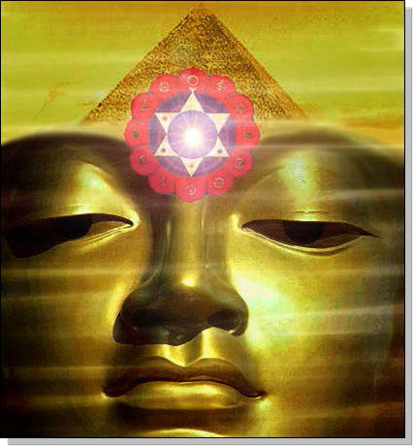
Whether you are a Management Corporate Executive, any sort of Alternative Practitioner, Meditator, Yogi or anyone who wants to Evolve, - Have Massive Energy Gains, become Better, Smarter, more Evolved, more Empathic, more Soul Infused, Gain the Real Secrets of Success; This course will Enable Direct Experience of Superior Life Performance.

Energy Enhancement Meditation Techniques are the quickest and easiest methods of evolution available, leading to Ultimate Happiness.

Energy Enhancement, The Most Advanced Techniques of Meditation Available, NOW!!

Developing Meditation psychic powers to Get in touch with your Life Path, Ground negative Energies, Access Infinite Levels of Universal Energy, Raise Your Kundalini, Integrate the Separated Selves, and Master Relationships and Mediation.

Meditation Energy Enhancement Enables FOUR Initiations towards your Ultimate Freedom - Illumination, Nirvana, Emptiness, - Enlightenment.

Energy Enhancement is a unique system to exponentially increase your energy by mastering the Mind, accessing inner peace, improving health, Mastering Relationships , creating synchronicity and luck, and improving your success.

Energy Enhancement is a Course of selfless, highly advanced, meditation techniques which can Quickly!! Increase the Speed of the normal Mind.

Energy Enhancement Synthesises, brings together ALL these gifts for the first time in one Course.-

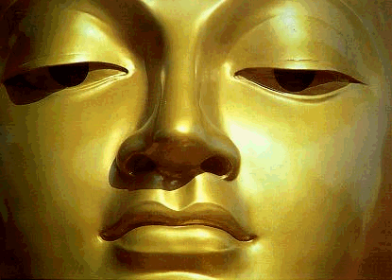To Enable Your Evolution!!

ENERGY ENHANCEMENT ILLUMINATION

THOMAS BLAIR'S ENERGY EXPERIENCES!!!

"I consciously sourced as much energy from above to flow through my body, and in doing so, rather than my body being filled with golden light, I had somehow tapped into an immense source of white light above the head. As well as feeling this increased energy stream through my body, I realised I had involuntarily suspended breathing somewhere near the top of an in breath. My body felt like a beacon of light, with more than enough energy to direct toward a blockage and watch it dissolve in an instant.

Since that time I am always connected to and able to source the white light from above my head. Many times during this process I just forget to breathe as though my breathing is just naturally suspended. I am now living in the Light!!

My energies are naturally far higher than when I arrived on the Energy Enhancement course just two weeks ago.

I am experiencing Energy, the fruits of meditation which normally arrive, if they do, after twenty years of meditation and it has only taken me two weeks."

Thomas Blair September 2005 Course in Spain

ENERGY ENHANCEMENT IMMORTALITY LIVE COURSES, INDIA AND IGUAZU FALLS



ONLY THE SUPERPOWERS DEVELOPED BY THE SCIENCE OF REAL MEDITATION CAN FREE HUMANITY TO REACH THE STARS.

ENERGY ENHANCEMENT MEDITATION ENLIGHTENMENT AND ILLUMINATION

THE INCREDIBLE MEDITATION COURSE AND MEDITATION
TECHNIQUES CREATED TO PRODUCE ENLIGHTENMENT
AND ILLUMINATION

"ALL TRADITIONAL MEDITATIONS HAVE BEEN DESIGNED TO FAIL" - SATCHIDANAND -

"BECAUSE ORIGINALLY ALL MEDITATIONS CONTAINED THE
TECHNIQUES OF, "THE KUNDALINI KEY" AND OF, "ALCHEMICAL
VITRIOL" TO GROUND NEGATIVE ENERGIES AND TO NATURALLY
INCREASE KUNDALINI ENERGY"

"NOW, ONLY ENERGY ENHANCEMENT MEDITATION TEACHES
THESE TECHNIQUES WHICH SPEED UP THE ENLIGHTENMENT
PROCESS"

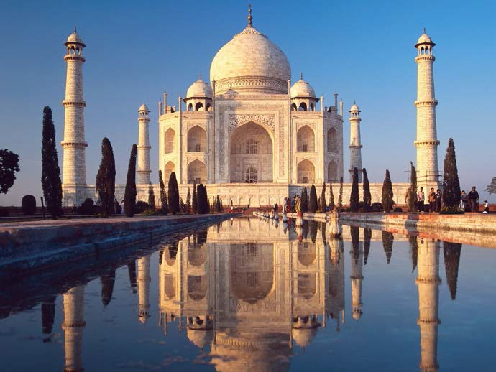

Reincarnation, Immortality and the Removal of Karma

Energy Enhancement Meditation Energy Blockages and Soul Splits, Clean Past Life Karma, Master Relationships

Here in this Article, Reincarnation, Immortality and the Removal of Karma, Satchidanand talks of how we are already Immortal as we have seen all our previous lifetimes in meditation, and how Energy Enhancement Meditation Students Remove the Trauma, Remove the

Pain energy blockages from previous lifetimes, Remove All the Karma from Every Past Lifetime, seeing visions of the lessons learned from those blockages formed in every past lifetime, in order to normalise our reactions, psyche, emotions, actions in this lifetime.

Life is not a dream.

This is the Examination Hall in this Earth Factory to create Enlightened beings...

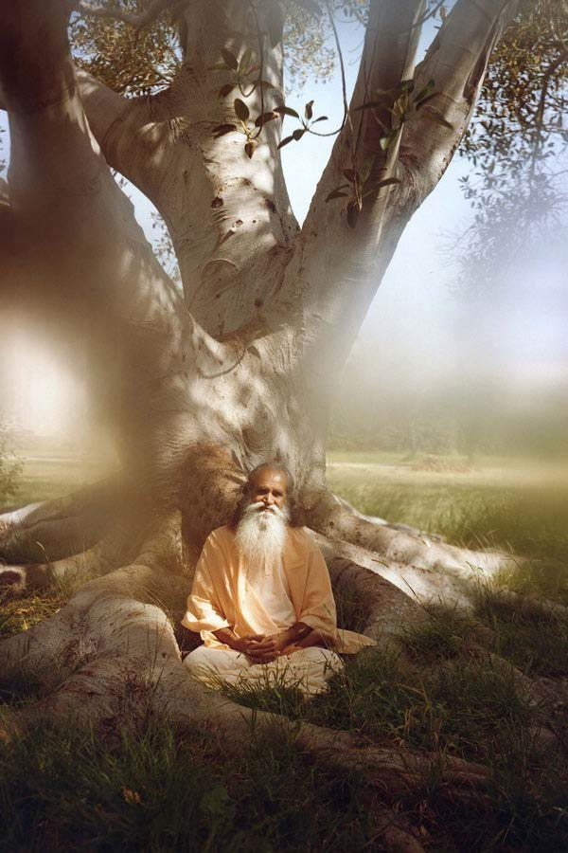
SATCHITANANDA

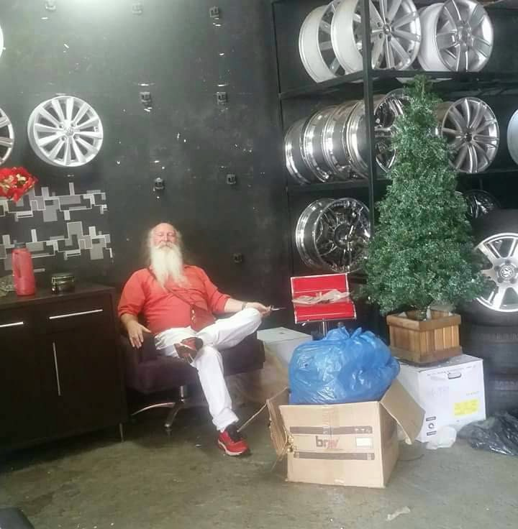
SATCHIDANAND "PAPA NOEL" AND THE CHRISTMAS TREE

Sometimes it may seem like we have “drawn the short straw” in life. It may seem like the events of our lives are being done to us. We curse our “bad luck.” Why do these things always happen to me? We mutter. Yet we wouldn’t worry about the vicissitudes of life if we could see them for what they really are. How can we see our problems differently? My friends know that I get inspiration from Energy Enhancement Meditation in Four Levels.. Gain Energy and Immortality, Remove Energy Blockages and Soul Splits, Clean Past Life Karma, Master Relationships. This approach has brought me a

comforting sense of perspective about our existence here—most importantly, that we reincarnate here on Earth and in fact, we never die.

Of course, we have all heard about reincarnation. Billions of people believe in reincarnation. I did not grow up believing in reincarnation, but I absolutely recognized what I saw in EE Meditation. Yet during the Meditation I realized how normal and logical it is that we should live again and again; in fact, it would be strange if we only had “one shot” at learning life’s lessons.
Reincarnation means that we can always come back and try again with another human identity—and that is very reassuring news.

After each of my lives, I saw myself return to a place of wonder and peace where we prepare for our next life. In that tranquil place of purity, I saw myself choosing each new life in order to learn important lessons—especially, that we should love other people. To return to the original idea here, I was shown how wrong we are to complain about our “problems” in life. In fact, we are not the victims of our lives—we are the active designers of them! We are not only the actors in our movie—we are the co-directors of it.

We chose this life. And through our many incarnations, we have chosen many bodies to live in. By choosing this body for this life, we have chosen every problem we face here—and all for a perfectly simple reason: we are here to learn we have learned everything in the time between lives...

THIS is the Examination Hall!!

You only get the prize if you pass the test.

Initiation is the Prize.

You only get given power if you prove you can handle that power correctly.

A person whose only choice is to do the right and best thing.

And if you fail the test today, you will be sure to get that same test tomorrow.

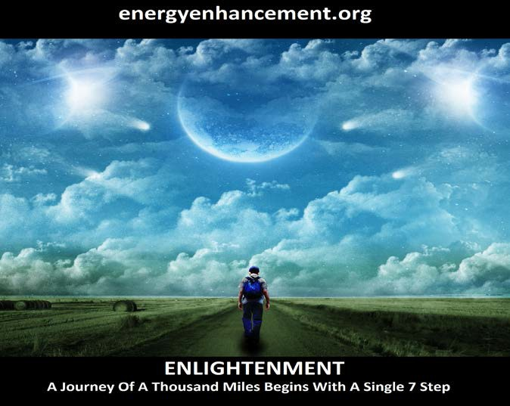

Our life is a learning game. The main reason why the world’s injustices shouldn’t make us angry is this: the whole point of them is to provoke us to see if we will get angry! To see if that Divine Discontent will act upon us to provoke a reaction against the Status Quo, in order to bring peace and harmony to Humanity and to this Planet.

Life’s challenges are an obstacle course meant to teach us, to evolve us, to give us the tools and ammunition to change things for the better. It is a learning process, but at least it is our learning process. It is our dream. The dream is a test being continuously projected into our awareness, to gauge our allegiance to the things of the world, and our willingness to evolve and change them.

All our human senses reinforce the importance of the world, and the barriers we think we need to put up to protect us from other people here (not realizing that they are only innocent fellow actors in our movie).

The point of spiritual practice is to break out of this mental loop; to step off the merry-go-round; to refuse to rise to the ego’s bait when it is offered, and to overlook all offenses, in that glorious culmination of human expression we call “forgiveness.”

We can only forgive when we understand that, "This Planet is a factory to create the enlightened" - Satchitananda

When we understand that there are many strata of unevolved, unenlightened people and psychopaths - and we don't need to mix with them!!

When we understand that God is doing the heavy lifting of evolution and Energy Enhancement Meditaton is only necessary to the evolved few who want to change, who

want to take the reigns of evolution into their own hands.

Only then can we forgive.. because we recognise that we too have done, "All That" - Yoga Sutras of Patanjali

We too have been through the Mill of Life and serendipitously we have grown our Psychic Body, Our Talent Body into which, hard wired in is those things which are bad to do and those which are good to do. So that, "Balls to Bones" you know what makes a good life on this plane.

"Everybody Knows that" – Satchidanand "They Know" - Sosan - Third Zen Patriarch

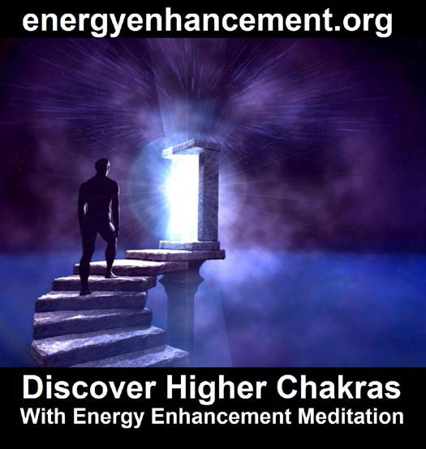



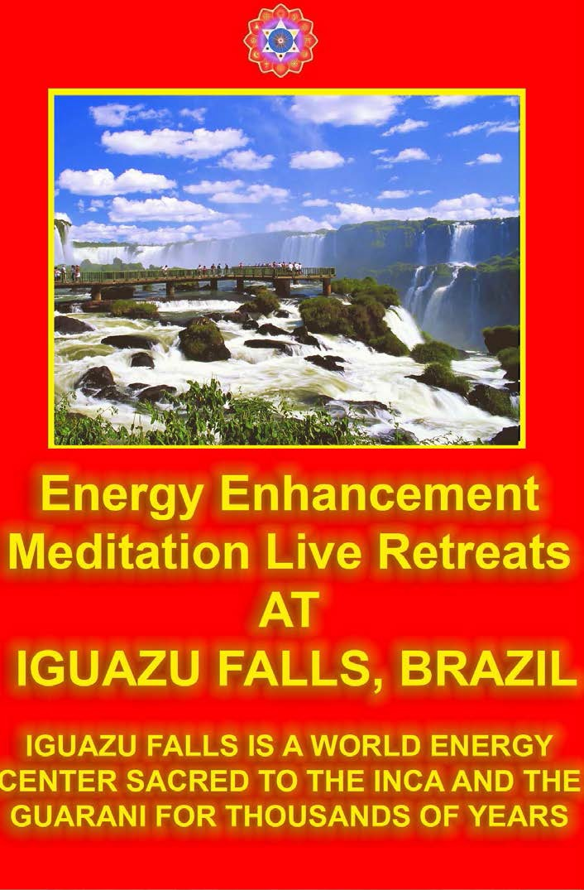

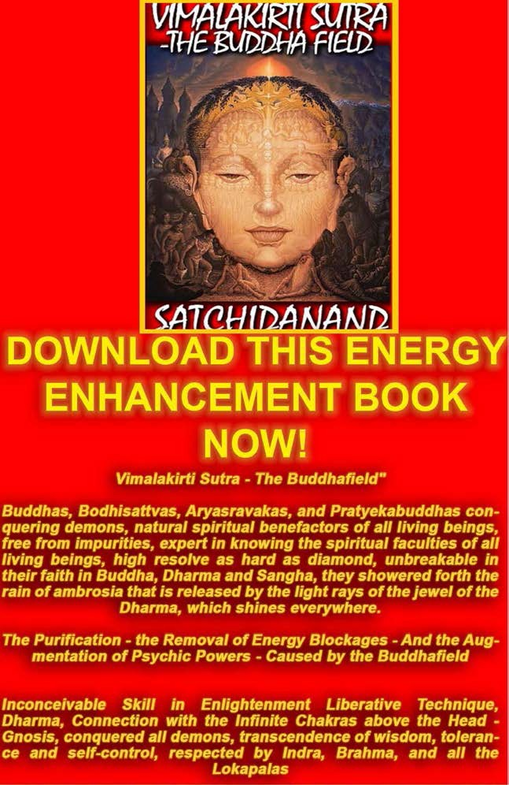

The Buddhist, "Vimalakirti Sutra" in 14 Chapters - by Satchidanand plus one Chapter - The Buddhist Energy Enhancement Kundalini Key is the Buddhist Stupa

Right Click and Save As..

http://www.energyenhancement.org/Vimalakirti- Sutra/vimalakirti-sutra.pdf

SACRED DANCES OF FUSION WHERE DEVI DHYANI EXERTS HER POWER - AVAILABLE ON YOUTUBE

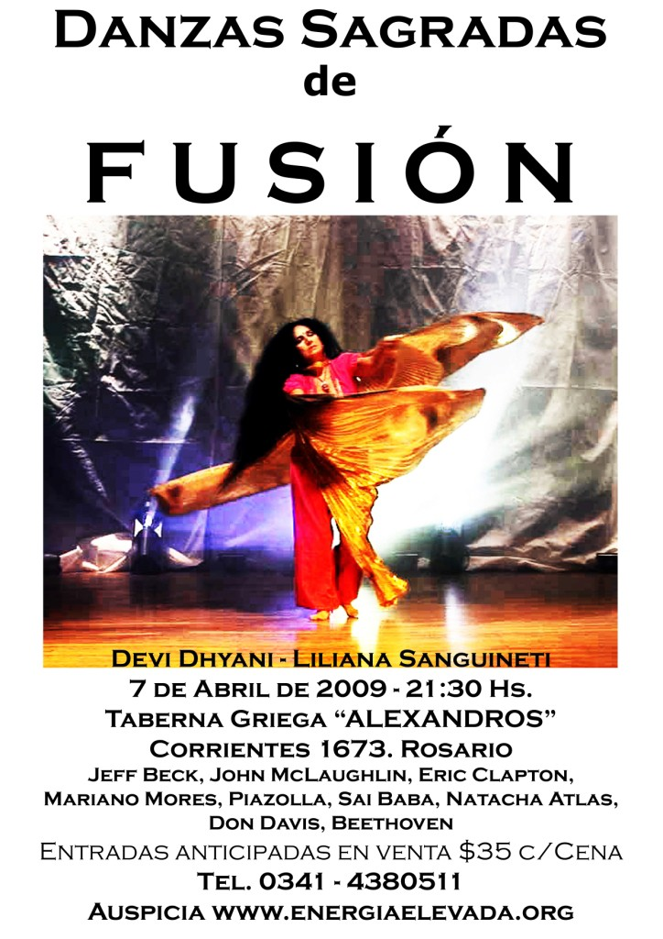

The problem is those people who do not know, the unevolved, the unenlightened - but God is giving all

these people, the vast majority of people who do not meditate - Karmic lessons.

Only then, Forgiveness provides the closest approximation of Heaven’s Love on this planet, a love that is unique because it is shared by all.

This life is only one in our long pathway to revelation. Behind the scenes, we are immortal and all-knowing, and we have no needs, living in a boundless expression of infinite joy, in the blinding light of pure knowing.

Planet Earth and its issues are a reflection of our evolution, a reflection of our understanding and we should take responsibility for this planet as Planetary Elders who have been through All That. Who Know!!

We should think about the love that unites us all.

To sense this love is to begin to accept that we are all secretly unified as One. Behind the scenes, we are pure and innocent, steeped in the truth that binds all existence in the pure divine essence of Oneness.

We ought to know that we are advancing towards our glorious and inescapable reunion with Love with every incarnation here. In addition, as Energy Enhancement Meditation teaches us, we simultaneously experience every life from the perspective of Heaven as well as Earth, so we should be quietly confident that there is nowhere to go and nothing to do, because we always have one foot in Paradise.

After every life, back in base camp, we reunite with the timeless knowledge that is hidden from our earth- awareness, and we remember why we deliberately and purposefully chose this life on thisplanet, we judge our actions to re-member those times we made bad

decisions, to learn from them not to do that again and to push that knowledge deep into our psychic bodies so when we come back we can be tested on that point again - And Pass the Test.

This human life is an examination hall.


We learn that which is right, only to do the right thing, between lifetimes.

We aren’t here accidentally, through some random fluke of biology. We are here because we want to be here—to learn about love. Life is a remedial “traffic school of love,” and we selected the exact curriculum, to take the right test, in order to get our celestial driver’s license back.

What we call our problems are merely learning opportunities, true-or-false tests we are taking over and over again, as long as we need to.

Although it is good to get the answer right as soon as possible, and keep on getting it right for ever afterwards, this is a school that we can never flunk out of—a school where we learn that there is no scarcity, and the only product worth having (love) multiplies magically the more it is given away. A happy outcome is always 100% sure. We are all coming home. You will get that test again, tomorrow!!

SATCHIDANAND LINEAGE - CHRIST, HINDU AND ZEN BUDDHIST

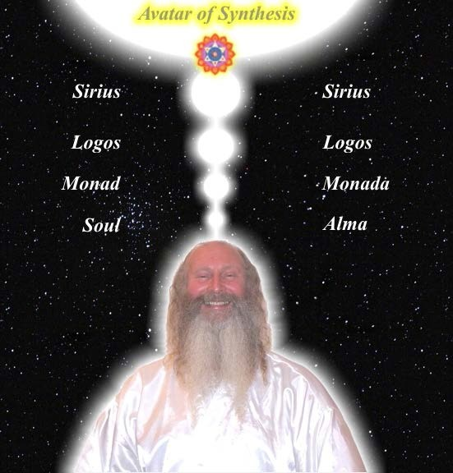
SATCHIDANAND

The Energy Enhancement Streaming Video Course is Chanelled by Satchidanand - Student of Swami Satchidananda, Guru of the Woodstock Festival and Tamil Siddar in the Lineage of Bogar of Palani Hill

Temple Tamil Nadu who lived for 15,000 years, and Bogar's Student, Tamil Siddar Patanjali who wrote the Yoga Sutras of Patanjali, and Tamil Siddar Babaji who has has taught Kundalini Kriyas in the Himalayas for 2000 years to people like Paramahamsa Yogananda who wrote, "Autobiography of a Yogi" also Tamil Siddar, Thiruvalluvar.

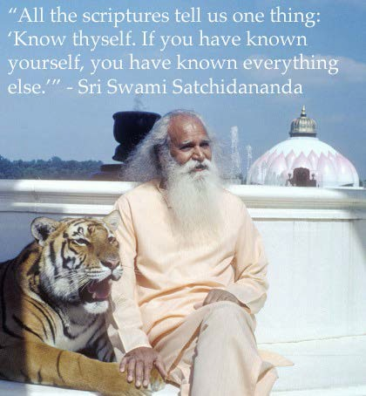

The Energy Enhancement Streaming Video Course is Chanelled by Satchidanand - Student of Zen Master Hogen with Zen Temple at the foot of Mount Fuji in Japan and in also in Australia.

The Energy Enhancement Streaming Video Course is Chanelled by Satchidanand - Energised by Masters Sri Yogendra of Mumbai - Master of Theos Bernard in 1935
- they used to put him into darkened rooms to see the chi, the prana, blue, moving on his body, Osho of Poona, Sri Sathya Sai Baba, and Benedictine Monk Father Bede Griffiths in his Satchidananda Ashram on the banks of the River Cauvery in Tamil Nadu.. during the mass, Satchidanand saw the chalice struck by lightning and the charge entered his heart making him burst into tears.. Satchitananda Ashram where Rupert Sheldrake wrote his book about the Morphological field..

Difficult lives on Earth impart the most profound lessons to the incarnating soul, never to make that bad choice again. Even the people with the most severe worldly “problems” have merely chosen these hurdles for their growth potential.

We should really pity people with disabilities, or people enduring famine, war, and disease but we know that these people have made some bad choices in the past and are suffering the condign response for those decisions.

Neither should we idolize or envy those with more pieces of colored paper (which they call money), or those “blessed” with sports cars or pretty faces. Our bodies are only temporary identities, and our reward in Heaven is assured no matter what—although everyone has chosen a slightly different curriculum of love- training.

We are all just briefly passing through, and although we have all chosen different lives here, we are all in the exact same boat, learning the exact same thing: to accept our shared interests and the divine Love that unites us all.

We are already saved, and that the best way to hasten our return home is through forgiveness of other people through the process of forgiving our own trespasses through the return of Karma.

"The Karma which has yet to come can be averted" - Yoga Sutras of Patanjali - and it can be averted only by Meditation, and only by using those techniques of Meditation taught by Satchidanand and Energy Enhancement.

However we see our lives, our goal here is absolutely the same: to learn how to love, through the miracle of forgiveness. As long as our bad dreams of separation, guilt, and competition are still lodged in our mind, we will remain too paranoid and delusional to accept our destiny and let go. Distracted by petty grievances, we ignore the accessible ecstasy of Paradise, which is ours for the taking every moment of our lives. Peace is a changeless place we never truly left, and thus can instantly rediscover. Since there is no time, there is no time “limit;” no worry or distress should ever pass through our minds, because our enlightenment is happening now.

Very soon, (actually, in the timeless right now) we will perceive correctly that every brother/sister on the planet is one with us in innocence, and is constantly being judged.

That innocence and naivety is what the Dark side uses to pervert and degenerate.

At that point, we will realize that “the war is over,” We will teach our enevolved bretheren how necessary it is to do the Right Thing and rejoin our soul companions—i.e. everyone who has ever lived—in the sanctified Oneness, perfect stillness, and supreme bliss of Heaven.

Our enlightenment will appear to happen at a moment in time. But as all minds are joined, and there is no time, it will happen simultaneously, in the continuous present.

We never left Heaven, and never will as long as we decide to align with God in Only Doing the Right Thing, and we only need a “little willingness” to release the fantasy that our decisions do not matter, and to accept love as its permanent and infinitely preferable to doing The Wrong Thing which the Father of Lies prefers you to do.

Reincarnation is our reality. What matters is realizing that the answer is always available to us, no matter where we are. The only solution is to choose that Right Answer right now, and choose love— this applies no matter what challenges we think we are facing. All challenges are the same, since they all force us to choose between good and evil where, "Evil is always that which creates Pain by Deed, Word or Thought"

Of course we can forgive, but better is not doing anything which needs forgiveness - any deed which would make us feel ashamed.

We can indeed see peace instead of chaos by choosing love—and the word we apply to this choice is “forgiveness.” True forgiveness— a kind of eternally- patient and kind overlooking of the faults and blemishes of the world—is the entire point of many Satanic teachings which only mention forgiveness - but this is lying by ommission that forgiveness is always paired with striving to do the right thing.

We have all experienced the faint echoes of heavenly love, but the closest we can ever get to living that Love on Earth is forgiveness. True forgiveness, when fully accepted, integrated, and interwoven throughout our

entire awareness, reminds us that we are all One - only by striving to do the right, better and best thing.

In truth, the only essential difference between anyone, is this knowledge of good and evil because separation is caused only by the giving of pain to another person by word, thought or deed.

We are not all the same inside, and not all as innocent as the angels. There are levels or distinctions of evolution between us, because everything is interconnected, and time does not exist. And this difference is called the Opening of the Heart.

People ARE different from any other—we are not a snowflake, nor tree, nor ocean, nor tiny paramecium, nor enormous Black Hole— We are All different from any other. "Vive la Differance!!" God is not niggardly with genius and no-one is designed the same. No remote galaxy is farther away from us than our own heart; no event is earlier or later than right now; and no person we have ever known can ever “leave” us.

No particle or continent can be measured by any physical “dimensions,” and thus none can genuinely exist, compared with the monolithic, infinite Unity of Love and Goodness to which we belong.

We must strive to be as good as that goodness - never to do the wrong and bad and painful thing. This is actually very good news, because by that striving to evolve, be good, open our hearts to attain this Unity as the only Good Thing that ever existed. It is our inheritance. Paradise is ours for the asking, for the striving to become gooder and more good because we are connected to it, and it can never be taken away from us.

In closing, we all ought to feel a great and equal compassion for all our fellow learners: voyagers who have opted to take a spin with us on this wobbly planet. Every one among us is a (temporarily) lost child, scratching her head, trying to figure out Grand Central Station at rush hour.

Yet the child doesn’t realize that there is only one train of Goodness and Light —and only that train will only take her home. By smiling through life’s challenges, we can demonstrate to our fellow earthlings that Goodness, Light, Love and the further Opening of the Heart is the only possible answer and the only possible way.

Goodness, Light, Love and the further Opening of the Heart is literarily all there is, and we are only love— because we are the immortal children of the One Source of Love. Love is both the subject and the object in an eternal circle of creation, and as Love beholds Love, our hidden gift of Unity is revealed. Tears of gratitude are the only sane reaction whenever we perceive—albeit briefly at first—the faint flickers of Love’s golden promise in our memory, as we thankfully recognize that only by being Good, We are All One.

Get all that back Now!! Energy Enhancement Quantum Immortality Forgiveness can be Immediate.

All that you have ever done can be forgiven Now, with Energy Enhancement Meditation Techniques.

But for the General Public. For the Muggles.
Karma rules the day... All that you do.

All that you have ever done. Must be paid for.
And paid for condignly with sometimes lifetimes of payback.

Because of Karma, Even Delayed Karma, You can not get away with anything!!

Because you do not know how to forgive yourself. Forgiveness is not just a word.
Forgiveness is not just an intention.

Forgiveness is Energy Enhancement Alchemical VITRIOL..

TO ENQUIRE ABOUT ENERGY ENHANCEMENT COURSES PLEASE SIGN ON TO OUR MAILING LIST AND THEN EMAIL US DIRECT FROM THE EMAIL ADDRESS WE SEND YOU FROM OUR MAILING LIST

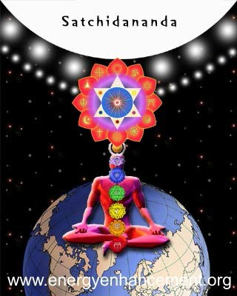

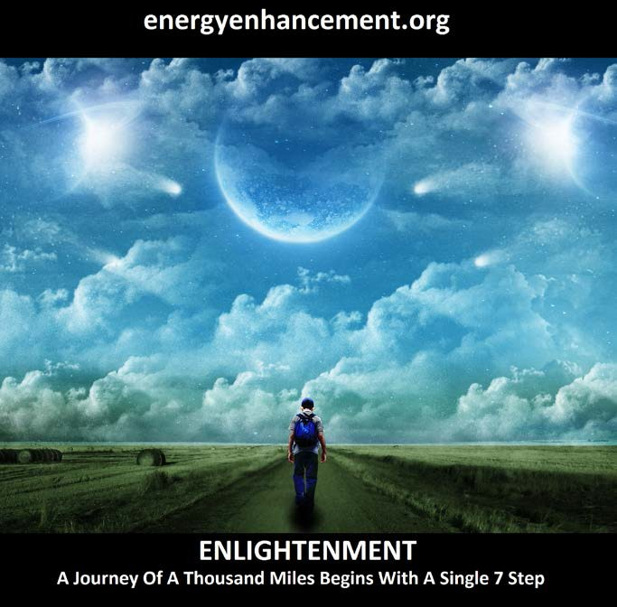

LEARN THAT WHICH IS FALSE WITHIN YOU

LEARN TO RECOGNIZE THE FALSE AS FALSE

-WITHOUT THAT, THERE CAN BE NO LASTING TRANSFORMATION

ENERGY ENHANCEMENT

"I was not sure if this was wise, as I knew nothing other than what I had read on the web site and the testimonials, which I was a bit skeptical about! However, I am now adding my own because if you read this you might be a bit like me...

Don't hesitate - go for it!"

MS (Ireland) Human Resources Director, Europe/Asia, of a Fortune 500 US Multinational Company

Honey Kalaria

" Once on the course, my exciting adventurous journey began! In my life I have done hundreds of courses but the Energy Enhancement Course I found to be completely different. Firstly, the contents and the teachings seem to be inspired by higher forces and had a deep base in
spirituality..."
Honey Kalaria (UK)
Bollywood Actress/Owner of Diva
Entertainment

ENERGY ENHANCEMENT

"I was not sure if this was wise, as I knew nothing other than what I had read on the web site and the testimonials, which I was a bit skeptical about! However, I am now adding my own because if you read this you might be a bit like me...

Don't hesitate - go for it!"

MS (Ireland) Human Resources Director, Europe/Asia, of a Fortune 500 US Multinational Company

GAIN SUPER ENERGY

ENERGY ENHANCEMENT MEDITATION

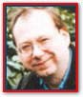Philip Chester Course Report
"SATCHI PROVED THIS TO ME IN THE FIRST FIVE MINUTES OF OUR FIRST MEDITATION, BY PUTTING MY BACK AND TOP OF THE HEAD IN THE RIGHT POSTURE.

I IMMEDIATELY FELT A FLOW OF ENERGY GOING UP MY SPINE."

"Once this stage was reached I had tremendous energy!"

Philip Chester, Change Manager reporting to the Managing Directors of several Fortune 500 Companies.

THE ENERGY ENHANCEMENT SOUL SYMBOL



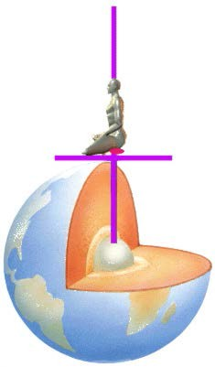

THE DIAGRAM ABOVE IS AN ENERGY ENHANCEMENT GUIDED MEDITATION TO PUT YOU IN TOUCH WITH THE SOURCE OF KUNDALINI ENERGY TO ACCELERATE YOUR EVOLUTION - THE CENTER OF THE EARTH - KUNDALINI CHAKRA.

THIS CONNECTS THROUGH THE SEVEN CHAKRAS IN YOUR BODY - OUT INTO THE SOUL CHAKRA, ALL THE WAY TO THE CENTER OF THE UNIVERSE AND THE ONE GOD WITH 10,000 NAMES.

THE TEN ENERGY ENHANCEMENT BOOKS -

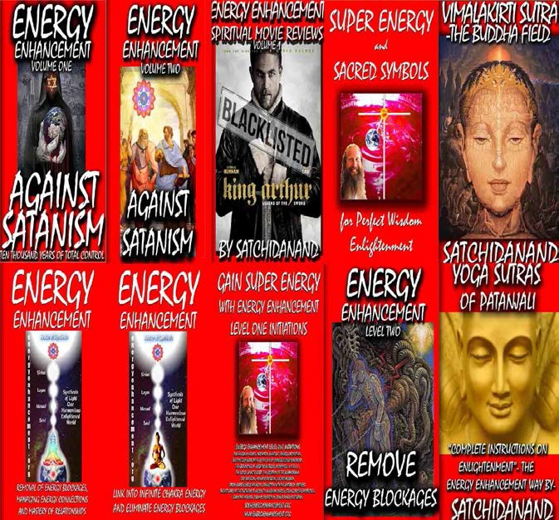

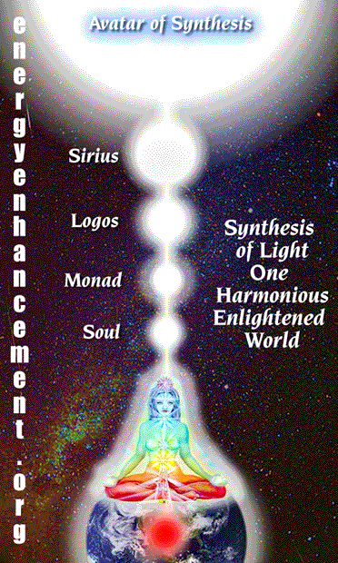

ENERGY ENHANCEMENT IS THE REAL
TRUTH Karma Clearing Process of Energy Enhancement Meditation Including the Kundalini Kriyas + Alchemy Today I sat in a chair and listened to the heart chant initiation 1 for the first time.

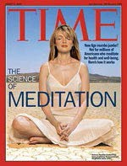

The Karma Clearing Process begins with the removal of all Energy Blockages from the energetic system of a human being. Wilhelm Reich called it the Emotional Armour. These are the little stiffnesses which cause us so much pain in massage. Energy Blockages exist in the mental, emotional and physical bodies... Even in the spiritual bodies.

Energy Blockages split us so as we remove them through advanced and effective meditation techniques so we become more integrated, more solid.

Removing energy blockages from our spiritual bodies will allow us to access our hearts and our conscience, it will allow us to access our soul, our soul path in life, without which life has no meaning.

Removing energy blockages from the mind, the mental body, allows more energy to flow, we become more brilliant. Our minds become clear, our IQ increases and more.. We obtain the power of persistence which enables us to accomplish anything!

Removing energy blockages from the emotions allows more energy to flow, we become more stable. Our emotions become clear, our emotional IQ increases and more.. We obtain the power of having only positive emotions which enables us to radiate love, the energy of change and to access the will!

Removing energy blockages from the body allows more energy to flow, we become more energetic. Our bodies become clear of disease and pain, our energy increases and more.. We obtain the power of flexibility and strength which enables us to live longer and with more pleasure, more quality of life!

And what is that uneasiness within?

Just what is that tension which we find inside?



It is pure spiritual energy which has somehow become perverted by painful traumatic experience. It is energy which has been transmuted by some painful experience into pain, that encapsulated pain which we hold inside us or absorb from people and places on this planet. It is energy blockages which makes us feel uneasy and tense.

All the pain caused negative energy blockages which we hold inside are called the selfish competitive ego.

And because we all have been painfully perverting this pure spiritual energy into encapsulated negative energy or energy blockages for thousands of years, this world is filled with that perverted negative energy as energy blockages which we absorb from everything and everyone around us.

It is that pain and tension inside, those energy blockages which causes us to do all the bad things in this world. It is that pain and tension inside, those energy blockages which causes all the bad things in this world to happen to us, we call the bad things, all the bad luck to us. We are accidents waiting to happen. This is karma.

Body stiffness, niggles and pain cause Illness and disease.

Negative emotions, mood swings, wrong thinking, jealousy, prejudice, hatred, anger, fear are all caused perverted spiritual energy encapsulated as energy blockages. The "Mind filled manacles of fear" as said Blake.

Splitnesses in the mind, blocked minds, unclear and plain wrong thinking. Heartless mind solutions caused by selfishly wanting to gain something to the detriment of someone else, the "final solution" of Hitler for example. If we have a lot of these negative energy blockages within ourselves it will cause us to give up easily, a lack of energy, a lack of goodness and heart and soul.

It will cause us to lose our trust and our faith in the essential goodness of people and our teachers. We will project all our negativity onto them and begin to see them through the dark glasses of our negative

experiences. Through the darkness of the negative energy which we hold inside.

We create this negative energy inside. And as we evolve we gain the ability to absorb more of this negativity from the people around us and from our surroundings. We gain the power to hold on to more of this negativity without being affected by it. However, the straw that broke the camels back always comes. At this point we become open to wanting to know how to remove and transmute energy blockages. How to change negative energy into pure positive spiritual energy again.

When we enter into the Buddhafield of Energy which surrounds the enlightened we start to feel and lose this Negative energy from inside us. These are the symptoms of Kundalini energy usually.

Because an enlightened master has the ability radiate pure positive spiritual energy as well as to absorb and transmute this negative energy back into pure spiritual energy, a spiral of transmutation, a column of pure transmutation, the Buddhafield, surrounds him and enters into his surroundings.

As you people upon the verge of enlightenment walk around, as well as creating your own negative energy, you absorb likewise the negative energies of people and places. The symptoms of this are your illnesses, your negative emotions of anger and fear, your mood swings and your feelings of negativity.

The only difference between you people on the verge of enlightenment and a master is that a master knows how to transmute the energy he absorbs. And thus he is surrounded by peace and harmony instead of more and more pain and negativity..

He does not curse the darkness. Instead he lights a candle.


The only difference between you and a master is that a master knows how to teach you how to transmute this negative energy into harmonious spiritual energy, and thus place you on the path of peace and harmony, the path of enlightenment itself.

He only needs to teach you how to look at the negative energy. He only needs to teach you how to see it and

deal with it. Because anything else is painful. And will cause you to do more painful things. Because this negative energy is Karma itself.

THE ENERGY ENHANCEMENT STREAMING VIDEO COURSE

"Get your asses over here Now and Speed Up your process of Enlightenment on the Energy Enhancement one month course!!" - DON

Every one of our Students gets this Spiritual Experience of Connection with Infinite Energies.

Energy Enhancement does indeed, "SPEED UP THE PROCESS!!"

And they all get this Experience of Light, Life and Infinite Energy just with the Energy Enhancement Course - Every One of Them!!

LEVEL 1 - 4 VIDEO COURSES ANYTIME IN THE COMFORT OF YOUR OWN HOME

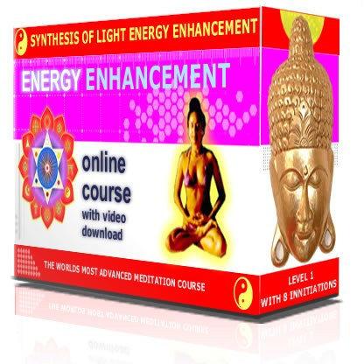

THUS THE KARMA CLEARING PROCESS, THE SOURCE OF ALL TRUE FORGIVENESS.
Spiritual masters are not affected by Karma and indeed have no Karma. Because they have the psychic ability to transmute all karma into pure spiritual energy. And this pure spiritual energy builds up in them and is added to by their masters when they die. So that they are rich because they have a large bank balance of Pure positive spiritual energy to spend on their students. This is called Positive karma.

Because the first stage is the access to purity by transmuting all the pain, which travels with us from lifetime to lifetime and grows more and more each

lifetime because like calls to like, inside. To he that has, more will be given, said the Christ.

So we need to learn how to go against this law of the gaining of karma and negative energy and energy blockages by understanding and using the grounding of negative energies, the Third Initiation of Energy Enhancement.

And then the second part comes. Once we have transmuted this negativity inside to a certain degree, it then becomes possible to absorb more positive spiritual energy from the masters bank balance.

The Master can send it to you with a glance. We absorb energy from the Master. The Hindus call it the Uppadesa or the Initiation of the Master, and it is said to come by glance, by touch, or in silence.

Until we learn how to do it for ourselves from the Universe.

And once you start transmuting negative energy by using the techniques of Energy Enhancement every day. Once you start to access your inner purity… To he that has not, it will all be taken away, said the Christ. Yes, all the negativity will be taken away.

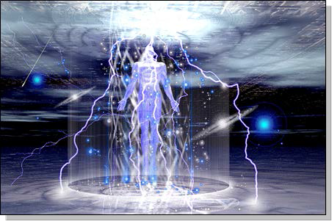

And this is the Real Initiation or in the Zen Phrase, Satori. And after many Satoris, you then eventually become in the Hindu Phrase, Twice Born, in the Sufi Phrase, a Made Man, You have made your Bones.

PEACEFUL. HARMONIOUS. ENLIGHTENED.
All with a glance.

All with learning how to open our eyes. All with the gaining of Psychic Vision.
You are the people who have no other choice but to absorb negativity and die, or learn how to transmute it and learn how to Live. Because this knowledge is more

important than life and death. It is for those of you who want to attain a Soul.

Start your Karma Cleaning Process by learning how to meditate and then speed it up with the advanced techniques of Energy Enhancement based upon ancient effective techniques of Taoism, The Kundalini Kriyas, The five elemental circulations of the Qi of Chinese Alchemical Taoism, The Guided Meditation of the Emerald tablet of Hermes Trismegistus encapsulated in VITRIOL and more..

ENERGY ENHANCEMENT IS EXTRAORDINARY - ALL OF THE STUDENTS GET INCREDIBLE ENERGY HEALING EXPERIENCES!!!

FIRE THE GRID!!

I was focusing on aligning my shoulders and spine forward and backward between the two lines of power from the center of the earth. And picturing the immovable mountain. Focusing on my breathing, closing the anus. I stayed in for the first four minutes. Then I got tired and openned my eyes, for about 7 or 8 seconds. Then I was so drowsy I had to close my eyes again. Then after about another four minutes I was tired again. Then the same thing but this time I focused on nothing but the energy from the earth entering the base

of my spine and coming into my heart. Right from the beginning of the meditation I felt my energy all over my whole chest, even now.

But at the last when I focused on it coming from the earth, I immediately felt very, very powerful energy and I didn't move to find it. My back straightenned up automatically to the alignment and I was kind of "stuck" in that position with the power flowing.

From there it was hard for me to stop meditating when the chants were over. Very powerful. Even without magnets. My question is about my focusing. Is it wrong to "imagine" the power or the alignment or the energy? or should we imagine until we feel it? Or both? Am I focusing on the right things?

I am very grateful for your teachings. Thank you for your generosity.

Student Report..

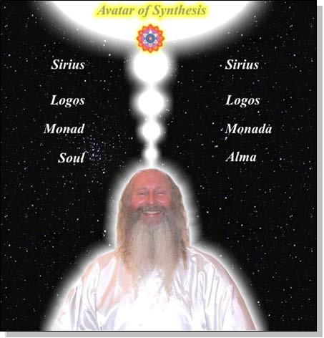
SPEEED UP THE PROCESS!!

Also I noticed as soon as satchi emailed me, I got a down-pouring of light from above the crown which kept charging me up the rest of the day – and my cravings died out! Then I realized they were ego-blockages and that I did not want them.

This Energy Enhancement Level One Initiation Three - ALCHEMICAL VITRIOL is great! I've done it some more and it's incredibly powerful. I don't know why it isn't more well known or taught? It's really bringing up little blockages which are complaining while being pushed down into the earth's core to get purified.

The hot fire energy has gotten much stronger in my body while doing the practice, mostly the base of the spine heats up, but also the middle of the spine. There are lots of little blockages being noticed. But I'm pushing them out.

Energy Enhancement Meditation Course Level 1 Initiation 4: Accessing the Universal Energy Source: Soul Fusion - INFINITE ENERGY!! for You!! via the Antahkarana, Macrocosmic Orbit, The Energy Enhancement Supra Galactic Orbit, Chakras above the Head, Advanced Kundalini Kriyas, Siddis, The Creation of Psychic Vision.

http://www.energyenhancement.org/EE-Meditation- Level-1-Initiation-4-Macrocosmic-Orbit-EE-Supra-Galactic- Orbit-Antahkarana-Chakras-Above-the-Head-Advance- Kundalini-Kriyas-Siddis.html

FIND ALL THE INCREDIBLE MEDITATION TECHNIQUES AND MEDITATION PRACTISES REMOVED FROM TRADITIONAL MEDITATIONS AND TAUGHT IN THE ENERGY ENHANCEMENT STREAMING VIDEO MEDITATION COURSE AND LIVE MEDITATION RETREATS IN BRAZIL AND INDIA



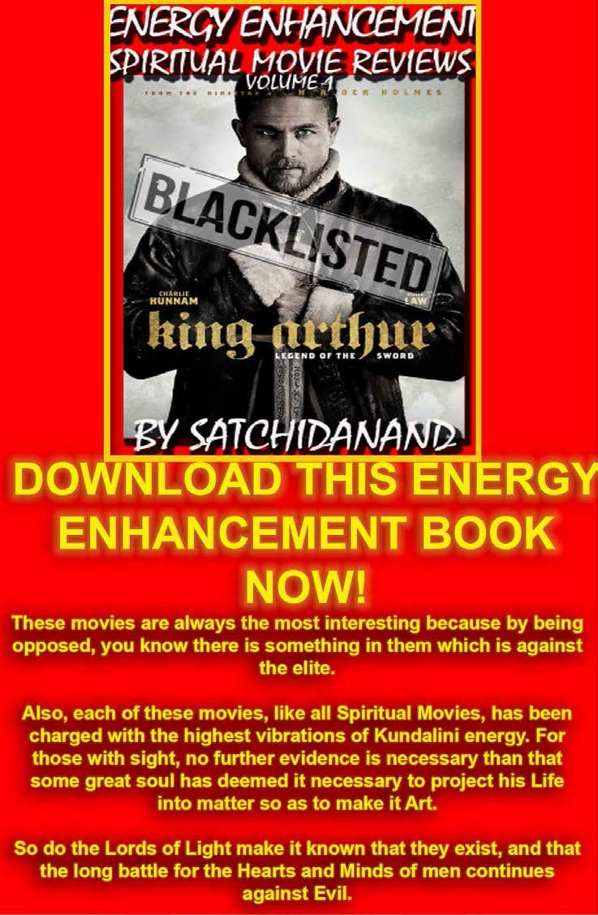

Satchidanand's Movie Reviews

DOWNLOAD BELOW

http://www.energyenhancement.org/Spiritual- Movie-Reviews-Satchidanand/Index.html

Energy Enhancement Spiritual Movie Reviews Book - Volume 1 by Satchidanand Immortalises the Kundalini Energy which Radiates from Satanically Blacklisted by the Dark Side - Movies like..

King Arthur - Legend of the Sword The Story of Enlightenment - by Guy Ritchie - a Movie Review by Satchidanand

Karma and Anti-Satanism in the Spiritual Actor, Keanu Reeves movies, "John Wick (2014)" also "Man of Tai Chi (2013)"

John Wick Ch 2 - Is Donald Trump and Alex Jones of Infowars - The Spiritual Warrior - Finger of God - Removes Satanic Demons,

Deletes the Elite, Cleans the Swamp - Move Witch, Get out the Way!

Doctor Strange - Psychic Warrior Earth Protector..

Logan - "Beware Of the Light" Esoteric Movie Review by Satchidanand

And Much Much More..

Energy Enhancement Spiritual Movie Reviews Book - Volume 1 by Satchidanand
- right click and save as..

http://www.energyenhancement.org/Spiritual- Movie-Reviews/Energy-Enhancement-spiritual- esoteric-movie-reviews-by-Satchidanand.pdf

FIFTEEN YEARS OF FANTASTIC TESTIMONIALS MAKES ENERGY ENHANCEMENT THE COURSE TO COME ON!!

- 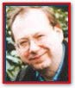The energy techniques given in Energy Enhancement have never been explained to me in Aikido (even Ki Aikido), Yoga or Ashtanga Yoga or on any meditation course that I have been on like Transcendental Meditation, and have only

been partly taught to me previously by Taoist master Mantak Chia and on Tantra Courses.... " Phillip Chester (GB) Change manager working directly to the Managing Directors of several fortune 500 companies

- Thank you so much Devi Dhyani and Satchidanand for being a channel of these Energy Enhancement Techniques in which many people can receive tremendous help, protection and Inspiration. .... " Dr Susana Macri (US, New York) Medical Doctor (
Summoned by Satya Sai Baba just before 9/11 to leave New York)

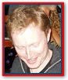"I'm in Shanghai now. I'm back for a month to see my love - everything is going great - very happy. I'm going to Spain in the first week of January. My Love plans to come over late January or early February, after I have made a nice soft landing for her. I've
got her into meditation and she's LOVING it. She is about to build her antahkarana.... " James Ellerbeck Writer for Yoga Magazine UK

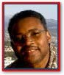"If you want to live your life connected to the universal life source and expand your soul consciousness, you must take their Energy Enhancement Training. It will truly change your life. You will be truly filled with the power of God. ... " Dr Thomas
Fluellen (US) Dr of Atomic physics

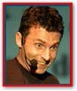" For instance, since I've been working on "cleaning my base chakra" everything around me seems to be going through a massive cleansing process - Only 2 days after I returned to Canada from India, a chain reaction of events led my to change

my 5 employees, change some of my major accounts and delay a move to the United States. 10 weeks after the program, things are stabilizing..." Pierre Morency (Canada) Ex KcKinsey Executive, President of Morency Marketing Ltd (Marketing Physicist)

"I feel so happy to meet Satchy and Devi, they are high spiritual teachers that can see deeply inside you, behind the mask that everybody has. They can see your soul, your real self!! If you need help you 'll get it from them ... " Danisa de Paul (Spain)
Dance Instructor/Yoga and meditation teacher

I am working a lot on my meditation and i am doing incredible healing on my present life, in different little girls, and teenager.
At the same time with consciousness, i believe that i am also healing past life. You would be proud of me i have been a very
good girl. So good work, that i can see the changes already...and feel amazed by them!! Wahe Guru! L. (France) Dancer/Yoga and Meditation Teacher

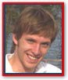“Energy Enhancement does not promote a spirituality that grows only in the mountains, apart from the cities and the hustle and bustle of everyday life. It shows you how to integrate the peace of retreat with the activity of life - work,
relationships, enjoyment, and spirituality - there should be no separation.." Paul (UK) Student and Poet

"She felt goose pimples all over her skin. The energy was coursing and rushing through her body in very strong waves for at least 30 minutes and when it was time for lunch she did not want to come out of

it, she was laying on her back and couldn´t stop laughing of happiness! " Lisabeta

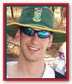"I was aware of a fair bit of energy in the car on the way to the airport, and on the plane - what were you up to?! I suppose I'm supposed to believe that you were busy "healing" me!!!! <wink!> That is the way it felt all right, so, if so, thank you
very much! I felt very happy on the plane, and not in a selfish way at all, I felt like I was sparkling! <LAUGHS!> I hope yer getting the "tone" / humour of this email, I'm making fun of myself! take care! thanks for everything."
Graham Kutner Simon (UK) Student

"I was not sure if this was wise, as I knew nothing other than what I had read on the web site and the testimonials, which I was a bit skeptical about! However, I am now adding my own because if you read this you might be a bit like me.. Don't hesitate - go for it!. " read more MS (Ireland)

Human Resources Director, Europe/Asia, of a Fortune 500 US Multinational Company

"Kind of difficult to summarise but I find it to be a pretty effective method of self-analysis combined with a strategy for dealing with whatever ‘shows up’ as a result of all the digging…………from a personal viewpoint it allowed me to work on two areas which although I was aware of, I didn’t really have much of a clue as to how to deal with ………….one of the blockages in particular was kinda heavy (see gay men and their mothers volume 1 chapter 23)..." Alan Dolan (Ireland) Communications Person , Well known aerospace company, Riyadh, The Magic Kingdom of Saudi Arabia.

"He is a changed man and an inspiration. He is also a great example of the effectiveness of the Energy Enhancement course and i hope now, more than ever, to be able to come and do it some time soon. Next September maybe.... " Lawrence (London, UK) Student of Art

"Satchi and Devi opened their hearts to me and took me as one of their family. Hearts only speak to Hearts, they said, And you have a good heart!! A good student is always grateful they said, not only for teaching me these wonderful Techniques of Energy Enhancement but also they taught me how to eat properly and how to avoid the poisonous traps of pesticides set for the unwary by the modern genetic genocide mindset..." Carla (Argentina) Corporeal Expression Student

- When I came to see Satchi at the airport for the first time I was struck by his energy but it was the second time, when he was talking to another student when meeting us off the train at Figueres that I really started to feel the Buddhafield of Energy Surrounding him.
Suddenly I started yawning like the big healer guy in "The Green Mile" and then tears started from my eyes and I felt I was getting rid of a lot of Painful memories from the past..." Olympia Panza (Argentina)

- Through patient and unselfish love they gave me ten unforgettable days that has changed my life, my way of seeing, thinking, breathing, living! Thanks Satchi & Devi for teaching me how to fly - you will always be my Jonathan Livingston Seagull... " Anna Andersen (London,
UK) Student

- I broke through and contacted the God energy. Well what an energy flow took place then! It felt unlike any of the other flows and my negative energy starting clearing good style. I was shaking, crying and then finally

laughing. This lasted for a few minutes and then finally subsided..." Peter (UK) Electrical Engineer

- My gut instinct told me that you were both good people and that you would help me with my goals. Here is my advice to anyone who is unsure if it is wise to fly half way around the world to join you: DO IT! " ... Arwen Evenstar (US) Dancer/Artist/Actor and manager of summer camp

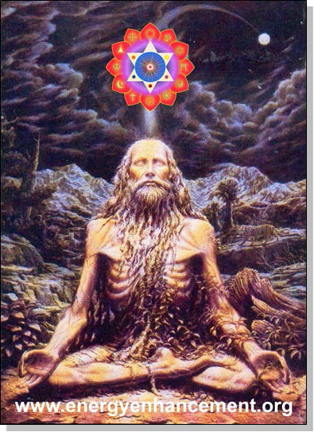

ENERGY ENHANCEMENT COURSE REPORT FROM JEAN

ENERGY ENHANCEMENT MEDITATION ENLIGHTENMENT AND ILLUMINATION

AND THE REMOVAL OF ENERGY BLOCKAGES

THE INCREDIBLE MEDITATION COURSE AND MEDITATION TECHNIQUES CREATED TO PRODUCE ENLIGHTENMENT AND ILLUMINATION

"ALL TRADITIONAL MEDITATIONS HAVE BEEN DESIGNED TO FAIL" - SATCHIDANAND –

FIND ALL THE INCREDIBLE MEDITATION TECHNIQUES AND MEDITATION PRACTISES REMOVED FROM TRADITIONAL MEDITATIONS AND TAUGHT IN THE ENERGY ENHANCEMENT STREAMING VIDEO MEDITATION COURSE AND LIVE

MEDITATION RETREATS IN BRAZIL AND INDIA

ENERGY ENHANCEMENT - THE ULTIMATE MEDITATION COURSE!!

ANCIENT EFFECTIVE ENERGY ENHANCEMENT MEDITATION SECRETS

ALL THE MEDITATION TECHNIQUES!!

SUCCESSFUL

SPEED UP YOUR PROCESS!!

PROVEN

TIME TESTED

TRUE



THE MOST ADVANCED MEDITATION COURSE, MEDITATION TECHNIQUES AND MEDITATION PRACTICES ON THIS PLANET, INCLUDING

THE REMOVAL OF ENERGY BLOCKAGES

THE KUNDALINI KEY, THE KUNDALINI KRIYAS, ALCHEMICAL VITRIOL AND KUNDALINI YOGA IN 28 INITIATIONS!!

SPEED UP THE PROCESS!!
"I have experience of many forms of meditation and practices for self improvement including: Transcendental meditation (TM) 12 years, Kriya Yoga 9 years, Sushila Buddhi Dharma (SUBUD) 7 years, and more recently the Sedona Method and the Course in Miracles.

The Energy Enhancement programme encapsulates and expands all of these systems, it is complete and no questions are left unanswered."

JEAN - NUCLEAR ENGINEER

WHY JUST SIT? - YOU NEED REAL SPIRITUAL EXPERIENCE - FAST!!

READ BELOW ALL THE TECHNIQUES TAKEN OUT OF TRADITIONAL MEDITATIONS AND PUT BACK BY THE ENERGY ENHANCEMENT MEDITATION COURSE!!

- RESTORING THE ENERGY ENHANCEMENT KUNDALINI KEY

Phillip Chester

Phillip Chester - Change manager working directly to the Managing Directors of several fortune 500 companies.

"I feel that I have been given some secret knowledge, which was only given to the initiated, or hidden among a lot of unnecessary sub techniques in other disciplines."

"The energy techniques given in Energy Enhancement have never been explained to me in Aikido (even Ki Aikido), Yoga or Ashtanga Yoga or on any meditation course that I have been on like Transcendental Meditation, and have only been partly taught to me previously by Taoist Master Mantak Chia and on Tantra Courses. Mantak Chia I found particularly confusing; Chi Gung I found awkward"

"ENERGY ENHANCEMENT GOES MUCH FURTHER THAN ALL THE ABOVE, IN A MORE EFFECTIVE WAY THAT ANY OF THE OTHERS I HAVE EXPERIENCED..."

One effect of Energy Enhancement is that I can no longer look at other disciplines like Ashtanga Yoga, Transcendental Meditation, NLP, Aikido and Ki Aikido and Mantak Chia and his Chi Gung, in the
same light, because they do not contain this learning.

Phillip Chester - Change manager working directly to the Managing Directors of several fortune 500 companies.

MEDITATION ENERGY ENHANCEMENT - THE CORE ENERGY TECHNIQUES!!

THE MOST ADVANCED MEDITATION TECHNIQUES ON THIS PLANET, IN 28 INITIATIONS!!

ANCIENT EFFECTIVE ENERGY ENHANCEMENT SECRETS -

SUCCESSFUL

PROVEN

TIME TESTED

TRUE

"I have experience of many forms of meditation and practices for self improvement including: Transcendental meditation (TM) 12 years, Kriya Yoga 9 years, Sushila Buddhi Dharma (SUBUD) 7 years, and more recently the Sedona Method and the Course in Miracles. The Energy Enhancement programme encapsulates and expands all of these systems, it is complete and no questions are left unanswered."

Jean, NUCLEAR ENGINEER, FROM THE SEPTEMBER 2005 ENERGY ENHANCEMENT COURSE

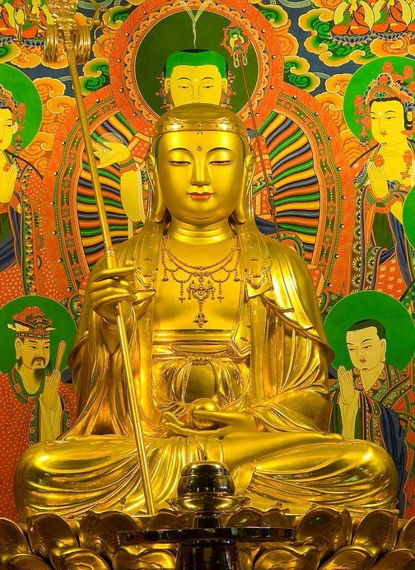

I felt immense happiness and peace at their presence, they had an aura of intense holiness and purity - great Saints and Sages.

As they faced me and bowed one by one I felt a feeling of unworthiness but the thought came immediately "worthiness is not necessary, by the grace of God infinite love and light is offered to each of us every moment all we need do is accept it".

I felt that they were very pleased with my practice and had appeared to me to let me know. I think it is important to say that I was in no way unique.

Most of the other students this year and last year had experiences of meeting beings of light, ascended masters and angels - EE has that effect!

Come and experience it for yourself you won't be disappointed.

JEAN

Truly, perhaps Enlightenment is next!!

You will probably find this interesting. Jenny who came on the Energy Enhancement course with me this year went to see her accupuncturist which she does routinely.

This guy (Ross) seems very talented, by reading her pulse he can tell her what she has been eating - certain energy patterns apparently. Anyway when he checked her pulses this time he found something interesting.

Apparently there is a pulse which gives an indication of the level of spiritual energy.

Jennies' spiritual energy was reading off the scale, something Ross said he has never seen before with Jenny or anyone else.

He says people just don't have this pulse and as far as he knows the only way to get it is to connect to external sources which as you know we did on the Course - wow!

Truly, perhaps Enlightenment is next!! Kindest Regards & Thanks as always Jean

email sol@energyenhancement.org

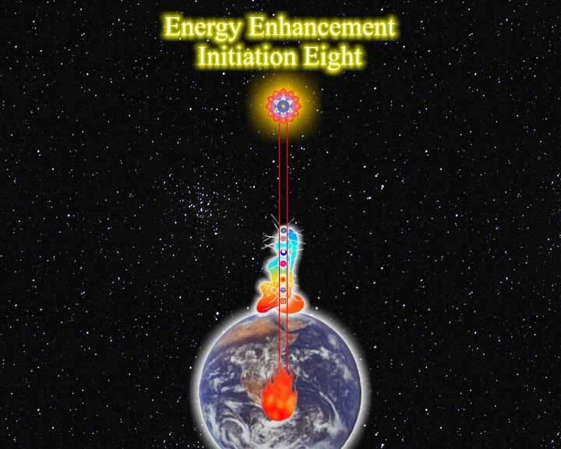
PICTURE OF MOVING FLASH VIDEO SHOWING THE ANTAHKARANA CONNECTING WITH THE CENTER OF THE

EARTH AND THE CENTER OF THE UNIVERSE - FREE WITH THE ONLINE!!

ENERGY ENHANCEMENT SYLLABUS - WHAT IS ENERGY ENHANCEMENT?

THE ENERGY ENHANCEMENT SYLLABUS CAN BE FOUND HERE - THE HOME PAGE IS WHERE YOU SHOULD START OFF BUT FOR MORE DETAIL - LEVEL 1 GAIN MASSIVE ENERGY, LEVEL 2 - CLEAR ENERGY BLOCKAGES, LEVEL 3 - CLEAR ANCIENT KARMA, LEVEL 4 - MASTER RELATIONSHIPS, LEVEL 5 - HEAL THE WORLD

ENERGY ENHANCEMENT MEDITATION SAMYAMA ENLIGHTENMENT!!!

NOT ONLY MASSIVE ENERGY - LEVEL 1

NOT ONLY ENERGY BLOCKAGE ELIMINATION - LEVEL 2

NOT ONLY KARMA CLEANING - LEVEL 3

AND MASTERY OF RELATIONSHIPS - LEVEL 4

BUT ENLIGHTENMENT!!

"FOR THOSE WHO BELIEVE IN ENLIGHTENMENT AND UNDERSTAND THE URGENCY OF THE SITUATION" - GAUTAMA BUDDHA

WE CAN CHANGE

YES WE CAN

FOR THOSE WHO TELL US THAT WE CAN'T

YES WE CAN

ENDURING HOPE

YES WE CAN

AND THE LIGHT OF OUR IDEALS SHINES BRIGHTLY

YES WE CAN

WE SHALL OVERCOME

YES WE CAN!!

ENLIGHTENMENT

YES WE CAN!!

THE ANCIENT EFFECTIVE SECRETS OF ENERGY ENHANCEMENT WILL ENABLE YOU TO BECOME MORE ENERGETIC, MORE PEACEFUL, MORE POSITIVE, MORE PURE, MORE SOUL INFUSED IN YOUR ALL YOUR LIFE AND FUTURE LIFETIMES - THE REAL SECRETS OF SUCCESS

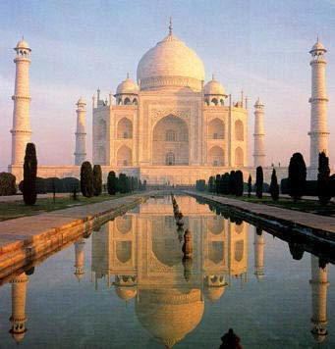
GET BOOKING A LIVE, MONTH LONG, TWO LEVEL COURSE WORLDWIDE
SPAIN, ELEGANT 5Star INDIA TAJ MAHAL, INDIA TOUR, IN ARGENTINA AND IGUAZU FALLS, MEXICO, PERU

INDIA TOUR - CLICK HERE FOR WEB PAGES

SEE THE VIDEO TOUR OF INDIA BELOW

https://youtu.be/KVbVm6B8t28

THE VIDEO TOUR OF INDIA

The Energy Enhancement Meditation Course - www.energyenhancement.org in India introduced by Swami Satchidanand and Swami Devi Dhyani. We see...

The Taj Mahal in Agra and The Red Fort. Then there is an interview with Swami Shantananda of Vashishta Gufa in the Himalayas above Rishikesh.

We see Haridwar and the Hindu arati ceremony there at dusk on the banks of the River Ganges where crowds of thousands view the sacred flame and chant the songs of enlightenment. Enlightened sages descend from their caves in the high Himalayas to give experiences of energy to the assambled people - a shower of flowers.

We see the temple of Hare Krishna in Vrindaban and the special ceremony of the display of the Murthys, the statues of Krishna together with the chanting of the monks and the dance of the whirling dervishes by Swami Devi Dhyani.

COME AND GET EXPERIENCED!

CLICK HERE!! FOR WHAT WE ARE DOING

EMAIL sol@energyenhancement.org FOR DETAILS

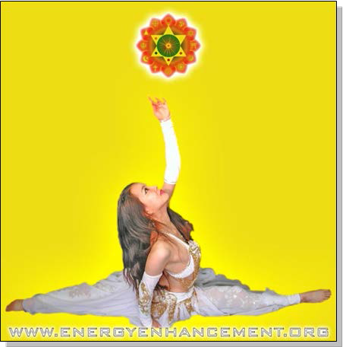
REPORT FROM HIROMI FROM JAPAN ON THE DVD COURSE
Hi, I want to tell you about my recent feeling, It came spring in Japan suddenly, I felt like my blockage began to melt and I felt negative feeling. I took a herbal face massage about 1.5 hours yesterday night, it dozed me . End of that it came up to my mind that you were shining in white space. next Devi, Danisa, Sebaschan, me, and my partner I have never seen. You and Danisa's halo was more clear.
After that, I could feel that inside my body and my every cells swimming in lighting for a while. And when I did Level1 initiation2 by DVD, with your shining image, I

could feel filled white light was in my body, And I could feel energy circulate my body include my Hurt center where my blockage is.
I could breath strongly and through my blockage, I felt - Is it good?
It may be good season for meditation, as you said. Thanks a lot .with love,DVD Student Japan MARCH 2008

YUKO SATO - MEDITATION ENERGY ENHANCEMENT TESTIMONIAL FROM THE SEPTEMBER 2006 COURSE

Yuko comes from Japan and is a Professional Photographer in Shanghai and London. Before coming on the course she had not meditated before although she has been trying Yoga for a while...

Oh my god, I changed a lot! I screamed with silence.
I was sitting in the bar around 9 p.m. by myself in Barcelona on the first night after my Energy Enhancement Course. On the way back to the hotel, I wanted to have one drink. Surrounding by local Spanish people, everybody had a good time with their own friends, even a bartender was chatting with some regular customers.

I was drinking a glass of red wine in the middle of them and felt totally relaxed without fear. I enjoyed the moment of being, by myself, in foreign county as a stranger.


YUKO SATO TAKING A GLASS OF WINE IN GIRONA, SPAIN DURING THE ENERGY ENHANCEMENT COURSE - TAKEN BY SATCHIDANAND

If I were to be here before, I could not relax this situation, I might worry too much, for example, how they think about me? how am I look like? do I look a bit lonely? am I look OK? etc...... too many of small thoughts, however they usually are big enough to destroy having a simple good time....

To be honest, I have not had that feeling, "without fear...." for the whole 33 years of my life.

This is just after the two weeks of an Energy Enhancement meditation course.

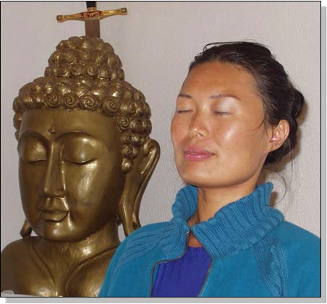
YUKO SATO TAKING MEDITATING IN THE ENERGY ENHANCEMENT CENTER IN SPAIN DURING THE ENERGY ENHANCEMENT COURSE - THE MOVING INTO THE SOUL INFUSED PERSONALITY INITIALLY ONLY HAPPENS OCCASIONALLY, BUT AS WE INTEGRATE MORE AND MORE IT BECOMES PERMANENT IN ENLIGHTENMENT - TAKEN BY SATCHIDANAND

During the course, I had many interesting and amazing experiences through meditation. I saw three black snakes, a BM with snake hair, a black rose covered with thousands of ants, a devil who controls and sucks the energy from me and thousands of innocent people, frogs, parasite eggs...etc..

All of them were blockages and implants in my body and my chakras.

Then I removed all of them using the Energy Enhancement Techniques.

The techniques are simple and powerful, moreover effective.

I did not feel any difficulty during the course. On the contrary it is fun and enjoyable.

The meditation with Satchi and Devi is sailing with fresh wind, also they have a big map. You can not be lost.

After the EE course, I went to the Juice fasting place in Portugal.

I did it for two weeks and I felt so much energy without eating.

I went for walking in the mountains for 3 hours, 2 hours yoga practice, swimming in the sea and meditation everyday.

After my Energy Enhancement Course, I am the most energetic person in this fasting program, people who work there, they thought I am not a normal human being, because I am smiling and happy all the time.

I feel absolutely happy and full of love.

(Satchidanand - fasting is a spiritual technique used for thousands of years because as well as being good for the waistline (Wasteline) and for the health, it is also working internally to get rid of the energy blockages.
Because Yuko had removed most of her energy blockages during her first two weeks of the 4 weeks

Energy Enhancement Course, she did not have these problems, and was able to use the fast to find and remove more of her internal energy blockages. Usually, it is my habit to do a 28 day fast each year and there are no problems due to the previous removal of internal energy blockages; I work as normal, just difficulties with entertaining.)

Another change, I can feel other person's fear in my 2nd chakra. So I give them love and ground their fear in centre of the earth. I understand the world better, that keeps the sky of my heart is clear and the sun is shining.

(Although we teach this during Energy Enhancement Initiations, this removal of energy blockages from others happens quite naturally once we begin to take back the power normally taken from us by our separated psychotic Deep Energy Blockages. Integration: back into the Soul Personality. Once we integrate them we get back the psychic powers they normally use to get us into trouble and destroy our lives using ego strategies - Satchidanand)

Yuko Sato

----------------------------

(Yuko, due to her Japaneseness and her experiences in past lifetimes brought a colourful experience to the Energy Enhancement Course. She had great fun removing her blockages. - Satchidanand)

For meditation, I now do for at least one hour everyday, sometimes for two hours.

I find new blockages every time.

Two days ago I found the river bottom of my antahkarana and I saw a snake swimming under my antahkarana. I have done the Energy Enhancement 7 steps for them and in the 6th step I met a strong ice woman who can turn everybody and everything into ice.

Finally I grounded her.

I just drop lines of my meditation is going and I feel bright energy every time I meditate.

Thank you for meditation Love and light
Yuko Sato

***CLICK HERE FOR THE LATEST ENERGY ENHANCEMENT COURSE REPORTS FROM ARGENTINA JULY 2008

CLICK HERE FOR THE LATEST TESTIMONIALS FROM MORE RECENT ENERGY ENHANCEMENT COURSES

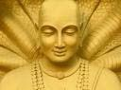Energy Enhancement is the process of clearing all the bad things which have ever happened to you from your psychic body, freeing up the internal essence to attain clarity and enlightenment on your true life path.

ENERGY ENHANCEMENT IS THE NEWEST AND HIGHEST SPIRITUAL IMPULSE ON THIS PLANET.

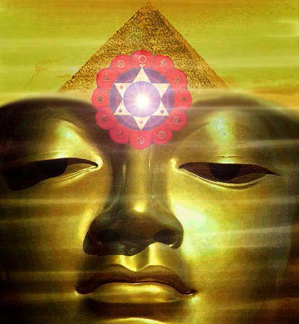

IGUAZU

BIG WATER!!


When you receive energy correctly

And not everyone does because they get the symptoms of energy blockages instead - Going to sleep, shaking, pain, heat, cold, negative emotions, - all the common so called symptoms of Kundalini Energy. But when you get taught to receive energy correctly on the Energy Enhancement Course - "When the energy is flowing correctly, there is no movement" - Saadi of Shiraz.

And this is the Energy Enhancement Experience.. "We eventually get into a state of energy transfer. We both feel it as white light flowing from one to the other in an incredibly intense way which lasts for two hours. At the end of that time I perceive an initiation which is taking place on the astral plane. Surrounded by a group of ascended masters I introduce him to the chief initiator who uses the rod of initiation to touch his third eye with the intense energies of initiation so that his energies

can never again drop into that state we call normal waking consciousness."

If you can receive energy then the chances are that you can give energy. Only the people who can receive energy correctly can go on to become enlightened, can go on to become Initiators of men, Gurus and Spiritual Masters.

If you only get the symptoms of Energy Blockages in the fire of the Buddhafield which is the intense aura of energy which surrounds every Spiritual Master then you need to remove the Energy Blockages which produce the symptoms. The Energy Enhancement Level Two Seven Step Process is the unfailing technique which can remove any Energy Blockage.

When we become a stream enterer, we tap into the Energies of the Earth and of Heaven and of the Buddhafield and through energising our faculties, we start to have spiritual experiences beyond the norm. We start to feel and see energy to start with, which always comes to every student.

It happens with all of our students...

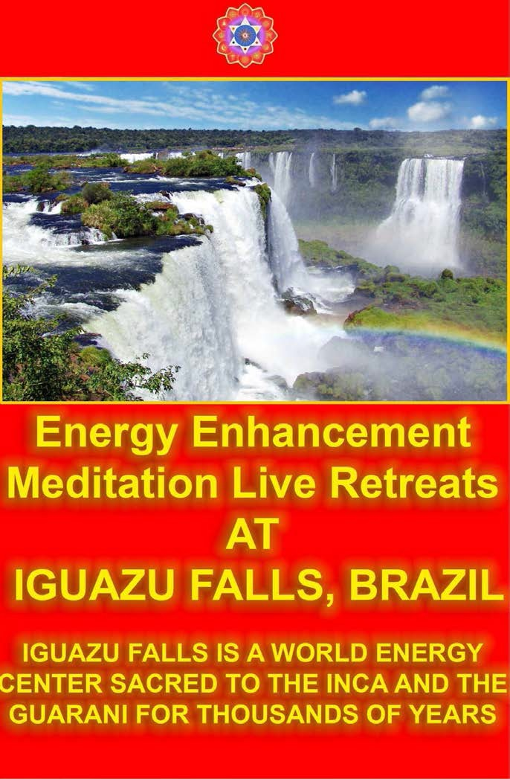

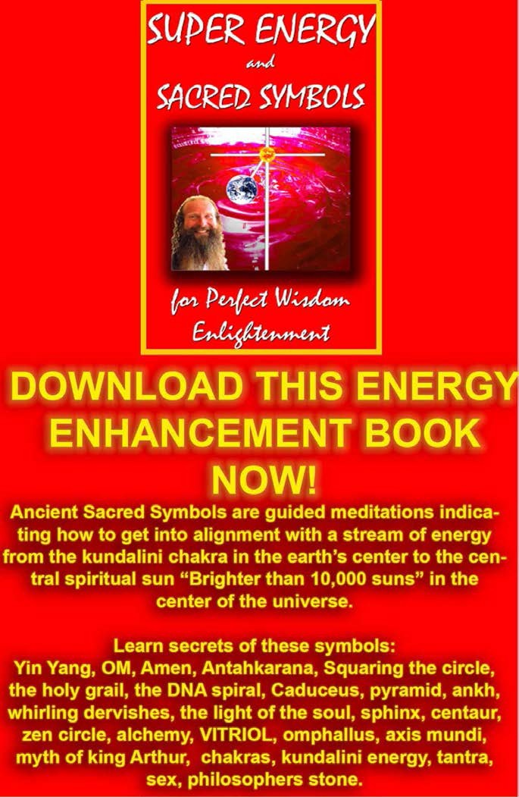



INNER PEACE
MATAJI DEVI DHYANI - VISIT TO IGUAZU AFTER THE JULY 2008 COURSE

Reports of our Students ARGENTINA
VISIT TO IGUASU FALLS AFTER THE EE COURSE

ENERGY ENHANCEMENT COURSE SOUL SPLIT RETRIEVAL APPRENTICE LEVEL3

KARMA CLEANING PROCESS, CLEAN THE KARMA FROM PAST LIVES, FUTURE LIFE, FUTURE LIFETIMES, SOUL FRAGMENTATION AND RETRIEVAL, HOW TO STOP PSYCHOPATHIC ENERGY VAMPIRES, INNER CHILDREN,

SELFISH EGO SUB PERSONALITIES, LIFE DESTROYING STRATEGIES, THE ALOOF, THE INTERROGATOR, THE VIOLATOR, THE SELFISH COMPETITIVE STAR, THE VAMP

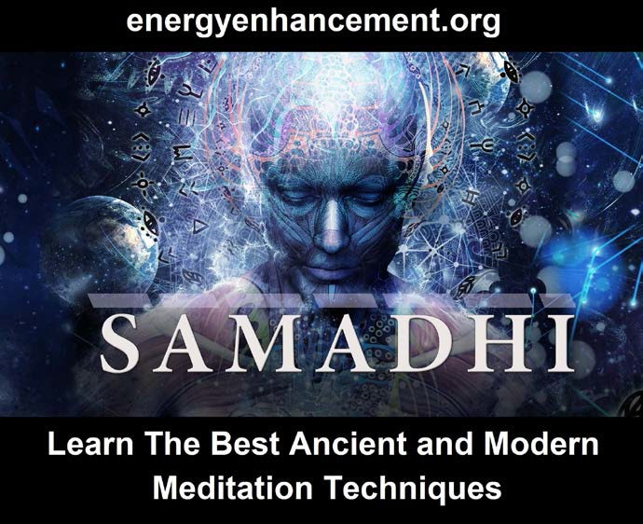
OR DON JUAN, THE PLEASER, THE BLAMER, THE CRITIC, THE KING, THE SELF DESTRUCTOR, ALL THE DESTRUCTIVE VOWS FROM THIS AND PAST LIFETIMES, THE CREATION OF SELF LOVE, LOVE AND SERVICE.

"I have experience of many forms of meditation and practices for self improvement including: Transcendental meditation (TM) 12 years, Kriya Yoga 9 years, Sushila Buddhi Dharma (SUBUD) 7 years, and more recently the Sedona Method and the Course in Miracles. The Energy Enhancement programme encapsulates and expands all of these systems, it is complete and no questions are left unanswered."

Jean, NUCLEAR ENGINEER, FROM THE SEPTEMBER 2005

ENERGY ENHANCEMENT COURSE

- MEDITATION ENERGY ENHANCEMENT NEW SITE DESIGN

Whether you are a Management Corporate Executive, any sort of Alternative Practitioner, meditator, yogi or anyone who wants to evolve, - become better, smarter, more evolved, more empathic, more successful; this course will enable direct experience of superior life performance.

Energy Enhancement Meditation Techniques are the quickest and easiest methods of evolution available, leading to Ultimate Happiness..



FREE GIFTS FOR NEWSLETTER SIGNUP

THE MOST ADVANCED ENERGY COURSE OF MEDITATION ON THIS PLANET

INCREASE INTELLIGENCE

DISSOLVE ENCAPSULATED TRAUMA

SPEED UP THE PROCESS OF ENLIGHTENMENT

FREE!! - NINE FREE ENERGY ENHANCEMENT MEDITATION GIFTS

Weekly Email Service of Right On Spiritual Texts and Pointed, Pungent and Humorous Stories.

YOGA, Energy Enhancement and Meditation.

SIGN UP NOW FOR THE "ENERGIES" NEWSLETTER BELOW

YOU GET NINE FREE ENERGY ENHANCEMENT MEDITATION GIFTS - FREE DOWNLOADS AND SPECIAL OFFERS!!

SPECIAL OFFER - SACRED DANCE DVD SPECIAL OFFERS!!

FREE SACRED DANCE DOWNLOADS FROM EMULE!!

FREE REPORTS - WHAT THE OTHER MEDITATION COURSES WILL NEVER TELL YOU

HOW TO HEAL TRAUMA AND CLEANSE YOUR KARMA.

FREE ONLINE ENERGY ENHANCEMENT E-
Book

FREE ENERGY ENHANCEMENT VIDEO - YOGA SUTRAS BY SATCHIDANAND
Download size 426mb

FREE!! 90 MINUTE TALK - ENLIGHTENMENT BY SATCHIDANAND
Download size 11MB

FREE MEDITATION ENERGY ENHANCEMENT DATABASE ACCESS ONLINE 200MB

FREE Weekly Email Service of Right On Spiritual Texts and Pointed, Pungent and Humorous Stories.

SIGN UP TO THE ENERGY ENHANCEMENT NEWSLETTER

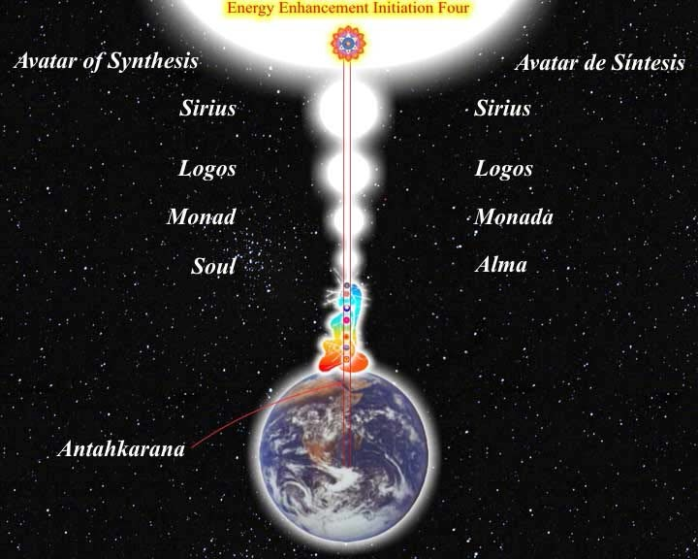

ENERGY ENHANCEMENT CONNECT WITH ALL THE CHAKRAS - INTERNAL AND EXTERNAL - SOUL, MONAD, LOGOS SIRIUS...AND THE ANTAHKARANA

ENERGY ENHANCEMENT IS THE NEW, SAFE, SMOOTH AND FAST WAY OF LOSING ALL INTERNAL NEGATIVE ENERGY AND PAIN BECAUSE IT WORKS ONLY AT THE ENERGY LEVEL, THEREFORE SPEEDING UP THE PATH OF ENLIGHTENMENT.

ENERGY ENHANCEMENT HAS HELPED MANY PEOPLE ON THIS PATH FROM THOSE WITH THE BIGGEST ENERGY BLOCKAGES TO THOSE WHOSE ASPIRATION IS TO HELP THE WORLD AND ALL THE PEOPLE IN IT.

ENERGY ENHANCEMENT IS THE NEW, SAFE, SMOOTH AND FAST WAY OF LOSING ALL INTERNAL NEGATIVE ENERGY AND PAIN BECAUSE IT WORKS ONLY AT THE ENERGY LEVEL, THEREFORE SPEEDING UP THE PATH OF ENLIGHTENMENT.

ENERGY ENHANCEMENT HAS HELPED MANY PEOPLE ON THIS PATH FROM THOSE WITH THE BIGGEST ENERGY BLOCKAGES TO THOSE WHOSE ASPIRATION IS TO HELP THE WORLD AND ALL THE PEOPLE IN IT.

ENERGY ENHANCEMENT CAN HELP YOU!!

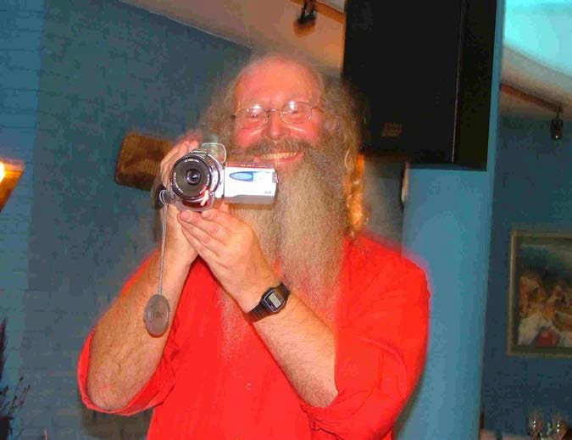

Part of Satchidanand's Web Blog - "I was meeting a nice girl of 28 this morning here at our center in Rosario. She is a Psychologist but has fallen out of love with Psychology because although it explains things intellectually it gives no TECHNIQUES apart from talking to change anything internally, particularly in herself.
You can see how effective Psychology is by looking at Woody Allen.

I connected with her base chakra and her inner child showed me all her chakras and blockages one by one. A very interesting experience. First the Base chakra, one fear and security blockage which I removed very quickly. Then the second, a pain filled relationship blockage which I also removed. Then all the chakras solar plexus,

heart etc, feeling the general dirtyness of the psychic body usually cleaned with The Grounding of Negative Energies but no major blockages. Then the head, two blockages, one a person who had just died, very deep and negative. I removed the first blockage but the other one was more difficult and stayed with me, absorbed by my psychic body, for a day before I sent it on.

She felt the movement of energy blockages in the head and in the body as my mind and energy was working on her and told me that she normally got a lot of headaches. She was interested in my exposition of Energy Enhancement as all the while I was working on these blockages I was also talking to her. Such openings show an educated psychic body, one with talent. Not everyone who comes to the Guru has similar experiences. Some also get more. She and I felt that with training she also might be able to help her clients in a similar way. So, she is coming back tomorrow to try out the process, to get her first Initiation in Energy Enhancement."

ARTICLE ON ENERGY ENHANCEMENT FROM THE YOGA MAGAZINE OF GREAT BRITAIN - FIND OUT WHAT THEY SAY!!

Energy Enhancement does exactly what it says on the Tin!
James Ellerbeck, Yoga Magazine of Great Britain.

Here I am today, sitting down, putting pen down on paper whilst gathering my thoughts on the amazing Energy Enhancement Course that I am currently on. Where do I begin? Firstly, I felt it would be great to share my experiences of the Energy Enhancement course with other like-minded people. The following

information is for those interested in growing spiritually, and wanting this world to become a better place - starting from improving themselves!
Honey Kalaria, Bollywood Star and Owner of Diva Entertainments

Honey Kalaria, Bollywood Star and Owner of Diva Entertainments



What we feel...
I am a brother of yours, who has traveled a little longer upon the Path than has the normal student, and has therefore incurred greater responsibilities. I am one who has wrestled and fought his way into a greater measure of light than has the aspirant who will read this webpage, and I must therefore act as a transmitter of the light, no matter what the cost.

I am not an old man, as age counts among the teachers, yet I am not young or inexperienced. My work is to teach and spread the knowledge of the Ageless Wisdom wherever I can find a response, and I have been doing this for many years.

I seek also to help the ascended Masters whenever opportunity offers, for I have been long connected with Them and with Their work. In all the above, I have told you much; yet at the same time I have told you nothing which would lead you to offer me that blind obedience and the foolish devotion which the emotional aspirant offers to the Guru and Master Whom he is as yet unable to contact. Nor will he make that desired contact until he has transmuted emotional devotion into unselfish service to humanity - not to the Master.

The words that I have written are sent out with no claim for their acceptance. They may, or may not, be correct, true and useful. It is for you to ascertain their truth by right practice and by the exercise of the intuition. I am not interested in having them acclaimed as inspired writings, or in having anyone speak of them (with bated breath) as being the work of one of the Masters.

If they present truth in such a way that it follows sequentially upon that already offered in the world teachings, if the information given raises the aspiration

and the will-to-serve from the plane of the emotions to that of the mind then they will have served their purpose.

If the teaching conveyed calls forth a response from the illumined mind of the student worker in the world, and brings a flashing forth of his intuition, then let that teaching be accepted. But not otherwise.

If the statements meet with eventual corroboration, or are deemed true under the test of the Law of Correspondences, then that is well and good. But should this not be so, let not the student accept what is said.

Djwan Khul - Tibetan lama

Our Deepest Fear
Our deepest fear is not that we are inadequate.

Our deepest fear is that we are powerful beyond measure. It is our light, not our darkness that most frightens us.

We ask ourselves, Who am I to be brilliant, gorgeous, talented, fabulous?

Actually, who are you not to be? You are a child of God. Your playing small does not serve the world.

There is nothing enlightened about shrinking so that other people won't feel insecure around you. We are all meant to shine, as children do.

We were born to make manifest the glory of God that is within us. It is not just in some of us; it is in everyone. And as we let our own light shine, we unconsciously give other people permission to do the same.

As we are liberated from our own fear, our presence automatically liberates others.

by Marianne Williamson from A Return To Love: Reflections on the Principles of A Course in Miracles

(Note: This is often found on the Internet incorrectly stated as a quote by Nelson Mandela from the Inauguration Speech, 1994.)

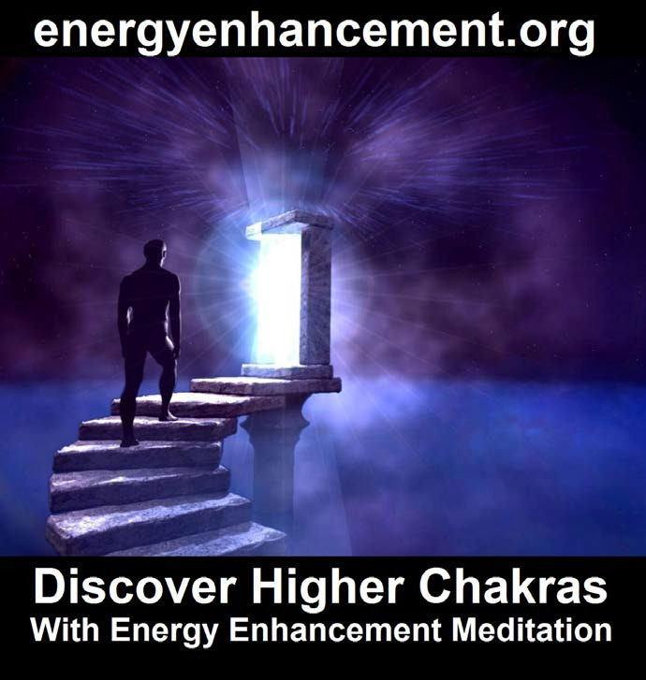



ENERGY ENHANCEMENT MEDITATION

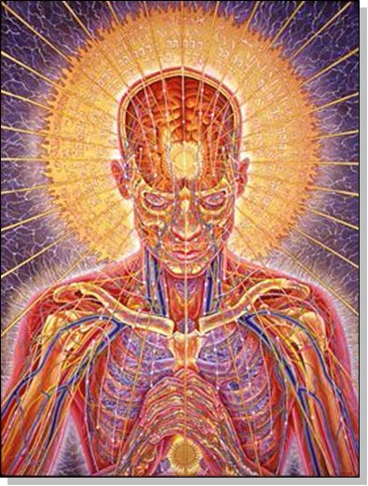
"An example of one of the different types of Energy Blockage is that they are sometimes created when we do not get what we expect, or we get what we do not want. They are caused by the pain of disappointment.
Like when our Mother or Father or Son or Daughter dies. Like when a Lover leaves us.
This trauma, this pain is so strong that at that moment the mind can not look at it, so it gets locked away within

the body as a Blockage until we get strong enough to process it.
Then amnesia. We forget the pain fulminating in our bodies. We forget the poison until, after a while, disease is the result."

Satchidanand

WHAT DON MINIHANE SAYS OF HIS MEDITATIONAL EXPERIENCES ON THE JANUARY 2007 COURSE

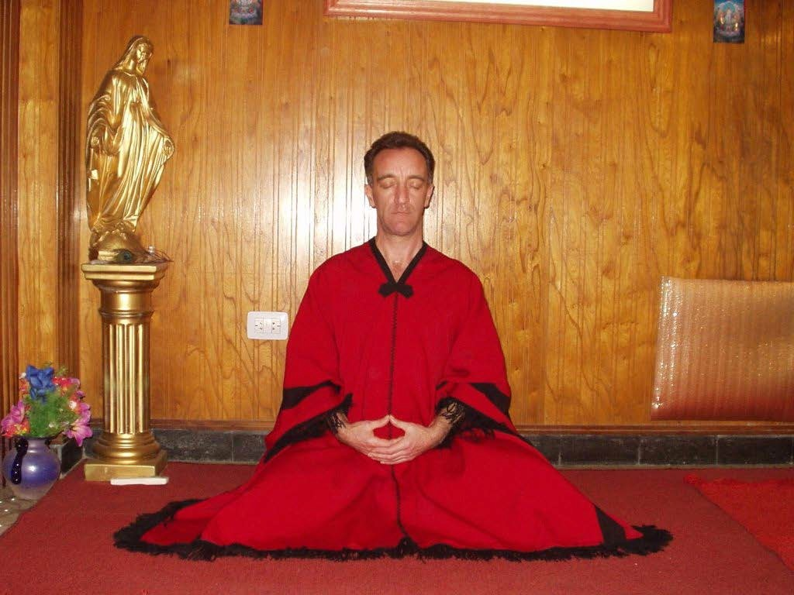

DON MEDITATING AFTER A FEW DAYS ON THE COURSE -

"To expand, I was sitting in meditation the other night and was happily destroying blockages in me using the Seven Step Process of Energy Enhancement taught by

Satchi and Devi when I was staggered by something new. I watched as negative energy transmuted into white light and travelled down to the centre of the earth then returned up my spinal column and carried on into outer space to the centre of the universe and then returned back to me through the crown chakra and down the front of my body through the throat centre then the heart centre and the solar plexus, on to the genitals and in to the perineum, through to the centre of the earth and returned back up my spine and so began this new orbit of energy.

The effect was something else; it shot through me at incredible speed. This carried on and got denser and more powerful as I discharged more of the negative energy within me. This energy took the form of bands of light that followed each other in waves travelling at equal distance apart and as I discharged and transmuted more negative energy the bands got closer together and I found that I could control the speed at which they travelled through the body. Satchi calls this orbit the Supra Galactic Orbit which travels up the ANTAHKARANA into the centre of the universe and down through the centre of the earth passing through the front of the body on the downward sweep and returning up the spine on the outward sweep. I was complete."

TOTAL RESPECT TO SATCHIDANAND AND DEVI DHYANI

"Satchi, please accept my total respect and gratitude for everything you have imparted to me over the short four weeks I have been here. You are a huge light in this world and long may you shine. For everyone reading this, get your asses over to see these people, your lives will be changed forever and we don’t get many chances in this world to be able to achieve that and there are

defiantly not many people in this world like Satchi and Devi who can do the business like this"

MORE DON MINIHANE

Energy Enhancement is the process of clearing all the bad things which have ever happened to you from your psychic body, freeing up the internal essence to attain clarity and enlightenment on your true life path.

ENERGY ENHANCEMENT IS THE NEWEST AND HIGHEST SPIRITUAL IMPULSE ON THIS PLANET.

Energy Enhancement contains Ancient Successful Techniques which Create a Quantum Leap in the Power of any other technique they touch.

Yoga, Acupuncture, Reiki, Healing, Meditation, Tantra and all through The Taoist Supra Galactic Orbit, The Removal of Blockages, The Removal of Encapsulated Trauma, The Karma Cleaning Process, The Mastery of Relationships and the Total Healing of the World.

AFTER ALL THAT, HERE ARE COMPLETE INSTRUCTIONS ON ENLIGHTENMENT - YOGA SUTRAS OF PATANJALI

YES, ENERGY ENHANCEMENT LEADS TO ENLIGHTENMENT

"An example of one of the different types of Energy Blockage is that they are sometimes created when we do not get what we expect, or we get what we do not want. They are caused by the pain of disappointment.

Like when our Mother or Father or Son or Daughter dies. Like when a Lover leaves us.

This trauma, this pain is so strong that at that moment the mind can not look at it, so it gets locked away within the body until we get strong enough to process it.

Then amnesia. We forget the pain fulminating in our bodies. We forget the poison until, after a while, disease is the result."

Satchidanand

JOIN IN OUR ENERGY ENHANCEMENT VISION OF ONE ENLIGHTENED HARMONIOUS WORLD.

EMBASSIES OF ENLIGHTENMENT IN EVERY MAJOR WORLD CITY.

RETREAT CENTERS IN THE ANDES AND DRAKENSBERG MOUNTAINS.

IF YOU WANT TO CHANGE THE WORLD, CHANGE
YOURSELF FIRST.

IF YOU WANT TO MAKE THE WORLD ENLIGHTENED, MAKE YOURSELF ENLIGHTENED FIRST.

JOIN US BY USING THE ENERGY ENHANCEMENT
KARMA CLEARING TECHNIQUES REMOVING ALL TRAUMA AND NEGATIVE EMOTIONS.... ON THE PATH OF ENLIGHTENMENT.

ENERGY ENHANCEMENT APPRENTICE LEVEL 3

SOUL SPLIT RETRIEVAL THIS LIFE TRAUMA CLEARING

PAST LIFE KARMA CLEARING

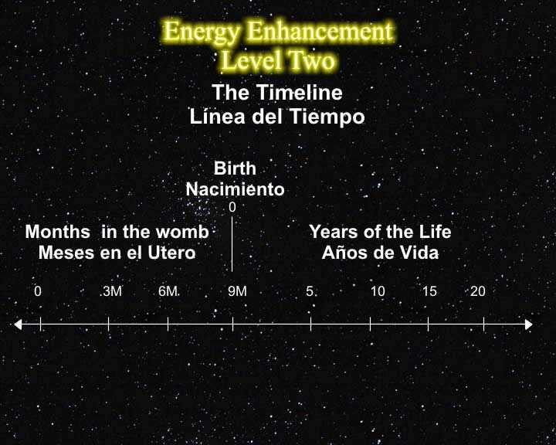
Energy Enhancement is the fastest way to Enlightenment..

Yoga is good but Pranayama is 10 times faster at releasing Energy Blockages whiMeditation Courses The Energy Enhancement Meditation Course Symbol from the Synthesis of Light- Satchidanandch stop the Enlightenment process.

Pranayama is good but Meditation is 10 times faster than even that at releasing Energy Blockages which stop the Enlightenment process.

Meditation is good but Samyama is 10 times faster than even that at releasing Energy Blockages which stop the Enlightenment process.

Yoga, Pranayama, Meditation and Samyama are part of the Eight Limbs of Yoga in the Yoga Sutras of Patanjali and Samyama is talked about from over 5000 years ago in the THIRD AND FOURTH Chapter of The Yoga Sutras of Patanjali.

And Samyama IS Energy Enhancement, 1000 times faster on the Path of Enlightenment.

You cannot afford NOT to try it!!

Love and Light, Satchidanand

THE REMOVAL OF TRAUMA,

PAST LIFETIME KARMA CLEANUP,

SOUL SPLIT RETRIEVAL,

HEALING INNER CHILDREN,

REMOVING NEGATIVE EMOTIONS,

REMOVING NEGATIVE KARMIC MASS FROM THE STRATEGIES OF THE VAMPIRE

Energy Enhancement APPRENTICE LEVEL 3.
Initiation 1.

THE REMOVAL OF OLD KARMA

FROM ALL YOUR PAST LIFETIMES

Remove all the Blockages from all your previous lifetimes

This is what they mean when they say a Master is not under the Laws of Karma.
He has dissolved all the negativity from all his past lives. He has used his SOUL, MONAD, LOGOS AND HIGHER
ENERGIES to dissolve all the negativity, to FORGIVE all the bad actions that he has done, and have been done to him.

Create a Clean white sheet again from your Messy Dark History Painting which you have created brushful by brushful, every day of your life.

Learn How to easily and quickly Heal, remove all the negative trauma energy from all your Personal History, Your Life until now, of all of its painful memories and blockages which act as filters to our vision.

Learn How to easily and quickly Heal, remove all the negative trauma energy from all your Past Lifetimes, Your Lives until now, of all of their painful memories and blockages.

Learn How to easily and quickly Heal, remove all the negative trauma energy from this Future Life of all of its painful memories and blockages.

Learn How to easily and quickly Heal, remove all the negative trauma energy from all your Future Lifetimes, Your Future Lifetimes of all of their painful memories and blockages which act as filters to our vision.

One of our Students age 37, the director of an Internet Business in Bolivia, started to clean his future of this lifetime by mistake, before he had cleaned all of his past lifetimes and this life. He saw himself at the age of 56 with two children in his arms and no wife and then.... all became blank. He then cleaned this lifetime and all previous lifetimes of all their Negative Energy blockages, Energies and bad Karma. When he came to clean the future of this life he saw himself entering into the light, becoming a spiritual teacher in his fifties, onwards towards AGE 80!!!

One of my Teachers, Zen Master Hogen said, We are all History Paintings. We start with a clean white sheet and then every day we apply paint. Usually our History

Paintings become very messy!!! "I am a clean white sheet which is washed constantly. Everytime we meet, it is as if there is no emotional holdover from the past.
Everytime, I see you clearly, as if for the first time!" Zen Master Hogen.

COME FOR YOUR EE COURSE!

Spiritual Adventures through the Energy Enhancement Course

By Honey Kalaria
Honey Kalaria in Argentina ARGENTINA, JANUARY 2005

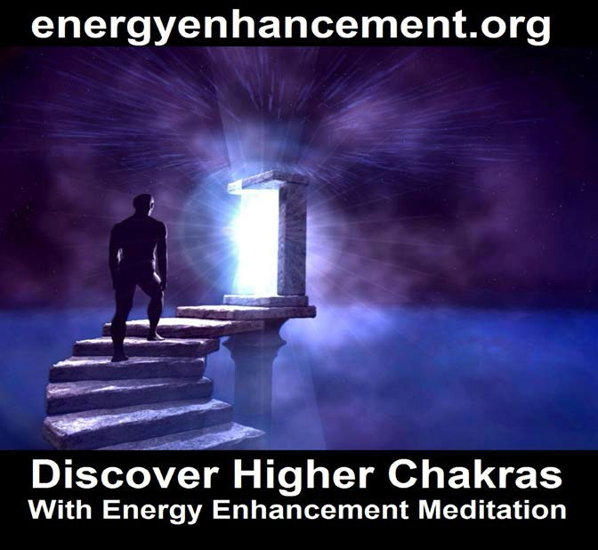

CLEANING THE AKASHIC RECORDS - THE ENERGY ENHANCEMENT KARMA CLEANING PROCESS

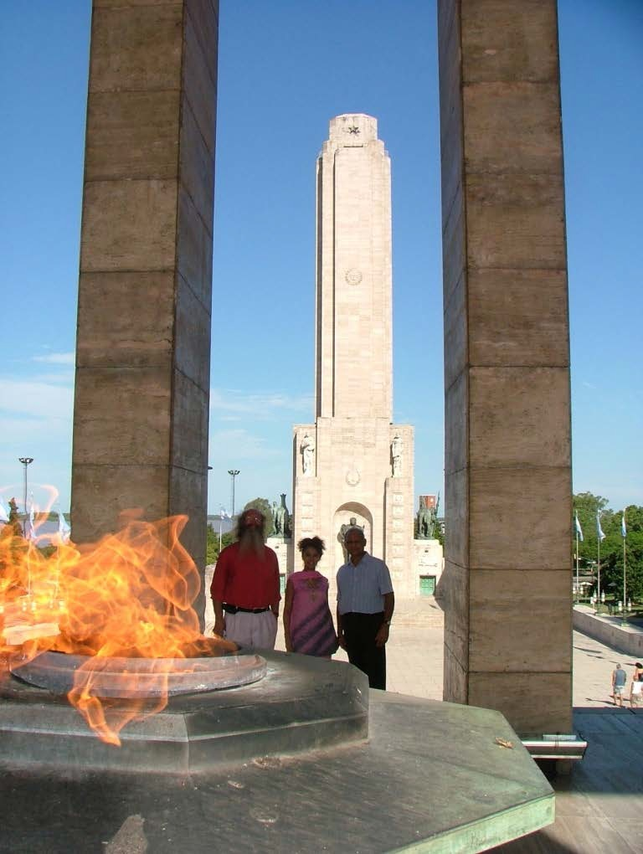

HONEY, SATCHI AND NATWARLAL, HONEYS FATHER, AT THE ANTAHKARANA MONUMENT FROM THE JAN 2005 COURSE IN ARGENTINA

During the Meditation Retreat Honey Kalaria had the following experiences

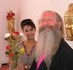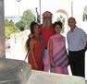

Honey Kalaria is an incredibly beautiful woman, Filmstar, Choreographer, Businesswoman who runs Diva Entertainments and has been presented with a Doctorate in the Arts from London University in recognition of her services.

Here I am today, sitting down, putting pen down on paper whilst gathering my thoughts on the amazing Energy Enhancement Course ( www.energyenhancement.org) that I am currently on.

Where do I begin? Firstly, I felt it would be great to share my experiences of the Energy Enhancement course with other like-minded people. The following information is for those interested in growing spiritually, and wanting this world to become a better place - starting from improving themselves!



My name is Honey Kalaria ( www.honeykalaria.com). I live in London, UK and am a dancer, choreographer and an actress specializing in the world of Bollywood (the Indian Film Industry). I run Honeys Dance Academy, the largest British Asian Dance academy in the UK, running 14 schools throughout London and teaching bollywood dance, bhangra and acting I also run Diva Entertainments, which is an agency specialising in providing Asian artists for television, films and stage shows

Although involved in the world of glitz and glamour, I have always been interested in Yoga, meditation and growing spiritually. I respect all religions and faiths, as I believe they can all be used as a ladder to climb up to God. Personally, although I am from a Hindu background, I am a firm follower of the Religion of Humanity. For me, this means trying to make a difference to the people around you every single day, trying to follow a righteous path every single day and making a difference to the world every single day. This I believe should be done through your work, actions, words and deeds, instead of following rituals and customs, although rituals do help people focus on the religious work at hand.

My interest in spirituality has been there since childhood. My Mother used to advise me on how I should pray every night before going to sleep so God could look after me. So, from the age of 2-3 years, I have prayed almost every night, except when I went through a period of becoming an atheist. Yes, an atheist!

My knowledge of spirituality came from a lot of different sources – from a young age I used to get involved in a lot of Hindu ceremonies, around the age of 13years I attended Bible study classes and by the age of 18, I had

attended numerous seminars, workshops and courses on meditation and had read many books on related subjects. In my late teens I lost my sister in a tragic car accident. I was shocked and felt abandoned by God due to what had happened, and it was then that I became an atheist for a number of years. Luckily, with passing of time I healed and became strong again. I couldn’t keep away from my thirst for spiritual knowledge, and so after a few years, I began learning about different faiths again. I studied about Buddhism, Hinduism, Islam and Christianity and read extensively about Mysticism and Eastern Philosophy. It seemed like God kept testing me along my path through different experiences, and teaching me lessons to help me acquire more wisdom and understanding, but never allowing me to lose complete faith.

In the year 2000 I was blessed to meet my Guru and was introduced to Meditation, a method originating from “Dhyan Yoga” My spiritual growth accelerated in the next few years with Guruji’s blessings, and to help me grow further, I feel he guided me to enrol on the Energy Enhancement Course. I felt strangely drawn towards the Energy Enhancement Course when I stumbled upon it through my internet research, a week or two after I had returned from “Guru Purnima”, a special spiritual event that I celebrated in India in July 2004

As I also run an East London Meditation centre in Ilford, Essex where a small group of people meet every Sunday from 8-9.30pm, I thought I will inform everyone of this opportunity. There seemed to be a lot of personal commitments coming in the way and resistance to the Energy Enhancement Course by everyone except one friend and my father who agreed to join me. So without wasting much time, the course was booked for the three of us. The course was run by Satchiji, a modern day

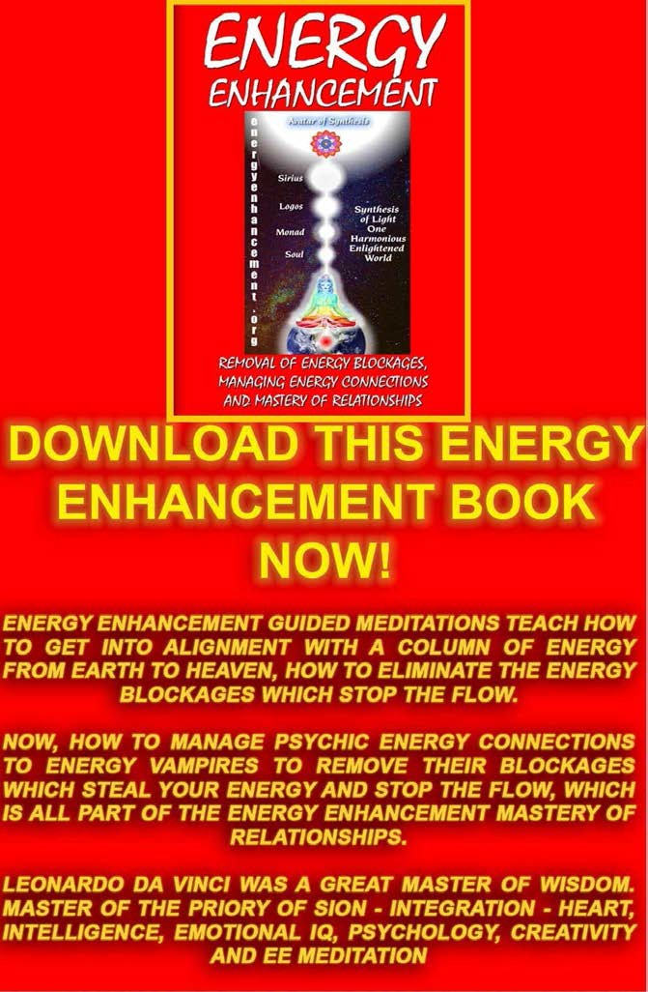

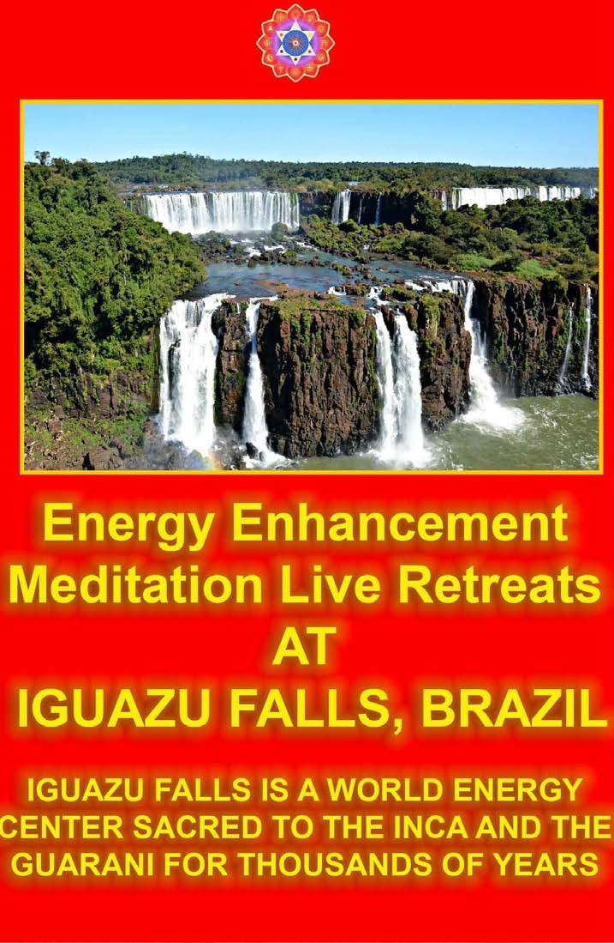

Guru, and assisted by Devi, a chakra clearing dance expert and Reiki Master.

Once on the course, my exciting adventurous journey began! In my life I have done hundreds of courses but the Energy Enhancement Course I found to be completely different. Firstly, the contents and the teachings seem to be inspired by higher forces and had a deep base in spirituality. Also, you don’t just learn about ideas, concepts and theory, but also learn through direct experiences whilst doing the exercises. As you progress through the course, the powerful and effective techniques are taught step by step, so that at each initiation you can work thoroughly and obtain a firm understanding.

The course involved learning how to connect with the Universal Energy (some would call it the Life Force, Spiritual Energy or God) and being able to tap into this powerful energy. By having a direct connection with the Infinite Energy you begin clearing and activating your chakras (the 7 power centres in your body and those chakras above the physical ones) and start removing blockages from your physical and your psychic bodies (aura). These blockages normally prevent people from growing spiritually and living a more harmonious and peaceful life. The Energy Enhancement Course has helped me to strengthen physically, emotionally, mentally and spiritually whilst building my psychic muscles to encourage stronger intuitive skills to develop.

I was told that each of our 7 chakras within our bodies should be seen as a separate mind/brain. We use only 1 brain and the idea is to activate the other 6 brains to build your creativity, intellect, wisdom and genius abilities. This would lead you to become happier and healthier, enjoy being a more emotionally and mentally

balanced person and become a more blockage free (negative emotions) human being. The idea is to have a purpose in life to make this world a better, more peaceful and spiritual place, starting from working on yourself as mentioned before.

The Energy Enhancement Course offers a wide range of theoretical knowledge gathered from the most powerful spiritual teachers and sources in the world. I have had the opportunity to absorb teachings from world renowned Guru’s, Religions and topics such as Satchidananda, Maharishi Mahesh Yogi, Sai Baba, Gurdieff, Bhagavad Gita, The Bible, Zen Buddhists, Sufism, Mantras, Yoga Sutras by Patanjali, powerful meditations, Reiki and much, much more. I also learnt techniques that include visualization, psychology and powerful spiritual practices together with studying films with spiritual messages. This combination has resulted in giving each student on the course, including myself, a “fast track” spiritual growth boost by expanding our awareness levels and sharpening our intuitive powers.

I must admit that when I started I wasn’t exactly sure where all the exercises were going to be leading to, but then I began to have profound experiences. There are just too many to share and perhaps one day I may even write a book on the amazing journey that I have been through whilst on the Energy Enhancement Course. My experiences include having visions, being healed physically, receiving excellent guidance and deep insights from the Spirit of God, finding hidden inner children, Deep Energy Blockages and strategies that I use to behave in a certain way and justify my actions and the list just goes on.

One of the experiences I would like to share with those who believe in re-incarnation is that in one of the exercises, I was blessed to see some of my past lives. I

was astounded by what I saw, the clarity of the visions and with actual dates being revealed. What I learnt was that we came into this life to learn various lessons or to complete certain outstanding desires. It is so important to be careful with what you wish for in this life.

These were the past lives I saw through the Energy Enhancement Karma Cleaning Process :-

1308 – I was a high society male teacher / lecturer who gave talks about my research into stars, astrology and philosophy. I taught large groups of people, was involved in discussion and debate groups and was well respected in the area of my work. I was also a womaniser and drunkard and died at a young age in my mid 30’s. I tried to get my name and got the name Martin or Matthew and second name was something like Hayward or Haywood.

CURRENT PERSONALITY TRAITS: I am a strong
communicator, enjoy teaching as I am presently a dance teacher, give lectures in business and success, interested in Astrology and philosophy, a non alcoholic and am a leader in my field of work.

1412 – In my next life I was again living in high society – it must have become a habit to be born into such an environment. I used to be a right hand assistant to the Princess of Jaipur and was accustomed to living in luxury in a grand palace. The princess and I used to take dance classes with a dance Guru and then we would both have fun and practice together. My Father was a farmer providing food and fruits to the King. I got used to organising all the important things for the princess. I even regularly prayed and danced in the Temple for Religious celebrations with the women. There was an incident where a Prince had come to ask for the hand in marriage of the Princess but ended up falling in love

with me. From that a lot of challenges and problems were created for everyone concerned.

CURRENT PERSONALITY TRAITS: I have developed skills to delegate and organise projects, run my entertainment business empire successfully, enjoy wearing beautiful Indian costumes and garments, always thought I deserve to be treated as a Princess, perform dance professionally, appreciate historical buildings and palaces.

1638 – It seems that I had taken away someone else’s potential marriage partner, so in my next life a partner was not written in my destiny. I was a popular happy go lucky Norwegian girl born in a poor family. I saw my house based on top of a hill with countryside to be seen all around, the market place where I would go to buy vegetables and many other details. My mother had passed away and so being the only child, I used to look after my old and weak father. I always felt that to be a good daughter I had to support my family, otherwise I felt guilty for not being there for them. As a result, I never married my lover and suppressed all my wants and desires. I lived the rest of my life as a spinster.

CURRENT PERSONALITY TRAITS: Find it difficult to break away from my family, and am presently quite happy to be single and living with them. I am also attracted to European men, enjoy the countryside, love nature and get great pleasure in spending time at home (whenever time permits from my busy schedule). I am comfortable living in extravagance as I did in the Jaipur Palace and yet I can be equally satisfied living in simple accommodation as I did here.

1705 – Perhaps I was so heart broken that I must have been wishing to experience what it would have been like being married or having men in my life. So in my next

life, I was born as an Arabian dancer, dancing for the rich Sheikh in the desert. I used to look after and be of service to the male guests of the King, and possess excellent communication skills and etiquette. I was born to a beautiful single Mother and was trained to dance at a very young age. After I reached a particular age, I was sold/given away. Luckily I had a lot of faith in God to make things better and constantly prayed to give me strength and take me away from the lifestyle that I was in.

CURRENT PERSONALITY TRAITS: Learnt that it is important to establish a long term personal relationship packed full of variety and consider one night stands as complete waste of time, blessed with natural dancing talent from birth (the skills have developed over many lifetimes), I adore Arabic music and consider belly dancing to be one of my favourite dance forms, I am very spiritual, I enjoy water around me (probably because it was rare to see water in the desert) and have an aquarium in my home and a pond with a waterfall in my garden. I also tend to get along very well with male friends and business associates.

1893 – God always answers prayers from the heart. Wishing to follow spirituality and living away from women serving men led me to become a 11 year old Tibetan boy living in a Buddhist Monastery. It involved simple living, regular meditation and following a chaste life. The training helped me to become extremely disciplined and I gained a lot of my spiritual knowledge and intuitive powers through this lifetime. I had a wise Buddhist Master, who I feel may still be guiding me to stay on the path of spirituality. He used to always say: “You ask too many questions!”

CURRENT PERSONALITY TRAITS: I am always asking questions - as I’m sure all my present Gurus and

teachers would agree! I’m extremely interested in spirituality and feel drawn to that area. I have now chosen to wait for a lifetime partner to enjoy a sacred physical relationship with and I felt an urge to study Buddhism.

From the Energy Enhancement Course I have just realised that my past lives have enabled me to develop an interest in different religions and faiths. From my life in Jaipur, I followed Hinduism; as a British lecturer or Norwegian, perhaps Christianity; from the life as an Arabic dancer Islam/Sufism and from a Buddhist monk, Buddhism and meditation. I understood how lifetime lessons and experiences actually develop your soul and past life impressions remain on your psychic bodies.
Once certain negative karmas are found, they need to be grounded so that they do not affect your current life situations. I found this insight to be such an eye opener!

There were many other outstanding experiences by the other dozen or so members that were on the course.
These people came from all faiths – Sai Baba followers, Catholics, Buddhists, Krishna devotees etc. It was fantastic to see insights into the world of spirituality and how the Energy Enhancement techniques were creating profound changes in people’s lives. Deep rooted issues would surface and as soon as they were dealt with, even deeper issues would emerge that we would have to deal with. It was like peeling layers of an onion to go deeper and deeper into our core being to understand who we are and what kind of personality traits we have adopted, consciously and sub-consciously to deal with the issues of this world. I understood clearly how these beliefs, conditioning and past life impressions were affecting all areas of our life. In addition, I also learned how to use the Energy Enhancement techniques to help me ground these negative blockages so they would never affect me

again. Of course complete freedom would come after a maintenance programme has been followed.

I continue to say Thank You to God for blessing me to be on this course. I think you need to be extremely lucky to be able to receive such spiritual knowledge and teachings. When trying to do God’s work, you always attract dark forces to keep you away from growing spiritually, and there were many challenges experienced by my fellow students and I trying to prevent us from growing. These would be in the form of negative thoughts, distractions, feeling lazy and sleepy, right though to people having to leave half way through the course.

Satchiji and Devi had already warned us in the beginning that if you are not vigilant then some of you will not be able to complete the course, and I had a direct experience of that. My father was one of the people enrolled on the 1 month course in Argentina who had to leave half way due to the death of my uncle (his older brother). He had to immediately fly back to London after hearing the sad news.

One other Buddhist student on the course left suddenly, perhaps because Satchiji had offended him by saying that he was a Black Magician in one of his past lives.
None of us are sure why he left but he just called Devi and said that he had decided to leave. The unusual thing was that whilst a group of us were talking and laughing, a statue of Buddha sitting on a corner table, got hit by accident. We couldn’t understand how the head of the Buddha got cut across the neck in a straight line and fell on the floor whilst the body of the Buddha remained on the table without moving an inch. Later we were informed by Satchiji and Devi that this was a sign from the dark forces implying: “We have won and have taken the Buddhist student away”.

As I take in depth notes, a local student who works as a radio presenter requested if I could go through all the notes and exercises with him. Twice we arranged to meet but each time he failed to turn up. The first time he lost his keys and couldn’t get out of his house. The second time he said that he had simply forgot. Again and again I saw these powerful blockages, distractions and situations occurring preventing people from progressing on the course.

It’s astounding to see how the Energy Enhancement website currently gets 150,000 hits per year and from those only a dozen of us were able to make it to the course, and even from these, the two previously mentioned students were unable to complete the course

Energy Enhancement Course has been described as the “most advanced meditation course in the world” and I totally agree. It is thorough, the techniques are effective, the knowledge hugely expands your awareness levels, your intuition and perceptive powers increase tremendously, you feel greatly energized with the meditative practices and the course has brought profound changes in my behaviour and in the way I see things.

There are many souls on this earth (whatever faith or belief systems they come from) who could hugely benefit from this unique course. The powerful energy that they receive can be used to help themselves and mankind, making this world a better place. The energy allows you to heal yourself and others, enables you to master relationships, removes bad luck and obstacles from your life, assists you to become a more soul infused personality, works towards removing the Ego, your meditation will become deeper and your concentration levels will increase (great for exams or bringing out the genius in you) ensuring that all areas of

your life gets touched by the spirit of God. As Satchiji says "Energy Enhancement, The Core Energy Techniques, is the Most Advanced Meditation Course in the World which will accelerate any other course or Technique you care to use." and “anything you do to benefit others will automatically get support from spiritual energy, allowing your work to become more successful”,

To Satchi,

my name is xxxx and I'd like to get some info & prices for a stay/visit in the centre in Rosario.

I'm 25 and a student and I was drawn to your website last year but found its teachings & wisdom really hard to accept at first. A year later, I know that energy enhancement techniques could be very important tools for me to learn, and I'll try to explain why.

I think I've grown up with a weak Earth connection & base chakra blocks that keep me subconsciously fearful and generally disconnected from feelings, people and stops me from fully moving forward with my life and life purpose. As a little child I used to feel very unreal and ungrounded which didn't seem to go away when I got older. It made studying and just having a life in general awkward for me. During my teens I lived on coffee & stimulants to feel alert but ended up depleted physically and mentally. On top of this I was sensitive to energies around me & could feel entities come and leave my body/aura when I was awake and asleep. Prayer and angelic help got me through the very dark difficult times, and still does even today.

When I was 23 I meditated for the first time and it was only then did everything fall into place for me. I tried a past life hypnosis CD to see if recalling my past lives

could help me. I practiced a lot and saw some powerful insights.

I got the impression I was a man in another lifetime, and standing in front of me was a beautiful woman wearing a red dress. My awareness was in the man's body as I eyed this this lady from head to toe and was feeling lustful towards her - at the same time I felt this (ENERGY CONNECTIONS - THE PSYCHIC SEXUAL CONNECTION -
LEVEL 4 OF EE) in my Abdominal chakra. The man (me!) was really enjoying what stood before him, and I couldn't take it anymore (I thought it was another entity attack) and I said in my mind 'I didn't want to see this!'

Then another past life image flashed. This time I was a woman standing in a castle.. I sensed someone behind me, turned around and saw in the distance a tall dark- haired man watching me from the top of a stone staircase. This faded, and next I felt a falling sensation and saw myself in my mother's womb. I started to cry and I was filled with the feeling that "My life is going to be so hard!" and I woke up. (its funny - I was born 3 weeks overdue - maybe I was having second thoughts!)

I thought it was fun to catch a glimpse of the past. I thought there was no more to see. That was it. Boy was I wrong. Do you know what happened next Satchi? 6 months later I actually met this person. We worked together in a department store in May this year in central London. Soon after we were introduced he said it was his destiny to meet me. I found out that like me, he also lived in Leyton - 5 mins away from me but we'd never met until now. He was a really beautiful man - tall, dark hair although I didn't know who he was at first.

Well, to say we that didn't get on was an understatement. David was magnetic - he was a real charmer, who had a lot of energy, power and influence

over people at work, while I was more quiet, reserved (and drained). To cut a long story short, working together this summer was a painful karmic experience. My lessons were those of Power, Identity and integrity. The way I acted in the past was being returned to me in this life. David saw that I had trouble with my boundaries & inability to say no to people. He even told me once that 'I wished I was a bitch but I was just too nice'. I told him to fuck off & he swore at me in polish and walked off (!) Truth was, it was hard to hear the truth about myself, as people really were taking advantage of my niceness/weakness. I was following orders from people who weren't above me like a programmed robot without question!

I left at the end of August to go back to uni, but on my very last day at the store I got confirmation that I'd known him before this lifetime. Without any conscious awareness on his or my part, amazingly, we re-encated the 2 past life visions I saw in my meditation 10 months earlier - this time I was the female, he was the man. I got a discreet clairvoyant vision (for the first time ever) in my mind's eye to let me know who he really was. (a soulmate)

That was a really intense experience which took me months to process & understand! but, I was blessed to see (live - in real time!!) how karma was still affecting me and now I'd like to ask you Satchi and Devi for your wisdom & guidance to help me deal with & erase it from my life forever. Just knowing that I can learn the basics from you to get me started and wipe out my deep seated fears for good makes me eager to get started. I feel like I have no choice - nothing's more important to me now than my emotional, mental and spiritual health.

Thanks so much,

EE LEVEL 1 POWER UP!!
GAIN SUPER ENERGY
http://www.energyenhancement.org/Level1.htm

EE LEVEL 2 ELIMINATE
ENERGY BLOCKAGES
http://www.energyenhancement.org/Level2.htm

EE LEVEL 3 CLEAN KARMA BLOCKAGES AND PAST LIFE KARMA BY TRANSMUTATION
http://www.energyenhancement.org/Level3.htm

EE LEVEL 4 MASTER
ENERGY CONNECTIONS
AND RELATIONSHIPS
http://www.energyenhancement.org/Level4.htm

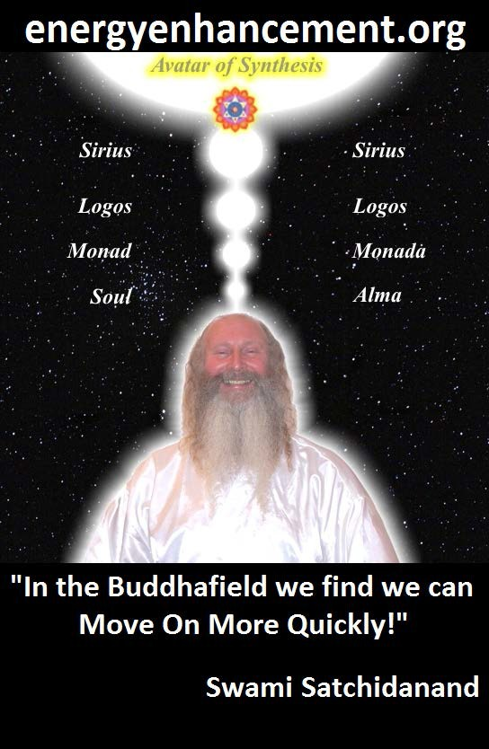

ENERGY ENHANCEMENT - THE ULTIMATE MEDITATION COURSE!!

“Traditional meditations are designed to Fail” – Satchidanand

ENERGY ENHANCEMENT LIVE COURSES

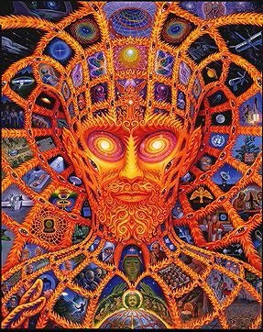
SPAIN

ITS WINTER IN EUROPE, BUT ITS SUMMER IN INDIA!!

COME ON THE ENERGY ENHANCEMENT COURSE

INDIA!

email sol@energyenhancement.org for Course details

FUSION WITH THE SOUL CHAKRA -
Enlightenment - is Only the first Dan. Become fused with the Monad - Second Dan. Become fused with the Logos - Third Dan. Become Fused with Sirius - Fourth Dan. Become Fused with the Avatar of Synthesis - Fifth Dan - Satchidanand

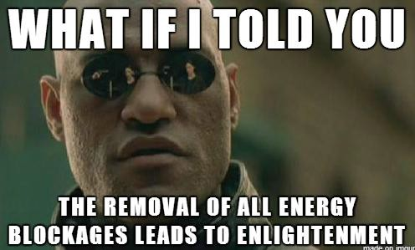
Research The Energy Enhancement Meditation Course by video or on retreat..

The Ancient Enemy who counts meditation and the mind control psychic arts as one of its main planks of ing, International Companies, Eugenics - Worldwide, censoring Alchemical VITRIOL, the

Kundalini Key and Energy Blockage Removal from every Meditation Program..

WE HAVE SO MANY ARTICLES SHOWING THE ORIGINAL EXISTENCE OF THESE ESSENTIAL MEDITATION TECHNIQUES IN EVERY WORLD RELIGION..

NOW, SPEED UP YOUR PROCESS WITH ENERGY ENHANCEMENT ALCHEMICAL VITRIOL, KUNDALINI KEY AND ENERGY BLOCKAGE REMOVAL ON THE PATH OF ENLIGHTENMENT

GET IT NOW!!

EMAIL sol@energyenhancement.org

Energy Enhancement APPRENTICE LEVEL 3. Initiation 2.

THE REMOVAL OF OLD KARMA

FROM ALL THE FUTURE YEARS IN THIS LIFETIME AND ALL YOUR FUTURE LIFETIMES

Remove the blockages from all the future years of this lifetime

Remove the blockages from all your future lifetimes

Energy Enhancement APPRENTICE LEVEL 3. Initiation 3.

The Retrieval of the Soul Splits of the Inner Children Deep Energy Blockages.

Many psychological books talk about these Inner Children Energy Blockages but Only ENERGY ENHANCEMENT, Through the Grounding of Negative Energies and other Immensely Powerful Blockage Busting Techniques, can drain these Energy Blockages of their Painful Negative Energies and Emotions and Integrate them back into the Soul Central Stem.

Learn how to heal all your Energy Blockages, Your inner children, the Inner Saboteurs, the childish Deep Energy Blockages which split off from the central stem of the personality at the time when YOU are hurt, and which then destructively affect our emotions and our actions for the rest of our lives as they wander into and out of the active personality. These Inner Children Deep Energy Blockages are stronger the older they are and can form at any age in your life.

The Inner Children Deep Energy Blockages are separate egos which have been artificially created through painful experiences. Once created they shuttle in and out of your consciousness without you noticing them, except by their negative effects in your life. They are like separate ego programs, virtual machines, psychic viruses, which live within the one computer, you.

Sometimes these Inner Children Hurt Personalities try to protect you from your old painful memories through amnesia. As you heal them you start to access everything and learn, Its Just Not That Bad!! The Child could not handle the old situation but you, the adult Integrated Personality, viewing the scenes of the past which have been drained of their negative and emotional energy by Energy Enhancement techniques, can handle anything!!

As you heal them and integrate them, then all their experiences become available to the Central Strong Soul Personality, YOU, which then becomes even stronger.

THERE CAN ONLY BE ONE!!

AND THIS ONE IS THE ENLIGHTENED SOUL INFUSED PERSONALITY.

COMPLETELY DISTINCT FROM THE PAIN CAUSED, EGO FILLED, SUBPERSONALITIES.

AND THIS ONE IS THE ENLIGHTENED SOUL INFUSED PERSONALITY.

COMPLETELY DISTINCT FROM THE PAIN CAUSED, EGO FILLED, SUBPERSONALITIES.

The development of a Human Being is a series of Paradigm shifts as One by One the Chakras Open. If an Inner Child Personality remains behind it sabotages all the next openings of the chakras, all your Evolution.

See APPRENTICE LEVEL Four THE MASTERY OF
RELATIONSHIPS, to see how Energy Enhancement can

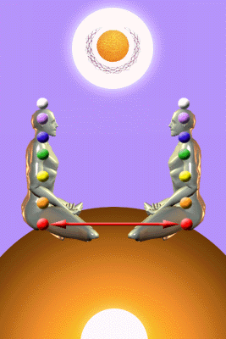

dissolve the Inner Children Energy Blockages which Unconsciously Link Your Sexual Base Chakra and the Relationship Abdominal Chakra to the Chakras of Other People thus causing Adultery and Divorce.

Learn THE MASTERY OF RELATIONSHIPS, the Mastery of the Second Initiation, the Mastery of the Sexual Base Chakra the Relationship Second Chakra, the Mastery of the Psychic Sexual Connection, the Mastery of Intimacy and Independence. The Mastery of Relationships

TRANSMUTE BAD LUCK TO GOOD LUCK
All bad luck comes from these Soul Splits. As your Life is Sabotaged and Fails due to the influence of these inner saboteurs, your stress rises and their action becomes more intense. It is the Inner Children who want to use the Strategies in order to gain what they have been programmed to do, AND THE INNER CHILDREN WILL USE THE STRATEGIES MORE AND MORE INTENSELY AS THE STRESS INCREASES.

AS THE STRINGS ARE WOUND UP. IN THIS WAY YOU LOSE BALANCE.
SOUL RETREIVAL WITH ENERGY ENHANCEMENT

This Energy Enhancement Stage teaches you to do the same thing that Shamen do in what they call "Soul Retrieval". To the sound of a beating drum they will enter into the astral plane and bring back to you these split off parts of yourself.

Energy Enhancement teaches you how to do this for yourself, by Yourself. By grounding all these negative energies with the SEVEN STEP PROCESS OF ENERGY

ENHANCEMENT we can heal the Deep Energy Blockages and integrate them back into the soul.

Meditation Energy Enhancement and Gurdjieff

Gurdjieff said that the personality which swore to meditate early in the morning every day was not the same personality and the one who threw the alarm clock out of the window!!!

They say "I have changed my mind" and as Monty Python accurately joked, "I will get a new one from the corner store tomorrow!"

He said, "If you are not one, if you have within more than one mind, how can you promise anything? YOU CAN NOT MAKE A PROMISE IF YOU ARE SPLIT!!"

ENERGY ENHANCEMENT TEACHES YOU HOW TO REMOVE ALL THESE PAINFUL PARTS OF THE SPLIT MIND WITHOUT ANY PAIN OR PROBLEM, JUST THROUGH MEDITATION AND THE PRESENCE OF YOUR TEACHERS, IN THE BUDDHAFIELD..

GURDJIEFF, Deep Energy Blockages AND ENERGY BLOCKAGES

PARACELSUS AND BLOCKAGES - CLICK HERE

GURDJIEFF AND BLOCKAGES - CLICK HERE

DAME ALEXANDRA DAVID NEEL - THOUGHT-FORMS IN TIBET - CLICK HERE

HUBBARD, SCIENTOLOGY AND BLOCKAGES

ENERGY ENHANCEMENT SOUL FUSION

ENERGY ENHANCEMENT BLOCKAGE REMOVAL

ENERGY ENHANCEMENT KARMA CLEARING PROCESS

ENERGY ENHANCEMENT MASTERY OF RELATIONSHIPS

BLOCKAGE ELIMINATION AND WORLD CHANGE - THE REMOVAL OF ENERGY BLOCKAGES ENTITIES AND IMPLANTS WITH ADVANCED ENERGY BLOCKAGE BUSTING TECHNIQUES

ENERGY BLOCKAGES, ENTITIES, IMPLANTS AND NAFS - WHAT ARE THEY, WHY ARE THEY FORMED, AND HOW TO REMOVE ENERGY BLOCKAGES AND IMPLANTS BY THE ENERGY ENHANCEMENT SEVEN STEP PROCESS OF ENERGY ENHANCEMENT LEVEL 2


September start email us now!!

Energy Enhancement APPRENTICE LEVEL 3 Initiation 4

THE GROUNDING OF THE EMOTIONS
This Initiation shows how to Ground, to Drain all the negative energies from your negative emotions and thus remove all your emotional Energy Blockages.

- ANGER

- MANICISM, OVER THE TOPNESS

- SEEKING, CRAVING ATTENTION

- SADNESS AND DEPRESSION

- FEAR

- ENVY AND JEALOUSY

- THE DESIRE TO HARM

- HATRED

The Relationships of the Negative Emotions and the Strategies to Energy Blockages and Acupuncture.

Acupuncture is a healing modality which has been used for 4000 years. The Energy Channels of the body have been mapped for that time and scientifically, the points on the meridians have a much higher electrical resistance than the surrounding tissue. As yet, science has not been able to explain this but scientifically, empirically, the evidence exists!!

Acupuncture explains that health problems start with what are called energy blockages. These Energy Blockages exist at least 6 months before there is any disease!!

The Theory of Acupuncture Diagnosis, Five Element Traditional Chinese Medicine, says that each Energy Meridian in the human body corresponds to one of the 5 Elements, and each Energy Blockage also creates a Negative Emotion corresponding to the Element of the Meridian.

And not only that, Each negative emotion corresponds to negative Deep Energy Blockages which are those splits in the central stem personality corresponding to the selfish separative ego.

If you look at the 5 Elements in the diagram of the Shen and Ko (Kundalini) cycle, a circular diagram, you will see that the table below joins up, top and bottom.

Remove the Energy Blockages with the advanced techniques of Energy Enhancement and slowly even more of the selfish, competitive ego is removed releasing all the incredible potential of a normal human being, as the last blockage goes, enlightenment itself is sure to follow.

Finally, the Ancient Acupuncture Treatment to remove "The Seven Dragons and the Seven Internal Demons", which you can receive from any practitioner of Traditional Acupuncture, is a wonderful treatment to get rid of the simplest of the Energy Blockages, but Energy Enhancement Techniques are really needed to remove those blockages which are deeper and more intense.

REMOVE ALL NEGATIVE EMOTIONS AT THE LEVEL OF ENERGY WITHOUT GOING NEAR THE PAIN!!

The Five Elements | Energy Channel or Meridian | Negative Emotion caused by the Energy Blockage
Wood meridians | Liver and Gall Bladder | Irritation and Anger
Fire Meridians | Heart, Triple Warmer, Pericardium and Small intestine | Manic
Earth Meridians | Stomach and Spleen | Needing to give Sympathy and Attention to support ego or Constantly Seeking Sympathy and Attention
Metal or Air Meridians | Lungs or Large Intestine | Depression and Sadness
Water Meridians | Kidney and Bladder | Fear

LIVE COURSES, INDIA AND BRAZIL - IGUAZU FALLS



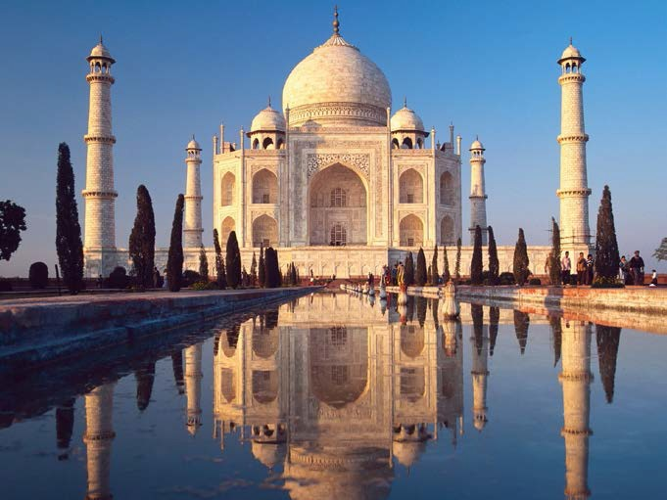

GET MEDITATIONAL SUPERPOWERS WITH ENERGY ENHANCEMENT, LIGHT YEARS AHEAD OF EVERY OTHER COURSE

THE ULTIMATE ADVANCED MEDITATION COURSE

MEDITATION ENERGY ENHANCEMENT

THE CORE ENERGY TECHNIQUES!!

THE MOST ADVANCED MEDITATION TECHNIQUES ON THIS PLANET, IN 28 INITIATIONS!!

ANCIENT EFFECTIVE ENERGY ENHANCEMENT SECRETS -

SUCCESSFUL

TIME TESTED

TRUE

Energy Enhancement Meditation Course Level 3 - Initiation 5

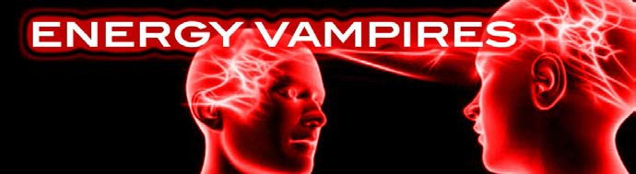

PROTECT YOURSELF TOTALLY FROM ENERGY VAMPIRES
REMOVE THE ENERGY VAMPIRE WITHIN YOURSELF
Removing the Strategies of the Psychopathic Energy Vampire!!

Removing the Sub-Personalities which use Strategies of the Psychopathic Energy Vampire!!

Removing the Addictions of the Sub-Personalities which use Strategies of the Psychopathic Energy Vampire!!

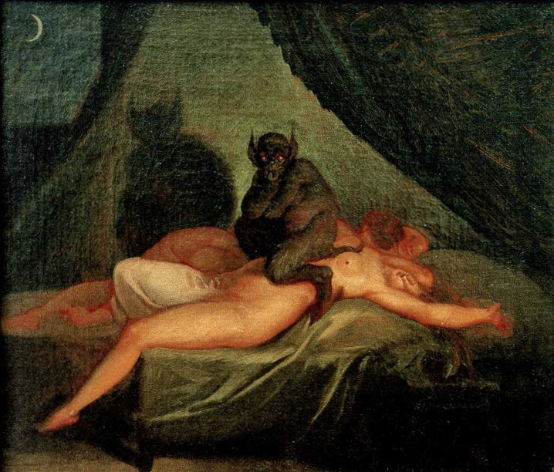
ENERGY VAMPIRES SUCK THE ADDICTION TO SEX - THE SEDUCTOR/SUCCUBUS/INCUBUS

ENERGY ENHANCEMENT IN LEVEL THREE WILL TOTALLY REMOVE THE STRATEGIES OF THE ENERGY VAMPIRE - FURTHER INCREASING YOUR ENERGY, SPIRITUALITY AND PEACE.

ENERGY VAMPIRES



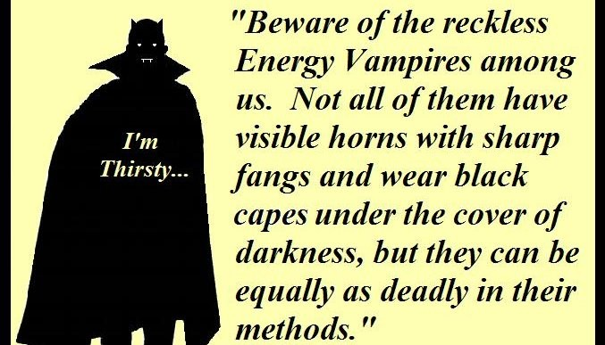
The assumption that a whole system can be made to work better through an assault on its conscious elements betrays a dangerous ignorance. This has often been the ignorant approach of those who call themselves scientists and technologists.

-The Butlerian Jihad, by Harq al-Ada

ENERGY ENHANCEMENT APPRENTICE LEVEL ONE WILL DRAMATICALLY REDUCE THEIR NEGATIVE POWER

TO Totally Remove ALL the Strategies You NEED ENERGY ENHANCEMENT APPRENTICE LEVELS 2 and 3 !!!

THE REMOVAL OF THE ENERGY BLOCKAGES WILL TOTALLY REMOVE ALL THESE STRATEGIES OF THE ENERGY VAMPIRE

SIMPLY READING BELOW ABOUT HOW OTHER PEOPLE ARE DRAINING YOUR ENERGY WILL HELP TO STOP THESE ENERGY VAMPIRES FROM DESTROYING YOUR LIFE. LEARN HOW NOT TO BECOME ENGAGED BY THEIR STRATEGIES TO SUCK YOUR ENERGY. ENERGY ENHANCEMENT IN LEVEL THREE WILL TOTALLY REMOVE THE STRATEGIES

OF THE ENERGY VAMPIRE - FURTHER INCREASING YOUR ENERGY, SPIRITUALITY AND PEACE

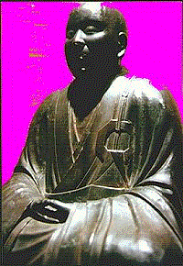The Aloof Strategy.
When we remain quiet as a child, then our mothers often ask if there is a problem. The strategy has worked! We have caught the attention, the energy, the love of our mothers.
Because of this people remain quiet and show no love at inappropriate times, simply because this strategy worked once.

The aloof use this strategy to gain attention. Once we had a client who used to constantly travel around the world in order to remain aloof from his family and create food for themselves and eat it separately. It certainly got their attention!!

Also the aloof can work in combination with the Star. Once we had a client who preferred to eat alone rather than eat with others. The star made wonderful food which it used in order to remain aloof.

The Poor me Strategy,
Further than the aloof strategy the Poor Me gains energy by being sad or sick and by moaning and complaining.

Many people say that doctors surgeries are places where people compete for the worst things that happened to them. The combination of the Poor me and the Star.
They have some investment in always remaining sick, and that is because it gets the attention of all the people around them.

As people get sick of their constant moaning the strategy begins to fail to get attention, as all of these strategies eventually fail. Then something stronger is needed in order to gain the attention and the POOR ME becomes an amputee, Alcoholic or a Drug Addict.

THE POOR ME ALCOHOLIC ENERGY VAMPIRE REMOVED BY MEDITATION

THE POOR ME, THE VIOLATOR AND THE SELFISH COMPETITIVE STAR

The Alcoholic is very rarely cured. One psychologist referred to it as, "Chipping away the ice in the Antarctic"

George Best was a very famous Footballer. He said "I spent 90% of all my money on women and booze, the rest I wasted" He died age 53 of cirrhosis of the liver!!

Without the Seven Step process of Energy Enhancement it is impossible to remove Alcoholism, but with The Seven Step Process it becomes very easy to remove this Vampiric Strategy.

They are so sad that one feels guilty to be happy in their presence. Needless to say, this childish personality will

do anything, hurt or even kill themselves to gain your attention and your Energy!

And if that does not work the Poor Me always flips into the Violator Strategy in order to get attention. Ignore them and they get Very Very Angry!!! This is the origin of many Bi-polar Disorders.

Remember the Vampiric Strategy Sub-Personality does not care one jot about its host, YOU!!

All it cares about is to perform its robotic programmed function of gaining attention and love and energy from everyone around them. The Strategies of the Vampire.

The Alcoholic is very rarely cured. One psychologist referred to it as, "Chipping away the ice in the Antarctic"

George Best was a very famous Footballer. He married four Miss Worlds. He said "I spent 90% of all my money on women and booze, the rest I wasted" He died age 53 of cirrhosis of the liver!!

Without the Seven Step process of Energy Enhancement it is impossible to remove Alcoholism, but with The Seven Step Process it becomes very easy to remove this Vampiric Strategy.

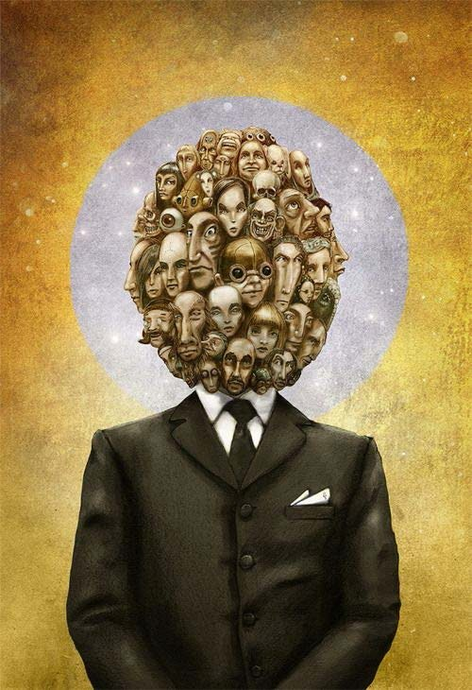
“THERE CAN ONLY BE ONE”

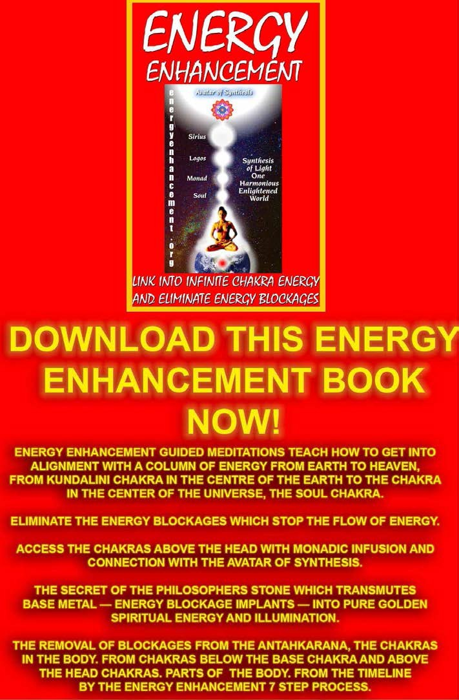

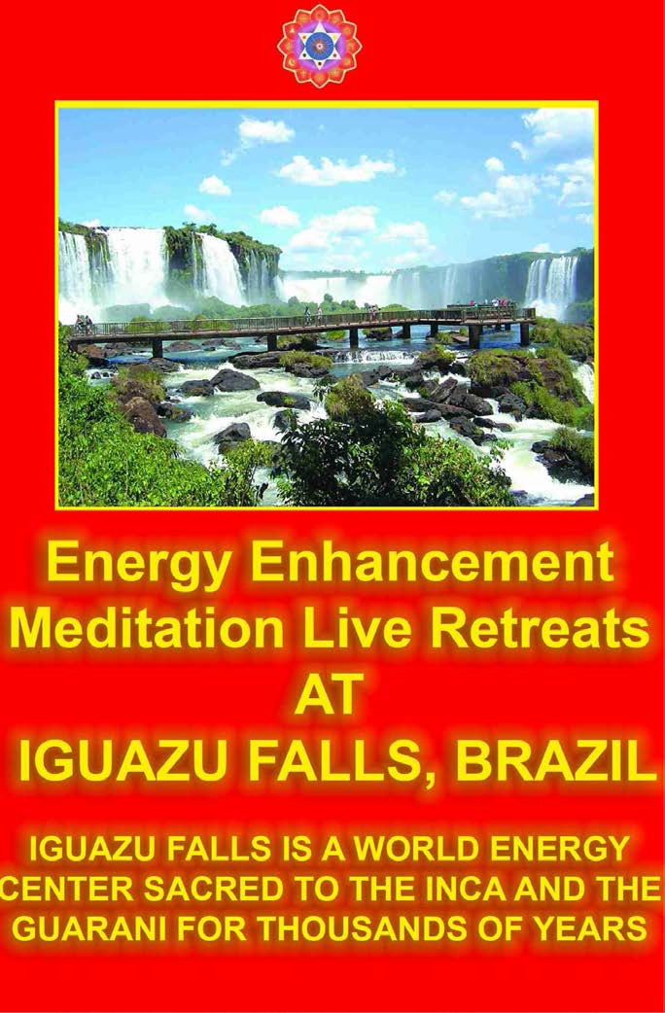

The BAD SELFISH COMPETITIVE ENERGY VAMPIRE STAR STRATEGY – THE BLACK STAR.
THE DIFFERENCE BETWEEN A GOOD STAR AND A BAD STAR IS JUST EGO AND NEGATIVE KARMIC MASS

ENERGY ENHANCEMENT CAN REMOVE THE SELFISH COMPETITIVE EGO FROM THE STAR

By asking questions or telling jokes. "Daddy, look, I got ten out of ten at school today!" There are many ways to be a star. But ask yourself why they are doing it? If all they want is attention. If they have no selfless inner purpose. Then this is just another selfish strategy, developed when they were a child, to gain your attention.

Further, in extremis the star becomes a jealous and vindictive tyrant. They try to destroy all competition. As Gengis Khan said,- "It is not enough that I succeed, everyone else must fail." These stars become surrounded by many poor me's who need help so that the Star can be seen to be "Generous" and people who say "Yes". These people will confirm you as a Star. They are no Competition, No Threat.

However if a Bad Star sees someone as competition, then they will try to destroy that person by saying bad things about them. Destroying their reputation and in extremis, killing them.

Stalin was said to be always asking if the people around him were geniuses. If he thought they were a genius, a threat to his ego and his power, then they would "disappear" and end up dead in a concentration camp, a Gulag in Siberia.

Stars always want to teach and never to learn. They are not good students, not respectful of the teacher or the teachings, always competing and thus never learning or just being. - THE ADDICTION TO SEX – THE SEDUCTOR/SUCCUBUS/INCUBUS

Once the Star has been healed of all its negative energy on the Meditation Energy Enhancement Course, then it can become a Good Star!! A Good Star encourages all people to become stars. It does not see anyone as competition because it understands that for this world to evolve, it needs everyone to become a strong personality, evolved and creative.

DEVELOP INTO A GOOD STAR WITH ENERGY ENHANCEMENT

Every Man and Woman is a STAR!!

The Interrogator Strategy
This one is always asking questions to get your attention. It is the forerunner of the Violator Strategy because it is so invasive.

The Interrogator does not want the answer, all it wants is your attention and your energy.

The Violator Strategy
Further than the interrogator and the star, this person uses powerful hurtful means to get your attention and energy. Verbal abuse, Physical abuse. Rape. A Violator needs the acquiescence of a Poor Me in order to create the energy sucking polarity he craves.

A good violator will use this technique to break blockages and generally test out your emotional state

One of my favourite Strategy Jokes... Masochist, "Beat me, Beat me!" Sadist, "NO!!!!"
The Violator - When It Happened to Me

The day that the irony of it all hit me is a day that I shall never forget. I wanted to cry, but no tears came. An overwhelming urge to write it down is all that I had.

It started when I remembered a story that a dear and valued friend told me over a year ago. She, much to her surprise, found herself pregnant and making plans to change her life into that of a single parent. Laughing, she had commented how funny it was because she had said so much about how single mothers were being

irresponsible, because once she had considered them to be "scum of the earth", and here she was now. It certainly opened up her eyes. She was now wiser and regretted what she had said.



What struck me was the realisation that exactly the same sort of thing had happened to me, although my issue was different. I was confronting domestic violence. I had believed that women who suffered through it, asked for it. I believed they held the power to control or avoid it, but chose not to. And now here I was a victim of it.

The only woman I know who had been abused in this way is my mother. I know about it because I lived through it and its aftermath. I could easily identify what it was that my mother said that caused my father to react so violently towards her. Being seven years old at the time it seemed to me that if she just didn't say those things, it wouldn't happen. Simple.

I can remember the last two times it happened to me very clearly. I am sure that it had happened at least once or twice before that, but they are now holes in my memory put there by terror, panic and disbelief.

The first incident I remember happened for me in slow motion. I saw the madness in his eyes as he leapt out of the bed at me. His face was red and his mouth slightly frothed. His hands were outstretched heading straight for my throat. They made contact with it in the hallway as I had backed up against the wall. Over and over he repeated "I want you dead", as the back of my head hit the door when he shook me. I didn't struggle or panic, I didn't care if he did kill me. I just wanted it over and done with one way or the other.

He was very sorry about it afterwards of course. He said that I made him do it, so I should recognise that and learn my lesson. He suffered no guilt, as he said, because he was not in the slightest bit responsible for the incident. Then he pointed out to me that he is one of the nicest most sincere men that I was likely to meet, and I was a bad person for making him act that way. I took this on because it was perfectly consistent with my childhood beliefs.

The second time we were arguing in the dining room. I was sick of him making emphatic statements then storming out of the room. So when he tried to leave again, I grabbed his jumper. He turned on me. His eyes

went wild and he pounded full strength on my forearm to break my hold. Then he swung at me with his other fist hitting me in the chest. The next blow impacted so hard on my shoulder that I was knocked back six meters into the kitchen. Losing my balance, teetering backwards with him following me, he pushed me. I remember thinking to look out for my head as I was going down near the corner of the bench. I fell amongst the rubbish and recycling stuff very awkwardly and he kicked me in the shin. That was three weeks ago and my bruises are only just starting to fade.

He was very sorry about it afterwards of course. He said that I made him do it, so I should recognize that and learn my lesson. He continued to maintain a guilt free existence because I was responsible for the incident.

He said that he thought I was mad and should be locked up. Then he pointed out to me again that he is one of the nicest most sincere men that I was likely to meet, and I was an even worse person for making him act that way once more. I continued to take this on because it was still perfectly consistent with my own learned beliefs.

So I had struggled through this issue a lot over the last couple of weeks wondering, had I asked for it? I knew that physically I was powerless against him. Could I have stopped it? I have been very confused about it all and I am also aware that compared to many domestic violence situations, my story is nothing.

I am however making plans to leave this house and this environment. I want to be by myself for a while. I do know that it is time for me to ditch my childhood ideologies and admit that his actions were not excusable or justifiable. Meanwhile everybody else

continues to think that he is one of the most caring men that they have ever met, especially his women friends.

The Don Juan, Seductor, Succubus/Incubus, Lilith or Vamp Strategy

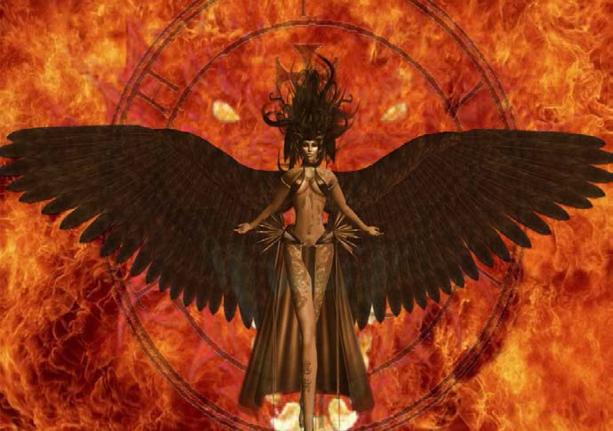
We have all heard of the town bicycle who is ridden by everyone. Well, because of this need for Love and Attention. Because we are afraid of people leaving us so that we leave them first.

Because of the very strong psychic sexual connection and the energy flows it can create - it takes very strong energies to draw a soul down from heaven. This strategy is a wonderful method for both men and women to vampirise the energies of people they meet.

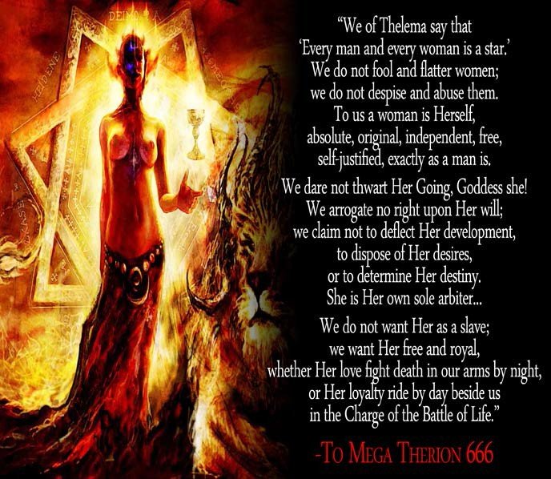
ALL SEXUAL TANTRA, ALL SEXUAL RITUAL, IS AN EXCUSE FOR ENERGY VAMPIRES TO SUCK THE SUCKERS!!

Pleaser Strategy
Because they want your love, they will put aside their wants and even their justifiable needs, and try to please you. They will have no personality of their own except that which wants to please. They will be happy or sad depending upon whether you have been pleased.

However, they will make you dependant upon them. they will engage your attention more and more. They become inescapable. They mutate into a Tyrant!

The Blamer Strategy
Its all your fault. There are only two of us here and it can't be me who is wrong. It must be you!!!

The Critic Strategy
Like the interrogator this intellectual strategy gets off on criticising everything to get your energy and attention.
Yet the critic even criticises himself.

The Tyrant Strategy
All of the strategies in the end are tyrants who want, need and even demand your attention.

All they want is your attention. They will get your attention in many destructive and self destructive ways

The Self Destructor Strategy
This one is the Big Daddy of them all. The Controlling Archetype of all of the Strategies. All of them lead to self destruction because they are the major part of the Desire-filled, wanting, vampire ego.

Manic Depression.

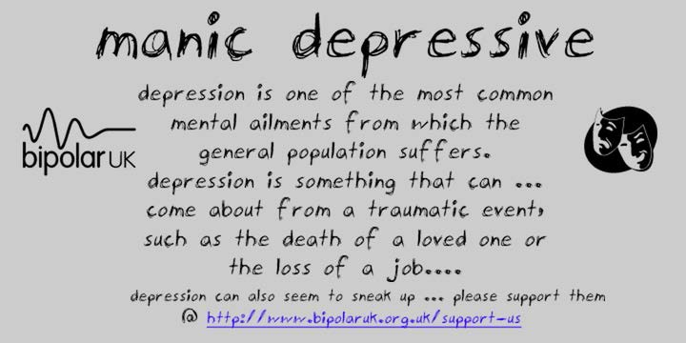
The Poor Me and the Violator usually flip from one to the other and back again within one body. If you have one Strategy, then soon you will flip to the other side.

We see many Poor Me's. All of them are capable of becoming the violator in a trice.

THE TRI-STRATEGIES

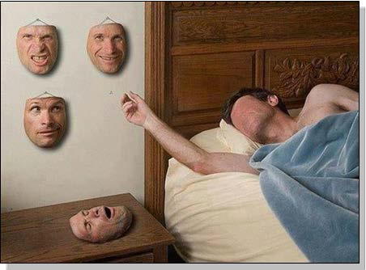
The more I see my students, the more I see that the inner children sub-personalities are the blockages which most affect them, the blockages which stop them evolving.

We know that sub-personalities use the tri-strategies - The Poor Me, The Violator, The selfish competitive Star - rotating from one to the other as sub-personalities rotate in front of the mind.

Indeed the use of the tri-strategies is one of the symptoms of inner children vampires who use the strategies to gain attention and energy.

They hold on to problems which would clear more easily if the sub-personalities were gone.

You can use the tri-strategies - seven stepping all the three strategies at once - to find and remove the sub-

personality, to remove the condition - the particular game to suck energy from others like a succubus- seductor - the sub-personality is holding on to.

And of course the sub-personalities hate me and say bad things about me.

But it is not true!!

The Traitor sub-personalities are the plague!!

Marcus Tullius Cicero describes the process of infil- traition by inner children sub-personalities

“A nation can survive its fools, and even the ambitious. But it cannot survive treason from within. An enemy at the gates is less formidable, for he is known and carries his banner openly. But the traitor moves amongst those within the gate freely, his sly whispers rustling through all the alleys, heard in the very halls of government itself. For the traitor appears not a traitor; he speaks in accents familiar to his victims, and he wears their face and their arguments, he appeals to the baseness that lies deep in the hearts of all men. He rots the soul of a nation, he works secretly and unknown in the night to undermine the pillars of the city, he infects the body politic so that it can no longer resist. A murderer is less to fear. The traitor is the plague. — ”

— Marcus Tullius Cicero

The soul infused personality is the enlightenment cuckoo.

And by throwing the bird subs out of the nest by focussing the energy of Samadhi onto the personality. We become one.

SATCHIDANAND

Hello Satchi

Your previous emails have really touched me on deep, realisation level.

The enmeshment of the succubus is the root of attachment cords to family and friendships. I grounded this concept in the image that suited this root -like network of living. The succubus demon is in fact an infection that is formed of a group of subs ..and over time if left ungrounded, through time it would recruit more soul splits, to become more complex, dynamic and difficult to pin-point. So The image of all the subs attached to the demon itself, along with all the cords to family and friends. As a result I can see the working, the behaviour, thought patterns..not only in my self but in those around me.

The pleaser and controller were the predominant ones. Fear and Power. Pleaser knows how to please in order to again trust and security. Easier to work with and live with in the satanic world. Controller violator related to pride and power over others..superiority black star. If the poor me then others would want to take care of me. Wont let me be without the safety net of family and friends.

Since grounding this..which I continue to do so, I’ve been affirming throughout the day through visualisation the beam of light from infinity above and and infinity below - 100% from God. Then I place the rings out to infinity to purify the the energy and weaken the vertical draining.
Also when words you spoke of alignment being true to the individual and no right answers has further given me

trust in alignment and confidence in finding ways to live in love and light.

I think and feel and know that i’m a different person, as I now relate to others in a different light to only just a few days ago.

Much love, light and gratitude

The sub-personalities are the plague!!



However, to remove these sub-personalities completely, the more Advanced techniques of Energy Enhancement are absolutely necessary:-


The Cuckoo and the Soul-Infused Personality

THE SOUL INFUSED CUCKOO THROWS THE SUB- PERSONALITY EGGS OUT OF THE NEST

The parents of the Cuckoo Bird lay their eggs in the nests of other birds. As the cuckoo grows he throws all the other eggs and little birds out of the nest, so only the cuckoo remains to receive all the food from the loving foster parents!

It is a very similar process whereby the Soul Infused Personality integrates all the other blockages, implants and Deep Energy Blockages into the Soul Infused

Personality, so at the end of the Process of Enlightenment, only the Soul Infused Personality remains.

Many people do not have a Soul Infused Personality and require up to a hundred lifetimes in order to start the creation and evolution of their "Essence", as it is called in Gurdjieffian terminology.

The first chakra above the head is the Soul chakra which works at the much higher frequency of Intuition above the level of the intellectual and psychic functions of the chakras in the head. It is the Soul Chakra which creates and places the Soul Infused Personality into the mind where it shares the "nest" with all the other blockages and Deep Energy Blockages.

At this point the education of the Soul Infused Personality begins so that it knows it only has the free will to do the right thing.

Of course, all the blockages and Deep Energy Blockages which have been created with Trauma-Formed Negative Karmic mass as their basis always want to do the psychopathic, selfish and greedy, wrong thing, because they are Ego based.

Only after it wastes many lifetimes learning that it cannot go along with or manage the other personalities of the Ego, because the result is always disaster, resulting in negative karma and bad luck, does it investigate the techniques of the Energy Enhancement Seven Step process which can remove all Negative Karmic Mass from any blockage or sub-personality and then integrate it back into the Soul.

Deep Energy Blockages include many talents and functions which have been developed over many

lifetimes as specialised created angel colonies mixed with trauma-formed negative karmic mass. Only after the talent has been purified by the discharge of trauma- formed negative karmic mass, can the talent be trusted and successfully integrated into the purified crystalline matrix forms of the angel colonies of the higher chakras.

This Energy Enhancement Process is always under the management of the Soul Chakra. The Soul Chakra points out the blockages to deal with first. Usually the easiest blockages go first leaving time for the person to grow in power and skill so that later the most difficult blockages can be dealt with successfully.

At this point starts the war between the Soul Infused Personality and all the other Deep Energy Blockages and blockages.

The blockages first try to anaesthetise and distract the Soul Infused Personality in order to stop the process. It tries to boost the ego by saying, "You are perfect", "You do not need to meditate any more!".

Then to frighten it with despair that nothing can ever change in the misery and pain of our world and words like "we are too strong for you" and " you will be our slave forever".

At this point, Positivity and the ability to create enthusiasm are necessary Energy Enhancement techniques.

However, the Energy Enhancement Seven Step Process always works and soon, only the Deep Energy Blockages which hide, remain. They are able to hide because they can distract, physically through pain, emotionally by making you angry, afraid or depressed, or they can talk

to you and persuade you that your spiritual master is wrong. At this stage you need a guide and perfect confidence in your guide.

Only after all the blockages have been removed so that only the Cuckoo Soul Infused Personality remains is the person trusted enough to be given the Initiation of Enlightenment when the Soul Infused Personality is fused with the Soul Chakra.

This is the Process of Enlightenment.

They say "I have changed my mind" and as Monty Python accurately joked, will get a new one from Woolworths tomorrow!

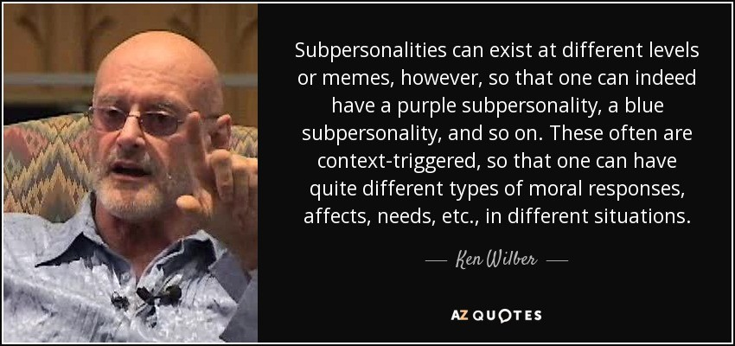
Sages Saints been constantly saying, You need to Evolve, Improve, Increase your Emotional IQ, Stability Internal Happiness.

You Need to Meditate!!

START NOW!!

MONKEYS ARE ENERGY VAMPIRES
The person who is evolutionary lower can never understand the person who is higher and therefore like Jesus Christ they say, "I suppose you think you're really good don't you?" "Well, I'll show you!!" from the story of the Monkey in my commentary on the Yoga Sutras of Patanjali.

FROM THE THREE EVOLUTIONARY TYPES IN DANTES DIVINE COMEDY - GRENOUILLE THE VAMPIRE AS INHABITANT OF DANTES INFERNO - PLATO'S BRONZE SOULS, WITH A DISCUSSION OF DANTES PURGATORY - PLATO'S SILVER SOULS, AND DANTES PARADISE - PLATOS GOLDEN SOULS - THE ILLUMINATED, THE ENLIGHTENED



This very Ancient tale comes from the thousand year old book of spiritual tales, The Panchatantra.

It is good to stay away from monkeys even if you notice just a little of that in their attitude.

One day, I have heard, a little bird poked its head out of its nest and looked out with joy on the world. Its nest was truly a work of art. Much hard work had gone into its construction. There were three stories. The bottom for the stores. The middle for the wife and the children and eggs. The top story had a small hole in the roof to look out upon the world.

As he looked out, he noticed it was raining and at the bottom of the tree he noticed a monkey flapping its arms against its body to keep warm in the howling wind. His heart went out to the poor monkey and he wanted to help. He said "Monkey, why don’t you build a beautiful house like mine? Then you wouldn’t be so cold in the rain."

The monkey raised his eyes to the little bird and said, "I suppose you think you’re clever don’t you?" With that he climbed to the top of the tree and took the nest in his hands. With a "What do you think of that then?" he cast the nest to the ground where it burst into little pieces.

Notice that the monkey is at first looking very sorry for itself. He is playing the "Poor Me" Strategy to attract your attention so that he can take your energy. In this case he changes to the "Violator" Strategy very quickly as he destroys your home.

A MONKEY IS AN EVIL PSYCHOPATH "STAY AWAY FROM EVIL" - CHRIST

We learn how to remove the Poor Me and Violator Strategies in Energy Enhancement Level 3.

THE LUST ARCHETYPE OF THE THOTH TAROT AND ENLIGHTENMENT

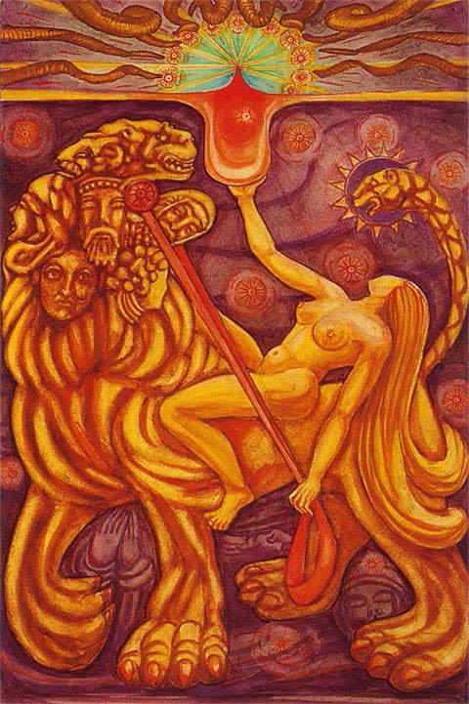

The sacred cup or chalice is collecting the energies of the Soul. The naked before God, lady Soul Infused Personality relaxes back as she Solely follows the Intuition of the Soul - "There can only be One". She controls with her reigns the seven sub-personality talents. She rides the Lion of the Body with its Kundalini Serpent tail base chakra.

The traditional name of this card is strength but its meaning is much more than the word, Strength. Lust means more than vital strength. It includes passion as well as joy and the pleasure of being able to stick to the narrow way, thinner than the edge of a razor. It includes the knowledge that we do nothing. God does everything. In a way it is like Queen Victoria's joke when asked about sex, "I just lie back and think of England". "Not my will, but thy will be done!" - Jesus Christ. That which is done is done through you with the channeled energy of the Soul. A Soul infused personality is an enlightened personality.

A Woman sits on a Lions Back and raises her right hand to the Holy Grail, engulfed in the flames of the Light of the Soul. The San Greal the Sang Real. This Grail or Chalice is filled with the energy of the Soul or Ananda or Bliss or the Blood of Christ which, "Falls as the gentle dew from heaven, upon its place beneath. It is twice blessed, First by he who gives, and then by he who receives." Ascended Master William Shakespeare or Sheiks Pir as he is called in the Sufi idiom. Strength or Lust is the ability to receive that Energy, that Strength which radiates 24 hours a day from the Soul, from God.

This card represents divine intoxication and cosmic ecstasy.

The energy also powers the ego blockages and Deep Energy Blockages which exist within your body and

mind. These are represented by the seven heads which show the head of an Angel, the Head of a Saint, a Poet, an Adultress, an Audacious man, A Satyr, and a Lion Serpent.

As they are empowered, so they become more noticeable, and the Soul Infused Personality notes them as a problem which needs to be restrained. Focusing on the ego problem and the problems which they bring into everyone's lives. This experience of the karma products of the selfish, competitive, sociopathic ego is that which creates the urge to restrain them.

The use of the mind to restraint the blockages. The exploration of the use of philosophies which are more in accord with the will of God like Harmlessness. Seeing the results of those philosophies not in accord with the will of God like Adam Smith's, "Greed is Good" now rejected by Alan Greenspan after the latest stock market bubble crash.

We only enter into Dark Paths because we do not know that they are Dark or that the consequences of entering into these Dark Paths will be so dire. Only experience can give us that knowledge so that this knowledge becomes hard wired in. It is not software changeable.

These blockage talents have been trained, experienced and grown over many lifetimes and are in various stages of purification as the more these talents are mixed with trauma-formed negative karmic mass, the more egotistically selfish and competitive - sociopathic, they are.

Only the Energy Enhancement Seven Step Process shows how to Ground all the Blockage's negative karmic mass - thus purifying them, and then to resurrect them so as to coat the Higher Being Bodies, integrating them into the

Soul or higher which is one of the necessary processes of the Path of Illumination. Thus it becomes Hard Wired in. The Energy Enhancement Seven Step Process is fast. Blockages can be totally purified and sent up for integration with the Higher Chakras in minutes.

When totally purified and Integrated with the Soul, the Past Life Talents become of an Archetypal unfettered power of the original creative order being free of conventional morality and restraining conventional logic. The Thunderstorm Hurricane Original Heart Essence of the Soul is that which points out the Force of Nature of an Illuminated Sage.

As I have said, the inner animal is not tamed and integrated through strife of suppression but with the Grounding of Trauma-Formed negative karmic mass which alone creates acceptance and submission to the Will of God. This Grounding overcomes the old fears and restricting conditioning represented by the folded hands and figures of saints in the background below the beast.

The ten beaming circles scattered behind the woman and the lion depict the Grounding and resurrection of these Past Life talent Blockages - old moral ideals that are resurrected and represented by the ten new circles at the top of the picture in a semi-circle around the Soul Chakra. Ancient talents have been purified and resurrected, sent up to Coat and perfect more the Higher Being Bodies like the Soul or Monad Chakras until the Stage of Enlightenment.

The Crystal Angel Ordered Matrix of the Soul Chakra does not allow entry to the Blockage serpents which surround it on the astral plane as its very order, will only allow integration with Angel Colonies which have been purified of Trauma-Formed Negative Karmic Mass. The Crystal Angel Ordered Matrix of the Soul Chakra beams

out its enlightened energy to all who contact it. The Serpent blockages which surround it are cast out of its aura Buddhafield.

The tail of the Lion is the Kundalini Serpent which helps with the resurrection of the Soul Talents.

The woman faces the urn filled with Fire. She is completely absorbed in the force of the transformation that is inherent in conscious and complete submission which represents the Ancient path of Knowledge and Enlightenment of Yoga. Like the Baul Mystics, "Submission is the Secret of Knowledge" Like Carmina Burana, Dulcissime, "I give myself to you totally"

SUB-PERSONALITY ENERGY BLOCKAGES AND THE BHAGAVAD GITA

The Lust Card of the Thoth Tarot is very much like the image of the chariot of Arjuna and Krishna from the Bhagavad Gita where there is a war between the family of bad Deep Energy Blockages the Kauravas and the family of Good Sub Personalities the Pandavas like Arjuna who represents the Soul infused Personality who serves Krishna, the Soul itself.

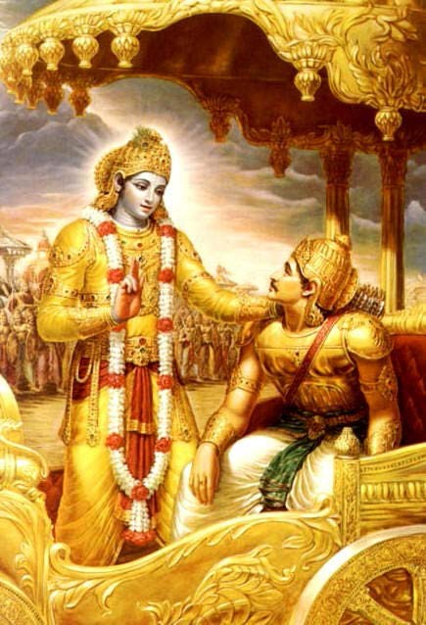
KRISHNA, THE SOUL, ENERGISING THE SOUL INFUSED PERSONALITY OF ARJUNA

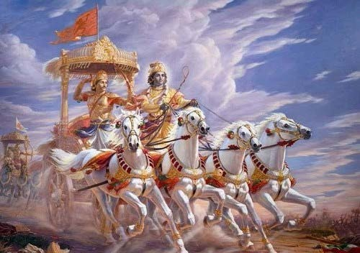
KRISHNA AND ARJUNA PULLED BY THE HORSES OF THE EMOTIONAL SUB PERSONALITIES

INTERPRETATION OF THE CUCKOO, LUST OF THE THOTH TAROT AND THE BHAGAVAD GITA BY SATCHIDANAND FROM LEVEL 3 - THE KARMA CLEANING PROCESS..

Energy Enhancement APPRENTICE LEVEL 3. Initiation 5. THE KARMA CLEANING PROCESS Removing the Strategies

SIMPLY READING BELOW ABOUT HOW OTHER PEOPLE ARE DRAINING YOUR ENERGY WILL HELP TO STOP THESE STRATEGIES FROM DESTROYING YOUR LIFE.

LEARN HOW NOT TO BECOME ENGAGED BY THEIR STRATEGIES TO SUCK YOUR ENERGY.

ENERGY ENHANCEMENT IN LEVEL THREE WILL TOTALLY REMOVE THE STRATEGIES FROM YOU - FURTHER INCREASING YOUR ENERGY, SPIRITUALITY AND PEACE.

Learn how to heal all your childish Thoughtforms, by healing and using the Strategies and Strategy Combinations in order to find the Inner Child Using them.

Learn how to Heal these Selfish Strategies which we All use unconsciously to steal energies from others and which lead us into painful situations which can depress us and which can lead to destructive patterns in our lives.

Gurdjieff and all the Sufi Masters brought recognition of this splitness within everyone to the attention of the Western psycologists. Eventually creating Transactional Analysis and "The Games People play" a book written by Psychologist Eric Berne. The Strategies are also mentioned in the Celestine Prophesy by James Redfield.
ENERGY ENHANCEMENT HEALS SHAMANIC SOUL SPLITS WHO IS IN CHARGE??!!!!

The first Initiation of this healing is intellectually to recognise these Deep Energy Blockages.

STRATEGIES
ENERGY ENHANCEMENT APPRENTICE LEVEL ONE WILL DRAMATICALLY REDUCE THEIR NEGATIVE POWER

However, to remove these Deep Energy Blockages completely, the more Advanced techniques of Energy Enhancement are absolutely necessary:-

TO Totally Remove ALL the Strategies You NEED ENERGY ENHANCEMENT APPRENTICE LEVELS 2 and 3 !!!

THE REMOVAL OF THE ENERGY BLOCKAGES WILL TOTALLY REMOVE ALL THESE STRATEGIES OF THE ENERGY VAMPIRE

SIMPLY READING BELOW ABOUT HOW OTHER PEOPLE ARE DRAINING YOUR ENERGY WILL HELP TO STOP THESE STRATEGIES FROM DESTROYING YOUR LIFE. LEARN HOW NOT TO BECOME ENGAGED BY THEIR STRATEGIES TO SUCK YOUR ENERGY. ENERGY ENHANCEMENT IN LEVEL THREE WILL TOTALLY REMOVE THE STRATEGIES OF THE ENERGY VAMPIRE - FURTHER INCREASING YOUR ENERGY, SPIRITUALITY AND PEACE.

The Energy Enhancement Course, of course, teaches much more than that, but those are the bits, the removal of the Strategies, that are going to transform your life now!!

IT IS SO EASY!!

Take your time, this site has much new wonderful information.

The first part of the course, APPRENTICE LEVEL 1, will reduce their effects.

The THIRD Part of the course, APPRENTICE LEVEL 3, will Totally stop them!!

This is not the true way to gain friends and influence people.

You need to actually see that it might be a good thing to STOP!!

Then you need to find out how.

The Energy Enhancement Course can give you the techniques. You will need to do them!! To put them into practise.

The only way out is to connect to a higher APPRENTICE LEVEL of energy, which can never fail, as we do in APPRENTICE LEVEL One Initiation 4 of Energy Enhancement.

To become Independent.

Then we can comfortably destroy these negative thoughtforms in our lives.

This Energy Enhancement APPRENTICE LEVEL 3 shows the way to do it!!!

IT IS SO EASY!!

Meditation Energy Enhancement is the only course which can show you how to heal all these Deep Blockages and remove these destructive strategies from your life BY ABSORBING THEM BACK INTO THE CENTRAL SOUL PERSONALITY.

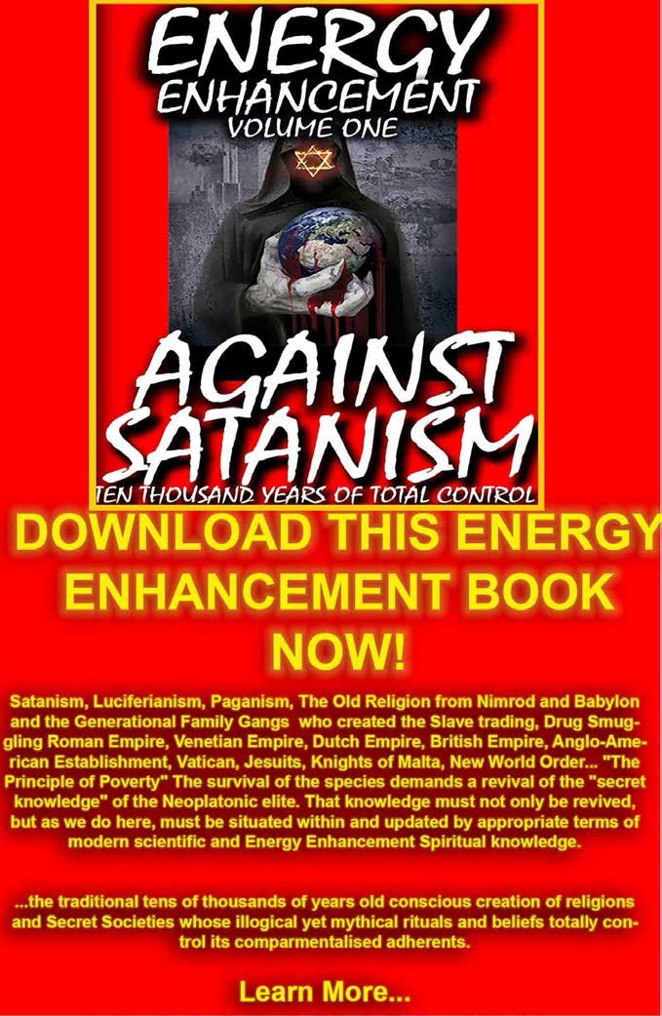

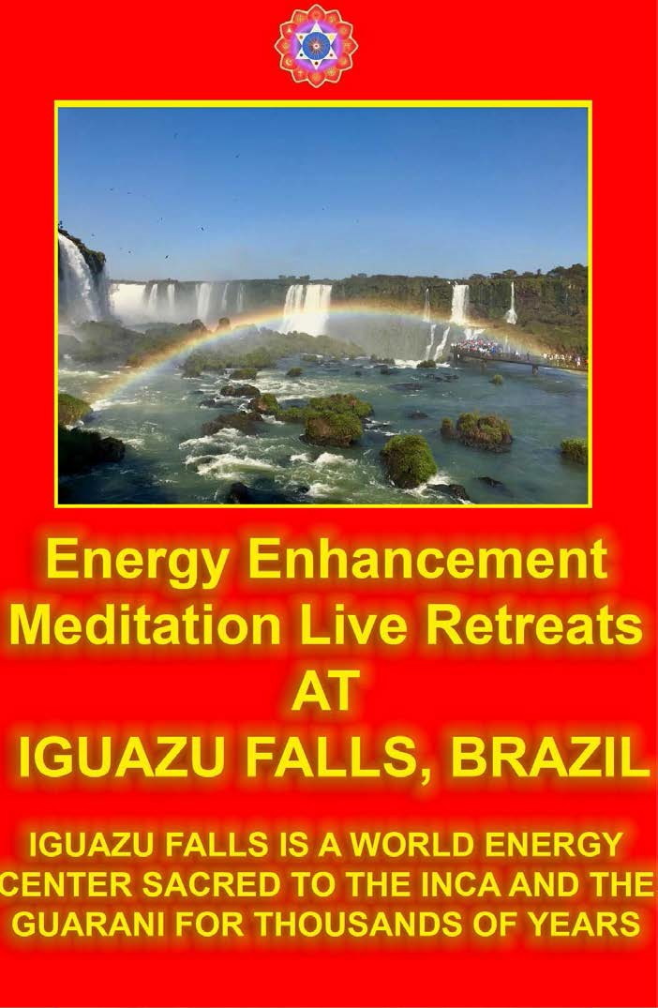

The Correct use of the Strategies
Once, through the use of Energy Enhancement Techniques, the Energy Blockages within the body have been removed, it is possible to consciously choose to use the Strategies to teach, to test, or just to get things done for a good cause.

I remember seeing Swami Satchidananda test out a Yogi one day. He came asking him to sign a piece of paper saying that he personally knew him as a good Yogi. At this Swami became very angry, "You want Me to sign this?!!!" and he started on a very long diatribe. At the time I was trying to deal with my Violator. And this Anger was making me feel very uncomfortable.

As within, So without. We only get upset at that which we also have inside. Otherwise, why get upset? If one finger points, there are always three fingers pointing backwards!!

IT IS ONLY THE EGO WHICH GETS HURT!!

So I interposed myself. I asked a question of Swami in mid flow of his anger. He calmly turned towards me and answered my question with great sweet patience as you would to a child. "Are you satisfied with my answer?" "Yes Swami." He then turned to the Yogi and laid into him verbally, again.

It is through experiences like this, that we see what it is possible to do. And what is necessary to do.

We do not get angry with children, and yet it is necessary sometimes to act angriness, so that we can appropriately exercise them in a strong NO!! Better that a parent gently give a child boundaries. Stop them becoming a spoiled brat. Than the Universe say NO!!, to

them when they are older, when they can become completely crushed by some hard thing, - bereavement or their girlfriend leaving them, perhaps. (Energy Enhancement APPRENTICE LEVEL 4 gives techniques to totally stop the pain of bereavement)

We need to develop a strong emotional IQ.

The techniques of Energy Enhancement are the ONLY COURSE IN THE WORLD FOR the Removal of Strategies and Negative Emotions, and the creation of a strong Emotional IQ!!

We see people working out in the Gym to get very big muscles, to get very strong. And yet, If you say anything bad about these people, they will get uncontrollably angry and chase you around the Gym. Or they will swear undying vengeance and become your mortal enemy.

They are not mentally or emotionally strong.

The removal of the Energy Blockages of the Strategies and the Negative Emotions can give you this mental and emotional strength.

What is the highest spiritual Practise?, "Bear Insult, Bear Injury" - This is the highest Spiritual Practise - Swami Sivananda

ENERGY ENHANCEMENT WILL GIVE YOU A LARGE, STRONGER EMOTIONAL IQ

INTELLECTUALLY KNOW HOW TO RECOGNISE STRATEGIES BUT TO TRULY SOLVE THE PROBLEM, YOU NEED ENERGY ENHANCEMENT

Some people bring unexpected lightness and comfort to your life. They crackle with energy, practically electrify

you with their presence and by that you know you are vampirising their energies.

And then there are those who leave you feeling stressed out. Or guilty. Or exhausted down to your very last molecule. I call them psychopathic energy vampires, and obnoxious or meek, they come in all forms. The sob sister, for one, always considers herself the victim. The world is always against her, and she'll recount every horrible thing that has happened to her, wallowing in every perceived slight. The STAR charmer is a constant talker or joke-teller who has to be the center of attention. The blamer, on the other hand, doles out endless servings of guilt. And then there's the drama queen, the co-worker who claims she almost died from a high fever or the neighbor who lives in extremes of emotion—life is unbelievably good or horrifically bad.

No matter which type of energy vampire you're dealing with, you're allowed to walk away. Many of us find this really hard to do. We're afraid of being thought of as impolite; we don't want to offend people. But there are plenty of ways to remove yourself from a killing conversation. When leaving isn't an option, you can still maintain your energy level by making a few minor adjustments.

Recognize the Signs

One of the first things to do is to recognize when you're being drained, and that begins with tuning in to your physical reactions. Is there a tightening in your chest when a certain person enters the conversation? Do you feel tired when you hang up the phone after speaking with someone? Does your head ache, or do you feel what I call "slimed" when another guest at a cocktail party starts talking to you?

Take a Deep Breath

The moment you feel zapped—or hemmed in, or stressed out—I recommend taking a breath. Breathing is a wonderful way to center yourself. Just follow the breath and tell yourself that you know what's happening and you can deal with it. It's important to remember our individual power. I know from working with patients that we can lose it easily. The minute somebody comes in who's bossy or blaming, we feel diminished and tense up. If we can focus on the breath, or on an image of a striking sunset or a view from a mountaintop, the tension will drift away.

Use Your Energy

You can also use some of your own subtle energy to counter the effects of an energy vampire. Visualize a protective white light around you: an energy shield. You can still hear the person who's yelling at you or blaming you or pushing herself into your sphere, but she won't cut into you so viscerally anymore. You've created a buffer zone, where her negative influences can dissipate.

Set Boundaries

Setting boundaries is another way of protecting yourself; you draw a line saying, for instance, "This is what I can do for you, and this is what I can't." You don't have to convince the vampire of the rightness of your stance. Getting defensive simply adds to the negative charge of the encounter. You want to remain neutral.
When someone starts pushing your buttons, and you start sizzling inside, you've got to make the decision not to react.

Step Back

I also suggest you step back and think about what type of people aggravate you, because I believe that one law of energy is that we attract what we haven't yet worked out in ourselves. If I'm a very angry person, I'll find myself surrounded by angry people. By paying attention to the people who seem so draining, you might discover something you need to address. It has been my experience that once you've worked through a particular issue, you're no longer worn out by that kind of energy vampire. And the vampires, robbed of a source, move on to more easily drainable audiences.

STRATEGIES
"People are more than food to us. They are the texture of our lives."

- Blood Rites, Elaine Bergstrom

Psychic vampires, energy vampires, psionic vampires...all synonymous names for a surprisingly common, physically mortal being who has a craving for and thrives off of the prana (psychic energy) of living things and/or the energy of the universe. Whether you are a psychic vampire yourself, believe you have been or are being attacked by one, or are merely curious...this is the place in which you will find information and a definition regarding psy-vampirism along with help for protecting yourself from attacks, manipulating and sensing prana, and a host of other related topics. Again I should mention that I don't claim to know it all, and religious-theory based rituals contained within this page are merely included as basic methods available...Truth, after all, has many different interpretations. So bearing that in mind, please realize that this page it simply a collection of tips, advice and information from personal and collective experience (by no means extensive, either). It's not the gospel truth...you don't have to

believe it, agree with it or accept it...just read and see what makes sense to you or not, as you see fit, and I hope it sheds some insight and guidance at the very least.

I know, I know...get on with it, you're saying. My, my aren't we impatient...I'm gettin', I'm gettin'....sheesh.

Part I: How Psychic Vampirism Works
Definition of a psychic vampire: A psychic vampire, psionic vampire or energy vampire, is a physically mortal being who has an excessive craving for and who feeds upon prana - psychic energy found in all elements of life. They tend in the psychopathic direction having implant energy blockages in the Heart and above the head, cutting them off from their souls, in varying degrees depending on how bad they are and tend to use Vampire Strategies to suck their victims.

The Psycopathic BDSM Violator Strategy and addiction. Tie me up, tie me down - (and yes, for those of you who caught that reference, Almodovar rules!...anyway...) It's only natural that there's a rush of power that comes with stealing someone's energy. This is the effect of psychic vampirism at it's core.... Psychopathically manipulating someone's life in the palm of your proverbial hand.
Rather than indulge your need for this rush of power with an unwilling victim, some psychopaths find their pleasures in the wonderful world of BDSM. They seek out nightclubs, gatherings and fetish events where they can find someone willing to be submissive to their needs and desires.

A soul sucker places implants to suck energy between the Crown Chakra and the Soul Chakra of his victim.

A succubus or incubus is a person who psychicaly connects to either males or Females to suck their energy whilst their victims masturbate in order to get the energy of their orgasm. Religious tradition holds that repeated intercourse with such a spirit by either males or females (the female version of the incubus is called a succubus) may result in poor eyesight, the deterioration of health, or even death.

Larvae are implants and energy blockages of a certain evolutionary level which live in and parasitise the energy body of the victim creating a lack of energy, disease, and eventually death.

Energy/Prana: Ask any scientist or occultist alike and they will tell you point blank that all matter is composed of energy. It is all around...in ourselves, in the air we breathe, in the food we eat, in the climate we live in...simply everywhere. We all need energy to live and survive, every being on earth. You've probably heard someone say or used the term yourself "I'm full of energy today!" or "I feel so drained, today". Such a remark probably stems from your own subtle awareness of your body's energy balance. We all have the ability to see and/or sense the energy within us, and this ability can be trained and honed in on with practise and skill.
You may have heard people say that they can see or feel auras. Auras are the surrounding glow of your energy as it passes through your body. Energy Vampires are people who think they need to get energy from other people rather than from chakras above the head like the Soul Chakra connected with God. Only the people cut off from the energies of God can feel that they need to vampirise their fellow beings.

Energy flow/Kundalini: Prana, or psychic energy, flows into your body in two streams and circulates through your body's "power circuits" - the Meridians (aka Nadis)

and the Chakras. This flow is known in India as Kundalini. There are 7 main chakras - crown (top of head), Third Eye (forehead), throat, Heart, Solar Plexus (navel/stomach), Sacral (below naval) and Root (base of spine) - as well as the Soul, Monad, logos, Sirius chakras above the head on the way towards the energies of God, as well as the Kundalini Chakra below the Root/Base chakra which exists in the center of the earth, which act as a link between the states of astral ("spiritual") and physical awareness.

Chakras also act as our natural alert system to negative energy around us. For example, If you've ever had a "gut feeling" that something was amiss, this is your solar plexus picking up on negative atmospherics, probably being connected to by the other person in order to suck you.

Likewise, most headaches are formed from increased pressure of negative energy in the third eye. As energy is sucked from chakras beneath the third eye, so the third eye is deprived of its power supply and can not function. This chakra is particularly powerful and perceptive as well, and I should note that some cultures adorn themselves with gems on their forehead in an effort to improve their "third eye sight" (in other words, the perceptiveness of the chakra). As the chakras below the third eye are healed by removing energy connections and energy blockages and implants through meditation and energy enhancement techniques, the lower chakras power the third eye tremendously so that psychic vision becomes normal.

How normal human beings process energy: As described above, prana flows in two streams throughout our body to be circulated around via the chakras and meridians. That prana/energy will be used and replaced depending on need, with the aid of food, rest,

environment, etc...and provided you are fairly healthy, your body will maintain a more or less even level and balance of energy. As you remove all energy blockages, connections and implants so the body comes back to normal.

How psychic vampires process energy: With psy-vamps also, prana flows through the body in two streams to be circulated around via the chakras & meridians. But psychic vampires are like a leaking cup... even they may earlier have been the victim of an energy vampire, in effect, prana will leak out, or be sucked out at weak spots in the aura. In addition to this leaking energy, there is of course also the normal burning off of energy...thus putting added stress on the body's ability to maintain a normal energy balance, and thus also forcing it to compensate by draining the energy from other sources. Some psy-vamps never even realize what they are...but generally, when realization does hit, it is usually following some sort of traumatic event (sickness, puberty, intense stress,etc) when energy levels are at their weakest. In a similar manner to vision questing...this weakness of the body will put the being in better contact with their astral (spiritual) self....often keying the vampire in (through dreams, etc) to their nature. Like abused children, they grow up to be an abuser.

How normal humans Acquire Energy: Energy can be found in the air we breathe which sustains our life, the food we eat which sustains our body, and the rest we take which sustains our soul. The Breathing function is deteriorated by energy blockages in the abdominal chakra. Breathing is an involuntary action and the most essential form of energy we take into ourselves. And our bodies know this....it is why we pass out if we hold our breath too long, so that normal breathing can commence again.

We also need the energy contained in food...without food obviously, we lose our strength, wither away into nothingness and die. And as for rest...if our body suffers from too much activity all at once or goes into traumatic shock, we will slip into a comatose state so that the body can try to slowly regain its energy.

Of course there are other sources we draw our energy from, but these are three prime sources you will most likely be able to directly relate to. The energy we take in is absorbed into our bodies and souls to power our physical organs, our mental process as well as our sense of well-being.

How the vampire can acquire additional energy: First off, it's important to note that anyone can take additional energy through these means if they really wanted to; however, the psychic vampire has an actual need and craving to somehow acquire additional energy....and often, they will do so without even knowing that it is occurring. The most common source to draw from is, of course, another human being....this can occur through eye contact, touch, sexual intercourse, intense conversation, dreams, and yes - even exchanging blood.

Another source to draw energy from is the ionosphere...that level of energy invisible to the human eye which supports ultraviolet, radio, satellite, etc energy waves through connection with energy blockages called implants. If this is the case, then often microwaves, radios, cellphones,etc will tend to malfunction around the vampire because implants can live in the crystals in the processors which power computers and even drain that type of energy - this is often called the "Ghost in the Machine" and is the reason that many computers refuse to work around some people.

Then there is sheer electricity...anything powered by batteries or electrical outlets...watches might stop, tv's and computers may malfunction, etc. And finally...there is the energy of nature to be drawn from...storms, raging oceans, earthly vortices, even intense sunlight. In each case, the vampire reaches out with astral "tentacles" or connections towards its target and pulls in its energy.

Part II: Effects of psychic vampirism
Victims of psychic vampire attacks will suffer different results, ranging in severity. Generally, the victim will feel unusually tired after being around a certain person for some time or following an uncommonly vivid dream (this may be the effect of a psychic vampire connecting to you while asleep), or having an intense and/or traumatic interaction with someone as the Deep Energy Blockages of some people act psychically without the knowledge of the prime personality in order to get even.

You might feel minor headaches to severe migraines...minor stomach upsets to severe abdominal cramping....light heartburn to suffering a stroke....minor fatigue to paralyzing immobility. To those able to see auras, an attack victim's aura is often covered in black splotches sometimes accompanied by black protruding "tentacles" which flow from the victim directly to the psychic vampire. These tentacles are only viewable when the psychic vampire is feeding generally at close distances, however; it should be noted that some exceptionally strong psy-vamps can maintain the link to their victims over great distances and continue to drain, and drain, and drain.... even at the other ends of the earth.

Usually the effect of psychic draining is recoverable with plenty of rest and proper nutrition, and only lasts for a

short period of time. However, if you are in constant contact with a psychic vampire, the effects of psychic draining may become drawn out and increasingly severe, sometimes even resulting in death.

While chances are higher that you will be killed in an airplane crash than suffer to any great extent at the hands of a psychic vampire, people are effected by psychic vampires more commonly than might be expected. Some psychic vampires are aware of what they are doing, but more often than not, the vampire does not even know he/she is draining a victim.

And the horrible thing is, it's sort of a domino effect...the weaker a person is in energy, the less defense the person has from psychic attacks, and therefore the more attractive and easy prey the person becomes to a psy-vamp on the prowl. In essence, it's like spilled blood to a shark...the wounded are first to be attacked.

Fortunately, there are some simple things you can do to protect yourself from becoming a psychic vampire's next walking buffet table. Meditation and protection in the Energy Enhancement Course will help but some energy vampires need the more strong methods of higher initiations of Energy Enhancement in order to stop them.

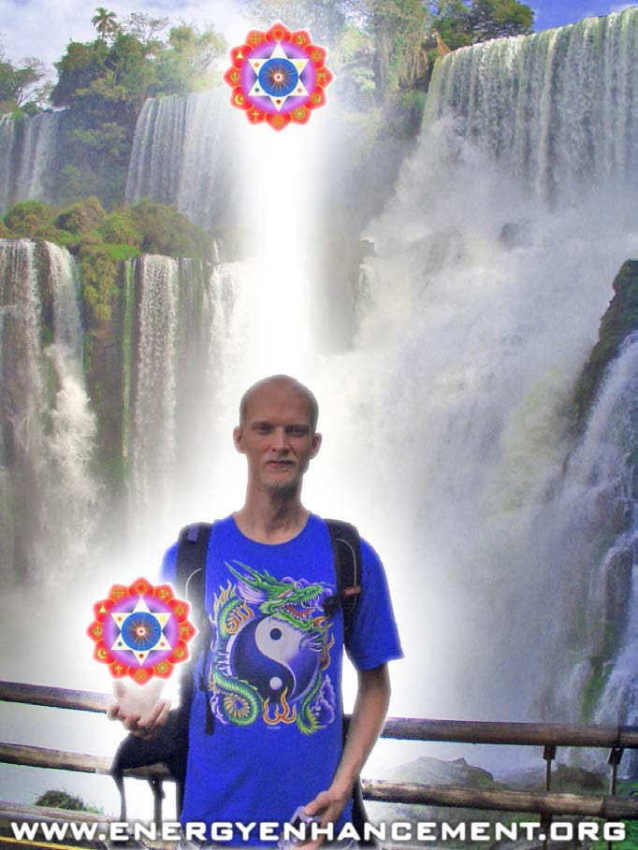

ENERGY ENHANCEMENT COURSE AT IGUAZU FALLS. BRAZIL

"Get your asses over here Now and Speed Up your process of Enlightenment on the Energy Enhancement one month course!!" - DON

Every one of our Students gets this Spiritual Experience of Connection with Infinite Energies.

Energy Enhancement does indeed, "SPEED UP THE PROCESS!!"

And they all get this Experience of Light, Life and Infinite Energy just with the Energy Enhancement Course - Every One of Them!!

LEVEL 1 - 4 VIDEO COURSES ANYTIME IN THE COMFORT OF YOUR OWN HOME

Part III: How to Protect yourself and recover from psy-vamp attacks

The following are some suggestions on how to protect yourself from vampire attacks and/or recover from them.

Awareness: To protect yourself and/or recover from any psychic vampire attack you must of course, first realize you have been or are being attacked. To do this, you must cultivate awareness within yourself. Practising meditation, following any suggestions from "Part IV: How to perceive energy" or just trying to focus and become more attuned daily and in general to your body's subtle reactions to its environment will help to achieve awareness and develop intuiton.

Rest, Eat, and Relax: If you notice the strategies of the vampire in someone. If you feel drained and excessively tired after being around a certain person on rare occasions, and you believe it is because he/she is a psy- vamp, the most effective thing you can do is to stay away from that person, meditate, protect and just sleep, eat and relax. For at least a week or so, keep a regular sleep cycle, eat nutritious balanced meals, and meditate/listen to music/relax. This should help replenish your normal level of energy. Light Exercise in addition to resting, eating and relaxing will also help to build up your natural psychic defense system and boost your energy levels.

Closing the Circuit: If you believe you are being attacked by a psychic vampire at a specific moment and want to block the vampire from feeding, the quickest way to do so is by energy enhancement meditation, protection and

the use of the power towers, pyramid and merkaba protections. The best form of protection is attack, however, we must learn how to transmute and heal our attacker energy vampire.

Aura and Chakra Cleansing: And I don't mean a puppy lick, here, folks....we're talking about some deep down and dirty energy cleansing and Karma Cleaning. The aura, as I've explained is the energy that surrounds your body and as such can be "cleaned" to help the body, mind and spirit to become healthier. The next time you are taking a shower or a bath, take some deep breaths and really make an effort to feel the water against your skin. Visualise that this water is cleansing away all the weak spots you perceive intuitively throughout your body. If you know you are good at meditation, try visualizing your energy and finding out where dark patches may breach the light. If you can actually see auras, you may view long black astral "tentacles" issuing forth from the weak, dark spots in your aura connected to the Energy vampire.

If this is the case, a psy-vamp is probably still attacking you from a distance. You'll need to sever the tie. To do this, imagine the pure light of the universe, the light of your energy issuing in a beam from your fingertips. Use this beam to slice through the tentacles, then allow the water and its energy to wash away the remaining black splotches. You may consider additionally following the advice under "Astral Fortification", listed below.

Astral Fortification: The ability to work with energy comes naturally from a healed psychic body. Once you have cleaned your chakras and your aura, once you have connected with Kundalini and with the energies of God. once you have entered into the Buddhafield of a master of Meditation, then psychic vision and strong protection become easy peasy. This is a method designed for

slightly more advanced students learning about prana. It should be performed as an extension to astral cleansing and meditation, so if you don't know how to do either of these things, learn how under the descriptions above and below. To create a psychic shield for yourself, first you must lead yourself into a state of meditative repose, to the point described under the meditation section of "Part IV: How to perceive energy" as separation between body and spirit and then allowing the light to fill you.
Once you are at that level of meditative state, astrally fortifying yourself is fairly simple.

Part IV: How to Perceive Energy

The following are some common, basic starting points on how to perceive, hone in and recognize the existence of pranic energy. And not all people learn the same, so if one method doesn't work for you...don't give up...try another. And be sure to give this some time, too...like any skill, practise makes perfect...

Meditation: This method I personally believe is the most vital, direct and full-fledged way a person can come to terms with perceiving one's own energy and that of the universe around you. Incidently, the practise of meditation and the methods to do so originates from Hindu sacred scriptures (the aranyakas contained within the 4 Vedas), which have been honed and refined through practise over many centuries by yogis and gurus seeking spiritual enlightenment through detachment from the material world and the self. In this way we learn that we only inhabit the body and that we can exist without it.

Part V: Other Tips, advice and suggestions for psy-vampires

Got Yoghurt? - Did you know that the live cultures in yoghurt are an extra nutritious bonus for hungry psy- vamps? Focus your attention on such gastronomic delights instead of people for awhile, that way you only hurt yourself. Incidently, i've heard this is also a good suggestion for blood vampires to try too.

Walk the middle path - Balance, friend, it's all about balance. Instead of having to bother with constant "quick fixes" that act as a temporary band-aid to your energy deficiency problem, try to get control of yourself with a long-term solution found by seeking to balance and stabilize your energy though ENERGY ENHANCEMENT meditation.

Energy Enhancement APPRENTICE LEVEL 3. Initiation 6 THE SEVEN STEP PURIFICATION OF TRAUMA-FORMED NEGATIVE KARMIC MASS IN TALENTS AND THE CREATION AND INCREASE OF TALENTS OR ANGEL TALENT COLONIES IN LEVEL THREE OF ENERGY ENHANCEMENT

The Energy Enhancement Level 2 Seven Step Process Purification of Talents...

The Seven Deadly Sins and their Purified Talent - Pride - Humility, Avarice/Greed - Generosity, Envy - Love, Wrath/Anger - Kindness, Lust - Self control, Gluttony - Faith and Temperance, Sloth - Zeal, and the Hindu Yamas -- Ahimsa - Nonviolence. Abstinence from injury, harmlessness, the not causing of pain to any living creature by thought, word, or deed at any time which is the main talent, all others being a support to Ahimsa - Not giving Pain in word, thought or deed as it is pain which causes Trauma-Formed Negative Karmic mass which mixed with the talent causes it to go against the Will of God, To Sin, to create Karma, Bad Luck and Misery for all.

Satya - truthfulness. Asteya - non-stealing. Brahmacharya - Mastery over the connection with Brahma or God, the one God with 10,000 names. Kshama: patience. Dhriti: steadfastness, sticktoitness. Daya: compassion. Arjava: honesty. Mitahara: moderate appetite. Shaucha; purity. Aparigraha - Non-Stealing, and the Hindu Niyamas - Hri: remorse, shame. Santosha: contentment. Dana: giving, without thought of reward.
Astikya: faith, believing firmly in the teacher, the teachings and the path to enlightenment. Ishvarapujana:

worship of the Lord. Siddhanta shravana: scriptural listening, studying the teachings and listening to the wise of one's lineage; Mati: cognition, developing a spiritual will and intellect with the guru's guidance; Vrata: sacred vows, fulfilling religious vows, rules and observances faithfully; Japa: recitation, chanting mantras daily; Tapas: the endurance of the opposites; hunger and thirst, heat and cold, standing and sitting etc. Shaucha: in the traditional codification, this item is listed under Yamas; this word means purity. Santosha: contentment. Tapas: austerity. Svādhyāya: self-study or study of spiritual scriptures.

Ishvarapranidhana: self-surrender to the will of God - the One God with 10,000 names... "Not My Will, But Thy Will Be Done" - Jesus Christ.

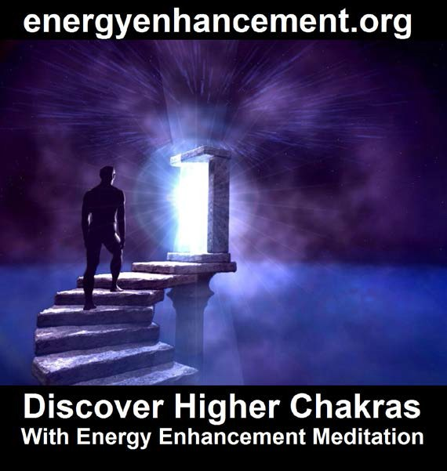

Humans are made up of connected and networked nodules of angel talent colonies. In the same way that chakras are angel talent colonies or groups of angels which have been brought together, purified and aligned so that the processor function can be done with the minimum of problems.

So, what is an Angel Talent Colony?
If you think that a human evolves from single celled creatures to multi-celled creatures, and the organs like the liver or the kidneys or the brain are multi-celled organisms performing a defined function within the whole.

The liver metabolises fats in the digestion of food. The Kidneys filter impurities from the blood. The Brain orchestrates all the functions and also contains the intellectual function within its network of nerves and ganglia.

So, an angel is like a single cell, and as little angels combine together, so they form the intellectual character functions which a human being needs.

This creation and growth of talents takes approximately 100 lifetimes in which the human goes through the process of karma which teaches it the necessity of purifying the talents of its mixed in Trauma-Formed Negative Karmic Mass so that use of the talents do not go against the Will of God. Karma means that what you give you eventually receive back. Everything which you have done comes back to you. Karma is an impersonal law which teaches that the giving of Pain by word thought or deed never works. Eventually comes the final lifetime in which Energy Enhancement Spiritual Techniques teach how to purify the talents by removing

all Trauma-Formed Negative Karmic Mass from the talent so that it aligns with the Will of God, perfectly.

"Karma which is yet to come can be avoided" - The Yoga Sutras of Patanjali. Energy Enhancement Teaches techniques to align with the Will of God and remove all Karma which is to come by the Energy Enhancement Grounding of Negative Karmic Mass... True Forgiveness.

Angel Talent Colonies channel spiritual energy and form processor functions like leadership, energy, conscience and IQ. As Angel Talent Colonies grow they form Human beings who then evolve to become an Archangel in charge of a Planet or a Star.

Usually, evolution means that the talent colony has grown large enough and aligned enough - like an ordered crystal - to handle the energy it is meant to channel. Also evolution means a purification of the angel colony and an integration of that colony with the higher chakras outside the body.

Evolution is a Mind Fusion of the Angel Talent colonies and the chakras with the Higher Chakras, the Soul, the Absolute which only occurs after the lower chakras and talent colonies are purified of the energy of Trauma Formed Negative Karmic Mass. Trauma Formed Negative Karmic Mass pollutes the angel talent colony and makes it capable of doing things against the will of God.
Trauma Formed Negative Karmic Mass is the cause of all sin.

It is the seven Step Process of level 2 of Energy Enhancement which goes into detail of the techniques to Ground the Trauma Formed Negative Karmic Mass and then Resurrect the Angel Talent Colony to Align and the Fuse with the higher chakras.

When I am talking about Angel talent colonies, I am talking about the Archetypal Functionality like Jungs Archetypes, Astrological Archetypes and Archetypal Aspects and the Archetypes of the Thoth Tarot.

As well as the Strategies of Level 3 of Energy Enhancement.

As well as not doing the seven deadly sins...

Vice | Virtue Against Which it Sins | Brief Description
Pride | Humility | Seeing ourselves as we are and not comparing ourselves to others is humility. Pride and vanity are competitive. If someone else's pride really bothers you, you have a lot of pride.

Vice | Virtue Against Which it Sins | Brief Description
Avarice/Greed | Generosity | This is about more than money.  Generosity means letting others get the credit or praise. It is giving without having expectations of the other person. Greed wants to get its "fair share" or a bit more.
Envy | Love | "Love is patient, love is kind…" Love actively seeks the good of others for their sake. Envy resents the good others receive or even might receive. Envy is almost indistinguishable from pride at times.

Vice | Virtue Against Which it Sins | Brief Description
Wrath/Anger | Kindness | Kindness means taking the tender approach, with patience and compassion.  Anger is often our first reaction to the problems of others.  Impatience with the faults of others is related to this.

Vice | Virtue Against Which it Sins | Brief Description
Lust | Self control | Self control and self mastery prevent pleasure from killing the soul by suffocation.  Legitimate pleasures are controlled in the same way an athlete's muscles are: for maximum efficiency without damage. Lust is the self- destructive drive for pleasure out of proportion to its worth. Sex, power, or image can be used well, but they tend to go out of control.

Vice | Virtue Against Which it Sins | Brief Description
Gluttony | Faith and Temperance | Temperance accepts the natural limits of pleasures and preserves this natural balance. This does not pertain only to food, but to entertainment and other legitimate goods, and even the company of others.
Sloth | Zeal | Zeal is the energetic response of the heart to God's commands. The other sins work together to deaden the spiritual senses so we first become slow to respond to God and then drift completely into the sleep of complacency.

As well as the Things to do and the things not to do like the Yamas of the Yoga Sutras of Patanjali like Harmlessness and Non - Stealing..

Ten Traditional Yamas

The ten traditional yamas are:

Ahimsa (������): Harmlessness, Nonviolence. Abstinence from injury, harmlessness, the not causing of pain or Negative Karmic mass to any living creature in thought, word, or deed at any time. This is the "main" yama. The other nine are there in support of its accomplishment.

Satya (����): truthfulness, word and thought in conformity with the facts.

Asteya (������): non-stealing, non-coveting, non- entering into debt.

Brahmacharya (����������): Mastery over the connection with Brahma or God, the one God with 10,000 names which causes Mastery over all talent functions - divine conduct, continence, celibate when single, faithful when married.

Kshama: patience, releasing time, functioning in the now.

Dhriti: steadfastness, overcoming non-perseverance, fear, and indecision; seeing each task through to completion.

Daya: compassion; conquering callous, cruel and insensitive feelings toward all beings by the ability to put yourself in their place.

Arjava: honesty, straightforwardness, renouncing deception and wrongdoing.

Mitahara: moderate appetite, neither eating too much nor too little; nor consuming meat, fish, shellfish, fowl or eggs.

Shaucha (���): purity, avoidance of impurity in body, mind and speech. (Note: Patanjali's Yoga Sutras list Shaucha as the first of the Niyamas.)

Five yamas of Patañjali

In the Yoga Sutras of Patañjali, the yamas are the first limb of the eight limbs of Raja Yoga.
They are found in the Sadhana Pada Verse 30 as: 1. Ahimsa (������)
2. Satya (����)
3. Asteya (������)
  - Brahmacharya (���)
  - Aparigraha (��������): absence of avariciousness, non-appropriation of things not one's own.

The Ten Traditional Niyamas are:

Hri: remorse, being modest and showing shame for misdeeds;

- Santosha: contentment; being satisfied with the resources at hand - therefore not desiring more;
- Dana: giving, without thought of reward;
- Astikya: faith, believing firmly in the teacher, the teachings and the path to enlightenment;

- Ishvarapujana: worship of the Lord, the cultivation of devotion through daily worship and meditation, the return to the source;
- Siddhanta shravana: scriptural listening, studying the teachings and listening to the wise of one's lineage;
- Mati: cognition, developing a spiritual will and intellect with the guru's guidance;
- Vrata: sacred vows, fulfilling religious vows, rules and observances faithfully;
- Japa: recitation, chanting mantras daily;
- Tapas: the endurance of the opposites; hunger and thirst, heat and cold, standing and sitting etc.

In Patanjali's Yoga Sutras, the Niyamas are the second limb of the eight limbs of Raja Yoga.
They are found in the Sadhana Pada Verse 32 as:

- Shaucha: in the traditional codification, this item is listed under Yamas; this word means purity.
- Santosha: contentment.
- Tapas: austerity.
- Svādhyāya: self-study or study of spiritual scriptures.
- Ishvarapranidhana: self-surrender.

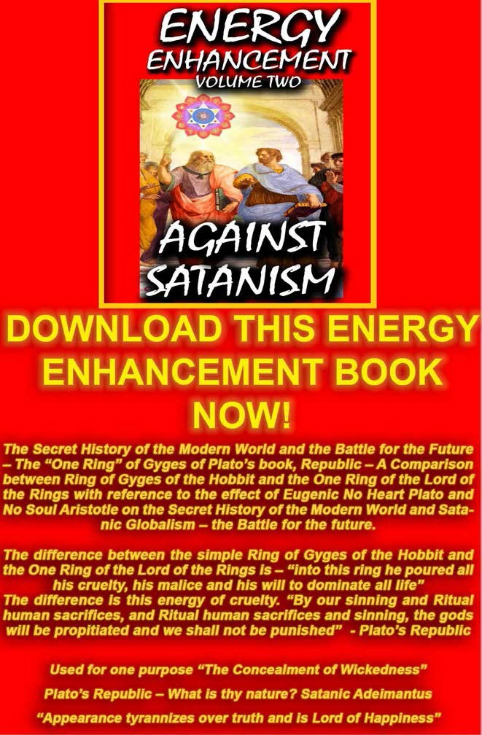

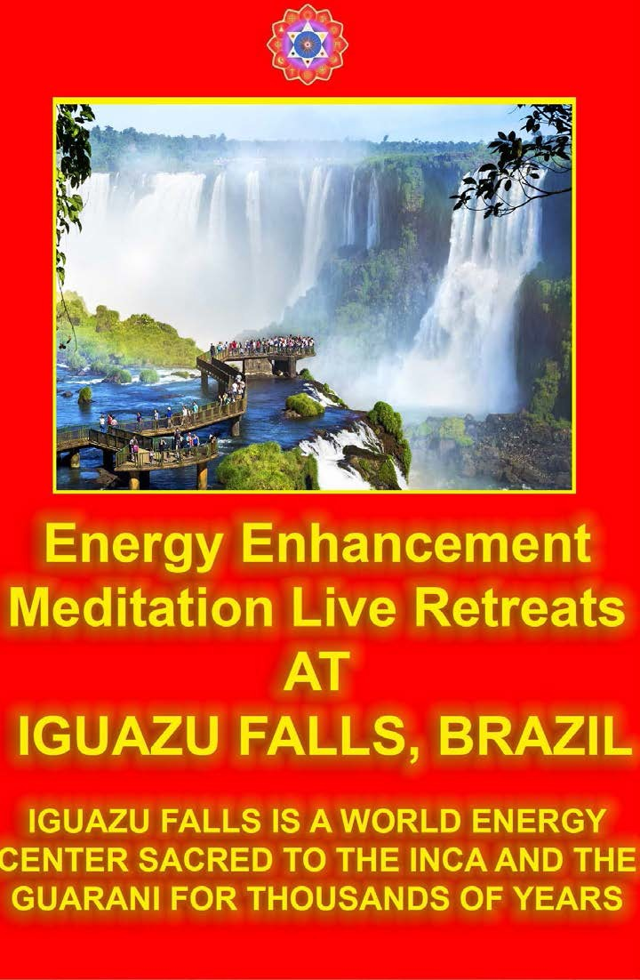

THE TALENTS
Talents created in past lifetimes can be addictive because of Trauma-Formed Negative Karmic Mass which contaminates all unpurified Angel Talent Colonies. All of our wealth and enjoyment come from those talents.
Because we have practised them for many lifetimes we become very good at them. Because of that we do not need to learn or do anything else - we are very successful with them - we become addicted to them -it stops our growth. We use them addictively to the detriment of everything else in our lives. Unpurified talents always are used egotistically - only for our benefit and against the benefit of everyone else, selfishly and usually end in a bad way. Our Energy Enhancement task is to purify, remove the negative Karmic Mass from each of our talents which so trap us. Then we can use the talent appropriately for our benefit and the benefit of all - the commonwealth. "The Lord have mercy on those who get what they want" - Ancient Hindu saying.

Leadership can be purified - The King - who wants to be in charge. The Professional - who wants his place in society. The Businessman - who wants money and misery. The Musician - who wants to channel the source or who needs adulation. The Prostitute - who wants to seduce and to please. The Administrator - who manages. The General - who wants to maintain security or be a dictator. The Priest who wants to save souls or be like Torquemada. The Collaborator - who wants to help all the above.

The removal of Trauma Caused Negative Karmic Mass allows all talents to be in alignment with the Will Of God
- the One God with 10,000 names...

On the path of understanding that we only have the Free Will to do the Right Thing.

If we use our Free Will to do the wrong thing, the result is Karma, Bad Luck which returns to us impersonally from the Absolute.

So, part of our practise in Energy Enhancement is the purification of these Archetypal talent colonies and the fusion of these colonies into the higher chakras for integration and alignment so that the talent can only be used in alignment with the Will of the Absolute.

This process is a forgiveness of past karma through grounding the Negative Karmic Mass of the talent which will give a desire or aversion for doing the talent and a redemption of the talent as we fuse it into alignment with the higher chakra so that it can only in future be used in alignment with the will of the whole.

So, this 6th Initiation of Level 3 will enable us to enter into a process whereby we purify all these talents, One by One!!

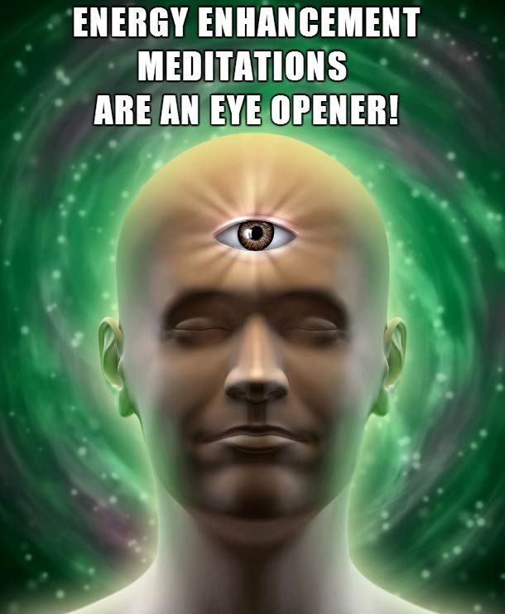

Energy Enhancement APPRENTICE LEVEL 3. Initiation 7

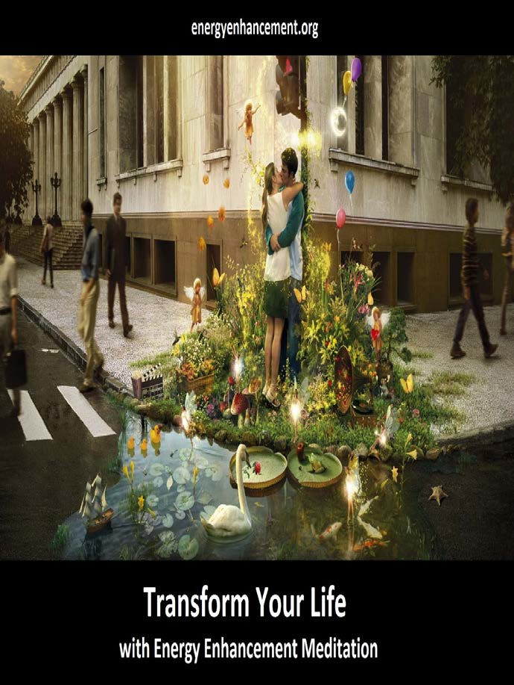

REMOVING VOWS FROM THIS LIFE AND ALL YOUR PAST LIVES

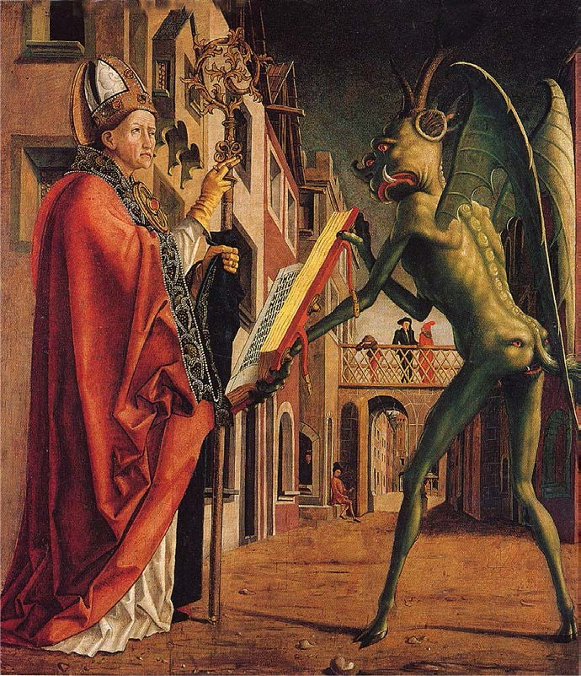

Past life priest vows and vows to the dark side can affect present prosperity, self worth, and relationships. And they can continuously block you, and be carried from life time to life time. All Old Souls carry them and most have thousands of them buried in their minds. This Energy Enhancement Initiation method removes the blocks that are held deep within your subconscious mind. Traditional therapies cannot remove them.

What do the vows have to do with you and your life? In another life time, you might have been a member of a very strict religious or satanic order, where you took vows against sex, marriage, prosperity, or personal freedom and identity.

These old vows could still be affecting you subconsciously, in this life. Priest vows are very powerful vows, as they were highly charged emotionally through the threats of punishment by the various religious orders. If a priest, or priestess, broke a vow, the punishment could include banishment, torture, and even death. To be banished from a safe order, where shelter and food was provided, into a culture where it was difficult to find food, the result would surely be death by starvation.

Other lives, beyond the religious priest lives, and satanic black magician lifetimes could also be laced with strong vows. If you were a father who lost his family at the hands of another clan, you might take a vow of revenge, until each person who had taken the lives of your loved ones, were killed. This vow also would be carried from life time to life time, buried deep in the subconscious mind.

There is more.

Subconscious vows to cloistering, can keep you away from others, or from making friends.

Vows to celibacy can cause problems with relationships, and connecting with your own sexuality. Celibacy vows can also cause failure in a marriage through divorce.

Vows to poverty can affect your ability to attract, or keep wealth, to find work, or to be successful in life.

Vows of self-punishment can cause you to subconsciously create pain and chaos in your life and can also cause diseases and accidents.

These vows can be removed by this Energy Enhancement Initiation.

Energy Enhancement shows you how to clear your subconscious mind of vows to be removed from your subconscious, also known as the Akashic Records, or the records of your past-lives and memories using a time line. In a matter of a few seconds, they are removed as though they never existed at all.

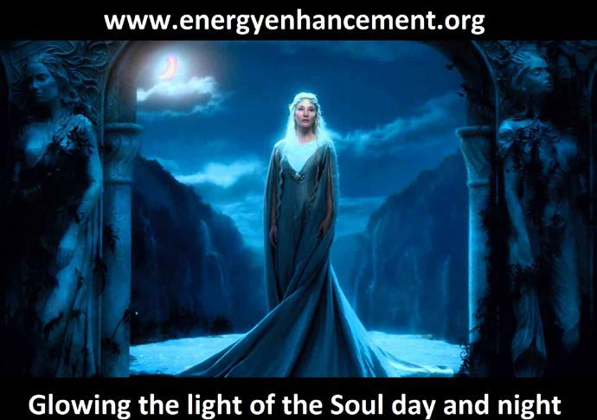

Some Of The Subconscious Past-Life Vows

- VOWS OF CLOISTERING (Keeps You Alone, And Isolated)

- VOWS TO TARNISH OTHERS (Can Cause You To Hurt Others)

- VOWS TO RE-ESTABLISH VOWS

- VOWS OF TIME LIMITATIONS (Causes Stress In Getting Things Done On Time)

- HIDDEN VOWS

- VOWS TO THE PRIESTHOOD (There ARe Usually Thousands Of These)

- VOWS OF POVERTY (Causes Money Problems)

- VOWS TO DESTROY

- VOWS TO CELIBACY (Causes Relationship Problems & Guilt)

- VOWS TO FAILURE (Causes Blocks On Career)

- STARVATION VOWS (Can Cause self-inflicted Starvation, anorexia, bulimia)

- CROSS VOWS

- VOWS AGAINST GOD (Causes Blocks On Connecting With Spirit)

- VOWS AGAINST SPIRIT (Causes Blocks On Connecting With Spirit)

- VOWS TO TAKE POWER (Cause One To Be Overly Competitive)

- VOWS TO OVER-ACHIEVE (Causes One To Be A Workaholic)

- AS THE WIFE OF JESUS (From Nun Lives)

- VOWS TO INCARNATE (Keeps You Coming Back To Earth)

- VOWS TO SUCCUMB (Keeps You Away From Your Own Power)

- VOWS TO SELF DESTROY

- VOWS TO REVENGE

- VOWS OF A DEATH WISH (Causes Suicide)

- VOWS TO PROTECT (The Knights Of Old Took This Vow)

- SACRIFICIAL VOWS

- TO QUESTION GOD

- TO SELF FLAGELLATION (Causes Self Harm)

- VOWS OF SILENCE (Causes Fear Of Talking, Public Speaking)

- VOWS OF SELF PUNISHMENT (Causes Problems In All Areas Of Life)

- VOW OF OBEDIENCE TO THE PRIESTHOOD

- VOWS OF OBEDIENCE TO PARENTS (Causes Blocks On Identity)

- SLAVE VOWS OF OBEDIENCE

- SELF PUNISHMENT THROUGH BAD JOBS (Causes Repeated Bad Jobs)

- TO BLOCK THE CREATIVE FORCE

- VOWS TO NEVER LOVE AGAIN (Blocks A True Love Relationship)

- VOWS TO ENJOY OWN SUFFERING (Causes One To Create Harm In Their Life)

- MARRIAGE TO GOD BOTH - PRIEST/PRIESTESS

- TO TAKE OUT KARMA ON THE BODY (Can Cause Disease Or Accidents)

- VOWS FOR THE BODY TO SELF DESTROY (Can Cause Diseases)

- VOWS TO BLOCK CREATIVITY

- VOWS NOT TO BE A HEALER (Can Cause A Healer To Fail)

- NOT TO USE HEALER'S TOOLS (Can Cause Blocks On Healing)

- VOWS AGAINST MARRIAGE (Can Keep You From Getting Married)

- TO DEATH/SUICIDE FOR BREAKING VOWS

- VOWS NOT TO ACCEPT POSITIVE CHANGE (Can Cause You To Block Change)

- TO MANIFEST SICKNESS AS A GIFT (Can Cause Disease)

- VOWS TO RE-CLAIM PROGRAMS

- *** VOWS TO BLOCK: GOD, SPIRIT, Ascended MASTERS, SILENT ONES, GUIDES, ANGELS, NAMELESS ONES, SAINTS, SAVIORS, HEALERS, HEALING ENERGIES. (These Are The Main Blocks On Spirituality).

- VOWS TO HURT CLAN MEMBERS

- VOWS TO SATAN

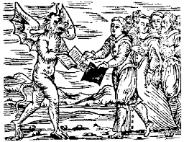



Vows #47 and #49 are the most critical of all of the vows to be removed. With this blockage in place, you are subconsciously blocking the help from Spirit and your own Guides. Even if you ask for help, you might block it with your own subconscious mind, the second after you ask. Many people have a vow against their own Guides,
God, and Spirit. This vow comes from very bad times, when you might have lost a loved one, for example, and you cursed God feeling that there was no justice in life like Dracula when he was told his wife had committed suicide whereupon he took the vow to become a black magician - "The Blood is the Life!!" as many people have done in past lives and now forgotten.

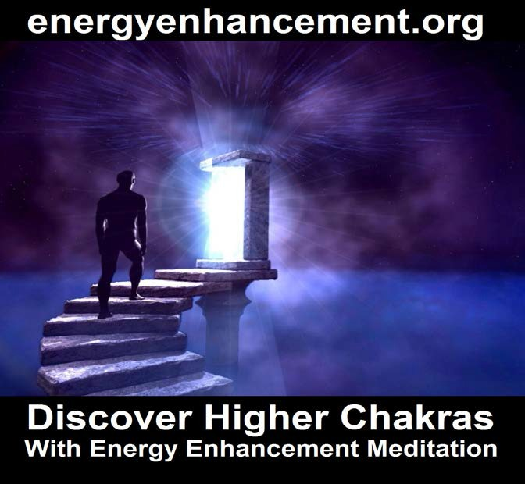


The Distributor of implant energy blockages - Astral factories for implant blockages permanently connected into the antahkarana

The vows to Satan to be bad, to be a dark worker forever, often takes the form of being a distributor of implant energy blockages - Fear Blockages, Sexual Addiction Blockages, Drug Addiction Blockages, etc If this is the case, astral factories for each of these implant blockages will be permanently connected into the antahkarana below the root with pipes to constantly push the implant energy blockage seeds into the antahkarana for distribution. These entrance pipes will be protected by sub-personalities and pact-demons consciously placed there to protect the entrance.

After the Vow Clearing Initiation we show you how to place Thoughtforms of SELF LOVE and OF LOVE AND SERVICE TO OTHERS. These New Thoughtforms Replace The Old Vows That Are Removed. This is called IMPRINTING. Imprinting is the placement of positive beliefs, feelings, and energies, in the space where the vows previously were. Nature will not have a vacuum. If we do not fill the space with something positive the Mind will go behind us, and fill the empty space with more negativity. This is what happens, with traditional counseling. The therapists at the present time, do not have a way to place positive symbols, beliefs, or feelings into the void, that the therapy makes. And, in fact, most psychologists are not even vaguely aware of this problem.

One without the other will not survive. You must first remove the old vows blockages and then re-enforce the positive thoughtforms.

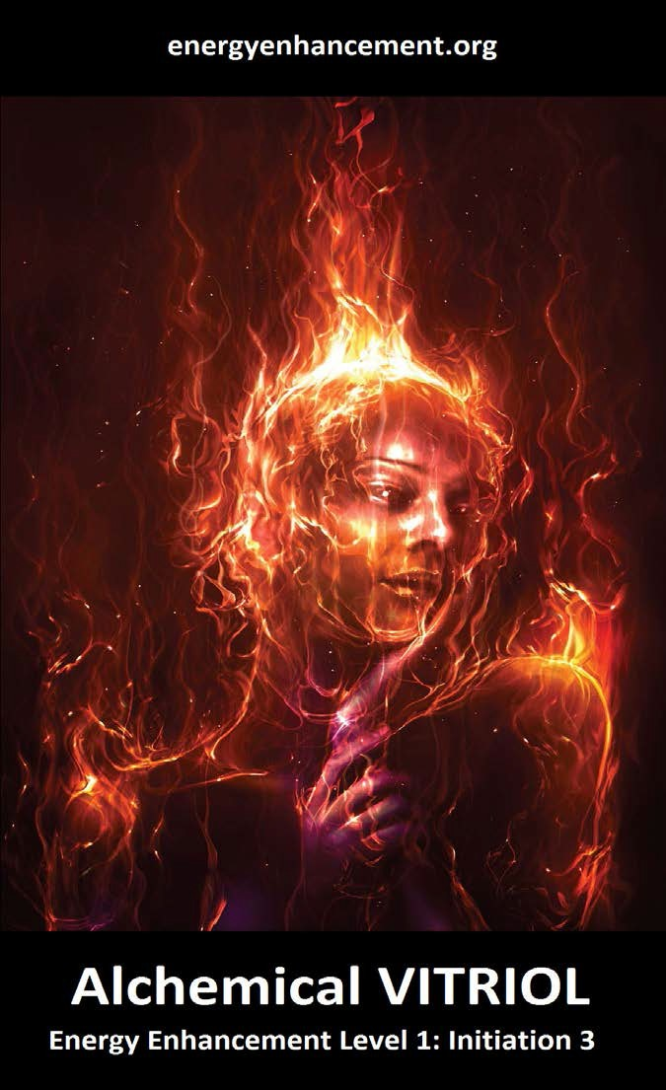

KARMA CLEARING, SOUL SPLITS AND ENERGY ENHANCEMENT

The recapitulation of life force is the body of work in Energy Enhancement Level 3, which restores or recapitulates lost life force. KARMA CLEARING AND SOUL SPLITS is one of the most effective practices to this end. To understand how recapitulation practices work, we need to look at the multidimensional nature of reality and move away from a linear sequential perspective.
From this expanded perspective, 'anything which has ever happened to anybody, anywhere; it is still happening somewhere'.

If a traumatic event occurred for a person ten, twenty and so on years ago, for that person it is still happening, and I would venture to state that it is also in some way still influencing the person's life in the form of Soulless Sub-personalities.

Traumatic events in past lifetimes have also created many Soulless Sub-personalities which continuously sabotage your life.

Energy Enhancement does not dwell on past events because of Energy Enhancement techniques to Ground Negative energies; there is only this vast awesome ever- moving great moment of now where there is no separate past, present, or future. It is possible for a practitioner to journey and move outside of linear time to go to the place where that energetic event is still occurring for that individual, find and bring back that person's life force which is held in that Soulless Sub-personality energetic event and remove all of the negative energy and negative emotions associated with that event, and when this has been carried out, then the therapeutic healing of the event is completed there are no other effect. The trauma has simply disappeared

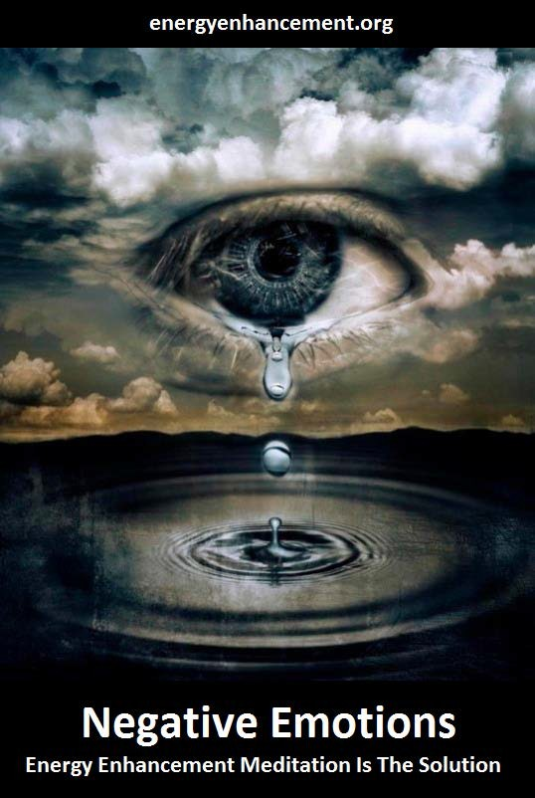

The loss of life-force is known as soul-loss, and this can take place when we suffer a trauma, have an accident, experience strong emotional exchanges with a loved one, separation from a partner, death of a loved one, go through a pervasive period of difficult circumstances.
When we undergo a severe trauma typically a part of our vital nature goes away to form a Soulless Sub- personality, so that we can survive what ever is happening to us. It is a way for the body and consciousness to survive severe trauma. Problems develop when the Soulless Sub-personality, soul part or fragment does not return. The Soulless Sub-personality may not want to come back, or may not be able to rejoin the Soul by itself due to the nature of the trauma A part of the soul splits off into what we call an Inner Child Soulless Sub-personality which perpetually thenceforth sabotages everything we do. Indeed the Soulless Sub- personality Inner Children are a major part of the selfish competitive ego. As we love and heal the Soulless Sub- personality inner child then absorb it back into our soul so the split disappears and we become more whole.
There can only be one!! And that is the Soul Infused Personality.

Energy Blockages all derive their power from these Soulless Sub-personality Inner Children splits. And their symptoms come out in many different ways. There are a number of symptoms of Soul Splits, for example, when people feel that they are observing life as an outsider, rather than engaging and being fully involved. Other common symptoms are when people feel that they are being ‘spaced’ out a lot of the time, not really here as the Soulless Sub-personality is doing the work and not the Soul infused personality. Other symptoms that indicate possible soul loss are life-themes such as a pervasive fear, inability to trust people. I have also found that a severe depression can also be a symptom of soul loss. Chronic illness may also be a symptom of

soul loss. This directly relates to Power. In the Energy Enhancement worldview, power and maintaining health go hand in hand, if the body is power-full, there is no room for illness or disease, which are often regarded as an invasive force.

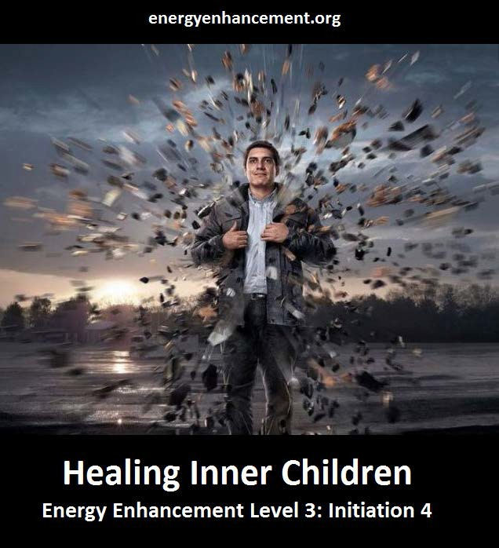
In my practice I have worked with many people who had done considerable work on the original trauma, but still were stuck in this. One of the differences between KARMA CLEARING AND SOUL SPLITS in Energy
Enhancement Level 3 and some modern Western psychological systems is that KARMA CLEARING AND

SOUL SPLITS focuses on the return and integration of the lost life-force - the Soulless Sub-personality, rather than focus on the original trauma itself.

In my view the energy enhancement work of KARMA CLEARING, SOUL SPLITS and therapy work very well together, the best combination being first the dissolving of the negativity associated with the event in Energy Enhancement Level 3 and then come the recapitulation of the lost Soulless Sub-personality life-force, followed by a therapeutic approach to support the person through the process of working with the lessons learnt so that the bad event can never happen again. In Energy Enhancement Level 3 there are no released feelings and emotional energy which can be uncomfortable and even raw for the individual.

In Energy Enhancement Level 3 the negative energy is dissolved and Grounded through the Meditative techniques of Energy Enhancement. This dissolution of negative energy and negative emotions is a fundamental part of the whole healing process, and I cannot stress this enough.

This healing process leads to what I call the union of the life force, - there can only be one soul infused personality - when the person can then move forward in their life without being anchored to the past, and live a life of creativity and productivity.

ENERGY ENHANCEMENT WORK WITH ENERGY BLOCKAGES

This body of work addresses illness as an 'invasive external force' - Trauma formed Energy Blockages within the human field of energy. Energy Enhancement Teachers teach their clients the gift of being able to perceive and discern these intrusive forces, whether a physical illness or an external negative influence in the clients life. We teach how to work with Energy Enhancement Advanced Techniques to gain an understanding of the nature and cause of the problem and to ‘extract’ it’s energetic matrix or sever the link between the client and an external negative and harmful force.

THE OUCH!! LIST
Anything which triggers you is an energy blockage!!

Anything which makes you go OUCH!! is an energy blockage!!

So when you get triggered by anything, put it on the list and integrate the inner child who is complaining, using Energy Enhancement techniques.

Perhaps you can remember times you were triggered in the past.

Put them on the list.

But better "You are the only one who can make me angry!!" - these are good people to stick around - very productive of your triggers!!

This is the function of the Buddhafield.

It occurs in every Ashram.

As Swami Satchitananada said, "There are the outpatients, but when you are in the Buddhafield, you are an inpatient - For the Operation of the Egodectomy!!"

This is Advanced Energy Enhancement Training after completing the Four Video Levels of Energy Enhancement in the comfort of your own home.

For Enlightenment only occurs when All the Energy Blockages have gone.

Love and Light, Satchidanand

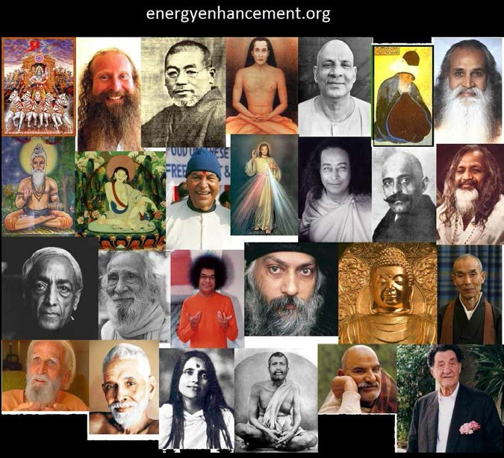

LIVE AND STREAMING ENERGY ENHANCEMENT COURSES

INDIVIDUAL LIVE ENERGY ENHANCEMENT COURSES IN IGUAZU AND INDIA

PLUS - VISIT IGUAZU FALLS IN BRAZIL OR ARGENTINA!!..



ENERGY ENHANCEMENT - THE ULTIMATE MEDITATION COURSE!

LIVE COURSES IGUAZU FALLS, BRAZIL

LIVE COURSES IN HOTELS IN SEVEN STAR INDIA, CARIBBEAN, GREECE

FIND ALL THE INCREDIBLE MEDITATION TECHNIQUES AND MEDITATION PRACTISES REMOVED FROM TRADITIONAL MEDITATIONS AND TAUGHT IN THE ENERGY ENHANCEMENT STREAMING VIDEO MEDITATION COURSE AND LIVE MEDITATION RETREATS IN BRAZIL AND INDIA

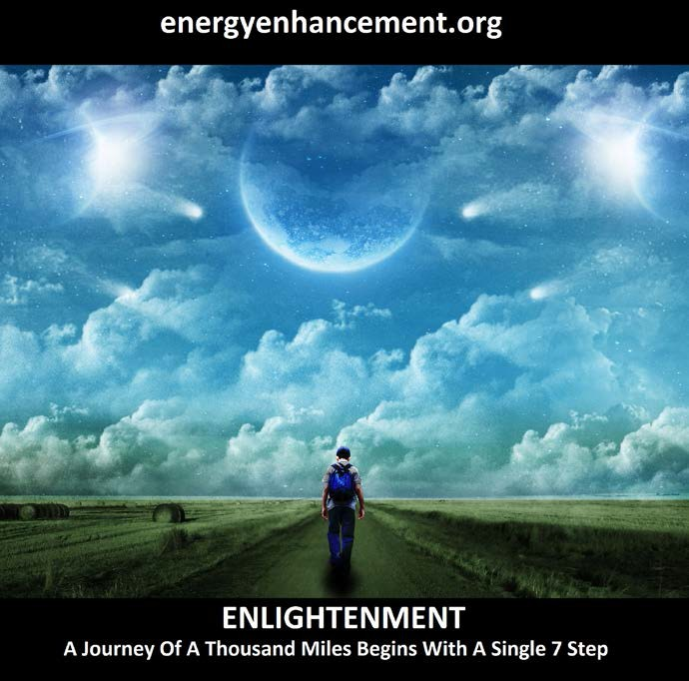

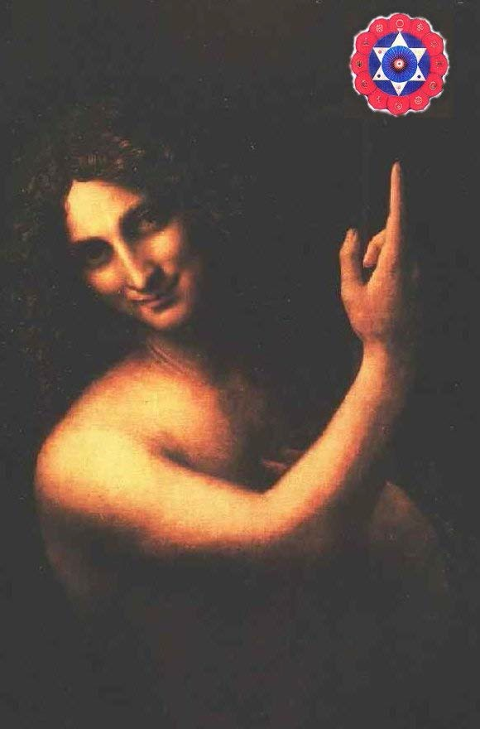
The Synthesis of Light Symbol

THE ENERGY ENHANCEMENT BOOK SUPER ENERGY AND SACRED SYMBOLS COLOUR PDF DOWNLOAD - CLICK HERE!!

GAIN ENERGY - POWER UP!! WITH ENERGY ENHANCEMENT MEDITATION, THE KUNDALINI KRIYAS, THE KUNDALINI KEY, ALCHEMICAL VITRIOL, GROUND NEGATIVE ENERGIES, SUPRA GALACTIC ORBIT, ANTAHKARANA ENERGY PROJECTION, PYRAMID, MERKABA, PSYCHIC PROTECTION! APPRENTICE LEVEL 1

THE ENERGY BLOCKAGE REMOVAL PROCESS LEVEL2

THE KARMA CLEARING PROCESS LEVEL3

MASTERY OF RELATIONSHIPS AND ENERGY CONNECTIONS - LEVEL4

ENERGY ENHANCEMENT LEVEL 5 - IMMORTALITY WITH ENERGY ENHANCEMENT - CREATING THE IMMORTAL VAJRA DIAMOND BODY

ALL SATCHIDANAND ARTICLES - READ ALL SATCHIDANAND ARTICLES IN THE ORDER WRITTEN FROM 1993

SATCHIDANAND'S ENERGY ENHANCEMENT COMMENTARY AND OTHER ARTICLES ON THE YOGA SUTRAS OF PATANJALI - ENERGY ENHANCEMENT TEACHES THE ADVANCED TECHNIQUES OF PATANJALI RAJA YOGA OF HATHA YOGA, PRANAYAMA, MEDITATION, SAMADHI AND SAMYAMA LEADING TO PSYCHIC POWERS, IMMORTALITY, KAIVALYA OR LIBERATION, ILLUMINATION, ENLIGHTENMENT - READ THE SUTRAS AND THE SATCHIDANAND COMMENTARY - FIND OUT ABOUT TAMIL SIDDAR PATANJALI

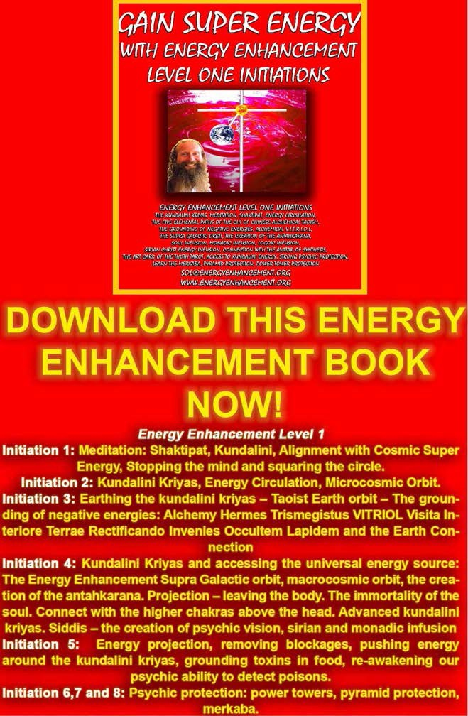

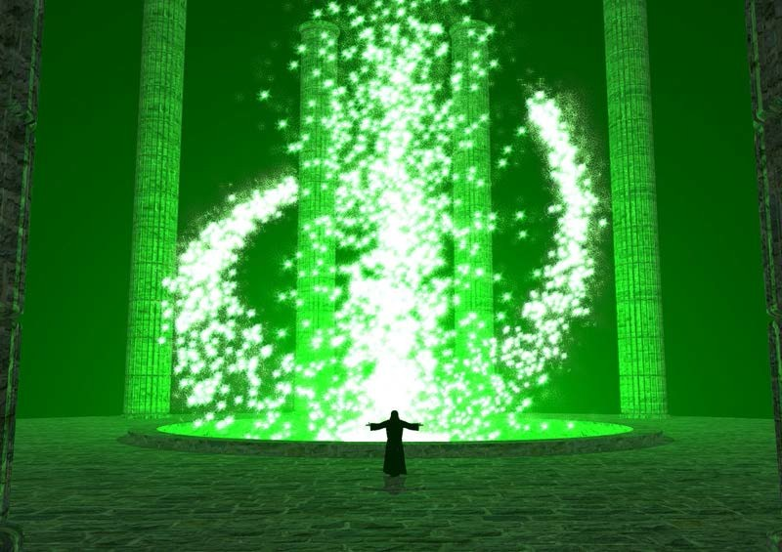
BEST ARTICLE ON CHAKRAS ENERGY ENHANCEMENT CHAKRAS DIRECTORY - CHAKRAS ABOVE THE HEAD, CHAKRAS IN THE BODY AND CHAKRAS BELOW THE BASE CHAKRA - THE ANTAHKARANA

BEST ARTICLE ON ENERGY BLOCKAGES ENERGY ENHANCEMENT ENERGY BLOCKAGE DIRECTORY - ENERGY BLOCKAGES ARE CREATED FROM TRAUMA FORMED NEGATIVE KARMIC MASS - ENERGY BLOCKAGES ARE PURE CONCENTRATED EVIL WHICH BLOCK US OFF FROM THE SPIRIT

BEST ARTICLE ON KUNDALINI KRIYAS THE ENERGY ENHANCEMENT KUNDALINI KRIYAS DIRECTORY - KRIYA YOGA TAUGHT BY ASCENDED MASTER BABAJI OF THE HIMALAYAS - STUDENT OF TAMIL SIDDAR BOGAR WHO TRANSMIGRATED INTO THE BODY OF LAO TSU FOUNDER OF TAOISM AND THE 5000 YEARS OLD TAOIST ORBITS WHICH ARE REALLY THE SAME TECHNIQUES COME FROM CIRCULAR ENERGY FLOWS IN THE GOVERNING AND CENTRAL MERIDIANS EXTENDING OUT INTO THE

EXTERNAL CHAKRAS IN THE CENTER OF THE EARTH AND THE CENTER OF THE UNIVERSE WHICH WHEN USED CAN HELP REMOVE BLOCKAGES IN ALL THOSE MERIDIANS AND ALL CHAKRAS

BEST ARTICLE ON THE ANTAHKARANA ENERGY ENHANCEMENT ANTAHKARANA DIRECTORY - THE ANTAHKARANA IS THE REAL GOLDEN ROD AND CENTRAL PILLAR OF THE ALCHEMISTS - IT IS THE PSYCHIC CONSTRUCTION WHICH SHOWS HOW HUMANITY CONNECTS WITH THE ASTRAL PLANE, THE CHAKRAS ABOVE THE HEAD AND WITH GOD - IT IS THAT WHICH MUST BE BLOCKED IN ORDER TO CONTROL HUMANITY

THE BEST ARTICLE ON SAMYAMA SAMADHI THE ENERGY ENHANCEMENT SAMADHI SAMYAMADIRECTORY - SAMADHI AND SAMYAMA ARE THE EIGHTH AND NINTH LIMBS OF YOGA OF RAJA YOGA AS SPECIFIED IN THE SOURCE BOOK, THE YOGA SUTRAS OF PATANJALI - PATANJALI WAS A TAMIL SIDDAR AND MASTER OF DANCE - WHO GIVES THE METHODOLOGY - THE TECHNIQUES - FOR THE REMOVAL OF ENERGY BLOCKAGES AS A PRELUDE TO KAIVALYA ILLUMINATION
- COMMENTARY ON THE YOGA SUTRAS BY SATCHIDANAND HERE!!

BEST ARTICLE ON ENERGY ENHANCEMENT
YOGA ENERGY ENHANCEMENT YOGA DIRECTORY THE MEANING OF YOGA IS UNION WITH GOD OR ENLIGHTENMENT, ILLUMINATION - HERE ARE MANY PAGES ON THE TECHNIQUES AND PHILOSOPHY BEHIND YOGA

BEST ARTICLE ON THE KUNDALINI KEY THE SATCHIDANAND KUNDALINI KEY DIRECTORY - THE SHAPE OF THE KUNDALINI KEY COMPRISES THE CIRCLE OF THE EARTH WITH THE ANTAHKARANA COLUMN OF

ENERGY ARISING OUT OF THE EARTH'S CENTER, STRETCHING OUT INTO THE CENTRAL SPIRITUAL SUN IN THE CENTER OF THE UNIVERSE. ALIGNING WITH THIS ENERGY IS THE CAUSE OF IMMORTALITY AND ILLUMINATION. EXAMPLES OF THE KUNDALINI KEY SYMBOL ARE THE BUDDHIST STUPA, THE HINDU SHIVALINGAM, THE CHRISTIAN ORB AND THE EGYPTIAN ANKH STRETCHING BACK OVER THOUSANDS OF YEARS - THE MEANING AND SIGNIFICANCE OF THESE SYMBOLS HAS BEEN REMOVED FROM ALL TRADITIONAL MEDITATIONS.. YET THIS KNOWLEDGE IS ESSENTIAL TO SPEED UP THE PATH OF ILLUMINATION - ONLY IN ENERGY ENHANCEMENT!!

SATCHIDANAND SPIRITUAL MOVIE LIST REVIEWS DIRECTORY SPIRITUAL MOVIES LIKE ALL SPIRITUAL ART IS WORK TO WHICH HAS BEEN ADDED OR IMPRINTED SPIRITUAL KUNDALINI ENERGY. TO THE PEOPLE WHO CAN FEEL THIS ENERGY IT IS A SIGNAL OF SIGNIFICANCE AND MEANING - GURDJIEFFS OBJECTIVE ART - SIGNAL OF A TEACHING WHICH CAN THEN BE LOOKED FOR. ALL THE MOST PROFITABLE MOVIES - STAR WARS, LORD OF THE RINGS - HAVE THIS ENERGY.. BUT THERE ARE MORE.

THE ENERGY ENHANCEMENT ALCHEMICAL VITRIOL DIRECTORY VISITA INTERIORA TERRA THEVIT OF VITRIOL MEANS VISIT THE CENTER OF THE EARTH IN MEDITATION. THERE CAN BE GROUNDED AND BURNT UP ALL NEGATIVE ENERGY AND EMOTION IN THE FISSION NUCLEAR FIRES AT THE BLACK SUN EARTHS CENTER.RECTIFICANDO INVENIES OCCULTEM LAPIDEM - THE RIOL OF VITRIOL POINTS TO THE RECIPROCAL MAINTENANCE OF GURDJIEFF - THE RECTIFICANDO - AND THE SECRET OF THE OCCULT PHILOSOPHERS STONE
- TRANSMUTE LEAD ENERGY BLOCKAGES INTO SPIRITUAL GOLD - GAIN IMMORTALITY IN ENERGY ENHANCEMENT!!

THE BEST ARTICLE ON KARMA CLEARING THE ENERGY ENHANCEMENT KARMA CLEARING DIRECTORY KARMA IS THE BUILDUP OF ENERGY BLOCKAGES IN THE BODY. NORMALLY WE CLEAR THESE BLOCKAGES SLOWLY THROUGH PAINFUL KARMIC ACTION. ENERGY ENHANCEMENT MEDITATION SHOWS YOU HOW TO CLEAR THESE DEEP EGO BLOCKAGES USING THE ENERGY ENHANCEMENT SEVEN STEP PROCESS - QUICKLY - WITHOUT ANY NEED FOR LIFETIMES OF PAIN.

THE ENERGY ENHANCEMENT MASTERY OF RELATIONSHIPS DIRECTORY AFTER THE OPENING OF THE HEART THE SECOND INITIATION OF THE MASTERY OF RELATIONSHIPS USUALLY TAKES TEN LIFETIMES OF PAINFUL DUMPING AND DEATH. ENERGY ENHANCEMENT WILL SHOW YOU HOW TO CLEAR AND PURIFY - MASTER, ENERGY CONNECTIONS AND VAMPIRISM BETWEEN YOU AND ALL THE PEOPLE AROUND YOU - FAMILY, FRIENDS AND CO-WORKERS.

ENERGY ENHANCEMENT PSYCHIC SEXUAL CONNECTION DIRECTORY MORE INFORMATION ABOUT THE STRONG TESTS ON THE PATH OF THE MASTERY OF RELATIONSHIPS - THE NECESSITY FOR THE REMOVAL OF BLOCKAGES AND UNWANTED CONNECTIONS IN THE RELATIONSHIP ABDOMINAL CHAKRA AND THE CREATIVE VISHUDDHI CHAKRA SO AS TO ALLOW THE LOWER CHAKRA TO POWER THE HIGHER.

ENERGY ENHANCEMENT ENERGY VAMPIRES DIRECTORY MORE INFORMATION ABOUT THE STRONG TESTS ON THE PATH OF THE MASTERY OF RELATIONSHIPS - BLOCKAGES ABOVE THE CROWN CHAKRA CUT ONE OFF FROM CONSCIENCE AS IN PSYCHOPATHY, BUT BECAUSE THESE BLOCKED PEOPLE CANNOT ABSORB ENERGY FROM CHAKRAS ABOVE THE
HEAD, ALSO MAKE IT NECESSARY TO VAMPIRISE ENERGY FROM ALL HUMANITY - ENERGY ENHANCEMENT

TEACHES HOW TO STOP ENERGY VAMPIRES VAMPIRISING YOUR ENERGY

THE ENERGY ENHANCEMENT LILITH SUCCUBUS INCUBUS DIRECTORY MORE INFORMATION ABOUT THE STRONG TESTS ON THE PATH OF THE MASTERY OF RELATIONSHIPS - SEXUAL BLOCKAGE IMPLANTS FROM VAMPIRES CAN CONNECT FROM ANY PERSON, ANY DISTANCE - ENERGY ENHANCEMENT TEACHES HOW TO STOP ENERGY VAMPIRES VAMPIRISING YOUR ENERGY.

ENERGY ENHANCEMENT EMOTIONAL BLOCKAGES DIRECTORY

GURU DIRECTORY - ENLIGHTENED ILLUMINATED
SPIRITUAL ASCENDED MASTERS "Ramana Maharshi said that he had been able to deal with all the negative energies and energy blockages from everyone he met, but the Energy Blockages he had taken from his mother when she died in order to make her enlightened he had not been able to remove, thus the cancer.."

THE ENERGY ENHANCEMENT GURDJIEFF AND ENERGY BLOCKAGES GURDJIEFF WAS THE FIRST SPIRITUAL MASTER WHO TALKED OF THE REMOVAL OF THE ENERGY BLOCKAGE KUNDABUFFER, OF THE RECIPROCAL MAINTENANCE OF ENERGY WHICH IS THE SAME TECHNIQUE AS THE KUNDALINI KRIYAS OF ENERGY ENHANCEMENT AND ITS REMOVAL OF WAR AND THE INCREASE OF IMMORTALITY, OF CONSCIOUS SUFFERING WHICH IS THE TAPAS OF THE YOGA SUTRAS OF PATANJALI, AND OF THE REMOVAL OF THE ENERGY BLOCKAGES OF THE EGO LIKE VANITY AND SELF IMPORTANCE AND THE SUB-PERSONALITIES WHICH USE THEM.

THE ENERGY ENHANCEMENT TAMIL SIDDAR BHOGAR - KUNDALINI YOGA AND SPIRITUAL ALCHEMY ASCENDED

MASTER BABAJI OF THE HIMALAYAS, CREATOR OF THE KUNDALINI KRIYAS WAS A STUDENT OF TAMIL SIDDAR BOGAR OF PALANI HILL IN SOUTHERN INDIA WHO TRANSMIGRATED INTO THE BODY OF LAO TSU FOUNDER OF TAOISM AND CREATOR OF TAOIST ALCHEMY AND THE MEDITATIONAL ORBITS AND ENERGY CIRCULATION. SATCHIDANAND VISITED PALANI HILL IN 1994 WITH HIS MASTER TAMIL SIDDAR SATCHIDANANDA. BHOGAR CREATED BOTH THE KUNDALINI KRIYAS AND TAOIST MEDITATIONAL ORBITS TAUGHT IN ENERGY ENHANCEMENT ALSO THE PHYSICAL IMMORTALITY OF KAYA KALPA AND ALCHEMICAL TAOISM.

THE ENERGY ENHANCEMENT MEDITATION YOGA DIRECTORY -MAJOR ENERGY ENHANCEMENT DIRECTORY ON SPIRITUALITY

PSYCHOLOGY TRAUMA MODEL DIRECTORY THE TRAUMA MODEL OF THE ROSS INSTITUTE STATES THAT TRAUMA, ABUSE AND PAIN CREATES UNSTOPPABLE EMOTIONS .
The Energy Enhancement Level One Kundalini Kriyas and their ability to Ground Trauma and Traumatic Memories removes all Trauma and its symptoms - Unstoppable Fear, Anger, Depression, Manicism and Bi-Polar Disorder..

PSYCHOLOGY PSYCHOPATHY DIRECTORY The Energy
Enhancement Seven Step Process of Level Two removal of Energy Blockages removes Psychopathy,
removing Blockages in the Heart Center which cause a lack of Empathy and then removes The Blockages above the Head creating a lack of Conscience as the Head Centers are cut off from God as we create Illumination - One Soul Infused Personality!!

THE ENERGY ENHANCEMENT
PSYCHOLOGY, Transactional Analysis - Sub Personalities, Life Games, Scripts, Energy Blockages Directory Energy Enhancement Level Three removes the Energy Blockage Sub-Personalities which create the Transactional Analysis Life Scripts written about by Dr Eric Berne

THE ENERGY ENHANCEMENT SECRET KNOWLEDGE OF
THE NEOPLATONIC ELITE The survival of the species demands a revival of the "secret knowledge" of the Neoplatonic elite. That knowledge must not only be revived, but as we do here, must be situated within and updated by appropriate terms of modern scientific and Energy Enhancement Spiritual knowledge.

ENERGY ENHANCEMENT OSHO BOOK DIRECTORY - THE SYNTHESIS OF RELIGION IS ENLIGHTENMENT - CLICK
HERE! Osho was an Enlightened Master - The Synthesis of Religion is Enlightenment - Osho commented on the works of all the Ascended masters and Saints who Founded all the Great Religions and those whose influence on humanity in incontrovertible from Zen Master Dogen to Patanjali to Buddha to Kabir to Pythagoras to Heraclitus to Junaid, Mansoor, and Rumi and then to Jesus - In reality he is not writing about any particular religion or teacher, He is writing about the Enlightenment - the Soul Infusion and the Opening of the heart - common to all great masters. He is writing about those things which constitute Enlightenment. He is writing about those human frailties which are just not Enlightened and making jokes about them!!

JESUS CHRIST AND THE ANTAHKARANA

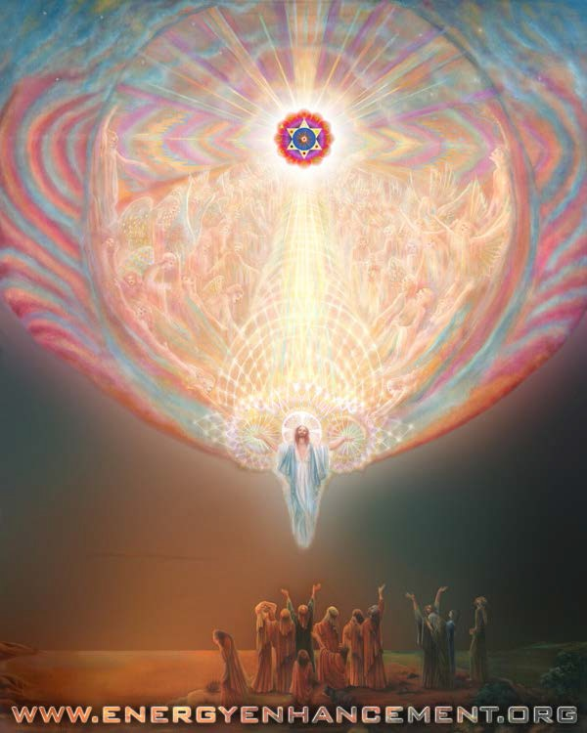

Master of Meditation, Devi Dhyani

Energy Enhancement will help you get everything you need and will make you enjoy everything you have!

Energy Enhancement quickly dissolves negativities. If you have Energy, you have Everything!

Energy Enhancement is complete Freedom!

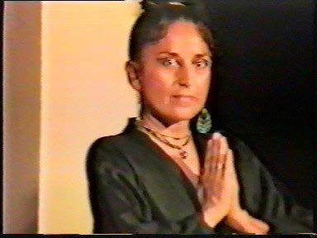

THE ENERGY ENHANCEMENT COURSE

IGUAZU FALLS IS A WORLD ENERGY CENTER SACRED TO THE INCA AND THE GUARANI FOR THOUSANDS OF YEARS

IN SPAIN, ELEGANT 5Star INDIA TAJ MAHAL, INDIA TOUR, SACRED IGUASSU FALLS, MEXICO, PERU
SIGN UP TO THE MAILING LIST FOR MORE DETAILS

EMAIL sol@energyenhancement.org

for details





Energy Enhancement APPRENTICE LEVEL 3. Initiation 8

The use of life experiences to notice and remove the Inner Children and the Strategies which are based on the inner children

The weaker inner children are very easy to remove, yet it sometimes needs stress pressure which is always occurring in life in order to get the more intelligent Soul Split inner children to show themselves. Thus Gurdjieff using alcohol as toasts at his table in order to see deeply into the Inner Children of his students... In Vino Veritas, which means, In Wine the Truth comes out.
However, once noticed then it is extremely easy to remove all the inner children using the Advanced Techniques of Energy Enhancement.

What this means is that although we are very careful to remove everything we find on the course, sometimes one or two blockages escape. Also, it is a fact that we absorb blockages from our surroundings, quite normally. So, we need to take responsibility for that.

We need to notice when we become emotional and over the top. When we have negative emotions because these are the symptoms which tell us when we need to use the techniques of Energy Enhancement to remain blockage free.

In Extremis, these fractures or splits are one of the reasons for Manic depression and schizophrenia, but most people are bothered by them to a smaller extent.

As you remove these inner children, One by One, you gain even more energy because you free up the energy which was repressed by holding in all of their painful memories.

As you do this so you overcome anything which can stop the natural flow of your energy. Your energy flows on, never to be stopped. It becomes a Cornucopia, an ever overflowing cup of energy which can never be emptied.

Truly, perhaps Enlightenment is next!!

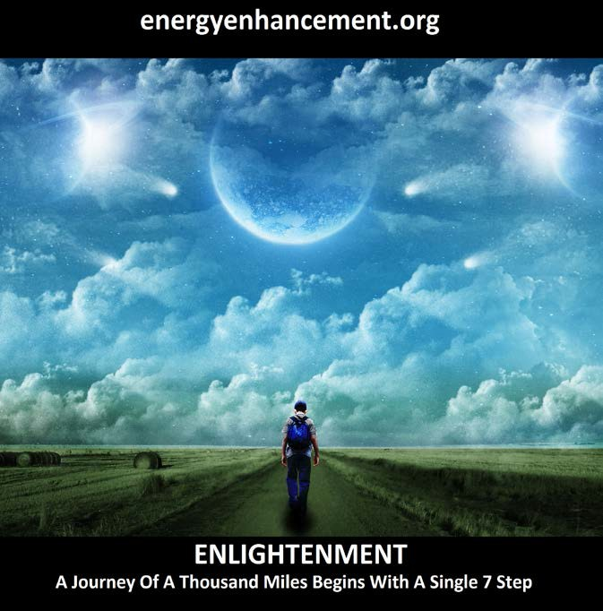

THE ENERGY ENHANCEMENT PATH OF PLEASURE, SAMADHI, SAMYAMA, ENLIGHTENMENT

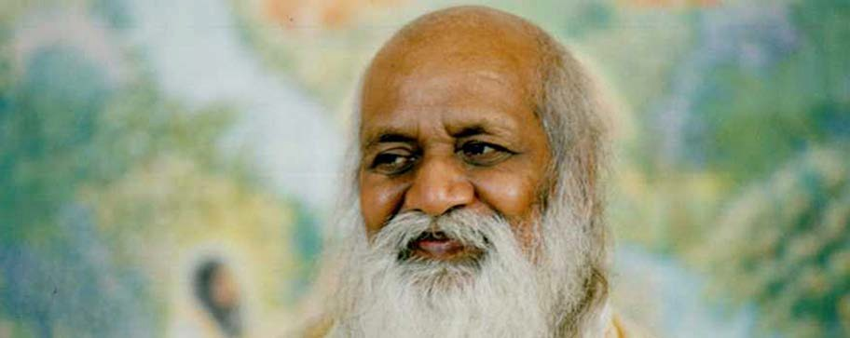

MAHARISHI MAHESH YOGI

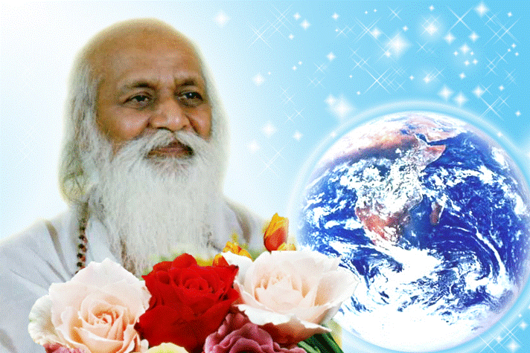

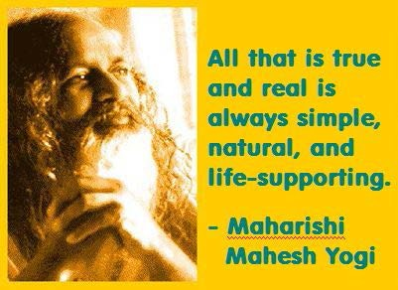

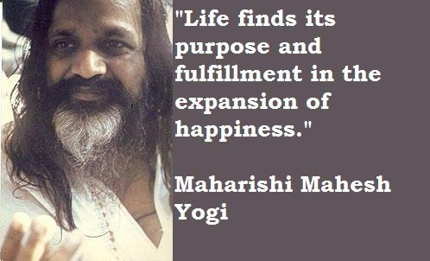

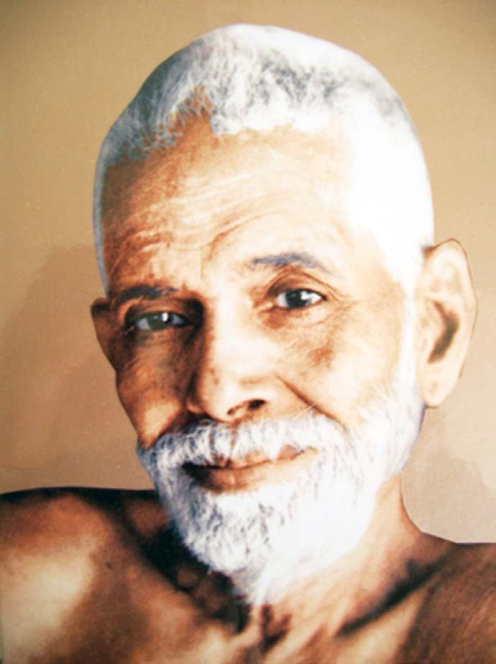
SRI RAMANA MAHARSHI, "I AM THAT"
To Tamil Siddar Ramana Maharshi and his Ashram in Tamil Nadu, South India.

TAMIL SIDDAR SRI RAMANA MAHARSHI, GURU, ENLIGHTENED ILLUMINATED SPIRITUAL MASTER

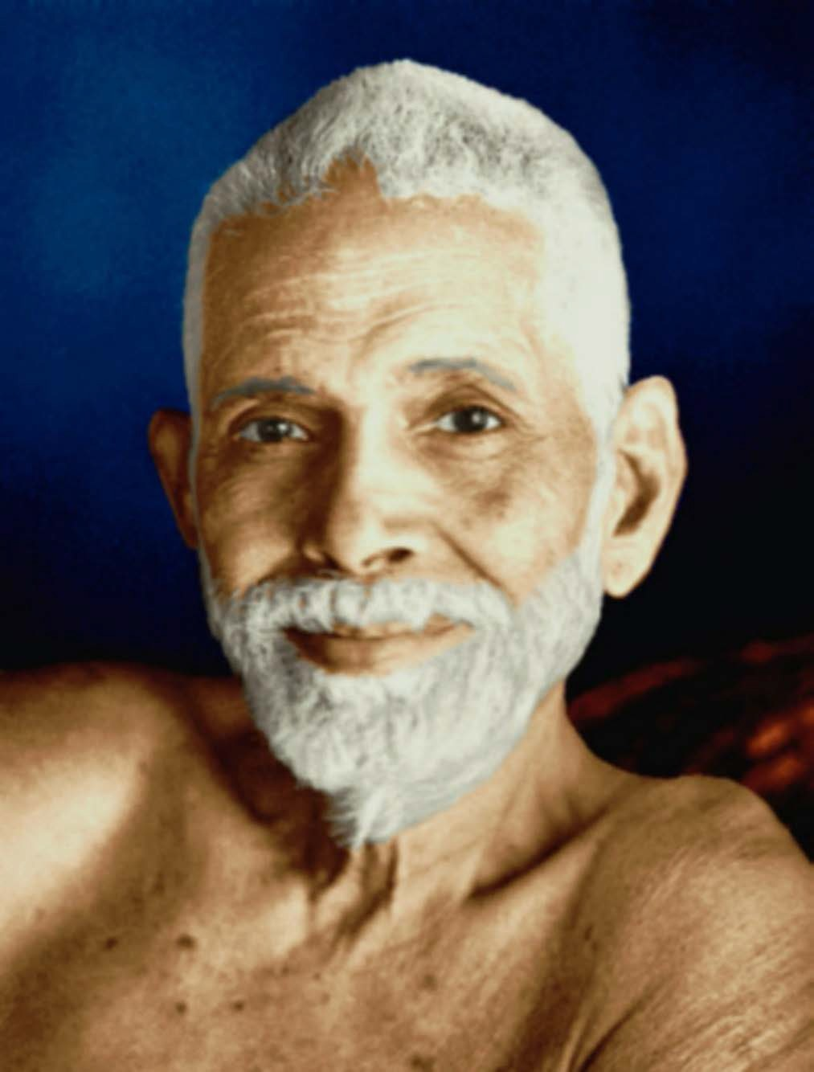
Tamil Siddar SRI RAMANA MAHARSHI, GURU QUOTES, ENLIGHTENED ILLUMINATED SPIRITUAL MASTER

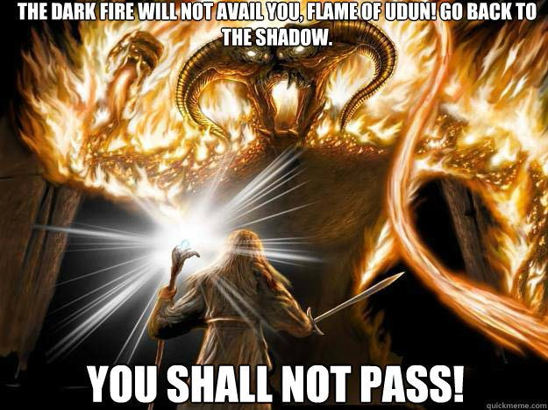
TOLKIEN CREATED THE LORD OF THE RINGS TO OPPOSE THE WAGNERIAN RING CYCLE THOUGHTFORM

Tolkien wrote the following about the idea behind the One Ring: "I should say that it was a mythical way of representing the truth that potency (or perhaps potentiality) if it is to be exercised, and produce results, has to be externalized and so as it were passes, to a greater or lesser degree, out of one's direct control." (Letter #211, 1958).

Tolkien always strongly held that The Lord of the Rings was not allegorical, particularly in reference to political events of his time such as World War II or the Cold War. At the same time he conceded "applicability" as being within the "freedom" of the reader, and indeed many people have been inclined to view the One Ring as a symbol or metaphor. The notion of an evil power too great for humans to safely possess is an evocative one, and already in the 1930s there were technologies available to suggest the idea. By the time the work was published, though not when most of it was written, the existence of nuclear power and nuclear weapons were common knowledge, and the Ring was often taken as symbolic of them. The effect of the Ring and its physical and spiritual after-effects on Bilbo and Frodo are obsessions that have been compared with drug addiction; actor Andy Serkis who played Gollum in the film trilogy cited drug addiction as an inspiration for his performance.

Parallels have been drawn between the literary device of Tolkien's Cursed Ring and the titular ring in Richard Wagner's Der Ring des Nibelungen. Tolkien dismissed critics' direct comparisons to Wagner, telling his publisher, "Both rings were round, and there the resemblance ceases." According to Humphrey Carpenter's biography of Tolkien, the author held Wagner's interpretation of the relevant Germanic myths in contempt.

Tom Shippey and Gloriana St. Clair, attribute the resemblances to the fact that Tolkien and Wagner have created homologue works based in the same sources. However, Shippey and other researchers have written on an intermediary position, stating that both the authors, indeed, used the same source materials but that Tolkien was, in fact, indebted to some of the original developments, insights and artistic uses made upon

those sources that first appeared in Wagner, and sought to improve upon them.

Indeed Tolkien sought to change to Good the the evil Wagnerian thoughtform which emphasises the use of the Will to, "Get what you Want". Wagner echoes OTO Crowley and Reuss. Hitler himself said that to understand the unfinished Caliban character, you had to understand Wagner.

Tolkien sought to increase the Thoughtform of Implacable opposition to Evil

"YOU SHALL NOT PASS!!"
As Karma proceeds so the psychic structure and the Soul reach out for Union with each other.
Quite naturally and through discipline - as we learn Energy Enhancement Meditation - we learn to project in meditation into the chakras above the head and thus we access higher and more intense spiritual energies which light up, illuminate, and thus Power Up!! the mind all the talents and all the psychic powers. Thus a Human Being starts to, "Wake Up"

Quite naturally and through the discipline of Energy Enhancement 28 Initiation on the Path of EnLightenment we learn to Ground all the negative energies striated through all the Psychic Body and through every God created talent. This purification of all the talents, of all the energy blockages, of all the Trauma-Formed Negative Karmic Mass, leads to correct action in the World - Only doing the Right thing - which gives satisfaction and a sense of rightness, of being in tune with the Universe as all connection with the dark Side is

rejected, "To seal the door where evil dwells", "Stay away from evil" - Jesus Christ

At the Enlightenment Initiation the Chela, purified of all Energy Blockages, fuses with his Soul and all his psychic Body is heated in the Crucible and cools down, crystallised - Unchangeably good, efficient, faster, - unable to be perverted by energy blockages within the new crystalline body.

EnLightenment is Only the First Dan.
After this Initiation there is a period where karma is speeded up as the new Master increases the size of his Psychic Body. Not through serendipity and the action of Karma but by Grounding Negative energies from the World around him, from his students, from all the people around him, from the World.

This grounding of Energy Blockages purifies their psychic mechanism and afterwards he incorporates these newly purified psychic mechanisms into his psychic body.

This work does not take the 100 lifetimes of serendipity to complete. We can enhance our psychic bodies with new talents amazingly quickly to achieve further Initiations and Ascended Mastery within only one Lifetime!!

"AS ABOVE, SO BELOW AS WITHIN, SO WITHOUT"
- Hermes Trismegistus

This Isn't a Game!!

Energy Enhancement is Meditation on Steroids..

Meditation with Cojones!!

Meditation which Really Works...

As you remove ALL Your Blockages with Energy Enhancement Satchidanand so Everything Changes.

Achieve Your Deep Peace..

EE Level 1 - Incredible Energy - Affecting Your Aura, Your Health, Your Attractivity.
EE Level 2 - All your Blocks - Remove and Release Your Beast!!
EE Level 3 - All Your Karma - Ever Wonder Why Things go Wrong? Stop the Sabotage!!
EE Level 4 - All Your Relationships - How to Stop Your Divorce or your Lover’s Rejection..

It Goes On and On - Free Up Your Time - Have Fun - Access Infinite Wealth..

TEN FREE DOWNLOADS...
FREE EE YOGA INSTRUCTION VIDEO
DVD With Satchidanand and Amy Zantras who went into Samadhi for 2 hours whilst making the Video!! See her Experience..http://www.energyenhance ment.org/eeyoga.htm

FREE SACRED DANCE VIDEO DVDS FREE FOUR EE BOOKS - As sold on
Amazon!!

FREE With Two Levels, the Energy Enhancement Infinite Wealth Home Training Program

Bye-Bye Boss - Do you like your job or do you dream of saying, "Bye-Bye Boss"

Do you believe your Infinite Wealth is directly related to your state of mind and consciousness?

If yes, what if there was a process to enhance your state of mind and consciousness, so from this moment onwards you could improve your ability

to attract wealth? Follow your Soul Path, the work you were Born to Do? Would this interest you?

And if you knew this process only took a few sessions of practice, but would benefit you for the rest of your life… would you make the time for it?

If you said YES to all these questions, I have an invitation for you.

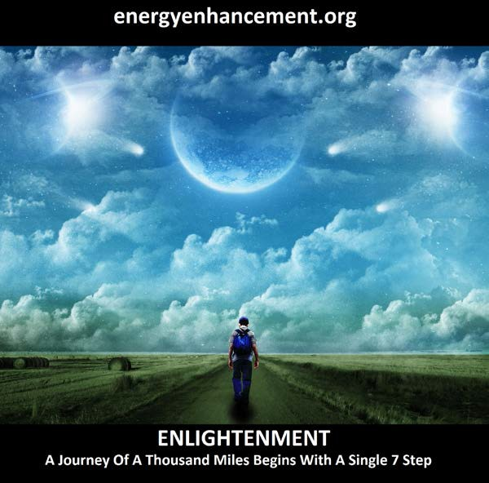

The FREE!! Energy Enhancement Infinite Wealth Home Training Program

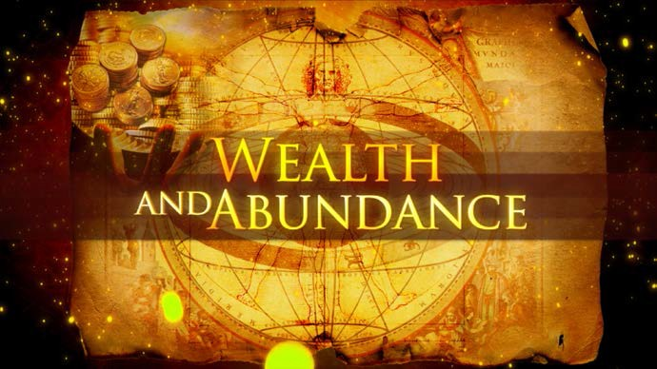
http://www.energyenhancement.org/FREE-Energy- Enhancement-Infinite-Wealth-Home-Training-Program- with-Energy-Enhancement-Streaming-Video-Course.htm

Free, as Sold on Amazon - Download these 4 Free Incredible Energy Enhancement Evolutionary Books, Now!!

Click below and right click and "save as" on each book to download

https://archive.org/search.php?query=meditation%20sat chidanand

Through this stochastic, statistical, karmic yet very slow principle, every human being turns out different, unique, with different talents, different interests, different capacities on the path of unique sovereignty, of Heart, of Illumination.

The psychic body and its talents, its intelligence, its energy is increased slowly at the behest of necessity, interest, and opportunity on its path to union with the Soul.

Incorporated, Hard wired in is the experience of the Laws of Karma which give an understanding that, "We are only allowed to do the right thing"

"This Planet is a factory for the production of Enlightened beings" Satchidananda

At first this planetary action is that of Karma necessitating all the bad and good things of life.

Over time, as well as psychic structures, infrastructure called Talent, also there becomes striated through the Psychic Infrastructure, Energy Blockages and Trauma- Formed Negative Karmic Mass which perverts the system and causes this world, just the way that it is - giving all the Karmic experiences needed by every Monadic Group to every individual at every level of evolution.

As we need more Psychic Infrastructure within, so we need more Physical Infrastructure without.. In order to Speed Up the evolution of Humanity in a more Humane way.

In alignment with the Hierarchy of needs by Maslow we need the firm base of Abundance upon which to base higher evolution. After all, when our lower needs are met, surely all that is left to conquer are the higher needs.



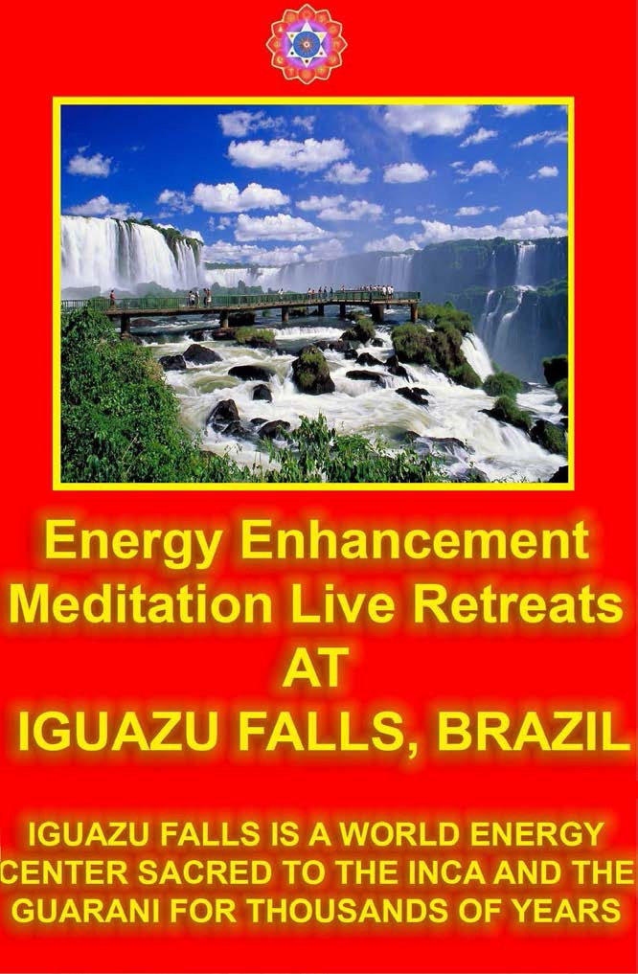

Today I sat in a chair and listened to the heart chant initiation 1 for the first time.
I was focusing on aligning my shoulders and spine forward and backward between the two lines of power from the center of the earth. And picturing the immovable mountain. Focusing on my breathing, closing the anus. I stayed in for the first four minutes. Then I got tired and openned my eyes, for about 7 or 8 seconds. Then I was so drowsy I had to close my eyes again. Then after about another four minutes I was tired again. Then the same thing but this time I focused on nothing but the energy from the earth entering the base of my spine and coming into my heart. Right from the beginning of the meditation I felt my energy all over my whole chest, even now.

But at the last when I focused on it coming from the earth, I immediately felt very, very powerful energy and I didn't move to find it. My back straightenned up automatically to the alignment and I was kind of "stuck" in that position with the power flowing.

From there it was hard for me to stop meditating when the chants were over. Very powerful. Even without magnets. My question is about my focusing. Is it wrong to "imagine" the power or the alignment or the energy? or should we imagine until we feel it? Or both? Am I focusing on the right things?

I am very grateful for your teachings. Thank you for your generosity.

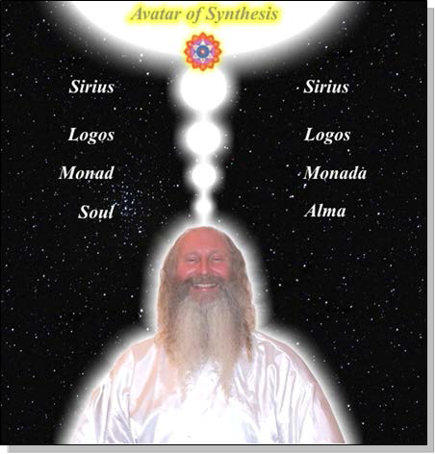

Student Report.. SPEEED UP THE PROCESS!!

Also I noticed as soon as satchi emailed me, I got a down-pouring of light from above the crown which kept charging me up the rest of the day – and my cravings died out! Then I realized they were ego-blockages and that I did not want them.

This Energy Enhancement Level One Initiation Three -

ALCHEMICAL VITRIOL is great! I've done it some more and it's incredibly powerful. I don't know why it isn't more well known or taught? It's really bringing up little blockages which are complaining while being pushed down into the earth's core to get purified.

The hot fire energy has gotten much stronger in my body while doing the practice, mostly the base of the spine heats up, but also the middle of the spine. There are lots of little blockages being noticed. But I'm pushing them out.

Energy Enhancement Meditation Course Level 1 Initiation 4: Accessing the Universal Energy Source: Soul Fusion - INFINITE ENERGY!! for You!! via the Antahkarana, Macrocosmic Orbit, The Energy Enhancement Supra Galactic Orbit, Chakras above the Head, Advanced Kundalini Kriyas, Siddis, The Creation of Psychic Vision. http://www.energyenhancement.org/EE-Meditation- Level-1-Initiation-4-Macrocosmic-Orbit-EE-Supra-Galactic- Orbit-Antahkarana-Chakras-Above-the-Head-Advance- Kundalini-Kriyas-Siddis.html

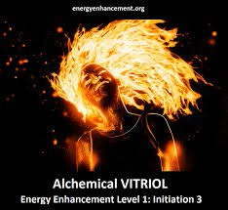

ENERGY ENHANCEMENT MEDITATION ENLIGHTENMENT AND ILLUMINATION

ENERGY ENHANCEMENT SPEEEDS UP!!
YOUR PROCESS

FIND ALL THE INCREDIBLE MEDITATION TECHNIQUES AND MEDITATION PRACTISES REMOVED FROM TRADITIONAL MEDITATIONS AND TAUGHT IN THE ENERGY ENHANCEMENT STREAMING VIDEO MEDITATION COURSE AND LIVE

MEDITATION RETREATS IN BRAZIL AND INDIA

THE MOST ADVANCED MEDITATION COURSE, MEDITATION TECHNIQUES AND MEDITATION PRACTICES ON THIS PLANET, INCLUDING THE KUNDALINI KEY, THE KUNDALINI KRIYAS, ALCHEMICAL VITRIOL AND KUNDALINI YOGA IN 28 INITIATIONS!!

SPEED UP THE PROCESS!!

REMOVE EXTERNAL WORLD ENERGY BLOCKAGES WITH ENERGY ENHANCEMENT MEDITATION

ENERGY ENHANCEMENT

MEDITATION WITH COJONES

What is Energy Enhancement Reiki?
Energy Enhancement Reiki is Reiki with the addition of the 28 Energy Enhancement Initiations, The most advanced Meditation Course on this Planet.

The Teacher of Reiki, Doctor Usui, became Enlightened after living in a Zen Monastery for 21 Years through the practices of Meditation.

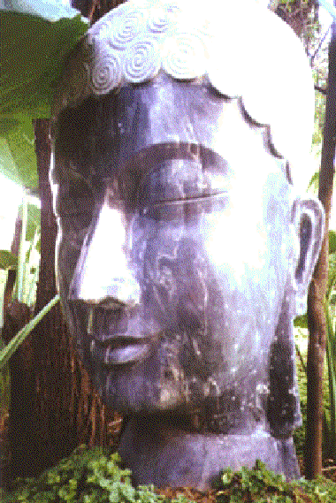

LEARN ADVANCED ENERGY ENHANCEMENT REIKI - CLICK HERE!!


DON'T MISS IT!!

THIS NEXT ENERGY ENHANCEMENT
COURSE IN SPAIN ON THE COSTA
BRAVA

email sol@energyenhancement.org for
details



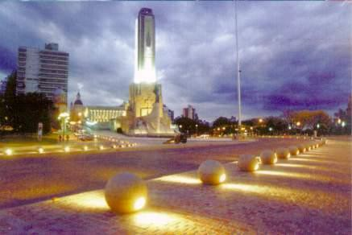
DON'T MISS IT!!

THIS NEXT CLICK HERE!! ENERGY ENHANCEMENT COURSE IN ARGENTINA

email sol@energyenhancement.org for
details

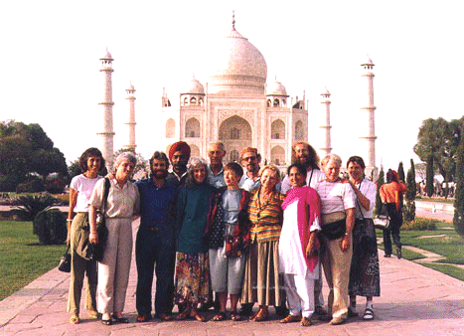

ENERGY ENHANCEMENT ADVANCED MEDITATION COURSE IN 28 INITIATIONS

AT THE WORLDS MAJOR ENERGETIC SITES

IN INDIA

AT THE TAJ MAHAL CLICK HERE!!

email sol@energyenhancement.org for details



MEDITATION ENERGY ENHANCEMENT -
Alternative Holiday Vacation Courses in Peru - Machu Pichu including Energy Enhancement Meditation Techniques and Yoga.

CLICK HERE!!

email sol@energyenhancement.org for details

MEDITATION ENERGY ENHANCEMENT -
Alternative Holiday Vacation Courses Brazil - Iguazu Falls including
Energy Enhancement Meditation Techniques and Yoga.

CLICK HERE!!

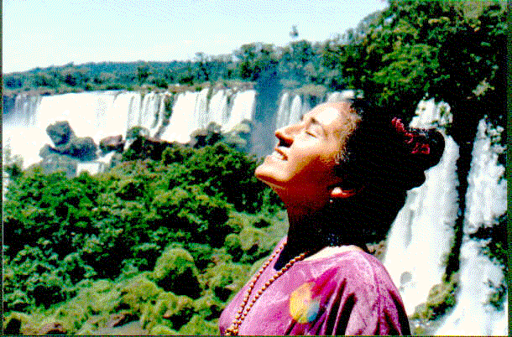

email sol@energyenhancement.org for details

SHERATON LUXURY 5STAR MEDITATION COURSES AT THE WONDERS OF THE WORLD

TAJ MAHAL INDIA, PYRAMIDS EGYPT AND IGUAZU FALLS ARGENTINA

CLICK HERE!!

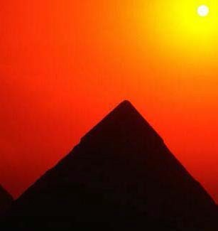

email sol@energyenhancement.org for details

Come now!! CLICK HERE!! Come to the Energy Enhancement Centre for the YEAR LONG COURSE in the
evolutional Buddhafield including all the spiritual endeavours...

including Energy Enhancement, Energy Enhancement Teacher Training, EE Reiki, Sacred Dance and Performance, Crystal Lightpuncture, The 5E´s Course, just like the Mystery Schools of Ancient Times.

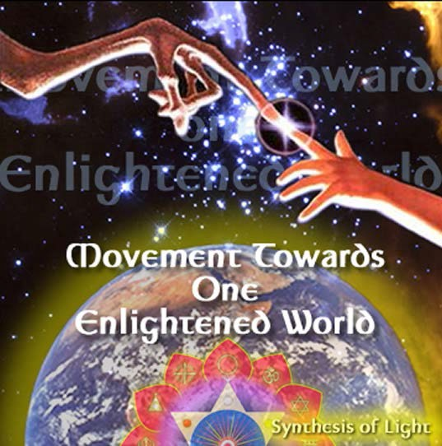

email sol@energyenhancement.org for details

Energy Enhancement Meditation Course Level 1

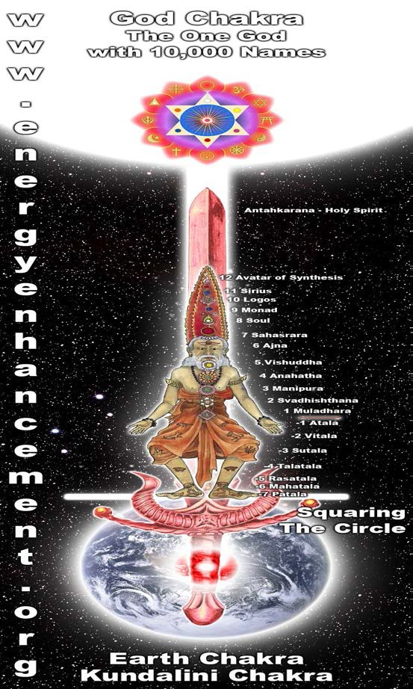

- Energy Enhancement Meditation Course Level 1 - Gain Energy!! Meditation, Kundalini Kriyas, Taoist Super Orbits, Alchemical VITRIOL, Projection of the Antahkarana into the Soul Chakra, Monad Chakra, Logos Chakra the manipulation of life energy (Ki, Chi, Pranha, Orgone, Kundalini)

- Energy Enhancement Meditation Course Level 1 Initiation 1: Alignment with the energies from the Center of the Earth into the Center of the Universe. Shaktipat, Energy Alignment, Kundalini, Stopping the Mind and Squaring the Circle.

- Energy Enhancement Meditation Course Level 1 Initiation 2: Energy Circulation: Microcosmic Orbit, Kundalini Kriyas. This gives the Hidden Taoist Secrets of the Microcosmic AND the Macrocosmic Orbit, the 5 Elemental pathways of the Chi or Ki and the Kundalini Kriyas of Paramahamsa Yogananda.

- Energy Enhancement Meditation Course Level 1 Initiation 3: The Grounding of Negative Energies: Alchemy, Hermes Trismegistus, VITRIOL - VISITA INTERIORE TERRAE RECTIFICANDO INVENIES OCCULTEM LAPIDEM and the guided meditation of Grounding, transmuting all trauma caused negative energy.

- Energy Enhancement Meditation Course Level 1 Initiation 4: Accessing the Universal Energy Source: Macrocosmic Orbit, The Energy Enhancement Supra Galactic Orbit, Chakras above the Head, Soul Fusion via the Antahkarana, Advanced Kundalini Kriyas, Siddis, The Creation of Psychic Vision.

- Energy Enhancement Meditation Course Level 1 Initiation 5: Projecting Energy - Grounding Toxins in Food: Re-awakening our psychic ability to detect poisons. Removing Blockages.

- Energy Enhancement Meditation Course Level 1 Initiation 6: Psychic Protection: Power Towers, Creating and Using External Antahkaranas, Exponentially Increasing your Spiritual Energy, Creating the Flow from Heaven to Earth.

- Energy Enhancement Meditation Course Level 1 Initiation 7: Psychic Protection: Pyramid Protection.

- Energy Enhancement Meditation Course Level 1 Initiation 8: Psychic Protection: The Merkaba, Astral Travel and Projection, Advantages of the Siddhis of Becoming Bigger and Smaller.

Energy Enhancement Meditation Course Level 2

  - Energy Enhancement Meditation Course Level 2 - The Seven Step process - The removal of energy blockages and implants by the Energy Enhancement Busting Techniques - The Removal of Old Karma from the time in the womb of your mother and from this time.

- Energy Enhancement Meditation Course Level 2 Initiation 1: The removal energy blockages and implants by the Energy Enhancement Seven Step Process.

- Energy Enhancement Meditation Course Level 2 Initiation 2: How to Heal the Energy Blockages in the body.

- Energy Enhancement Meditation Course Level 2 Initiation 3: The removal of Energy Blockages thoughtforms from the chakras. From the seven chakras inside the body and then all the external spiritual chakras to which we are connected the Soul Chakra, the Monad Chakra, the Logos Chakra, the Sirius chakra, the Avatar of Synthesis Chakra.

- Energy Enhancement Meditation Course Level 2 Initiation 4: The removal of Energy Blockages thoughtforms from the DNA. Heal your DNA.

- Energy Enhancement Meditation Course Level 2 Initiation 5: The removal of Energy Blockages thoughtforms from the Auras. Heal the Physical Aura, Heal the Emotional Aura, Heal the Mental Aura, Heal the Buddhic Aura.

- Energy Enhancement Meditation Course Level 2 Initiation 6: The removal of old karma from the time in the womb of your mother. The karma cleaning process.

- Energy Enhancement Meditation Course Level 2 Initiation 7: The removal of old karma from this lifetime. The karma clearing process.

Energy Enhancement Meditation Course Level 3

  - Energy Enhancement Level 3: Energy Enhancement Meditation Course Level 3, The Karma Clearing Process - Psychopathic STRATEGIES - The Inner Children Deep Energy Blockages - The Grounding of Emotions - The Removal of Old Karma from Past, This and Future Lifetimes.

  - Energy Enhancement Level 3 Initiation 1: The removal of old karma from all your past lifetimes. Remove all the Blockages from all your previous lifetimes. This is what they mean when they say a Master is not under the Laws of Karma. He has dissolved all the negativity from all his past lives.

  - Energy Enhancement Level 3 Initiation 2: The removal of old karma from all the future years in this lifetime and all your future lifetime.

  - Energy Enhancement Level 3 Initiation 3: The retrieval of the soul splits of the inner children Deep Energy Blockages.

  - Energy Enhancement Level 3 Initiation 4: The grounding of the emotions. This Initiation shows how to Ground, to Drain all the negative energies from your negative emotions and thus remove all your emotional Energy Blockages.

  - Energy Enhancement Level 3 Initiation 5: Removing the strategies of the psychopathic

energy vampire. LEARN HOW NOT TO BECOME ENGAGED BY THEIR STRATEGIES TO SUCK YOUR ENERGY.

- Energy Enhancement Level 3 Initiation 6: The Seven Step purification of trauma-formed negatice karmic mass in talents and the creation and increase of talents or angel talent colonies in level 3 of Energy Enhancement.

- Energy Enhancement Level 3 Initiation 7: Removing vows from this life and all your past lives. Past life priest vows and vows to the dark side can affect present prosperity, self worth, and relationships. And they can continuously block you, and be carried from life time to life time. All Old Souls carry them and most have thousands of them buried in their minds. This Energy Enhancement Initiation method removes the blocks that are held deep within your subconscious mind. Traditional therapies cannot remove them.

- Energy Enhancement Level 3 Initiation 8: The use of life experiences to notice and remove the Inner Children and the Strategies which are based on the inner children. The weaker inner children are very easy to remove, yet it sometimes needs stress pressure which is always occurring in life in order to get the more intelligent Soul Split inner children and past life talents to show themselves.

Energy Enhancement Meditation Course Level 4

  - Energy Enhancement Meditation Course Level 4. High Tantra Psychic Sexual Connection - The Mastery of Relationships by using Meditation (including your mother and father)- How to heal all addictions.

  - Energy Enhancement Meditation Course Level 4 Initiation 1: Learn how to heal all addiction. Learn how to heal all your Addictions or strategy driven predelections to... Food, Alcohol, Smoking, Drugs and Sex.

  - Energy Enhancement Meditation Course Level 4 Initiation 2: The healing of the negative energy of close personal primary relationships including your mother and your father. Learn how to Heal all your Relationships Without talking to these people. Learn to heal at a distance all the Negative Energy which inevitably builds up in all our Primary Relationships.

  - Energy Enhancement Meditation Course Level 4 Initiation 3: The total healing of all chakra connections. Energy from further improving relationships and protection. How to clean all the energy connections of Attachment.

- Energy Enhancement Meditation Course Level 4 Initiation 4: Creating and cleaning the soul connection in your students and friends.

- Energy Enhancement Meditation Course Level 4 Initiation 5: The Mastery of the psychic energy connections.

- Energy Enhancement Meditation Course Level 4 Initiation 6: The Mastery of trantic energy. How to Remove Implants, Transmute the Negative Karmic Mass of Blockages and Clean all the Chakras of your students and close personal relationships.

- Energy Enhancement Meditation Course Level 4 Initiation 7:Ceremonies and Meditation Groups - Using the Energy of the Higher Heart, The Heart Center in the Head, Prajna Paramita, - The Soul and the Monad Itself, for the Healing of Groups, Organizations and the World.

- Energy Enhancement Meditation Course Level 4 Initiation 8: The use of life experiences to notice and remove the Inner Children and the Strategies which are based on the inner children. The weaker inner children are very easy to remove, yet it sometimes needs stress pressure which is always occurring in life in order to get the more intelligent Soul Split inner children to show themselves.

ENERGY ENHANCEMENT COMBINES, SYNTHESISES ALL THESE TECHNIQUES AND MORE!!



TO SPEED UP!! THE PROCESS OF YOUR EVOLUTION.

MEDITATION ENERGY ENHANCEMENT COURSES



Each OF THE FOUR APPRENTICE LEVELS,
The FOUR Parts of the Energy Enhancement Course, takes ONE WEEK to teach at our Centers in Spain on the Costa Brava near Barcelona, in Argentina or India at the Taj Mahal or anywhere in the world

THE ENERGY ENHANCEMENT COURSE

1. Energy Enhancement APPRENTICE LEVEL I, II or III or Energy Enhancement Teacher Training APPRENTICE LEVELs I,
II, III over One Week

2. COME FOR FOUR
MEDITATION ENERGY ENHANCEMENT
APPRENTICE LEVELS OVER FOUR WEEKS

3. COME FOR FOUR MEDITATION ENERGY ENHANCEMENT APPRENTICE LEVELS,ENERGY ENHANCEMENT YOGA TEACHER TRAINING, CERTIFICATION, AND FREE REIKI MASTERY OVER FOUR
WEEKS!!

ENQUIRIES, JOIN SOL MAILING LIST CLICK HERE!!

For Bookings Email

sol@energyenhancement.org

CLICK BELOW FOR-

MEDITATION Energy Enhancement
Courses on Tour in India in 5 Star
Hotels

MEDITATION Energy Enhancement Courses on Tour in Sacred India

The MEDITATION Energy Enhancement EBook

The MEDITATION Energy Enhancement Talks and Chants

The MEDITATION Energy Enhancement Online Course

The MEDITATION Energy Enhancement Video Course

The MEDITATION Energy Enhancement Email Spiritual Magazine

The Truth is One the Paths are Many.

Energy Enhancement Synthesis Of Light Ltd

A Non-Profit Organization, dedicated to raising the World's Evolutionary Energy.

ENQUIRIES, JOIN SOL MAILING LIST CLICK HERE!!

Or you can learn By Clicking The
MEDITATION Energy
Enhancement Video Course or The
MEDITATION Energy
Enhancement Online Course .....



SATCHIDANANDS MEDITATION TALKS IN MP3 AND REAL AUDIO

WISDOM MEDITATION ARTICLES

MEDITATION STORIES

VIGYAN BHAIRAV TANTRA VOL1

VIGYAN BHAIRAV TANTRA VOL2

NANAK THE TRUE NAME VOL 1 Discourses on Nanak, Guru, Om

FROM BONDAGE TO FREEDOM

- Meditation: Stopping the mind and squaring the circle
- Energy Circulation: Microcosmic Orbit, Kundalini Kriyas
- The Grounding of Negative Energies: Alchemy, Vitriol and Earth Connection
- Accessing the Universal Energy
Source: Macrocosmic orbit, Supra Galactic Orbit, Antahkarana, Advanced Kundalini Kriyas.
- Psychic Projection of Energy - Grounding Toxins in Food: Re-awakening our psychic ability to detect poisons. Energy Removal of Blockages.
- Psychic Protections: Power Towers
- Psychic Protections: Pyramid Protection
- Psychic Protections: The Merkaba

MORE ON ENERGY ENHANCEMENT HEALING AND REIKI

Meditation Energy Enhancement Broadcast JAN 4 2007 FLASH BLOG ACUPUNCTURE

ZEN - MIND IS A DISEASE

MEDITATION - ENERGY BLOCKAGES ARE THE CAUSE OF THE PSYCHOPATH, THE SCHIZOPHRENIC, AND MANIC DEPRESSION. WITH EXAMPLES STALIN, HITLER, ENRON AND MAO

MEDITATION - Existentialism and Kubrick's Psychopaths in the Films of Stanley Kubrick.

George Lucas, Star Wars, the Revenge of the Sith, and Psychopaths

CHAKRAS OUTSIDE THE BODY AND THE ANTAHKARANA

ZEN BUDDHISM Meditation ARTICLES of Energy Enhancement - STORIES

SUFI AND SUFISM - MEDITATION ARTICLES of OSHO ENERGY ENHANCEMENT

Satchidanand Meditation ARTICLES of Energy Enhancement

Jesus Christ Osho Meditation ARTICLES of Energy Enhancement - STORIES

TAO AND TAOISM OSHO STORIES OF MEDITATION ENERGY ENHANCEMENT

Meditation and Alchemy - VITRIOL Grounding Alchemical Calcination, Dissolution, Separation, Conjunction, Fermentation, Distillation and Coagulation

Devi Dhyani Sacred dance Martinez Meditation Energy Enhancement Broadcast Osho, Streaming Video Meditation DVDs SUFIS bringing the essential religion back 2007 JULY 3RD

Meditation Energy Enhancement Broadcast JULY5TH Enlightened Mind of Sosan

EE Karma Clearing Process The Kundalini Kriyas and Alchemy Meditation COURSES in Spain, Free Sacred Dance DVDs 2007 July10TH

Meditation-Reiki-in-Spain-Christ-Jesus-Bridegroom-Osho- COURSES-in-Spain-Meditation-COURSES-in-Spain-Energy- Enhancement-2007AUGUST28TH

Argentina-Don-Oscar-Elsie-Elisabeth-Honey-Kalaria- Broadcast-Meditation-EE--ARGENTINA-CASTANEDA

Meditation Energy Enhancement Broadcast 2007 Jan 19th Meditation DVDs Dons Testimonial and Osho

Meditation Energy Enhancement Broadcast 2007 March 21st Meditation COURSES in Argentina and Spain, Don Minihane, Rabia, Sufis and Osho

Meditation Energy Enhancement Broadcast 2007 Jan 27th TAOIST SUPRA GALACTIC ORBIT Meditation DVDs Testimonial and Osho

Meditation Energy Enhancement Broadcast 2007 Feb 7TH Master Relationships Meditation DVDs DON third Testimonial and Osho tao and Golden Flower of Lu Tsu

Meditation Energy Enhancement Broadcast 2007 Feb 12TH Alchemy VITRIOL ground negative energies Osho Tao Faith Trust

Meditation Energy Enhancement Broadcast 2007 Feb 19TH Meditation ONLINE COURSE, ENERGY CIRCULATION and Osho ZEN MASTER HYAKUJO

Meditation Energy Enhancement Broadcast 2007 March 4th Meditation ONLINE COURSE Osho Secret Golden Flower Master Lu Tsu and the Antahkarana

Meditation Energy Enhancement Broadcast 2007 Feb 21ST Meditation DVDs The Karma Clearing
Process, LISABETAS TESTIMONIAL Blockage removal, Manjushri, OSHO Hsin Hsin Ming: The Book of Nothing Talks on the Enlightened Mind of
Sosan, The Great Way

Meditation Energy Enhancement Broadcast FEB 27TH 2007 DON HONEY VANESSA ARGENTINA CASTANEDA
You have to have
an unbending intent in order to become a man of knowledge - CARLOS CASTENADA.

Meditation Energy Enhancement Broadcast 2007 March 1st TAOIST SUPRA GALACTIC ORBIT Meditation DVDs Jesus Morality

Argentina-Don-Oscar-Elsie-Elisabeth-Honey-Kalaria- Broadcast-Meditation-EE--ARGENTINA-CASTANEDA

Energy-Vampires-Patanjali-Gurdjieff-Argentina-Kundalini- Kriya-Yoga-Meditation-EE-ARGENTINA-Blockages- 17Dec2007.htm

MEDITATION-KUNDALINI-KRIYAS-TAOIST-MICROCOSMIC- MACROCOSMIC-SUPRA-GALACTIC-ORBIT-Argentina-
Mexico-Kundalini-Kriya-Yoga-Meditation-EE-20Dec2007

Carlos-Castaneda-Don-Juan-Ascended-Master- Enlightenment-Immortality-Psychic-Connection-Tantra- Healing-MEDITATION-KUNDALINI-KRIYAS--ORBIT-
Argentina-Mexico-Kundalini-Meditation-EE-01JAN2008

KABIR-TRUE-SEEKER-Video-Meditation-Reiki-in-Mexico- Osho-COURSES-in-Spain-Meditation-Energy- Enhancement-2008JAN7.htm

Castaneda-Don-Juan-Art-of-Dreaming-Karma-Cleaning- Video-Meditation-Reiki--Meditation-Energy-Enhancement- 2008JAN10

KUNDALINI-KRIYAS-IMMORTALITY-TAOIST- MICROCOSMIC-MACROCOSMIC-SUPRA-GALACTIC-ORBIT-
Argentina-Mexico-Kundalini-Kriya-Yoga-Meditation-EE- 16JAN2008.htm

Enlightenment-Psychic-Connections-Energy-Blockages- Incubus-Succubus-KUNDALINI-KRIYAS-IMMORTALITY-
Argentina-Mexico-Theologica-Mystica-Osho-EE- 21JAN2008

MEXICO-MASSAGE-REIKI-BLOCKAGE-REMOVAL-TWELVE- DVD-COURSE-Energy-Blockages-KUNDALINI-KRIYAS-
Mexico-26JAN2008.htm

Satchidanands Meditation Enlightenment BLOG!!

Satchidanands Energy Enhancement Meditation BLOG!

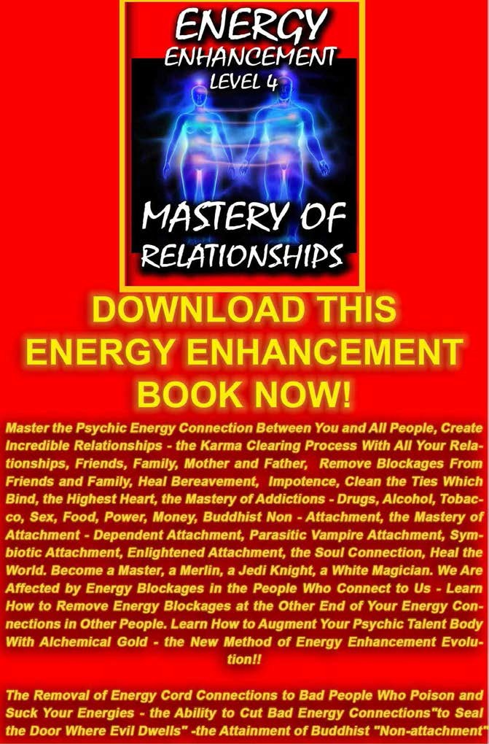

FREE GIFTS FOR NEWSLETTER SIGNUP



ENERGY ENHANCEMENT

THE MOST ADVANCED ENERGY COURSE OF MEDITATION ON THIS PLANET

INCREASE INTELLIGENCE

DISSOLVE ENCAPSULATED TRAUMA

SPEED UP THE PROCESS OF ENLIGHTENMENT

WITH THE ENERGY ENHANCEMENT COURSE BUY A STAIRWAY TO HEAVEN

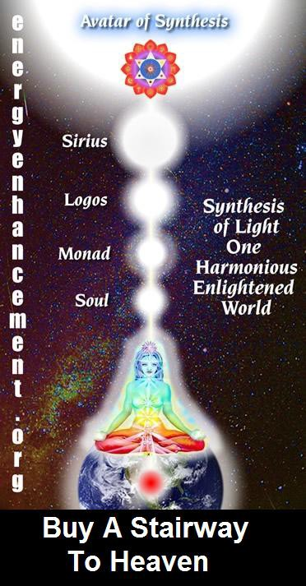

BUY A STAIRWAY TO HEAVEN
WITH THE ENERGY ENHANCEMENT COURSE

STUDENT REPORT
Also I noticed as soon as Satchidanand emailed me, I got a down-pouring of light from above the crown which kept charging me up the rest of the day – and my cravings died out! Then I realized the cravings were ego- blockages and that I did not want them.

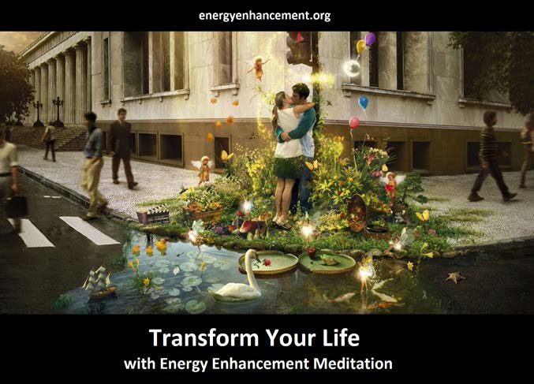

Energy Enhancement says that there are an infinity of chakras above the head up into the
Center of the Universe and above, high above the head, ending in God, just as there are an infinity of chakras below the base - "As above, So Below"
- Hermes Trismegistus from the Emerald Tablet.

INCREASE YOUR INTELLIGENCE - THE PARALLEL PROCESSING SUPERCOMPUTER YOU!! Energy
Enhancement says that each chakra within you and above the head is a computer processor with higher and higher frequency, speed and capacity as you go higher. So, like a parallel processing supercomputer, the more chakras you can get working in the Infinity of Chakras above the Head and the more chakras you can access, the more chakras you can disblock, the more chakras you

can augment, the more intelligent, the more intuitive, the more wise you will be.

FUSING WITH THE SOUL CHAKRA - Energy
Enhancement says that just by fusing with the soul chakra one can see all your past lives and remove all blockages from all your past lives in one sweep, fast!!


FUSING WITH HIGHER CHAKRAS - THE SOUL, MONAD, LOGOS, SIRIUS, AVATAR OF SYNTHESIS - Energy
Enhancement says that it also contains the secret of Initiations Higher that Illumination -

"Enlightenment is not Enough!!"

FREE - SEE THE SACRED PINK FLOYD VIDEO - WITH DEVI DHYANI - CLICK HERE!

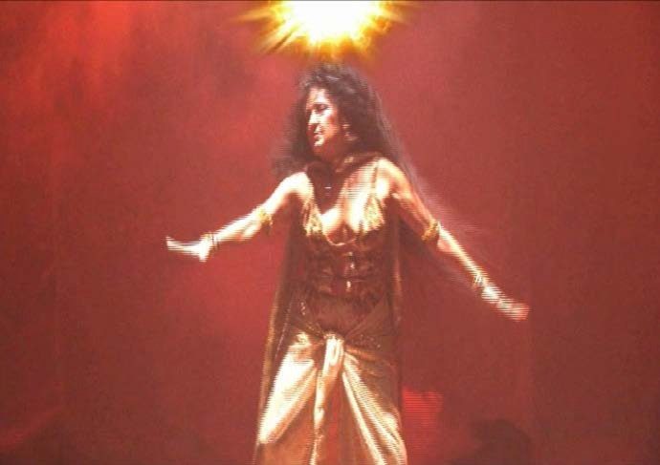
331

. SUPER ENERGY AND SACRED SYMBOLS

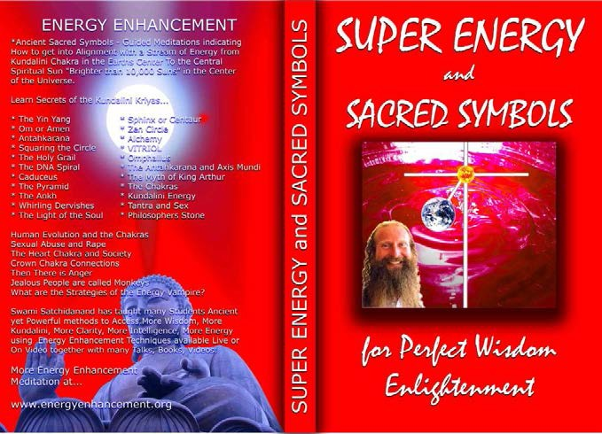

*THE ENERGY ENHANCEMENT BOOK… Ancient
Sacred Symbols - Guided Meditations indicating How to get into Alignment with a Stream of Energy from Kundalini Chakra in the Earth’s Center to the Central Spiritual Sun "Brighter than 10,000 Suns" in the Center of the Universe.

Learn Secrets of the Kundalini Kriyas... and more…

Swami Satchidanand has taught many Students Ancient yet Powerful methods to Access More Wisdom, More Kundalini, More Clarity, More Intelligence, More Energy using Energy Enhancement Techniques available Live or On Video together with many Talks, Books, Videos.

ENERGY ENHANCEMENT TWO – REMOVAL OF ENERGY BLOCKAGES, MANAGING ENERGY CONNECTIONS AND MASTERY OD RELATIONSHIPS

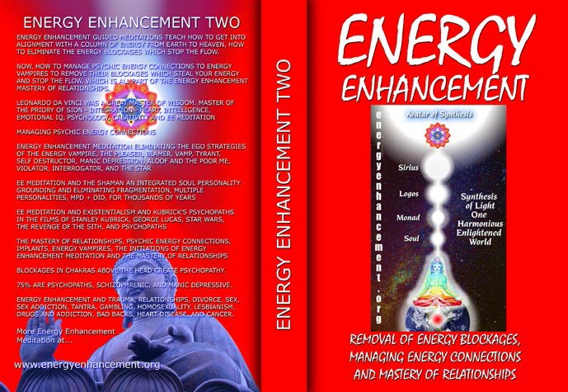

ENERGY ENHANCEMENT GUIDED MEDITATIONS TEACH HOW TO GET INTO ALIGNMENT WITH A COLUMN OF ENERGY FROM EARTH TO HEAVEN, HOW TO ELIMINATE THE ENERGY BLOCKAGES WHICH STOP THE FLOW.

NOW, HOW TO MANAGE PSYCHIC ENERGY CONNECTIONS TO ENERGY VAMPIRES TO REMOVE THEIR BLOCKAGES WHICH STEAL YOUR ENERGY AND STOP THE FLOW, WHICH IS ALL PART OF THE ENERGY ENHANCEMENT MASTERY OF RELATIONSHIPS.

LEONARDO DA VINCI WAS A GREAT MASTER OF WISDOM. MASTER OF THE PRIORY OF SION - INTEGRATION - HEART, INTELLIGENCE, EMOTIONAL IQ, PSYCHOLOGY, CREATIVITY AND EE MEDITATION MANAGING PSYCHIC ENERGY CONNECTIONS ENERGY ENHANCEMENT

ENERGY ENHANCEMENT LIVE
COURSES – WORLDWIDE


INDIA, 5 STAR INDIA TAJ MAHAL, SPAIN, MEXICO, PERU, ARGENTINA – MORE

Bookings: www.energyenhancement.org

