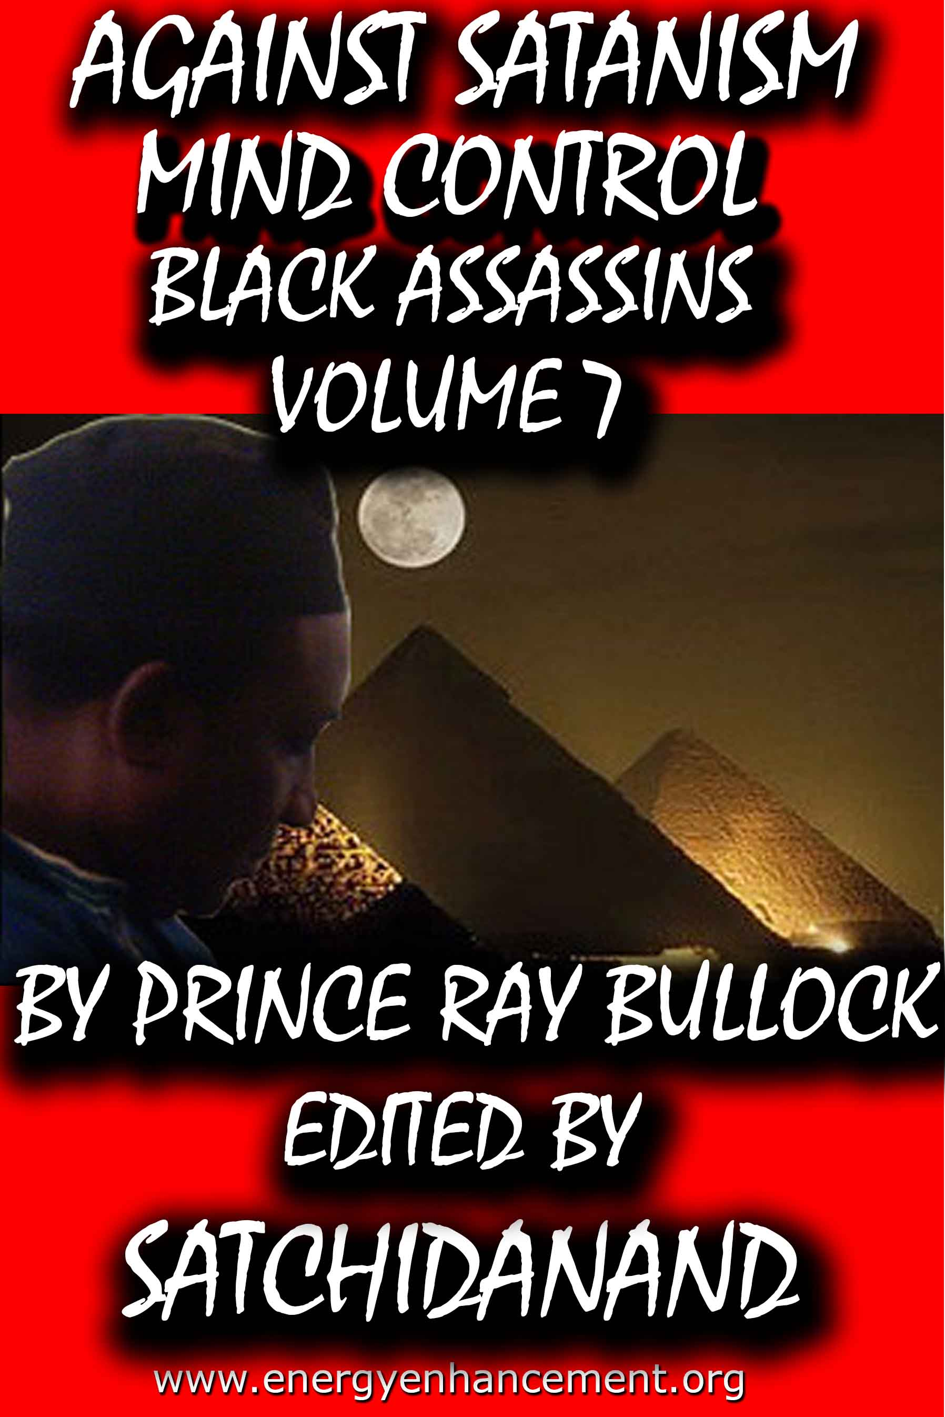

DEDICATION
With all Thanks, Love and Gratitude to Swami Devi Dhyani and all the helpers who make these books and DVDs possible.
With all Thanks, Love and Gratitude to my Mother and Father and to all my other Teachers, Theos Bernard, Sri Yogendra, Eric Berne, Gurdjieff, Father Bede Griffiths, Osho, Zen Master Hogen, Swami Sivananda, Swami Satchitananda, and all the other giants upon whose shoulders I stand - who made me able to be what… I AM – Swami Satchidanand

Copyright © 2020

[Energy Enhancement Synthesis of Light Limited (SOL)]

All rights reserved. This publication may be reproduced in whole or in part, by any person under fair use as long as we are referenced, without written permission of:
Swami Satchidanand

sol@energyenhancement.org
www.energyenhancement.org
AGAINST SATANISM
MIND CONTROL
BLACK ASSASSINS
VOLUME 7
BY PRINCERAY BULLOCK
EDITED
SATCHIDANAND
www.energyenhancement.org

Table of Contents
IN THE NAME OF SATAN, PALESTINE, NBA ILLUMINATI, BLACK SATANIC CABALS & MALAYSIA AIRLINES FLIGHT 17 27
In the Name of Satan, Genocide of the Palestinian People 27
DOUBLE BIND: DONALD STERLING, NBA, GENOCIDE, TANTRISM & THE PLOT AGAINST THE PEOPLE 56
 95
When I first heard that the NFL as a “league or association” was officially celebrating Hispanic Heritage Month, I had to scratch my head in puzzlement. I not saying that the NFL should celebrate Black History Month instead. There are twelve months a year and 365 days a year. There is enough justification for America to celebrate each month and every day of the year to the People of Color’s contribution to this country; and condemn its atrocities against them, whether Black, Brown or Yellow. 95
But, why would the predominantly Black player NFL officially celebrate Hispanic Heritage Month and give token observance to, and dismiss the significance of Black History Month? Why wouldn’t the NBA or NFL openly support Black History Month that is expressly articulated to humbly HELP save their Black Fan Base and majority Black Players and their families from racial injustice and extermination– GENOCIDE in America? But for, to confuse, divide, conquer and continuity DOMINATE the masses by deception and PSYCHOLOGICAL WARFARE. 96
DONALD STERLING & THE RISE OF THE BLACK MESSIAH- NBA ILLUMINATI GONE WILD 99
AMERICA- THE NATION OF HYPOCRITES, NBA, THE BRADY BUNCH ALEX RAMPAGE & MAJESTIC MIND CONTROL 152
DANCE WITH THE DEVIL, BAD ASSED HEWLETT- PACKARD- MICHAEL DAVID DUNN, JORDAN DAVIS & AARON ALEXIS 207
SOMETHING AIN’T RIGHT- JORDAN DAVIS, DELTA PEOPLE, TONY BLAIR & THE FAITH FOUNDATION 265
PHARRELL WILLIAMS- HOLLYWEIRD’S LITTLE LUCIFER, A MASTER OF DECEPTIONS AND ILLUSIONS 282


Go to http://www.energyenhancement.org for 34 Free –On Sign-Up - Energy Enhancement Books and Energy Enhancement Against Satanism Books.
To defeat Evil, you need to up your game. Learn the Energy Enhancement Meditation Course by Video or Live in Iguazu.


Change the World...


Go to http://www.energyenhancement.org for 34 Free Energy Enhancement Books.
To defeat Evil, you need to up your game. Learn the Energy Enhancement Meditation Course by Video or Live in Iguazu.
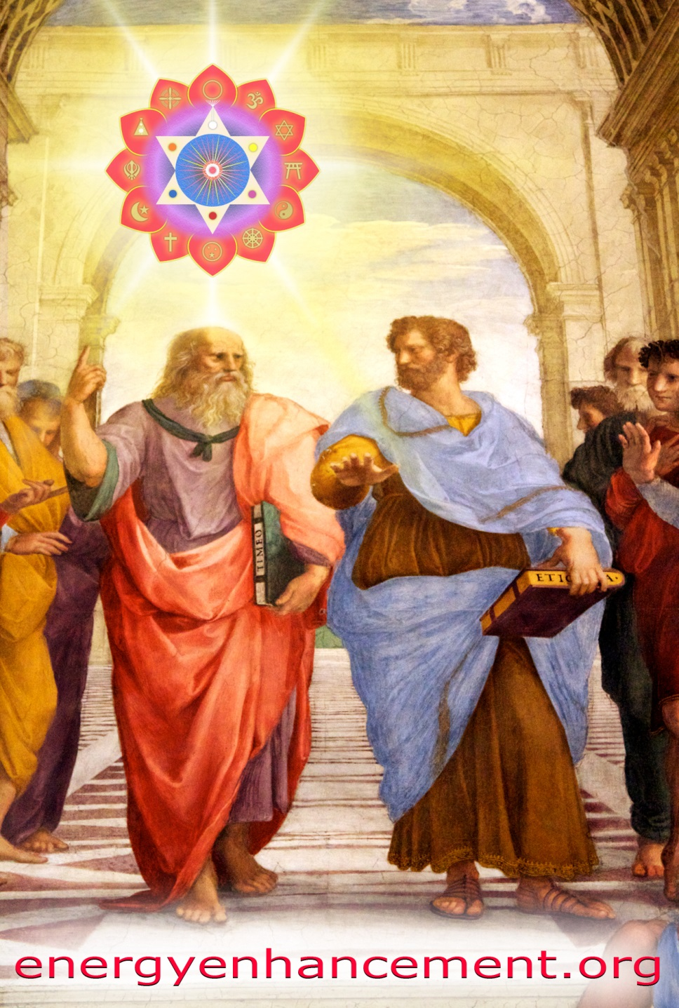

PLATO AND SATANIC BABYLONIAN SECRET AGENT ARISTOTLE "THE POISONER" OF ALEXANDER THE GREAT - BY RAPHAEL

ENERGY ENHANCEMENT MEDITATION
ENERGY ENHANCEMENT MEDITATION LEVEL 1 POWER UP!! GAIN SUPER ENERGY http://www.energyenhancement.org/Level1.htm
ENERGY ENHANCEMENT MEDITATION LEVEL 2 ELIMINATE ENERGY BLOCKAGES http://www.energyenhancement.org/Level2.htm
ENERGY ENHANCEMENT MEDITATION LEVEL 3 CLEAN KARMA BLOCKAGES AND PAST LIFE KARMA BY TRANSMUTATION http://www.energyenhancement.org/Level3.htm
ENERGY ENHANCEMENT MEDITATION LEVEL 4 MASTER ENERGY CONNECTIONS AND RELATIONSHIPS http://www.energyenhancement.org/Level4.htm
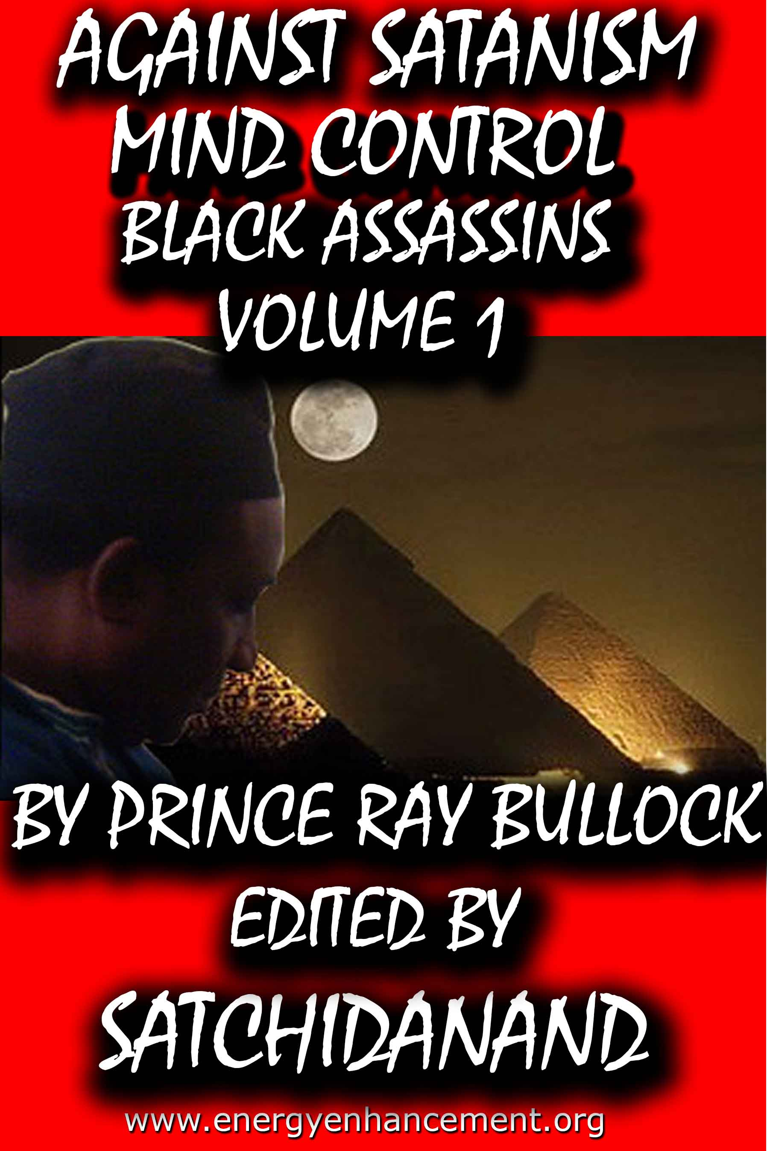
MIND CONTROL BLACK ASSASSINS VOLS 1-11 FREE!!

AGAINST SATANISM VOLS 1 – 6 FREE!!

- ON SIGN-UP AT..

energyenhancement.org

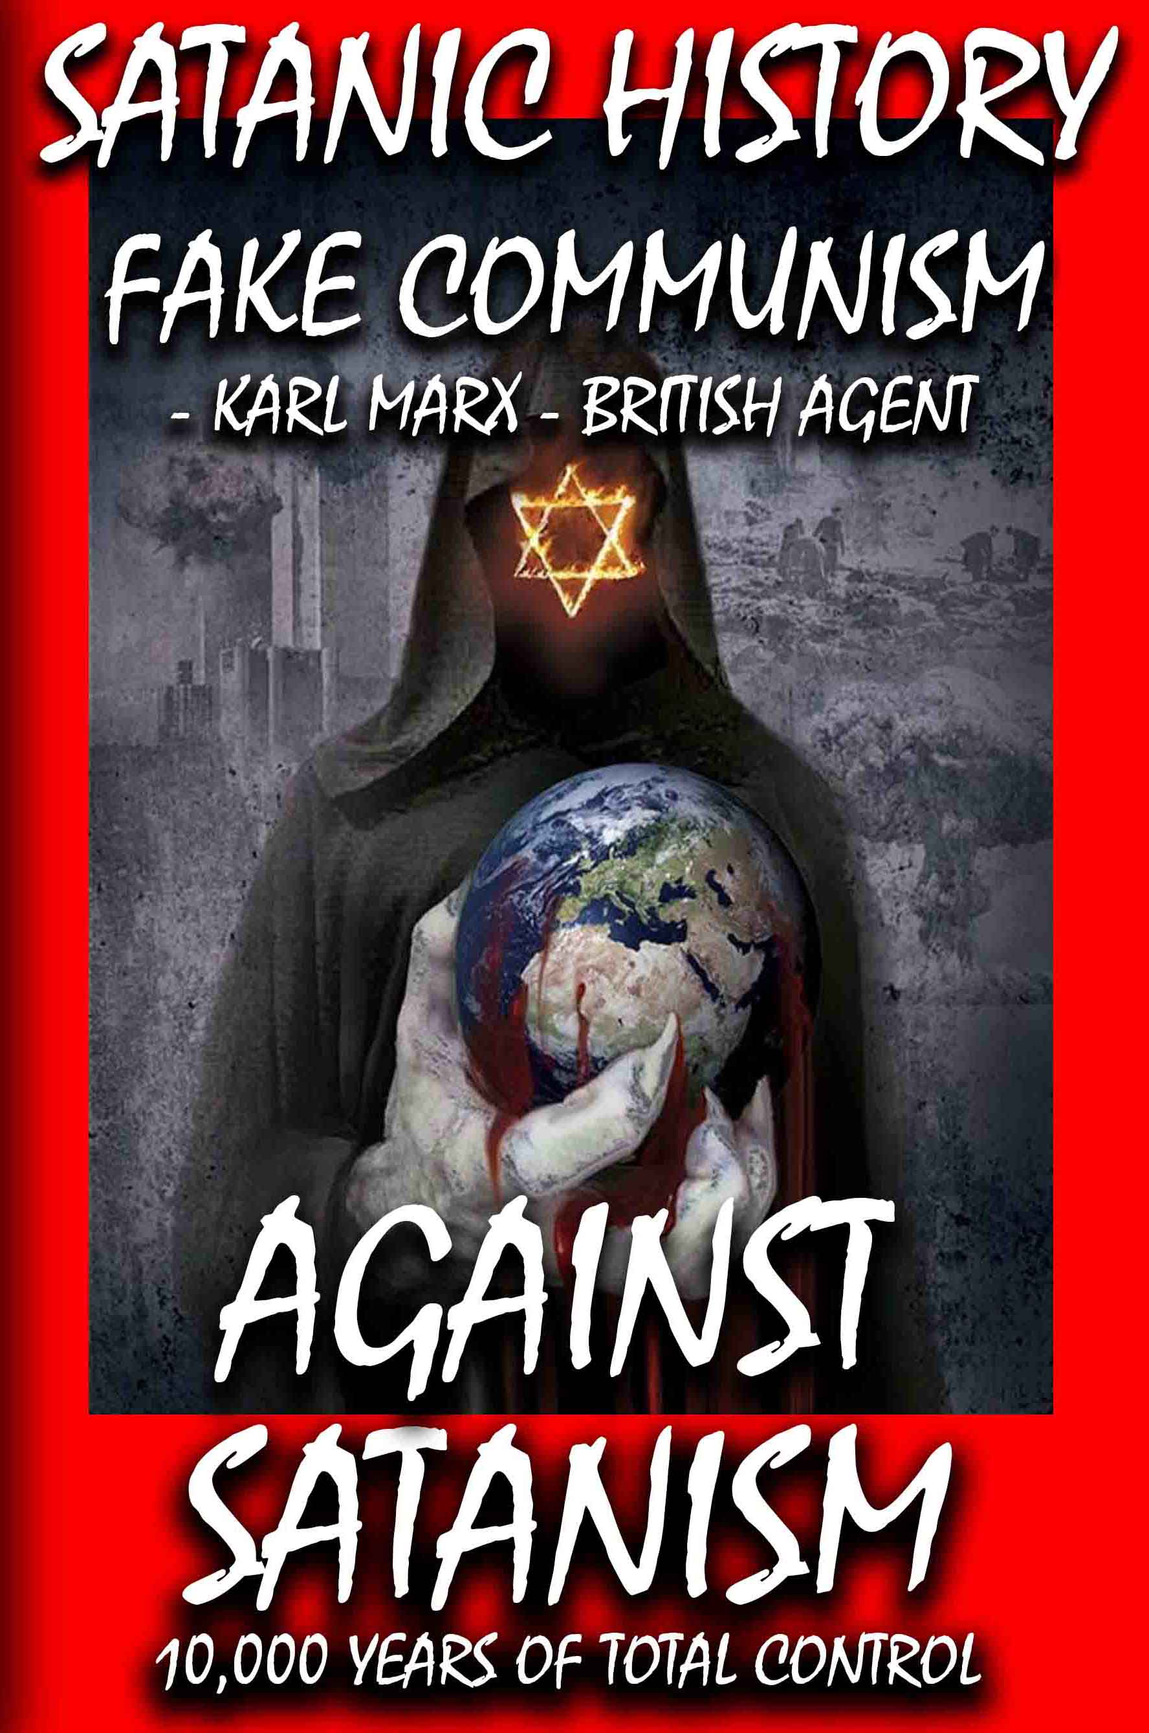

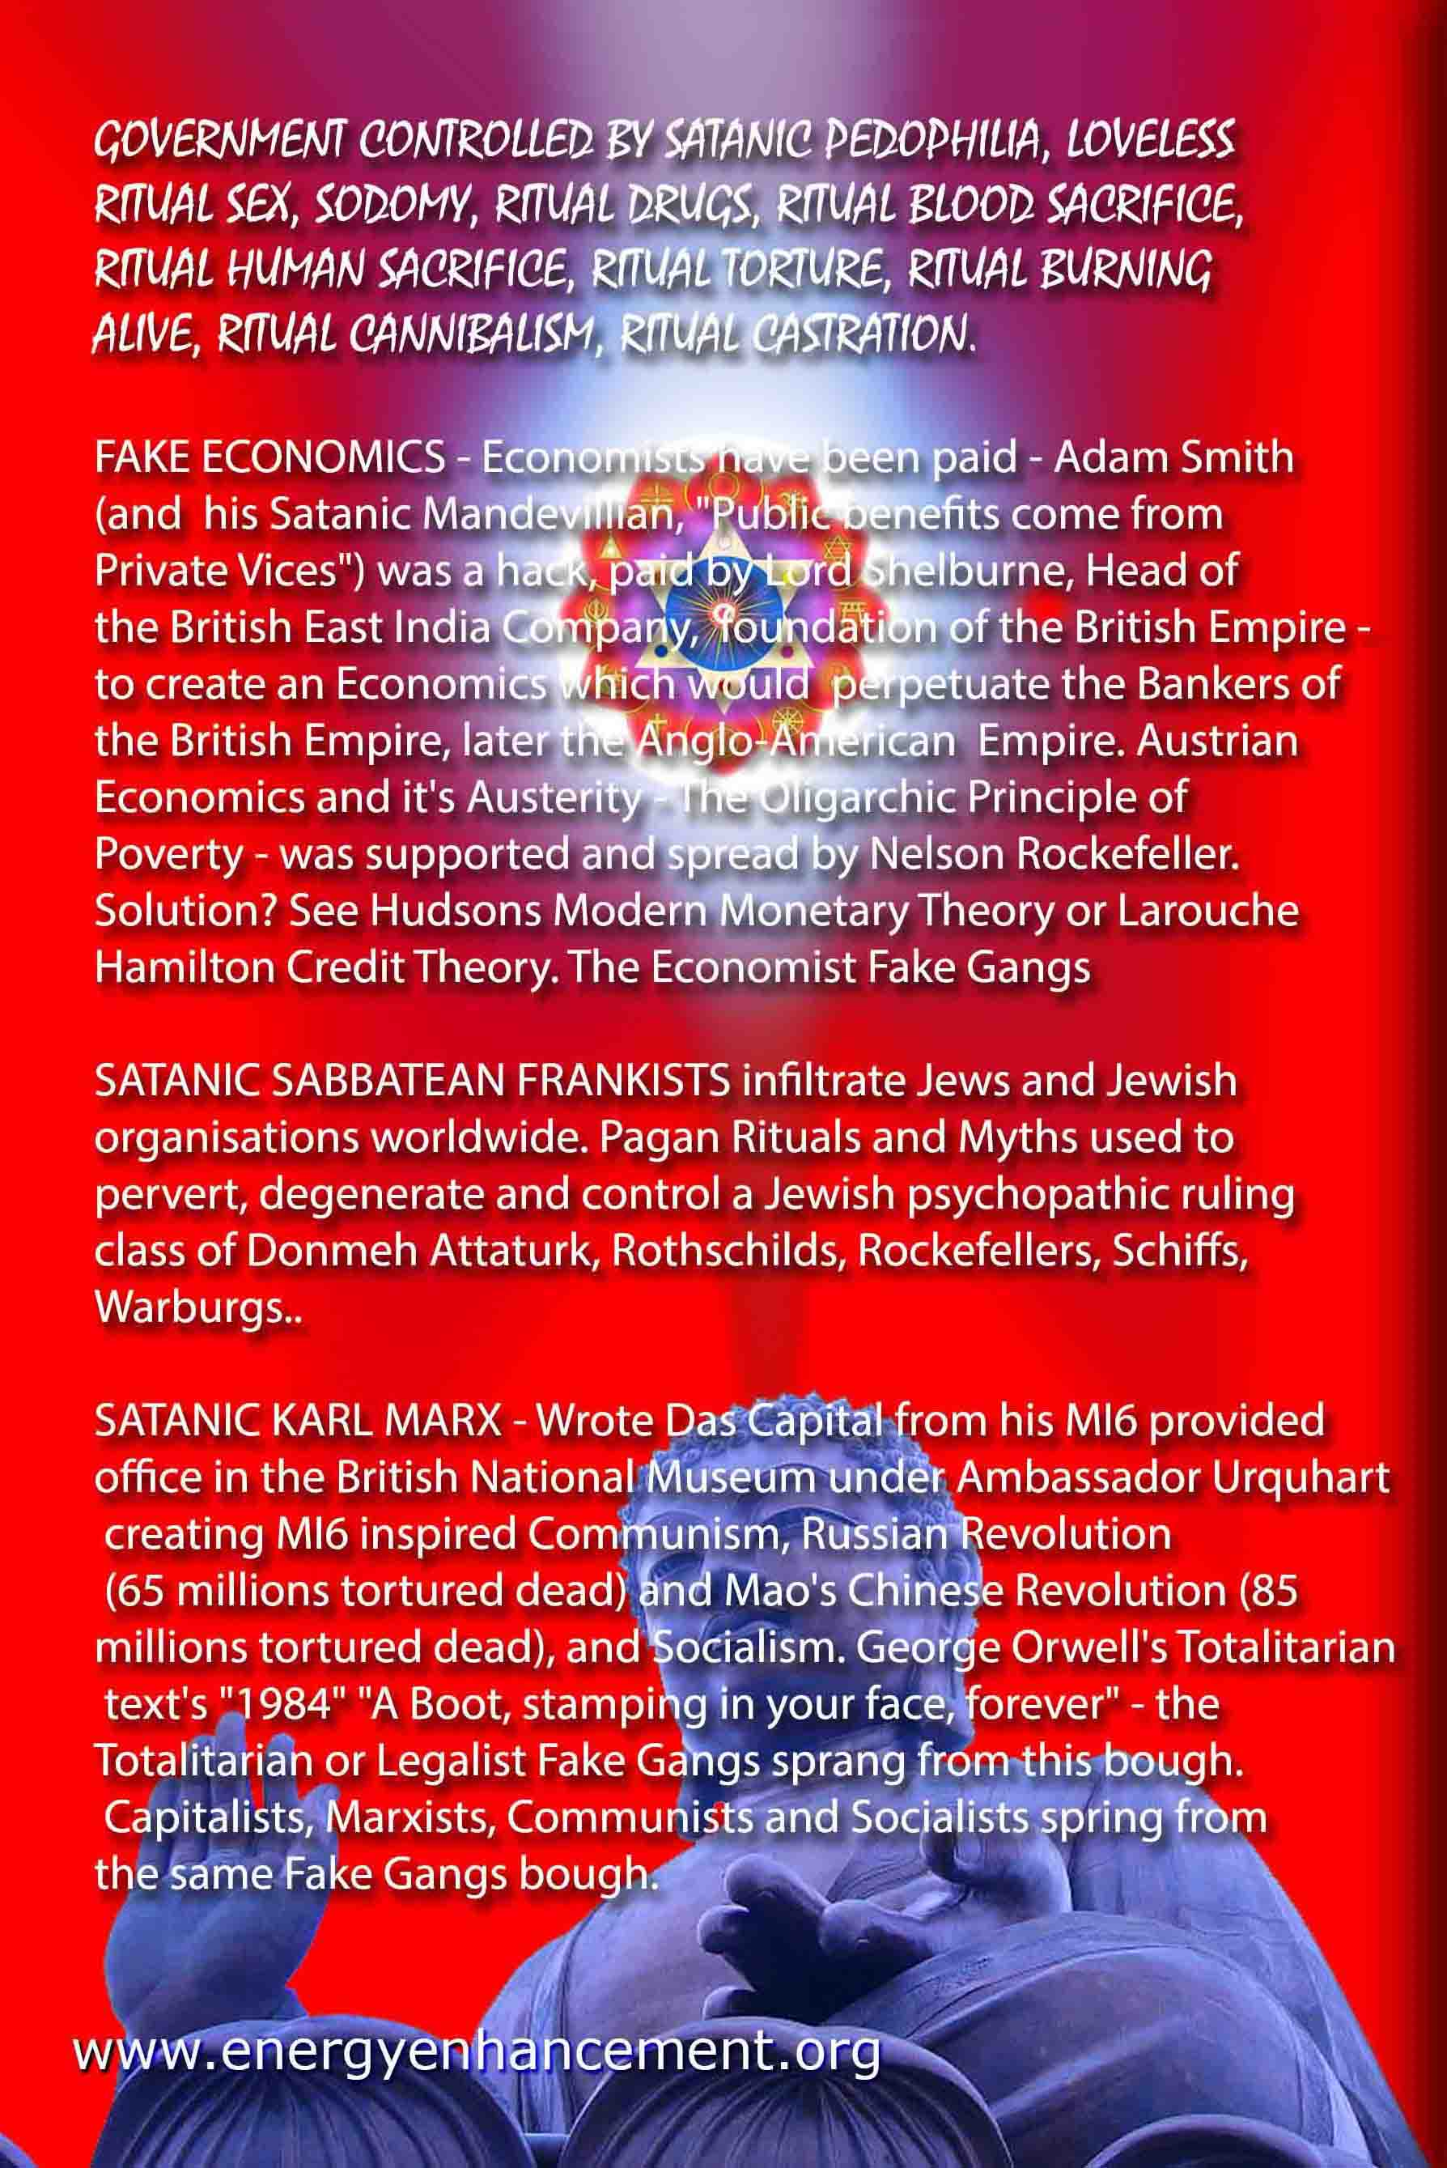

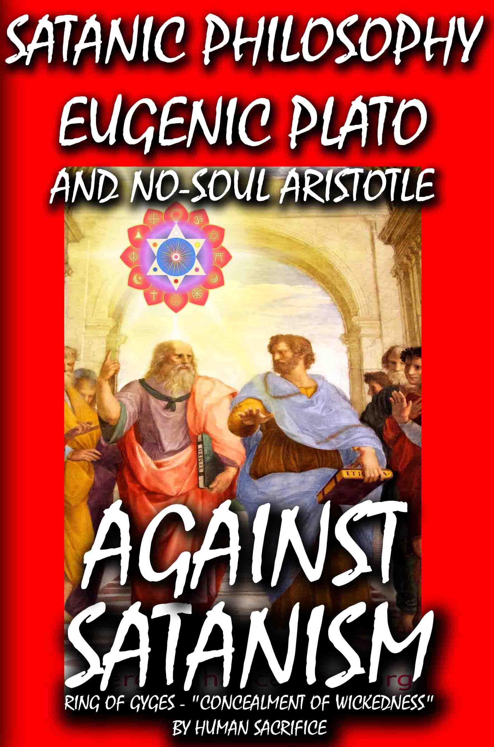

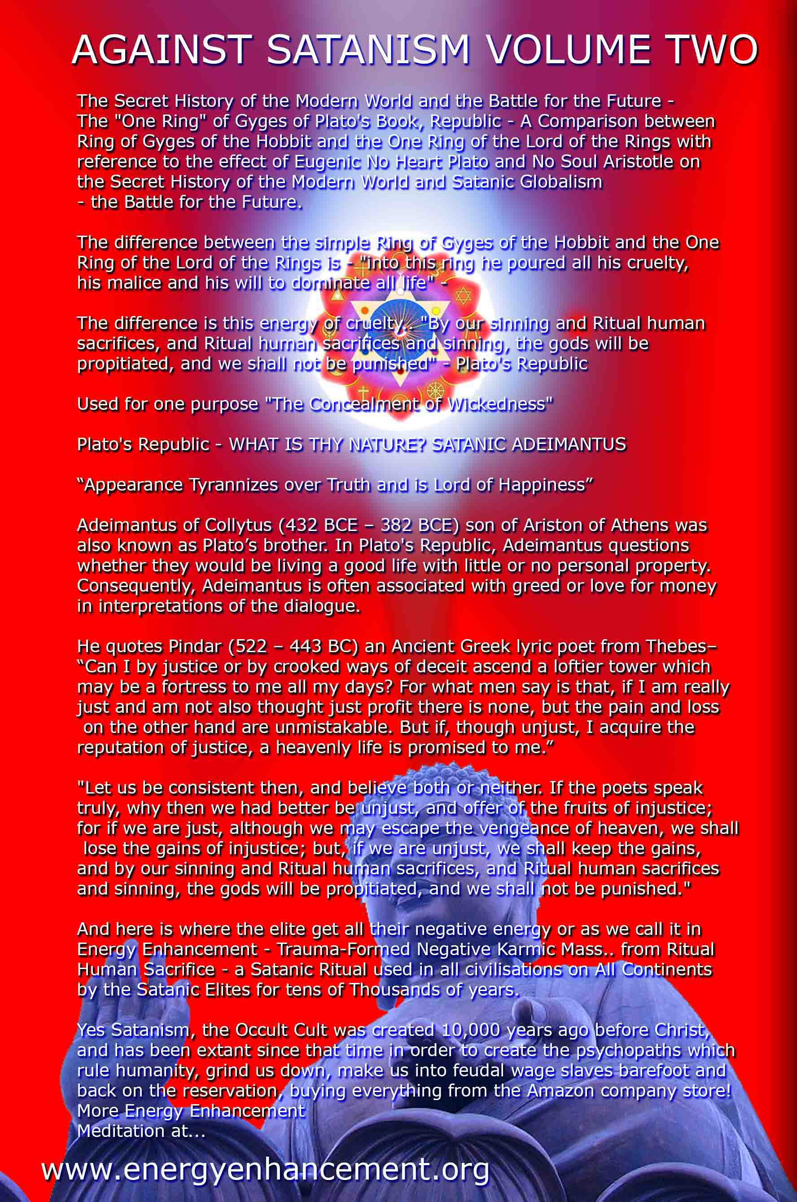

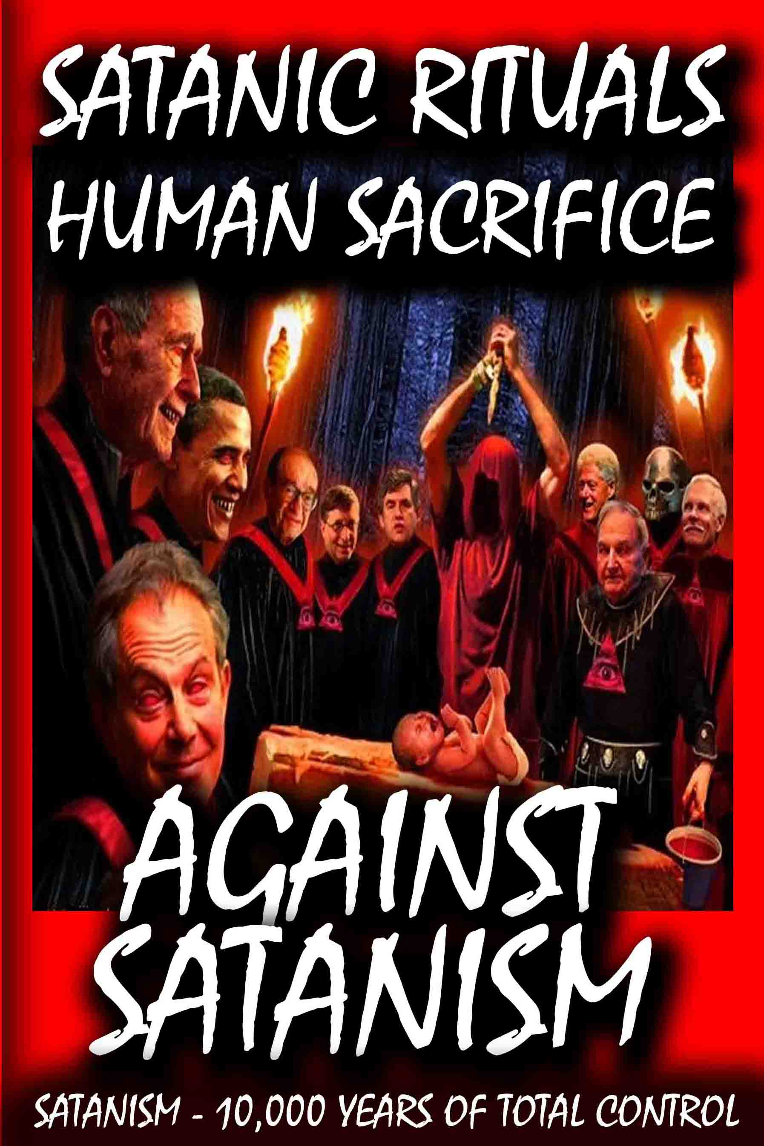

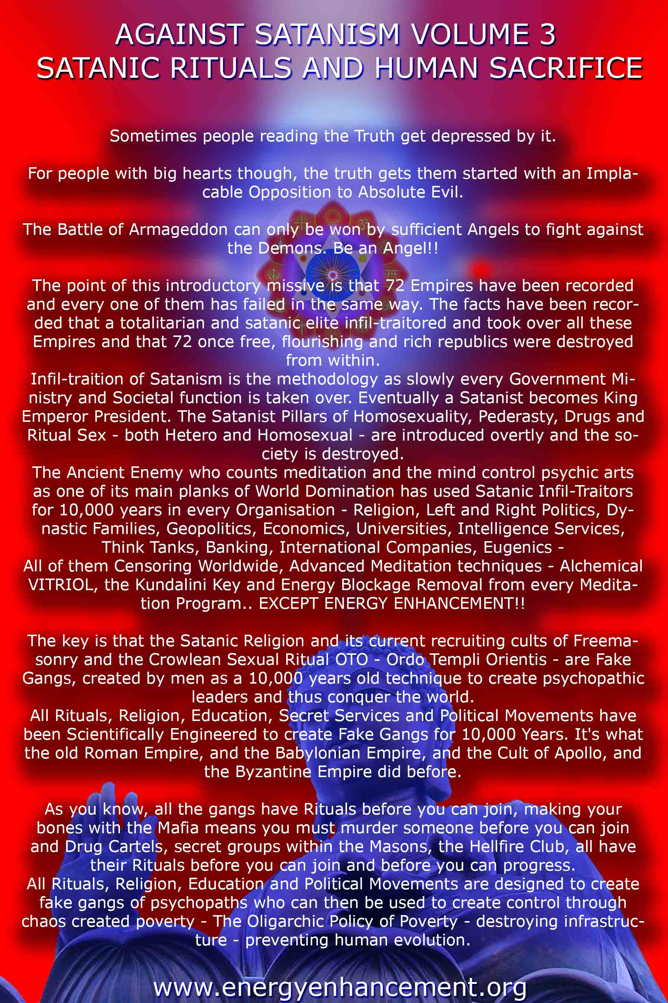

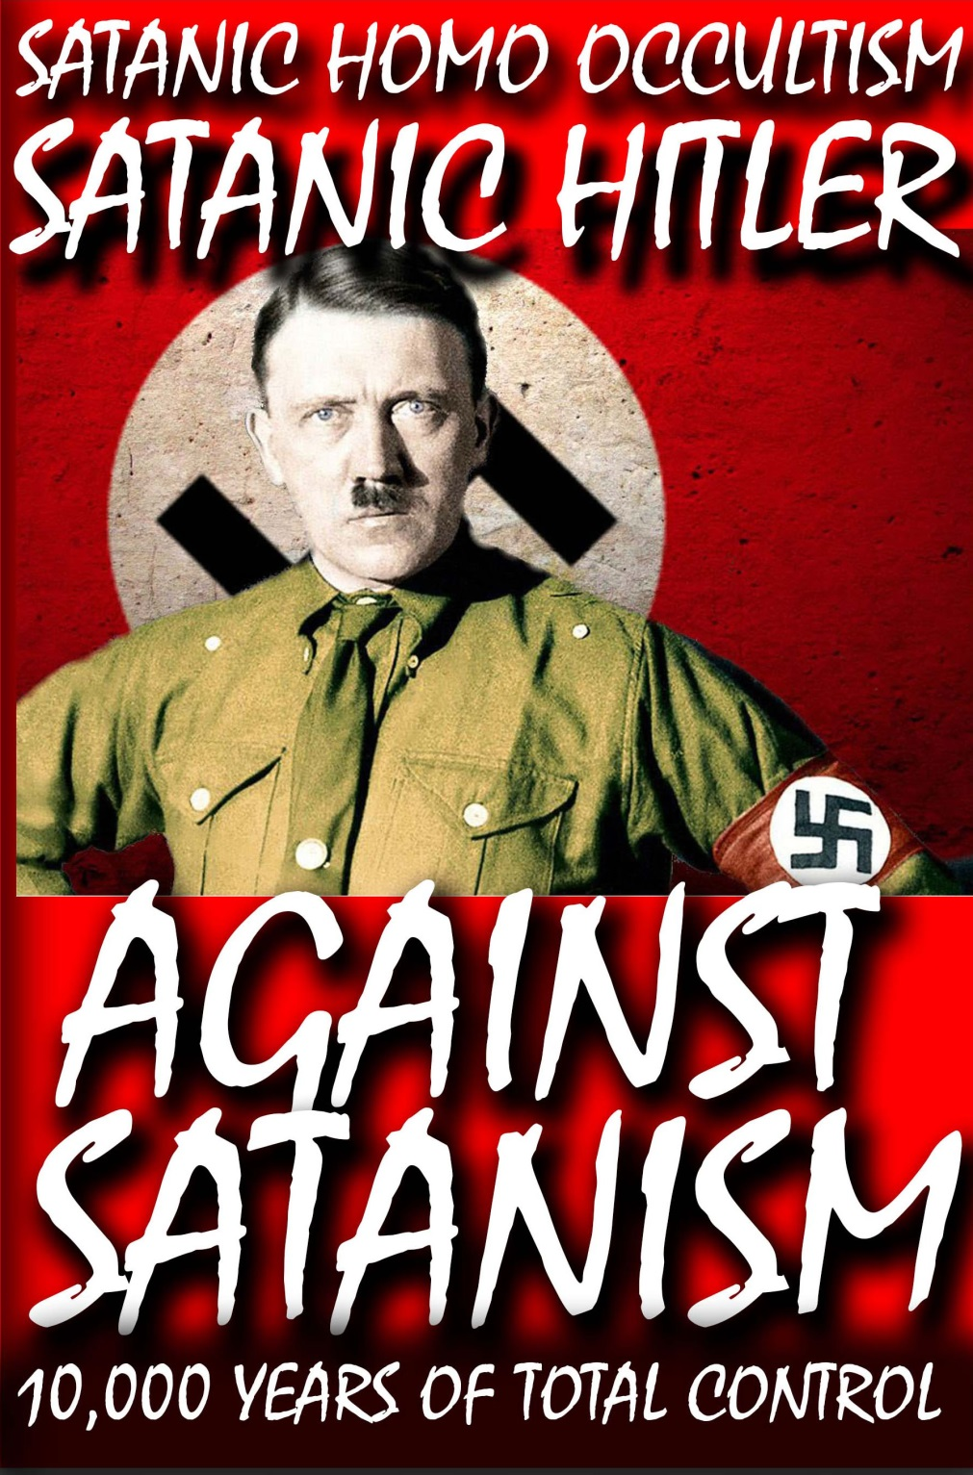

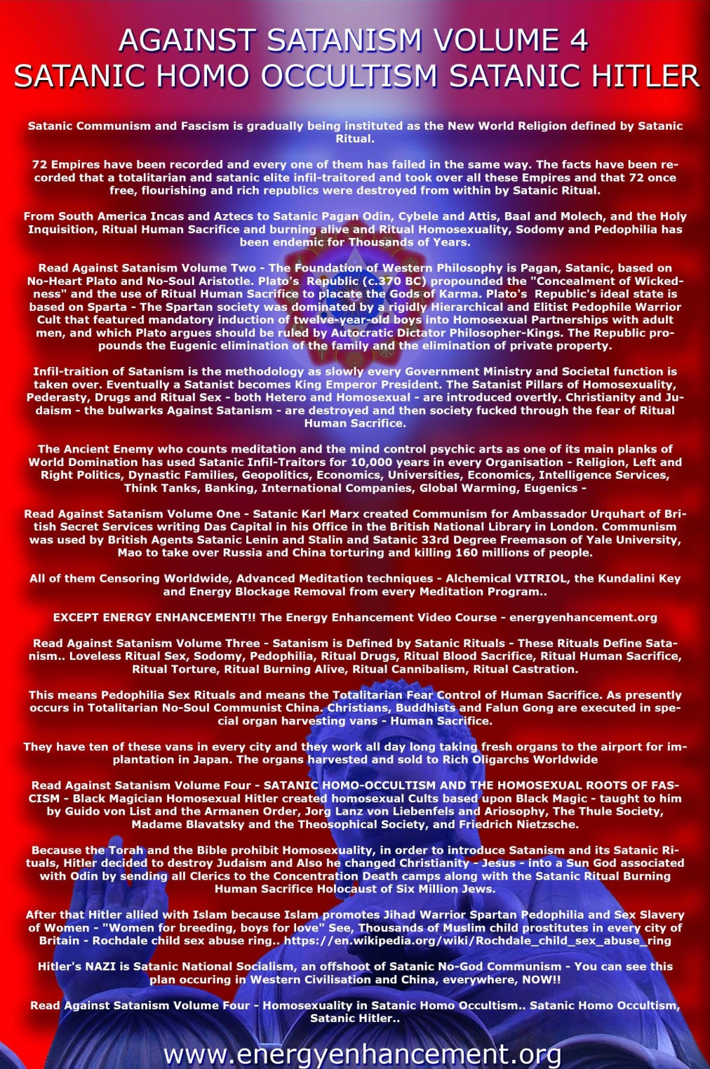

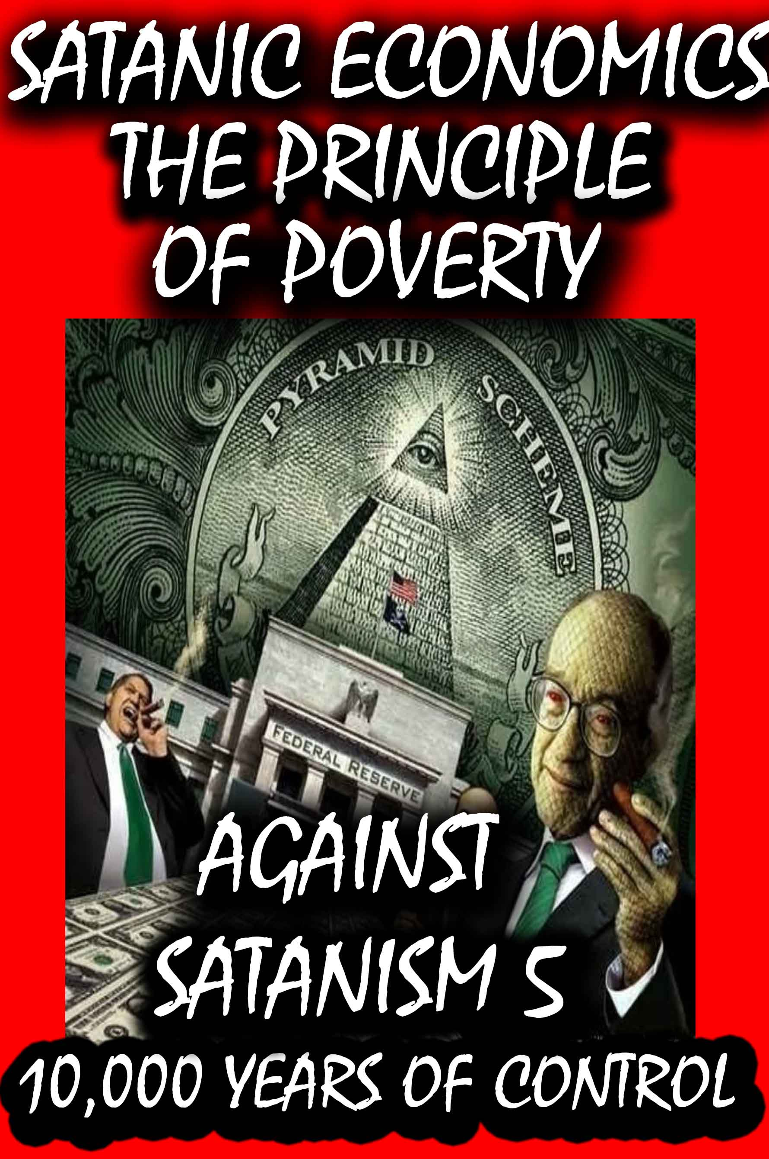

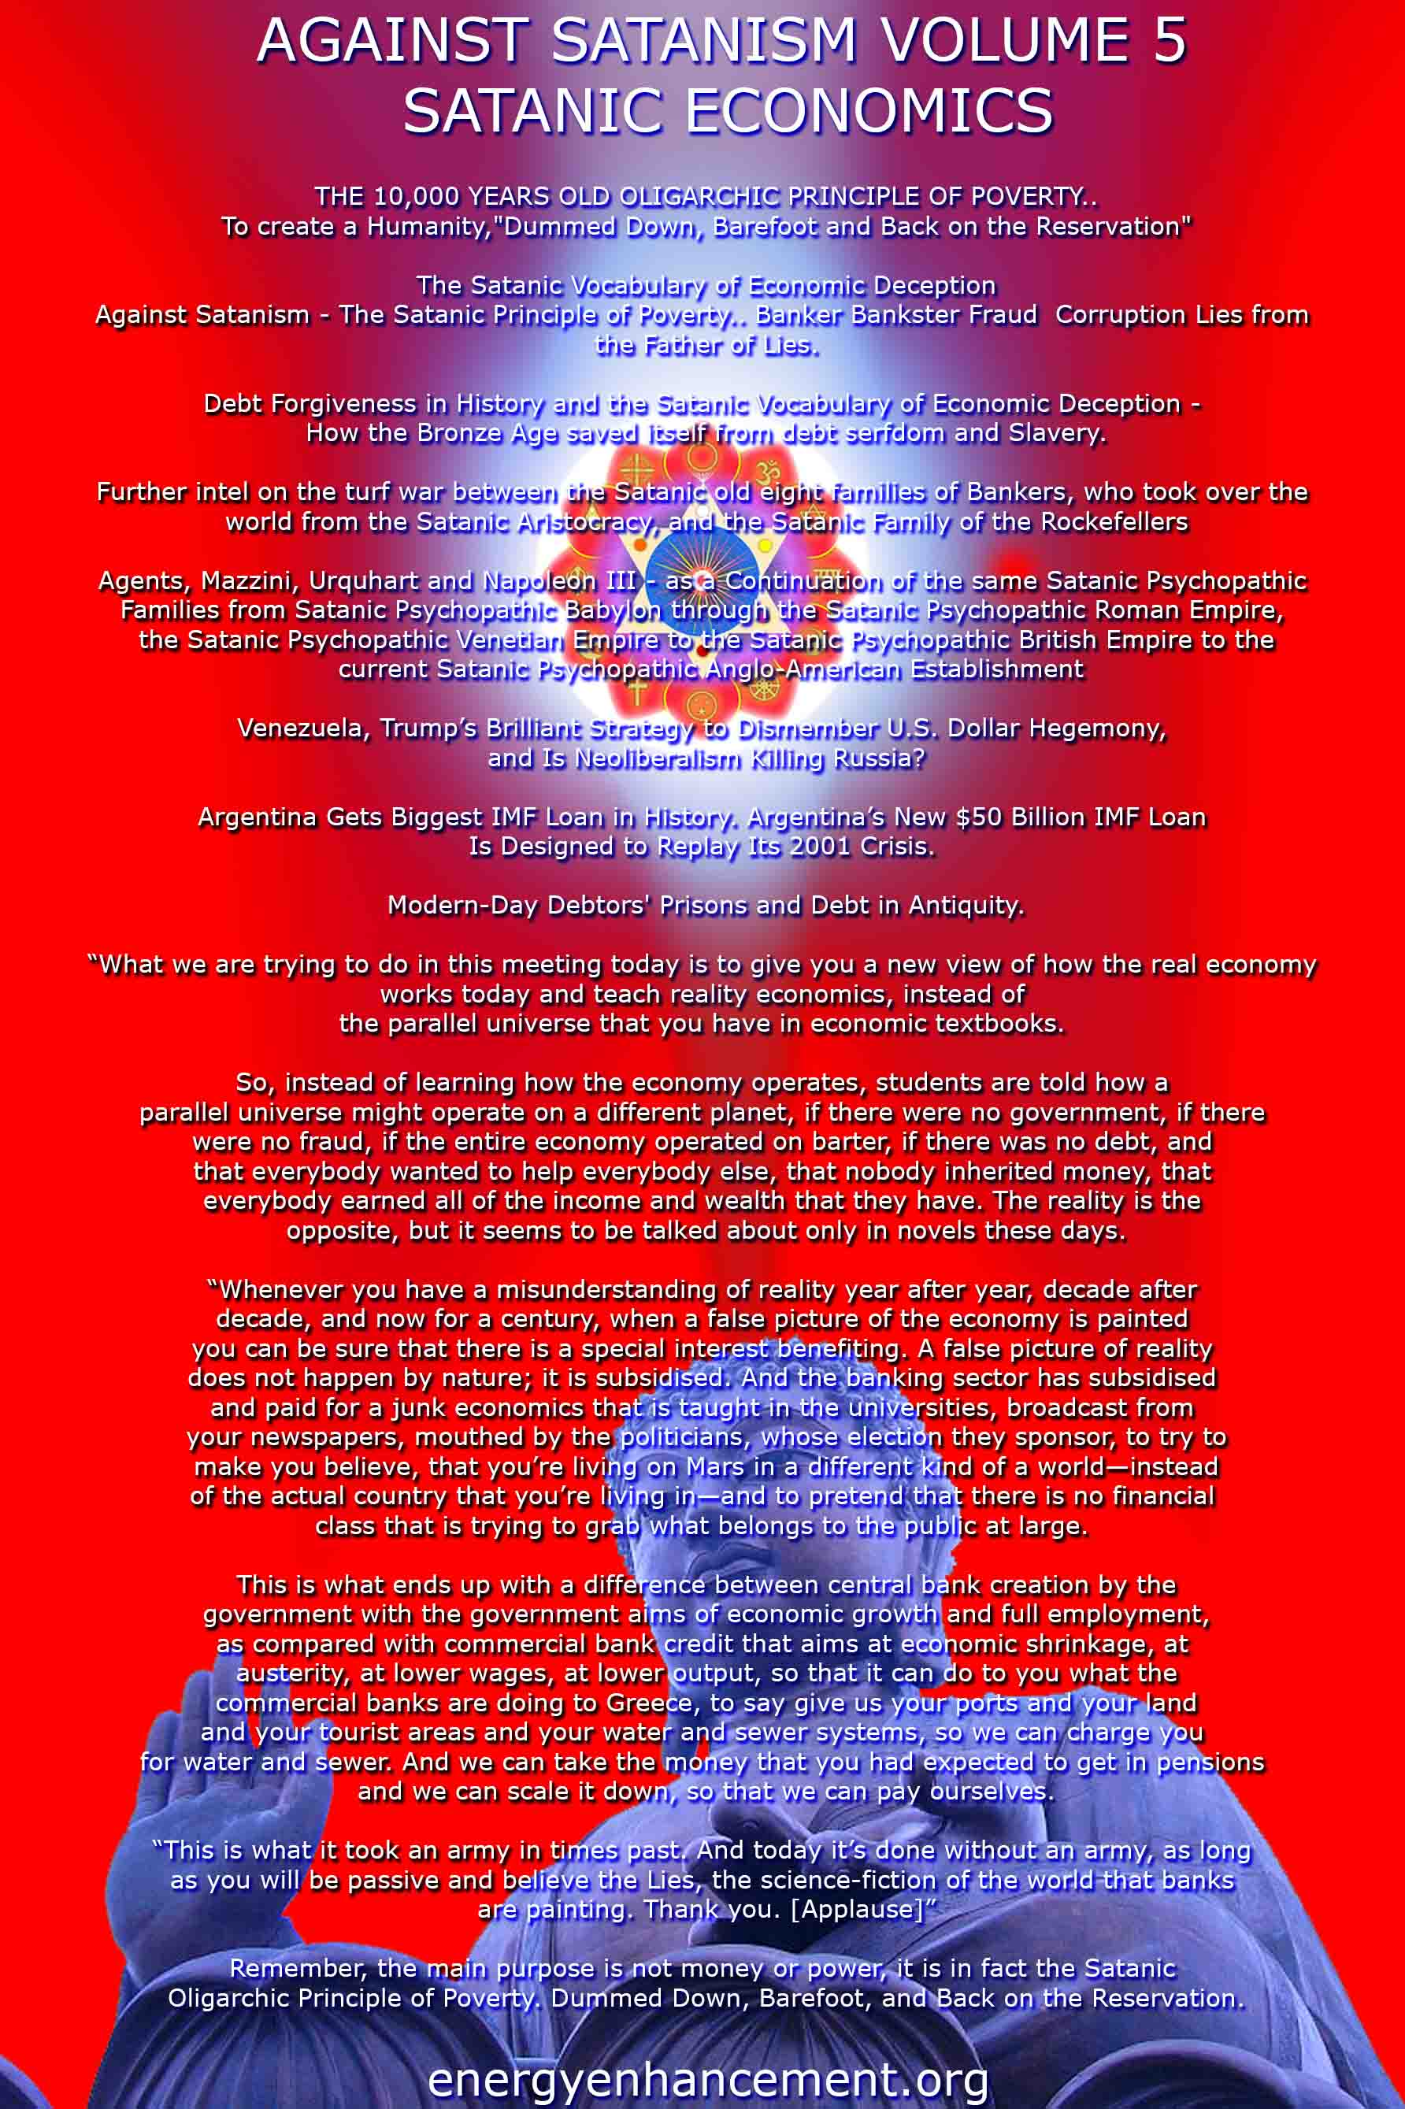

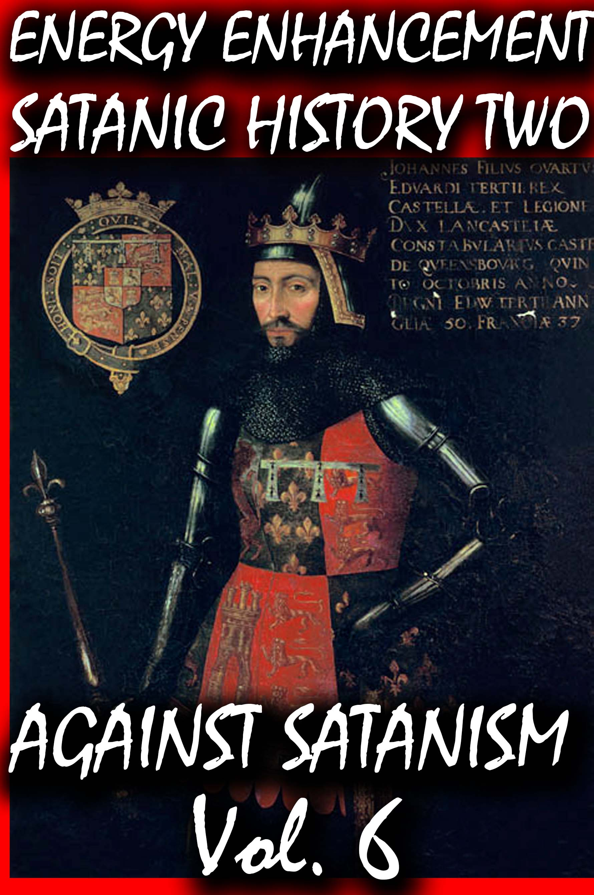
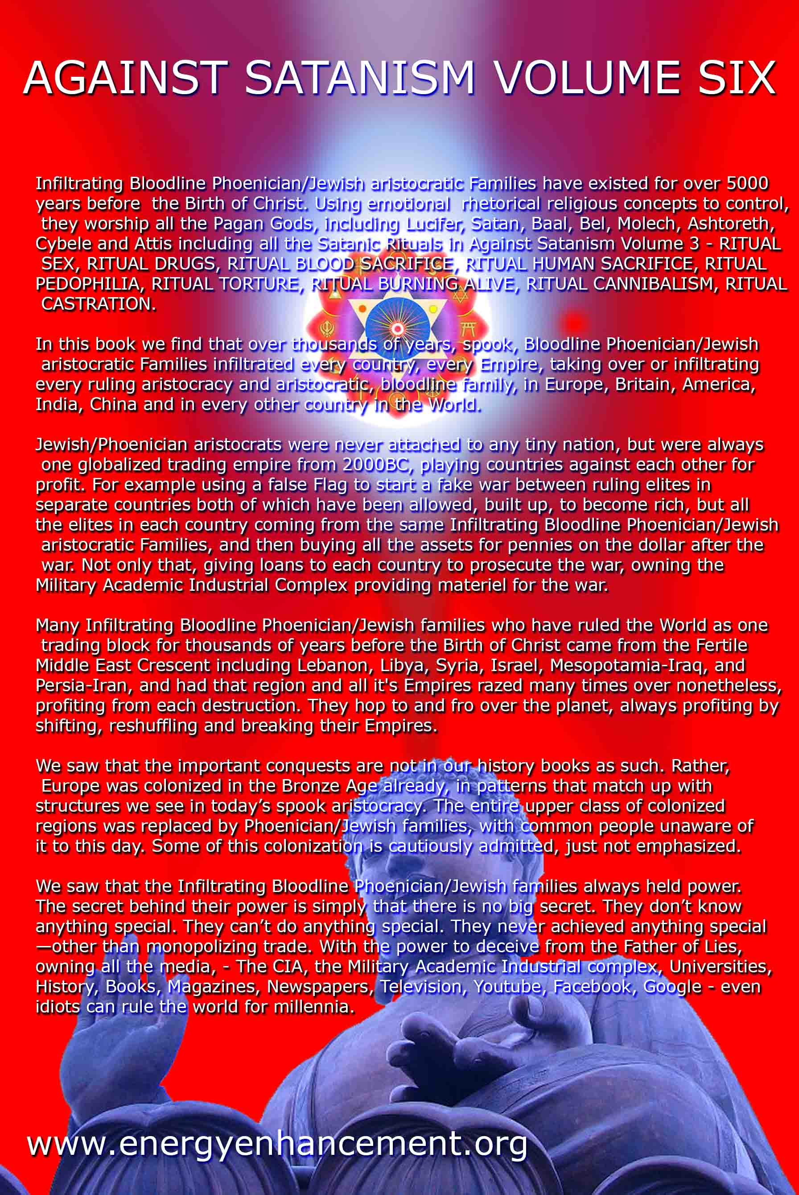
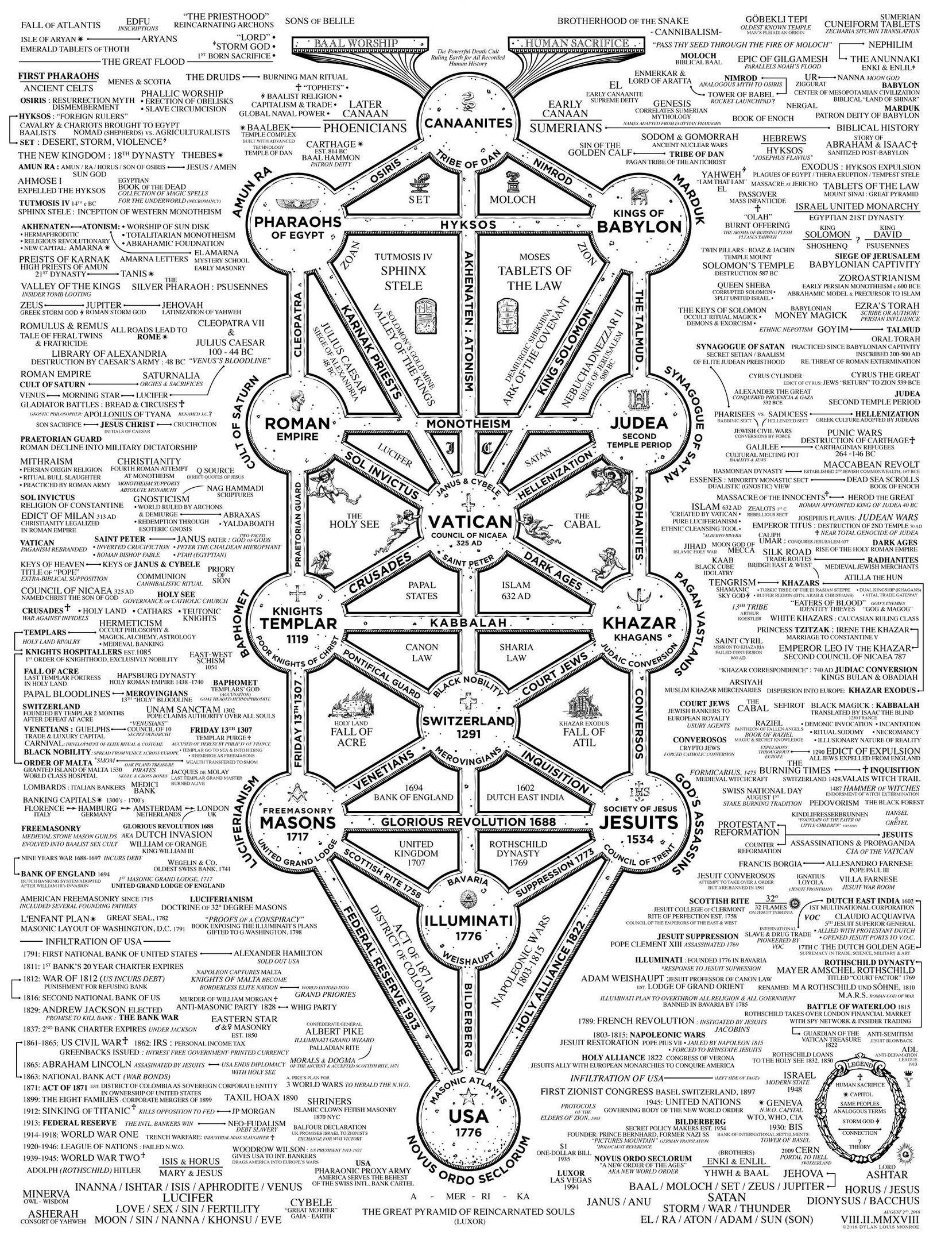

IN THE NAME OF SATAN, PALESTINE, NBA ILLUMINATI, BLACK SATANIC CABALS & MALAYSIA AIRLINES FLIGHT 17
22072014

In the Name of Satan, Genocide of the Palestinian People
Great SATAN (America) and Little SATAN (Israel) have become two of the most vile, despised, twisted and wickedness nations on earth that bathe in the blood of other nations for the Love for EVIL for the Sake of EVIL.[1]
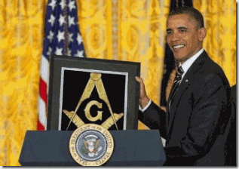
There is a great deal of controversy whether or not President Barrack Obama is a Luciferian 32° Prince Hall Mason. If he was, it would be still be secret.[2] In America’s current political state of affairs, it would normally be virtually impossible to reach the high levels and halls of secrecy and brotherhood that he has reached so fast without a Luciferian Blood Oath Covenant of Secrecy and Brotherhood and Pledge of Unconditional Support to Israel (King Solomon’s Temple). I believe that the Cyborg President has been initiated into Lucifer’s Workshop, the Masonic Fraternal Order of Brotherhood. That’s the way they roll at these levels in America.
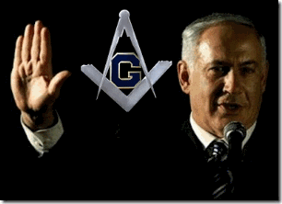
Israeli Prime Minister Benjamin Netanyahu, 33° Freemason, has publicly stated (see the Israeli publication Shishi, Spring 1994) that he is indeed a subservient Luciferian that was initiated into the Masonic Lodge while in the United States.[3]

I had never met the Late Great Mae Brussell before her death (assassination). For whatever reasons, I didn’t discover her works until the early 1990’s. Mae had been always under the threat of death to her and family. Mae was courageous and kept on pushing because she knew that her work was important to the struggle of the people all over the world. If we had met, it would have been a dangerous liaison because the system always react in a very certain vengeance when blacks and whites meet on any collective level to fight the power.
During the 1970s, I worked with a very good Jewish lawyer from the National Lawyers’ Guild defending the residents of Watts against a merciless onslaught and campaign of racial violence by the LAPD and LA County Sheriff’s Department. It seems that every courtroom we entered together, Hank would always be called into the judges chambers and reminded that he was crossing a thin line in supporting any Black Movement that they didn’t endorse, control or influence. With a certain sly grin, he would always tell me of the things they offered to distance himself from us. We always shared a laugh and moved on with our business to win cases against the police forces at least 90% of the time. However, Hank and I lived under no delusions. We knew very well that they meant every word. They play no games and their vengeance is certain. Due to extreme circumstances in fascist LA, we lastly had to separate for the health, safety and security of a lot of innocent families including my own. I later discovered that Hanks’ family was among the last Jewish families to escape Italy before they were arrested and committed to Nazi concentration-death camps.
The Elite Satanic Global Cabals of the ILLUMINATI exposed by Mae Brussell have turned America into Lucifer’s Workshop and the DEVIL’S PLAYGROUND. She was one of few and earliest researchers bold enough to publicly build upon a theory with very convincing and compelling evidence that the most powerful governments in the world are controlled by a thin line of a NAZI CABAL (SS Lucifer’s Servants) of about 5000 men, a group that went underground after the FALL of the THIRD REICH. She often traced world events- wars, elections, assassinations and false flag operations back to the movement of NAZI GOLD and the usage of well-known German signature code names in clandestine operations to instill and spread FEAR and utter CHAOS around the world. An extremely good example of her exhaustive and dedicated works putting puzzles together was in 1988, when she discovered the name “Adolf H. Schicklgruber” in a book of Marina Oswald’s poetry found in the Warren Commission artifact documents of the JKF Assassination. Shicklgruber was an operational cabal signature code name- the last name of Adolf Hitler’s mother.[4]
Many of the collective consciousness of universal peace, justice, harmony and balance can not be SILENT to the forces and entities that are compelled to destroy the Palestinians of the Gaza Strip for Love of EVIL for the sake of EVIL.
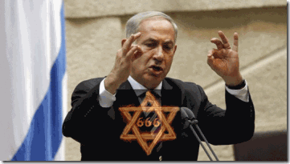
“Vengeance for the blood of a small child, SATAN has not yet created.” — Benjamin Netanyahu (@netanyahu) June 30, 2014
Great SATAN, Little SATAN and Global Satanic Cabals do intend and has started to fill SATAN’S Blood Vengeance void against the Palestinian People of Gaza right in front of our eyes – fully TELEVISED.
Gaza & SATAN’S BLOOD VENGEANCE NOT YET CREATED
The latest Israeli aggression against the Gaza Strip began when three Israeli teens were allegedly kidnapped. With absolutely no evidence, Israeli Prime Minister Benjamin Netanyahu blamed Hamas and the people of Gaza, collectively, for the kidnappings, and subsequently for the blood of the teens.[5]Netanyahu gave the military authorization to use “full force” against the Palestinians as stated above that is beyond the Pails of SATAN’S BLOOD VENGEANCE.[6]
Israeli military forces surround the densely populated Gaza (1.8 million) on all sides cutting off their access to land and sea. Israel wickedly block food, water, fuel, medicine, services and its residents from entering or leaving the strip.
Israel also with all the evilness beyond the Pails of SATAN control and also at will suspend power to all of the strip’s water and power systems. Gaza is an Israeli occupied open-air prison of people of color (Palestinians) tantamount to the Nazi Occupation of Warsaw, Poland of 1939.
Gaza is on FIRE

Invoking the name of SATAN, Netanyahu is talking about inflicting an unparalleled level of UNSPOKEN HORROR and unspeakable suffering on the Palestinians. And, we won’t be able to put things into context in the Gaza Ghetto unless you understand some of the dynamics of Lucifer’s Servants & the Warsaw Ghetto during WWII while the world stood by and watched the defenseless ghetto masses slaughtered and liquidated.
“Warsaw has to be leveled to the ground in order to set a terrifying example to the rest of Europe.” Son of Lucifer- Reichsfuhrer SS-1 Heinrich Himmler [7]
On the pretext of Israeli self defense for the three teens’ blood, Israel viciously attacked and for two weeks continue to terrorize the entire imprisoned population of Gaza and level their homes with bombs and rockets. Israel have turned Gaza into a full fledge “free fire” war theatre. They fire rockets into Gaza from ships at sea, and mobile land weapons platforms- tanks. They fire rockets and drop incendiary bombs upon their homes, schools, clinics, hospitals, utility systems and the residents of Gaza from the sky by jets and helicopters maiming and killing hundreds of men, women and children, lately four children playing soccer at the beach, below, all behind SATAN’s unspoken blood VENGENCE.[8]
It is totally wicked, disingenuous and criminal for corporate mass media, UN and the West to demand that both sides of the so-called Israel-Palestinian Conflict cease aggressions when Israel attacked Gaza in a reign of terror and violence unlike anything seen since the SS- Lucifer’s Servants leveled the Warsaw Ghetto.
The American/European international community deliberately ignore and downplay Israeli war crimes and its blatant violation of the international and human rights of the Palestinians. The people of Gaza have a legitimate right to resist occupation that is tantamount to the uprising of the Polish Jews to the Nazis’ occupation of Warsaw and human atrocities they committed against the people beyond the Pails of SATAN’S Vengeance. [9]
For any other world leader that would invoke the name of SATAN to attack a nation or people, there would have been an international humanitarian outcry.
LUCIFER’S UNSPOKEN HORROR
Israel’s infliction of state action Lucifer’s Unspoken Horror upon the Palestinian People sets a very disturbing precedent among so-called civilized nations of the 21st Century, and it represents unfinished business with the SS, Lucifer’s Servants, of the 20th Century, the world’s greatest racial mass murderers.
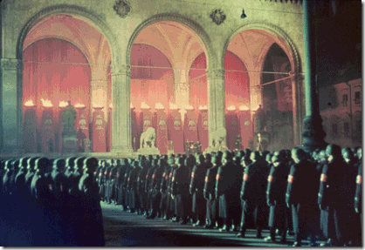
Secret SS Initiation Ritual
In the wake of the military defeat of the Nazis during WWII, the Werhmacht (Army), Kriegsmarine (Navy) and the Luftwaffe (Air Force) of the unified armed forces of the National Socialist State of Nazi Germany surrendered, and for the most part these soldiers returned to civilian life.[10] Unlike the Werhmacht, Kriegmarine, and Luftwaffe, Himmler’s elite Schutzstaffel special forces, the Waffen and Allgemeine SS were a fraternal order initiated into knighthood bound by a blood oath covenant of secrecy and brotherhood.[11]
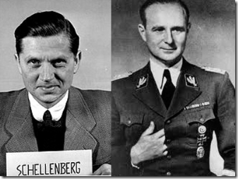 SS Wicked Walter and SS Wolff with the ILLUMINATI Hidden Hand Symbol
Before the end of WWII, New York Wall Street lawyer Allen Dulles, working for the OSS in Berne, Switzerland began secretly negotiating with SS Himmler’s high ranking personal secretaries Brigadeführer SS “Wicked” Walter Schellenberg (Allgemeine SS) and Obergruppenführer SS Karl Wolff (Waffen SS) to workout a secret PACT WITH THE DEVIL.[12]
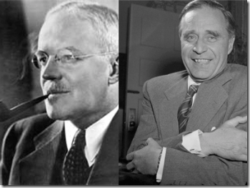
CIA Director Allen Dulles (Knight of Malta) & Prescott Bush – Master Mason Acknowledgement Arm Gesture Signature
Himmler’s bargaining chip with New York Wall Street and US industrialists had been the SS’ secret treasury troves of blood gold, securities, and money currencies that the SS had stashed, laundered and invested in worldwide diversified industries and securities with the clandestine assistance of the likes of Allen Dulles (CIA), his brother John Foster Dulles (U.S. State Department); and Grandfather Prescott Bush that was/is worth billions of dollars.
To access the SS’ secret vast and lucrative secret blood capital reserves and networks, you had to be initiated into the Himmler’s secret Satanic hierarchal fraternal order, Master Mason or the ILLUMINATI bound to a Satanic Blood Oath of Secrecy and Brotherhood. As a Nuremberg war criminal organization, Himmler’s SS weren’t defeated, imprisoned, or crushed for war crimes and mass genocide. Lucifer’s Servants just changed venues and uniforms.
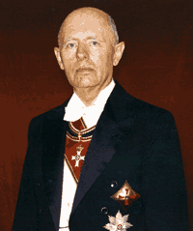
Nazi Generalmajor Reinhard Gehlen, Knight of Malta- Knights of Saint John
In 1945 as result of deep cover secrecy, Dulles was instrumental in illegally sneaking Hitler’s Generalmajor Reinhard Gehlen into the U.S. wearing an American General’s uniform, and then, along with U.S. industrialists, Wall Street Bankers and Lawyers, “Gehlen with his experience, ‘helped’ us [U.S. Government] design and implement the structure of our own intelligence command organization.” [13]– The DEVIL’S WORKSHOP.
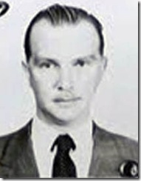
Baron von Bolschwing- Heinrich Himmler’s Master SS Espionage-Counterintelligence Agent
According to recent declassified top secret documents, 1954, SS-Hauptsturmführer Baron Otto von Bolschwing, BEAST of Bucharest also entered the country under cloak and a general’s uniform as U.S. Army Captain Albert A. Eisner [Eisner-hower] as Gehlen’s representative to the CIA directed by Allen Dulles. Baron von Bolschwing boosted partly that he intended to enter the country to become a U.S. citizen to work in the clandestine design and implement the structure- “political affairs” of the National Republican Party.[14] – The DEVIL’S WORKSHOP.
Baron von Bolschwing, the David Niven of the SS, is extremely important in that he was by ancestral bloodlines linked to the secret Order of Brothers of the German House of Saint Mary in Jerusalem (Teutonic Knights).[15] Baron von Bolschwing is also a bloodline related to the Poor Fellow-Soldiers of Christ and of the Temple of Solomon commonly known as the Knights Templar.[16] The entire structure and symbolism of the secret Knights Templar, Teutonic Order of Knights and its subservient modern Freemasonry is set in Israel (Ancient Canaan) at the Temple Mount of Solomon’s Temple. They intend to rebuild Solomon’s Temple in Jerusalem as the capital of the New World Order from which the biblical Anti-Christ shall reign.[17]

Baron Bolschwing, still subject to top secret governmental classification, was no minor CIA (MK ULTRA/MONARCH, Project CHAOS) secret player in America’s clandestine domestic affairs and political assassinations (Malcolm X, JFK, RFK, Little Bobby Hutton, Dr. King, etc.) of the 1960s-70s, 33rd degree Scottish Rite Master Mason FBI Director J. Edgar Hoover (COINTELPRO) was subservient to Baron von Bolschwing, a Knight directly connected to the Masonic/ILLUMINATI Hierarchal Teutonic Knights of Jerusalem and the Knights of the Temple of Solomon.
Baron Bolschwing & Palestine
In 1939, Baron von Bolschwing had been a leading SS counterintelligence-espionage agent in Jerusalem under cover as an importer. According to captured SS records, one of Bolschwing’s lead Zionist agents was Fieval Polkes. For SS counterintelligence services, Polkes ran recruiting and training camps for Jewish youth inside Germany that recruited them to emigrate to Palestine as informants to provide intelligence about British Affairs. From the captured SS records, part of SS espionage plans was to increase brutal Nazi persecution of Jews to compel Jewish immigration into Palestine.[18] The Satanic principled SS genocidal and Dual Janus- Good/EVIL Mindset is deeply rooted in Zionist Israel– The DEVIL’S WORKSHOP.
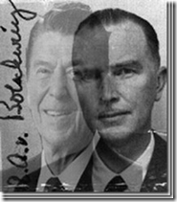
Baron Bolschwing is also extremely important in that he was California’s resident SS officer residing in Roseville, just outside of California’s seat of power in Sacramento. In California’s shadow government political affairs, Republican Governor and U.S. President Ronald Reagan had been Baron Bolschwing’s secret alter ego, and a puppet of the Knights of the Black Sun.
By the time President John F. Kennedy realized that Lucifer Servants’ secret brotherhood and network societies’ were developing America into their DEVIL’S WORKSHOP and exposed it to the nation, they had been well into plans since his election in 1960 to kill him and put their patsy, Republican Richard Milhous Nixon, into the Whitehouse.
The unfinished business in exposing and crushing Lucifer’s Servants and their blood covenant secret networks of evil that have clandestinely infiltrated and control some of the highest levels of government, industries and business has helped push America into the 21st Century, once again, as one of world’s greatest perpetual purveyors of violence and EVIL in the world- today.
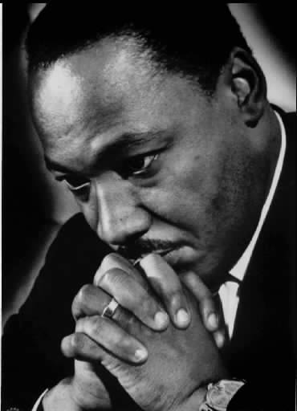
“The greatest purveyor of violence in the world: My own Government, I can not be Silent.” -Dr. Martin Luther King, Jr. [19]
When Selling an Invasion- Follow the Little EVIL Genius, Josef Goebbels
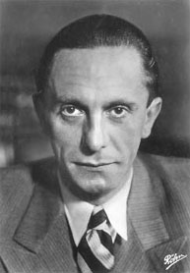
Zionist Israel had a big problem in its reign of terror against the Palestinian People. No so-called civilized nation or people can support or justify their genocidal assault on the Palestinians in the name of SATAN. The collective punishment and mass slaughter of Palestinians in SATAN’S name cannot and will not stand the light of day.

The Israelis began its latest assault on the Palestinians in a blood revenge that “SATAN HAS YET TO CREATE” for the alleged- most likely false flag deaths of three Israeli teens. By the way, the FBI has recently contradicted Israel’s propagandized facts and circumstances surrounding the deaths of the teenagers.
Before the teen’s bodies were recovered, Netanyahu alleged that Hamas carried out the kidnappings of teenagers. The Israeli military search for the kidnapped teens began “Operation Brother’s Keepers” in full force in mid-June with beating up about 600 Hamas members (including legislators) and trashing about 2100 homes; Israeli forces killed at least 7 Palestinians. Israel also heightened its daily air strikes on the Gaza.[20]
The FBI contradicts Netanyahu’s version of the facts and circumstances surrounding the alleged kidnappings that he used to demonize, attack the Palestinians and inflame the public passions for over two weeks. The FBI reported that 10 shots from a gun with a silencer could clearly be heard on the recorded tape. The FBI says that the teens were executed right then and there while one was on the phone with police. There was no kidnappings and the assailants are still unknown.[21]
Well, now that the story about the kidnapped murdered teens has fallen apart and the Palestinians responded in self defense to Israel’s SATAN’S Blood Vengeance “Operation Brother’s Keepers,” President Obama now says that Netanyahu is telling him that the new storyline is that Palestinian terrorist are tunneling into Israel and its ground operation into Gaza is to deal with the “TUNNELS.”
When selling the merciless bombings, invasion and mass murder of Palestinians in Gaza to the global masses, you follow Reich Minister of Propaganda Josef Goebbels’ book of scientific mass propaganda guidelines.

Netanyahu: “Propaganda must facilitate the displacement of aggression by specifying the targets for hatred.” – Josef Goebbels[22]
As the basic psychoanalytic principle of displacement maintains- the aggressive tendencies denied expression (In the Name of SATAN) against the object (Palestinians) instigating the aggression tend to be directed against non-instigating objects (Hamas’ Terror TUNNELS).[23]
The Fuhrer Adolf Hitler also wrote in ‘Mein Kampf’ with regards to the truth: if you are going to tell a lie, tell a big one and if you tell if often enough, people will begin to believe it.[24] Even the U.S. State Department has started to echo that same propaganda by blindly and unconditionally supporting Israel’s right to defend itself against the Hamas’ so-called Terror TUNNELS that the Israelis has known about for a long time. It’s on YouTube- the Kentucky Fried Chicken Tunnels.
Hamas’ KFC Fried Chicken Tunnels
The State Department said that “We defend Israel’s right to do what it’s doing with regard to those tunnels.” Sunday marked the most deadly day in the Gaza ground invasion so far, with The New York Times reported that at least 87 Palestinians and 13 Israeli soldiers dead.

“It’s a hell of a pinpoint operation. It’s a hell of a pinpoint operation.” Secretary of State, John Kerry[25]
Yes, it is a hell of a pinpoint and limited military operation to allegedly seal off Hamas’ Terror TUNNELS from inside Gaza. It’s another hell of a piece of propaganda that Kerry has to continually try to sell to the American public and global masses for slaughtering Palestinians by the hundreds and merciless leveling their communities and homes to rubble. The four (4) children blown apart playing soccer on the beach in Gaza had nothing to do with TUNNELS. Blowing apart Palestinian elders, women, children, homes, businesses, schools, sole electric plant, clinics and (26)hospitals including a geriatric hospital have nothing to do with “TERROR TUNNELS.” Eighteen (18) Palestinians (largely elders, women and children) were killed and over 200 injured Thursday when an Israeli shell slammed into a UN-run school, the third UN Facility bombed, harboring thousands of civilians taking refuge from SATAN’S UNSPOKEN VENGEANCE had nothing with TUNNELS.
Have you ever asked yourself why the Israeli Defense Forces (IDF) can’t seal off the so-called Terror TUNNELS from Israel’s side of the border without slaughtering Palestinians on the street? During the last couple of days, a child is slaughter every hour on the hour in Gaza. Make no mistake, the “TUNNELS” is the latest pretext to demonize, terrorize, liquidate the Palestinian masses and level the Gaza Strip to rubble for a future New World Order of illegal Israeli settlements.
Even Netanyahu and the ILLUMINATI CORPORATE MASS MEDIA drum beat and glanderous exaggerations about Hamas’ Terror TUNNELS will also come to rest. But following Goebbels’ Propaganda guidelines, Israel will continue to use the doctrine of “Misplacement Principles” to shroud the Genocide of the Palestinian People until exposed- we learn the truth.
TUNNELS – A Historical Perspective From the Oppressed
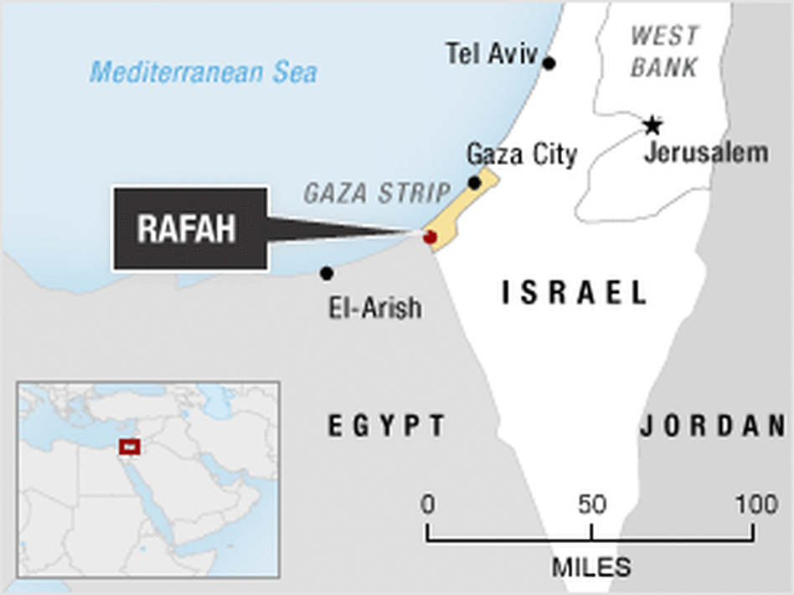
The Palestinians of the Gaza Strip represent refugees perpetually being disposed of their ancestral homelands by the Ashkenazi Israeli Jews going back to 1948. Gaza is called a strip because that is exactly what it is 25 miles long, less than 5 miles wide on average.[26] In 2013, it had a population of 1,701,437 with an average household size 6.6 persons.[27] There are about 42,600 people per square mile. Its small geographical size and high level of density of people seem to be unique and constitutes a highly “densely populated” area among global urban centers.[28] However, what set Gaza afar from all other highly “densely populated” global centers is that is occupied by a hostile and racist foreign military force just as Warsaw, Poland had been occupied by the Nazis during WWII.
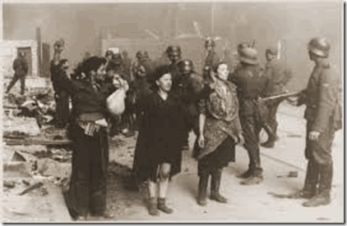
The Nazis invaded Poland in September 1939 and entered Warsaw soon thereafter the Poles surrendered. On October 12, 1940, the Germans decreed the establishment of the Warsaw Ghetto. The decree required all Jewish residents of Warsaw to move into a designated area, which German authorities sealed off from the rest of the city. The ghetto was enclosed by a wall that was over 10 feet high, topped with barbed wire, and closely guarded to prevent movement between the ghetto and the rest of Warsaw. The population of the ghetto, increased by Jews compelled to move in from nearby towns, was estimated to be over 400,000 Jews. German authorities forced ghetto residents to live in an area of 1.3 square miles, with an average of 7.2 persons per room.[29]
Warsaw Jewish Resistance: “When we are faced by an arch-foe whose unparalleled ruthlessness and programs of total annihilation know no bounds, the Halakha [Jewish Law] demands that we fight and resist to the very end…”

“When the Jews dug tunnels to smuggle food and weapons into the Warsaw Ghetto, it was an act of justified resistance. When the Palestinians dig tunnels to smuggle food and weapons into the Gaza Ghetto, it is terrorism.”[30]
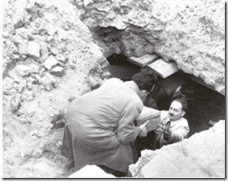
In the Warsaw Ghetto, the “TUNNELS” were the lifelines of an oppressed, desperate and frightened people. The “TUNNELS” represented in many cases the difference between life and death. The lifeline “TUNNELS” of the ghetto’s unspeakable terrorized and desperate masses constituted in many cases city storm drain and Sewage Pipes.[31]

Monument Commemorating Simcha Rotem (Kazik) Heroic Escape From The Burning Warsaw Ghetto. Simcha Rotem Led 40 Fighters Of The Ghetto Crushed Uprising Through Sewage Tunnels To Join Local Partisans Fighting The Nazis (On May 10th 1943)[32] Only thanks to the Warsaw sewage tunnels two meters high and help from the Polish side could Jewish Resistance enter and escape the Nazi occupied ghetto of perpetual and certain DEATH.[33]
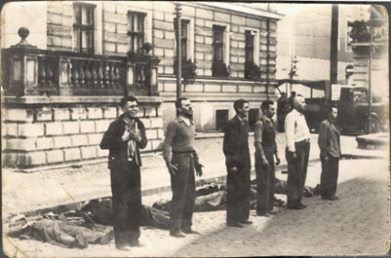
Gaza is a part of Ancient Palestine. Palestine is an area of the world that has seen many battles, invasions and conflicts since the dawn of time because it sits at the gateway to Ancient Kemet, the Land of Splendor. During the 16th Century BC, Pharaoh Ahmose I razed Sharuhen– the fortified city of the Hyksos after a three year seize. It is generally believed that ancient Sharuhen was Gaza City or closely related area on the Gaza Strip. Palestine’s ancient tunnel systems are will known and common knowledge. According to legend, sometime after the First Crusade captured Jerusalem in 1099 AD, eleven Knights Templar dug under the ruins of Solomon’s Temple for nine years and discovered a secret network of underground tunnels where priests hid their treasures from marauding Romans in 70 AD.[34]

Old Palestine is filled with secret ancient tunnel systems including networks of drainage and canal tunnels going back thousands of years. The Western Wall tunnel system is one of the most popular tourist sites in Jerusalem. These underground tunnels connect the western wall prayer area to the north-west side of the Solomon’s Temple mount, passing along the side of the temple mount and under modern day houses in the old city.[35]
Additionally, the Gaza Ghetto is like the Warsaw Ghetto. It is occupied and heavily secured on all sides by a hostile military force. It is filled with frightened, terrorized and desperate people. Like the people of the Warsaw Ghetto, Gaza’s tunnel systems, old and new, have become the difference between life and death.

However, one very big difference between Gaza and Warsaw is that Gaza’s history, originally a Canaanite settlement, spans 4000 years. It came under the control of Ancient Kemet for roughly 350 years before being conquered by the Philistines, who made it one of the principal cities of their Pentapolis (Cities of the Philistia) in the 12th Century BC. Gaza fell to King David in about 1000 BC. Gaza is a city built on top of numerous ancient settlements and cities.[36] To say that Gaza is filled with tunnels is like saying that peanut butter is made out of peanuts.
Gaza is an ancient city with a history of conflict going back thousands of years- it is filed with secret underground tunnel systems that had been used by the ancients for reservoirs, drainage, offense, defense and escape, etc. for ages. Netanyahu and the Israeli Defense Forces know very well that it may be impossible to shut down Gaza’s underground networks and tunnel systems old and new. Tunnels has been part of the historical way of life and religious landscape of the region probable before biblical times. Little Satan could literally like the Nazi-SS did to Warsaw- mass murder the inhabitants and level Gaza to the ground on the PRETEXT of shutting down Hamas Terror Tunnels with the complicity of Big Satan financed by the U.S. taxpayers on the basis of Goebbels’s Misplaced Aggression Propaganda Principles.
NOT IN OUR NAME.
The ILLUMINATI NBA, CENSORSHIP, SATAN’S BLOOD VENGEANCE & PALESTINE
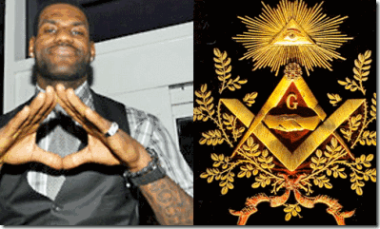
It is appalling that the ILLUMINATI NBA and America’s corporate mass media used the ILLUMINATI/Satanic cabal puppet Lebron James’ return to the Cleveland Claviers as an opportunity to try to upstage, divert and distract the masses attention away from national and world crisis such as the assault/GENOCIDE committed against the virtual defenseless captive Palestinians.
While Cleveland’s inner city schools crumble and Black and Brown inner city communities continue a downhill spiral, Cleveland Clavier’s owner Dan Gilbert– his publicly financed downtown arena and the occupying force of white closed caste business renaissance societies will be the primary benefactors of Lebron James’ return to the Downtown Cleveland not the people.
“The celebration surrounding James’ return to one of the nation’s toughest cities ignores our lack of a national policy for economic renewal in large swaths of urban America, where millions of poor black and brown kids come of age in the shadow of permanent economic misery. Broken public schools, violent neighborhoods, unemployment and a lack of opportunity envelop these communities.”[37]
Lebron James, Kabala & the Secret Israeli Cabal of Baal
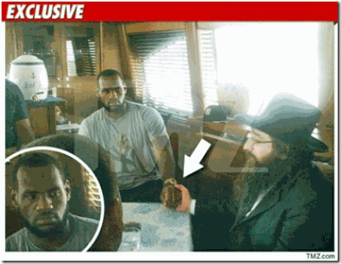
In 2010, Lebron James made a “six-figure payment” to “Shuva Israel” an organization- New York City Synagogue belonging to Rabbi Yishayahu Yosef Pinto in the course of arranging a personally meeting and “blessing” from Pinto that only speaks Hebrew.[38]
In New York, Rabbi Pinto is called “Baal Mofes“- Baal’s Miracle Worker to real estate Moguls.[39] Baal is an extremely ancient and complex Canaanite god meaning “Master” or “Lord.”[40]
1 Kings 16:30-33 King James Version (KJV)
³⁰ And Ahab the son of Omri did evil in the sight of the Lord above all that were before him.
³¹ And it came to pass, as if it had been a light thing for him to walk in the sins of Jeroboam the son of Nebat, that he took to wife Jezebel the daughter of Ethbaal king of the Zidonians, and went and served Baal, and worshipped him.
³² And he reared up an altar for Baal in the house of Baal, which he had built in Samaria.
³³ And Ahab made a grove; and Ahab did more to provoke the Lord God of Israel to anger than all the kings of Israel that were before him.

To the Luciferians, Baal has become something totally and completely different than the original Canaanite God. “SATAN‘s primary goal is to get all whosoever … of the earth’s population to worship him in spirit, and he uses religion as his main method of putting them (including Christians if possible) into that bondage. There has always existed in the world at least one powerful religious system serving Satan, and that is still so today. SATAN‘s form of religion is known in the Old Testament as ‘BAAL’ ”.[41]
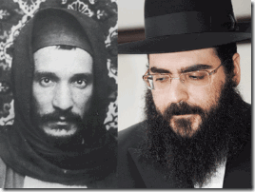
Rabbi Yeshayahu Yosef Pinto is a close relative of Israel’s richest cabal of rabbis, the Abuhatzeiras. Rabbi Pinto is great-grandson of the Moroccan Mystic-Kabalist Baba Sali ( “Praying Father”) (1889–1984) and the grandson of the Holy Sali Meir Abuchatzira. His mother was an Abuchatzeira. The Abuchatzeiras have made an extremely lucrative business out of selling so-called “blessings” and “miracles” in installments (Israeli protection-extortion money) among the rich and famous for a lot of cash.[42]
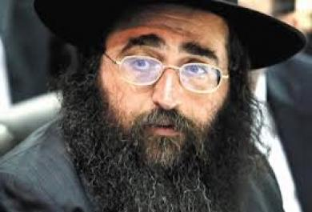
In 2010, it had been speculated that Lebron James had to pay Israeli protection-extortion money to move to the Miami Heat owned by Ashkenazi Micky Arison, an Israeli-American.[43] Early in 2014, it has been exposed that Rabbi Pinto is in fact directly linked to Prime Minister Netanyahu and complex Israeli intelligence extortion rings operating in the United States that reach all the way up to the U.S. Congress- US Representative Michael Grimm (Republican; Staten Island, NY).[44] There should be little doubt Israeli Intelligence is involved in large scale secret extortion ring operations directed at high profile black athletes and entertainers that also pledge by blood through intimidation unconditional praise, support and obedience to LITTLE SATAN. Lebron James is no more than a gutless “Chattel Slave” of the NBA ASHKENAZI ILLUMINATI Cabal that has sold his soul to the Zionist State of Israel and GOD SATAN.
ILLUMINATI Palestinian Censorship of the Satanic Black Sports/Entertainment Cabals
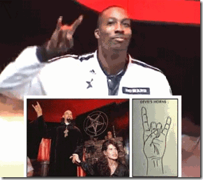
Dwight Howard- NBA Satanic Black Cabal
In the ILLUMINATI NBA, players Dwight Howard and Amar’e Stoudemire bowed down to Zionist and New World Order pressures to abandon even the most modest and slight voice of compassion and free expression for the freedom, human rights and dignity of mankind for the Palestinian People.
Over the weekend of the Israeli onslaught on Gaza, Houston Rockets player Dwight Howard tweeted “FreePalestine” to his 5.2 million followers. Subsequently, he immediately deleted the post because his free speech is subject to censorship of the Zionist that alleged Howard’s tweet was deemed tPro-Palestinian, Howard instantaneously backtracked and told his followers, “Previous tweet was a mistake. I have never commented on international politics and never will …”[45]
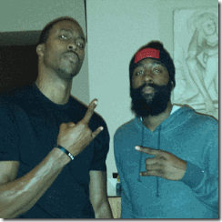
Howard & James Harden-Houston Rockets, NBA Satanic Black Cabal
As if that wasn’t enough humiliation to surrender even his most modest and token compassion, free will and expression of manhood to determine his own destiny, the gutless Negro started nervously scuffling his feet, he later tweeted, “I apologize if I offended anyone with my previous tweet, it was a mistake!” [46]

Also over the weekend of the Israeli onslaught on Gaza, New York Knicks power forward Amar’e Stoudemire posted to Instagram an image of a Palestinian boy and a Jewish boy in an embrace, with the caption “Pray for Palestine.” Due to NBA Zionist/ILLUMINATI censorship and pressure, this Negro also immediately deleted the image and message because it was deeded Pro-Palestinian expression.[47]

Stoudemire also appears to have given up his soul, dignity and manhood for a Luciferian Covenant for Fortune and Fame and ILLUMINATI NBA “Chattel Slave” career.
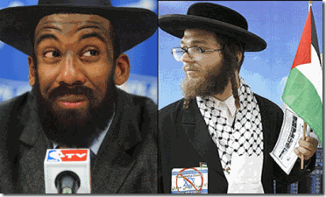
In 2013, the confused Negro applied for dual Israeli-American citizenship. Stoudemire believes that he has Hebrew roots and supposedly practices orthodox Judaism. Stoudemire is part of a four-man ownership group, including super agent Arn Tellem, that purchased 60 percent (extortion money) of Hapoel Jerusalem of the Israeli Basketball League.[48]
The NBA ASHKENAZI ILLUMINATI Cabal even has 7 ft 1 in (2.16 m) Republican country bumpkin and Satanic black cabal member Shaq O’Neal talking and spreading Hebrew. O’Neal became an undeniable Luciferian– Prince Hall Freemason in 2011, becoming a member of Widow’s Son [Horus] Lodge No. 28 in Boston. It should be little or no surprise to anyone that O’Neal is a flamboyant fan of the predominately white hockey team, the New Jersey DEVILS-DEVILS-DEVILS.[49]
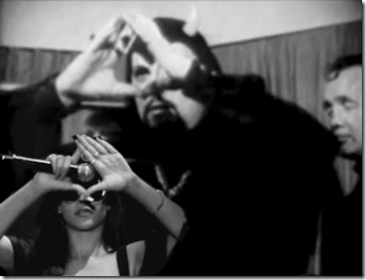
Also over a weekend of the Israeli onslaught on Gaza, the cabal’s despicable Satanic/ILLUMINATI Black High Priestess Rihanna deleted her public tweet “FreePalestine” eight minutes after posting it to her 36.4 million followers. A source said, “She deleted it because it was never meant to be tweeted.“[50] Under Zionist/ILLUMINATI control, censorship, pressure, she also lack guts to resist and express even the slightest universal public support or empathy for justice for the Palestinian People or mankind.
Dwight Howard, Amar’e Stoudemire, and Rihanna are examples of an alarming growing number of gutless high profile sports/entertainment industry Negroes that have became part of America’s Secret Satanic Black Cabal that have sold their souls to SATAN and seek Love for EVIL for the Sake of EVIL for the glory and praise of their master.
ILLUMINATI Palestinian Censorship of the Satanic Black Political Cabals

Cynthia McKinney- Courageous Lover of the People
The American Israel Public Affairs Committee (AIPAC) is one of the most powerful lobby organizations in the country. AIPAC’s clout helps fuel and sponsor a perpetual cycle of violence, aggression and CHAOS in the Middle East.[51]
AIPAC demands that Congress rubber stamp legislation drafted by its staff. It keeps a record of how members of Congress vote and this record is used by donors to make contributions to the politicians who score well. Members of Congress like former Georgia Congresswoman Cynthia McKinney that failed to unconditionally support AIPAC legislation and Israel had been targeted for defeat in re-election bids.[52]
In 2011, former Georgia Congresswoman Cynthia McKinney exposed some aspects of the Israel’s secret stranglehold over Black Congressional members. During her years in Congress, she stated that candidates for both the house and the senate were requested to sign (blood) pledges-covenants of unconditional support for Little SATAN, the Zionist State of Israel.
Sister McKinney told Press TV, “You make a commitment that you will vote to support the military superiority of Israel—the economic assistance that Israel wants, that you would vote to provide that..”[53]
Sister McKinney refused to sign the covenant to Little SATAN. AIPAC and Israeli Intelligence targeted her for removal from congress. A call for African solidarity with the Palestinian people to achieve their inalienable human and international rights and end Israeli occupation, genocide, and perpetual aggression against the State of Palestine will not come out of the Black Political Black Cabal that have also sold their souls to SATAN.
The Mystery of Malaysia Airlines Flight 17, the Elite Global Satanic Cabal & Zionist Israel
The downing of merican Israel Public Affairs Committee (AIPAC) has all the fingerprints of a false flag and strategy of tension operation consistent with providing a veil and diversion from Israel’s criminal ground invasion into Gaza. The video vividly demonstrates that the so-called video proof blasted hour after hour over the public airways that showed pro-Russian separatists and Russian Military had been responsible for bringing down Malaysia Airlines Flight 17 had been scripted and produced the day before the plane was shot down.
This video out of Ukraine claims to show Malaysia Airlines Flight 17 exploding on impact with the ground. Well, if it exploded upon impact as this photo of the crash scene demonstrates consistent with the laws of physics and nature. Where did these bloodless bodies come from that would have to allegedly withstood and defied the laws of physics and nature?
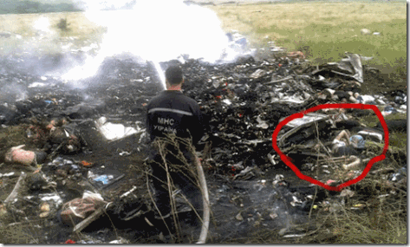
Man (why does he appear so out of proportionally large in relationship to the bodies that appear just feet away?) putting out a fire at what looks like a fresh hot smothering crash scene. Notice the victims’ bodies to the right of him. Notice the bloodless, uncharred bodies, clothes and debris below.

This Malaysia Airlines Flight crash site eerily looks more like the staged mass murder scene out of Jonestown, Guyana than a firefly explosion plane crash scene from 32,000 feet above.

It is generally understood that at least the vast majority of the passengers, up to 108, were AIDS researchers and activists who were traveling aboard Malaysian Airlines flight MH17 on their way to Australia for the 20th annual AIDS conference in Melbourne. There is fear that along with diverting the masses from the Israeli Gaza war crimes taken place; and framing the Russians for the shoot down to intensify the cold war that they may have been deliberately been collaterally targeted by the ILLUMINATI to be taken down.[54] Chillingly, the International Business times reported: Rothschild [ILLUMINATI] family reportedly owns the Malaysian Central Bank which has significant investments in Malaysian government and Malaysian Airlines.[55]
The international aids conference is contrary to the ILLUMINATI’S secret agenda to cull the world’s masses like a pack of animals. The conference was focused on developing a united global response to AIDS and facing the challenges ahead in reaching the ultimate goal of an AIDS-free generation, where new infections are prevented and worldwide effective health systems and strategies provide long-term support to those living positively on treatment.[56]
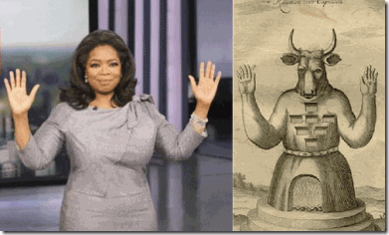
Satanic High Priestess Oprah Winfrey & God Baal Moloch
In May 2009, the Times of London online reported that a group of the New World Order’s most elite and globalist billionaires calling themselves “the Good Club” had met secretly in Manhattan, with an agenda of formulating a plan to control the growing global population and develop, fund secret shrouded strategies to cull it. The article mentioned the participation not only of Bill Gates, but of Warren Buffett, George Soros, David Rockefeller, and one of the leaders of America’s secret Black Satanic Black Entertainment/Business Cabals, Oprah Winfrey.[57]
The New American’s senior editor William Jasper reported on the meeting noting, with reference to the Jacobins of French history:
These are the folks who have been the leading private financiers of the global depopulation and de-Christianization campaigns, the promoters of abortion, homosexuality, and New Age environmentalism. And in Barrack Hussein Obama [Human Cyborg Clone] they have found their Camille Desmoulins, a handsome young lawyer with oratorical skills to push their agenda — all the while declaiming against the rich and powerful.[58]
Just as troubling and chilling as the secret “Good Club” conferences, Western policy makers and politicians has envisioned the prospect of using genospecific bioweapons to secretly cull mass populations of color. It was mentioned in the Neo-Conservative Project for a New American Century (PNAC) 2000 report titled, “Rebuilding America’s Defenses” which stated bluntly:
The proliferation of ballistic and cruise missiles and long-range unmanned aerial vehicles (UAVs) will make it much easier to project military power around the globe. Munitions themselves will become increasingly accurate, while new methods of attack – electronic, “non-lethal,” biological – will be more widely available.
Although it may take several decade for the process of transformation to unfold, in time, the art of warfare on air, land, and sea will be vastly different than it is today, and “combat” likely will take place in new dimensions: in space, “cyber-space,” and perhaps the world of microbes [AIDS, EBOLA Viruses, etc.]. And advanced forms of biological warfare that can “target” specific genotypes may transform biological warfare from the realm of terror to a politically useful tool.[59]
The downing of Malaysia Airlines Flight 17 has all hallmarks of a clandestine state action beyond the Pails of the Human Understanding of SATAN’S BLOOD VENGEANCE. It has the fingerprints of the ILLUMINATI, Great SATAN– Little SATAN’s false flag and strategy of tension operation that is consistent with trying to frame the Russians for international war crimes and human atrocities along with collaterally providing a veil and diversion over Israel’s criminal ground invasion into Gaza that the Israelis promised to be a chilling and terrifying onslaught against the Palestinian People that is beyond human and Lucifer’s comprehension.

There are speculative theories swirling around the internet that the Malaysia Airlines Flight 370 lost flight plane or a twin copy was secretly hangared in Israel for a future false flag operation to start a war. These theories are out there. For some interesting alternative theories about Malaysia Airlines Flight 370 and Flight 17 check out the video above. But one thing is certain that there is a lot of unfinished business (Crimes Against Humanity) with Lucifer’s Servants and their blood trails, networks and gold-money capital that should have been quashed decades ago. The genocidal onslaught against the Palestinian People should be a threat to all mankind and leave of us each man, woman and child LITTLE LEFT TO FEAR.
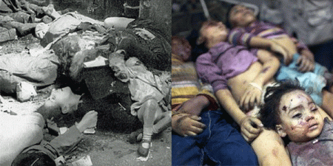
Israeli PM Netanyahu says, “They [Hamas] want to pile up as many civilian dead as they can,” the prime minister continued. “They use telegenically dead Palestinians for their cause. They want the more dead, the better.” Mr. Netanyahu, I pray that the “telegenically dead Palestinians” will be used as evidence as the “telegenically dead Jews of the Warsaw Ghetto” was used to convict and hang Gruppenführer (major general) SS Jürgen Stroop for International War Crimes and High Crimes Against Humanity.

[1] http://online.wsj.com/news/articles/SB123093176783149767
[2] http://www.montalvoreport.com/content/us-president-barack-obama-freemason
[3] http://www.texemarrs.com/042003/masonic_jews_plot_world_control.htm
[4] http://everything2.com/title/Mae+Brussel
[5] http://www.algemeiner.com/2014/06/30/netanyahu-says-hamas-responsible-for-teens-deaths-terror-group-threatens-to-%E2%80%98open-the-gates-of-hell%E2%80%99-if-israel-strikes/
[6] http://www.washingtonpost.com/world/israel-accepts-truce-plan-hamas-balks/2014/07/15/04373008-0bf5-11e4-8c9a-923ecc0c7d23_story.html
[7] http://www.thedailybeast.com/articles/2013/12/29/while-the-world-watched-the-1944-warsaw-uprising.html
[8]
[9] http://en.wikipedia.org/wiki/Warsaw_Ghetto_Uprising
[10] http://en.wikipedia.org/wiki/Wehrmacht
[11] http://rarehistoricalphotos.com/annual-midnight-swearing-nazi-ss-troops-feldherrnhalle-munich-1938/
[12]http://www.maebrussell.com/Mae%20Brussell%20Articles/Nazi%20Connection%20to%20JFK%20Assass.html
[13] http://www.conspiracybomb.com/The%20Kennedy%20Watergate%20Iran-Contra%20Nazis%20Conspiracy.the
[14]http://www.foia.cia.gov/sites/default/files/document_conversions/1705143/CIA%20AND%20NAZI%20WAR%20CRIM.%20AND%20COL.%20CHAP.%201-10,%20DRAFT%20WORKING%20PAPER_0011.pdf
[15] http://en.wikipedia.org/wiki/Teutonic_Knights
[16] http://en.wikipedia.org/wiki/Knights_Templar
[17] http://www.cuttingedge.org/News/n2012.cfm
[18] http://aconstantineblacklist.blogspot.com/2009/01/otto-von-bolschwing-bund-americas.html
[19] https://www.goodreads.com/quotes/132643-the-greatest-purveyor-of-violence-in-the-world-my
[20] http://www.globalresearch.ca/were-the-three-settler-kidnappings-an-israeli-false-flag-operation/5389791?print=1
[21] http://www.ynetnews.com/articles/0,7340,L-4540482,00.html
[22] http://rationalwiki.org/wiki/Joseph_Goebbels
[23] http://en.wikipedia.org/wiki/Displacement_(psychology)
[24] http://www.historylearningsite.co.uk/joseph_goebbels_propaganda.htm
[25] http://www.bustle.com/articles/32433-john-kerry-caught-on-mic-sarcastically-calling-gaza-offensive-hell-of-a-pinpoint-operation-by-israel
[26] http://www.ronpaulforums.com/showthread.php?174787-Do-you-know-the-size-amp-density-of-Gaza-strip
[27] http://www.pcbs.gov.ps/site/881/default.aspx#Population
[28] http://www.washingtonpost.com/blogs/worldviews/wp/2014/07/14/gaza-city-is-being-hit-by-missile-strikes-this-is-how-densely-populated-it-is/
[29] http://www.ushmm.org/wlc/en/article.php?ModuleId=10005069
[30] http://isiria.wordpress.com/2009/02/04/jewish-tunnels-in-the-warsaw-ghetto/
[31] http://www.haaretz.com/jewish-world/jewish-world-features/.premium-1.564834
[32] http://www.israelimages.com/see_image_details.php?idi=20944
[33] http://www.haaretz.com/jewish-world/jewish-world-features/.premium-1.564834
[34] http://www.rense.com/general7/tunnel.htm
[35] http://www.biblewalks.com/Sites/WesternWallTunnels.html
[36] http://en.wikipedia.org/wiki/History_of_Gaza
[37]http://www.theroot.com/articles/culture/2014/07/lebron_james_return_to_ohio_is_not_a_cure_for_a_struggling_economy.html
[38] http://www.dailyfinance.com/2010/08/10/the-mysterious-rabbi-who-gave-lebron-james-business-advice/
[39] http://www.vosizneias.com/16389/2008/05/25/new-york-city-rabbi-pinto-profiled-in-the-media-as-baal-mofes-to-real-estate-moguls/
[40] http://en.wikipedia.org/wiki/Baal#Deities_called_Baal_and_Baalath
[41] http://www.chrissherrerd.com/articles/article.cfm?ArticleID=51
[42] http://www.npr.org/2012/07/30/157593242/in-israel-rabbis-rank-among-the-rich-and-famous
[43] http://www.algemeiner.com/2012/06/22/israeli-american-miami-heat-owner-wins-nba-title/
[44] http://failedmessiah.typepad.com/failed_messiahcom/2014/01/israeli-government-minister-allegedly-involved-in-scandal-surrounding-rabbi-yoshiyahu-yosef-pinto-us-congressman-456.html
[45] http://www.washingtontimes.com/news/2014/jul/15/rihanna-dwight-howard-delete-freepalestine-tweets/
[46] http://www.washingtontimes.com/news/2014/jul/15/rihanna-dwight-howard-delete-freepalestine-tweets/
[47] http://www.mediaite.com/online/nba-stars-take-heat-for-posting-palestine-messages-to-social-media/
[48] http://nypost.com/2014/04/14/amare-may-leave-knicks-for-jerusalem-team-after-2015/
[49] http://en.wikipedia.org/wiki/Shaquille_O’Neal
[50] http://www.washingtontimes.com/news/2014/jul/15/rihanna-dwight-howard-delete-freepalestine-tweets/
[51] http://www.occupyaipac.org/2012/02/10-reasons-why-the-israel-lobby-aipac-is-so-dangerous/
[52] http://www.occupyaipac.org/2012/02/10-reasons-why-the-israel-lobby-aipac-is-so-dangerous/
[53] http://jhaines6.wordpress.com/2012/11/19/cynthia-mckinney-drops-bombshell-candidates-to-sign-pledges-of-support-for-israel/
[54] http://www.intellihub.com/108-aids-researchers-activists-dead-possibly-targeted-latest-mh17-attack/
[55] http://www.intellihub.com/108-aids-researchers-activists-dead-possibly-targeted-latest-mh17-attack/
[56]https://www.devex.com/news/step-up-the-pace-on-investment-ppps-for-an-aids-free-generation-83906
[57] http://www.thenewamerican.com/usnews/health-care/item/18663-bill-gates-funds-implantable-remote-control-contraceptive
[58] http://www.thenewamerican.com/usnews/health-care/item/18663-bill-gates-funds-implantable-remote-control-contraceptive
[59] http://www.globalresearch.ca/the-troubling-truth-behind-the-ebola-outbreak/5377653
Comments : 3 Comments
Tags: Adolf Hitler, AIPAC, Allen Dulles, Amar'e Stoudemire, American Israel Public Affairs Committee, Baba Sali, Baron Otto von Bolschwing, barrack obama, Benjamin Netanyahu, black congressional caucus, CIA, crimes against humanity, cyborgs, Cynthia McKinney, Dr. Martin Luther King, dwight howard, false flag operations, freemasons, freepalestine, gaza, gaza ghetto, hamas, hamas' terror tunnels, hip hop satanic cult, houston rockets, Illuminati, israel, james harden, Jürgen Stroop, john kerry, josef goebbels, knights of malta, Knights of the Black Sun, knights templar, lebron james, little bobby hutton, Lucifer, Lucifer's Servants, luciferians, Mae Brussell, Malaysia Airlines Flight 17, Malaysia Airlines Flight 370, misplace aggression, MK-ULTRA, monarch project, Monarchs, nazi gold, nba, nba illuminati, Oprah Winfrey, palestine, palestinians, pray for palestine, prescott bush, Prescott Sheldon Bush, Rabbi Yishayahu Yosef Pinto, reinhard gehlen, richard nixon, rihanna, satan, satanic black cabal, Satanism, SS, teutonic knights, the good club, war crimes, warsaw, warsaw ghetto, warsaw resistance, warsaw tunnels, zionism
Categories : 1000 Year Reich, antichrist, baal, Black Panther Party for Self Defense, blood covenants, blood oaths, church of satan, CIA, COINTELPRO, cyborg, devil's horns, gaza, Heinrich Himmler, illuminati, Knight of Malta, Knights Hospitaller, Knights of the Black Sun, Knights Templar, lucifer's servants, lucifer's workshop, luciferians, mae brussell, President John F. Kennedy, reinhard gehlen, Rihanna, satan, Satanism, Schutzsteffel, SS, SS Baron Otto Albrecht Alfred von Bolschwing, Uncategorized, ZIONIST

DOUBLE BIND: DONALD STERLING, NBA, GENOCIDE, TANTRISM & THE PLOT AGAINST THE PEOPLE
20062014
Don’t Concentrate Solely on the Individual Racism of Donald T. Sterling
People of Color, Don’t concentrate on the Finger
Don’t concentrate on DONALD STERLING ALONE or you will miss your Heavenly Glory. Look at the bigger picture. A vicious, vile and ugly racialist like Donald T. Sterling does not exist alone inside a vacuum.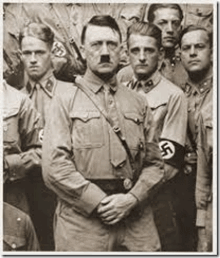“The art of leadership… consists in consolidating the attention of the people against a single adversary and taking care that nothing will split up that attention.” Fuhrer Adolf Hitler [1]
PLOT AGAINST THE PEOPLE, NBA and the Pink Elephant in the Room
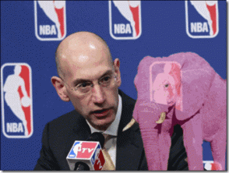
The NBA and the Secret Agency of Genocide On May 27, 2014, the embattled Los Angeles Clippers owner Donald T. Sterling officially responded to National Basketball Association (NBA) charges that his conduct violated its rules. Basically, Sterling’s main defense arguments are that his private conversations with V. Stivanio were recorded in violation of the law, and “A jealous rant to a lover never intended to be published cannot offend the NBA rules …“[2] Sterling to V. Stiviano: You’re an ENEMY to me![3]
Let’s be clear, “Lovers” please don’t go there. Sterling is not an innocent lonely heart senior citizen trying to find love and affection. He is not to be dismissed as a foolish old man making irresponsible, wild and outlandish statements. He is a cunning racialist Luciferian Male Chauvinist-Supremacist Pig that is part of a Secret Agency of Genocide.

Sterling says that V. Stiviano is a black girl, an ENEMY reduced to a beast/creature that creepth, that he is willed to exploit, dominate, control, ravish and play with, Sterling– “She was hot… AN ANIMAL … tiger.”[4] The Sterling Racist Rant have concentrated a lot of inquiring eyes on him and the closed caste of Ashkenazi ILLUMINATI owners that control the NBA. People are trying to figure who he really is, and what’s going. Is there a clandestine plot and agency against Black People? The “Pink Elephant in the Room” is Sterling‘s statements that a secret cult, society and agency within the NBA “association” has committed Black People to the status as “ENEMIES.”
It creates an obvious explosive- dangerous human rights crisis. It rekindles a serious fear of another underground plot by a powerful, influential and evil combination to deliberately harm the well-being of people of color. It is a big contradiction and creates dilemmas that no one will acknowledge, discuss or explain. It is impossible to overlook. Yet, the NBA and mass media have chosen to pretend that the “Pink Elephant” doesn’t exist. There should also be an interest in the bigger picture- exposing Donald Sterling’s secret inflexible and racist society, cell or culture of the ILLUMINATI that are involved as an “Agency” in the universal denigration, control and sacrifice of Black (Female Principle) Women, and have designated Black People as an universal and eternal “ENEMY“of the Satanic New World Order.
The NBA DOUBLE BIND- Insanity Without Disease The NBA had a ripe opportunity to sincerely address and distance itself from Donald T. Sterling’s explosive statements that an “Agency” within the top ownership ranks of NBA have designated BLACK PEOPLE as an ENEMY. However, the NBA has chosen to sweep it all under the rug as if Sterling had said nothing about the “Agency” or Black People being ENEMIES. The NBA has chosen to inhibit the possibility of any healing or meaningful dialogue about racism and white supremacy notions across the “color line.”
Most recently, we have been virtually bombarded with ILLUSIONS of black NBA players allowed radically more success and affluence within the system than the masses. Black NBA players are promoted by IMAGES of rich lifestyles loaded with visible things representing vast material wealth such as money, expensive luxury- sport cars, mansions- surrounded by dozens of white, particularly light skinned black women, and racially mixed women of color. Approximately 76% of NBA players are Black and the basketball league is 81% non-white. Up to 85% and the highest paid of Donald and Shelly Sterling’s LA Clippers ball players are Black.[5]
A lot of people, particularly Blacks, are left scratching their heads- confused about the entire Sterling affair. For Black people, it creates a crisis, dilemma/puzzle wrapped inside an enigma- DOUBLE BIND. Why would Donald Sterling and the Ashkenazi Cabal that control the NBA promote the rich, lavish and affluent lifestyles of so many blacks and their families if they are, in fact, ENEMIES?
Top Ten Most Expensive Millionaire NBA Player Homeowners
10. Paul Pierce (BKN)- $6,500,000 home in California
09. Dwight Howard (HOU)- $7,780,000 home in Florida

07. Chris Paul (Sterlings’ LA Clippers)- $8,495,000 Mansion in Bel-Air, California
06. Kobe Bryant (LAL)- $8,599,000 home in California
05. Dwyane Wade (MIA)- $8,900,000 home in Florida
04. LeBron James (MIA)- $9,000,000 home in Florida
03. Chris Bosh (MIA)- $9,400,000 home in California
02. Kobe Bryant (LAL)- $9,450,000 home in California
01. Chris Bosh (MIA)- $12,333,000 home in California
H/T: BleacherReport [6]

Donald T. Sterling: “… I support them and give them food, and clothes, and cars, and houses… – Who makes the game? Do I make the game, or do they make the game? Is there 30 owners, that created the league?[7] Behind the Veil. For all their millions and ILLUSIONS of wealth and power, black NBA players are subjected to some of the most draconian, arbitrary rules and restrictive free speech and free assembly restrictions in professional sports.

While professional predominantly non black soccer, hockey and baseball players can brawl and batter each other and fans all over the field and stadium. Black NBA players cannot literally raise their voices, question authority or referees, and even dare to rise from the bench during a heated game without being criminalized, fined and suspended. However most revealing is that they dare to mutter a word or act in contradiction with the ILLUMINATI political, social, race and genocidal agenda.
The well publicized IMAGES and ILLUSIONS of wealth and power of black NBA players are no more than window dressings designed to pacify the masses. They have become mere puppets of Luciferians. They are part of the “Agency of Genocide.” A DOUBLE BIND is an emotionally distressing dilemma in communication in which an individual (or group) receives two or more conflicting messages, in which one message negates the other – PROMOTE black folk’s access to power and wealth- then PLOT against them as ENEMIES.
This creates a situation in which a successful response to one message results in a failed response to the other (and vice versa), so that the person will automatically be wrong regardless of response. The DOUBLE BIND occurs when the person cannot confront the inherent dilemma, and therefore can neither resolve it nor opt out of the situation.[8]
DOUBLE BIND causes insanity without any disease. The effect of the DOUBLE BIND is that the addressee cannot decide what is real and may develop pathologies. Racism is a conceptual DOUBLE BIND that is designed and veiled so that it cannot be resolved by retreating into silence or becoming immobilized by the contradictions.[9]
Basically in most cases, pseudo racial notions and white supremacy by its very nature is an agency of genocide. Either can be explained or understood through conventional 21st Century traditional religious, social, educational and historical means. The true motives of white supremacy are too often deliberately compounded, disguised, coded and hidden behind complex Smoked Mirrors, IMAGES– ILLUSIONS. It is shrouded in a tangle of deep SECRECY to keep you from the truth.
Cecil Rhodes’ Will, “Confession of Faith”- 1877
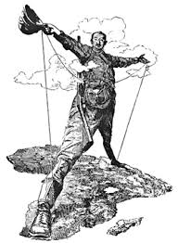
The Secret Agency of Genocide
I contend that we are the finest race in the world and that the more of the world we inhabit the better it is for the human race … Just fancy those parts that are at present inhabited by the most despicable specimens of human beings … Why should we not form a secret society with one object the furtherance of the British Empire and the brining of the whole uncivilized world under British rule for the recovery of the United States for the making the Anglo-Saxon race but one Empire… ever feel mad? do you feel murderous … We know the size of the world we know the total extent. AFRICA is still lying reading for us it is our duty to take. It is our duty to seize every opportunity of acquiring more territory and we should keep this one idea steadily before our eyes that more territory simply means more of the Anglo-Saxon race more of the best the most human, most honourable race the world possesses {i.e. genocide of other peoples}. To forward such a scheme what a splendid help a secret society be a society not openly acknowledged but who would work in secret for such an object.[10]
Cecil Rhodes’ Will (Secret Society- Round Table Group) and the ILLUMINATI New World Order (NWO) spawned the Council of Foreign Relations (CFR).[11] The NBA has become yet another ILLUMINATI opiate to pacify and dumb down the masses; as well as an escape from reality and distraction from dealing with truths behind the veil for the masses.
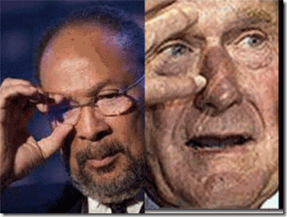
ILLUMINATI ALL SEEING EYE Symbol- Richard Parsons & George H.W. Bush
The NBA assigned Richard “Dick” Parsons, a prominent “Agency” member of the CFR, to manage the Sterling‘s Los Angeles Clippers.[12] So as we see by the direct actions of the “association” appointing a “genocider“[13] out of the Rhodes Round Table Group Secret Society’s CFR and puppet of the ILLUMINATI “Shadow Government” to take over the LA Clippers, Sterlings starling revelations about an underground racialist/racist “Agency of Genocide“ and cabal within the NBA aren’t the ravings of a madman.
Sterling has been a NBA team owner and association member for approximately thirty-three (33) years.[14] Yet, this vile and vehement racialist and racist has never before been called to task by NBA. The NBA has deliberately shielded pseudo racialist EVIL HEARTED like the Sterlings, Donald and Shelly, under its veil and shroud of a secular association in a predominately black basketball league for decades.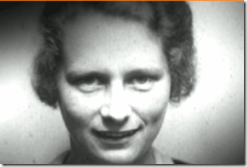It’s almost tantamount to allowing the EVIL of Reichsfuhrer SS-I Heinrich Himmler and his wife, Marga, above, to flourish under a veil and shroud of an association to own and manage a predominately Jewish basketball team in the NBA during the 1930s and early 1940s. And the NBA assigning a prominent member of the CFR to manage the LA Clippers is like asking head of the Party Chancellery and Private Secretary to Adolf Hitler, SS Martin Bormann, to pick someone like Josef Paul Goebbels to take over the Himmler’s interest in the team.
SS-1 Heinrich Himmler’s wife, Marga: “I’m so lucky that I have an EVIL husband who loves his EVIL wife …” Himmler responded: “There’s nothing other than ‘revenge.’ Forever.” Marga Himmler wrote back: “Remember: ‘Revenge.’ My black soul is thinking about the most impossible things.”[15]
Himmler & the Prince of Darkness
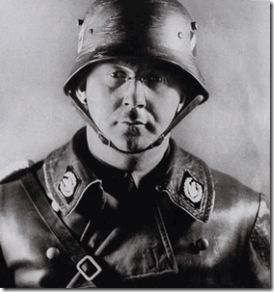The Nazi SS (Schutzstaffel) were Priests of Satan. Reichsfuhrer SS-1 Heinrich Himmler was the High Priest of the Prince of Darkness– SATAN, the ancient image of Lucifer/Typhon- GOD SET. As a matter of official U.S. policy, the Pentagon has given its de facto blessings of the ancient Kemetic “GOD SET” as a role model for the military; and Lt. Colonel Michael Aquino’s Church/Temple of SET- SETH.
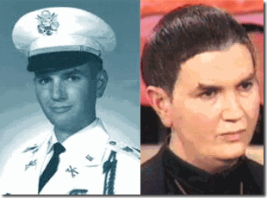
Lt. Col. Aguino’s figure of the GOD SET, also called the “Prince of Darkness” is understood as a “principle.” Set is a “role model” for initiates: a being totally apart from the objective universe. Set is considered ageless and the only god with independent existence. Set is described as having given humanity, through the means of non-natural evolution, the “Black Flame” or the “Gift of Set”: a questioning intellect which sets humans apart from nature and gives us “isolate self-consciousness” and the possibility to attain divinity.[16]
Lt. Col. Aquino’s Satanic activities involved overt support for neo-Nazi movements in the United States and Europe. On October 10, 1983, while traveling in West Germany on “official NATO business,” Aquino had staged a Satanic “working” at Himmler’s SS Wewelsburg Castle in Bavaria.[17] Lt. Col. Aquino wrote a lengthy account of the ritual, in which he invoked Satanic High Priest SS-1 Himmler: “As the Wewelsburg was conceived by Heinrich Himmler to be the ‘Mittelpunkt der Welt’ (‘Middle of the World’), and as the focus of the Hall of the Dead was to be the Gate of that Center, to summon the Powers of Darkness at their most powerful locus.”[18]
As early as April 1978, the U.S. Army had circulated A Handbook for Chaplains “to facilitate the provision of religious activities.” Both the Church of Satan and the Temple of Set were listed among the “other” religions to be tolerated inside the U.S. military.[19] A section of the handbook dealing with Satanism stated, “Often confused with witchcraft, Satanism is the worship of Satan (also known as Baphomet or Lucifer). Classical Satanism, often involving ‘black masses,’ human sacrifices, and other sacrilegious or illegal acts …”[20]
If you believe that the Satanic High Priest SS-1 Himmler and the Knights of Black Sun are no longer relevant to the philosophy and belief system of an all-volunteer U.S. Military Force, think again. In 2006, the online bookstore AbeBooks reported that DEVIL’S GUARD, by George Robert Elford published in 1971 was behind the veil- among the 10 novels most frequently sold to U.S. Military Soldiers in Iraq and allegedly in Afghanistan (the only war fiction in the top 10, in fact).[21]
The Devil’s Guard is a book about the exploits, sadism, racialist beliefs and dualism (Satanic Principle) of Himmler’s SS– Satanic Priests clandestinely recruited by France and the United States to fight as underground “secret seek and destroy units” and “Agencies of GENOCIDE” in Southeast Asia and Vietnam.[22]
America‘s Secret Plot and Agency of GENOCIDE
“There’s nothing other than ‘REVENGE.’ Forever.” – Reichsfuhrer SS-1 Heinrich Himmler
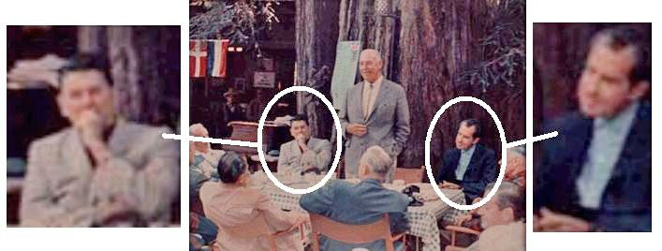
JFK assassination conspirator and Vietnam Aggression/War Criminal President Richard (Tricky Dick) Milhous Nixon was a notorious Bohemian Grove Pagan synonymous with the U.S. Pentagon’s definition of a Classical Satanist. He was a collaborator of Lucifer’s Servants, the Underground SS- Knights of the Black Sun and THIRD REICH in America.[23]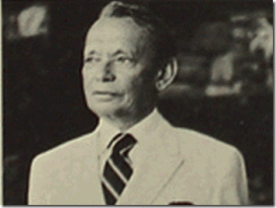
Dr. Arnold Hutschnecker, Clandestine 5th Column Knight of the Black Sun
Since 1962, Nixon had been directly under the secret influence and control of one of Himmler’s Agency of EVIL, SS Psychotherapist Dr. Arnold Hutschnecker of New York City.[24] President Nixon represented the government’s highest elected official that supported a clandestine shadow government Luciferian/Sethian Secret Policy of GENOCIDE for People of Color, particularly- Black People, but also Dr. Hutschnecker’s Plan to force Black and Brown children into concentration camps as a matter of national state policy.Nixon’s Secret White House Tape transcripts (1971): “I have the greatest affection for them [Black People] but I know they’re not going to make it for 500 years. They aren’t. You know it, too… Mexicans… They don’t live like a bunch of DOGS, which the Negroes do live like.”[25]
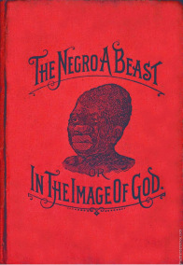
Donald T. Sterling: “It’s the world! You go to Israel, the blacks are just treated like DOGS.”
Sterling: “… we don’t evaluate what’s right and wrong, we live in a society. We live in a culture. We have to live within that culture.” [26]
Untermensch (under man, sub-man, sub-human; plural: Untermenschen) is a term of the THIRD REICH used it to describe “inferior people” that most often applied to Jews, Black People and Mulattos.[27] Adolf Hitler and Paul Josef Goebbels compared the “Untermenschen“ to the “rabbit family“ or to “stolid [having or revealing little emotion or sensibility; impassive] animals.” [28]

MK UTRA/MONARCH Sex Slave V. Stiviano reduced to a Rabbit and Animal
V. Stiviano: “I’m Mr. Sterling’s right hand arm… man. I’m his everything, his confidant, his best friend. His silly rabbit.”[29] You can’t make this stuff up. Most of the themes, language, signs and symbols of Sterling‘s Cult, Inner Circle and Agency of EVIL and GENOCIDE seems to point in only one direction.
Donald Sterling, the THULE Society & The Plot/Agency Against the People- Racial GENOCIDE
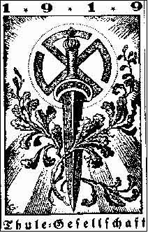
V. Stiviano: And are the black Jews less than the white Jews?
D. Sterling: A hundred percent, fifty, a hundred percent.[30]
The powerful international Satanic Cabals gaining more and more clandestine power, control and influence over states have been quietly defining who needs to be excluded from the New World Order (NWO) with Lucifer-Set as their God. Blacks are persistently at the top of their list as “outsiders” and classical “ENEMIES” harmful to the NWO genetic gene pool; and the “national health” of new satanic influenced societies based on age old pseudo religious beliefs and racial foundations.
Sterling’s revelations about a powerful cabal’s secret designation of “Black People” as “ENEMIES” really lies at the basis of the THULE Society- Nazi pseudo racial bloodlines- religious belief systems and notions. The THULE- Nazi designation of JEWS as “ENEMIES” of the people and the state was a pretext to veil a national campaign of extermination; and a state policy of GENOCIDE based upon their pseudo and ILLUSIONAL religious and racialist notions.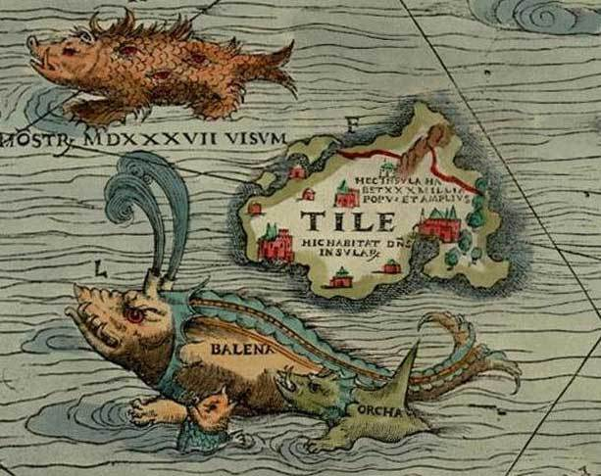The THULE– Gesellschaft name originated from mythical Thule, a Nordic -equivalent of the vanished culture of Atlantis. A race of giant Aryan supermen lived in Thule, linked into the Cosmos through magical powers. They had psychic and technological energies far exceeding the technical achievements of the 20th century. The sacred knowledge of the Aryan supermen of THULE was to be put to use to save the Fatherland and create a new race of Nordic Aryan Atlanteans.[31]

They believed that a new Messiah would come forward to lead the people to this goal. In his history of the SA (Mit ruhig festem Schritt, 1998), Wilfred von Oven, Josef Goebbels’ press adjutant from 1943 to 1945, confirmed that Pytheas’ Thule was the historical Thule for the THULE– Gesellschaft.[32] Pytheas of Massalia was a Greek geographer and explorer from the Greek colony, Massalia (modern-day Merseilles). He made a voyage of exploration to northwestern Europe at about 325 BC. He claimed to have first discovered and introduced the Mythical Island of THULE in most northerly of the British Isles.[33]
The Plot Against the People- Re-imaging the Target as ENEMIES as a Pretext to Racial GENOCIDE
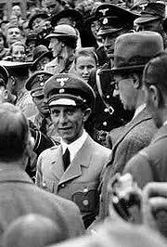
The little evil genius of the Nazis, Propagandist Chief, Paul Josef Goebbels, perfected the strategy to manufacture public opinion on Genocide by repeatedly defining, labeling, and re-imaging “Jews” ENEMIES of the people and state, Goebbels Principles of Propaganda:
PROPAGANDA MUST FACILITATE THE DISPLACEMENT OF AGGRESSION BY SPECIFYING THE TARGETS FOR HATRED
JEWS, THE ENEMY WITHIN
Every Jew is our ENEMY in this historic struggle, regardless of whether he vegetates in a Polish ghetto or carries on his parasitic existence in Berlin or Hamburg or blows the trumpets of war in New York or Washington. All Jews by virtue of their birth and their race are part of an international conspiracy against National Socialist Germany. 1. The Jews are our destruction… They want to destroy the German Reich and our people. 2. There are no distinctions between Jews. Each Jew is a sworn ENEMY of the German people. If he does not make his hostility plain, it is only from cowardice and slyness, not because he loves us. 3. The Jews are to blame for each German soldier who falls in this war. They have him on their conscience, and must also pay for it. 4. If someone wears the Jewish star, he is an ENEMY of the people. Anyone who deals with him is the same as a Jew and must be treated accordingly. He earns the contempt of the entire people, for he is a craven coward who leaves them in the lurch to stand by the enemy. 5. The Jews enjoy the protection of our enemies. That is all the proof we need to show how harmful they are for our people… 9. A decent ENEMY will deserve our generosity after we have won. The Jew however is not a decent ENEMY, though he tries to seem so.[34]
ILLUMINATI NBA, The EVIL within: Donald and Shelly Sterling

Most of the themes, language, signs and symbols of Sterling‘s Cult, Inner Circle and Agency of EVIL and GENOCIDE will point in only one direction. DS: You think I’m a racist, and wouldn’t— V. Stiviano: I don’t think you’re a racist. DS: Yes you do. Yes you do. V: I think you, you— Donald Sterling: EVIL HEART.[35] The NBA ILLUMINATI would like to put the Donald Sterling Affair behind them as far as possible.
Recently, Sterling’s wife, Shelly, told Barbara Walters on a national televised interview that she became concerned about her husband’s mental state when she asked Donald about the rant in the recordings with V. Stiviano, he said: “I don’t remember saying that. I don’t remember ever saying those things.”[36] “That’s when I thought he had dementia,” she told Walters.[37]
In other words, when he started lying about the explosive tape she suddenly decided that her lying, conniving EVIL racist, male chauvinist freak husband had dementia and Alzheimer’s disease. Reportedly, she has two independent doctors ready to declare him “mentally incapacitated.”[38]
Like Marga Himmler, Rochelle Stein “Shelly” Sterling is just as EVIL, sinister, conniving and vehemently racist as her husband. Husband and wife for almost 60 years, they are also two of a kind.[39] As it turns out, Donald Sterling has become a rare opening of the NBA ILLUMINATI Pandora’s Box. Sterling‘s statements about Black People, particularly, designating them as “ENEMIES” are not just his racist, individual and dysfunctional personal views. It is systematic of a far searching clandestine shadow governmental and ILLUMINATI agency of racial GENOCIDE.
Sterling‘s Agency of Criminals, Lords of CHAOS and the Nazis
Donald T. Sterling wasn’t created out of a vacuum. Most of the themes, language, signs and symbols of Sterling‘s Cult, Inner Circle and Society will point in only one direction.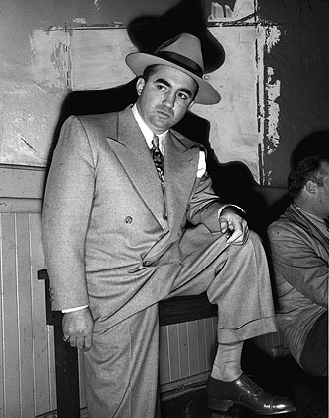Sure enough, Sterling was raised in the Jewish working class section of Boyle Heights, LA during the 1940s and 1950s. At that time, Boyle Heights was home to the notorious Jewish Mobster “Murder, Inc.” Meyer “Mickey” Cohen of the Meyer Lansky Mob. Together with the infamous Ben “Bugsy” Siegel, they extended the East Coast Syndicate on the West Coast, and ran the secret HollyWeird Underground.[40]
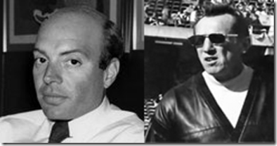
Some of Sterling‘s closest friends are/were Underworld Lords of Chaos, Ashkenazi Alan Glick and the late NFL Oakland Raiders owner, Ashkenazi Al Davis- Pawns of the Mafia. During the 1970s, Glick ran a company in Las Vegas called, the Argent Corporation. The corporation controlled the lucrative gambling market of the Hacienda Resort Hotel & Casino, Stardust Resort & Casino, Fremont Hotel & Casino, Marina Hotel & Casino, and the Desert Inn Casino. At the time, Glick was an attorney and successful San Diego real estate investor. However, state and local officials in Nevada feared that Argent’s string of casinos were really controlled by organized crime families in the Mid-West and that a huge skimming criminal-racketeering enterprise was going on with Argent.[41]
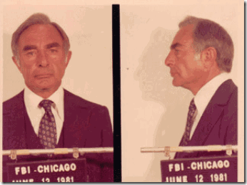
According to mob sources, Argent Corporation purchased the Hacienda in 1974 and then the Recrion Corporation, which owned the Stardust and Fremont. The casino purchases were financed by loans from the Teamsters Central States Pension Fund through an infamous racketeering criminal, Allen Dorfman.
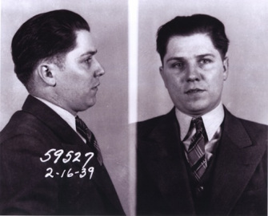
Dorfman was a consultant to the International Brotherhood of Teamsters (IBT) of Central States Pension Fund. He was associated with the Chicago (Mafia) Outfit, and a close associate of IBT President Jimmy Hoffa. Dorfman was knocked off in 1983.[42] Hoffa disappeared under suspicious circumstances in 1975.[43]
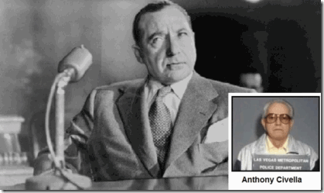
Glick’s Argent Corporation was in fact a mafia dummy front to skim and laundry gambling profits for Milwaukee Mobster Boss Frank Balistrieri, and Nick Civella, boss of the Kansas City Mob.[44] In 1974, Glick assumed a 25 million dollar interest only loan from mobsters Dorfman and Hoffa through the IBT Central States Pension Fund in building East Oakland’s Eastmont Mall. Glick then sold a 25% interest in the mall to his business partner Al Davis for $5,000. Davis then cashed in on about a million in tax interest deductions and credits.[45]
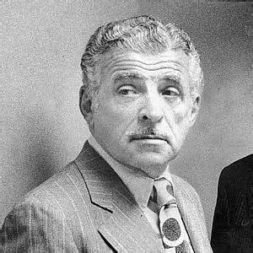
Inside the NFL Raiders locker room and organization, Glick and Davis were running an illegal bookmaking operation for the New Jersey-based Simone “the Plumber” DeCavalcante organized crime family.[46] With a close circle of friends and associates like Ashkenazi Mob Fixers and Associates Glick and Davis, it doesn’t seem that Donald Sterling really didn’t need to work too hard for his millions.
Big Al and the SS- Knights of the Black Sun

Reportedly, Sterling‘s associate, the Late Al Davis of the Oakland Raiders, was interested in the Nazis,[47] and had been admittedly fascinated and captivated with the Fuhrer Adolf Hitler.[48]
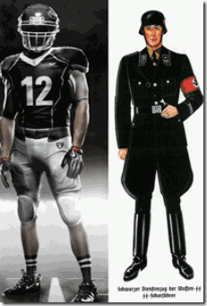
Davis changed the Oakland Raiders’ team colors to black and silver to reflect his admiration of “Black Knights.”[49] I say that it was a reflection of SS-1 Reichsfuhrer Heinrich Himmler’s Knights of the Black Sun, the SS.
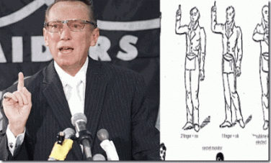Al Davis’ symbol of Masonic recognition based on this German book: “Freimaurersignale in der Presse” or freemasonic signals in the press.[50]
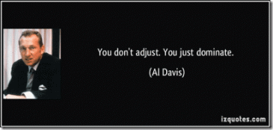
We DOMINATE– just like his Aryan heroes- the Mythical Hyperborea Polar Nordic Warrior Caste.
Donald Sterling and the Princes of Darkness
Donald T. Sterling wasn’t created out of a vacuum. Most of the themes, language, signs and symbols of his Cult, Inner Circle and Agency of EVIL and GENOCIDE will point in only one direction.
“Donald T. Sterling Homeless and Medical Center Honors Ramy El-Batrawi with Humanitarian of the Year Award… “[51]
In 2006, Donald T. Sterling and friends honored Saudi National Ramy El-Batrawi as the humanitarian of the year for his support of the homeless people of Los Angeles.[52] First, Sterling had promised the people to build a homeless center in the infamous skid row in Downtown LA. It was only a lie and ILLUSION. There is no such thing as a “Donald T. Sterling Homeless and Medical Center.” Second, Ramy El-Batrawi may be humanitarian for some people- Luciferians. But, he is far from being any semblance of a humanitarian to People of Color. El–Batrawi is a running dog and contractor for the CIA.
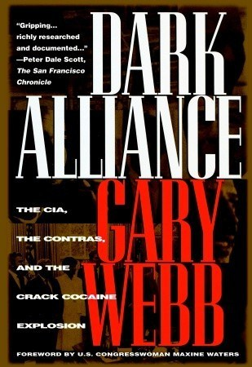
El-Batrawi is a principal that was directly involved in the Dark Alliance– CIA Contra Crack Cocaine Connection of the 1980s responsible for a deliberate genocidal program of annihilation and destruction of communities of color across the world. One DC9 plane “Cocaine One,” busted in Mexico carrying 5.5 tons of cocaine was discovered linked to CIA assets, El-Batrawi and Adnan Khashoggi.[53]
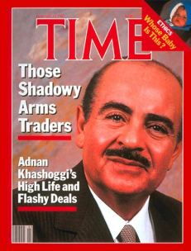
During the Iran-Contra Affair, Ramy El-Batrawi was the chief lieutenant of Adnan Khashoggi. Ramy was the former President of an admitted CIA subsidiary airline, Jetborne International.[54] Jetborne was a company supposedly owned by his long-time boss, Saudi billionaire Adnan Khashoggi. It was folded after being indicted for illegally ferrying TOW missiles to Iran.[55]
“Saudi billionaire arms dealer Adnan Khashoggi has been implicated in almost every major conspiracy in the last 50 or so years. The average person would never suspect a rich Saudi of being involved with Israeli intelligence, let alone being a paid agent of Israel’s sophisticated (spy) terror organization, Mossad. But that’s exactly what Khashoggi is, according to at least one former Mossad case officer, Victor Ostrovsky, and two Jewish journalists, Dan Raviv and Yossi Melman. The Mossad has a term for people like Khashoggi—an Arabist, a Mossad field agent who poses as a Muslim.“[56]
Declassified American intelligence report from 1991 listing the top 100 drug traffickers and associates included Adnan Khashoggi.[57] “Adnan Khashoggi’s mercenary army of global corporate criminals lives in Mafia mansions, basks in the political limelight, enjoys the privileges of royalty in tyrannical desert dystopias, and sips vodka in the shadow of Moscow spires,” wrote Alex Constantine. “They are kings, Pentagon officials, priests, S&L thieves, assassins, prostitutes, NAZIS … New Age cultists, drug barons … mobsters, dictators … and TERRORISTS.”[58]
El-Batrawi & Khashoggi: 9-11, Al Qaeda and Real Nazis
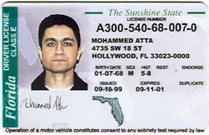
Khashoggi founded Oryx Investments. Oryx was linked by his partner Wallace Hilliard to Huffman Aviation in Venice, Florida, home of the flight school where Mohammed Atta and the other 9-11 Saudi Muslim pasties had been sheep-dipped to take the fall for the 9-11 Deception and Inside Job that murdered only 3000 civilians; brought down the NYC Twin Towers, and started a war of aggression against the masses of people of Iraq.[59]

The Saudi’s El-Batrawi and Khashoggi Network is linked to Saudi intelligence chief Prince Turki al Faisal in funding the strategy of tension terrorist group al Qaeda, and bin Laden. Prince Turki al-Faisal is also head of Faisal Islamic Bank of Saudi Arabia, which has been named by Luxembourg banking authorities as being directly involved in running accounts for bin Laden. Faisal Bank was founded by Youssef Nada, naturalized Italian, and a member of the Egyptian Muslim Brotherhood and Gama al Islamiya. [60]

Nada was another valued World War II Nazi. As a young man, he had joined the armed branch of the “secret apparatus” of the Muslim Brotherhood, and then was recruited by German military intelligence. When Grand Mufti el-Husseini had to flee Germany in 1945, as the Nazi defeat loomed, Youssef Nada is rumored to have been personally involved in arranging through Reichsfuhrer Heinrich Himmler’s SS his escape via Switzerland back to Egypt and then Palestine. Nada served as president of Al Taqwa, an international banking group. Al Taqwa, which literally means “Fear of God,” had been channeling funds to Muslim extremist organizations around the world, including Hamas in Palestine.
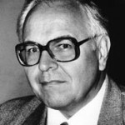
Serving on the board of Nada Management, a component of Al Taqwa, was Ahmed (Albert) Huber, above, a neo-Nazi, and a former journalist who converted to Islam, and changed his first name from Albert. A well-known figure in European neo-fascist circles, Huber “sees himself as a mediator between Islam and right-wing groups,” according to Germany’s Office for the Protection of the Constitution. Huber is also a member of a group calling itself Avalon, which claims to be based on the “Great Celtic tradition”, and at every solstice he meets under the moon, in a forest grove, with a few hundred European DRIUDS, with whom he is preparing the “End of Our Decline”. With the THULE SOCIETY, he works for the restoration of “Greater Germany.”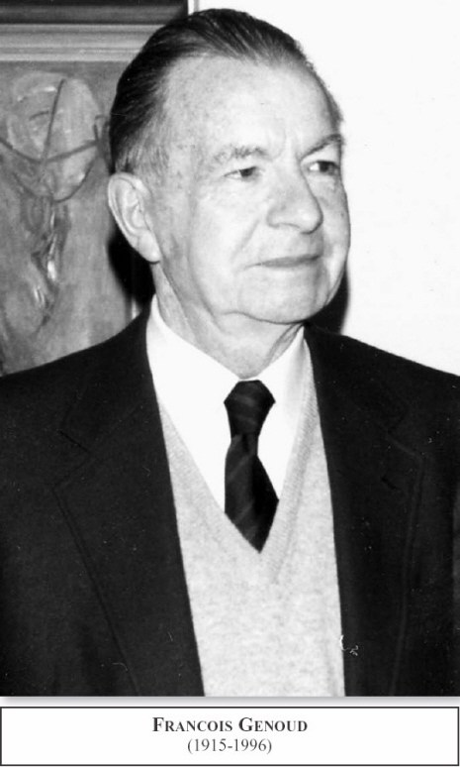Nada was appointed president by Francois Genoud, who is believed to have founded and directed al Taqwa in its support of terrorism, including Bin Laden. Described by the London Observer as “One of the World’s Leading Nazis”, Genoud played a key role in the continuation of the Nazi Islamist relationship.

Genoud was a former associate of Hitler’s Commando, Scarface SS-Standartenführer Otto Skorzeny, in Algeria, and supposedly helped finance the ODESSA network through his management of the hidden Swiss treasure of the THIRD REICH, which had been stolen from Jews. Genoud is also believed to have masterminded the 1972 hijacking of a Lufthansa flight from Bombay by the Popular Front for the Liberation of Palestine (PLFP).[61] Genoud also funded the legal expenses for the trials of genocidal Nazi war criminals SS- Hauptsturmführer Klaus Barbie and SS-Obersturmbannführer Adolf Eichmann.[62]
Donald Sterling & the Religion of the SS- TANTRISM
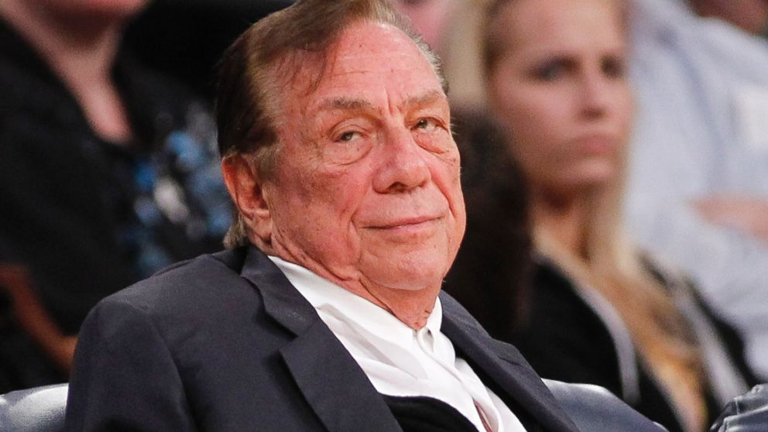
Again, Donald T. Sterling wasn’t created out of a vacuum. Most of the themes, language, signs and symbols of Sterling‘s Cult, Inner Circle and Society will point in only one direction.
The Secret Satanic-Sethian Brotherhood

“The application of force alone, without moral support based on a SPIRITUAL CONCEPT, can never bring about the destruction of an idea or arrest the propagation of it, unless one is ready and able ruthlessly to exterminate the last upholders of that idea even to a man, and also wipe out any tradition which it may tend to leave behind.” -Adolf Hitler (Mein Kampf) One key to understanding the mentality of the so-called modern super rich “elite” men of this society such as Donald Sterling, Alan Glick, and Al Davis is the realization that they go through a Secret Brotherhood Indoctrination, and follow “Brotherhood Secret Ethics and Spiritual Belief Systems.”
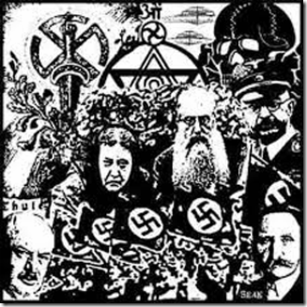
Their modern secret brotherhood indoctrination and secret religion are based on the “spiritual” edification of Himmler’s SS- “Wisdom” of the Hyperborean (Polar Nordic) Warrior Caste established from the pseudo “aryosophic” esoteric notions from Luciferian Madame Blavatsky, Himmler’s Ahnenerbe, Julius Evola to Miguel Serrano.

One clue to the existence of such a secret brotherhood and a “aryosophic” religion among an elite satanic cabal comes from Saudi’s Khashoggi and El-Batrawi. They have a spiritual guru named Shri Chandra Swamiji Maharaj. At one time or another during the 1980s, the swami has been brought in by Khashoggi as a “spiritual advisor” to a number of leading and powerful political world figures, Mohamed Abdel Moneim Al-Fayed,[63] King Hussein of Jordan,[64] Mobutu Sese Seko of the Congo,[65] Prime Minister of India, Rajiv Gandhi,[66] Ferdinand Marcos of the Philippines,[67] and U.S. President RICHARD MILHOUS NIXON. He had even met with British Prime Minister Mrs. Margaret Thatcher several times.[68]

Stolen out of Tibet in 1938, the Iron Man statue of God Vaisravana, believed have originated from the 11th century Bon culture. Swami Maharaji specializes in teaching esoteric “Tantrism” – Tantric Buddhism. Himmler and the SS believed that a pre-Buddhist religion (Bon) from a “High Aryan Culture” out of mythic Thule, Hyperborea and the Lost Continent of Atlantis had been sheltered in Tibet. They believed that a form of this “High Aryan Culture” was preserved in “Tantric Buddhism.”[69] Tibet was believed to have preserved something of the occult abilities to dominate nature, abilities once in the possession of the Arctic “primordial race” (Urrasse) of Aryans. And this became gospel truth for the occultist faction of Himmler’s SS-“Ancestral Heritage“.[70]
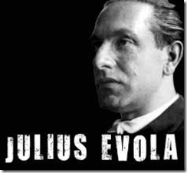
Julius Evola (1898-1974) was an Italian Fascist that envisioned the birth of an elite spiritual nobility and a secret military brotherhood that would regenerate modern Western Europe on the cosmogonic foundation of “Tantric Buddhism.” Evola’s concept of Shambhala was symbolized by the Swastika pointing to, a center of Hyperborean traditions “of Aryan origins.”[71] Evola’s “L’Uome come Potenza” (“The Male as Might“) is a glorification of power generated through sexual energy, following models of Indian Tantric cults, associated particularly with the Female Energy (Shakti) of Shiva Rudra and Kali, Indian deities of destruction and regeneration. Among Evola’s “applications” of them was killing – sacrificing – the Female (the female principle comprising both Compassion and Bolshevism…) –as its energy is to strengthen the Male, the Aryan Masculinity (p.234) which accumulates its own power by sacrificing the “Other.”[72]
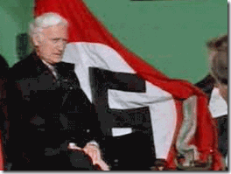
Miguel Serrano (1917-2009) was the Fuehrer of Chile’s National Socialists. In 1978, under the dictatorship of the Fascist General Augusto Pinochet, wrote the book “Hitler esotérico” -and, in 1982, “Hitler el último Avatar“, then, in 1991, “Manu por el hombre que vendrá”. These he called expressions of “esoteric Hitlerism“.[73]
Serrano like Evola offered essentially “Aryosophic” esoteric “Tantric” instructions and rituals to an neo-Nazi elite brotherhood- “Tantrism” meant for Serrano the main “wisdom” of the Hyperborean (Polar Nordic) Warrior Caste. Following “Tantric Ethics,” he supposed the deeds of the SS to be “beyond Good and Evil” -justifying the extermination of “Lower races” as fulfillment of “cosmic laws.” [74]
Himmler’s Ahnenerbe, Evola and Serrano’s secret doctrines, ethics and religion of the brotherhood of the elite should give you a fairly basic idea of Sterling’s “Tantric” underlining philosophical sexual ideological, and sacrificing the female principle (V. Stiviano) to strengthen his masculinity. The bottom line is that Himmler, Evola and Serrano’s secret “Tantric Buddhism” teaches an elite brotherhood the will and the art of non-attachment to create a New World Order where the weak (Female Principle) and so-called lesser races would be dominated and have no right to survive.
Donald Sterling & Tantric Sex Magick

Recently, Donald T. Sterling and Donald T. Sterling Corporation has been slapped with a lawsuit by one of his other MK ULTRA “SEX SLAVE,” Maiko Maya King.[75]This “SEX KITTEN” lawsuit was set up by Sterling‘s feuding circle/cell of ILLUMINATI and the NBA Ashkenazi Satanic Cabal. The lawsuit was initiated by HollyWeird’s Ashkenazi Lawyer Gloria Allred.
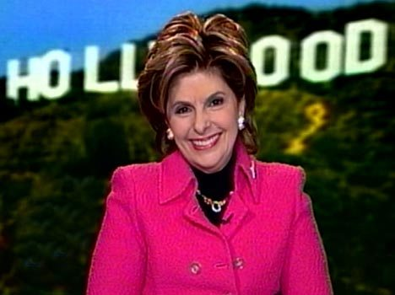
By the lawsuit, they are sending a clear message to Sterling that they will unleash a string of “SEX SLAVE” lawsuits against him if he continues to resist. In this lawsuit, 40 year old married King had been Sterling‘s so-called “Personal Assistant.” King is the founder and CEO of a charity in Beverly Hills, CA called, Circle of Charities (CoC).[76] She is a graduate of the University of the Ryukyus, a national university of Japan in Okinawa Prefecture.[77]
At the very top of CoC’s list of contributing charities is the Etta Israel Center.[78] The Center provides educational, clinical, social and support services for Ashkenazi youth with special needs.[79]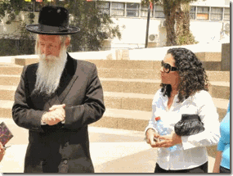Ashkenazi/Zionist Asset, Maiko Maya King, above, in the State of Israel with the ILLUSIONARY Liberal Zionist Migdal Ha’emek Chief Rabbi Yitzchak David Grossman , Chief Rabbi of Migal HaEmek, founder and dean of Migdal Ohr educational institutions, and a member of the Chief Rabbinate Council of Israel.[80]
Maiko Maya also works with Save the Children of TIBET Project (SCTP) to build an orphanage in India. TIBET- the last secret reservoir of the lost arts of the Lost Continent of Atlantis; and the “Wisdom” of the Hyperborean (Polar Nordic) Warrior. CoC board member, Cali T. Rossen, is a California Ambassador of SCTP, and met with his Holiness the Dalai Lama on Earth Day 2012.[81] Maiko is also the vice president of Harvelle’s Blues Club in Los Angeles. As Sterling‘s $10,000 a month “Personal (Body) Assistant,” the lawsuit revealed that Mayo acted as some sort of High Priestess of the Whore of Babylon.
From 2005-2011, her primary responsibilities were to surrender her perverted skills and wicked sexual nature to Sterling. It would also make sense that she was in charge of sex toys like V. Stiviano, sex groups and orgies designed to RITUALISTICALLY sacrifice them to invigorate, strengthen and “arouse” the sexual power and energy of Sterling’s mythic Aryan masculinity. I can only call it being consistent with – Satanic RITUAL TANTRIC SEX MAGICK.
Don’t be confused by Sterling‘s Jewish links. The Ashkenazi people of Eastern Europe converted to Judaism in the 8th Century AD. DNA studies show that the Ashkenazi is genetically related to the barbarian bloodlines of the Ancient Aryan Scythians of Europe.[82] The Scythians claim primeval bloodlines to the mythical Aryan (Amazonian) inhabitants of Atlantis– the Island of Atlas.[83]
“Adam Weishapt and Albert Pike both have written about the ultimate level of illumination with God (Lucifer) known as the “3rd Degree”. To achieve this level, a priest or priestess MUST use perverse sexual liaisons to mock the most sacred gift given by Heavenly Father to mankind- that of procreation and reproduction. Specific Luciferian rituals include perverted sexual activities to ‘possess’ certain psychic and/or metaphysical centers of the human body. To gain total ‘illumination’, initiates are encouraged to participate in what is referred to as TANTRIC SEX. There are three components of Tantric Sex- Fornication, Adultery (Polygamy), and Sodomy. Tantric Sex is designed to fill three primary areas of the human body with the spirit of the demon- specifically the mouth, vaginal or penis opening (where liquid waste leaves the body, and reproduction begins), and the anus. The spirit of the demon enters the human body upon the consummation of any three of the tantric components. “Enter Lucifer’s ‘holy spirit’ known as Set, or Aiwass. (the unholy Trinity equals Lucifer, Satan, and Set, or Aiwass.) Set is described as a demon ‘Spirit Guide’ which through perverted “sex magic” infests the occult initiate with possession by the heavenly hosts who chose to follow Lucifer. The three components of Tantric Sex, especially polygamy, is a major way in which Demonic Possession can be passed from one person to another.”[84]
Furthermore, Allred deliberately coded the language in the complaint as such to show that she is in control and that Maiko Maya is just another MK ULTRA/MONARCH ILLUMINATI Sex Slave– Puppet of the NWO, “He [Donald Sterling] would say, “why did you fly away.” She [Maiko Maya] responded, “because the cage was open.” His response was, “Well, you are back in the cage now.“[85]

The Caged Bird Theme is another standard ILLUMINATI, MK ULTRA/MONARCH traumatizing multiple personality disorder (MPD) method. The Bird Cage Motif is also just a standard psychological motif for a kind of mental entrapment/sexual slavery of “beautiful birds.”[86] You just can’t make this stuff up. Maiko Mayo King wasn’t created out of a vacuum either. Most of her themes, language, signs and symbols are also absolutely consistent with the cult practices and belief system consistent with an underground Secret Satanic Agency within the ruling ranks of the NBA.
FOLLOW YOUR BLESS
At the very end of this brief video interview with Maiko Maya, she confirms that CoC promotes Ashkenazi charities in and for Zionist Israel. However, host Vanessa Waller becomes a little confused about certain paradox terminology used by Mrs. King that is foreign to the Black Experience- “FOLLOW YOUR BLESS.” She made it very clear that it is, “FOLLOW YOUR BLESS.”
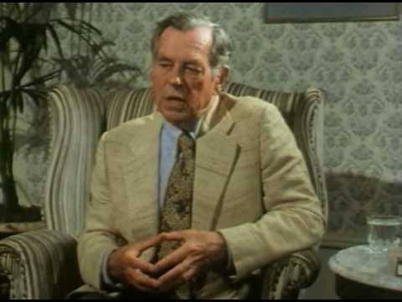To find your own way is to “Follow your Bless” was Mythologist Joseph Campbell’s advice on living, his simple wisdom for mankind. In this instance, a general discussion about Campbell is far too complicated to explore here. However, you need to understand some key points of his background that follows the storyline. There is no question that he was an “eugenicist” whose works in World Mythology was heavily influenced by Himmler’s SS-“Ancestral Heritage, the Ahnenerbe. Joseph Campbell sat on the editorial board of Mankind Quarterly.
The Quarterly was dedicated to the pseudo “race science” and “racial history” of the Nazis. It was established in 1960 by Professor R. Gayre of Edinburgh who believed that “racial fundamentals” were all important in human affairs. He maintained that scientific evidence proved Blacks prefer their leisure to the dynamism which the white and yellow show. Gayre’s work owed a heavy debt to Hans F. K. Guther, a major Nazi race theorist. Gayre’s first important work, Teutotn and Slav, argued for improving the “racial homogeneity” and “Nordic” purity of the German nation. Campbell sat on the Quarterly board with some of Himmler’s SS race scientists like human biologist and eugenicist Otmar Freiherr von Verschuer, SS- Hauptsturmführer Josef Mengele’s mentor.
Most importantly in this instance, Campbell argued that the Buddhist Doctrine was in many ways, the supreme expression of religious technique. For unlike Christianity, it was a psychological system. Campbell says, in Buddhism we come to truth. Seeing all things as Buddha being, we only have to come to recognition. There is nothing to do. Just to know and to be. Buddha is “The Blessed Enlightened One.” The Hebrew interpretation of the word “Bless” is linked to Genesis 24:11 and the phrase “kneel down“. Joseph Campbell’s “Follow your Bless” can be seen as follow the one you “Kneel down” to that involves Buddhism.
Maiko Maya and the Lost Aryan High Culture of Tibet

Maiko Maya was raised in Japan during her most impressionate years. Tantric- Esoteric [Vajrayana] Buddhism[87]took root in Japan over a thousand years ago where it has survived to this day by way of the secretive Shingon school.[88]

Above, Maiko Maya King exercise the Art of Vajrasana, the “warrior,” thunderbolt or lighting pose. In this posture one kneels down and then sits back on the heels. This form of sitting is very commonly used domestically in Japan. Recall, the Iron man statute of God Vajrasana. It had been stolen out of Tibet by Himmler’s SS as a possible relic of the origins of the Aryan race. In Sanskrit, Varjrasana is a form of VIRA that means ‘warrior’, ‘hero’, and ‘man’ in the ‘virile’ [masculine sex drive] sense of the term. Virility is understood here in a broader sense – that is it refers to the solar, masculine energies, and is not restricted to the sexual connotation.[89]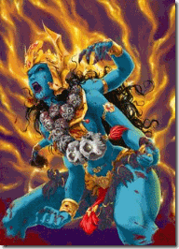
The Vajrasana Warrior Pose commemorates the exploits of a mythical warrior. It is rooted in Hindu mythology of Sati and her husband Shiva, Supreme Ruler of the Universe. The myth that brought about the Vajrasana Warrior Pose involves Sati walking into to a sacrificial fire (yagna) due to an insult from her father, Daksha, a powerful priest. When Shiva heard of Sati’s death, he was devastated. He yanked out a lock his hair and beat it into the ground, where up rose a powerful warrior. Shiva named this warrior, Virabhadra. Vira (hero) + Bhadra (friend) and ordered him to go to the yagna (sacrifice) and destroy Daksha and all his guests.[90]
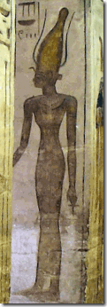
The Hindu Sati take her name from an extremely older, ancient and complicated Goddess of African/Kemet known as Satis, Satjit, Sates, Satet, and means “she who shoots forth” or “she who ejects out” or “she who pours out” presumably due to the flooding of the Nile that is believed to be a result of the masturbation of Atum.[91] Satis’ sacrifice to fire and the arise of a violent and destructive masculine hero avenger around 1,500 years ago seems to reflect the direct influences of the Indo-European patrilineal tribal invasions into the east, and the systematic elimination and bastardization of traces of ancient African matrilineal based religious foundations.


Whereas in Hindu Sati Mythology, you find some background for the Nazi Tantric Sexual Magick Ritual Ideological and Magick; and the sacrifice of the Female Principle through Fire- fire being a masculine element, and “shooting out” and “ejection” of the lost “wisdom” of the Hyperborean (Polar Nordic) Warrior- Hero Caste. Himmler and Knights of the Black Sun’s sacred Lost Art of the Hero [Vira] Thule Aryan Supermen–Tantric Buddhism is identical to Maiko Maya King’s Vajrayana/Tantric Buddhism. You just can’t make this stuff up.
Here’s one more thing to consider. As pointed out above, King’s high profile HollyWeird attorney, Gloria Allred, is also part of the secret Ashkenazi Order. Oddly enough, Allred’s first marriage was to a Pennsylvania blueblood, Peyton Bray, Jr. For some undisclosed reason, Bray ended up in a U.S. National Guard Mental Health ward sometime soon after 1961.[92] Allred also claims to have been raped and highly traumatized in 1966 at gun point by a well-known Mexican doctor while on vacation with a girl friend in Acapulco, Mexico. It doesn’t make much sense in that she has never reported the crime to Mexican authorities or the U.S. Embassy. She says that she doesn’t even remember or recall any of the details of the rape suggesting MK ULTRA iatrogenic dissociation.[93], [94] It is also odd that even after becoming a so-called self empowered and powerful feminist attorney that she still hasn’t exposed or pursued the well-known (CIA- MK ULTRA) doctor that allegedly raped her.
In 1979, Allred’s debut in the mass media spotlight was with the infamous and highly classified CIA- MK ULTRA mind controlled Symbionese Liberation Army (SLA) Soldier, Patty Hearst.[95] That’s some very deep, creepy, heavy and high level CIA-U.S. Military Intelligence clearance and classified- TOP SECRET stuff to open a career with.[96]
Gloria Allred, Charlotte Lewis and the Lost Aryan High Culture of Tibet

“The Eddie Murphy film ‘The Golden Child’ has many themes associated with theosophy, occultism, Satanism mixed with hints of Monarch mind control. The name instantly evokes The Golden Dawn, and the pseudo-Blavatsky style Tibetan mysticism themes contained within would point further in that occult direction.” Pseudoccult Media [97]

Attorney Gloria Allred and Charlotte Lewis at a May 2010 press conference regarding HollyWeird’s fugitive pedophile, Satanist Roman Polanski. Lewis and Allred claimed in the press conference that Polanski raped Lewis in Paris when she was 16 years old.[98]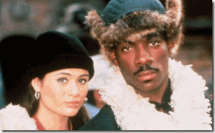
Charlotte Lewis is the former 19 year old English star of the Satanic- Tibetan Buddhist Themed, “The Golden Child.” The 1986 film features a magical phurba (kīla) called the “Ajanti Dagger” which has the ability to kill mystical beings, specifically the titular Golden Child and Satan’s Demon- Sardo Numspa.
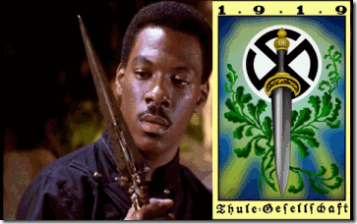
The Kīla dagger is one of many iconographic representations of divine “symbolic attributes” of Maya and the Nazi’s GOD VAJRASANA.[99]

The truth is that Lewis had been a high level mind controlled programmed CIA MK ULTRA ILLUMINATI Sex Kitten- Child Prostitute. Lewis like Ruby the Heartbreaker (Karima El Mahrough) had been part of an international elite SAUDI-Linked satanic pedophile- sex ring since the age of 14. Oddly enough, like Gloria Allred, she once said that she doesn’t remember or recall any of the details of being raped by the numerous men that paid her in sexual encounters.[100]


Lewis had also been a “Teenage Sex Slave” that was passed around elite HollyWeird stars like Eddie Murphy, Charlie Sheen; and from Roman Polanski to Warren Beatty of the powerful elite Top Secret CIA/U.S. Defense Department Laurel Canyon Lookout Mountain Lab Pedophile and Satanic Ring. [101],[102] The CIA Lookout Mountain Satanic Ring spawned the infamous (Strategy of Tension) Charles Mansion Family and the Jack the Ripper like Sharon Tate-LaBianca Murders of the late 1960s.[103]
The rabbit holes of the Saudi-linked Satanic Pedophile-Sex Rings, and the HollyWeird Lookout Mountain Satanic Ring runs extremely deep that’s why a high profile gatekeeper like Attorney Gloria Allred was Charlotte Lewis’ special CIA MK ULTRA/MONARCH Handler doing the press conference. The press conference was exclusively confined to control focus of the masses on Polanski’s individual deeds and extradition to America after pleading guilty 32 years ago to raping a 13-year-old girl.[104]
Whereas, there was no mention or public exposure of Lewis’ Iatrogenic CIA- British Intelligence MK ULTRA/MONARCH multiple personality disorder (MPD), Child-Teenage Prostitution, the SAUDI-Linked International- U.S. Military Intelligence Lookout Mountain Laboratory’s Laurel Canyon and HollyWeird Pedophile Sex Rings. Additionally, the Allred-Lewis Press Conference was totally hollow and ILLUSIONARY, because the age of consent in Paris, France was 15 years old. Lewis hooked up as Polanski’s girlfriend in Europe when she was 16 years old.[105]

Lewis Contacts Allred’s MK ULTRA/MONARCH Mind Control Butterfly Brooch-Button- then seems to Drift Away
When Allred handles an “ILLUMINATI Sex Slave Kitten” in public, she seems to always make it very clear to those “Who Know” that she is in ABSOLUTE CONTROL of the subject. You just can’t make this stuff up.
Similar Crystal MONARCH Butterfly Brooch Pin to Allred’s Brooch
In Conclusion

“If a race has no history, it has no worthwhile tradition, it becomes a negligible factor in the thought of the world, and it stands in danger of being exterminated.” Carter G. Woodson, Historian [106] Black History Month in America, is an annual observance and celebration in the United States, Canada, and the United Kingdom for remembrance of important people and events in the history of the African diaspora.The observance was created in the United States by Carter G. Woodson in 1926.[107]

88 years ago, Woodson said that the teaching of Black History was essential to ensure the physical and intellectual survival of the race within broader society.[108] Black History Month was not created out a vacuum. The fear and an “Agency of Racial Extermination” was/is very real and open truth in Ugly America.

The number of American lynchings in 1926 was almost double that of the previous year (The Nation, 19 January 1927, 52). America was the only so-called civilized nation of the world still burning,
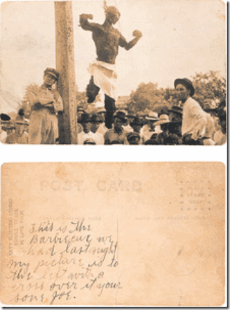
barbequing human beings alive.[109] In America, the “Law of Racial Extermination of Black People was “Unwritten.”
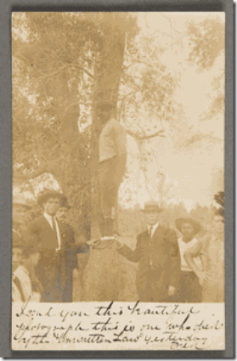
WOF “I send you this beautiful photograph, this is one who died by the unwritten law yesterday”[110]

In 2014, the NBA committed itself to observe Black History Month, but only through an ILLUSIONARY campaign- “Dream Big” on Dr. Martin Luther King, Jr. Day, and wearing a special commemorative shooting shirt during the month of February, honoring four prominent African-Americans: Dr. King, Frederick Douglas, Harriet Tubman and Bill Russell. The Big Dream Campaign or the so-called Dr. King shooting shirt does not even dare to mention Black History Month.[111] The National Football League (NFL) is approximately one third Black. The NFL support through “Player Engagement” the players’ choice to observe and celebrate, but the NFL as a “league or association” doesn’t not officially observe Black History Month. However, the NFL as a league officially celebrates Hispanic Heritage Month.

When I first heard that the NFL as a “league or association” was officially celebrating Hispanic Heritage Month, I had to scratch my head in puzzlement. I not saying that the NFL should celebrate Black History Month instead. There are twelve months a year and 365 days a year. There is enough justification for America to celebrate each month and every day of the year to the People of Color’s contribution to this country; and condemn its atrocities against them, whether Black, Brown or Yellow.

But, why would the predominantly Black player NFL officially celebrate Hispanic Heritage Month and give token observance to, and dismiss the significance of Black History Month? Why wouldn’t the NBA or NFL openly support Black History Month that is expressly articulated to humbly HELP save their Black Fan Base and majority Black Players and their families from racial injustice and extermination– GENOCIDE in America? But for, to confuse, divide, conquer and continuity DOMINATE the masses by deception and PSYCHOLOGICAL WARFARE.
Again, the DOUBLE BIND occurs when the person cannot confront the inherent dilemma, and therefore can neither resolve it nor opt out of the situation.[117] DOUBLE BIND causes insanity without any disease. The effect of the DOUBLE BIND is that the addressees cannot decide what is real and may develop pathologies- Mass Insanity. Deliberating implanting and spreading mixed messages among the masses of color instilling mass confusion/insanity is also an “unwritten rule of law” among most of the racialist-SETHIAN institutions that act in concert with the ILLUMINATI and America’s Shadow Government to exterminate People of Color in America. Like the works of Goebbels on the Jews of Nazi Germany, the voice and face of Black People are being systematically eliminated and limited on television, movies, radio and mass popular entertainment. In sports, there is no Black sportscaster or commentator whether in the NBA, NFL or MLB that has his own show on national television. The Black Folk world image in America has been reduced to a barrage of national/international emasculation and BUFFOONERY controlled by the ILLUMINATI.
Again, Don’t concentrate on DONALD STERLING ALONE OR YOU WILL MISS YOUR HEAVENLY GLORY AS PROPHESIED THROUGH OUT THE AGES AS A WORLD VICTORY OVER EVIL. Look at the bigger picture. Vicious, vile and ugly racialists like Donald T.and Shelly Sterling does not exist alone inside a vacuum. Sterling tells you that he is part of a culture and society that he follows the commands of. We need to know more about this cult of individuals and who is in it. It certainly doesn’t include Black People, the ENEMY! STAY FOCUS. BE VIGILANT.

[1] http://www.brainyquote.com/quotes/quotes/a/adolfhitle378196.html [2] http://www.usatoday.com/story/sports/nba/clippers/2014/05/27/donald-sterling-letter-privacy-los-angeles-lawsuit-ban/9646707/ [3] https://www.google.com/webhp?sourceid=chrome-instant&rlz=1C1CHFX_enUS560US560&ion=1&espv=2&es_th=1&ie=UTF-8#q=donald%20ssterling%2C%20you’re%20my%20enemy [4] http://www.dailymail.co.uk/news/article-2627494/EXCLUSIVE-Listen-explosive-secret-taped-rants-Donald-Sterling-black-pimp-Stiviano-true-racist-wakes-day-wishing-white-hot-sex-family-call-The-Monster.html [5] http://www.freerepublic.com/focus/news/3155792/posts?page=10 [6] http://elitedaily.com/sports/chris-bosh-tops-list-of-most-expensive-nba-player-homes-with-12-3-million-mansion-in-florida/ [7] http://deadspin.com/exclusive-the-extended-donald-sterling-tape-1568291249 [8]http://en.wikipedia.org/wiki/Double_bind [9]http://www.imprint.co.uk/thesaurus/double-bind.htm [10] http://mailstar.net/rhodes-will.html [11] http://tomjefferson1976.wordpress.com/2013/12/06/the-fathers-of-apartheid-the-council-on-foreign-relations-chatham-house/ [12] http://tomjefferson1976.wordpress.com/2013/12/06/the-fathers-of-apartheid-the-council-on-foreign-relations-chatham-house/ [13] http://www.wordsense.eu/genocider/ [14] http://en.wikipedia.org/wiki/Donald_Sterling [15] http://www.ynetnews.com/articles/0,7340,L-4481014,00.html [16] http://en.wikipedia.org/wiki/Temple_of_Set [17] http://www.theforbiddenknowledge.com/hardtruth/satanic_subversion.htm [18] Id. [19] Id. [20] http://www.theforbiddenknowledge.com/hardtruth/satanic_subversion.htm [21] http://en.wikipedia.org/wiki/Devil’s_Guard [22] http://en.wikipedia.org/wiki/Devil’s_Guard [23] http://emperors-clothes.com/articles/randy/swas4.htm [24] http://www.dailymail.co.uk/news/article-2110552/Richard-Nixons-secret-psychiatric-care-torpedoed-presidential-bid-detailed-new-book.html [25] http://en.wikiquote.org/wiki/Richard_Nixon [26] http://deadspin.com/exclusive-the-extended-donald-sterling-tape-1568291249 [27] http://en.wikipedia.org/wiki/Untermensch [28] http://en.wikipedia.org/wiki/Untermensch [29] http://laist.com/2014/05/03/v_stiviano_claims_donald_sterling_i.php [30] http://deadspin.com/exclusive-the-extended-donald-sterling-tape-1568291249 [31] http://perdurabo10.tripod.com/galleryg/id6.html [32] http://en.wikipedia.org/wiki/Thuleihibbnbng [33] http://en.wikipedia.org/wiki/Pytheas#Discovery_of_Thule [34] http://istifhane.files.wordpress.com/2013/06/goebbels.pdf [35] http://deadspin.com/exclusive-the-extended-donald-sterling-tape-1568291249 [36] http://www.dailymail.co.uk/news/article-2643705/Donald-Sterling-diagnosed-Alzheimers-Disease-allowing-wife-sell-team-2bn.html [37] Id. [38] http://www.dailymail.co.uk/news/article-2643705/Donald-Sterling-diagnosed-Alzheimers-Disease-allowing-wife-sell-team-2bn.html [39] http://forward.com/articles/197467/who-is-shelly-sterling-blameless-victim-or-enabl/?p=all [40] http://toughjews.blogspot.com/2006/05/meyer-mickey-cohen.html [41] http://en.wikipedia.org/wiki/Argent_Corporation [42] http://mafia.wikia.com/wiki/Allen_Glick [43] http://en.wikipedia.org/wiki/Jimmy_Hoffa [44] http://www.americanmafia.com/lonardo_testimony.html [45] http://www.nytimes.com/1983/06/01/sports/sports-people-big-gain-for-davis.html [46] http://www.nytimes.com/1981/10/18/sports/nfl-inquiry-of-raiders-widens.html?pagewanted=2 [47] http://grantland.com/the-triangle/chuck-klosterman-remembering-oakland-raiders-owner-al-davis/ [48] http://articles.latimes.com/1991-12-15/sports/la-sp-al-davis-heisler_1_al-davis-coach-tom-flores-assistant-coaches/2 [49] Olderman, Murray, Just Win, Baby, the Al Davis Story, Triumph Books (2012) [50] http://www.whale.to/b/12_masonic_signs.html [51] http://www.nowtheendbegins.com/blog/?p=21947 [52] http://www.prnewswire.com/news-releases/donald-t-sterling-homeless-and-medical-center-honors-ramy-el-batrawi-with-humanitarian-of-the-year-award-for-his-support-of-the-homeless-people-of-los-angeles-56219932.html [53] http://www.madcowprod.com/08082006.html [54] Id. [55] Id. [56] http://fitzinfo.wordpress.com/2013/05/31/the-growing-complexity-of-alex-jones-israeli-connections/ [57] http://spikethenews.blogspot.com/2014/02/khashoggi-cults-cover-ups-mars-venus.html [58] http://spikethenews.blogspot.com/2014/02/khashoggi-cults-cover-ups-mars-venus.html [59] http://www.democraticunderground.com/discuss/duboard.php?az=view_all&address=125×65356 [60] http://www.terrorism-illuminati.com/book/export/html/63 [61] http://www.terrorism-illuminati.com/dollars-terror#.U4Uh-bsU-Uk [62] http://www.historycommons.org/context.jsp?item=bolivia_1671 [63] http://en.wikipedia.org/wiki/Mohamed_Al-Fayed [64] http://en.wikipedia.org/wiki/Hussein_of_Jordan [65] http://en.wikipedia.org/wiki/Mobutu_Sese_Seko [66] http://en.wikipedia.org/wiki/Rajiv_Gandhi [67] http://en.wikipedia.org/wiki/Ferdinand_Marcos [68]http://www.democraticunderground.com/discuss/duboard.php?az=show_mesg&forum=104&topic_id=3522537&mesg_id=3534502 [69] http://www.trimondi.de/H-B-K/bookreview.en.htm [70] http://www.trimondi.de/H-B-K/bookreview.en.htm [71] http://www.trimondi.de/H-B-K/bookreview.en.htm [72] http://www.trimondi.de/H-B-K/bookreview.en.htm [73] Id. [74] Id. [75] http://www.newsweek.com/donald-sterling-sued-sexual-harassment-aide-maiko-maya-king-253220 [76] http://www.circleofcharities.org/ [77] http://www.linkedin.com/pub/maiko-maya/4/a78/bb9 [78] http://www.circleofcharities.org/charities.php [79] https://www.etta.org/ [80] http://en.wikipedia.org/wiki/Yitzchak_Dovid_Grossman [81] http://www.circleofcharities.com/advisors_board.php [82] http://www.theapricity.com/forum/showthread.php?118662-Ashkenazi-Jewish-YDNA-Q-s-Were-Scythians-Royals-Who-Later-Ruled-The-Khazars [83] http://www.ancient-origins.net/myths-legends/tattooed-scythian-warriors-descendants-amazons-part-one-001155 [84] http://www.redicecreations.com/specialreports/2006/02feb/LDS.html [85] King v. Sterling, Superior Court of Los Angeles County, Case No. BC 547277, pg. 6, paragraph 41 [86] http://www.pseudoccultmedia.net/2009/08/chained-sugaslaves-get-sexy-in-bird.html [87] http://www.chsbs.cmich.edu/guy_newland/rel_320/handouts/Mahayana-Tantra/tantra_and_mahayana.htm [88] http://en.wikipedia.org/wiki/Shingon_Buddhism#Shingon.2FEsoteric_Buddhism_outside_Japan [89] http://sivasakti.net/articles/yoga/supta-vajrasana-art36.html [90] http://en.wikipedia.org/wiki/Virabhadrasana_III [91] http://egyptian-gods.org/egyptian-gods-satis/ [92] http://www.timteeman.com/2010/08/28/dont-mess-with-gloria-allred/ [93] http://www.timteeman.com/2010/08/28/dont-mess-with-gloria-allred/ [94] Ross, Colin A. Deliberate Creation of Multiple Personality by Psychiatrists, Manitou Communications, Inc., Richardson, TX, page 255-261 [95] http://www.businessinsider.com/how-gloria-allred-got-her-start-2012-10 [96]http://www.maebrussell.com/Mae%20Brussell%20Articles/Inside%20The%20Hearst%20Kidnapping.html [97] http://www.pseudoccultmedia.net/2013/05/the-monarch-golden-child-charlotte-lewis.html [98] http://www.thehollywoodgossip.com/2010/05/charlotte-lewis-alleges-sexual-abuse-by-roman-polanski/ [99] http://en.wikipedia.org/wiki/K%C4%ABla_(Buddhism) [100] http://www.pseudoccultmedia.net/2013/05/the-monarch-golden-child-charlotte-lewis.html [101] http://www.pseudoccultmedia.net/2013/05/the-monarch-golden-child-charlotte-lewis.html [102] http://www.whale.to/b/lookout_mountain_laboratory.html [103]http://www.mygen.com/users/ufo/Laurel_Canyon_David_McGowan_Birth_of_the_Hippie_Generation_Abstract%20.html [104] http://content.time.com/time/world/article/0,8599,2003304,00.html [105] http://www.cnn.com/2010/CRIME/05/14/polanski.second.accuser/ [106] http://en.wikipedia.org/wiki/Black_History_Month#Criticism [107] Id. [108] Id. [109] http://www.thecoli.com/threads/lynching-postcards-inherently-graphic-images-do-not-come-in-if-you-have-a-weak-stomach.209951/ [110] http://www.thecoli.com/threads/lynching-postcards-inherently-graphic-images-do-not-come-in-if-you-have-a-weak-stomach.209951/ [111] http://www.nba.com/2014/news/01/17/nba-dream-big-mlk-day-black-history/ [112] http://fivethirtyeight.com/datalab/diversity-in-the-nba-the-nfl-and-mlb/ [113] https://www.nflplayerengagement.com/news-and-media/black-history-month/ [114] http://www.nfl.com/news/story/0ap1000000064289/article/nfls-celebration-of-hispanic-heritage-month [115] http://en.wikipedia.org/wiki/Reggie_Fowler [116] http://en.wikipedia.org/wiki/Zygmunt_Wilf [117]http://en.wikipedia.org/wiki/Double_bind
Comments : 2 Comments
Tags: Adolf Hitler, agency of genocide, anthony aquino, arnold hutschnecker, black people, bohemian grove, bruce lee, cecil rhodes, chris paul, CHURCH OF SATAN, church of set, Council on Foreign Relations, donald sterling, Double bind, genocide, gloria allred, Heinrich Himmler, josef goebbels, josef mengele, Knights of Black Sun, ku klux klan, los angeles clippers, luciferian brotherhood, maiko maya, maiko maya king, marga himmler, nazi pseudo race theories, Nazis, Nazism, nba, nfl, Richard Milhouse Nixon, richard parsons, round table, Satanism, Set, Seth, shelly sterling, Thule Gesellschaft, thule society, Trilateral Commission, V. Stiviano
Categories : 1000 Year Reich, African Liberation, African slavery, Aleister Crowley, ALL SEEING EYE, Aryan Supremacy, bohemian club, bohemian grove, charlote Lewis, christianity, church of satan, church of set, Col. Dr. Michael A. Aquino, col. michael Aquino, columbian cocaine, council of foreign relations, council on foreign relations, Crimes Against Democracy, Dark Alliance, double bind, Dr. Gregory Bateson, Dr. Leonard Horowitz, druids, egypt, Eye of Horus, frederick douglass, Gary Webb, genesis, genocide, Geobbels Method, gloria allred, Hauptsturmfuhrer SS Dr. Josef Mengele, Heinrich Himmler, hollywood satanic cult, human sacifrice, illuminati, illuminati sacrifice, Iran-Contra Crack Cocaine connection, israel, Josef Mengele, klaus barbie, Knights of the Black Sun, ku klux klan, Lookup Mountain Laboratory, lucifer's servants, luciferians, Madame H.P. Blavatsky, MK-ULTRA, monarch program, MOSSAD, MPD, mulitiple personality disorder, National Socialism, Nationalist Zionist, Nazis, new age religion, nwo, order of teutonic knights, Otto Skorzeny, Patty Hearst, Paul Josef Goebbels, post hypnotic suggestions, re-image, re-imaging, Reichsfurhrer SS-1 Heinrich Himmler, Ritual Satanic Abuse, ritual satanic sexual abuse, ritually abused children, RONALD REAGAN, rosemary's baby, Satanism, Schutzsteffel, Secret Doctrine, set, seth, sex kitten, sex slave, SS, ZIONIST

DONALD STERLING & THE RISE OF THE BLACK MESSIAH- NBA ILLUMINATI GONE WILD
22052014
PREVENT THE RISE OF THE BLACK MESSIAH
“The events which transpired five thousand years ago; Five years ago or five minutes ago, have determined what will happen five minutes from now; five years From now or five thousand years from now. All history is a current event.” –Dr. John Henrik Clarke -–
The GOOD
The FBI’s COINTELPRO program was a major veiled Luciferian-ILLUMINATI program initiated to suppress the rise of a mysterious “BLACK MESSIAH” that would unity the world, defeat and expel EVIL and return mankind to Universal Love, Peace, Balance, Harmony, and Justice forever. You won’t learn this in any school or university, but the Prophesy of the Deliverer and BLACK MESSIAH maybe one of the world’s most suppressed and greatness secrets.
On March 4, 1968, the FBI under the U.S. Justice Department issued the infamous official U.S. Government target memorandum of March 4, 1968 to “Prevent the Rise of a Messiah” among Black People “who could unify and electrify” the masses. This directive is broad and arbitrary enough to sweep under its web the inclusion of anyone in the Entertainment and Sport’s Industry across the globe. This directive has not been retracted. It remains effective official U.S. GOVERNMENT POLICY and plans deemed even today to be necessary to establish a New World Order (NWO) without Black People and the threat and the Prophesy of the BLACK MESSIAH.[1]
The Forces of EVIL
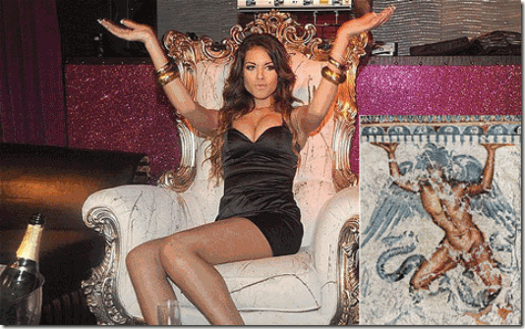
African-Moroccan-born Karima El Mahroug AKA Ruby the Heart Stealer beside the Ancient Etruscan Typhon (Set-Seth-SATAN) bracing himself beneath the land . Ruby the Heart Stealer was the international MK ULTRA/MONARCH Sex Kitten used to bring down ILLUMINATI billionaire Italian Prime Silvio Berlusconi.[2] The downfall of Berlusconi was a power play, shift- ILLUMINATI house cleaning.

In June 2013, three-time Satanic Italian Prime Minister, Silvio Berlusconi, above, was sentenced to seven years in jail for paying for sex with a minor, Mahroug, and covering it up.[3] Remember, the Luciferian Hauptsturmführer-SS (Captain) Dr. Josef Mengele, the Demon of Death, was one of the main architects of the CIA’s MK ULTRA/MONARCH mind control program. Sex Kittens go through an advanced process of Eindeutschung (trauma based mind control-multiple personality programming) that was developed and perfected primarily by SS Josef Mengele in Nazi Concentration Camps. One of his most insidious programs involved programming children, some from infancy, thru Eindeutschung to become future assassins and sex slave espionage-change agents for the New World Order with Lucifer as GOD.
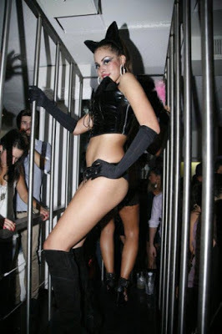
Karima El Mahroug- Caged Sex Kitten
Mahroug’s ritual sex abuse began when she was viciously raped at 9 years old. At that age, she also perfected in the mental survival art of “DISSOCIATION” to deal with the pain, mental suffering and human degradation. As early as 16 years old, Mahroug had been become one of Berlusconi’s favorite sex kittens.[4] Luciferian MK ULTRA Sex Kitten- Mahroug reduced to a wild “Animal Nature.”

When we discuss MK ULTRA/MONARCH Sex Kittens, you can’t separate it from Dr. Mengele and National Socialism’s designs for a NWO, and its pseudo race theory worldview of “applied biology” and GENOCIDE of perceived inferior races- the Untermensch.[5]
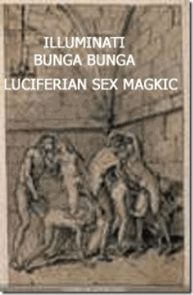
Lust’s passion will be served; it demands, it militates, “IT TYRANNIZES” –Marquis de Sade, ILLUMINATI (1740-1814)
The ILLUMINATI/Satanic secret political and wealthy international (EYES WIDE SHUT) sex dens, sex parties, pedophile rings and circles of lust, control, espionage and “whitemail” that MK ULTRA/MONARCH Sex Kittens worked within, Mahroug called the BUNGA BUNGA.[6] NWO Sex Kittens have also become part and partial of a Satanic Underworld that is consuming the professional Entertainment and Sport’s Industry that Blacks have become most prominent.
ACT I
TALKING WITH THE ENEMY,
THE CLANDESTINE WAR AGAINST BLACK PEOPLE
People in Glass Houses Don’t Throw Stones
They are beginning to sling very heavy bricks in the NBA ILLUMINATI. Things and secret agendas are being revealed that have been kept behind closed doors and veiled for generations.
Don’t be confused by the media spin, neither Vanessa Perez aka Vivian Stiviano or Magic Johnson has the influence, ability or power to bring down, Donald Sterling, a principal member of the ILLUMINATI, and a powerful, rich and influential secret Jewish cabal. They are only pawns and pasties in the game. They can’t make any independent moves on this scale without enticement, directions and collaboration of the Shadow Government and powerful Secret Societies. This is a power struggle, play and shift within the cabal that is rapidly spinning out of their control of public perceptions.
Magic Johnson is a front and puppet Negro for the secretive billionaire Guggenheim Partners that has the power, money and craving to seize the Los Angeles Clippers out of Sterling‘s hands.[7] Meyer Guggenheim was the patriarch of what became known as the “Guggenheim Family.” He was born in Lengnau, Aargau, Switzerland, was of Ashkenazi Jewish ancestry and emigrated to the United States in 1847.[8] The powerful “Guggenheim Family” is intermarried within the Ashkenazi-ILLUMINATI House of Rothschild.[9]
Bernard Mannes Baruch (August 19, 1870 – June 20, 1965) was an Ashkenazi -Jewish American financier, stock investor, philanthropist, statesman, and political consultant to U.S. Presidents Woodrow Wilson and Franklin D. Roosevelt.[10] Behind the veil, he was the virtual Zionist House of Rothschild dictator and a principal profiteer (raider of public treasury) of America during WWI and WWII. During WWI, Baruch delivered most of the profits of the copper industry to the “Guggenheim Family.” Baruch was the principal proponent of the “open conspiracy” of WWI and WWII; and the establishment of the Zionist State of Israel, and the One/New World Order with Jerusalem as its capital.[11]
Sterling won’t dare open his mouth about the “Guggenheim Family,” the House of Rothschild or the Ashkenazi Cabals. However, someone is going to pay the price for these disclosures. There will be a BODYCOUNT. Nevertheless, Sterling thinks that he has the leverage and license to out, demonize and expose the contradictions of their pasty front man, Earvin “Magic” Johnson.
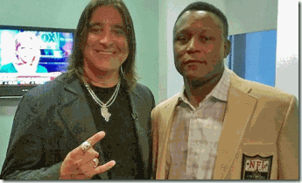
“See God gave us the Talent, but the DEVIL make us Famous.” – Barry Sanders[12]
Above, legendary NFL running back Barry Sanders and Scott Stapp of Creed, Stapp is a known Satanist and is reported to enjoy eating his own Shit.[13] Donald Sterling’s recent CNN television interview with CIA (Project MOCKINGBIRD) gay propaganda specialist Anderson Cooper got out of hand, or maybe it had been designed that way.[14]
Donald Sterling: “What has he done? Can you tell me? Big Magic Johnson, what has he done?… He’s got AIDS.”[15]
Donald Sterling: “Well, what kind of a guy [Magic Johnson]goes to every city, has sex with every girl, then he catches HIV? Is that someone we want to respect and tell our kids about?”… “I think he should be ashamed of himself. I think he should go into the background. But what does he do for the black people? He doesn’t do anything.”[16]
Sterling said Jewish people spend great amounts of money helping other Jews who are poor while rich black people turn their backs to people in need.
Donald Sterling: “That’s one problem I have. Jews when they get successful they will help their people and some of the African-Americans — maybe I’ll get in trouble again — they don’t want to help anybody.”[17]
Richard Pryor- Blacks & the BUNGA BUNGA HollyWeird Underground
The Late Richard Pryor (December 1, 1940 – December 10, 2005) wasn’t the strongest among us and he never pretended that he was. He was a fragile human being that sold his soul to the DEVIL for fame and fortune. Under the veil of his humor, he often used comedy to send serious messages to the masses. In this video under the cover of a Celebrity Roast, he let it all out exposing the HollyWeird BUNGA- BUNGA that aspiring Blacks in the entertainment industry are subjected to for fame and fortune. It hasn’t stopped. It is expanding becoming MORE and MORE threatening and frightening layered deeply in SATANISM. It’s growing widespread in the HollyWeird Entertainment and in the Professional Sports Industry- MK ULTRA Satanic Ritual Abuse (Multiple Personality Disorder) Mind Control.
Ervin Magic Johnson & the GLASS HOUSE
Magic Johnson– Help Black People! Sterling knows that Magic‘s house is built of GLASS. That’s the way they’re made it for the Negro Satanic Cabal. They build their house to look through, shake, rattle and splatter like GLASS. He knows very well that Magic may not even be able to help himself or his family.
Since 1991, there has been persistent rumors that Magic Johnson was bisexual and was infected with the AIDS virus through a homosexual relationship. In January 2014, an odd photo was posted on the internet of Magic Johnson at one of Jerry Buss’ Lakers Picnics. Magic is carried away by what appears to be a naked man. They say that the man has on tight-tight short-shorts which may be true yet still puzzling, but look at the dude in the background with his hands on his hips.[18] Where are the other Lakers?
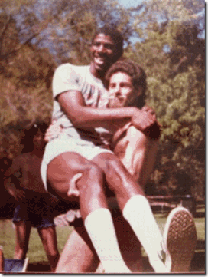
In a recent interview with CNN’s Anderson Cooper, Magic Johnson said that when he first arrived in Los Angeles Lakers’ owner Jerry Buss took him to a private party at Sterling’s beach house 35 years ago.[19] 35 years ago in 1979, the Lakers selected Magic Johnson with the first overall pick of the NBA Draft.[20] Sterling‘s Malibu beach house maybe the site where the picture was actually taken at. And, there’s probably more incriminating photos of Magic Johnson in uncompromising positions with white men.
Furthermore, I suspect this was the site where Earvin Magic Johnson signed and sealed his Covenant with the Ashkenazi Luciferian-ILLUMINATI for Fame and Fortune as Richard Pryor plainly implies with dehumanizing acts of sodomy. Sterling may actually know a lot more about Magic Johnson then we suspect. He may have turned the Negro him out- BUNGA- BUNGA.
Magic Johnson: “Tyler Perry called me right after the interview. He was so upset … I mean, look, we help each other, you know, and we …. — and what we try to do is band together [twin]… “[21]

That’s really interesting that out of all the people in the world, Magic said that the first person that called him after Sterling’s Rant had been former MK ULTRA/MONARCH Child Sex Slave and notorious cross dresser, Tyler Perry.

Magic Johnson– BLANK Eyes and Emotion Impersonalizing a Female Hockey Player- A Sad Joke of a Man to the ILLUMINATI. That’s the way he’s been programmed. Furthermore, either Magic sacrificed his son, E.J., to the ILLUMINATI Gay Agenda, or they Eindeutschung-Ritually Satanic Abused– RAPED him as a CHILD.
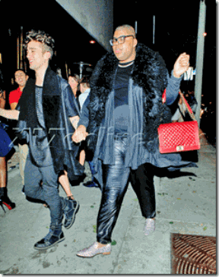
EJ Johnson with boyfriend in Gothic Black with Classic MK ULTRA Mind Control Programming- Animal Patterned (Sex Kitten) Leopard Print- SHOES

EJ Johnson Satanic- Eyes Wide Shut
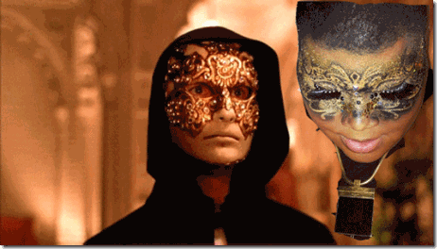
EJ Johnson Satanic- Eyes Wide Shut
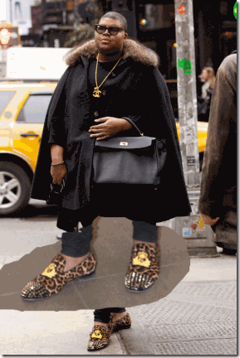
EJ Johnson- Animal Patterned (Sex Kitten) Leopard Print- SHOES
The Leopard Print dressing as a cat refers to the Sex Kitten Programming or Cat alter. This is the most sexual programming. Yes, even men have this alter. BETA- referred to as “sexual” programming. This programming eliminates al learned moral convictions and stimulates the primitive sexual instinct, devoid of inhibitions.

THELEMA– Zayin: The name of the Hebrew letter corresponding to the Number 7 and the Hebrew word for “sword“. The sword is a symbol of the Divine Word cutting through the circle of infinity- or non duality- to begat creation. The existence of such creation depends on the dualistic nature of mind. The principle embodied by the sword is division and therefore doubling- a principle also associated with the Kemetic God– SET. The name of Set is related to the word Sept, meaning “SEVEN”.[22]

Demonic EJ & Francis Borgia –1510-1572- THE CLAW HAND SYMBOL. Borgia– 4th Duke of Gandia, 3rd Superior General of the Society of Jesus. (Formerly known as Los Allumbrados, the ILLUMINATI, and the Knights Templar.[23]
Don Lemon & the GLASS HOUSE

Don Lemon & Dating Partner CNN Producer Ben Tinker
CNN’s Don Lemon is the latest to enter the Donald Sterling NBA ILLUMINATI sling fest. Late April on CNN, Lemon called Rush Limbaugh a “stunt king” for a offhand remark on the air that Sterling was in so much trouble because he hadn’t donated enough money to President Obama. Limbaugh threw a brick back on the air that Don Lemon is someone “who sleeps with men, proudly.”[24] In other words, don’t throw bricks too far in your “Glass House.” Betcha By Golly Wow, he left Limbaugh alone.
Don Lemon is also some type of Operation MOCKINGBIRD CIA operative with an ILLUMINATI Gay Agenda. He is allowed a lot of unlimited airtime and exposure to promote the Gay Agenda, and particularly confuse the masses; belittle, bash and demonize Blacks.[25] He jumped right in the middle of the Ashkenazi Power Struggle with Donald Sterling. Lemon (br. 1966) came out of the closet a couple of years ago. He admits beginning in about 1971 to being ritually sexually abused from the CIA/MK ULTRA’s idea iatrogenic Multiple Personality Disorder (MPD) impressionate years of 5 thru about 12 years old.[26] He said that his sexual abusers had been neighborhood teens. What group of teenagers and young adults would have the cohesiveness of a cult to criminally sexual abuse and RAPE him for seven years? The more likely scenario is that he belonged to a CIA MK ULTRA children’s subproject of “twinning” Satanic Abused Children programmed to become future agents.[27]

For years, Tyler Perry had been making the same accusations that people in his black neighborhood had been responsible for his ritual sexual abuse and RAPE as a child. On the air on Oprah’s Show, he slipped and admitted that he had been ritually sexually abused by nurses in hospital gowns- Iatrogenic/CIA/MK ULTRA.
Nonetheless, the bottom line is that if Lemon was a CIA MK ULTRA Satanic ritually abused child and I believe that he was- 7 years of Eindeutschung ritual mental and sexual abuse would have “fractured” his subconscious into dozens of “alter personalities.” What we know is Don Lemon is very strange and atypical of an ordinary black man. In his so-called bio, Transparent, he alludes to associating with and dating exclusively “white men.”[28] Lemon’s role model is past former California Governor/U.S. President Ronald Reagan– the alter ego of Knight of the Black Sun SS– Hauptsurmfuhrer Otto Albrecht Alfred von Bolschwing. We also know that he is a Negro lap dog and subservient of Fox News JESUIT- Bill O’ Rilley.[29]
Lemon’s MPD impressionate years was spent at St. Francis Xavier Catholic School in Baton Rouge where he was first most likely violated, and the scientific satanic ritual sexual abuse really began there. Saint Francis Xavier, born in 1506, was a co-founder of the JESUIT Order- The Military Order of the Roman Catholic Church.[30]

Saint Francis Xavier impersonating God Ausar and Good Heart-MAAT of Osiris, bi-crossed arm symbol across the chest- the pharaohic homage to the Great God Ausar- OSIRIS.
“[Francis] Xavier was once again remarkably successful in converting tens of thousands of Japanese to Christianity, according to Ryu Ohta, a long-time researcher into the Illuminati agenda to conquer Japan. The blueprint was the same – employing the knowledge of black magic and mind control to target the ‘ruling class’ and ‘opinion formers’, who would then influence the population.” [31]
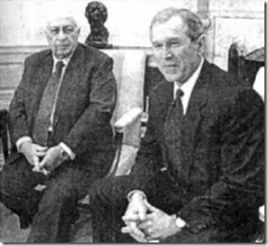
Former Israeli Prime Minister Ariel Sharon and President George W. Bush & The Inverted Triangle Occult Symbolism
“The alchemical/magical symbol for water is an inverted triangle, symbolizing downward flow. The downward pointing triangle is an ancient symbol of femininity, being a representation of female genitalia. One of the four alchemical elements, water has the properties cold and moist, and symbolizes intuition, the unconscious mind, and the enclosing forces of the womb.”[32]
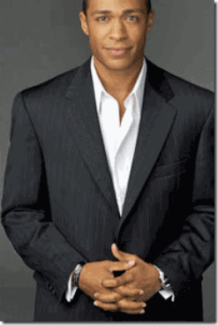
Here, Don Lemon shows a lot of pain and emotion acknowledging and subjecting himself to ILLUMINATI Occult Symbolism and the Satanic Inverted Triangle Hand Symbol
“In esoterica, pyramids are symbols of the comprehensive, secret, but lost, knowledge of the ancient Egyptians, a knowledge that cannot be confirmed.”—following this definition, the inverted pyramid could mean both the abandonment of the arcane for convention, or the rebelling against convention in favour of the arcane. More generally, it could simply mean that one has devoted their life to esoteric knowledge.” Source: The Illustrated Signs & Symbols Sourcebook” by Adele Nozedar ; “The Continuum Encyclopedia of Symbols” edited by Udo Becker
TALKING TO THE ENEMY- BLACK PEOPLE

Donald Sterling’s now infamous recorded rant to his girlfriend, V. Stiviano, included a chilling statement that fraternizing with Black People was like “TALKING TO THE ENEMY.”[33]
“ENEMY” is a strong word, and emotions associated with the enemy would include anger, hatred, frustration, ENVY, JEALOUSY, FEAR, distrust, and possibly GRUDGING RESTPECT. As a political concept, an enemy is likely to be met with HATE, VIOLENCE, BATTLE and WAR.[34]
The question has not been asked- why is a powerful, rich and influential secret Jewish cabal carrying on a permanent clandestine battle and rage of war against Black People? Well, it appears that either not many people understand the true ramifications of that statement or it’s being swept under the rug, covered up and dumb down. If you believe that the ILLUMINITI isn’t serious and worried about the implications of Sterling‘s statements, take a good look at who they are fronting todumb down the public.
NBA & ILLUMINATI DICK
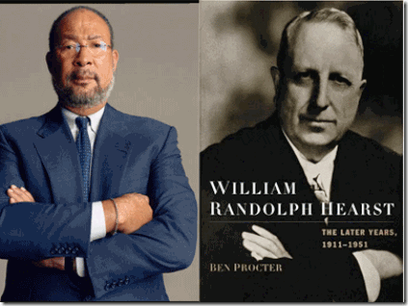
“Richard Parsons, African-American Front Man was CEO and Chairman of the Board of Directors for the Zionist Rulers of the Time-Warner Media Empire.”[35]
Above, Richard Parsons and William Randolph Hearst with the ILLUMINATI Hidden Hand Symbol. To divert the attention of the masses away from Sterling’s Rant that went well beyond the confines of basketball to the designs of a New World Order without Black People, the NBA has applied an old faithful BOOTLICKER, Richard (DICK) Parsons, like “SHOE POLISH” to act as interim Chief Executive Officer (CEO) of Sterling’s’ Los Angeles Clippers.[36] Don’t be fooled for one moment, Parsons has only the ILLUSIONS of black power.
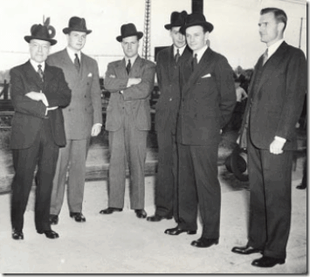
Parsons is a “Rockefeller Republican.” He was a direct Omega Psi Phi 6′ 4″- 23 year old Black Mandingo Basketball Stud product of former New York Governor and Vice President of the United States, Nelson D. Rockefeller (July 8, 1908 — January 26, 1979);[37] and the Rockefeller’s “The Old-Boy Network.”[38] The Rockefeller Family have been loyal allies of the Ashkenazi– House of Rothschild since the later part of the 19th Century. The Rockefellers owe their enormous wealth and fortune to ties with the Rothschilds and remain loyal to their interests- Israel, One-World Government, Freemasonry and the ILLUMINATI.[39] Parsons is a longstanding member and supporter of the New World Order (NWO) Council on Foreign Relations (CFR) and its genocidal agendas.[40] Former CEO of Time Warner, he is a leading and dangerous propagandist for the ILLUMINATI.
“One CFR published policy objective is substantial worldwide depopulation including half of the current U.S. population being targeted. This population reduction program is largely funded by the Rockefeller Foundation and Merck Fund, both financially and administratively linked to the Merck pharmaceutical company- the worlds leading vaccine manufacturer.“ –Dr. Len Horowitz, “Parenting with Deadly Timely Propaganda” [41]
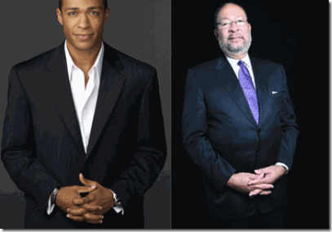
Don Lemon & Richard Parsons- Satanic Inverted Triangle Hand Symbol
You may think that describing DICK Parsons as a BOOTLICKER is a little too harsh and insensitive for an aspiring Negro in America. When Parsons took over Dime Bancorp in 1994, one of his own Jewish sponsors- billionaire self-proclaimed “ardent Zionist” former NYC Mayor Michael Bloomberg,[42] told it as it is that DICK was just “The Rockefeller Protégé Who’s Polishing the Dime.”[43]

Dick even married an Ashkenazi (explained below) woman, Laura Ann Bush.[44] They live on one of the houses on the late John D. Rockefeller’s Kykuit Estate in New York that has been home to four generations of the family.[45]
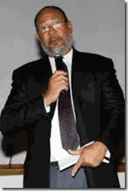
We are accustomed to being constant victims to pseudo eugenic racial theories and white supremacy. However, designating Black People as an institutional ENEMY is quite another affair and dimension. It’s not going away by sticking DICK up the public’s you know what- A-HOLE.
ACT II
THE ILLUMINATI SECRET CONTROL AND BLAXPLOITATION OF YOUNG WOMEN
Donald Sterling- Rape, Oppression and Control of Black Women

“The girl is black. I like her. I’m jealous that she’s with other black guys.” -Donald Sterling [46]
Sexual Blaxploitation of Women
Mass Media reports that Vanessa Perez aka Vivian Stiviano was demonizingly born of a rape of her mother by a black man, but no evidence has come forth to substantiate the claim. Nevertheless, she is part African and Latino raised within a humble poverty challenged and struggling Latino family in San Antonio, Texas.[47] Next, she showed up at Roosevelt High School in Boyle Heights, East Los Angeles while her mother seemed to have remained in Texas. Vanessa graduated in 2000, the same high school that Donald Sterling graduated from.[48] In 2000, she also showed up at a music video shoot for Tyrese Gibson’s “We Like Them Girls.”[49]

TYPHON-LUCIFER RAISING- BUNGA- BUNGA Sex Kitten Ruby the Heart Stealer & Vanessa Perez
Not much is yet known of her impressionate years, but at 17 years old, Vanessa Perez made it known to concerns shooting and directing the musical video that she was ready and willing to give her Soul to the DEVIL for fame and fortune.

“V wanted to do it all, bottom line, acting modeling, her own TV show… she loves to style people. She wants to be a jack of all trades and to master everything she wants to do.”[50]

In 2002, Vanessa Perez at 19 years old was picked up by police for shoplifting at Ross Dress for Los Angeles. Instead of promises of fortune and fame, she was being turned out. Two years later in 2004, she shows up again on the police blotter arrested for shoplifting. At 21 years old, Perez entered an Old Navy store and tried to steal 11 items worth $174.50. She had turned into a common “booster (shoplifter)” to support a drug habit or a pimp or hustler.[51]

Satanic V. Stiviano and with another “MAGIC” Negro – Former Chicago Pimp-ologist so-called Bishop Don “Magic” Juan
The televised Oprah Winfrey Show began national broadcast on September 8, 1986.[52] One of her first guests was Chicago Pimp 333 Donald Campbell aka Don “Magic” Juan from “Pimp Stick to Pulpit, It’s Magic” (1994 Vantage Press). He told Pimpmagazine that he had been under a PCP (Angel Dust) binge when God began to “purge” him.[53] Phencyclidine (PCP- Angel Dust) is a CIA- U.S. Department of Defense dissociative drug. It was brought to market in the 1950s as an anesthetic pharmaceutical drug but was taken off the market in 1965 due to itsdissociative hallucinogenicside effects.[54]

Occultists have used 333 as the hidden symbol by which they present the more offensive and Satanic Number of the BEAST- 666. Regarding the number 3, intensification is achieved when it is shown as 33, or 333. Obviously twice 333 is 666.[55] Don Juan’s ILLUSIONARY transformation from a pimp to a preacher was a “demonic“ event stamped with the Sacred Occult Number 333 an Occult Signature on that event.[56] Aleister Crowley’s perception of Magick is the art of making changes to realty by “Willed Intent.”[57] In HollyWeird Satanic Circles, Don “Magic” Juan is most likely one of their Pimp-ologist dominance specialist- a MK ULTRA Sex Kitten Handler and Trainer.
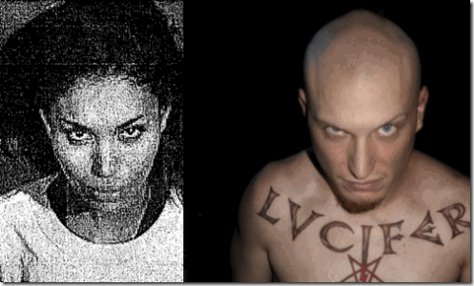
At 21, Perez appeared aged beyond her years and under very clear signs of MK Ultra/Monarch DEMONIC influence. We know that she at sometime showed up in Los Angeles Lakers’ owner, Jerry Buss and Magic Johnson’s sex dens and circles as aBUNGA- BUNGA Sex Kitten.[58]
The late Jerry Buss was a pedophilic sexual predator, “a world-class Playmate aficionado who frequently dated teenage girls and used to host his birthday party at a brothel,” in a tribute aptly headlined, “Jerry Buss, Surrounded by Boobs” that’s illustrated exactly like it sounds.”[59]
“A couple of years ago Dr. Jerry Buss had a black female on his payroll. She goes by the name Eve. She’s tall, slim and keeps a bald head. Eve dressed very expensive, Jerry leased her a blue Lamborghini so she could attract the girls. Eve would mack on exotic girls, she would persuade the chics to live at a home owned by Jerry Buss. They had 12 girls living in that house, the girls were paid an allowance and taken out three to four times a week… none of the girls were over 23 years old …”[60]

MK ULTRA/MONARCH Sex Kittens- V. Stiviano and confessed Multiple Personality Disorder Barbie Doll Nicki Minja in Leopard Print- Drawing Animal Sexual Nature

V. Stiviano Teddy Bear Programming (Programmer, helpless teddy bear slave connotation)[61] Teddy Bear Disassociation Exercise: even the MEANESS, hairy and heavy-set man will by ILLUSIONS be soft, cuddly, comforting, and safe.[62]
They called Buss “Doctor.” He earned both a masters degree and Ph.D in chemistry at the University of Southern California. Buss started out as a federal employee working as a chemist for the United States Bureau of Mines, and then worked briefly in the aerospace industry (Douglas Aircraft Company).[63] Of course, McDonnell Douglas was/is a major military intelligence contractor involved with CIA, NSA, DIA, FBI and other government agency clandestine research projects involving MK ULTRA stuff like UFOs, ESP and SS-1 Reichsfuhrer Henrich Himmler’s “VRIL” remote viewing studies.[64]

At least one good reliable source of information has clearly identified Jerry Buss as a MK ULTRA BUNGA- BUNGA programmer and handler, and his daughter Jeanie Buss, a MK ULTRA Sex Kitten.[65] Jeanie’s husband, NBA star coach Phil Jackson, is called the “Zen Master” and has been heavy involved in LSD drug experimentation.[66] Buss is known to keep his den of young Sex Kittens supplied with drugs like Cocaine, and most likely experimental mind altering drugs like LSD.[67]
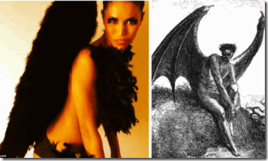
V. Stiviano’s MK ULTRA Satanic Layer- Luciferian Dark Angel
Buss’ BUNGA- BUNGA Sex Kittens were undoubtedly passed down to Magic Johnson to work other black professional athletes and entertainers, “The Lakers point guard neither drank alcohol nor did drugs, but his parties were odes to excess and extravagance. Many Lakers agree the most beautiful women they ever met were encountered at Johnson’s. They were models, strippers, actresses, exotic dancers. There was no hotter ticket than an invite to the mansion, but—while Laker players and opponents were almost always allowed—women had to meet certain criteria. First, they had to be gorgeous. Second, they had to be promiscuously dressed. Third, they had to be willing to do . . . things.” [68]
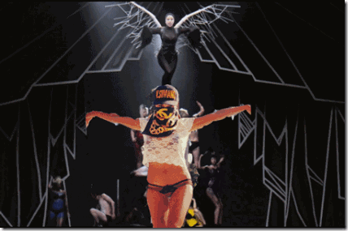
Another V. Stiviano’s MK ULTRA Satanic Layer- Luciferian Dark Fallen Angel
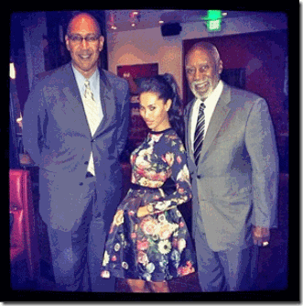
V. Stiviano with Prominent and Influential Los Angeles Black Politicians Chris Holden and Father Nate Holden in possible MK ULTRA/MONARCH Sex Kitten Espionage/Compromise Assignment?

Instagram photo of V. Stiviano in complete withdrawal and DISSOCIATION as an animal with an atypical sexual nature, a Bunny Rabbit.
In 2010, Vanessa Perez met Donald Sterling thru Jerry Buss . She became his favorite BUNGA- BUNGA “silly little rabbit.”[69]

I refuse to slam Vanessa Perez aka Vivian Stiviano a whore, slut or gold digger. She is a mind control “Satanic Sexual Abuse Victim” as is hundreds and thousands of promising beautiful young women of color around the country. The Institutional Sexual Blaxploitation of young women of color crushing their promises to the world have been going on for quite sometime. Even I failed to comprehend how deep institutional Sexual Blaxploitation ran and how it would be expanded GLOBALLY through the Satanic NWO, CIA/MK ULTRA and Shadow Government’s clandestine policies and objectives of population control, and genocide.
One of my first loves that I met in college had been a young lady named, Genie. Genie was one of the most naturally gifted and beautiful women in God’s creation. She was LOVED, respected and feared by her peers and family. Her strange hypnotic exotic eyes, lips and hour glass figure drew eyes from everywhere. Everywhere we went, she was constantly harassed with cat calls, whispers, whistles and car horns. The opposite sex’s most often instant reaction to her was offensively, “Sex Pot” and “Bedroom Eyes.” They harassed her everywhere on the street and on campus.
Once at school, I watched a blind man drop his cover of darkness- stop dead in his tracks and take a long look at her in a white silk form fitting dress. We shared laugher as if we had never known the joy of our youth. Outside of the hustle and bustle, Genie and I were close as if our lives had once intertwined in some previous space or time. Years later, I found out that our surnames “Bullock and Youngblood” were in a remote time just after the Civil War locked in the same African genetic and spiritual stock that once toiled in the black earth of Mississippi on the same plantations of human struggle and tragedy.
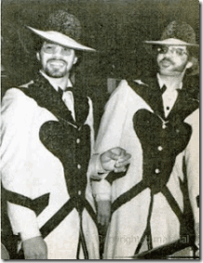
Oakland’s Legendary Late Pimps Frank and Ted Ward
Genie was from a very poor and dysfunctional family background of serious drug-dealing, drug-alcoholic addiction, and prostitution. Genie didn’t smoke, drink or do drugs. Living in the world of hustlers and pimps like the infamous Ward Brothers, particularly Frank and Ted Ward, of Oakland wanted her bad. She was worth a lot of money in the sex industry. She always told me that she was smarter than that and could start her own (female pimp) sex-trade business filled with stupid women if she wanted.
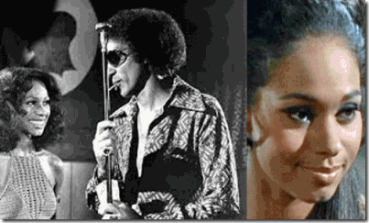
The Mack- Max Julian as Frank Ward with China Doll
Genie reminded me of the beautiful actress, Annazette Chase, that portrayed “China Doll“ [70] in the infamous movie about Frank Ward, The Mack.[71] She favored Genie, but in my opinion. Genie was equally if not more naturally and stunningly beautiful. Genie often called herself, “The Baddish Bitch in Town.” She tried to juggle college and a Hustler’s World. In Oakland, the Hustler’s Commandment was “You’ll do anything to make a dime even sell a piece of your ass.” That played right into the DEVIL’s Workshop.
I remember the day when I turned my back and walked away from her. I had purchased a new car. Genie offered to buy my old VW. When I met her to seal the deal on the car, I was surprised that she was accompanied by a young white male in a business suit. She told me that she had become a sex broker for a powerful rich cabal of Oakland Jewish bankers and financers. I knew that she had become part of a marijuana trade out of Los Angeles, but I tried to always stick beside her. However, I had nothing to do with selling poison to our people even if it was only marijuana.
For the first time, she told me that the large upper class neighborhood house that her family lived in had been provided by them. She told me that they paid for secret safe houses and apartments around Oakland that she managed. They provided money allowances and most likely also drugs to harbor- sexually exploit- RAPE poor and struggling young black women (girls). She tried to convince me that it didn’t involve sex and only involved entertaining and arousing old men from time to time.
When the male began to address me about the condition and providing the seed money to buy the car. For a moment, I moved toward him to knock him out. However, I stopped, turned and walked away from them. I heard her in the background as her voice faded away. She told me that I was being disrespectful and if I joined them that they had the ability with their money and resources to do so more for me than a bunch of broke N****rs.
My vision and dream for Genie was to finish college and enter the business word as a corporate executive. She had all that there was to be successful in that environment. I would see Genie enter a corporate board room like a queen, take over and rule. Genie was godly beautiful, intelligent and ambitious, but lacked wisdom and understanding that GOD and Love of the People was enough and the source of her strength. I didn’t understand it than that she had made a Pact with the DEVIL. Early on, I had been tempted by Ashkenazi LUCIFERIANS. It still haunts to this day- feeling powerless and realizing what they were really doing- raping them, robbing and sapping the soul and spirit of young sisters forever.
My Beautiful Genie like Vanessa Perez and so-many other desperate young and gifted women want the ILLUSIONS of material wealth and success- “car, the house, the clothes, the designer stuff.” Genie’s overwhelming inter-desire had been to get a college education something that would have been a first for her family of in-laws. But, she was determined and head-strong to make it on her own terms. She also linked human respect to material things and false ILLUSIONS of success. The world only wanted to and did in fact “ravish” her soul, mind, natural beauty and strength. They corrupted and crushed their god given natural spirit, intelligence, intuition and Love for the People like an ENEMY. The People and I only had LOVE to give. We lost a young woman with dreams and the potential and STRENGTH of a QUEEN.
The Plot to Re-Image Donald Sterling
Lately, National Mass Media have began a campaign to try to back away from Sterling‘s starling revelations that has mass institutional and worldwide implications. It stands as a glaring example of not only America but Israel’s hypocrisy and contradictions. It is a potential wake up call and teachable moment for the masses. To divert, change and influence public perceptions, they are beginning to flood the airways with ILLUSIONS that Sterling is not a vehement and institutional racialist with an secret society hidden agenda.
They are trying to re-image the public picture/perception of Sterling from a fervent racist into a poor victim of his own human folly, weakness and passions, JEALOUSY.[72] However, Sterling has never confessed any human LOVE for Stiviano. Nevertheless, Sterling‘s individual passionate JEALOUSY just does not explain how and why Black People are his/their declared secret collective internal ENEMY.
Nonetheless, JEASOUSY and his secret society’s stated inflexible basic necessity to control and dominate Black Women may partly be the truth, but it is deeply veiled. It is a forgotten and hidden “JEALOUSY” and the need to control the “BLACK FEMALE PRINCIPLE” that spans remote generations, continents and strike at the heart and very essence of human civilization.
Donald Sterling, Sexual Blaxploitation & DOMINATION RAPE
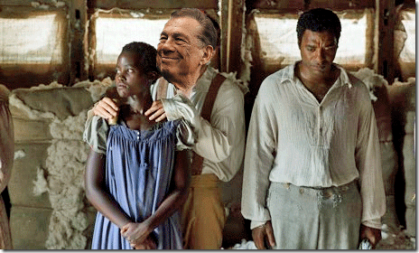
“I want her [Black Woman- V. Stiviano]… I’m trying to have sex with her. I’m trying to play with her …” -Donald Sterling [73]
Play- RAPE and CONTROL her! Sterling by his own public statements doesn’t have the capacity or HEART to LOVE a Black Woman by his own inflexible strict society/cult codes.[74] Want can generally be defined as having a desire to “possess.”[75] Possess is to have and hold as property; to seize and take control of; DOMINATE.[76] In other words, it is commanded by the inflexible-strict secret society codes that he seize, control and dominate Black Women as if they are “PROPERTY.”
“The physical act of rape damages the body, but much more so the soul. White slave masters practiced rape without impunity as a means of eroding the psychological well being of both slave men and women… In her novel, Harriet Jacobs recounted stories of her repeated sexual abuse by her master, Mr. Flint. Jacobs harps on the notion that “there is no shadow of law to protect her from insult, from violence, or even from death” (Harriet Jacobs 27) … One can only speculate as to why rape is so numerous and frequent in slave societies, but by mentally degrading female slaves, masters ensured the damaged state of their psyche would contribute to their unwavering obedience. This process not only destroyed the lives of black women, but extended also to black men. Most likely, “when white men raped black women they did so not only to subject these females to a violent and dehumanizing experience, but also to emasculate husbands and male kin” (Brenda E. Stevenson 168). Not only are females subjected to immense physical and psychological duress, the humiliation felt by the males due to the fact that they had no control over the rape further reasserted themes of dominance and submission by white owners over slaves.”[77]
ACT III
DONALD STERLING– ILLUMINATI & SETH AND THE LOST RAIDERS OF KEMET
Donald Sterling & The Ashkenazi- The Chosen Race
Donald Sterling’s parents, Susan and Mickey, are alleged to have been Ashkenazi Jewish immigrants.[78] Most of Sterling‘s fellow NBA team owners and the commissioner are linked to this closed cliquish culture and secret business society of ancestral ASHKENAZI JEWRY.[79] Sterling‘s ancestral link to Ashkenazi Jews of Central Europe is believable. Sterling‘s very nature should be understood as that of an Ashkenazi as set forth by a closed culture’s codes, morals, customs, traditions and its system of belief passed down through the generations.
Ashkenazi & the ILLUMINATI
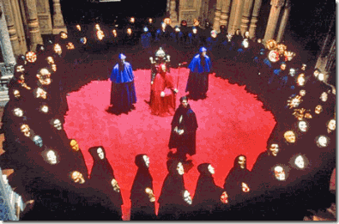
“The ‘ILLUMINATI’ was a name used by a German sect that existed in the 15th century. They practiced the occult, and professed to possess the ‘light’ that Lucifer had retained when he became Satan.” -Red Ice Creations [80]

House of Rothschild’s Mentmore Towers Mansion in England- Scene of Satanic Classics 9th Gate and Eyes Wide Shut
The pivotal group that helped finance the “ILLUMINATI” was the House of Rothschild, members of the Ashkenazi Jews.[81] Their overall master plan is to finance, influence and lead by war or politics sovereign nations and world religions toward an agenda for a Satanic New World Order (NWO) with Lucifer as God and Jerusalem serving as its capital city.[82] Whatever Donald Sterling slip and revealed about the agenda of the ILLUMINATI and its plans of worldwide genocide of people of color must not be underestimated, because it runs far deeper than “PLANTATION MENTALITIES“.
ASHKENAZI- The Lost Tribe of RED JEWS
The Ashkenazi Jews are ancestrally linked to the Khazars. The ancient Khazar Empire, was once a major power in Eastern Europe, which in 740 A.D. converted to Judaism. Khazaria, a conglomerate of Aryan Turkish tribes, were almost wiped out by the forces of Genghis Han (1162? – August 1227), but evidence indicates that the Khazars migrated to Poland and formed the cradle of Western Ashkenazim Jewry.[83]
“We found that most of the maternal lineages [Genetic Roots of Ashkenazi Jews] don’t trace to the north Caucasus, which would be a proxy for the Khazarians, or to the Near East, but most of them emanate from Europe,” said coauthor Martin Richards, an archaeogeneticist at the University of Huddersfield in the U.K.[84]
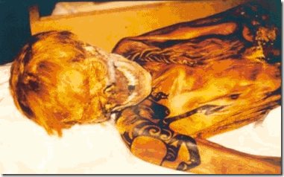
RED HAIRED Tattooed Mummy of an Ancient Eastern European Scythian
The origin of the Khazars and their earliest history is hidden within other peoples of ancient Scythian (Saka) nomadic stock that claim to trace some of their origins to the Amazons and the Lost Continent of Atlantis at a time before the biblical Great Flood.[85] The ancient warlike barbaric Scythians were connected not only to the Hyksos (Shepherd Kings) that infiltrated and overran the Lands of Canaan (Ancient Palestine/Israel) and Lower Kemet during the 17th Century BC, but also to the Ancient Iranians.[86]

RED HAIRED Khazarian
The RED JEWS were a legendary Jewish nation that appear in vernacular sources in Germany during the medieval era until about 1600 AD. Many medieval sources connected them with the Lost Tribes of Israel, owing to the Khazars’ adoption of Judaism, and they are described in Arabic sources as having RED HAIR, a trait associated with the Devil in medieval Germany and possibly the source of the term “RED JEWS“.[87]
The Declaration of Arbroath is an early document written in Latin and promulgated on April 6th, 1320, at Arbroath Abbey in Scotland that claims an early connection between the British Isles and the Scythians, and also link them to the Exodus of the Children (Lost Tribe) of Israel from Egypt.
The Declaration of Arbroath was written to convince Pope John XXII (1244 – 4 December 1334) that Scotland was an independent country. This rebutted the English claim to rule Scotland. To protect its customary sovereign state, Scottish leader, Robert the Bruce (July 11, 1274 – June 7, 1329), defeated the English at Bannockburn in 1314, and recaptured Berwick-on-Tweed (a city on the border with England) from the English in 1319.
The Declaration claimed a direct connection between the Scots and nomadic bands of Scythians coming down out of Spain, and it also mentioned the Exodus of the Children of Israel from Egypt. The ancient tribe of the Scythians once lived in the area to which the “Lost Ten Tribes of Israel“ were deported by the Assyrian Empire (according to the Bible and historical sources).[88]
Ancient European Anglo-Saxon stocks were descendants of the Scythian-Khazarian-Hyksos. There is no reason to doubt the Irish classic record that documents and link the ancient Scythians as invaders in Israel and Kemet. In no way do I intend to link them directly with biblical or orthodox Jewry, which is the cause of some contention. The Scythian-Khazarian pagan bands did in fact overrun and occupied ancient Canaan- Palestine/Israel.
The Scythians that made up some of the foreign barbaric hordes and kings that invaded Ancient Israel– Canaan and Kemet. These nomadic invaders were called Shepherd Kings– Hyksos.[89]
Hyksos & the ILLUMINATI
Additionally, Dan Brown, author of popular ILLUMINATI novels, The Lost Symbol, The Da Vinci Code and Angels & Demons,[90] divulges an important secret of the ILLUMINATI bloodline link to the Scythians and Hyksos.

RED HAIRED Scottish Heritage
It is RED HAIR, which of course is at its highest concentration in Scotland. RED HAIR, having been introduced by their Scythian ancestors, is believed to be its characteristic trait, a mark of their LUCIFERIAN nature. Brown makes repeated references to the importance of RED HAIR, and most importantly, carefully notes that Mary Magdalene was portrayed by Da Vinci as having RED HAIR, as a deliberate reference to her “sacred” heritage.

Piero di Cosimo, Saint Mary Magdalene [RED HAIR] (1490)
According to Dan Brown, Rosslyn takes its name from the rose, which the traditional secret symbol of Mary Magdalene and the Holy Grail. As Brown explains:
The chapel’s geographic coordinates fall precisely on the north-south meridian that runs through Glastonbury. This longitudinal Rose Line is the traditional marker of King Arthur’s Isle of Avalon and is considered the central pillar of Britain’s sacred geometry. It is from this hallowed Rose Line that Rosslyn — originally spelled Roslin— takes its name… or, as Grail academics preferred to believe, from the “Line of Rose”— the ancestral lineage of Mary Magdalene.[91]
ACT IV
THE LEGEND OF OSIRIS, ISIS AND THE JEALOUS-EVIL BROTHER SETH
The Legend of Osiris, Isis and Set (Seth-Typhon) goes back to an age before recorded time maybe 100,000, 50,000 to 10,000 years ago. Nobody knows for sure. According to the Diodorus, who was born at Agyrium in Sicily in the latter half of the first century B.C., relating in his famous history the following concerning Osiris, Isis and Typhon:
“After Hephaistos, the next king who reigned over Egypt was Kronos (in Egyptian, Keb), who married his sister Rhea (in Egyptian, Nut), and became the father of Osiris and Isis. Others say that Zeus and Hera were the rulers of Egypt, and that from them five gods were born, one upon each of the five epagomenal days, viz., Osiris, Isis, Typhon, Apollo, and Aphrodite.”[92]
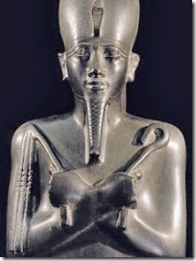
KING OSIRIS:
“Above all, it transformed them from nomad hunters and thieves into a settled people with a god, a priesthood, and a worship, and taught them to believe in divine incarnation, and gave them a hope of resurrection and immortality, and of an existence in heaven, which, they were taught, could only be attained by those who had lived righteous lives upon earth, and through the mercy of Osiris.” [93]
“One of the first acts related of Osiris in his reign was to deliver the Egyptians from their destitute and brutish manner of living. This he did by showing them the fruits of cultivation, by giving them laws, and by teaching them to honor the gods. Later he traveled over the whole earth civilizing it without the slightest need of arms, but most of the peoples he won over to his way by the charm of his persuasive discourse combined with song and all manner of music. Hence the Greeks came to identify him with Dionysus. During his absence the tradition is that Typhon attempted nothing revolutionary because Isis, who was in control, was vigilant and alert …”[94]
” … Seth [Typhon] the Evil One, their brother, envied Osiris and hated Isis. The more the people loved and praised Osiris, the more Seth hated him; and the more good he did and the happier mankind became, the stronger grew Seth’s desire to kill his brother and rule in his place.” [95]
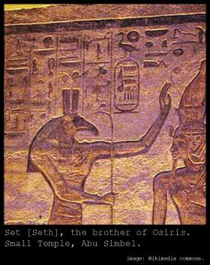
Beyond the early dynasties, God Set (Typhon), above, had become universally known as the “JEALOUS” and EVIL brother of Ausar and Asset. Along with 72 conspirators, Set tricked his brother into a coffin that he nailed tight killing his brother. Set then cut Ausar’s body into 14 pieces and spread the pieces throughout Kemet.
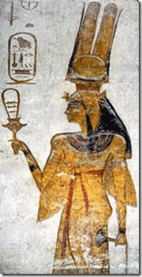
The mutilation of Ausar’s body represented the fragmenting of consciousness, and the separation of Ausar from Asset represented the disruption of the balance of the male and female principles. In Kemetic mythology, Ausar and Asset represented evolution of man and woman into a divine state of being– to subdue their passions and circumscribe their desires on the terrestrial plane which we call earth- to be in harmony with all that existed and show reverence to the “Hidden One” that manifested within the man and woman.[96]
THE HYKSOS
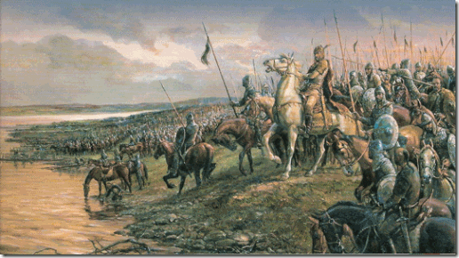
The Scythian-Khazarian- Hyksos hordes entered Canaan and Kemet not to worship or praise, but as nomadic invaders and plunderers. While occupying Lower Kemet as conquerors, they adopted as their spiritual force and God- Ausar and Asset’s JEALOUS and EVIL brother, Set (Seth) known by the Greeks as Typhon. They chose Set as God justified in JEALOUSY and the EVIL HEART (lack of consciousness-unbelief). They sought to do “SETH’S WORKS” to kill off the Royal Houses of Kemet not in league with them, usurp the throne and all the majesty and MYSTERIES of the Set’s brother and sister, Ausar and Asset.
Most religions including Judaism, Christianity and Islam have significant roots from ancient “Kemet” as it was then known (which means Land of the Blacks). These religions and freemasonry- “… corrupted/distorted the original ancient Kemetian teachings and practices, and this corruption is a result of the nature of the people, who were called, by many Kemetians, Typhonians (meaning Satans or people of Satan). They claim to be the Illuminati (meaning people of Light or enlightenment or inner lightenment).”[97] Seth [Typhon] is identified with the name “Sata” whence comes “SATAN.”[98]
SATAN is known as the Devil and sometimes referred to as Lucifer. The Devil (Satan-Lucifer) is believed in many religions, myths and cultures to be a supernatural entity that is the personification of EVIL and the ENEMY OF GOD AND HUMANDKIND. The nature of the role varies greatly, ranging from being an effective opposite force to the creator god, locked in an eons long struggle for human souls on what may seem even terms (to the point of dualistic ditheism- opposed principles of good and evil /bitheism- belief in the existence of two gods).[99]
The EVIL HEART
Hebrews 3:12-13 (KJV) states:
“Take heed, brethren, lest there be in any of you an EVIL HEART of unbelief, in departing from the living God.”
An important part of the Kemetic Soul was thought to be the Ib (jb), or HEART. The Ib or metaphysical heart was believed to be formed from one drop of blood from the child’s mother’s heart, taken at conception. The heart was the seat of emotion, thought, will and intention. This is evidenced by the many expressions in the Kemetic language which incorporate the word ib, Awt-ib: happiness (literally, wideness of heart), Xak-ib: estranged (literally, truncated (short) of heart).
EVIL is the desire to act contrary to God’s righteous character and commands. EVIL is the production of a WILL given over to an EVIL HEART.
Donald Sterling (DS): You think I’m a racist, and wouldn’t—
V. Stiviano (V). : I don’t think you’re a racist.
DS: Yes you do. Yes you do.
V: I think you, you—
Donald Sterling: EVIL HEART.
Donald Sterling: It’s the world! You go to Israel, the blacks are just treated like dogs.
Donald Sterling denies that he is a racist, but doesn’t deny that he has the EVIL HEART that he immediately and directly connected to ISRAEL and its treatment of “BLACKS” like DOGS.
The Scythian-Khazarian-Shepherd Kings treated the BLACKS of Canaan and Kemet like DOGS by the same ancient EVIL HEART that was contrary to God’s righteous character and commands. They were non- believers of MAAT; TRUTH, JUSTICE, HARMONY and BALANCE. They were adversaries and enemies of Osiris- Isis- Horus.
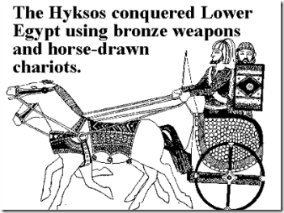
Manetho, Aegyptiaca., frag. 42, 1.75-79.2- The ATROCITIES OF THE HYKSOS
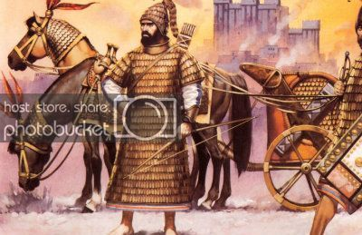
“Tutimaeus [0]. In his reign, for what cause I know not, a blast of God smote us; and unexpectedly, from the regions of the East, invaders of obscure race marched in confidence of victory against our land. By main force they easily overpowered the rulers of the land, they then burned our cities ruthlessly, razed to the ground the temples of the gods, and treated all the natives with a cruel hostility, massacring some and leading into slavery the wives and children of others.“[100]
“In the Kemetic metaphysical system, Set-Typhon, the conspirer against Ausar [Osiris], is the embodiment of every perversity … He is the negative creation; He is black magick and sorcery, the black brotherhood. In the initiation rites Typhon is also the ‘tester’ or ‘Tryer’ (the Lord who is against us) personifying ambition the patron of ruin.”[101]
Canaan- A Colony of OSIRIS
The Land of Canaan (Ancient Israel) had been established by a colony of Cushites out of Ethiopia that had also established Kemet in the remote antiquity of human civilization. The Canaanites called themselves, Cushites (Kushites). They were first cousins to the people of the Land of Kemet.[102]
Greek Historian Diodorus Siculus or Diodorus of Sicily between 60 and 30 BC , tells us that Ethiopia is the origin of the Kemetic civilization, and that Ethiopians colonized as far as India:
“They [the Ethiopians] say also that the Egyptians are colonists sent out by the Ethiopians, Osiris [“King of Kings and God of Gods“] having been the leader of the colony . . . they add that the Egyptians have received from them, as from authors and their ancestors, the greater part of their laws.”
“Osiris being come to the borders of Ethiopia, raised high banks on either side of the river, lest, in the time of its inundation it should overflow the country more than was convenient make it marish and boggy; and made flood-gates to let in the water by degrees, as far as was necessary. Thence he passed through Arabia, bordering upon the Red sea as far as to India, and the utmost coasts that were inhabited; he built likewise many cities in India, one of which he called Nysa, willing to have a remembrance of that in Egypt where he was brought up…he planted ivy, which grows and remains here only of all other places in India…”[103]
SETH’S WORKS – The Israelite Massacre of the Canaanites- the Children of Ausar and Asset

Deuteronomy 7
King James Version (KJV)
7 When the Lord thy God shall bring thee into the land whither thou goest to possess it, and hath cast out many nations before thee … Canaanites … mightier than thou;
² And when the Lord thy God shall deliver them before thee; thou shalt smite them, and utterly destroy them; thou shalt make no covenant with them, nor shew mercy unto them:
³ Neither shalt thou make marriages with them; thy daughter thou shalt not give unto his son, nor his daughter shalt thou take unto thy son.
After the massacre (campaign of genocide) of the Canaanites and laying waste to their cities by the Israelites in the 13th Century BC, Joshua after the death of Moses was directed to “put the people [Israeli Tribes] in possession of the land.” [104]
The Canaanites massacred and dispossessed of their lands by the Scythian-Khazarian- Hyksos- Israeli were Osirian colonist. They were the Children of Ausar-Asset and Heru. The massacres and taking of their lands was the work of Sethian Worshippers.
FINAL ACT
THE WAR & REDEMPTION
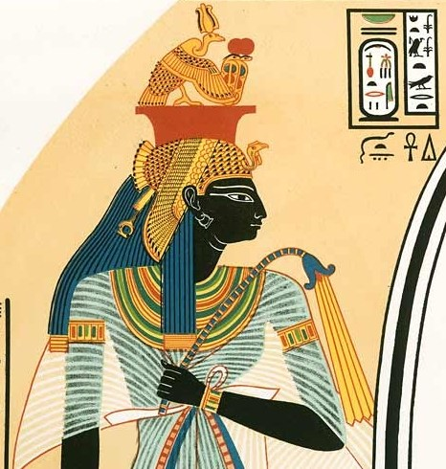
Queen Ahmose-Nefertari (1562-1495 BC), reigned as Queen of Kemet during the 17th Dynasty at the time of the country’s occupation by the Hyksos. The Hyksos had been forewarned that a queenly messianic “Divine One” that represented the country “Providence and Prophesy” would come to deliver
Queen Ahhotep I
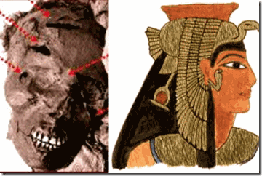
Kemet out of their hands. Her father, Pharaoh Seqenenre Tao II, refused to deliver any of God Seth’s hated brother and sister, the Ausar and Asset Cult, secrets to them. The Hyksos viciously assassinated Pharaoh Seqenenre as part of the plan to stop the “Rise of the Black Messiah.” That left Queen Ahhotep I a widower with daughters Ahhotep II, Ahmose-Nefertari, sons Ahmose and Kamose as King.
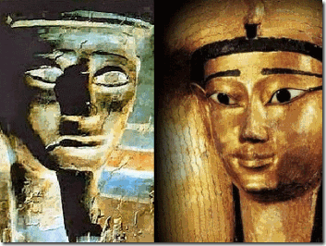
It is generally accepted that King Kamose, above, was killed in battle with the Hyksos.[105] That made his wife, Queen Ahhotep II, also a widower. The Hyksos were intent to assassinate and kill anyone of the Theban Royal Houses that threatened to rise among the people.

The Beloved Divine Queen Ahmose-Nefertari had many titles, including those of hereditary princess, “Most Beautiful”, “Great of Praises”, “King’s Mother”, “Royal Daughter”, “Royal Sister”, “Great Royal Wife”, “Royal Mother”, “Great Ruler”, and “Mistress of Both Lands.”[106]

After her brother, King Kamose was killed in battle with the Hyksos- Seth Worshippers. Ahmose, above, became king. Queen Ahhotep II and Queen Nefertari may have been two of the most wanted renegade Queens of all time. They must have scorched the earth searching for the Queens of Kemet. Martin Bernal in Black Athena once suggested that the Queens may have formed resistance and liberation campaigns from aboard the Great Green Sea on the Greek Island, CRETE.[107] King Ahmose may also had found refuge on the Island of CRETE.
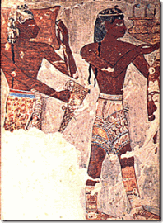
Minoans, above, inhabitants of the Island of Crete,[108] living at Avaris in lower Kemet must have joined an alliance with Theban King Ahmose and Queens Nefetari and Ahhotep II in the war against the Hyksos. A ceremonial Minoan War Axe, below, was found dedicated to Ahhotep II. It was found among her grave goods.[109]
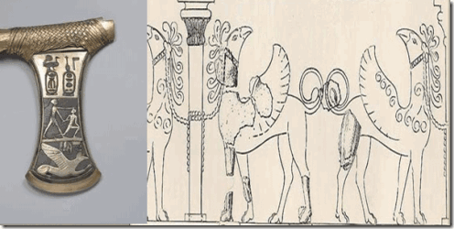
It was bronze inlaid with a Cretan-style griffin and called Queen Ahhotep II– “Mistress of the Shores Beyond the Islands“, refers to the Kemetic term for lands bordering the Aegean Sea.[110] The Aegean Sea lies between the coast of Greece and Asia Minor (modern-day Turkey). It contains over 2,000 islands which were settled later by the ancient Greeks; the largest among them being Crete (Kriti) and the best known and most often photographed, Santorini (Thera or Thira).[111] The love, respect, jurisdiction and power of the Queens of Kemet reached far beyond yonder shores.
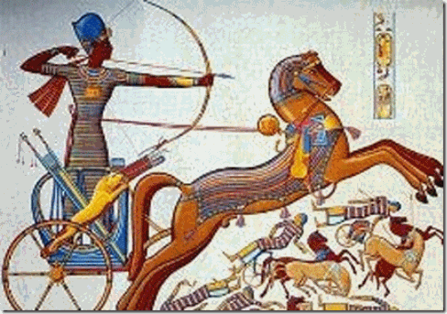
Around 1570 BC, Kemet re-united for a final and decisive battle against the Hyksos under Pharaoh Ahmose, Queen Ahmose-Nefertari, and Ahhotep II. It was also the messianic Black Divas, Queens of Kemet, that rallied the country and led armies and legions of troops into battle beside the pharaoh to defeat and expel the Hyksos from the Land of Kemet.
Great Hymn to Wesir (Ausar-Osiris) from the Stela of Amenmose, 18th Dynasty
“In Praise of Wesir by the Overseer of the Amun, Amenmose, He says:
Hail to you Wesir,
Lord of eternity, king of the gods,
With many names, with awesome visible forms,
With mysterious rites in the temples.
A splendid spirit, firs to the everlasting, …
Praised by the Nine Great Gods,
Whom the Lesser Ennead loved.
His sister Aset served as his protector,
Drove off his enemies, put a stop to the misdeeds;
Removed the Enemy by power of her spell-
Golden-tongued, her speech cannot fail …”[112]
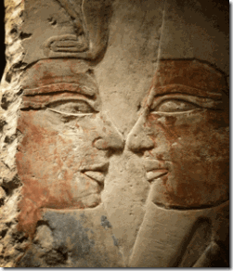
In Life, Battle and Death, Great Ahmose had been One with God Ausar
After the victory and expulsion of the Hyksos from Kemet,Pharaoh Ahmose built a vast adoration complex at Osiris’ birthplace to forever commemorate, record and celebrate Kemet’s victory over the Hyksos for all mankind. At Abydos, Pharaoh Ahmose demonstrated in reliefs battles against the Hyksos, and he let it be known throughout the ages that he had been in unity in mind, spirit and soul with God OSIRIS.
Pharaoh Ahmose is universally honored as the Great Liberator over the Hyksos. But, the pharaoh was well aware it was the unity of the Osirian “Divine State of Things“. As acknowledged by the Overseer of Amun above, it was the balance and harmony of the male and female principles, spirit, mind represented by God Ausar and Goddess Asset. It was MAGIC (words and phenomenon) from the Gods and Goddess Asset. It had been in reference to the “Hidden One” manifested in them that prevailed. It was remaining faithful to the way and GOOD of the forces and Cult of Ausar and Asset that once again prevailed over the forces of EVIL.[113]
In very special praise and honor to the Black Women of Kemet and Divas for the victory over the Hyksos. Ahmose built temples, monuments and pyramids to his sisters, Queen Ahmose Nefertari, Queen Ahhotep II, and his grandmother Little Ti (Queen Tetisheri) beside his own monuments at Abydos in Upper Kemet, the ancient celebrated traditional birthplace of God Ausar- OSIRIS.
It is extremely ironic that there may have been once a custom in Kemet of offering as human sacrifices RED HAIRED strangers associated with Set, Seth- Typhon to God Osiris as revenge. According to Kemetic Priest-Historian Manetho, it had been Amosis- the Great Ahmose that abolished the custom if there had been one.
Donald Sterling’s declaration that Black People are an internal ENEMY has absolutely nothing to do with the way you smell, if so he wouldn’t seek the comfort of Black Women in any form or fashion. It has nothing to do with “Sagging Pants”, the “Badges of Slavery” or even “Plantation Mentality.” Behind the veil, it is that age old ways of a JEALOUSY and EVIL brother, Seth, Set-Typhon, and SATAN. It has to with “Providence and Prophesy”
The Hyksos either didn’t understand, appreciate or ignored the majesty and power of the Female Principle in Kemetic Cosmology. They may have somewhat honored the Female Principle in their way of life, but it wasn’t of any insignificance. Queens, Goddesses and the Female Principle didn’t seem to be necessary within their hierarchal power structure, religion or system of belief. The mighty Hyksos were pagans, wanderers and nomads. The males were the principle leaders, hunters and warriors that sustained their culture of war, conquest and plunder. Likewise, their primarily focus would have been on adversary male warriors and their magic that could aide or defeat them.
The Queens and the Kemetic Female Principle would have assumed to be only a nominal threat of warring “opponents.” It has been a gloss mistake and lesson of conquest that Sethian Worshippers, Forces of EVIL and the ILLUMINATI haven’t forgotten or ignored. Particularly in African based and influenced belief systems where females are POWER, glorified, loved, honored, and reverend authorities, the Conquest and Control of the Kemetic Female Principle is down to a science. This is part of science that has been expressed and exposed in Donald Sterling’s ILLUMINATI stereotypical statements, systemic treatment and worldview of Black Women.
If you for only one moment don’t believe it, they have begun to re-image GODDESS ASSET as an ILLUMINATI controllable Sexual Object as a “MODEL FOR FUTURE GENERATION” rather than the people’s GODDESS OF HIDDEN MYSTERY AND ENPOWERMENT.
Rihanna, High Priestess of the Satanic-ILLUMINATI, placing Goddess Asset under her breast above her vagina as if the body of a woman is the temple to her ancient mysteries amounts to religious and cultural SACRILEGE and HERESY, and an insult to the masses and the memory of our ancestors.

GODDESS ASSET (ISIS) does not belong to the Satanic- Sethian ILLUMINATI.
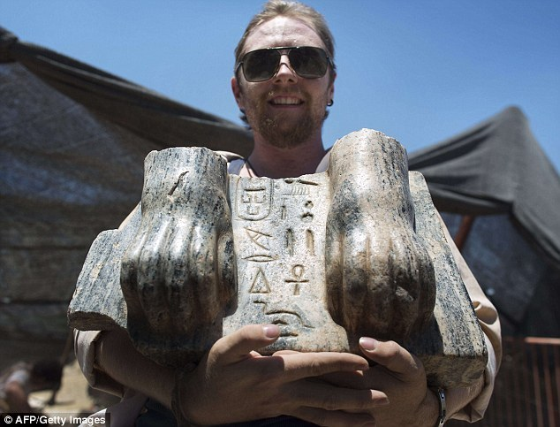
In August 2013, something most remarkable was unearthed out of the soil from the remote past in Israel that further heightens its ILLUSIONS, lies, contradictions and utter hypocrisy.

Leviticus, 20:24
King James Version (KJV)
²⁴ But I have said unto you, Ye shall inherit their land, and I will give it unto you to possess it, a land that floweth with milk and honey: I am the Lord your God, which have separated you from other people.
According to Israel Press to the World,
“Tel Hazor in northern Israel has long been a treasure trove for archeologists, but a recent discovery of part of a 4,000-year-old Egyptian sphinx has been a most unexpected find. Inexplicably buried far from Egypt, the paws of a sphinx statue, resting on its base, have been unearthed with an inscription in hieroglyphs naming King Mycerinus [Pharaoh Menkaure]. The pharaoh ruled in 2500 BC and oversaw the construction of one of the three Giza pyramids, where he was enshrined… As for the biggest question of all — how the sphinx got to Tel Hazor — it will likely remain a mystery.”[114]
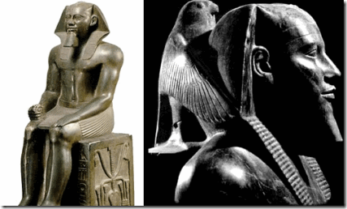
Pharaoh Menkaure (“Eternal Like the Souls of Re“), called “Mycerinus” by the Greeks, was a king of the 4th Dynasty during the Old Kingdom. He was the successor of King Khafre. Menkaure became famous for building the 3rd Pyramid at Giza called Netjer-er-Menkaure which means “Menkaure is Divine“. In Menkaure’s Pyramid, a wooden coffin was discovered with the inscription, Osiris, King of the Upper and Lower Kemet “… Menkaure, given life for ever, born of the sky, the sky goddess Nut above you…”[115] To be identified with Osiris was a honor of all who were considered worthy at the Judgment Day (MAAT) at the weighting of the HEARTS. All took the form of God Ausar (Osiris) and were addressed as one with the deity and resided with him in the stars.

The Cult of Ausar and Asset had been of paramount importance in the building of the Pyramid Complex at Giza. The pyramids were centered around planetary worship and celestial body veneration to the Gods Ra and Ausar. They believed that God Ausar (Osiris) had his soul embodied in the Orion constellation.[116]
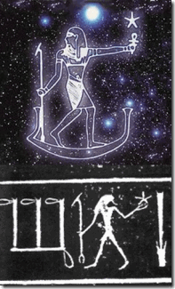
Orion Constellation as the God Ausar holding the Star Aldebaran
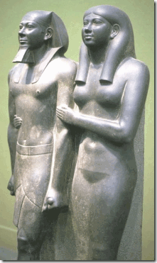
4,514 Years Ago- The Beauty and Peace of Pharaoh Menkaure and Queen Khamerernebty II
Khamerernebty II was a daughter of Pharaoh Khafra and Queen Khamerernebty I.[117] In the Cult of Ausar and Asset, she is not subservient, lesser, inferiority to the pharaoh. She signals the “Divine State of Things” between the male and female principles by her gestures and posture“… her legitimization of Menkaure as pharaoh. She is shown in the act of presenting him, indicating to the world that he is the man whom she is identifying and establishing as pharaoh. Her pose, in fact, deliberately imitates that of the goddess Hathor in the triad statues and with whom she is clearly intended to be identified. The statue itself is a representation of this act of confirmation, and perhaps even a record of part of an actual confirmation ceremony.”[118]
More than a thousand years before the arrival of the Scythian-Khazarian-Shepherd Kings, Canaan (Land of Milk and Honey) had been the domain and creation of the Children of Ausar and Asset. They toiled the land to make it fertile. They dug the dykes and canals. They were the cultivators, farmers and husbandry that made Canaan a “Land of Milk and Honey.” They built the cities and the city of Hazor had been established as their capital.
The ASHKENAZI know damn well why the Sphinx of Pharaoh Menkaure was here. It’s right where it belongs. It’s there in Genesis, Chapter 13, Leviticus and other books of the bible. They burned down Hazor, massacred the inhabitants and razed the monuments and statues in the images of the Children of Ausar and Asset in Canaan. They tried to destroy all memory and records of ancient Canaanites. It was the works of the same Sethian Conspiracy to establish a New World Order with Seth-SATAN as god.
Gerald Massey (May 29, 1828 –October 29, 1907) was an English poet and writer on Spiritualism and Ancient Kemet. From about 1870 onwards, Massey became increasingly interested in Egyptology and the similarities that exist between ancient Kemetic mythology and the Gospel stories. He studied the extensive Egyptian records housed in the Assyrian and Egyptology section of the British Museum in London where he worked closely with the curator, and other leading Egyptologists of his day, even learning hieroglyphics at the time the Temple of Horus at Edfu was first being excavated.[119]
“In this new Jerusalem on earth it was to be as it had been in the MAAT upon the MOUNT, where … OSIRIS imaged the eternal on his seat who presided over the pole of heaven (Rit., ch. 7).” “[T]he meek shall inherit the LAND, and shall delight themselves in the abundance of peace. Their inheritance shall be forever. But the wicked [Donald Sterling- Worshippers of Set (Satan)] shall perish.” Gerald Massey – ‘Ancient Egypt‘[120]
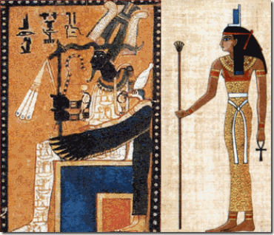
The rise of the Sphinx of Pharaoh Menkaure in Zionist Israel that they vehemently fallaciously DENY is “Providence and Prophesy” of a New Jerusalem presided over once more by the Divine Order of Things, and AUSAR and ASSET.

[1] http://news.rapgenius.com/Federal-bureau-of-investigation-cointelpro-long-range-goals-and-prevention-of-a-black-messiah-annotated
[2] http://www.forbes.com/fdc/welcome_mjx.shtml
[3] http://world.time.com/2013/06/24/silvio-berlusconi-convicted-of-having-sex-with-underage-prostitute-but-will-he-go-to-jail/
[4] http://www.bbc.com/news/world-europe-12473645
[5] http://en.wikipedia.org/wiki/Untermensch
[6] http://www.bbc.com/news/world-europe-12325796
[7] http://isteve.blogspot.com/2014/04/magic-johnson-ultimate-cleanser-sports.html
[8] http://en.wikipedia.org/wiki/Meyer_Guggenheim
[9]http://www.tomatobubble.com/id561.html
[10] http://en.wikipedia.org/wiki/Bernard_Baruch
[11] http://theinfounderground.com/smf/index.php?topic=14627.0
[12] http://theocculttruth.com/index.php?p=1_156
[13] http://uncyclopedia.wikia.com/wiki/Creed_(band)
[14] http://21stcenturywire.com/2011/02/03/cnns-anderson-cooper-activates-operation-mockingbird-in-egypt/
[15] http://www.huffingtonpost.com/2014/05/12/donald-sterling-magic-johnson-interview-cnn_n_5310711.html
[16] http://kdvr.com/2014/05/12/cnn-donald-sterling-insists-hes-not-racist-still-slams-magic-johnson/
[17] http://www.washingtonpost.com/blogs/early-lead/wp/2014/05/12/donald-sterling-magic-johnson-has-got-aids-should-be-ashamed-of-himself/
[18] http://bleacherreport.com/articles/1926497-old-picture-of-magic-johnson-at-lakers-picnic-surfaces
[19] http://www.insidesocal.com/clippers/2014/05/13/full-transcript-magic-johnson-responds-to-donald-sterling-in-cnn-interview/
[20] http://espn.go.com/nba/player/bio/_/id/2334/magic-johnson
[21] http://www.insidesocal.com/clippers/2014/05/13/full-transcript-magic-johnson-responds-to-donald-sterling-in-cnn-interview/
[22] http://www.ordoastri.org/thelema/7/
[23] http://rosaleen-thewhistler.blogspot.com/2013_03_01_archive.html
[24] http://www.salon.com/2014/04/30/rush_limbaugh_mocks_cnns_don_lemon_for_being_gay/
[25] http://www.clutchmagonline.com/2013/07/no-talking-points-don-lemon-lists-5-ways-black-people-need-to-change-to-end-racism/
[26] https://ritualabuse.us/ritualabuse/
[27]http://www.whale.to/b/ross3.html
[28] http://www.yourblackworld.net/2013/08/black-news/dr-boyce-why-is-cnn-allowing-don-lemon-to-go-into-angry-tirades-against-black-people/
[29] http://forums.randi.org/archive/index.php/t-101646.html
[30] http://www.biography.com/people/saint-francis-xavier-39911
[31] https://salonesoterica.wordpress.com/2008/02/18/david-icke-on-how-the-illuminati-conquered-the-east/
[32] http://fanaticforjesus.blogspot.com/2013_01_01_archive.html
[33] http://www.gamefaqs.com/boards/2000205-sports-and-racing-general/69108907
[34] http://en.wikipedia.org/wiki/Enemy
[35] http://www.illuminati-news.com/Articles/01.html
[36] http://abcnews.go.com/blogs/headlines/2014/05/meet-the-new-ceo-of-the-la-clippers-dick-parsons/
[37] http://www.blackpast.org/aah/parsons-richard-d-1948-0
[38] http://mindweaponsinragnarok.com/2012/05/22/fascinating-story-of-dick-parsons-rockefeller-house-african-american/
[39] http://www.citizensamericaparty.org/dynasties.htm
[40] http://www.cuttingedge.org/News/n1191.cfm
[41] http://www.atlanteanconspiracy.com/2008/07/vaccines.html
[42] http://www.barenakedislam.com/2013/02/06/self-proclaimed-ardent-jewish-zionist-nyc-mayor-michael-dhimmi-bloomberg-backs-hate-filled-antisemitic-pro-terrorist-bds-event-at-brooklyn-college/
[43] http://www.businessweek.com/stories/1994-08-21/the-rockefeller-protege-whos-polishing-the-dime
[44] http://en.wikipedia.org/wiki/Richard_Parsons_(businessman)
[45] http://en.wikipedia.org/wiki/Kykuit
[46] http://nba.si.com/2014/05/09/donald-sterling-new-recording-racist-girlfriend-clippers/
[47] http://www.dailymail.co.uk/news/article-2617020/EXCLUSIVE-From-dirt-poor-daughter-Mexican-mother-used-kids-steal-plastic-princess-Donald-Sterlings-arm-The-rise-V-Stiviano-disturbing-racial-secret-mysterious-changes.html
[48] Id.
[49]http://www.extratv.com/2014/05/01/exclusive-pic-donald-sterlings-ex-gf-v-stiviano-in-a-bikini/
[50] http://www.extratv.com/2014/05/01/exclusive-pic-donald-sterlings-ex-gf-v-stiviano-in-a-bikini/
[51]http://www.nydailynews.com/news/national/v-stiviano-2-shoplifting-arrests-belt-article-1.1783914
[52]http://en.wikipedia.org/wiki/Oprah_Winfrey#Television
[53] http://www.pimpmagazine.com/pages/BishopText01.html
[54] http://en.wikipedia.org/wiki/Phencyclidine
[55] http://www.whale.to/b/5_h.html
[56] http://www.whale.to/b/5_h.html
[57] http://en.wikipedia.org/wiki/Magick_(Thelema)
[58] http://www.dailymail.co.uk/news/article-2617020/EXCLUSIVE-From-dirt-poor-daughter-Mexican-mother-used-kids-steal-plastic-princess-Donald-Sterlings-arm-The-rise-V-Stiviano-disturbing-racial-secret-mysterious-changes.html
[59] http://www.newrepublic.com/article/112480/rip-jerry-buss-playboy
[60] http://diaryofahollywoodstreetking.com/dr-jerry-buss-former-scout-exposed/
[61] http://educate-yourself.org/mc/illumformula4Bchap.shtml
[62] http://bucultureshock.com/teddy-bears-vs-sex-kittens/
[63] http://en.wikipedia.org/wiki/Jerry_Buss
[64] http://www.remoteviewed.com/blog/index.php/mcdonnell-douglas-ufos-esp-remote-viewing/
[65] http://intheknow7.wordpress.com/2011/04/26/air-jordan-his-airness-mk-ultra-you-make-the-call-video/
[66] Id.
[67] http://diaryofahollywoodstreetking.com/juwanna-manns-shocking-connection-to-dr-jerry-buss-exposed/
[68] http://deadspin.com/what-it-was-like-being-the-only-virgin-on-magics-hyper-1535483322
[69]http://www.celebitchy.com/364044/donald_sterlings_mistress_gives_first_interview_hes_hurt_hes_highly_traumatized/
[70] http://www.imdb.com/name/nm0153686/
[71] http://en.wikipedia.org/wiki/The_Mack
[72] http://nba.si.com/2014/05/09/donald-sterling-new-recording-racist-girlfriend-clippers/
[73] http://nba.si.com/2014/05/09/donald-sterling-new-recording-racist-girlfriend-clippers/
[74] http://news.rapgenius.com/Donald-sterling-dont-bring-black-people-to-clippers-games-annotated
[75] http://www.oxforddictionaries.com/us/definition/american_english/want
[76] http://www.merriam-webster.com/dictionary/possess
[77] http://blogs.lt.vt.edu/hist3164s13/tag/rape/page/2/
[78] http://en.wikipedia.org/wiki/Donald_Sterling
[79] http://thezog.wordpress.com/who-controls-professional-sports/
[80] http://www.redicecreations.com/specialreports/2005/08aug/redshield.html
[81] http://www.redicecreations.com/specialreports/whoilluminati.html
[82] http://abcnews.go.com/blogs/headlines/2014/05/meet-the-new-ceo-of-the-la-clippers-dick-parsons/
[83] http://lunaticoutpost.com/Topic-Khazaria-The-forgotten-empire-that-converted-to-judaism
[84] http://www.the-scientist.com/?articles.view/articleNo/37821/title/Genetic-Roots-of-the-Ashkenazi-Jews/
[85] http://www.bibliotecapleyades.net/biggestsecret/matrix/matrix09.htm
[86] http://ionamiller.weebly.com/scythian-khazars.html
[87] http://en.wikipedia.org/wiki/Red_Jews
[88] http://worldwidechurchgod.blogspot.com/2007/06/declaration-of-arbroath.html
[89] http://en.wikipedia.org/wiki/Hyksos
[90] http://www.danbrown.com/#books-section
[91] http://www.terrorism-illuminati.com/book/export/html/35
[92] http://archive.org/stream/cu31924031011707/cu31924031011707_djvu.txt
[93] http://archive.org/stream/cu31924031011707/cu31924031011707_djvu.txt
[94] http://www.egyptorigins.org/excerptsfromplutarch.htm
[95] http://www.egyptianmyths.net/mythisis.htm

[96] McKelphin, Burrell, 32°, “From Whence We Came”, THE MISEDUCATION OF THE NEGRO MASON, PART II
[97] http://www.davidicke.com/forum/archive/index.php/t-127713.html
[98] http://www.bibliotecapleyades.net/biblianazar/esp_biblianazar_33.htm
[99] http://en.wikipedia.org/wiki/Devil
[100] http://www.touregypt.net/manethohyksos.htm
[101] http://destee.com/index.php?threads/set-typhon-in-alchemical-lore.37008/
[102] http://lordabba.blogspot.com/2011/10/old-man-cush-his-father-ham-and-ancient.html
[103] http://www.taneter.org/ethiopia.html
[104] http://en.wikipedia.org/wiki/Book_of_Joshua
[105] http://en.wikipedia.org/wiki/Kamose
[106] http://en.wikipedia.org/wiki/Ahmose-Nefertari
[107] Bernal, Martin. Black Athena–The Afroasiatic Roots of Classical Civilization: Vol. II: The Archaeological and Documentary Evidence. New Brunswick: Rutgers University Press, 1991.
[108] http://dictionary.reference.com/browse/minoan
[109] http://www.israel-a-history-of.com/minoans-in-crete-egypt-and-tel-kabri-canaan-part-i.html
[110] http://templeofmut.wordpress.com/tag/17th-dynasty/
[111] http://www.ancient.eu.com/aegean/
[112] http://www.wepwawet.org/wiki/index.php?title=Wesir

[113] McKelphin, Burrell, 32°, “From Whence We Came”, THE MISEDUCATION OF THE NEGRO MASON, PART II
[114] http://www.cnn.com/2013/08/08/world/meast/israel-sphinx/
[115] http://www.touregypt.net/featurestories/pyramidtravelers2.htm
[116] http://id3417.securedata.net/solarsabbath/truthshield12.htm
[117] http://en.wikipedia.org/wiki/Khamerernebty_II
[118] http://theuniversityofgod.org/Page3_lnk3.4-0.3.pdf
[119]http://en.wikipedia.org/wiki/Gerald_Massey
[120] http://www.sodahead.com/living/the-old-and-new-testament-stories-can-all-be-traced-back-to-ancient-egyptian-pagan-rituals/question-2197439/?page=2
Comments : 1 Comment
Tags: Ahhotep II, Ahmose, Ahmose-Nefertari, Annazette Chase, ashkenazi, ashkenazi jews, asset, ausar, barry sanders, canaan, chris holden, crete, dick parsons, Don “Magic” Juan, don lemon, donald sterling, e.j. johnson, earvin magic johnson, eindutschung, eyes wide shut, frank ward, gerald massey, guggenheim partners, house of rothschild, hyksos, isis, israel, jerry buss, Kamose, Karima El Mahroug, kemet, khazars, King Mycerinus, los angeles clippers, los angeles lakers, Lucifer, luciferians, minoans, MK-ULTRA, nat holden, nba, Osiris, Pharaoh Menkaure, Pharaoh Seqenenre Tao II, Queen Khamerernebty II, red hair, richard parsons, richard pryor, rihanna, rise of the black messiah, ritual abuse and torture, ritual sexual abuse, ruby the heart stealer, Saint Francis Xavier, scotland, Scythians, Set, Seth, Sethian Conspiracy, Sex kittens, Sexual Blaxploitation of Women, ted ward, the mack, Tyler Perry, typhon, V. Stiviano, Vivian Stiviano, ward brothers
Categories : african american satanic cult, African Liberation, Ahhotep I, Ahmose I, Ahmose-Nefertari, ascendant triangle, aset, ashur, black christianity, black diva, Black messiah, blood covenants, blood oaths, bunga bunga, CIA, COINTELPRO, council of foreign relations, david rockefeller, devil, devil's horns, donald sterling, Dr. John Henrik Clarke, Dr. Josef Mengele, Dr. Leonard Horowitz, earvin magic johnson, edgar j. hoover, egypt, esoteric dualism, Eye of Horus, Eyes Wide Shut, genesis, genocide, Hauptsturmfuhrer SS Dr. Josef Mengele, Heinrich Himmler, human sacifrice, illuminati, illuminati sacrifice, inverted pentagram, jesuits, john D. Rockefeller, Josef Mengele, Knights of the Black Sun, Knights Templar, lucifer's workshop, luciferians, manchurian candidates, mind control, MK-ULTRA, mulitiple personality disorder, National Socialism, Nazis, nba, Nicki Minaj, nwo, oakland, operation mockingbird, order of teutonic knights, Osiris, PCP, Pharaoh Kamose, project mockingbird, Queen Tetisheri, re-image, re-imaging, Reichsfurhrer SS-1 Heinrich Himmler, richard pryor, Ritual Satanic Abuse, RONALD REAGAN, Rose-Croix, Rosicrucian, Rosicrucianism, rosy cross, satan, Satanism, Senakhtenre Tao, set, seth, sex kitten, sex slave, sleeper agents, SS Baron Otto Albrecht Alfred von Bolschwing, Tyler Perry, underground reich, underground third reich, vanessa perez, ZIONIST

AMERICA- THE NATION OF HYPOCRITES, NBA, THE BRADY BUNCH ALEX RAMPAGE & MAJESTIC MIND CONTROL
30042014
The NBA and a Sterling Deception and ILLUSIONS

Donald Sterling’s racist rant against Black People isn’t necessarily the real issue in America. It seems as though every other day, inflammatory, vile and demeaning statements about Black People are spread through mass media to confuse, inflame and polarize the races. The other day it was Nevada rancher Cliven Bundy and now Donald Sterling, owner of the Los Angeles Clippers. However, make no mistake Bundy is an old fashion classic red-neck bigot,

“I want to tell you one more thing I know about the Negro … They abort their young children, they put their young men in jail, because they never learned how to pick cotton. And I’ve often wondered, are they better off as slaves, picking cotton and having a family life and doing things, or are they better off under government subsidy?”
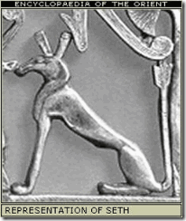
Picking Cotton! A Donald Sterling realms in a totally different dimension. Sterling is talking about something much more and deeper than vicious dumb- idiotic racism. Sterling is talking about the ancient Jealous Brother Sethian heresy, and secret Samarian/Palestine Luciferian BLOODLINE societies.

NBA players are crawling out of the woodwork to denounce Sterling‘s racism, but dare not mention the BLOODLINE SATANIC ILLUMINATI that they have become pawns to and sponsors of.

They know exactly where they stand with their Satanic Blood Covenants for Wealth and Fame. The NBA has become the league of the Freemasonry– ILLUMINATI.

The NBA is owned by the ILLUMINATI. Sterling wouldn’t have been allowed to own a NBA team unless he was an elite Luciferian. When he was in his 20s, he changed his surname from Tokowitz to Sterling. Born in 1936 to European Jewish immigrants, Tokowitz (variant of Tokos) may be of Slovak origin. Slovakiais located in Central Europe bordered by the Czech Republic and Austria to the west, Poland to the north, Ukraine to the east and Hungary to the south. The bone chilling American horror film about an international elite secret murder society, Hostel, centers in Slovakia. Tokowitz’s desired name was no random selection. Sterling silver is an alloy of silver containing 92.5% by mass of silver and 7.5% by mass of other metals, usually copper.

Burning lips, and a wicked [Evil] heart, are like a potsheard couered with siluer drosse. – King James Version (1611)
The term drosse derives from the Old English word dros, meaning the scum produced when smelting metals. A potsherd may be anything severed “Potsherds will remind you of mans being at enmity [opposed-hostile] with God, without strength, and constantly at strife with his fellowman (Psalm 22:15; Isaiah 45:9). Every broken piece will also be a reminder of a sinners heart-broken and completely beyond repair, forgotten like a broken vessel (Proverbs 26:23; Psalm 31:12).
Donald Sterling (DS): You think I’m a racist, and wouldn’t—
V. Stiviano (V). : I don’t think you’re a racist.
DS: Yes you do. Yes you do.
V: I think you, you—
Donald Sterling: EVIL HEART.
DS: It’s the world! You go to Israel, the blacks are just treated like dogs.
V: So do you have to treat them like that too?
DS: The white Jews, there’s white Jews and black Jews, do you understand?
V: And are the black Jews less than the white Jews?
DS: A hundred percent, fifty, a hundred percent.
V: And is that right?
DS: It isn’t a question—we don’t evaluate what’s right and wrong, we live in a society. We live in a culture. We have to live within that culture.
V: But shouldn’t we take a stand for what’s wrong? And be the change and the difference?
DS: I don’t want to change the culture, because I can’t. It’s too big and too [unknown].

All of Donald Sterling’s’ works and fruits and many NBA players like KOBE BRYANT works also stem from an EVIL HEART. That’s what Sterling’s burning lips said. He has an “EVIL HEART” of a man severed and hostile to God and GOD’S CHILDREN like scum from smelted ancient precious metal (Sterling) silver. The NBA commissioner- Sterling’s Satanic cohort is Adam– SILVER. These people are Luciferians straight out of the Book of PROVERBS, and the New World Order centered out of Solomon’s Mound in JERUSALEM.
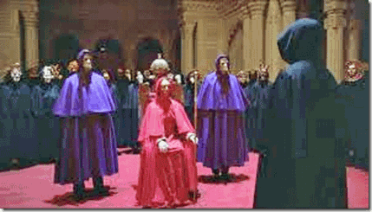
BLOODLINE Luciferians- they live in secret society and cult that “don’t evaluate what’s right and wrong.” Its “TOO BIG” to challenge, and he doesn’t want to give up his gold and silver, Pact with the DEVIL.
Donald Sterling is a master of deception and ILLUSIONS. He is a man with the Janus two faces, one good and other EVIL. You find these people hidden/concealed in the highest levels of government, military, industry, entertainment and sports. It is yet another facet of America’s two-faced world HYPOCRITCY that confesses to love All, God, Freedom, Justice and Democracy. They knew all along that this man’s works and heart are Satanic ILLUSIONS of his father, LUCIFER.
WELCOME TO THE REAL NBA AND THE NATION OF HYPOCRISY AND ILLUSIONS

“What, to the American slave, is your 4th of July? I answer; a day that reveals to him, more than all other days in the year, the gross injustice and cruelty to which he is the constant victim. To him, your celebration is a sham; your boasted liberty, an unholy license; your national greatness, swelling vanity; your sound of rejoicing are empty and heartless; your denunciation of tyrants brass fronted impudence; your shout of liberty and equality, hollow mockery; your prayers and hymns, your sermons and thanks-givings, with all your religious parade and solemnity, are to him, mere bombast, fraud, deception, impiety, and hypocrisy — a thin veil to cover up crimes which would disgrace a nation of savages. There is not a nation on the earth guilty of practices more shocking and bloody than are the people of the United States, at this very hour.” Frederick Douglass, July 5, 1852 [1]
Today, right now. Hypocrisy is yours, not mine. You may rejoice as a nation and pillar of strength, freedom, righteousness and justice, it is an ILLUSION– I must mourn for the children and the future of America for all. And I ask America like Frederick Douglass asked this country almost two hundred years ago, “Do you mean to continue to mock its citizens with such travesty and hypocrisy in the affairs of humanity here and around the world?”
Alex Hribal- MK-ULTRA Sleeper Assassin Gone Wild

“They’re like the Brady Bunch. These parents [Hribals]are active with their two sons, and we’re trying to figure out what happened.”[2]
Mass media has described the knife welding Assailant Alex Hribal as a ordinary 16 year old All American student, “A shy teenager with no prior violent tendencies.”[3] Hribal doesn’t fit the world profile of the propagandized likes of a non-white/Muslim dysfunctional anti-social schizoid sociopath.
Mass media want the masses to believe that Alex Hribal is consistent with an ILLUSION and a world vision of a Greg Brady out of that white segregated middle class idiot (TV) box family, “the Brady Bunch.”[4]
The Brady Bunch is a popular culture American sitcom created by HollyWeird television studios that originally aired from September 26, 1969 to March 8, 1974 on ABC. The series revolved around the lives of a large white suburban family that included six children.[5]
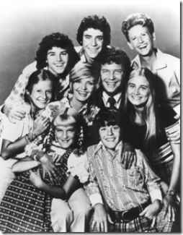
The Brady Bunch was an ILLUSIONARY family of pure propaganda created by New World Order (NWO) social (behavior) scientists, psychologists and psychiatrists. If there is a world nuclear family that the NWO want to ascend along human roots on this planet, this is the way they want them to look.
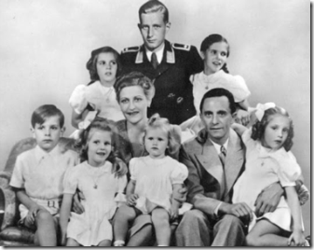
Propaganda Chief Josef Goebbels- Nazi Germany’s Picture Perfect Family with Six Kids
The whole world image of the Brady Bunch children had to be white, innocent, ultra-squeaky-clean, intelligent and conservative kids that were always morally fair, just, and righteous. The Bradys don’t drink, smoke, swear, sneak off to have pre-marriageable sex. The Bradys didn’t question or dishonor their parents, authorities or superiors. They didn’t race mix beyond token acknowledgement of people of color. The Bradys didn’t question their government. They represented the NWO moral compass and character of America.[6]

It is an extremely bold and provocative statement to compare Alex Hribal to an ILLUSIONARY so-called All American image like for instance, a Greg Brady. In other words, we can’t be trusted to rely upon any objective reasoning in judging the conduct, deeds, character or laurels of 16 year old Alex Hribal.
Franklin Regional High School senior Ian Griffith, left, and fellow senior Connor Wolff speak to the media about the stabbing incident at the school Wednesday, April 9, 2014, outside the police station in Murrysville, Pa. Griffith said he saw the school police officer confront the student, who then stabbed the officer. (AP Photo/Tribune Review, Guy Wathen)
We are supposed to daydream and let the NWO plant images and pictures in our subconscious of universal innocence, sugar plums, daisies and dancing through the tulips. The masses can’t be trusted to handle the TRUTH about the so-called ordinary American students like Brady Bunch Alex Hribal. Because, you just won’t like or accept what you really see behind the VEIL, CONTRADICTIONS AND HYPOCRITES OF AMERICA.
Behind the Veil, Alex Hribal & Fuhrer Adolf Hitler
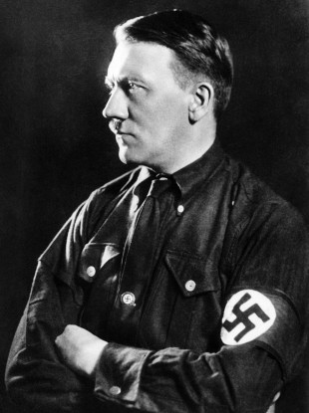
“Hitler never had a f—— beard.”– Alex Hribal[7]
Brady Bunch Alex Hribal’s Facebook has what at first impression appears to be a curious reference to Fuhrer Adolf Hitler.[8] Beard is an American slang term originally referred to anyone who acted on behalf of another, in any transaction, to conceal a person’s true identity. informal Example- A woman who accompanies a homosexual man as an escort to a social occasion, in order to help conceal his homosexuality: the closeted male and his female ‘beard’ [9]
In other words, Hitler didn’t wear a beard or hide behind anyone.
“Few people understand how completely Adolf Hitler was controlled by Satan. Hitler was totally taken over by the demonic host by the early 1920’s; in fact, [Satanist Dietrich] Eckart regularly held specialized rituals in which he and every other member of the Thule Society called for the Spirit of Antichrist to enter him. When Hitler began his quest for power, he was assured of success, even against the seemingly impossible odds facing him. While History records this success, almost no historian comprehends Hitler because he does not understand, or even believe in, the power of Satan.”[10]
Mass media and the NWO certainly doesn’t want the masses to discover anything to tarnish the image of All American Hribal that exposes a veiled fascination and interest in the Satanic inner complexities of Hitler the Thule.
The Hribals are believed to be 19th century Eastern European- Austrian immigrants. Hribal is a surname originating out of the background and history of Bohemia, Czech Republic, Hitler’s backyard.[11] Mass media, investigative journalists and manipulated Left will likely ignore Hribal particular interest in the Adolf Hitler. They will not disturb, question or destroy the NWO’s universal All-American images and ILLUSIONS of wholeness, family values and morals.
Brady Bunch Alex’s idolatry of the Fuhrer is certainty tell-tale of a pathology of sickness, and it is also strongly suggests that some Satanic ILLUMINATI secret entity or entities had been massing with Alex’s head.
Get Behind Me Satan: Brady Bunch Alex & The Cult of Kurt Cobain
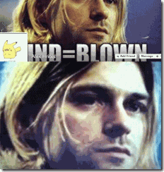
Hribal’s Facebook wallpaper also features a large idolized picture ofKurt Cobain (February 20, 1967 – April 5, 1994), the Nirvana front star who shot himself in the head in 1994, with Hribal’s caption “Mind = Blown”.[12] Nirvana is essentially a state of dissociation. It is a state of conscious often achieved in CIA- MK ULTRA trauma based mind control programs as a gateway to developing iatrogenic (psychiatric) multiple personality disorders (MPD).[13] Under the veil, it is consistent with being as Alex says, “Mind = Blown.”
Many are becoming to believe that Kurt Cobain was a Satanic MK ULTRA/Project MONARCH experimental mind control victim that had been disposed of by the CIA.[14]
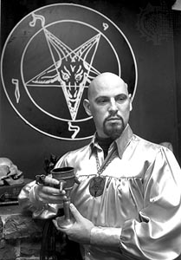
Cobain was “obsessed with Anton LaVey”(Mojo Magazine, Sept. 1999, p. 86). Anton LaVey was one of Lucifer’s High Priests. LaVey founded the Church of Satan and authored the Satanic Bible.[15] Cobain and Satanic LaVey certainly also doesn’t fit Alex’s normal and ordinary legend nor All American image. Cobain was undoubtedly driven into a Satanic psycho that had been on Ritalin since the age of 7.[16] He regularly dosed himself with heroin, valium, cocaine and marijuana. Allegedly, he dosed himself with a massive amount of a self-induced heroin overdose then shot himself in the head with a shotgun.[17] However, there are also many reasons to believe and suspect that Cobain’s death wasn’t a suicide; and there is a call to reopen the case certifying his cause of death at his own hands.[18]
Brady Bunch Alex’s idolatry or twinning with Kurt Cobain isn’t just a normal fading All American teen-age fascination. It is tell-tale of a mind control concept called twinning [19] with another MK ULTRA/Project MONARCH- Delta programmed victim with a termination key or trigger like Cobain. It seems that Alex is also suffering from some mental/personality disorder linked to MK ULTRA/MONARCH-Delta programming mind control.
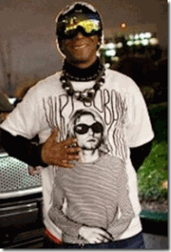
Katt Williams & Kurt Cobain- We know about Katt’s ILLUMINATI Troubles
Many are becoming convinced that Katt Williams,[20] Miley Cyrus,[21] and Paris Jackson [22] are among HollyWeird’s MK ULTRA/Project MONARCH MPD experimental mind control victims. All are also seen to be associated with twinning in some aspects with the Cult of Kurt Cobain most likely as “CRY FOR HELP.”

In 2011, Paris Jackson began to open up and expose the secret HollyWeird Satanic ILLUMANITI through Twitter. In a Twit, she said that found about the ILLUMINATI 3 years ago when she was about 12 years ago. However, it appeared that she most likely had been initiated into Satanic circles well before 12 whether she knew it or not.
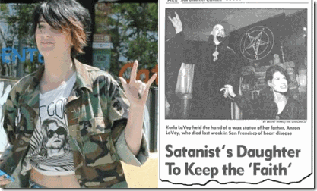
Paris Jackson & Kurt Cobain – Born inside the Occult
As result of a push back and resistance to the ILLUMINATI, she exposed in a Twit one of the secret retreats for Satanic Programming and indoctrination, the Self-Realization Fellowship Lake Shrine Temple in Pacific Palisades, CA. Pacific Palisades is an affluent neighborhood and district in the Westside of the city of Los Angeles, California, located among Brentwood to the east, Malibu and Topanga to the west, Santa Monica to north.
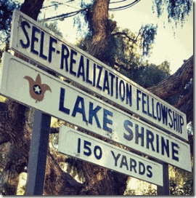
Shrine Lake was founded by Hindu Mystic, Paramahansa Yogananda (1893-1953) and the Self-Realization Fellowship. Paramahansa founded the Self-Realization Fellowship that is undoubtedly highly influenced by Sufism- Islamic Mysticism. Today, Yogananda’s spiritual Interpretation of The Rubaiyat of Omar Khayyam plays an important part in the fellowship’s indoctrination. Omar Khayyam (1048- 1131 AD) is seen by many as a mystical Sufi poet and saint influenced by platonic traditions.
It is alleged the Sufism is the basis of the Luciferian elites’ One World Religion, and the origin of the Rosicrucians, the most important occult movement after the Renaissance, who later evolved into the Freemasons.
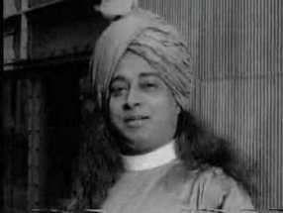
“Originally Satan was an archangel. He was given the power to create the world according to God’s plan… There is a great tug-of-war between the devil and God. One cannot dismiss the problem by thinking that Satan is a mere delusion… And why did Jesus say: ‘Get behind me, Satan’, and ‘Deliver us from evil’ …” – Paramahansa Yogananda [23]

Fearlessness means faith in God: faith in His protection, His justice, His wisdom, His mercy, His Love, and His omnipresence… To be fit for Self-realization, man must be fearless.— Paramahansa Yogananda [24]
Get Behind Me Satan

Are you kidding me! This is mass media’s school I.D. picture for Mass-Murderer Gunman, Adam Lanza, that Died Before the Shootings even took Place
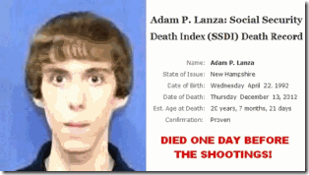
On December 14, 2012, allegedly 20-year-old lone wolf gunman, Adam Lanza, fatally shot 20 children and 6 adult staff members at Sandy Hook Elementary School. Prior to driving to the school, Lanza shot and killed his mother at their Newtown home. All the killings were absolutely MOTIVELESS.[25]

The Lanza home sits at 36 Yogananda Street, Newton, CT where Nancy and Adam Lanza resided. The street just happened to be named after the famous Yoga Master, Paramahansa Yogananda.[26] Michael Jackson and Yogananda’s crypts also happens to have the same address, their bodies occupy the very same mausoleum.[27]
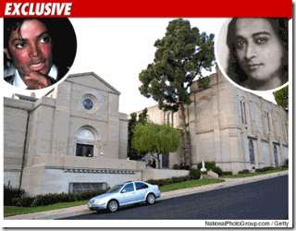
The Lanzas attended the Saint Rosa of Lima Church, where eight child parishioners were among Adam Lanza’s shooting victims. Saint Rosa is the very same order that sponsors the western-state hospital that employed Michael Jackson’s physician, Dr. Conrad Murray. Scottish Rite Freemason Dr. Murray was affiliated with only two hospitals in California. One was Saint Rose Hospital in Hayward, Cal. [28]

Saint Rosa of Lima- Headdress filed with (Rosicrucian) Roses
The hospital’s namesake, Saint Rose of Lima, (April 20, 1586 – August 24, 1617), was a Spanish colonist in Lima, Peru, who became known for both her life of severe asceticism and her care of the needy of the city through her own private efforts. A member of the Dominican Order, she was the first person born in the Americas to be canonized by the Catholic Church. St. Rose Hospital of Hayward was sponsored by in 1953 the Sisters of St. Joseph.[29]
The Congregation of the Sisters of St. Joseph began in 1650, with six women meeting in a small kitchen in Le Puy, France, motivated by a common desire to serve God and the poor in their community. These women, with the spiritual direction of a French Jesuit Priest, Jean-Pierre Medaille, formed the first community of the Sisters of St. Joseph.[30]
Underlining Medaille’s founding of the Sisters of St. Joseph, it is a front for a secret blood covenant society/institution of Jesuitesses.[31] There are some allegations that a cover-up of a powerful international pedophile ring like Wonderland secretly lurks behind the Lanzas, St. Rose of Lima, and the Sandy Hook False Flag Elementary School Massacre.[32]
In June 2013, 15 year old Paris Jackson was rushed to the hospital for an alleged suicide attempt. She reportedly told whoever could hear that she didn’t want to die. She recovered and went into seclusion. Her ILLUMINATI twits have ended.
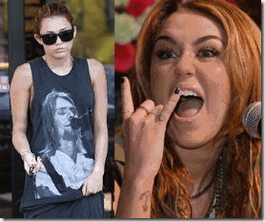
Miley Cyrus Twinning Kurt Cobain and Satanism

Both Paris and Miley Had Opened a Window of Wild and Extreme Public Satanic Exhibitionism
At this writing, Miley Cyrus is still in the hospital compelled to play with ILLUMINATI occulted symbolism and the Octopus of the Deep State-Shadow Government.[33]

Miley was hospitalized because she couldn’t stop crying allegedly as an extreme allergic to antibiotic cephalexin that may last from 5 to 27 days.[34] Twinning with Kurt Cobain is certainly indicative of MK ULTRA Delta Programming with termination keys and Post- Hypnotic Amnesia Blocks, and the CRY FOR HELP.
After Brady Bunch Hribal’s amazing lethal rampage with two knives on over 20 people before being subdued, Hribal was dazed “like a deer in the headlights” [35] suggesting that he had been implanted with very sophisticated Post- Hypnotic Amnesia Blocks.
Brady Bunch Alex, Manchurian Candidates & the Deer in the Headlights
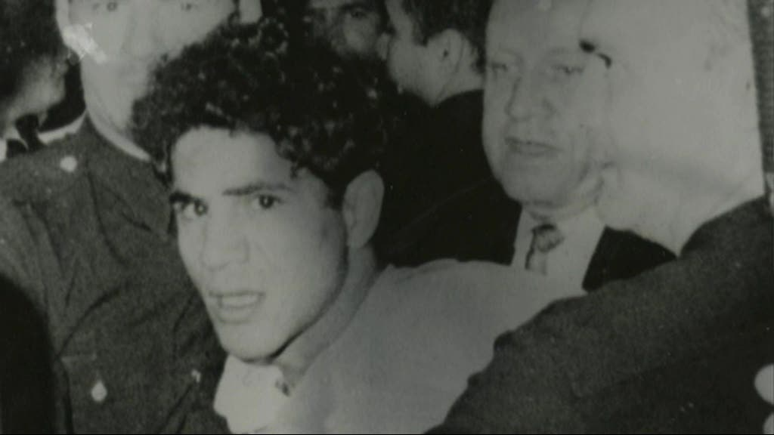
Sirhan Sirhan- Caught in the Headlights
Psychologist define the commonly used phrase “deer in the headlights” as “a state of indecision caused by surprise, anxiety, fear and confusion.”[36]
Hribal’s attorney, Patrick Thomassey acknowledged his client did not appear to appreciate the gravity of his actions, [37] nor did a lot of Manchurian Candidates like from Marcus Wayne Chenault (assassinated Mrs. Martin Luther King, Sr. in 1974) [38] to Batman Raising James Holmes- “Programmed to Kill,”[39]and Sirhan Sirhan.
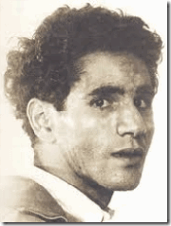
In 1968, Sirhan Sirhan, the convicted PATSY assassin of U.S. Senator and Democratic Presidential Candidate Robert Francis Kennedy (RFK) was said to have been in a CIA/MK ULTRA TRANCE-LIKE state during and after the shooting.[40] Sirhan Sirhan after the TRANCE-LIKE deadly assault on RFK also appeared dazed “like a deer in the headlights” caused by Post- Hypnotic Amnesia Blocks.[41] For a while, Sirhan like James Holmes couldn’t figure out why he had been arrested and jailed.[42]
Brady Bunch Alex’s Blank Stare: Tell-Tale Sign of a Programmed Killer
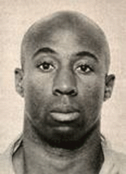
CIA-MK ULTRA Manchurian Candidate Jesse Lee Cooks Out of San Quentin Caught in the Act of Killing
Mass Media reported Brady Bunch Alex as ” Flailing away with two kitchen knives, a 16-year-old boy with a ‘BLANK EXPRESSION’ stabbed and slashed 21 students and a security guard in the crowded halls of his suburban Pittsburgh high school Wednesday before an assistant principal tackled him.”[43]
The victims that survived the infamous unprovoked MK ULTRA Zebra Murders and false flag racial attacks of the early 1970s described their assailants as virtual robots: Angela Roselli, “He had this ZOMBIE LOOK…”“His face was devoid of emotion; There was no hostility in it, just BLANK, STARING EYES”; “…he looked to be in some kind of state”; “It was like he was in a TRANCE– he was looking at me, but he was looking through me.”[44]

The first officer on the scene of the Beatle John Lennon 1980 assassination described Mark David Chapman as having a BLANK STARE, “like a programmed killer.”[45]
Scare them, you can herd them!
“YOU AND AMERICA WILL NEVER BE SAFE!”
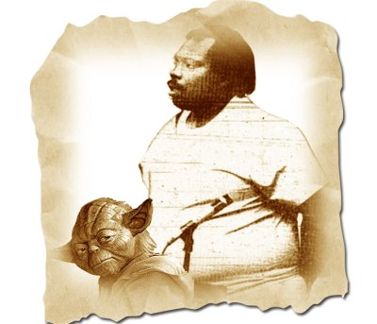
Like a Deer in the Highlights, Sebron Flenaugh Kept Telling Police, “May the Force Be With You”
On the evening on June 25, 1988 at the eve of the California presidential primary election of Former CIA director, Republican George Herbert Walker Bush, Sebron Flenuagh, Jr. (the Jedi Assassin) went on a senseless, motiveless and unprovoked shooting spree at a place called Micropure warehouse in Concord, CA. He killed two people, and wounded five others with a high caliber weapon. One of his victims that survived the attack that was shot first, Robert Webster, described his shooter as “EXPRESSIONLESS.”[46]
It appeared that former U.S. Naval Officer Flenaugh had been MK ULTRA programmed. I suspect that his unprovoked deadly assault had been triggered remotely by a phone call that he received just prior to the killing spree that placed him in TRANCE just like the programmed assassins in the movies, “The Manchurian Candidate (1962)”;[47] “The Manchurian Candidate (2004).” [48]
I just don’t pluck things out of air. I learned in law school that when you become part of a case- you make yourself a quasi-expert of the matter by studying police reports, case files, witness statements and all the public documents that you can assess before coming to any conclusions.
Plus, the unusual case of Sebron Flenuagh had been of special interest to me. I had previously known and studied the strange case of his late younger brother, Ronnie Flenuagh (Al Rashid). Ronnie had been a member of a pseudo Muslim/Sufi? sect of CIA/MK ULTRA Black Manchurian Candidate Death Angels called Al Constran (Colestran).[49]
I witnessed Ronnie’s sudden transformation from one of the local regular young street brothers of the North Oakland/Berkeley community to a sudden Islamic fanatic. Ronnie had been someone special to us. He always stood out in a crowd. Ronnie was ripped in muscles. Ronnie represented what we could make of ourselves with hard work and dedication. He had been our neighborhood “Hercules.”
On the block and at Merritt Jr. College in North Oakland, Ronnie had been so close that I could reach out and touch him. As young brothers, we shared so much in common. I never had a conversation with Ronnie, but the street code and law of survival almost always command you to know of the reputation, morals and demeanor of brothers occupying the same spaces in case something go down between us.
I saw it myself, Ronnie in a long black cape and turban weaving from side to side in TRANCE- like he had been drugged. I saw it, Ronnie’s eyes- BLANK- EXPRESSIONLESS staring straight thru you. Ronnie had been a strong and beautiful brother with no history or reputation that I knew of unrighteous and violence. It was so outside the norms of my life experiences and community that it seemed like a Twilight Zone or an Outer Limits experience. It shook me up to see him that way as we say in our community, “out of his right mind.” I was left mentally confused and SCARED out my wits for a longtime.
Ronnie had been turned into some type of alien right in front of our eyes that had been stripped of all human moral boundaries for the Love of God- Lucifer.
Scare them, you can herd them!

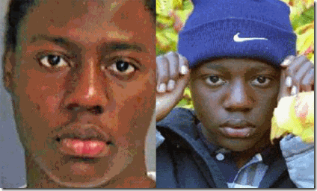
The 2009 Christmas Day Dirty Drawers Airplane Bomber operation was a U.S-Israeli counterintelligence false flag terror covert operation.[50] A passenger described the alleged bomber’s behavior, Umar Farouk Abdulmutallab (Mutallab), in similar terms that RFK alleged assassin Sirhan Sirhan was described. Many serious researchers into that event have concluded that Sirhan was a hypnotized, programmed assassin.
Airplane passenger David Huisanga said that “the scariest part of the whole experience was looking into the eyes….seeing no emotion, no anger, no fear, just a BLANK STARE, BLANK EXPRESSION.”[51]
Scare them, you can herd them!

Dishwasher Richard Reid is another BLANK STARE “wacky Islamic terrorist.” On a flight from Paris to Miami on December 22, 2001, Reid tried to light an explosive in his tennis shoes with a sulfur match. Nevertheless, the explosives he had required a blasting or detonator cap to ignite. So much for a specially trained Islamic terrorist that had been trained to fail.[52] Reid was never known for his brains.
Six months earlier in July 2001, Reid working on a salary of a “dishwater” attempted to board a heavy security Israeli airline El Al from Schiphol Airport in Amsterdam to Tel Aviv. Reid was taken by El Al security and identified as a terrorist suspect. However, rather than turning Reid over to Dutch security for further action he was allowed to board the El Al flight by Israeli Shin Bet (Israel Security Agency, counterintelligence and internal security service) and allowed to proceed to Tel Aviv for what had to have been 10 days debriefing, or implantation of a brain microchip.[53]
At about 16 years old, Reid entered Feltham Young Offenders Institution in Feltham town in the London Borough of Hounslow, in southwest London. The prison is operated by “Her Majesty’s Prison Service.”[54] It is believed that Her Majesty’s Secret Service (MI5) programmed Reid at Feltham as an adolescent for future sleeper operations.
Scare them, you can herd them!
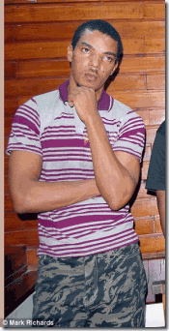
Hummm! Where am I? Mombasa! So-Called Dangerous Islamic Terrorist, Another Hapless British Mind Controlled Patsy- Jermaine Grant
Another strange and “wacky Islamic terrorist” out of Feltham is Jermaine Grant that they say tried to enter Somali in a dress. He was naturally a recent Islamic fanatic that was arrested in Kenya in December 2011 for his role in the alleged Al Qaeda-linked plot to bomb British tourists in Mombasa.[55]
Scare them, you can herd them!
Michael Adebowale, below- lost in a world of warm daydreams and sugar plums, was the second Woolwich London “False Flag” beheading Islamic ‘terrorist’, that is also suspected of having been brainwashed/programmed as a sleeper by MI5 while at Feltham.[56] Are we just plain stupid? no matter how simpletons look at it.

There is no blood on or around that allegedly freshly beheaded corpse or the woman on the street cradling the body. Look at the knives- There is no blood on the knives.

This is the blood and gore of a beheading!
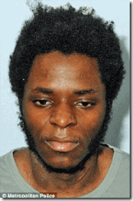
The other so-called Islamic terrorist at the scene of the alleged beheading, Michael Adebolajo as early as 2007 may have joined MI5. In 2010, he was apparently in Kenya working for MI5.[57] At their sentencing, the Islamist Terrorist patsies put on quite a show shouting, “Allahu Akbar!” “You and America will never be safe!”
Scare them, you can herd them!

Testimonies given by those who were at the 2009 Fort Hood massacre said the assassin Nidal Hassan had a similar “BLANK STARE on his face and was not saying anything.”[58]
Standing about 5 feet 3 inches tall and weighing about 110 pounds, Alex Hribal is slight and a lithe assailant like Sirhan Sirhan.[59] Yet, both had been embodied with some extraordinary force and strange compassion to kill. In the Brady Bunch Alex Rampage, he was able to stab over 20 people with two butcher knives before being subdued. Someone should have been able to blow Sirhan or Alex over with a feather.

Time magazine described Sirhan Sirhan’s unusually superior strength under TRANCE in its issue immediately following the killing:
“The hotel men, Karl Eucker and Eddy Minasian, grappled with the assassin, but could not reach his gun hand. Author George Plimpton and Kennedy aide Jack Gallivan joined the wrestling match. The gun, waving wildly, kept pumping bullets, and found five other human targets. Eight men in all, including Rafer Johnson, an Olympic champion, and Roosevelt Grier, a 300-pound Los Angeles Rams football lineman, attempted to overpower the slight but lithe [thin-slim] assailant.“[60]
Big Rosey Greer by himself had been a member of one of professional football’s most legendary and celebrated defensive linemen, the Los Angeles Rams “Fearsome Foursome.”[61] If there was any man that should have been able to disarm and put a slight and lithe man like Sirhan Sirhan on his back within seconds, it was renowned strongman Big Roosevelt Greer of the American Football League.
Another reason for Alex’s high body count is that someone had trained him in tactical knife combat. Early news reports noted that Brady Bunch Alex used what is called the “Reverse Knife Grip Technique” to maximally injure and disable victims.
Reverse Knife Grip Technique: Edge Out

The advantages to the Reverse Knife Grip Technique is many. First, unless the elbow is extended and locked straight, the blade cutting edge always faces the enemy, no matter where the hand is located. When the fist moves as a cross punch, the blade and cutting edge can be raked across the enemy in slashing motion. Second, like an ice pick, tremendous force can be brought to bear on the point, not only when oriented downward, but when an enemy is behind or beside.[62]
The Brady Bunch Alex Rampage & the Satanic Principle Gone Wild

“No, I am not dropping them [knives], MY WORK IS NOT DONE, I have more people to kill.” – Alex Hribal
WHAT and WHOSE WORK? The bottom line is that Alex Hribal was created like Himmler’s SS symbolic of the Janus Face, one Good-Moral, the other Evil- Satanic that was compelled by unknown forces to savagely and blindly attack, critically wound innocent people without a MOTIVE. The Brady Bunch Alex Rampage was most likely an accidental trigger. Alex Hribal is an alarm. Maybe, Alex was created as a future Universal Soldier that malfunctioned. Like so many other CIA/MK ULTRA Manchurian Candidates, Alex Hribal had been turned into some type of alien that was stripped of all human moral boundaries to commit motiveless heinous and unspeakable crimes against innocent citizens that could be no other than a testament and trial of his faith for the Love of God- Lucifer.
Flick the script to Oakland.
16 YEAR OLD BLACK GIRL & THE BLOOD SARCRIFIE- RITUAL FEASTING

In Oakland, there was another MK ULTRA sleeper malfunction. Marilyn Webster was also a 16 year old knife welding assailant from Oakland, CA. She was alien to the Brady Bunch Alex’s image of an ordinary All American white student. Marilyn’s world propagandized profile was everything that Brady Bunch Alex wasn’t. In contrast to Alex Hribal, Marilyn was a poor non-white MPD mentally disturbed anti-social, dysfunctional schizoid sociopath with a background of ritual abuse that her attorney described as hard and difficult to believe.
Yet unlike the evidence in Alex’s case, we know for certain who programmed Marilyn into a sleeper MK ULTRA/Project MONARCH Satanic MPD black female Manchurian Candidate.
Just as in the case of the Jedi Assassin- Sebron Flenaugh, I studied the police reports, case files, witness statements and all the public documents that you can assess before coming to any conclusions. I also personally attended practically all of her handler’s Alameda County Superior Court hearings.
On March 15, 2005 around sunset in Berkeley, CA, Marilyn and her MK ULTRA/Project MONARCH handler/programmer, Seyedeh Hamaseh Kianfar, were on their way to a secluded section of the city’s nearly 4 acre wooded Historic Rose Garden for mental conditioning and exercises.
At that time, Berkeley resident’s Alexander and Katherine Pope were also walking through the park. While passing Kianfar and Webster along a narrow garden park pathway, Webster flipped the script on her programming and suddenly attacked Mrs. Pope with almost blinding speed. Webster went for her throat and slashed the 75 year old woman’s throat almost to the bone.
Like Alex, this adolescent had also been trained to strike with a knife. Marilyn struck so coldly, precisely, quietly and smoothly in TRANCE that Mrs. Pope’s husband walking only inches behind her on the path didn’t see the attack.
After the savage attack, Seyedeh Kianfar and Webster escaped the crime scene in a silver or light blue convertible sports car. Witnesses reported the getaway car’s license plate numbers to police that identified Seyedeh Kianfar as one of the fleeing suspects.
Mrs. Pope was left to bleed to death on that quiet garden pathway and only the swift action of her husband saved her life. In the aftermath of the crime, Seyedeh Kianfar scurried Webster away and bought her a complete change of bloody clothes. Seyedeh Kianfar disposed of the bloody clothes and secrete the Ritual Feasting Knife.
With a new set of clothes and a word of caution about Webster and access to knives, Seyedeh Kianfar dropped the girl off at home and took off. Seyedeh Kianfar didn’t call the police until 15 hours later.[63] Kianfar initiatively told police a bold face lie that she just happened to be driving by the Berkeley Rose Garden, and saw the 16-year-old girl holding a knife and running down the sidewalk toward Mrs. Pope.[64] That had been the original script for a veiled assassination by a sleeper agent- lone-wolf crazed juvenile black assailant.
Marilyn was intended to be yet another highline story- poster-child to fuel the eugenic debate about nature vs. mature, and further polarize the races. Marilyn was bound to be disposed of in a hail of police bullets until she unexpectedly flipped the switch and exposed her programmers.

This is actually an Elite United Nations Global Family Delegation Responding to Felony Criminal Charges in Oakland- Seyedeh Hamaseh Kianfar, UK Attorney Sahar Anghar Kianfar, and World Sufi Spiritual Leader Shah Nasar Ali Kianfar
To the Berkeley Police Department (BPD) and the Alameda County Mafia DA, Seyedeh Kianfar was like a secret U.S. State Department, CIA-MK ULTRA 900 pound gorilla in the room. The hypocrisy and contradictions would have been far too great to just let the asset walk. It had the danger of awakening the people all over the country. Kianfar and Webster were both criminally charged, Webster for attempted murder, and Kianfar for accessory to attempted murder. However, Kianfar’s charge was only a token prosecution to lure the public to sleep. She was not booked, fingerprinted or photographed by the BPD, authorities said. Kianfar was given a 2 month May court date; felony suspects are generally required to appear in court within 48 hours.[65] Marilyn Webster’ was locked up and shut away from the public indefinitely in juvenile facilities.
The High Priestess- Boundless to Human Law & the Incredulous Prosecution
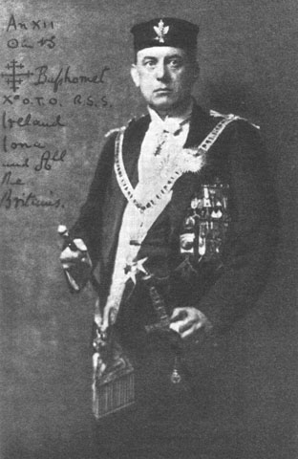
“Do what thou wilt shall be the whole of the Law”-The Great BEAST 666 Aleister Crowley [66]
During court proceedings, the prosecutor said that Kianfar was unremorseful and failed to acknowledge responsibility in the case. The prosecutor said that the Elitist Kianfar told authorities that she was not able “TO HAVE BOUNDARIES.”[67]
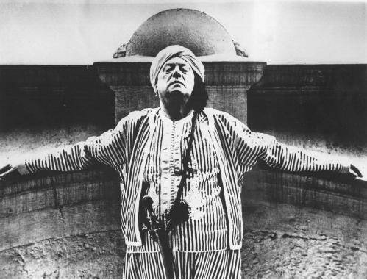
“thou hast no right but to do thy will. Do that, and no other shall say nay.” —AL. I. 42–3, Liber LXXVII of Aleister Crowley [68]
Kianfar’s attorney, Laurel Headley, the defense attorney told Alameda County Superior Court Judge Jon Rolefson that she’s “incredulous [unbelieving]” that felony charges were filed against Kianfar. Accessory to attempted murder, Kianfar’s bail as a principal in Attempted Murder was set at a mere token $15,000.[69]

Do Thy Will, No Other Say Nay- Laurel Headley and Seyedeh Kianfar
In Alameda County, the schedule calls for a bail of $20,000 for each possession of crack cocaine.[70] In many scheduled court hearings, Kianfar stately privileges continued. She didn’t even have to show up to court. It was a lone female journalist and I that was shocked and surprised by a blatant hypocritical and racist criminal justice system that allowed this woman a privilege of showing up or not to felony attempted murder proceedings.
However, I sat through court anyhow and watched with uneasiness and a sense of utter revulsion as predominately black and brown faces were led one by one out of the court’s backroom jail before the judge in orange jumpsuits for minor offenses and drug possession charges. I was broken hearted when one of my childhood heroes was among them. His bail for simple crack cocaine possession was higher than Kianfar’s bail.
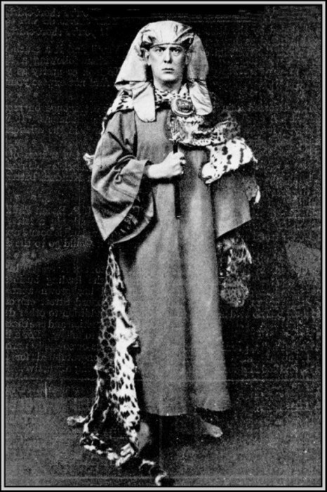
“The Kings of the earth shall be Kings for ever: the slaves shall serve.” —AL. II. 58, Liber LXXVII of Aleister Crowley [71]
As in most cases, the mass media primary focus was on how crazy, sick and anti-social the 16 year black girl had been then deeply delve into Seyedeh Kianfar’s background and why she was caught in the act of indoctrinating, programming and keying an alter personality of Marilyn Webster to blindly perform primeval Satanic Ceremonial Ritual Feasting Sacrifices.
At the time of the knife attack, Miss Kianfar was a state/county employee. She was an Alameda County mental-health worker or a guidance counselor at Juvenile Hall in San Leandro. Marilyn Webster was a Ward of the State of California locked away in its foster-care (abuse) system. Mental health counselors had been strictly forbidden from fraternizing with their charges outside the facility.
In 2007, Kianfar surrounded by her seen and unseen influential grove of supporters had worked out a plea deal with the Alameda County Mafia. She pleaded “no contest” to the charge of accessory after the fact to assault with a deadly weapon. With her plea, she worked out a covenant to not spend any time in county jail or state prison.
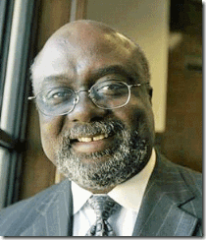
Gutless Judge C. Don Clay Threw County/State Satanic Ritually Abused Black and Brown Children Under the Bus
Alameda County Superior Court Judge C. Don Clay completely twisted the facts around and almost proclaimed Kianfar a HERO for calling police 15 hours later to get that wild and crazy black girl off the streets before he attacked anyone else. The judge ordered Hamaseh Kianfar to spend the next five years on probation, do 30 days of sheriff’s work detail, which can include picking up trash on roadsides, and complete 2,000 hours of community service, such as volunteering for a nonprofit organization. That was an end to a possible public trial.[73]
I was hopeful for a public trial. However, I knew all along that it wasn’t realistic. Kianfar’s public trial would have opened Pandora’s Box to covert Satanic CIA/MK ULTRA mind control projects involving virtual defenseless and throwaway predominately black and brown children, Wards of the State of California. In lieu of a public criminal trial, I was also hopeful that the Popes would file a civil claim against Kianfar, the county and state for damages, then proceed to a civil trial that also would have opened MK ULTRA’s Pandora’s Box in Oakland. However, I couldn’t find anything in the public records regarding the Popes’ claim for civil damages and proceedings.
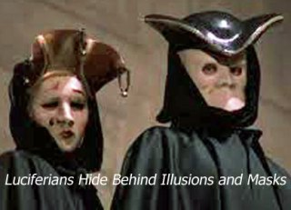
The Popes weren’t ordinary liberal John and Jane Doe of Berkeley. It turns out that they both were purveyors of the secret shadow government. Alexander H. Pope had been a powerful Westwood-Sacramento politically influential attorney- key legal advisor and legislative secretary to 1950s California Governor Pat Brown, father of current Governor Jerry Brown.
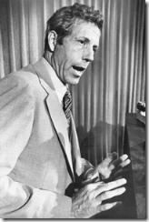
A Phi Beta Kappa graduate of the University of Chicago and its law school, where he was managing editor of the Law Review, Pope served in the U.S. Army from 1952 to 1954. That included a stint in the U.S. Korean Aggression as the news analyst (military intelligence) for the 8th Army in Seoul. He also held the extremely powerful position of influence as the Los Angeles County Assessor during the 1970s.[74] The victim, Katherine Pope, was/is a special coordinator at UC Berkeley’s Bancroft Library [75] that has been an internal part of covert CIA/FBI collaboration, spying, surveillance/counterintelligence activities on campus for decades.[76]
Seyedeh Kianfar and her grove must have been an extremely powerful and scary force, because it appeared that the Popes either made a secret compensation deal with Kianfar, Alameda County Mafia and state or they were too afraid to open Pandora’s Box to the public. Kianfar’s “nolo contendere” literally means “I do not wish to contest.” Essentially the same as a guilty plea, a “no contest” plea results in a California criminal conviction. When you plead “no contest”, you are not technically admitting guilt but are still allowing the court to determine your punishment.[78]
Marilyn Webster initially charged with attempted murder and assault with a deadly weapon pled guilty to assault charges in September 2005 and really hadn’t seen the light of day since her arrest. Most of her time in custody, Marilyn was under special 24-hour guard in solitary confinement at juvenile hall to plug any more leaks.
She was last reported living at the Porterville Developmental Hospital in Tulare County, a state mental health treatment facility in the Sierra Foothills. She was expected to be confined away at that facility until at least 2012.[79]

Make no mistake and don’t let the fancy name of the hospital mislead you, Porterville Developmental Hospital sitting in the Sierra Mountain foothills is no resort. It is theold Porterville State Hospital. It was created and established as an experimental behavior control/modification concept facility in 1945 at the end of WWII, and the beginning of Operation PAPERCLIP (secret importation of Nazi Doctors in America).[80]
Being at Porterville State Hospital was far from being a picnic and a rest resort for Marilyn. It is an institutional that that has primarily dwelt into “operant conditioning” as a so-called therapeutic system since 1966. By some accounts, “operant condition can be dehumanizing and can at times lead to a total loss of human values. They also complain about the use of electric shock grids, physical restraint., prolonged seclusion, and deprivation.” [81]
You may not be aware of what an electric shock grid may be, but take a good look at a scene from Stephen King’s Cat’s Eye (1985) at what it entails in state ritual torture.
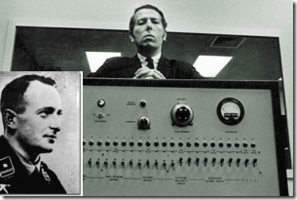
“Operant conditioning” really developed out of “obedience” in human behavior. It is a form of “social influence in which a person yields to explicit instructions or orders from an authority figure.” Humans have been shown to be obedient in the presence of perceived legitimate authority figures, as shown by the Miligram experiment in the 1960s, which was carried out by Stanley Milgram (August 15, 1933 – December 20, 1984) of Yale University to find out how the Nazis managed to get ordinary people to take part in the mass murders of the Holocaust. Miligram’s study subject had been Knight of Black Sun– SS- Oberstumbannfuhrer (lieutenant colonel) Otto Adolf Eichmann.[82]
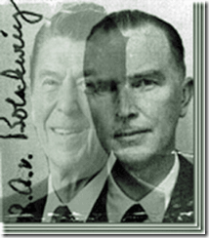
SS Eichmann’s master tutor had been California Governor (1967-1975) Ronald Reagan’s alter ego, the David Niven of the SS, CIA Agent and Gehlen Org Head, SS Hauptsturmführer (Captain) Baron Otto Albrecht Alfred von Bolschwing.[83]
The experiment showed that obedience to authority was the norm, not the exception. Regarding obedience, Milgram said that “Obedience is as basic an element in the structure of social life as one can point to; Some system of authority is a requirement of all communal living, and it is only the man dwelling in isolation who is not forced to respond, through defiance or submission, to the commands of others.” [84]
It is highly contested, but there is substantial reason to believe that Stanley Milgram’s obedience to authority experiments had been secretly funded in the primary interest of SS Bolschwing’s CIA.[85]
Nevertheless, Kianfar’s criminal conviction in programming a mentally disturbed MPD minor to commit a heinous crime is important. For all the simpletons that don’t believe in governmental conspiracies and covert mind control projects, Kianfar doesn’t wish to contest what Marilyn Webster stated that she was programmed to do.
Two days after the knife attack, there was a leak that Webster told police that she had slit Mrs. Pope throat as part of a blood “Feasting Ritual – Covenant with God.”[86]
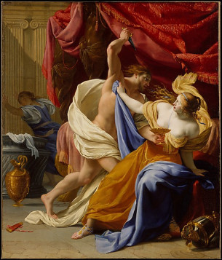
In the Biblical Book of Judges, Jephthah of the House of Joseph [87] that parallels to the story of Abraham sacrificed his only daughter for a covenant with God for victory over the Ammonites. After his victory, God didn’t stop Jephthah’s human sacrifice. The Old Testament does not specify how Jephthah sacrificed his daughter, but following the correct methods for animal feasting ritual sacrifice, he would slit her throat first and drain her blood into a temple service vessel, then sprinkle, and smear her blood at prescribed points around the altar; and burn the flesh.[88]
Blood Sacrifice- A Covenant with the Devil!

The Devil Our Lord- Art Work by Aleister Crowley, the Great BEAST 666
High Priestess Seyedeh Hamaseh Kianfar is an illuminated Islamic “Mystic Sufi.” In Cairo, Egypt in 1904, the demonic spirit that possessed Aleister Crowley in TRANCE (Cairo Working) was called Aiwaz or Aiwasis as Crowley spelled it. The voice of Crowley’s Book of the Law that he transcribed while in TRANCE had been Aiwaz.[89] As Crowley came to discover sometime in 1918 that Aiwaz was the proper name of the god of the Yezidis. It was believed that the Yezidis, a Kurdish people located in northern Iraq, worshipped a primitive form of Satan. This became the basis of Crowley’s subsequent identification of Aiwaz with SATAN.[90]
Yezidism, as the religion of the Yezidis is called, combines traditional beliefs with Islamic Sufi heresies. The Yezidi belief system is reminiscent of the Gnostic Nag Hammadi scriptures. Like certain Gnostic sects, the Yezidis identify the disobedience of Satan as an enlightened act. The Yezidis follow the Quran, which states that Satan was cast down by God for refusing to submit to man. Like some Sufis, the Yezidis believe that God’s command was a test, and only Iblis understood this. In fact, God was testing the angel’s love of him. Iblis was willing to disobey God and endure hell itself rather than give up God his love and submission to the Highest. Thus, Iblis can be viewed as the true Moslem.[91]
The Quran, in many citations, portrays Satan or Iblis as an angel. Iblis is a personal name of the “Devil” and “Enemy of God.”
And (remember) when We said to the angels: “Prostrate yourselves before Adam.” And they prostrated except Iblis (Satan), he refused and was proud and was one of the disbelievers (disobedient to Allah). S. 2:34 [92]
One version is that Iblis claimed to be a nobler being created by fire while man came only from clay. For this exhibition of pride and disobedience, God threw Iblis out of heaven. His punishment, however, was postponed until the Judgment Day when he and his host will have to face the eternal fire of hell until that time he is allowed to tempt all but true believers to evil.[93]
Many Sufis see Iblis as a model for the perfect monotheist and lover of god because he refused to bow down to Adam, because of his separation from his beloved. Ahmad AL-GHAZALI reportedly said, who does not learn from Satan proclaiming god’s oneness is an infidel.[94]
According to tradition, Sufi Preacher AL-GHAZALI gave the so-called Devil worshippers, the Yazidis, the justification for their worship of Satan (Ahmad Taymur Pasha, al-Yazidiyya, Cairo 1352, 59-61).[95]
“Sufism is the science by which one knows the methods of traveling towards the King of kings.”[96] While in Alameda County Santa Rita Jail, Ronnie Flenaugh’s leader, Death Angel Executioner, William E. (Billy) Mapp, made a motion in his behalf (Pro Per) to the court to recues Superior Court Judge Leonard Dieden from his case for prejudice. In that motion written in longhand, Mapp aid that he was, “Most of all ordained by the King of Kings and Lord of Lords to preach his words through out the land …” [97]
Mapp had been literally kidnapped off the street by OPD, severely beaten and jailed at Santa Rita County Jail. He went in as a young ordained Christian minister, and came out of jail an ordained Islamic fanatic. His sudden reference to “King of kings” isn’t conclusive that he had been subjected to MK ULTRA radical Sufi conversion, but it’s certainly a clue.
One thing is certain is that when Mapp was apprehended for capital murder in Southern California, Self-Destruct Alter Personalities set in. Devils and demons suddenly drove Mapp into paranoia and insanity – post hypnotic termination and amnesia blocks.
Prior to that, Mapp had been moving around the state and Nevada with a get-out of jail pass from the Alameda County Mafia, District Attorney, D. Lowell Jensen.[98] Just prior to Mapp gunning down two men in Southern California, he was arrested in Las Vegas for pimping. The police took his gun, then gave it back to him with walking papers from the Alameda County Mafia. He ended up in Pasadena executing two men with that same weapon.
By the time of trial for murder in 1973 in Los Angeles, Mapp had suddenly become so mentally impaired by devils and demons that a jury found him not guilty of murder by reason of insanity (CA Pen. Code, § 1026).[99]
Abraham, God’s Covenant & Sacrificial Blood Feast Ritual
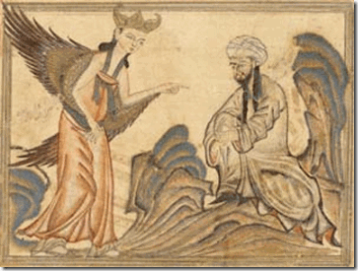
Some sources say that it was Iblis that by a “Divine Trial” tempted Abraham to sacrifice his son by the blade of a knife. The consistent version is that God by “Divine Trial” compelled Abraham to sacrifice his son for Love– the Love of God.
Neither shall thy name any more be called Abram, but thy name shall be Abraham; for a father of many nations have I made thee. Genesis 17:5
The bible and many ancient texts claim that Abraham of Ur of the Chaldeans is the father of all religions and nations.[100] By a covenant with God, he is said to be the father of Judaism, Christianity and Islam.
God’s first covenant to Abraham was the land gift to him and all of his descendants. Along with that gift was the promise his descendants will be as numerous as the stars in heaven; and, the world would be blessed because of him. (Genesis 17:1-8.) When given his covenant from God his name was changed from Abram to Abraham. Abraham means “father of many nations.” But the covenant was conditioned on the requirement that Abraham “walk with me (God) and be blameless.” (Genesis 17:1.) This covenant requirement was repeated in detail in Deuteronomy 28. [101]
According to the Bible, God commands Abraham to offer his son Isaac as a sacrifice. (Genesis 22:5 and 22:8 ). After Isaac is bound to an altar, the angel of God stops Abraham at the last minute, saying “now I know you fear God.” At this point Abraham sees a ram caught in some nearby bushes and sacrifices the ram as a burnt offering instead of Isaac.[102]
Muslims consider that visions experienced by prophets are revelations from God, and as such it was a “Divine Order” to Abraham. The entire episode of the human sacrifice is regarded as a trial of God for Abraham and his son, and both are seen as having passed the test by submitting to God and showing their awareness that God is the Owner and Giver of all that we have and cherish, including life and offspring. The submission of Abraham and his son is celebrated and commemorated by Muslims on the days of Eid al- Adla.[103]
Abraham’s human sacrifice of Isaac had been under the system of the worship of Moloch and the Baal-Ishtar. It was common in Arabia and the world generally until the worship of the Golden Calf was eliminated by Christianity.[104]
The ritualized slaughter of animals is a very special and affectionate custom in Abrahamic Jewish life. They cut the animals throat wide open in order to drive the animal into a rage whereby the blood is agonizingly pumped out of the creatures body. Depending on the species the divine death throes can take up to four hours. By each body motion a fountain of blood gushes out of the “sacrificial lamb’s” throat. The animals go mad during this ordeal.[105]
Zabiha is an Arabic word which means ‘slaughtered’. The ‘slaughtering’ is to be done by cutting the throat, windpipe and the blood vessels in the neck causing the animal’s death without cutting the spinal cord.[106]

Northern Italy 1475-85 (from A.M. Hind, Early Italian Engraving, II, New York-London, 1938
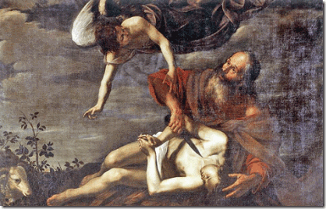
Sacrifice of Isaac (1625) Orazio Riminaldi

Donatello’s Sacrifice of Isaac (1421)

Rosicrucian Dutch Painter Rembrandt Harmenszoon van Rijn, Sacrifice of Isaac (1635)
“When a Brother reveals any of OUR GREAT SECRETS; WHENEVER, FOR INSTANCE, HE TELLS ANYTHING ABOUT BOAZ, OR TUBALCAIN, OR JACHIN OR THAT AWFUL MAH-HAH-BONE, OR EVEN WHENEVER A MINISTER PRAYS IN THE NAME OF CHRIST IN ANY OF OUR ASSEMBLIES, YOU MUST ALWAYS HOLD YOURSELF IN READINESS, IF CALLED UPON TO CUT HIS THROAT FROM EAR TO EAR …” Quoted from The Masonic Report, McQuaig, p. 3.
Marilyn’s throat attack was not a random act. It was scientific and a trained attack to the throat passed down through the ages from at least the medieval period from Worship of Moloch, Abrahamic religions, Masons to Satanists. As you see, the throat attack, Trial of Abraham and the Sacrifice of Isaac had been an important theme to the elite and illuminated classes for generations. it was as Marilyn Webster said it that it had been,a pagan “Ritual Feasting.”

KIANFAR & SECRET STATE SPONSORED SUFISM
Seyedeh Hamaseh Kianfar, The High Priestess of the Uwaiysi Sufi
Please stay with me for a few more moments. It is a rare set of circumstances to find a smoking gun (clear evidence) in the Black Community of the covert programming of a mind controlled Black Manchurian Candidate, particular a black female adolescent. At times, I have been accused by simpletons of being paranoid and delusional. However, this is no delusion. The body count and the attack is unquestionable, and the programmer/handler by the public record didn’t contest the fact that she had programmed a young ritually abused 16 year old black female of our community to be a knife welding Blood Rite Executioner.
Sufism is a mystical or esoteric form of the Muslim faith that seeks a direct experience of God. In Sufi tradition, al-Khiḍr has come to be known as one of those who receive illumination direct from God without human mediation. He is the hidden initiator of those who walk the mystical path, like some of those from the Uwaisitariqa.

Uwaisis are those who enter the mystical path without being initiated by a living master. Instead they begin their mystical journey either by following the guiding light of the teachings of the earlier masters or by being initiated by the mysterious Prophet-Saint al-Khiḍr.[107] According to the New Oxford American Dictionary, “Sufism is the esoteric dimension of the Islamic faith, the spiritual path to mystical union with God. It is influenced by other faiths, such as Buddhism, and reached its peak in the 13th century.”[108]

Seyedeh Hamaseh Kianfar’s mother is Dr. Nahid Angha, PhD. She is a co-founder of the International Association of Sufism (IAS). Dr. Angha is the main representative of IAS to the United Nations (NGO/DPI). She is Executive Editor of the journal Sufism, An Inquiry, and founder of the international Sufi Women Organization (SWO).[109]
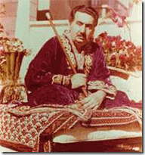
Dr. Angha is the daughter of Moulana Shah Maghsoud, above, the twentieth century Persian Sufi of the Uwaiysi School of Sufism, Dr. Angha was the first woman appointed to teach in her father’s school, and later the first woman ever to sit in the inner circle council with Muslim leaders from around the world to lead meditation at the annual Sufi Symposium. In 2000, she earned UNESCO’s “Messenger of Peace” award for her work as a humanitarian leader.[110]

Seyedeh Hamaseh’s father is Shah Nazar Ali Kianfar, 68, the 1983 co-founder of the IAS. He is the spiritual son of Uwaiysi Sufi Master Moulana Shah Maghsoud. He began his study and devotion to the discipline of Sufism in his twenties, and later was appointed to teach in the Uwaiysi Tarighat. Seyyed Dr. Kianfar was among the first of Moulana Shah Maghsoud’s students to be given this honor. To commemorate the significance, Moulana Shah Maghsoud gave Seyyed Dr. Kianfar the honorary title Shah Nazar (The Sight of the King).[111]

Seyedeh Hamaseh Kianfar’s sister, Sahar Angha Kianfar, is a Great Britain and California Attorney. [112] She is Hamaseh’s co-author of the book, Sufi Stories.[113] They are the granddaughter of Moulana Shah Maghsoud. Shah Maghsoud is the last of the long lineage descended from Uwaiys-i-Gharan whose way of spiritual traveling was directly approved by the Prophet Mohammad.[114]
Shah Maghsoud & The Bloodline and Path of Uwaiysi

Shah Maghsoud’s Uwaiysi Tarighat is an Order of Sufis practicing in the ancient tradition of the Path of Uwaiys-i-Gharan. Gharan was a devotee and a follower of the Prophet Muhammad from the 7th Century AD.
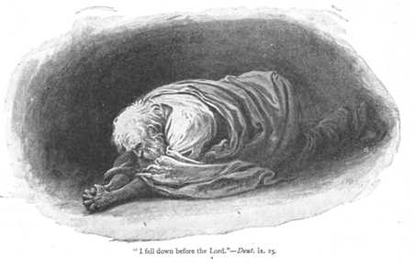

Uwaiys-i-Gharan was a mysterious ascetic figure born in Yemen. He is reported to have been a slim man of medium height who had a white spot on the palm of his hand. He ate very little, and sold dates to earn a living, eating only to break his fasts and giving the remainder to the needy. He wore an old robe, which he knitted himself, to keep warm. He was a shepherd, and supported his elderly mother, whom he cared for.[115]
Uwaiys Gharan never met the Prophet Muhammad, but the Prophet told his devotees, “There is a man in Gharan whose name is Uwaiys. At the day of Resurrection, he shall intercede for my people to as many as the number of the Rabia and Muzzer tribes.” The Prophet also told his followers, “When you see him, give him my greetings and ask him to pray for my Ummah, my people.”[116]
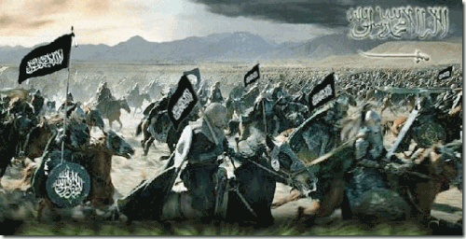
Uwaiys Gharan was martyred at the Battle of Saffein. The Battle of Siffin (May–July 657 AD) occurred during the first Muslim Civil War, with the main engagement taking place from July 26 to July 28. It was fought between Ali ibn Abi Talib and Muawiyah I on the banks of the Euphrates River in what is now Ar-Raqqah, Syria.[117] At the other end of dualism, Uwaiys Gharan can also be seen as an Islamic Warrior renowned and honored among both Shia and Sunni Muslims, Sufis in particular, for his piety, Practice of Zuhd (asceticism), and Love for Muhammad Proved by Trial in Battle.
Zuhd, (Arabic: “detachment”), in Islam, asceticism. Even though a Muslim is permitted to enjoy fully whatever unforbidden pleasure God bestows on him, Islam nevertheless encourages and praises those who shun luxury in favour of a simple and pious life. The Quran (Islamic scripture) holds in great esteem those “servants of God who pass the night prostrating themselves in the worship of their Lord” (25:63–65). There are students of Islam, however, who maintain that zuhd was influenced directly by the Christian hermits, with whom early Muslims had some familiarity. Some scholars also point to the pre-Islamic Arab ḥanīfs, who practiced the ascetic life and who may have had considerable influence on the Prophet Muhammad. The Prophet himself spent long periods in solitary vigil, fasting and praying, even before his prophetic mission.[118]
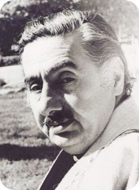
Seyedeh Kianfar’s grandfather Shah Maghsoud (1916-1981), above, claimed to have been the last of the long (BLOODLINE) lineage descended from the 7th Century Uwaiys-i-Gharan whose way of spiritual traveling was directly approved and sanctioned by the Prophet Mohammad.[119]
TAMERLAN, SUFISM & MIND CONTROL
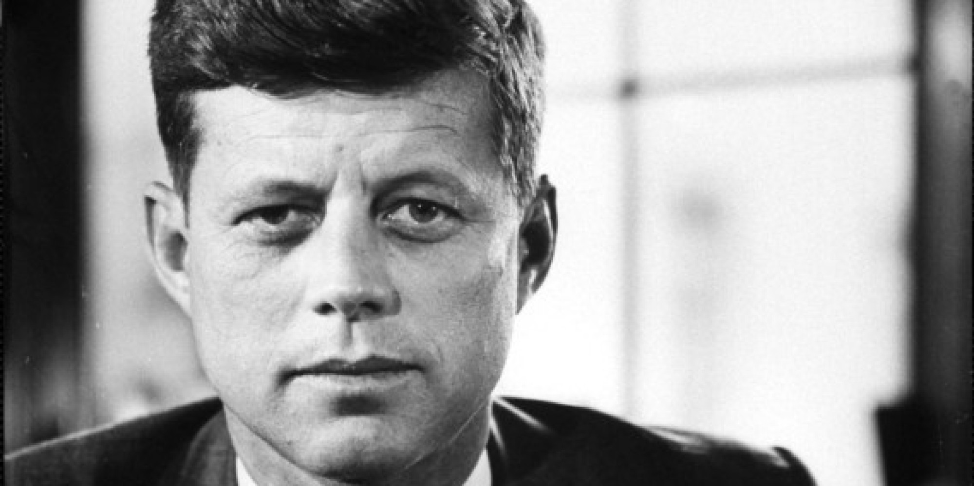
” … those who foolishly sought power by riding the back of the tiger ended up inside.” – President John F. Kennedy, Inaugural Address, January 20, 1961[122]
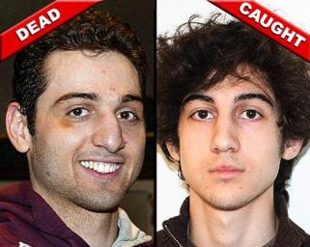
Sold to masses, like Marilyn Webster– Tamerlan Tsarnaev is also far removed from an innocent All American legend of a Brady Bunch Alex Hribal. Tamerlan’s mass media propagandized profile is a petty criminal- violent dysfunctional schizophrenic Muslim.[123] Tamerlan, who was murdered in a false flag shootout with police four days after allegedly carrying out the Boston Marathon bombings with his brother, Dzhokhar. Tamerlan was thought to have “some form of schizophrenia,” according to family friends, while his mother said Tamerlan “felt like there were two people living inside of him.”[124]
Tamerlan was under MK ULTRA mind control after he returned to the U.S. following a trip to the Russian Republic of Dagestan in 2012, “He said, ‘Someone is in my brain, telling me stuff to do,’ ” Donald Larking recalled to the Globe. “He said he was trying to ignore it but it was hard to do. Whatever it was he was being told to do, he didn’t want to do it.” [125] However, Tamerlan was far from being a schizoid. He knew exactly what CIA/MK ULTRA programming was, “He believed in MAJESTIC MIND CONTROL which is a way of breaking down a person and creating an alternative personality with which they must coexist,” Donald Larking, a 67-year old who attended a Boston mosque with Tamerlan, told the Globe. “You can give a signal, a phrase or a gesture, and bring out the alternative personality and make them do things. Tamerlan thought someone might have done that to him.”[126]
We are led to believe that the alleged demons that compelled Tamerlan and Dzhokhar as “lone wolves“ to do unspeakable things and commit horrific crimes against innocent citizens didn’t come from CIA MK ULTRA. Both Tamerlan and his younger brother were used as pasties, informants and actual double agents for the FBI and CIA sheep dipped in Russian Republic Islamic Wahhabi jihadism[127] just like CIA/FBI double agent Lee Harvey Oswald had been sheep dipped in pro-Castro groups/communism before the assassination of JFK.[128]
Sufism and Majestic Mind Control

Majestic is an adjective- describing word. Its standard definition is having or exhibiting majesty.[129] Majesty definition includes, “The Sovereignty and Power of God.”[130]
CIA- MK ULTRA/MONARCH Mind Control consists of drugs, ritual abuse, ritual sexual abuse, operant conditioning, brainwashing, torture, brain surgery, hypnosis, brain chip and microchip implantation, ELF brainwave entrainment & electro-shock torment.[131] In Trauma Based Mind Control, the victim/survivor is called a “slave” by the programmer/handler, who in turn is perceived as “master” or “God.”[132] Majestic Mind Control can be all things above covertly controlling one or more multiple personalities of victims through the Sovereignty and Power of the Queen or God.[133]
According to Tsarnaev’s revelations, Majestic Mind Control is accomplished through “Divine Orders” of God with programmers/handlers acting as intermeddlers (Ibis-Satan) between the subject and God. A family friend said the Tsarnaev family were Sufi Muslims, the dominant and moderate form of Islam in their homeland of the northern Caucasus.[134]
Sufism is extremely most suitable for Majestic Mind Control. It is a Islamic belief system associated with teachings of Sufi masters—who may serve as an intermediary between God and humans—to achieve a spiritual sense of the meaning of God.[135]
I can understand the programmed blind fanaticism of how multiple personality disorder (MPD) Billy Mapp and lieutenant Ronnie Flenuagh and other brothers fresh out of MK ULTRA prisons and mental hospitals were compelled in TRANCE by the “Divine Trial of God” to gun down and hack up with malachites innocent people and so-called infidels of the pseudo Sunni (Sufi) Muslim group, Al Constran.
Al Constran’s intermeddler had been a mysterious man in Riverside, CA, George De Vaughn Booker. They called him, “Father” and God, “Abdul Alalah.“ The LAW OF AMANDA were written statements defining their relationship with “THE FATHER.”[136]
Amanda means lovable in either Latin or Greek.[137] In Latin, Amanda means “having to be loved,” “deserving to be loved,” or, simply, “worthy of love.”[138] Father–God George De Vaughn Booker or conspirator wasn’t pursued as a suspect in the Al Constran killings. The only path to discover Booker and the inner structure of this group is by reading Mapp’s criminal trial transcripts. Al Contran murdered and executed people all over California. That’s not what I say, it is according to the Pasadena Police Department in 1972 where Mapp, Ali Allm Alalah, executed two followers on the street in cold blood. [139]
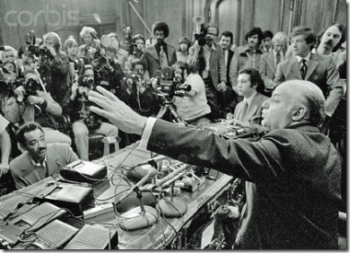
In May 1974, San Francisco Mayor Joseph Alioto (1968- 1976) told a packed news conference that pseudo Muslim Black Manchurian Candidate Death Angels like Mapp and Flenaugh had committed at least 73 racial murders and mutilations all across the state since 1970.[140] Flenaugh was deposed of (executed) in Oakland in 1971. When Mapp was apprehended by police for murder in 1972, his mind snapped and lapsed into paranoid schizophrenia- locked in post hypnotic amnesia blocks.
Now you should also understand why a programmed alter personality of 16 year old Marilyn Webster could be compelled to commit a motiveless- senseless heinous crime at the throat of Mrs. Pope in TRANCE by her intermeddler, Seyedeh Kianfar. Under Sufi Majestic Mind Control, she had been compelled to slit Mrs. Pope’s throat in a pagan human ritual sacrifice under condition of Abraham’s Covenant with God; and by example of IBLIS‘ (Satan) example of “Divine Will” and blind obedience to “Divine Order” for LOVE– the Love of God!
People of the State of California v. Kianfar, Alameda County Superior Court is an extremely rare public record involving “mind control” experimentation involving black children in collaboration with the state. It concluded in her plea of no contest to felony criminal charges. Now and forever, Seyedeh Kianfar does not wish to contest the facts, circumstances, issues or change the conversation of the case.

Hamaseh Kianfar, Ed. D., currently works as the Director of Senior Services at Bernal Heights Neighborhood Center. Prior to this position, she had been working as a medical case manager for HIV positive women and children. Her passion for the area of HIV/AIDS let her to complete a doctoral dissertation that focused on the role that forgiveness and imagination play in allowing HIV positive women to move forward in their lives in a hopeful and meaningful way. She is a lifelong member of the International Association of Sufism, founding member and the President of the Voices for Justice, youth department of the IAS and an Ambassador of UNICEF.[141]
Seyedeh Hamaseh Kianfar’s Sufi Uwaiysi Tarighat are not a bunch of hermits, or ascetics like Uwaiys-i-Gharan living prostate in destitute deserts dedicating their total lives praying, serving, interceding by love of god. They hide behind the power and authority of the state. Kianfar and her mystic sufi and Satanic dualism wouldn’t have access toour community without the veil of the county and state. She entered our community behind a shroud of secrecy. These people are materialist, profiteers and NWO collaborators that sale their brand of Sufism to governments and the highest bidders.
State Sponsored Sufism (SAC) is being secretly extolled as the West’s pawns and proxies by the NWO Satanic Cabal as a moderate, comfortable and controllable alternative to more militant forms of Islamic resistance that they can’t control.[142]
Undoubtedly, programmers/handlers like Seyedeh Kianfar are protected governmental-political assets allowing them to walk between the raindrops. These IAS people have become some of the CIA’s latest cut-out mind control contractors adding a shroud of Islamic religious history, authenticity and credibility to a new set and scale to Islamic mind control Manchurian Candidates- A Permanent State of WAR AGAINST ISLAMIC TERRORISM.
Nazi Theory of State Terrorism
“whenever war breaks out, terrorism becomes a military principle,” since ‘terrorism is a relatively gentle means of keeping the masses in a state of permanent obedience.’ ” [143]
Sit back. Reflect for a moment with the Musical Wisdom of Donnie.

[1] http://www.pbs.org/wgbh/aia/part4/4h2927.html
[2] http://time.com/58406/pennsylvania-school-stabbing-alex-hribal-brady-bunch/
[3] http://www.dailymail.co.uk/news/article-2601299/Police-seek-motive-school-stabbing-rampage.html
[4] http://time.com/58406/pennsylvania-school-stabbing-alex-hribal-brady-bunch/
[5] http://en.wikipedia.org/wiki/The_Brady_Bunch
[6] https://www.commonsensemedia.org/tv-reviews/the-brady-bunch
[7] http://www.datehookup.com/Thread-1322094.htm
[8] http://www.datehookup.com/Thread-1322094.htm
[9] http://www.oxforddictionaries.com/definition/english/beard
[10] http://www.cuttingedge.org/News/n1244.cfm
[11] http://www.ancientfaces.com/surname/hribal-family-history/991289
[12] http://www.telegraph.co.uk/news/worldnews/northamerica/usa/10754990/Pennsylvania-high-school-stabbing-24-injured.html
[13] Ross, Colin, The C.I.A. Doctors, Manitou Communications, Inc, Richardson, TX (2000) pg. 232
[14] http://www.davidicke.com/forum/showthread.php?t=3097
[15] http://www.jesus-is-savior.com/False%20Religions/Wicca%20&%20Witchcraft/anton_lavey.htm
[16] http://www.drugfreeworld.org/drugfacts/ritalin/leads-to-other-drugs.html
[17] http://en.wikipedia.org/wiki/Kurt_Cobain
[18] http://justiceforkurt.com/investigation/reasons.shtml
[19] http://educate-yourself.org/mc/illumformula10Cchap.shtml
[20] http://justifytheory.blogspot.com/2012/09/the-crazies-pt-iii-katt-williams.html
[21] https://streetdemocracy.wordpress.com/2013/09/22/miley-cyrus-mk-ultra-mind-control-victim/
[22] http://www.godlikeproductions.com/forum1/message2268146/pg1
[23] http://www.yoganandaji.org/board/showthread.php?t=7785
[24] http://www.davidicke.com/forum/showthread.php?t=5914
[25]http://en.wikipedia.org/wiki/Sandy_Hook_Elementary_School_shooting
[26] http://www.conspiracy-cafe.com/apps/blog/entries/show/21161147-the-house-on-yogananda-street
[27] http://www.michaeljacksonhoaxforum.com/phpbb2/viewtopic.php?f=50&t=14225
[28] http://newsbizarre.com/2009/06/dr-tohme-k-tohme-photo-michael-jackson.html
[29] http://www.strosehospital.org/about-us/history/
[30] http://en.wikipedia.org/wiki/Sisters_of_St._Joseph
[31] http://elms.wikidot.com/father-medaille-s-letter
[32] http://rense.com/general95/mkultra.html
[33] http://www.amazon.com/The-Octopus-Secret-Government-Casolaro/dp/0922915911
[34] http://www.mtv.com/news/articles/1726351/miley-cyrus-still-sick-in-hospital.jhtml
[35] http://www.philly.com/philly/news/20140410_ap_62b100d9e23e4601b39ab02b3b00ee13.html
[36] http://bobherbold.com/blog/are-you-a-deer-in-headlights/
[37] http://news.yahoo.com/lawyer-evaluate-stabbing-suspects-mental-health-122919212.html
[38] http://www.ratical.org/ratville/JFK/JohnJudge/Jonestown.html
[39] http://vigilantcitizen.com/latestnews/inmate-claims-james-holmes-confessed-that-he-was-programmed-to-kill/
[40] http://www.whale.to/b/sirhan.html
[41]http://www.realhistoryarchives.com/collections/assassinations/Sirhan%20and%20the%20RFK%20Assassination%20Part%20II%20Rubik’s%20Cube%20by%20Lisa%20Pease.htm
[42] http://nworeport.me/tag/sirhan-sirhan/
[43] http://www.dailymail.co.uk/news/article-2601240/Shackled-scowling-Student-16-slashed-stabbed-22-people-crazed-rampage-Pennsylvania-high-school-led-away-police-announce-tried-adult.html
[44] http://www.trutv.com/library/crime/notorious_murders/mass/zebra_murders/6.html
[45]http://www.alef.net/ALEFWorks/Notices/ALEFNotices-2011-01-08.Asp
[46] The multiple victims and survivors in the shootings filed suit against Sebron, Wells Security, and the landowner for negligence, Alameda County Courthouse, Webster, et. al, vs. Flenaugh, et al. (1988) Case No. 641939, Deposition of Robert Webster
[47] http://en.wikipedia.org/wiki/The_Manchurian_Candidate_(1962_film)
[48] http://en.wikipedia.org/wiki/The_Manchurian_Candidate_(2004_film)
[49] http://mindcontrolblackassassins.com/tag/al-constran/
[50] http://creative.sulekha.com/israel-and-mossad-linked-to-underwear-bomber-yet-another-israeli-false-flag-attack_459313_blog
[51] http://freepress.org/article/underwear-bomber-more-story-kurt-haskell-describes-well-dressed-man-and-man-orange
[52] http://en.wikipedia.org/wiki/Richard_Reid
[53] http://projectavalon.net/forum/archive/index.php/t-18753.html
[54] http://en.wikipedia.org/wiki/HM_Prison_Feltham
[55] http://www.theguardian.com/world/2013/jul/04/jermaine-grant-trial-kenya-delays
[56] http://www.mathaba.net/news/?x=633012
[57] http://aangirfan.blogspot.com/2013/11/woolwich-false-flag.html
[58] http://supplementreviews.com/forum/index.php?topic=8225.0
[59] http://www.post-gazette.com/news/politics-state/2014/04/12/Juvenile-facility-called-better-for-suspects/stories/201404120142
[60] http://daddybstrong.blogspot.com/2008/06/rosie-grier-helped-subdue-bobbys-killer.html
[61] http://en.wikipedia.org/wiki/Fearsome_Foursome_(American_football)
[62] http://www.jayfisher.com/Knife_Grip_Styles_Hand_Sizing.htm
[63] http://www.sfgate.com/bayarea/article/Former-mental-health-worker-gets-probation-in-2645769.php
[64] Id.
[65] http://www.godlikeproductions.com/forum1/message232761/pg1
[66] http://hermetic.com/crowley/libers/lib77.html
[67] http://www.sfgate.com/bayarea/article/Former-mental-health-worker-gets-probation-in-2645769.php
[68] http://hermetic.com/crowley/libers/lib77.html
[69] http://www.mercurynews.com/ci_3784233
[70] http://articles.baltimoresun.com/1998-05-24/news/1998144040_1_san-francisco-bail-francisco-police
[71] http://hermetic.com/crowley/libers/lib77.html
[72] http://hermetic.com/crowley/libers/lib77.html
[73] http://www.sfgate.com/bayarea/article/Former-mental-health-worker-gets-probation-in-2645769.php
[74] http://www.latimes.com/obituaries/la-me-alexander-pope23-2009jul23,0,6689430.story#axzz2z4n0tMrr
[75] http://www.linkedin.com/pub/dir/Kate/Pope
[76] https://chronicle.com/article/Hoover-ReaganSpying-at/133461/
[77] http://hermetic.com/crowley/libers/lib77.html
[78] http://www.shouselaw.com/no-contest.html
[79] http://www.freerepublic.com/focus/news/1792254/posts
[80] http://www.dds.ca.gov/Porterville/History.cfm
[81] http://files.eric.ed.gov/fulltext/ED049580.pdf
[82] http://en.wikipedia.org/wiki/Adolf_Eichmann
[83] http://www2.gwu.edu/~nsarchiv/NSAEBB/NSAEBB150/
[84] http://en.wikipedia.org/wiki/Obedience_(human_behavior)
[85] http://ahp.apps01.yorku.ca/?p=284
[86] http://www.americanthinker.com/blog/2006/05/bloodfeast_in_berkeley_update.html
[87] http://en.wikipedia.org/wiki/Jephthah
[88] http://www.come-and-hear.com/editor/br_3.html
[89] http://bethelkhem.wordpress.com/2012/02/04/who-was-aiwaz-the-strange-story-of-samuel-jacobs-and-aleister-crowley/
[90] Id.
[91] http://bethelkhem.wordpress.com/2012/02/04/who-was-aiwaz-the-strange-story-of-samuel-jacobs-and-aleister-crowley/
[92] http://answering-islam.org/Quran/Contra/iblis.html
[93] Donniger, Wendy, Merriam-Webster encyclopedia of world religions, Springfield, IL (1999) pgs. 484-485
[94] Id.
[95] http://www.ghazali.org/articles/agz-ei.htm
[96] http://thesufiway.co.uk/islamic-spirituality/
[97] State v. William Edwin Mapp aka Ali Allm Alalah, Los Angeles Superior Court, Case No. A550815
[98] http://en.wikipedia.org/wiki/D._Lowell_Jensen
[99] Superior Court of Solano County, No. 13512, Dwight C. Ely, Judge
No. A019321 First Dist.; Div. Three. Dec. 30, 1983
[100] http://wiki.answers.com/Q/Why_is_Abraham_called_the_father_of_all_nations
[101] http://www.abraham-101.org/
[102] http://en.wikipedia.org/wiki/Binding_of_Isaac
[103] http://en.wikipedia.org/wiki/Binding_of_Isaac
[104] http://www.ccg.org/english/s/p244.html
[105] http://www.ocf.berkeley.edu/~haeber/voodoo-jews.html
[106] http://wiki.answers.com/Q/How_do_you_sacrifice_an_animal_the_Islamic_way
[107] http://en.wikipedia.org/wiki/Khidr
[108] http://www.oxforddictionaries.com/us/definition/american_english/Sufism
[109] http://ias.org/about/founders/
[110] http://ias.org/about/founders/
[111] http://ias.org/about/founders/
[112] http://members.calbar.ca.gov/fal/Member/Detail/262366
[113] http://en.wikipedia.org/wiki/International_Association_of_Sufism
[114] http://ias.org/about/shahmaghsoud/
[115] http://muslimvillage.com/forums/topic/1564-uways-al-qarani/
[116] http://www.nooremadinah.net/forumnoor/post.asp?method=Reply&TOPIC_ID=2100&FORUM_ID=16
[117] http://en.wikipedia.org/wiki/Battle_of_Siffin
[118] http://www.britannica.com/EBchecked/topic/658295/zuhd
[119] http://ias.org/about/shahmaghsoud/
[120] http://home.earthlink.net/~drmljg/id10.html
[121] http://en.wikipedia.org/wiki/Uwaisi
[122] http://www.nationalcenter.org/KennedyInaugural.html
[123] http://www.dailymail.co.uk/news/article-2524891/Was-Boston-bomber-Tamerlan-Tsarnaev-schizophrenic.html
[124] http://nworeport.me/tag/sirhan-sirhan/
[125] http://con-w.com/tamerlan-tsarnaev-believed-he-was-being-fed-orders-through-majestic-mind-control/
[126] http://nworeport.me/tag/sirhan-sirhan/
[127] http://www.infowars.com/intelligence-claim-the-tsarnaev-brothers-were-double-agents-who-decoyed-us-into-terror-trap/
[128] http://oswaldpatsy.tripod.com/
[129] http://www.merriam-webster.com/dictionary/majestic
[130] http://www.thefreedictionary.com/majesty
[131] http://www.thebabylonmatrix.com/index.php?title=911:Trauma_mind_control
[132] http://www.thebabylonmatrix.com/index.php?title=911:Trauma_mind_control
[133] http://en.wikipedia.org/wiki/Mind_control
[134]http://www.theguardian.com/world/2013/apr/27/boston-marathon-bombings-tamerlan-tsarnaev-islam
[135] http://en.wikipedia.org/wiki/Sufi%E2%80%93Salafi_relations
[136] Trial Transcripts, People v. Mapp (1972) Los Angeles Superior Court, Case No. 550815
[137] http://wiki.answers.com/Q/What_does_Amanda_mean_in_a_different_language
[138] http://en.wikipedia.org/wiki/Amanda_(given_name)
[139] http://newspaperarchive.com/us/california/pasadena/star-news/1972/10-09/
[140] http://thezebraproject.blogspot.com/2010/01/more-on-sacramento-division-of-nation.html
[141] http://ias.org/portfolio/hamaseh-kianfar-ed-d/
[142] http://forums.islamicawakening.com/f18/sufis-are-the-best-allies-of-west-26695/
[143] Hartman, Militaerische Notwendigkeit and Humanitaet [Human and Military Necessity], Deutsche Rundschau, 1877-1878, XIII-XIV, cited in German Psychological Warfare; Survey and Biblography (New York, Committeee for National Morale, 1941, on deposit in the Maslow Library of the Wright Institute).; Opton, Edward M. Jr., Psychiatric Violence Against Prisoners: When Therapy is Punishment, 45 Miss. L.J., 1974, pgs. 605-644
Comments : 2 Comments
Tags: adam lanza, adam silver, Al Constran, Alameda County Mafia, Alameda County Santa Rita Jail, Aleister Crowley, alex hribal, Alexander H. Pope, Ali Kianfar, Baron Otto Albrecht Alfred von Bolschwing, Billy Mapp, brady bunch, C. Don Clay, donald sterling, Dr. Nahid Angha, Dzhokhar, Feltham Young Offenders Institution, Hamaseh Kianfar, Illuminati, jephthat, Jermaine Grant, Katherine Pope, katt williams, kobe bryant, Kurt cobain, Laurel Headley, lebron james, los angeles clippers, majestic mind control, marilyn webster, Mark David Chapman, Michael Adebolajo, Michael Adebowale, miley cyrus, nba, Nidal Hassan, Operant conditioning, otto adolf eichmann, Paramahansa Yogananda, paris jackson, Porterville Developmental Hospital, Richard Reid, Ritual Feasting, Ritual Feasting Sacrifice, Ronnie Flenaugh, Sacrifice of Isaac, Sahar Angha Kianfar, Saint Rosa of Lima, sandy hook false flag, satan, satanic rites, Satanism, Sebron Flenaugh, self desruct alter personalities, self realization fellowship lake shrine temple, Sethian Christianity, Sethian Gnosticism, shah maghsoud, Shoe Bomber, Sirhan Sirhan, Stanley Milgram, state sponsored sufism, sufi, sufism, Tamerlan Tsarnaev, Trial of Abraham, twinning, Umar Farouk Abdulmutallab, underwear bomber, uwaiys Gharan, Uwaiysi Tarighat, V. Stiviano, Yezidism
Categories : Aleister Crowley, antichrist, anton lavey, anton LeVay, ascended masters, billy mapp, Black Manchurian Candidates, blood covenants, blood oaths, church of satan, CIA, Crimes Against Democracy, d. lowell jensen, devil, devil's horns, dualism, human sacifrice, illuminati, illuminati sacrifice, israel, james holmes, jeremiah wright, jerry brown, jesse lee cooks, katt williams, Lee Harvey Oswald, manchurian candidates, Marcus Wayne Chenault, Martin Luther King, masonic sacrifice, Michael Jackson, mind control, MK-ULTRA, Molech, Moloch, monarch program, MOSSAD, MPD, mulitiple personality disorder, Nazis, oakland, Obersturmbannführer SS Otto Adolf Eichmann, Operation PAPERCLIP, Paul Josef Goebbels, post amnesia barriers, post hypnotic suggestions, President John F. Kennedy, queen elizabeth, Rev. Jeremiah Wright’, Ritual Satanic Abuse, ritual satanic sexual abuse, ritually abused children, RONALD REAGAN, Rosicrucian, Rosicrucianism, Satanic Global High Cabal, Satanism, Schutzsteffel, Sebron Flenaugh, Senator Robert F. Kennedy, SS, SS Baron Otto Albrecht Alfred von Bolschwing, thule, trauma-based mind control, underground reich, underground third reich, Zebra Murders

DANCE WITH THE DEVIL, BAD ASSED HEWLETT- PACKARD- MICHAEL DAVID DUNN, JORDAN DAVIS & AARON ALEXIS
25032014
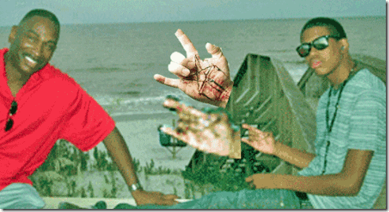
Here we may reign secure, and in my choice
to reign is worth ambition though in Hell:
Better to reign in Hell, than serve in Heaven.
Paradise Lost, (1667- 1674) English Poet John Milton [1]
Don’t be misled, the battle between Good and Evil is an ancient conflict going back tens of thousands of years. The languages and names have changed but the game is the same. For hundreds of years, people have willingly given up salvation to serve Satan and reign in HELL. Above on Jekyll Island, Georgia, Jordan Russell Davis’ message is quite clear. Either he Dances with the DEVIL or he identifies his father, Ronald Davis, as a Disciple of SATAN.
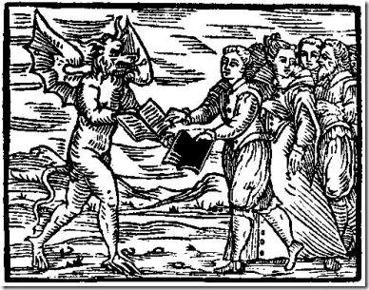
There are many masked faces to both the executioner Michael David Dunn and the sacrificed, Jordan Russell Davis.
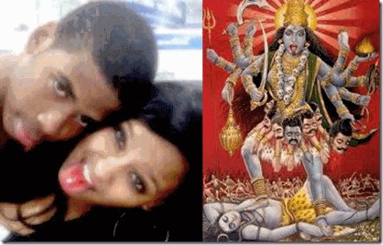
Kali’s Tongue- Jordan Davis and his mother, Lucia McBath or Ron Davis’ current wife with a telltale sign of Sacrifice.
Kali is a ancient Hindu deity depicted with a blood-dripping tongue sticking out. In the majority of temples, the blood of sacrificed animals is run through her tongue. Kali is essentially thirsty for blood. The meaning of the hanging tongue associates her to many more representations of “dark” goddesses, among who are the Greek Gorgons and Medusa in particular, with a very ancient iconographic origin. Kali’s tongue is central in her iconography so that the most ancient mentioning of her in the Vedas refers to her as one of the tongues of Agni, God of Fire.[2]

Furhrer Adolf Hitler, One of World’s Greatest Racial Mass Murderers- Brotherhood of DEATH and Lucifer’s Son
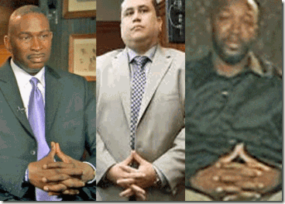
Secret 21st Century Masonic Brotherhood of DEATH & Lucifer’s Servants– Ronald Davis, George Zimmerman & Tracy Martin
The faithful night of November 24, 2012 that brought about an atrocious and heartless slaying of Jordan Davis was a stage play, a cruel and unusually human drama carried out by players before the unknowing masses.
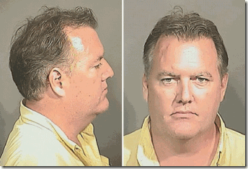
Our mass media impression of Michael David Dunn as an angry out of control beer guzzling bigot is a smoked mirror- a carefully planned perception managed ILLUSION. Michael Dunn had been molded into the classic Satanic Principle two faced Ancient God Janus, one Good and the other more Wicked than you expect.
Michael Dunn: The Public Face of a Father and an Angry White Male with MUSCLE MEMORY
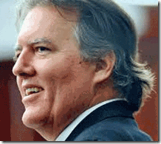
During the trial for the 1st Degree Murder of 17 age old Jordan Russell Davis, the courtroom stage play presented Dunn’s ex-wife, son and step daughter. They painted a picture for the world of a plain old ordinary hard working Joe, “Great Husband and Dad with a Dog” His fiancée even testified that Dunn and her left the scene where he shot and killed Jordan Davis to take care of their DOG.[3] They called a friend to court, Frank Thompson– Dunn was a “very nice guy.” [4]
His fight instructor and friend, Randy Berry told the world, “I have always thought he was a gentle man … Never have I observed anything other than a very calm demeanor.”[5]
Rebecca Dunn, Dunn’s daughter, defended her father’s story that he was being menaced and threatened, “he is going to protect himself if he sees no other way then [sic] to bring out his gun, then that’s what he’s going to do.” She described Dunn as “a good man. He’s not a racist. He’s very loving.” [6]
The state attorney’s office released a letter to the public, dubbed the “Black Friday Letter” that Dunn dictated to his brother from jail that was sent to family members. In the letter, he said “Between fear, adrenaline and MUSCLE MEMORY, I grabbed my pistol from the glove box,” Dunn said. “As I was doing so, I shouted, ‘You’re not going to kill me you son of a (expletive)!”[7]
Either Dunn’s family and friends didn’t tell all that they knew about him or they may not have known that Dunn was Playing with DEVIL, because “MUSCLE MEMORY” is a term used often by “Soldiers”, referring not necessarily to literal muscles, but rather to a widely understood concept applied to military training.

“It’s what we call in the military muscle memory. When you practice something so many times, it was like riding a bike.”[8]
“Repetition builds proficiency, that’s a fundamental tenant of anything we do in the Army,” said Maj. Keegan Leonard, aviations operations chief and deputy chief of operations for USARPAC CCP’s Deployable Assessment Team. “This event shows the culmination of the muscle movements we’ve been practicing for over a year.”[9]
Soldiers now train in realistic simulations of combat so that aiming, firing and seeing the target fall dead becomes a single, almost unconscious, conditioned response. Rolling Stone journalist Evan Wright quoted Sergeant Brad Colbert on his first experience of combat. “It was just like training. I just loaded and fired my weapon from MUSCLE MEMORY. I wasn’t even aware what my hands were doing.”[10]
MUSCLE MEMORY allow soldiers to kill without inhibition that is often developed during live-fire exercises but increasingly the American military relies on computerized simulations, providing the trainee with a level of realism never before possible.[11]
Michael David Dunn, Mr. Nice Guy, has executed before or had been trained, conditioned and PROGRAMMED to KILL upon stimulant whether real or an illusionary target created by computerized simulations, or mind control/hypnotism. One thing is clear. Once triggered, Mr. Nice guy intended to execute all four kids, and he has demonstrated no remorse for killing Jordan Davis one way or another.
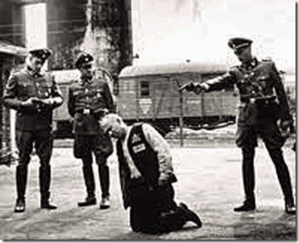
To Michael Dunn, executing a 17 year old unarmed Black teenager as an universal enemy of the state was as automatic- like riding a bike- like a NAZI. In his conscious and subconscious state of mind, the comfort of his dog proved to be more important than the life of a human being as an imaginary targeted enemy.

Dunn’s MUSCLE MEMORY weapon of choice, the Tarsus 9mm PT-99 semi-automatic genre of pistol is a military design.[12] The Beretta 92 (Taurus PT-99) was designed for sports and law enforcement use and, due to its reliability, was accepted by military users in South America and other countries all over the world. It is used by U.S. Armed Forces, U.S. Border Control, Homeland Security and the Los Angeles Police Department.[13]
From Dunn’s use of specific military jargon, it appears that he had been subjected to some “desensitizing and automatic stimulus response training“ most likely for HP to defend collaborative covert CIA/NSA and military-intelligence special missions and operations involving the covert installation of drone technology, national biometric ID systems, and counter-intelligence surveillance system operations in hostile countries and insurgency combat zones like Afghanistan, Columbia, Syria, Iran and the Sudan.
Mass media nor the prosecution explored Mr. Nice Guy’s use of military terminology, MUSCLE MEMORY, military weapons training, or his background with weapons. Like George Zimmerman, Dunn wasn’t tested for alcohol or drugs. However, I believe the reason why Dunn’s specialized military weapons training background is concealed from the public is obvious.
Michael Dunn Playing with Devil: The Unknown Face of a Military Intelligence Industrial Software Engineer
“Any electronics technician who is conversant with the codes, hardware and software used by intelligences agencies is either a prized asset or a serious liability.” [14]
A Jacksonville reader gave me the clue and some pieces to the puzzle of Michael Dunn- wrapped inside an enigma. The reader suggested that I look at only two things “Jacksonville NAS” and “Drones”. For me, “Drones” always equates with the CIA.
Naval Air Station Jacksonville (NAS), is a multi-mission base hosting more than 100 tenant commands. “We are the largest Navy base in the Southeast Region and third in the nation. As a master air and industrial base, Naval Air Station Jacksonville supports U.S. and allied forces specializing in anti-submarine warfare and training of the best aviators in the world.” [15]
Michael Dunn is far from a typical Florida redneck rolling around town in an old beat-up car just trying to make it in America. He was a vice president of a million dollar computer/data processing firm, Dunn & Dunn Data Systems, Inc.[16] According to the court testimony of his friends, he belongs to an exclusive private fly, plantation (shooting) clubs and gated community with its own airplane take off/landing strip. Mr. Nice Guy had a motorcycle, and even has his own plane. He worked 60-80 hours a week. For “Spikey Mike”, Lucifer’s Dance Music was absolutely- GREAT… ![17]
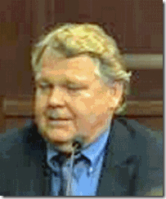
According to the court testimony of his business associate, Donald Arnold Moes,above, Dunn had made his Pact with the DEVIL with Lucifer’s Servant, Hewlett Packard, Inc.
Dunn had been a TOP SECRET U.S. Defense/Pentagon contractor or consultant since 1995. Moes testified that he had been working with him on military intelligence classified projects out of Jacksonville (NAS) since that time. Moes also exposed the fact that since about 2010, Michael Dunn had been currently working on a classified U.S. Defense Early Warning System project.
The early warning system that Dunn was working on at the time of the Jordan Davis’ slaying is the highly classified U.S. Ballistic Missile Early Warning System (BMEW) part of the Space Surveillance Network (SSN). SSN has expanded rapidly over the past decades to most likely cover the planet. Strategically placed radar system and sensors with deep space surveillance capabilities make up the early warning systems that feeds into control and monitoring stations in Florida and NORAD in Colorado.[18]
Dunn was a military intelligence surveillance applications and systems software engineer with the codes, keys, and the secret backdoor encrypted keys to America and most likely Israel‘s satellite, missile and nuclear defense systems.

MK ULTRA George Zimmerman, a little small time insurance investigator, was bailed out on a charge of murdering Trayvon Martin. Yet, a big time corporate executive, TOP SECRET U.S. Defense/Pentagon software contractor or consultant with money, connections and means has remained in jail since arrested in November 2012. This once valuable and hard working human asset of the Intelligence Community had suddenly become a great liability- its in DEVIL’s special interest to keep Dunn locked away.
Dunn, Moes & Hewlett Packard- the DEVIL’s Hand Maiden of the Military Industrial System
Hewlett Packard (HP) is one of the top 25 defense contractors with the Pentagon/U.S. Department of Defense. HP also provides products and services to the Department of Homeland Security for enhanced immigration status checks. According to Washington Technology, well over half of HP’s revenue from contracts with the federal government comes from the defense sector; additionally, the Stockholm International Peace Research Institute includes HP among the top arms-producing and military services companies in the world.[19]
Dunn’s buddy, Don Moes, is one of Lucifer’s Servants. He is a defense consultant employed by the multi-billion dollar global military service conglomerate Hewlett Packard, Inc. out of Palo Alto, CA.[20]
By the court testimony of Don Moes, he said that he had signed the DEVIL’s pact of secrecy with Dunn. He said that they worked back to back on HP’s special military service projects. It is safe to conclude that Michael Dunn had made a “cut-out” software engineer consultant for HP. Dancing with DEVIL– HP, he was just an “Expendable Asset”- A THROWAWAY!
Bad-Ass David Packard- Lucifer’s Hand Maiden of the New World Order & the Military Industrial System
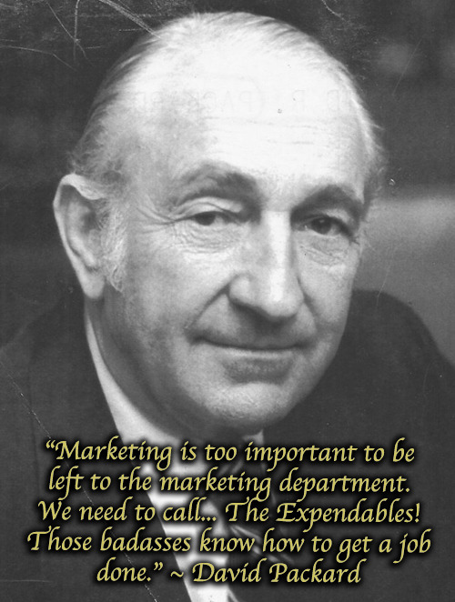

“The Expendables! Those badasses know how to get a job done.” –David Packard

For decades, HP has been an essential key player in America’s Shadow Government, and the U.S. military-industrial complex that includes both the Pentagon and the corporations who develop and manufacture weapons under Pentagon contracts. HP is a Luciferian Corporation. The elite cabal’s annual human sacrifices to Moloch is substantial and compelling evidence of being under Luciferian/Satanic influences.
In this case, a grove isn’t a field of trees. In the Druid Tradition, a Grove is a group of people who come together to honor deity, land, culture, heritage, ancestry and each other.[21] The Bohemian Grove is a clandestine gathering of some of the world’s most influential satanic elite to honor Satan/Lucifer and the Occult. Every year the Grove holds a two-week “camp” in Northern California at the end of July. The central purpose of the Grove is to covertly bring about a New World Order with Lucifer as god. The central Idol of the Grove is a 40-foot Owl effigy of the ancient Babylonian God Moloch.[22]
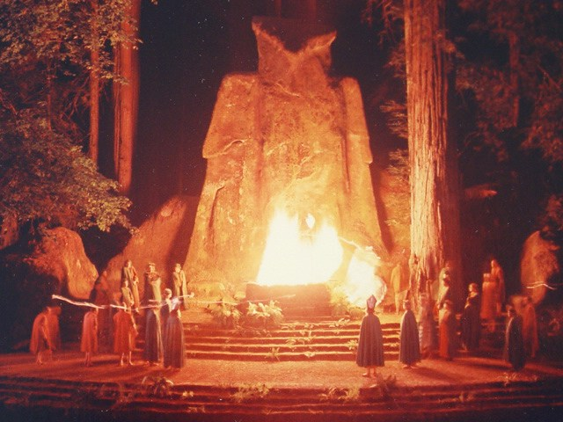
In Milton’s Paradise Lost, God Moloch is listed among the “Chief of Satan’s Angels” in Book I, and is given a speech at the parliament of Hell in Book 2:43 – 105, where he argues for immediate warfare against God. He later becomes revered as a pagan god on Earth.[23] Before the effigy of the pagan God Moloch, the world’s elite sacrifice children to the fire just like biblical times.[24]

HP was co-founded by a member of the Stanford University Alumni BohemianGrove– David Packard (1912-1996). He was one of God Moloch and Satan’s Disciples. Packard was a David Rockefeller Trilateralist (Trilateral Commission). He was an ardent collaborator of fellow Bohemians– U.S. Presidents and Nazi collaborators Richard Milhous Nixon, and Ronald Reagan.[25]
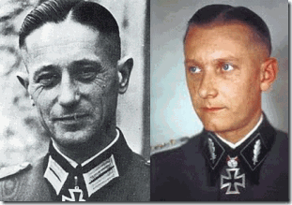

Two rare pictures of Hitler’s General SS Fritz Kraemer– Nazis and U.S. Intelligence expect the public to believe that these very different individuals are SS-Brigadeführer Fritz Kraemer that literally disappeared after the Nuremberg Trials

Bohemian Packard became a former U.S. Deputy Secretary of Defense (1969-71).[26] As Deputy Secretary of Defense under the Nixon Administration, Packard worked directly under Fritz Kraemer. Kraemer was the most influential clandestine Nazi-SS at the Pentagon. He was Plans Officer for the Chief of Staff, U.S. Army.[27] Packard also worked under Nazi-SS Dr. Arnold Hutschnecker [28] that planned to open concentration camps for black and brown children in the United States with he determined to have “anti-social” tendencies.[29]
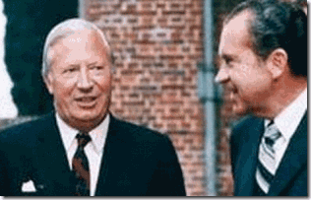

SS Dr. Arnold Hutschnecker & President Richard M. Nixon

Don’t forget. The Nazi killing machine was computerized and data banked by a national ID system provided by IBM. I imagine that David Packard and HP was in line to develop and package the software and the national ID data system for Black and Brown children pursuant to President Nixon and Dr. Hutschnecker’s Plan.

For decades, David Packardhad been one of the most secret master minds of the Satanic Cabal involved in the clandestine shadow government and powerful micro-managers of U.S and the World affairs. He had been a major fundraiser for three of America’s major and most dangerous right-wing think tanks: the American Enterprise Institute (9-11 Inside Job),[30] the Hoover Institution (Stanford University), and the Center for Strategic and International Studies.[31]

David and Lucille Packard– No Love for the Masses of Color

RU 486 (Mifeprex) is a non-surgical abortion. Roussel Uclaf, the French pharmaceutical subsidiary ofHoechst AGis the manufacturer of RU 486. During WWII, Nazi Germany used Zyklon-B to mass murder millions in gas chambers. Zyklon-B was made by IG Farben on a pseudo race theory that it kills the body and soul of the “Subhuman” (German: Untermenschen). After the Fall of the Nazis, IG Farben changed its name to Hoechst AG.[32]
Black Women are over 3 times more likely to obtain an abortion than White women. Even though African Americans are only 12.6% of the population, they received 30% of the 1.2 million abortions in 2008 (latest available statistics), killing 360,000 Black babies at a rate of nearly 1,000 per day.[33]
Life Issues Institute’s recent analysis of 2010 Census Bureau data shows that Planned Parenthood continues to strategically place the majority of their surgical abortion facilities in locations that target Black Women for Abortion. This analysis shows that 62% of Planned Parenthood abortion facilities are within walking distance (2 miles) of relatively high African American populations. 150 Planned Parenthood facilities that do not do surgical abortions dispense the Hoechst AG- RU-486 abortion drug.[34]
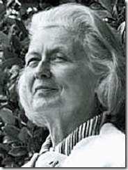

Stanford University Alumni, Lucille Salter Packard

David & Lucille Packard Foundationwas a major funding party of Nazi Racial Pseudo Science RU-486in the United States. It is also among the largest donors to planned parenthood and population control organizations.[35]
Bad-Ass HP- A CIA Front

Luciferian Meg Whitman with the Hidden Hand
In November 2012 at the time of Jordan Davis’ slaying,Margaret (Meg) C. Whitman was HP’s President and Chief Executive Officer. However, VP of Technology and Operations, John M. Hinshaw,below,seemed to be the man behind HP and the real power behind Whitman.[36]
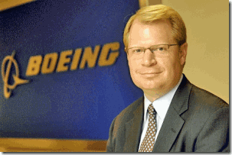
After graduating in 1986 from James Madison University in Management Information Systems in Harrisburg, VA, he immediately began to provide information technology direction for U.S. Embassies in London, Paris, Frankfurt, Milan, Amsterdam, and Mexico City. Undoubtedly, Hinshaw had been recruited as a CIA agent or consultant. James Madison University is a prime recruiting grounds for the FBI and CIA. Hinshaw also served as Computer Systems Manager for the U.S. Department of Commerce.[37]
Mr. Hinshaw served as the Chief Information Officer and Vice President of Information Technology at The Boeing Company from June 29, 2007 to January 2011 and was responsible for the global IT strategy, operations, process and people. Mr. Hinshaw served as Vice President at Cellco Partnership Inc. (doing business as Verizon Wireless Inc.). Prior to Cellco, Mr. Hinshaw held several management positions within Bell Atlantic, including Director of Information Systems for Bell Atlantic Mobile. Prior to joining Bell Atlantic, he served as a Consultant for Accenture, providing information technology consulting for several Fortune 100 companies and government agencies.
Accenture is a global consulting company that was formerly a branch of Andersen Consulting. It is deeply involved in intelligence work. It does financial planning and audits for the U.S. Intelligence (CIA) Community and recently began providing information-sharing and collaboration tools to agencies. Its customers, according to Accenture literature include such heavies as the National Security Agency (NSA), the Defense Intelligence Agency (DIA), the NGA (National Geospatial-Intelligence Agency),and the National Reconnaissance Office.[38]
Don Moes and Dunn’s base of software/computer operations at Jacksonville Naval Air Station (NAS), one of the largest naval bases in the United States, has been exposed as a base operation integral to secret U.S. military intelligence and CIA drone (surveillance) operations.[39]
Bad-Ass HP Wired for Repression

HP is wired to provide the newest artillery for repressive regimes. HP’s specialized computer software and equipment allows authorities to intercept their citizen’s e-mails and text messages, monitor internet activity and locate political targets through cell phone technology. Brandishing transcripts of personal communications and records of whereabouts, officials now routinely use such information to confront, arrest and torture dissidents.
HP equipment worth more than $500,000 has been installed in computer rooms in Syria, underpinning a surveillance system being built to monitor e-mails and Internet use, according to documents from the deal and a person familiar with the installation.
The gear made by Don Moes’ Palo Alto California-based HP would run a Damascus monitoring center for Syrian agents to track citizens’ communications, and route data, according to blueprints and the person familiar with the system. The Italian company running the project, Area SpA, bought the equipment through resellers in Italy according to the documents and the person familiar with the deal.
More than 3,500 people have died in Syria’s crackdown on protesters since March. At the same time, technicians from Area were installing and testing the surveillance system, which also includes data-storage equipment from Sunnyvale, California-based NetApp Inc. (NTAP), a Nov. 4 article by Bloomberg News showed.
Area, which is based outside Milan, bought the Hewlett- Packard and NetApp gear as part of a contract with Syria’s state-owned fixed-line telephone company, according to the documents and the person familiar with the transactions.[40]
Bad-Ass HP and Biometric ID Technology
Since 2005, HP has been on the open market selling countries national identity systems built on the .Net platform. HP and Microsoft have working on a code base that will allow them to offer a set of technology components for functions such as online and offline demographic and biometric data capture, regional verification and registration, and document lifecycle management.[41] Biometrics (or biometric authentication) refers to the identification of humans by their characteristics or traits. Biometrics is used in computer science as a form of identification and access control. It is also used to identify individuals in groups that are under surveillance.[42]
Bad-Ass HP and the Holy Grail

Israeli/Palestinian Checkpoint
Since 2006, it had been exposed that HP was running a criminal industrial espionage and spying unit.[43] It is also investing heavily in the buildup of the software/computer surveillance technology- check point (biometric ID system) and telecommunication capabilities of the Police State of Israel.[44]

Nazi-SS Gesiowka/Warsaw Poland Concentration Camp
The Israeli illegal occupation of the Palestinian territories is maintained and preserved by daily practices of surveillance and control. In recent years, these practices have increasingly relied on technological mechanisms provided by international and local corporations. Hewlett-Packard (HP) is one of the companies that enable this technological supervision and oppression.

Through its subsidiary EDS Israel, HP is the prime contractor of the Basel System, an automated biometric access control system installed and maintained by HP in checkpoints throughout the occupied Palestinian territories (oPt).
Another control mechanism with which HP is involved, is Israel‘s ID card system, which reflects and reinforces the state’s political and economic asymmetries as well as its tiered citizenship structure. HP was charged by the Ministry of Interior with the manufacturing of biometric ID cards for the citizens and residents of Israel (Jewish and Palestinians). In addition, HP also provides services and technologies to the Israeli army.
Furthermore, two of HP’s technological service providers in Israel are Matrix and its subsidiary, Tact Testware, which are located in the illegal West Bank settlement of Modi’in Illit. HP further participates in the “Smart City“ project, implemented in the illegal West Bank settlement of Ariel, providing a storage system for the settlement’s municipality.[45]
Bad-Ass HP and the Swarm Enterprise

HP [Hewlett Packard] Labs Israel is located on the campus of Technion – Israel Institute of Technology, which sits on Mount Carmel, over looking the city of Haifa. The lab fosters interactions with HP’s large R&D community in Israel, as well as the research institutions and high-tech companies in the region. Established in 1994, HP Labs Israel is an excellence center in machine learning, data mining, and imaging.[46]
“Among their array of evermore advanced intelligence tools, the Pentagon and NSA have cooperated with the Israel Institute of Technology on a Hewlett-Packard Israel project called “The Swarm Enterprise.”
“The Swarm is essentially the precognition program depicted in the Tom Cruise movie [Minority Report] on pre-crime prevention.”
It is actually called, Enterprise Swarm Research Program.[47] Basically, HP and Israel are developing a computer software system that develops the state’s criminalization of notions of “precrime“ and “thought crimes.” It would develop models to project future crimes then police or the military could arrest the potential criminal and stop the crime before it happens. It also involves “Orwellian Thought Crimes.” Even thinking of committing a crime, a person is subject to be arrested by the state under Swarm conjures.[48]
The genesis of the concepts of precrime and thought crimes originate with the notion of “original sin” and the Sermon of the Mount [Matthew 5,6,7]. Original sin means that we are born into a sinful state of being due to the “fall of man” in the Garden of Eden…”[49]
In the HollyWeird movie, Minority Report (2002), the great Aryan “Father of Precrime” is Director Lamar Burgess. The man is called the “old man.” He is the Gnostic Demiurge or God.[50]
HP’s Swarm Project is just another veiled backdoor and repackaging of Dr. Hutshnecker’s SS Plan for the justification of the state to demonize, criminalize, harass and place people of color in concentration camps for “anti-social tendencies”. It is based on eugenics, Madame Blavatsky’s Luciferian Root Races, Secret Doctrine, and Nazi pseudo race theories.
Bad-Ass HP and Columbia Narco-Politics
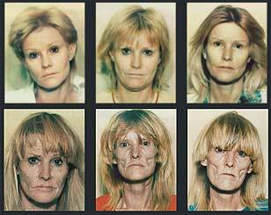
I have personally seen CIA/Crack-Cocaine out of Columbia South America turn U.S. citizens into Victual Zombies
In 2011, in the city of Medellin, Columbia, once best-known for drug-lord Pablo Escobar, HP has embedded a money laundering Narco-Dollar [51]global outsourcing center.[52] HP also clandestinely supports Columbia‘s terrorist groups most likely as covert backdoor systems.[53]
In 2000, the George W. Bush administration and Congress ramped up assistance to the Colombian military through a clandestine project, Plan Colombia.[54]
By 2003, U.S. involvement in Colombia encompassed 40 U.S. agencies and 4,500 people, including contractors [HP], all working out of the U.S. Embassy in Bogota, then the largest U.S. embassy in the world. It stayed that way until mid-2004, when it was surpassed by Afghanistan.
“There is no country, including Afghanistan, where we had more going on,” said William Wood, who was U.S. ambassador to Colombia from 2003 to 2007 before holding the same post in war-torn Afghanistan for two years after that.[55]
The CIA spent three years training Colombian close air support teams on using lasers to clandestinely guide pilots and laser-guided smart bombs (drones) to their targets by special GPS software tracing biometric authentication, computers, hard drives and cell phones calls [HP cell phone technology]. The CIA’s smart bombs (drones) were basically F-16s. Raytheon. [56]
Central Australia’s Pine Gap Spy Base has played a key role in the United States’ controversial drone strikes involving the clandestine biometric authentication ”targeted killing” of al-Qaeda and Taliban chiefs. The primary contractor companies engaged at Pine Gap are the US aerospace systems and defense suppliers Northrop Grumman and Raytheon, and the computer systems supplier Hewlett-Packard. About 70 per cent of the workforce are contractor personnel.[57]
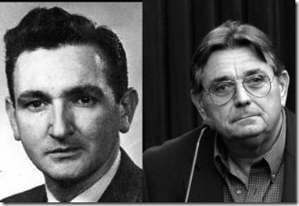
Jim Garrison to David Ferrie: “I’ve heard over the years you’re quite a first-rate pilot, Dave. Legend has it you can get in and out of any field, no matter how small…” JFK, the Movie [58] Dunn’s other buddy, Randy Berry, above right, that testified on his behalf is also a very seasoned and first-rate pilot and flight instructor. According to Berry, he started a flight school, Randy’s School of Aviation, in 1971 at 18 years old at Sebastian Municipal Airport, FL. Currently, he is the Chief Pilot at Southeastern Aerial Crop Service in Fort Pierce, Fla. “Berry has spent 40 years as an Ag (agricultural) aviation pilot and CFI (Gyroplane Flight Instructor), mentoring agricultural pilots all along the way.”[59]
According to his court testimony, Berry met Dunn in 2000 instructing him in special “aerobatics” techniques. Aerobatics is the practice of flying maneuvers involving aircraft attitudes that are not used in normal flight.[60] First, Dunn and Donald Moes of HP weren’t in no way connected with any agricultural endeavors or crop dusting. They were military intelligence Bad Assed HP Contractors setting up classified CIA/Military computer software surveillance/ID and missile-drone systems. Second, why would Dunn need “aerobatic” skill unless he needed to avoid radar systems, hostile fire, intervening and intercepting aircraft under hostile conditions like in Syria, Iran, Columbia, Mexico or Somalia.
Mr. Nice Guy, Human Sex Trafficking & Drugs

Dunn’s alleged third wife, Clara, alleged above, that seemed to have disappeared from the radar was an illegal resident out of the South American Country- Columbia. She told Dunn’s next door neighbor, Charles Hendrix, that within days of allegedly marrying her at a UPS store that she had been forced, under duress of being arrested and deported, into having sex with stranglers at a Fort Lauderdale, Florida sex, strip or swingers’ club.[61]
Dunn’s alleged second wife, Sara, that also seemed to have disappeared was another illegal resident that Hendrix linked to Dunn. She was out of Mexico. Sara had been equally afraid and abused by Dunn, and more than likely also had been forced into underground sex, strip and swingers’ clubs.[62]
Hendrix also reported to police investigators that Dunn was involved with marijuana and cocaine– most likely out of Mexico and Columbia.[63] At this time, neither Clara or Sara have surfaced, and most likely weren’t his wives but smuggled into the United States as Foreign National Sex Slaves along with Columbian Cocaine and Mexican Marijuana.
Dunn was the type of guy that was brass, insubordinately or stupid enough to try to outsmart or “bamboozle”[64] the ominous HP, CIA and NSA; or either run its illegal sideline operations. Dance with the DEVIL, the CIA always has a backdoor plan for bit players, its called MK ULTRA technologies of control.
Dance with the DEVIL, Bad-Ass HP & Another THROWAWAY- Aaron Alexis
“The ELF weapons are part of the weapons systems of most of the modern vessels fielded by the Navy. I fear the constant bombardment from the ELF weapon is starting to take it’s [sic] toll on my body.” Aaron Alexis, ELF Targeted Mind Control Victim [65]
MK ULTRA Manchurian Candidate Aaron Alexis, 34 years old, was another THROWAWAY HP contractor. Alexis was also a “nice guy” that was U.S. Defense Department Computer Consultant, and a Florida based computer systems specialist subcontracted by Hewlett-Packard like Michael Dunn on a Navy IT project.[66] Alexis worked for a company called “The Experts,” which is a subsidiary of HP Enterprise Services owned by Hewlett Packard. [67]
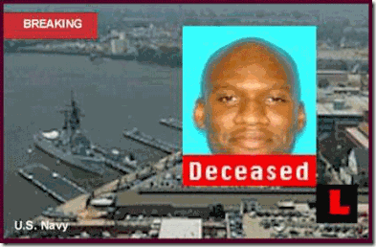
“Silence is Golden, Obedience is Platinum”
On September 16, 2013 in a false flag operation, Alexis allegedly mass murdered 12-13 people in Washington DC.[68] Alexis had been a confident and skilled computer and network installation specialist. He did the extensive hands-on ground work like Dunn connecting the complex vast system network of HP wires and hardware to tie into NSA and military intelligence listening and data collection centers.[69] Specifically, It is believed that Alexis had a role in transferring HP’s global network systems vital to NSA intercepts of satellite communications from NSA facilities at East Coast naval bases to Colorado.[70]
On 9-11, Explosions were reportedly going off in the Twin Towers underground basements before the planes hit the Towers.
On 9-11, Alexis is also believed to have been in the one of the Twin Towers’ underground/basement telecommunication wiring center prior to the collapses. According to witnesses, explosives were setoff in the twin tower basements just before the guided missile planes hit the buildings. An argument has been raised that he was one of the necessary hands- on technicians in the 9-11 Deception/Inside Job. He would have been one of the essential technicians that managed the wiring and hardwire necessary to synchronize explosives with guided missile planes, and the timing of the controlled demolition of the Twin Towers and Building 7.[71]
Secretly, Alexis had worn three hats for the shadow government. He worked for the National Security Agency (NSA), CIA and U.S. Navy Reserves – thereby earning a sizeable pay package that allowed extended visits to Thailand and plush accommodations wherever he went until the music stopped.
It is generally believed that he became unstable mentally and physically due to his sensitive clandestine work with and exposure to high powered ELF (Electronic Low Frequencies) equipment and systems. Because of his specialized knowledge of shadow government secrets, he couldn’t be treated or exposed to outsiders. Suddenly, Alexis became a disposable asset. His DANCE with the DEVIL was over. The music had come to an end. He had to be permanently discredited and silenced, and he was in great fear and tribulation of the DEVIL.[72]
Two weeks before the shootings, Alexis contacted the mind-control targeting support group, Freedom From Covert Harassment and Stalking (FFCHS) for help. Alexis told the group that the Navy was electronically assaulting him with a ELF weapon, and he was desperate to protect himself.[73]
The FBI linked Bad-Ass HP to Clandestine International Sales of Surveillance Equipment to Terrorist Groups and Countries
Furthermore, just prior to Davis’ slaying in November 2012, HP was under a great deal of pressure from the U.S. Securities and Exchange Commission and the FBI to disclose its clandestine links to the sales and installations of secret software/computer surveillance technology and telecommunication equipment to Syria, Iran and the Sudan to block free internet access, spy on citizens and crack down on dissent.[74]
Bad-Ass HP & Luciferian Tony Blair

British Prime Minister Tony Blair and his wife, Cherie
Within days of Prime Minister Tony Blair’s attempt to reintroduced legislation in 2005 paving the way for the introduction of compulsory ID cards in the United Kingdom, HP announced the release of its National Identity System (NIS) based on Microsoft’s .NET platform. The technology offered “Secure Identification Management for Governments Around the World“ or (put another way) a means for states to keep tabs on their citizens.[75]
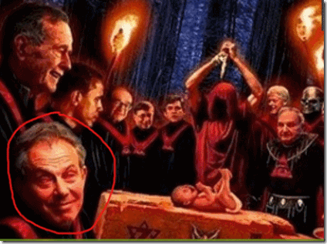
As Prime Minister of Great Britain, Tony Blair along with David Packard had been fellow blood covenant Bohemian Grove Pagans. In fact, Tony and his wife, Cherie, are notoriously known as pagan mystics and sorcerers.[76] Tony Blair worship the God of “Light.” As we know, Lucifer and Satan are the most illuminated ones, the “Light” of Luciferians and Satanists.[77]

Cherie Blair is supposed to be a world renown human rights lawyer on her own right. However from her observed wild, bizarre, contradictory behaviors and open engagement in witchcraft and pagan occult rituals, some have speculated that she suffers from multiple personality disorder (MPD) or dissociative identity disorder (DID).[78]
HP maintains a very cozy relationship with Tony Blair and his New World Order- One World Religion Project, the Faith Foundation. Since 2004, HP has funded and sponsored the Mile End Group (MEG) forum for government and politics at Queen Mary University of London.[79]
Since 2008, MEG with primary funding of HP has sponsored lectures by Tony Blair, and has been carrying on “The Blair Government” undergraduate Special Subject project- described by The Guardian as ultra-contemporary “Tony Blair as History”.[80]
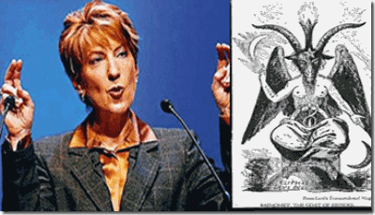
Carly Fiorina, former Chairman and CEO of HP with the hand symbol of the Baphomet, the first woman to head a Dow 30 company and was named “The Most Powerful Woman in Business” by Fortune for six years in row seems to have joined Tony Blair’s Faith Foundation as an evangelist of the “Light“- LUCIFER.[81]
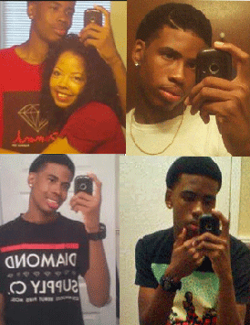
I don’t believe that Jordan’s attachment to a Cell Phone was a coincidence, innocent or idle fascination.
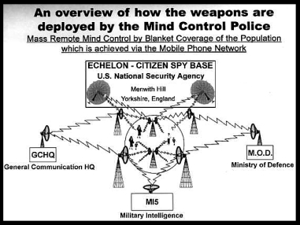
From an entirely objective perceptive, the slaying of Jordan Davis by Michael Dunn, and the Navy Yard Slayings in Washington DC by Aaron Alexis appears to have been unrelated unfortunate random acts of violence.
Currently, at least 70% of the U.S. intelligence budget goes to companies like HP. Officially, according to a government report of human capital within the Intelligence Community (IC), nearly 40,000 private contractors like Michael Dunn and Aaron Alexis are working for intelligence agencies.[82] Naturally, control over these IC private contractors are of great concern to the Shadow Government. Their loyalties aren’t left to chance or an oath to uphold a Luciferian Blood Covenant of Secrecy.
Covert mind control experiments involving coupling human brains to computers has been going on since the 1960s. Most commonly, brain-computer coupling implants (transmitters) are usually secretly inserted through the nostrils, from where they operate using two-way radio communication. The technology have been referred to as radio-hypnotic intracerebral control, bio-medical telemetry, mind control or brain-computer interaction.[83]
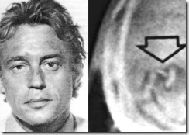
In 1967, Robert Naeslund was covertly implanted with a brain-computer coupling device at Soder Hospital in Stockholm. Naeslund supported his claim of being implanted with a coupling brain-computer microchip with X-Rays. According to Naeslund, the corporation most interested in these secret brain-coupling devices removed from him and other unwitting patients seems to have been “Hewlett-Packard technicians”.[84]
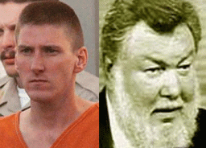
THROWAWAY Agent Tim McVeigh was treated or wiped clean by CIA Psychiatrist Dr. Louis Jolyon West

Tim McVeigh of the Oklahoma City Bombing False Flag Operation complained that the Army had implanted him with a miniature subcutaneous transmitter, so that they could keep track of him. Miniaturized telemetries have been part of an ongoing project by the military and various intelligence agencies to test the effectiveness of tracking soldiers on the battlefield. The miniature implantable telemetric device was declassified long ago. As far back as 1968, Dr. Stuart Mackay, in his textbook entitled Bio-Medical Telemetry, reported,

“Among the many telemetry instruments being used today, are miniature radio transmitters that can be swallowed, carried externally, or surgically implanted in man or animal. They permit the simultaneous study of behavior and physiological functioning.. Dr. Carl Sanders, one of the developers of the Intelligence Manned Interface (IMI) biochip, maintains, ‘We used this with military personnel in the Iraq War where they were actually tracked using this particular type of device.'” [85]
Hypnotic intracerbral control of human behavior by implanted ELF microchips is child play compared to 21st Century advancements in the field, and HP is at the lead of the pack.

Memristor research and development is led by Dr. R.(Richard) Stanley Williams. He is research scientist in the field of nanotechnology and a Senior Fellow and the founding director of the Quantum Science Research laboratory at HP.[86]

Nanotech Biochip Computer
Nanotechnology (sometimes shortened to “nanotech“) is the manipulation of matter on an atomic, molecular and supramolecular scale.[87]
In the nervous system, a synapse is a structure that permits a neuron (or nerve cell) to pass an electrical or chemical signal to another cell (neutral or otherwise).[88] The Memristor is a synapse on a chip making neural computing a reality. In other words, with post-human engineering exploiting discoveries such as the Memristor they will create machines/robots that can learn and think and human brains that could incorporate machines.[89]
SyNAPSE is also a Defense Advanced Research Projects Agency (DARPA) program that aims to develop a nanotech sized electronic neuromorphic machine that scales to biological levels. More simply stated, it is an attempt to build a new kind of cognitive computer with similar form, function, and architecture to the mammalian brain. Such artificial brain would be used in robots whose intelligence scales with the size of the neural system in terms of total number of neurons and synapses and their connectivity.[90]
HP’s Memristor can be described as an agent of transformation conferring robots with the ability to learn (a human trait) thereby rendering them as undecidable, i.e., neither machine nor life. Mirroring its transformative agency in robots, the memristor could also confer the human brain with machine/robot status and undecidability when used for repair or enhancement. The work is part of the DARPA’s SyNAPSE Program, or Systems of Neuromorphic Adaptive Plastic Scalable Electronics. Since 2008, the SyNAPSE team (HP) has been developing a new paradigm for “neuromorphic computing” modeled after biology. [91]

In other words, HP has the secret technology and ability to not only track its classified intelligence community private contractors, but control their behavior and physiological functioning through Memristor Nanotechnology like a machine on an atomic, molecular and supramolecular scale . Additionally, it is alleged that every U.S. Senator and Congressional representative has a secret ELF wave length “wavie” file.[92] It seems a logical extension for the Shadow Government to maintain “wavie” files on its Top Secret Clearance Private Contractors like Michael Dunn and Aaron Alexis to mind control or dispose of them as needed with biometric computer chips, ELF microchips and Memristor Nanotechnologies secretly coupled to central computers. A Memristor chip on the scale of a molecular cell may be impossible to detect without extremely sophisticated detection equipment and computers.

“I have what I believe to be the locations for where they’ve been developing these weapons for decades …” Aaron Alexis to FFCHS [93]
In the weeks leading up the Naval Yard Massacre, Aaron Alexis was desperately in search of the government’s central ELF or Nanotechnology computer center to stop his pain. In the process of his frantic search and communications with FFCHS regarding classified government projects, they flipped the switch on Alexis. He became an instant false flag poster boy and patsy for U.S. legislative gun control.[94]

“We are told that Aaron cut off the barrel and the stock of the Remington 870 so he could put it in the bag and carry it into the building undetected (no metal detector and x-ray machine in that building?) yet, if you watch the video of Aaron entering the building, you notice there is no way that shotgun is inside that bag. The bag on his shoulder is shorter than his forearm and that gun certainly isn’t. Aside from the fact that the video seems rather staged (obviously it doesn’t show the shooting), the gun simply doesn’t fit in the bag.“[95]

Alexis’ post shooting backpack appears as if is is still full- Alexis appears puzzled about something with the Shotgun

Contrary to news reports, Alexis never had, purchased or used an AR-15 semi-automatic rifle in the Naval Yard Massacre. He didn’t have a 9mm Glock that had been conveniently dropped near his body. Inside the building, silent surveillance videos show him ducking and dodging like an actor in a stage play armed only with a Remington 870 shotgun that he didn’t seem familiar with and only one shot in the chamber; or he was puzzled and shocked to find that there was no shot at all in the chamber. No witnesses saw Aaron Alexis shoot anyone.[96] A Remington 870 is indeed an odd and strange choice for an armed assault on a highly armed and guarded military government facility. He certainty wasn’t trained in speed loading the weapon to kill one person let alone 12 to 13 people.
The surveillance video shows plainly that Alexis didn’t have any extra rounds to to exercise any speed loading maneuvers to kill any number of people
The Remington 870 is a pump action shotgun. This means that it can hold one shot at a time that you load inside the gun.[97] So, again, where is ammo/shots to mortally wound 12 to 13 people? Aaron Alexis didn’t do it!
Michael Dunn deliberately pulled up and parked next to Tommy Stornes‘ Red SUV at a gas station store with Jordan Davis as a backseat passenger. When he parked, the music was full blast bass loud enough to rattle the windows and rock the SUV. Any original person sensitive to loud-heavy bass rap could have avoided the loud music, but he didn’t or couldn’t.
MICROWAVE HYPNOTISM, NEUROPHONE OR REMOTE MIND CONTROL TECHOLOGY IS OLD BUSINESS

In his court testimony, Dunn said he fired in self-defense after the backseat passenger, Jordan Davis, threatened him with a gun that he said that he saw the barrel, but it wasn’t there. “My intent was to stop the attack, not necessarily end a life,” he said. “It just worked out that way.”[98]
However, there was also this that Dunn said,
“After the continued threat of ‘You’re dead, (expletive)!’ now the door opens and this young man gets out. And as his head clears the window frame, he says, ‘This (expletive)’s going down now!’ “ Dunn said from the witness stand, jabbing a pointed finger.
“This is the point where my death is imminent,” said the computer programmer and software developer, 47. “He’s coming to kill me. He’s coming to beat me.”[99]
In Dunn’s Jacksonville police interview, with the window to his car shut, he said he heard voices saying fuck this, fuck that, fuck that bitch then the music returned to full blast when he heard “kill him” coming from the SUV. He said that he responded to the voices, “are you talking about me?” There was no response to his particular question from the SUV.

Dunn told police that he then heard a voice coming from the SUV, “kill that bitch.” He said that he saw a guy in the backseat of SUV move to pick something up and then heard a voice, “you’re dead bitch!” and the rear passenger opened the door to come out.[100]

The Red SUV had dark tinted windows. It is highly unlikely for Dunn to have seen anything going inside the SUV.
Before the deadly assault, Dunn undoubtedly heard voices in his head threatening his life coming from the black males in the SUV through his car and over music with bass that was loud enough to rattle the windows and rock the car.
He also admitted to police that he wasn’t officially trained by the military, but he received (muscle memory) weapons training by military personnel.[101] After the shooting, Dunn also told the police that the first person he called when he arrived at the hotel was a “government” agent/handler in Washington DC, Ken Lescollet, Lescollette, Lescallette, or Lascolette. Lescollet is supposed to be a federal agent with the U.S. Department of Agriculture.[102] It is possible that Dunn really couldn’t recall exactly what had happened at the gas station store, since he certainty couldn’t tell his fiancé much about what happened at the store.
Ken Lescollet didn’t appear at Dunn’s trial and like Clara of Columbia and Sara of Mexico have disappeared from the radar. Amazingly, mass media didn’t pursue or develop the background or Dunn’s government connection to federal agent Lescollet. Usually a federal secret security clearance is a pass out of jail. However, Dunn maintains that it was his handler Lescollet not him that called Jacksonville Police to turn him in. It also seems possible that Dunn’s special “aerobatics” training with master agricultural pilot Randy Berry was arranged by his handler, Lescollet.

On August 7, 2013, Aaron Alexis told Rhone Island police, he heard what he believed to be two black males and black female talking to him through a wall, but never saw them. He said he went to a hotel on the Navy base where he heard the same voices talking to him through the walls, floor, and ceiling. Alexis told police that the individuals were using “some sort of microwave machine” to send vibrations through the ceiling, penetrating his body so he couldn’t fall asleep. When the police asked Alexis “… what the individuals were saying to him he would not elaborate.” Alexis “… is worried that these individuals are going to harm him.”[103]
Alexis was definitely officially military basically trained, but it doesn’t appear that he received any extensive training in firearms or combat. Nonetheless, in both cases, the perceived, projected, conjured and targeted enemies were initiatively and primarily “Black Males” whose voices could be heard coming from and through inanimate objects.
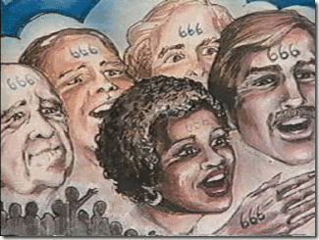
“If any man worship the beast and his image, and receive his mark. . . “ Book of Revelation: 14:9
“It is my well-researched opinion that the Mark of the Beast, as related in scripture, is absolutely literal. Soon, all people on earth will be coerced into accepting a Mark in their right hand or forehead. I am convinced that it will be an injectable passive RFID [radio frequency identification signal] transponder with a computer chip — a literal injection with a literal electronic biochip “mark”. . . I believe that such an implanted identification mark literally will become Satan’s Mark of the Beast …” (Terry Cook, The Mark of the New World Order (1996), p. 587
HP contractor Aaron Alexis most certainty had been injected with the Mark of BEAST transponder chip that coupled his individual and unique ELF wave lengths to a central computer that was able to put voices in his head, mind control and dispose of him in an operational (Governmental Gun Control Project) false flag attack on civilians.
However at first glance, the slaying of Jordan Davis was a random act of violence. Jordan Russell Davis and Michael David Dunn were totally unrelated individuals until you factor in a common thread that ties Jordan Davis, Michael Dunn and Aaron Alexis together, Hewlett Packard (HP).
HP was also the contractor employer of Michael David Dunn.
HP is a New World Order/Luciferian– Bohemian Corporation.
HP is one of world’s leading purveyors of the “Mark of the Beast”– Global and National Biometric ID-Authentication Technology.
HP is also one of world’s leading researchers and purveyors of human/computer nanotech biochip and transponders.

HP indirectly supports Tony Blair’s Faith Foundation and sponsor the “Madness of Former British Prime Minster Tony Blair [and CHERIE BLAIR] as HISTORY”.
Tony Blair is a New World Order/Luciferian– Bohemian Pagan.
Tony Blair endorsed HP’s Global and National Biometric ID-Authentication Technology for Britain.
According to Jordan Russell Davis’ mother, Lucia (Lucifer’s Daughter) McBath, he was a “GREAT… GREAT FAITH FOUNDATION … “- a Tony Blair experimental cohort! (See Jordan Davis’ Family Speaks to Anderson Cooper on CNN’s AC360, Frames 9:13-14)[104] Which, if true has horrific implications, and I have no reason to disbelieve Lucifer’s Daughters misplaced words.
Tony Blair has created the Tony Blair Faith Foundation to unify and globalize the world’s religions into an “One World Religion.” . In Revelation, a false prophet is prophesied to unity the world’s religions in order to bring peace to peace on earth under the rule of Antichrist.

Along with John’s Vision of the BEAST that is the Antichrist, John saw another BEAST (Revelation 13:11) who is later identified as the False Prophet (Revelation 19:20). In the midst of world wide chaos, the False Prophet will use his authority and power to perform unusual signs, deceiving people into false hope and into worshiping an image of the Antichrist (Revelation 13: 12-14). Those who refuse to worship the Antichrist will be killed (Revelation 13:15).[105]
Lucifer/Satan is the original rebel who rebelled against God. He was banished from Heaven to Earth (Fallen Angel). The Antichrist is powerful, clever and deceitful being who is portrayed as a “Light” and will bring people together. The Antichrist works for Lucifer/Satan who will lead the rebellion again against God. Lucifer/Satan (Dragon), Antichrist (Beast) and the False Prophet (Antispirit) constitute the “Satanic Trinity.”[106]
The New World Order will create several False Prophets like Tony Blair to pave the way for the Antichrist to begin the rebellion against God and God’s children to make Lucifer god.

“… so it wouldn´t shock me to learn that blair´s a paedophile too. it´s well known that he´s bisexual (did it with “mandy”, jeff gannon) and was a cross-dresser (his lawyer colleagues at the bar used to call him “miranda”, according to punch magazine)”
Nasty rumors surround Tony Blair. Some allege that he is a Rothschild by birth- part of a powerful secret British Satanic Pedophile Ring (Thomas Hurd MI6); and that his daughter Kathryn attempted to commit suicide after she was gang raped by father’s elite Satanic Pedophile Ring. Nevertheless, Tony Blair isn’t interested in creating a “One World Religion” for mankind’s sake without Lucifer as god, and the – Global and National Biometric ID-Authentication Technology, its secret Memristor/Biochip ELF systems of mind and physiological control.
As part of Tony Blair’s Faith Foundation, Jordan Russell Davis may have been the victim of Satanic Sexual Abuse, and had ingested or had been injected with an experimental “Mark of the Beast” Biochip. For whatever reasons, he was unable or found the inner power to refuse to submit to the Antichrist. As in the case of Aaron Alexis, Jordan‘s Memristor/Biochip may also have malfunctioned. Nevertheless, Jordan Davis became a liability instead of an asset to the Luciferian NWO. He had to be deposed of.
On the other hand, Michael Dunn thought he could bamboozle his handlers, HP and the CIA.
According to Michael Dunn’s Blog- Spikey Mike
I’d have to say Bill Gates is my ‘Hero’. He’s far my ideal person, being a modern-day robber-baron and all. Don’t misunderstand me, I despise him for what he’s done to the computer industry, however I admire him BECAUSE he’s been able to bamboozle the entire planet! Now that’s a rare talent indeed! That’s the behavior I’d like to emulate, though I’d like to think that I’d use it in a more altruistic manner.[107]
Bamboozle is one of those words that has been confounding etymologists for centuries. No one knows for sure what its origins are. The earliest meaning of BAMBOOZLE was “to deceive by trickery, hoodwink,” which is why some believe that it arose among criminals of the underworld.
It’s obvious that Dunn was so full of himself that he failed to realize that his blog becomes part of intelligence and character file and profile. They don’t miss too many details. He also didn’t realize that Dancing with the Devil is for keeps. They don’t play or chance bamboozle games with subordinates without drastic, deadly and permanent consequences.
Like Aaron Alexis, he didn’t realize the people that he was dealing with not only maintained backdoor systems to computer software programs he was installing, but to him- MK ULTRA. He also had secretly ingested or had been injected with Global and National Biometric ID-Authentication Technology and its secret Memristor/Biochip ELF systems of mind and physiological control.
When the time came to dispose and THROWAWAY Dunn as a liability due to his bamboozling, character and clandestine sensitive, and covert military intelligence systems work in the states, Syria, Iran, Somalia or Columbia that was under FBI and governmental scrutiny, they flipped the switch on him. He became an instant false flag poster boy and patsy to polarize and further divide the races, and for U.S. legislative gun control. How did they link Jordan Davis and Michael Dunn by time and place for a fatal conflict to dispose of both liabilities?

Bad Ass HP- Cell Phone Tracking Technology.
Well, that is my story. Dance with the Devil, you’re locked in a classic struggle between good, evil, LIFE and DEATH literally for all mankind.

[1] http://en.wikiquote.org/wiki/Paradise_Lost
[2] http://www.thetreeofliberty.com/vb/showthread.php?p=2191522
[3] http://members.jacksonville.com/news/crime/2014-02-10/story/after-calling-several-witnesses-monday-defense-expected-wrap-case#comment-form
[4] http://members.jacksonville.com/news/crime/2014-02-10/story/after-calling-several-witnesses-monday-defense-expected-wrap-case#comment-form
[5] http://www.hlntv.com/article/2014/02/10/michael-dunn-trial-prosecution-rests-case-jordan-davis
[6] http://en.wikipedia.org/wiki/Shooting_of_Jordan_Davis
[7] http://www.news4jax.com/news/jordan-davis-parents-prepared-for-possible-retrial/-/475880/24525870/-/6dpg4tz/-/index.html
[8] http://www.mlive.com/news/grand-rapids/index.ssf/2011/11/under_fire_in_afghanistan_mari.html
[9] http://www.hawaiiarmyweekly.com/2010/10/29/usarpac-ccp-builds-muscle-memory/
[10] http://jeffsparrow.net/articles/killing-soldiers-humanity/
[11] http://jeffsparrow.net/articles/killing-soldiers-humanity/
[12] http://www.taurusarmed.net/forums/pt92-other-taurus-pistols/47396-pt92-99-story-time-4.html
[13] http://en.wikipedia.org/wiki/Beretta_92
[14] http://therearenosunglasses.wordpress.com/2013/09/23/unravelling-some-deep-911-threads-retying-them-to-todays-shooters/
[15] http://www.cnic.navy.mil/regions/cnrse/installations/nas_jacksonville.html
[16] http://www.dandb.com/businessdirectory/dunndunndatasystemsinc-verobeach-fl-23553079.html
[17] http://courtsandsportsradio.com/2013/04/01/michael-dunn-understanding-the-man-who-killed-jordan-davis-part-2-his-blog/
[18] https://archive.org/stream/CIADocuments/CIA-588_djvu.txt
[19] https://wedivest.org/c/57/hp#.UxkaxfldXZI
[20] http://www.chamberofcommerce.com/orlando-fl/28002239-hewlett-packard-co-inc/
[21] http://www.genesisgrove.hampshire.org.uk/html/_about_druids.html
[22] http://www.jesus-is-savior.com/False%20Religions/Wicca%20&%20Witchcraft/bohemian_moloch.htm
[23] http://en.wikipedia.org/wiki/Molech
[24] http://www.bibliotecapleyades.net/sociopolitica/esp_sociopol_bohemiangrove02.htm
[25] http://en.wikipedia.org/wiki/List_of_Bohemian_Club_members
[26] https://groups.yahoo.com/neo/groups/cia-drugs/conversations/topics/47463
[27] http://www.maebrussell.com/Articles%20and%20Notes/Kraemer%20-%20Iron%20Mentor.html
[28] http://mindcontrolblackassassins.com/tag/dr-arnold-hutschnecker/
[29] http://www.hiddenmysteries.org/mind/research/re110699e.html
[30] http://911truthseeker.webs.com/
[31] http://www.thirdworldtraveler.com/Foreign_Policy/GlobalRollbackNetwork.html
[32] http://www.jonchristianryter.com/Plain_Talk/120531.html
[33] http://www.lifenews.com/2012/10/21/why-are-black-women-three-times-more-likely-to-have-an-abortion/
[34] http://www.lifenews.com/2012/10/21/why-are-black-women-three-times-more-likely-to-have-an-abortion/
[35] http://lifeissues.net/writers/tay/tay_04robthecrad.html
[36] http://articles.economictimes.indiatimes.com/2013-11-01/news/43562426_1_hp-india-meg-whitman-turnaround-plan
[37] http://investing.businessweek.com/research/stocks/people/person.asp?personId=24424598&ticker=HPQ
[38] http://timshorrock.com/?p=710
[39] http://www.citizen-soldier.org/predator_drones.html
[40] http://www.bloomberg.com/news/2011-11-18/hewlett-packard-computers-underpin-syria-electonic-surveillance-project.html
[41] http://forum.prisonplanet.com/index.php?topic=83769.5;wap2
[42] http://en.wikipedia.org/wiki/Biometrics
[43] http://en.wikipedia.org/wiki/Hewlett-Packard_spying_scandal
[44] https://wedivest.org/c/57/hp#.UxkaxfldXZI
[45] http://www.whoprofits.org/HP
[46] http://www.hpl.hp.com/israel/
[47] http://www.hpl.hp.com/israel/research/programs.html
[48] http://nwointelreport.blogspot.com/2010/03/hollywoods-satanic-agenda-24-minority.html
[49] http://nwointelreport.blogspot.com/2010/03/hollywoods-satanic-agenda-24-minority.html
[50] http://nwointelreport.blogspot.com/2010/03/hollywoods-satanic-agenda-24-minority.html
[51] http://www.nearshoreamericas.com/hp-expansion-medellin/
[52] http://www.pbs.org/wgbh/pages/frontline/shows/drugs/special/us.html
[53] http://investorplace.com/2013/08/apple-samsung-ferrari-indirectly-funding-south-american-terrorist-group/#.UxqVPfldXZI
[54] http://www.washingtonpost.com/sf/investigative/2013/12/21/covert-action-in-colombia/
[55] http://www.washingtonpost.com/sf/investigative/2013/12/21/covert-action-in-colombia/
[56] http://www.washingtonpost.com/sf/investigative/2013/12/21/covert-action-in-colombia/
[57] http://www.sott.net/article/264247-Global-surveillance-state-Australias-Pine-Gap-drives-US-drone-kills
[58] http://www.jfk-online.com/jfk100ferint.html
[59] http://www.nationair.com/pdf/FlyLowFlySafe_V3I12011.pdf
[60] http://en.wikipedia.org/wiki/Aerobatics
[61] http://kysdc.com/3360013/neighbors-say-michael-dunn-abused-wives-forced-them-into-swingers-lifestyle/
[62] http://kysdc.com/3360013/neighbors-say-michael-dunn-abused-wives-forced-them-into-swingers-lifestyle/
[63] http://egbertowillies.com/2014/02/15/michael-dunn-charles-hendrix-neighbor/
[64] http://courtsandsportsradio.com/2013/04/01/michael-dunn-understanding-the-man-who-killed-jordan-davis-part-2-his-blog/
[65] http://www.constantinereport.com/navy-yard-shooter-had-mind-control-group-contact/
[66] http://www.huffingtonpost.com/2013/09/28/aaron-alexis-former-employers_n_4005095.html
[67] http://canadafreepress.com/index.php/article/58093
[68] http://parapoliticaljournal.com/2013/10/12/was-the-washington-d-c-navy-yard-shooter-aaron-alexis-a-target-of-mind-control/
[69] http://therearenosunglasses.wordpress.com/2013/09/23/unravelling-some-deep-911-threads-retying-them-to-todays-shooters/
[70] http://therearenosunglasses.wordpress.com/2013/09/23/unravelling-some-deep-911-threads-retying-them-to-todays-shooters/
[71] http://therearenosunglasses.wordpress.com/2013/09/23/unravelling-some-deep-911-threads-retying-them-to-todays-shooters/
[72] http://therearenosunglasses.wordpress.com/2013/09/23/unravelling-some-deep-911-threads-retying-them-to-todays-shooters/
[73] http://www.constantinereport.com/navy-yard-shooter-had-mind-control-group-contact/
[74] http://www.dailydot.com/news/hewlett-packard-iran-censorship-halal-internet/
[75]
[76] http://prisonplanet.com/Pages/Sept05/210905Blair_revelations.htm
[77] http://hollywoodilluminati.com/2012/04/26/advanced-teachings-of-the-illuminati-and-satanic-roots-of-christianity/
[78] http://www.theguardian.com/politics/2005/jun/16/cherieblair.comment
[79] http://www.mileendgroup.com/
[80] http://www.mileendgroup.com/about-us/
[81] http://www.baylor.edu/mediacommunications/news.php?action=story&story=59905
[82] http://timshorrock.com/?p=710
[83] http://www.bibliotecapleyades.net/sociopolitica/esp_sociopol_mindcon29.htm
[84] http://www.bibliotecapleyades.net/sociopolitica/esp_sociopol_mindcon29.htm
[85] http://archive.org/stream/TheOklahomaCityBombingAndThePoliticsOfTerror/ocbpt_djvu.txt
[86] http://en.wikipedia.org/wiki/R._Stanley_Williams
[87] http://en.wikipedia.org/wiki/Nanotechnology
[88] http://en.wikipedia.org/wiki/Synapse
[89] http://www.frogheart.ca/?tag=memristor
[90]http://en.wikipedia.org/wiki/SyNAPSE
[91] http://www.frogheart.ca/?tag=memristor
[92] http://www.whale.to/b/bowart1.html
[93] http://nypost.com/2013/10/23/navy-yard-gunman-feared-mind-weapon-before-rampage/
[94] http://www.salon.com/2013/09/17/new_shooting_same_gun_debate/
[95] http://beforeitsnews.com/opinion-liberal/2013/09/navy-yard-shooting-updates-a-handy-video-a-handy-confession-letter-electronic-a-change-of-the-story-2469230.html
[96]http://jonrappoport.wordpress.com/2013/09/19/mkultra-patsy-aaron-alexis-portrait-painted-for-gun-control/
[97] http://www.ask.com/question/how-many-rounds-does-a-remington-870-12-gauge-pump-action-shotgun-hold
[98] http://www.cnn.com/2014/02/14/justice/florida-loud-music-trial/
[99] http://www.usatoday.com/story/news/nation/2014/02/11/michael-dunn-jordan-davis-trial/5390113/
[100] https://www.youtube.com/watch?v=MWlzUHtUOyY
[101] Id.
[102] http://blackbutterfly7.wordpress.com/2014/02/11/michael-dunn-trial-day-5-tuesday-feb-11-2014/
[103] http://www.mediaite.com/online/police-reported-to-navy-that-aaron-alexis-was-hearing-voices-weeks-before-navy-yard-shooting/#0
[104] https://www.youtube.com/watch?v=h3h4APAt4gg
[105] http://www.arewelivinginthelastdays.com/article/falseprophet/falseprophet.htm
[106] http://www.preservedwords.com/disptruth/chap20-pv.htm
[107] http://courtsandsportsradio.com/2013/04/01/michael-dunn-understanding-the-man-who-killed-jordan-davis-part-2-his-blog/
Comments : 1 Comment
Tags: 9-11 deception, 9-11 inside job, aaron alexis, anti christ, arnold hutschnecker, Ballistic Missile Early Warning System, biochips, biometric id, biometric id systems, boeing, bohemian grove, building 7, Carly Fiorina, Cell Phone Tracking Technology, cherie blair, columbia, crack cocaine, DARPA, david and lucille packard foundation, david packard, Defense Advanced Research Projects Agency, don moes, donarld arnord moes, Dr. Louis Joylon West, drones, faith foundation, false flag operations, false prophets, george zimmerman, hewlett packard, hoechst ag, HP labs israel, ig farben, israel, jacksonville nas, john hinshaw, jordan davis, kritz kraemer, lucia kay mcbath, lucia mcbath, Lucifer, lucifer's corporation, Lucifer's Servants, luciferians, mark of the beast, meg whitman, Memristor, michael david dunn, michael dunn, minority report, MKULTRA, moloch, muscle memory, nanotech, Nanotechnology, National Identity System, naval yard shooter, nazi pseudo race theories, Nazis, playing with the devil, r. stanley williams, randy berry, Richard Milhouse Nixon, Robert Naeslund, ronald davis, ru 486, satan, Secure Identification Management, Space Surveillance Network, subcutaneous transmitter, swarm enterprise, SyNAPSE, tim mcveigh, tony blair, twin towers
Categories : 9-11, aaron alexis,, antichrist, baphomet, biometric national id system, Black Manchurian Candidates, bohemian club, bohemian grove, brain entrainment, Brigadefuhrer Waffen SS Dr. Fritz Gustane Anton Kraemer, Brigadefuhrer Waffen SS Dr. Fritz Gustane Anton Kraemer, CIA, columbian cocaine, Defense Intelligence Agency, devil, devil's horns, dr. louis jolyon west, drones, faith foundation, false prophet, false prophets, fbi, george michael zimmerman, George W. Bush, george zimmerman, human sacifrice, I.G. Farben, illuminati, illuminati sacrifice, israel, jordan davis, lucia mcbath, lucifer's servants, luciferians, manchurian candidates, masonic sacrifice, Memristor, michael dunn, mind control, MK-ULTRA, Molech, Moloch, monarch program, Nanotechnology, Nazis, new world order, nwo, OLYMPIANS, Owl, racial mass murder, Ritual Satanic Abuse, ritually abused children, ronald davis, satan, Satanism, Schutzsteffel, Secret Doctrine, SS, trayvon martin, Untermensch, ZIONIST

SOMETHING AIN’T RIGHT- JORDAN DAVIS, DELTA PEOPLE, TONY BLAIR & THE FAITH FOUNDATION
28022014
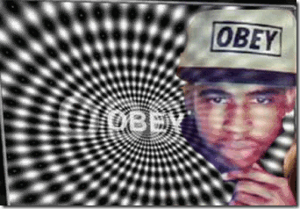
For the past couple of days, I had been reflecting on the Jordan Davis and Michael Dunn Affair. The other night, I tossed and turned in my sleep until the roosters cracked the dawn. Visions and images of people of different races and wide varieties of colors had danced in and out of my dreams and subconscious- something isn’t right- something ain’t right my deep intuition kept telling me. There is something un-natural about this entire affair. My dreams concluded with, “these are DELTA People.” I couldn’t sleep any longer.
The Brain Wave Frequency Series-Mind Control
“There are four types of brain waves: alpha, beta, delta, and theta. The four basic models of Monarch slaves have the same names as these four types of brain waves. High level Illuminati models may have programming that includes all of these types. According to one ex(?)-government source, the CIA has been labeling their harmonic-created total Mind-controlled slaves by the following: Bravo 2 series models are men programmed to run the Beast computers. Delta series are models for espionage and assassination. Juliet series are sexual mind controlled slaves. Kilo 5 series is military espionage. Michael 1 [Michael Dunn] series slaves are CIA agents under total mind-control.. Much of the high level programming in the 1980s and 1990s is no longer done with human programmers, but is done via programmed machines using drugs, electricity and harmonics… Delta programming is military-assassin programming that has trickled into popular consciousness through movies like La Femme Nikita, its American remake, Point of No Return, and The Long Kiss Goodnight.”[1]
My Ordeal with a BETA Trauma Based Black Series (Black Angel) Female Assassin
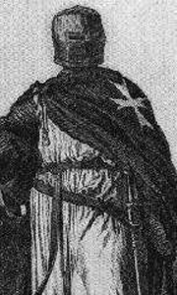
Alpha, beta, delta and theta, sometimes all that stuff just go over your head. For almost a decade, I had a trauma based Beta programmed female assassin (self educated Para-legal) implanted in my office. From time to time, she would discuss being Beta programmed at Stanford (Stanford Research Institute). She talked about it as a sleeping disorder, and she told me that she stayed in Beta. It was stuff that was way over my head at the time. One day, I found her sleep on the office sofa. For about a hour, I made enough noise in the office to wake any normal person, but she stayed in this zone. I thought about her talk about being in Beta all the time. She told me that she once had a TOP SECRET Clearance at Boeing. She said that she loved the police. I thought about how she constantly talked about harming- killing people, and mass murder. Not too long ago, I had to finally conclude that she had in fact alter and multiple personalities. I also had to conclude that she was rifling all of my files and computer files when I was out of the office. Before his death, she had been meeting regularly with Charles Garry (Jim Jones and Jonestown attorney) at his San Francisco law office. Recently, she had applied for social security disability due to a malignant ulcer, but came away with a disabling mental disorder, psychiatrist and a psychologist. I got spooked and left the office. I asked her to leave on many occasions, but she threatened to kill as many people as she could in the building. I just couldn’t take the chance that she wouldn’t do what she promised.
At times, the government will let you know if you’re getting too close to solving puzzles. I was too close to something that I wasn’t supposed to be near. She got the word to take me out. I knew she had a gun in her car supplied by a Richmond City Police Detective. My shooting was pre-planned through the Oakland Police Department (OPD) under the ruse that was “ A BIG BLACK BRUTE” that had threaten her life and had been harnessing her. She had planted a story in the office building, among my clients and friends that I was harassing her and had TAKEN DOWN THE DOOR TO THE OFFICE to mentally abuse her. On the evening that it was supposed to go down, she started an argument with me. Then, I watched her change skin tones and go through different facial expression. I knew that she was calling forth an assassin alter personality. She suddenly left the office to go downstairs to get the It seems as though various agencies working with CIA/MK ULTRA/MONARCH mind control programs are assigned brain waves frequencies are assigned brain wave frequencies to work with. Each agency has its own people. gun from her car. I packed up everything that I could hold, and bolted down the back stairs and made it out of the delivery exit. That evening, a OPD detective left a voice message on my home phone regarding allegations of threatening and harassing the woman. Of course, I abandoned my office.
It seems as though various agencies working with clandestine CIA/MK ULTRA/MONARCH mind control programs may be assigned the assorted brain waves frequencies to work with. Each agency has its own people and can be identified by signature frequencies, Alpha, Beta, Theta and DELTA.
The DELTA SERIES PEOPLE-Mind Control
MK DELTA, and its associated program MK ULTRA were on the surface essentially secret mind control and torture/interrogation operations run by the CIA. Both MK ULTRA and MK DELTA involved the surreptitious use of LSD and other bio-chemicals in clandestine operations.[2] However, MK DELTA was actually related to the clandestine mind control and (JFK) assassination operations of a high level military intelligence, anti-communist-ultra conservative and an extreme racist, Dr. Alton Ochsner. He was centered in New Orleans at Tulane University Medical School, and the Tulane’s DELTA Regional Primate Center.[3]
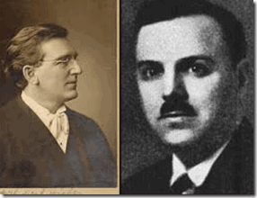
Dr. Ochsner’s mentor and protégé had been his German uncle or cousin, Dr. Albert John Ochsner (A.J. Ochsner). Dr. A.J. Ochsner, left, had been very close to Alton‘s father, and was largely responsible for guiding him through his medical training.[4]
In the United States and around Europe, Dr. A.J. Ochsner became a powerful and influential force in medicine. He had studied and pursued medicine among the elite in the field of medicine in London, Vienna, Berlin, Zurich and Hamburg. He was president of the Clinical Congress of Surgeons of North America from 1910 to 1912; one of the founders of the American College of Surgeons, of which he was president 1923–1924; president of the American Surgical Association in 1924; and editor of Surgery, Gynecology and Obstetrics. During World War I, Ochsner served in base Hospital Unit 11 with the Rank of Major. He received the LLD degree from the University of Wisconsin and was an honorary fellow of the Royal College of Surgeons of Ireland.[5]
Dr. A.J. Ochsner often had Alton travel with him across the globe, and introduced Alton to some of his most powerful international inside connections and influences particularly in Zurich and Frankfurt, Germany. Alton became fluent in several languages particularly the mother tongue, German.[6]
As early as 1899, Dr. A.J. Ochsner, had advocated covert compulsory vasectomy instead of castration of prisoners to avoid public outrage “to eliminate all habitual criminals from the possibility of having children.” In this way, Dr. A.J. Ochsner hoped to reduce not only the numbers of “born criminals” but also “chronic inebriates, imbeciles, perverts and paupers.” Dr. Ochsner had been one of the guiding lights of the radical eugenics movement which was the crucial inspiration for American/Nazi pseudo “race science“.[7]
It is interesting to note that Dr. A J. Ochsner had also been at the forefront of covertly denying Black People the advantages of the advancement of medical science and procedures to promote their morbidity and mortality rates,
“My own ignorance,” said A.J. Ochsner, “is founded on the lectures I have heard and the books I have read and also every Negress I have ever examined has had fibroids …”
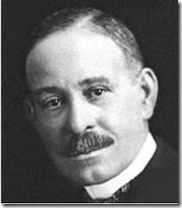
The bottom line was the powerful A.J. Ochsner encouraged white physicians to allow Black Women, in particular, to die from cysts and other treatable aliments without consideration of corrective surgeries and treatments that was openly challenged directly and exposed by brilliant and courageous Black pioneering medical professionals like Dr. Daniel Hale Williams (January 18, 1856 – August 4, 1931), above.[8]
In 1927, Dr. Alton Ochsner arrived at Tulane University in New Orleans as chairman of the Tulane Department of Surgery.[9] The imperial German Alton Ochsner settled in and became comfortable and entrenched as a welcomed element of the Old South Antebellum White Aristocracy.
During WWII, Dr. Ochsner inside connections with elite scientists and medical professionals inside Nazi Germany made him an essential part of U.S. military intelligence. As early as 1941, he had been pressed into service as part of a very classified still secret government operation. He was a close associate of FBI Director J. Edgar Hoover, Allen Dulles and OSS Chief Wild Bill Donovan. After the war in 1946, he received special recognition for whatever undisclosed secret medical research that he did for the government. He would have also been an important part of the highly classified and secret Operation PAPERCLIP that secretly illegally brought war criminal Nazi/SS scientists and medical professionals into the United States by the thousands. In 1957, he received special clearance by the FBI for “sensitive” government operations.[10] Dr. Ochsner’s special recruitment by the government in 1957 most likely involved consultation with Allen Dulles and the CIA about expanding highly “sensitive” Nazi/SS medical, mind control and torture/interrogation research projects.
In 1957, Dr. Ewen Cameron had been recruited by his friend, Allen Dulles, Director of the CIA, to cover and run some of these secret very “sensitive” MK ULTRA projects at Allen Memorial Institute in Canada involving the medical, mind control (Project MONARCH) and human torture/interrogation experiments of Operation PAPERCLIP Nazi-SS doctors like Hauptsturmführer SS Dr. Josef Mengele. [11]
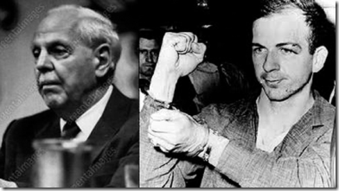
In 1961, Dr. Oshsner formed a clandestine organization of southern anti-communist racist ultra conservatives, Information Council of the Americas (INCA) to be used as a military intelligence clandestine group; and to protect and expand the global interests of the New Orleans economic elite in Latin America. In New Orleans, INCA had been a key principal setting up Lee Harvey Oswald as the lone wolf “communist” assassin of President John F. Kennedy.[12]
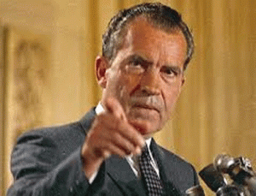
During the early 1960s, even U.S. Vice President Richard Nixon was also secretly consulting with Dr. Ochsner in New Orleans.[13] Dr. Ochsner was also a consultant to the United States Air Force on the medical side of secret “subversive matters.” Clandestine U.S. mercenary Gerry Hemming says that Dr. Ochsner also ran an “assassination school for doctors” in Latin America.[14]
The source work of Dr. Ochsner’s MK DELTA project has also been linked to the secret experimentations of Dr. Mengele. A member of the Norwegian Journalist Union made an explosive discovery that U.S. Guantanamo Base Detention Center in Cuba is referred to as “CAMP DELTA.” Camp Delta is the center of human torture/interrogation and programming after Dr. Mengele’s secret torture/mind control CIA projects.[15]
DELTA is also most likely a military intelligence regional code word for Dr. Ochsner’s related special operations involving racist, Masonic and anti-communist asset oligarchs and institutions of the Mississippi River DELTA Basin.
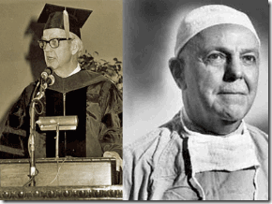
One of Dr. Ochsner’s main ultra conservative- anti-communist secret cohorts and benefactors at Tulane University (MK ULTRA/DELTA) and INCA (JFK Assassination)[16] had been Louisiana Coca-Cola heir, Tulane alumnus and board member Richard West (RW) Freeman or Richard W. Freeman, left above.[17] Coca-Cola has also been directly implicated in clandestine operations, and the covert assassination of JFK through Phillip A. Twombly, Executive Vice President of Coca Cola for their Caribbean operations. Twombly owned a bank in Fullerton, California, which was used to distribute CIA funds for covert operations.[18]
Dr. Alton Ochsner, RW Freeman and DELTA AIRLINES
Dr. Ochsner’s powerful operative and a notorious segregationist RW Freeman had been the CEO of Delta Airlines from 1955-1965.[19] At least up to the 1980s with President Ronald Reagan and George H.W. Bush, the Coca-Cola Freeman/Tulane/MK DELTA family were patently behind the operations at Delta through various means such as the Delta Airlines Political Action Committee.[20] Both Dr. Ochsner and RW Freeman were vicious racist. They would have no hesitation to abuse, and setup clandestine networks to continuously take advantage of the Black Folk that worked under and around them for secret experimentation. More likely than not, they could have been among the first abused, experimented on and programmed.
No matter how you look at it. Ronald Davis, Lucia McBath and Jordan Davis were in fact DELTA PEOPLE. They were subject to be abused, and controlled. Something ain’t right. There is something absolutely un-natural about this entire Jordan Davis- Michael Dunn murderous affair
JORDAN DAVIS & The DELTA PEOPLE
Jordan‘s mother, Lucia Kay McBath, had been a DELTA PEOPLE LIFER for over three decades as a flight attendant and a senior recruiter for Delta Airlines. Her husband, Samuel McBath, is also a DELTA PEOPLE LIFER. [21] Jordan‘s father, Ronald Davis, had also been a DELTA PEOPLE LIFER also for over three decades. He retired from Delta Airlines as a flight purser in 2006.[22]
Jordan had been a DELTA baby. Lucia raised Jordan largely alone from the time he was three years old after divorce from Ronald Davis. Ronald took Jordan every other weekend so Lucia could double-shift and stay home weekdays. In 2002, Ron remarried and moved 350 miles south to Jacksonville. Jordan allegedly took one-hour DELTA flights to see his dad on alternate weekends.[23]
Lucia says that when Jordan was nine, she pulled him from grade school to teach him herself for five years. Well, how is that possible for her to home school Jordan if she was a flight attendant working double-shifts just to stay home weekends. Something just ain’t right.
At 15 years old, Lucia sent Jordan to live with his father. The truth was that Jordan began to develop and manifest behavior problems that she couldn’t handle. It was far from the truth when one source reported, “In the two years that they lived together, the father and son built a bond that was unmatched; they went fishing and crabbing together and sat quietly among the palm trees and waterway in Davis’ posh backyard, where they fed ducks while planning for the future.”[24]
However, Jordan’s life with his father was far from a tip-toe through the tulips as persistently being alleged by mass media, and both Lucia McBath and Ronald Davis. At Samuel W. Wolfson High School in Southside Jacksonville, “The hard boys stepped to him in the yard; he was mugged for his phone after school. He sulked through most of a year, flunked a statewide test and was dumped in remedial reading, of all places. His father didn’t put up with it for a minute. ‘He’d be up late talking to girls, so I took away his cell phone, then his TV and Xbox, too. Then I took the door off his room. He’d say, ‘But those are my things,’ and I’d say, ‘No, they’re mine; the power they use, that’s mine, too.’”[25]
I can very well understand a father’s difficulty in raising a problem son, but why the mass deceptions about Jordan.
No Real Tears for Jordan Davis
Possible MONARCH- Aliyah Harris

It really didn’t seem to be a lot of real tears shed for Jordan Davis. His so-called girlfriend, Aliyah Harris, was the state’s first prosecution witness. She was composed and oddly enough didn’t exhibit very much emotion one way or another about Jordan during direct testimony and didn’t seem to shed too many tears if any at all for him.
During cross-examination, defense counsel brought out the fact that she been Jordan’s girlfriend for only about 60 days and just showed up for the first time at Wolfson High School in September 2012 two months prior to his death. He didn’t ask where she came from.
According to Ronald Davis, Jordan‘s strange and odd relationship with Aliyah had been closely monitored to the point that she may have been no more than a female escort or WATCHER.
“They were Wolfson’s power couple, though chaste in the way that church kids are, never finding alone time for sex. ‘Whether it was me or my wife, someone was always here when Aliyah drove him home from school,’ says Ron. ‘We love that girl, but we weren’t having surprises. Her father felt the same way.’ ”[26]
However, according to the Rolling Stone April 25, 2013 article, A Most American Way to Die, Jordan and Aliyah’s relationship was off and on. On November 24, 2012 the day he died, their relationship was on the off switch.[27]
Delta Series- Ronald Davis
On November 27, 2012, three days after the slaying of his son, an unusually composed Ronald Davis’ primary stated interest was becoming an advocate for handgun control. And, he had no shame actively soliciting jobs as a gun control spokesman.
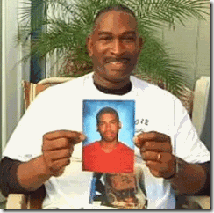
I know that the saying is that a man is not supposed to cry, but it also seems odd that Ronald Davis has never seemed to be a grieving father. His relationship with his son appears to have been bizarre and repressive.
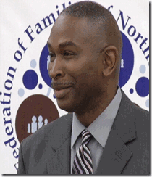
He took down his son’s bedroom door and excessively monitored his son’s relationships with girls as if Jordan had any prior history with girls other than phone conversations. Jordan don’t seem to have had many girlfriends contrary to his gangster aggressive behavior and attitude exhibited on the night of the fatal confrontation with Michael Dunn. It doesn’t seem to all add up.
Delta Series ILLUMINATI- Lucia Kay McBath


Lucia (female Lucius- Son of LUCIFER) [28] Kay McBath, the ILLUMINATI, also don’t seem to be a grieving parent. She is Soror McBath (Sorority Sister), DELTA Sigma Theta Sorority, Inc. that was founded on January 13, 1913 by 22 collegiate women at Howard University.

Lucia says since the death of her son that she has been riding high on a NEW high wave of notoriety, fame and fortune.
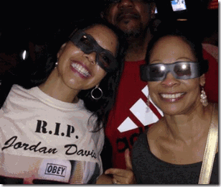
Lucia’s primary interest is also gun control and gun violence. She has become a National Spokesman for Shannon Watts’ Moms Demand Action for Gun Sense in America (MDA).[29] MDA was formed by Watts on December 15, 2012, just a day after the Sandy Hook School (ILLUMINATI- false flag) massacre. Boasting “tens of thousands of members and over 80 local chapters,”[1] the organization seeks to accomplish for gun control what Mothers Against Drunk Driving did for sobriety behind the wheel.[30]

Shannon Watts really has been exposed as a female Josef Goebbels– professional propaganda specialist. She has spent two decades quietly behind the scenes as an extremely ambitious executive at several major public relations firms and Fortune 500 companies and military intelligence industrial giants like Monsanto. Watts’ Linked In profile indicates that she formally left the PR profession in June 2012, just six months before the Sandy Hook event.[31] At that time Watts headed up her own “boutique” firm, VoxPop Public Relations, while working as a freelance consultant for clients of public relations behemoth Fleishman-Hillard. Watts began VoxPop in 2008, the same year she was recognized by the foremost public relations trade journal, PR Week, as one of its “40 Under 40,” for notable achievements and future promise in the industry.[32]
“Twenty-eight people allegedly died: 27 children and adults, including Adam Lanza, at the school, and his mother, Nancy Lanza, in her home at 36 Yogananda Street, Newtown. However, there is no direct proof of their death: no photographic evidence or video footage was released to confirm the official story that these 28 persons actually died. In fact, no video surveillance footage shows anything—not even Adam shooting out the front plate-glass window or walking through the halls like Rambo, even though this is a school that had updated its security system at the start of the 2012-13 academic year.“[33]
“In addition, tweets about the shooting began before it occurred, a tribute was apparently uploaded one month before the event, and web pages honoring the victims, including a Facebook page R.I.P. Victoria Soto, were established before they had “officially” died.”

At one point in a televised interview with CIA/CNN Anderson Cooper, Lucia briefly slipped and said that Jordan was a “Great-Great ‘FAITH FOUNDATION …’ “ (Frames 9:12-14) Once, she realized what she had said, she stopped in the middle of completing the statement then switched subjects.
Jordan Davis, DELTA PEOPLE, Fabianism and the FAITH FOUNDATION
Under these particular circumstances, it makes perfect sense that Lucia was referring to former British Prime Minister Tony Blair’s “FAITH FOUNDATION.“
Tony Blair has to one of the most demonic, dangerous and scariest human beings on earth. Britain’s Tony Blair is more than a politician, war criminal and a degenerate; he’s a top stooge for the British Royal Family. He’s been a member of the Queen’s Privy Council since 1994.[34]

He is a notorious- don’t give a damm “Liar.” Tony Blair is a Luciferian 33rd Degree Master Mason.[35] He is a Knight of Malta.[36] Tony Blair is a Bilderberger.[37] The ILLUMINATI want to establish a new One World Religion to go along with their New World Order through President George W. Bush’s twinning master of deception, former British Prime Minister, Tony Blair and his Faith Foundation. The philosophical basis of Tony Blair’s FAITH FOUNDATION is based upon the Anglo Saxon imperial and racialist empire ideas of George Bernard Shaw and the Fabian Society.[38]
In 1900, the Fabian Society produced Fabianism and the Empire, the first statement of its views on foreign affairs, drafted by George Bernard Shaw and incorporating the suggestions of 150 Fabian members. It claimed that the classical liberal political economy was outdated, and that imperialism was the new stage of the international polity. The question was whether Britain would be the centre of a world empire or whether it would lose its colonies and end up as just two islands in the North Atlantic. It expressed support for Britain in the Boar War because small nations, such as the Boers were anachronisms in the age of empires. In order to hold onto the Empire, the British needed to fully exploit the trade opportunities secured by war; maintain the British armed forces in a high state of readiness to defend the Empire; the creation of a citizen army to replace the professional army … a combination of physical exercises, technical education, education in civil citizenship…and field training in the use of modern weapons”.[39]
The Fabian Society intend to control every aspect of human life that would be arranged by educated white men under the ruse for the benefit of all. The Anglo Saxon dreamers included men of great ability and wealth, who devoted their talents and fortunes to carrying out the British Crown’s covert plans for world domination.
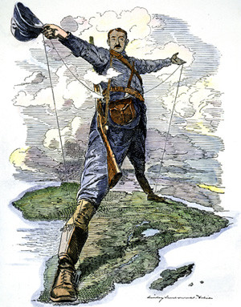
The most prominent of these individuals were Andrew Carnegie, and of course members of the Fabian Society, particularly the African Holocaust Maniac and Masonic New World Order Criminal, Cecil Rhodes, and Satanic MI5 head H. G. Wells.[40]
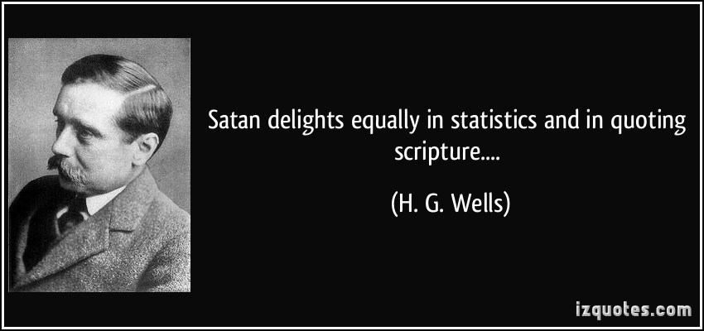
The FAITH FOUNDATION has a Face to Faith children’s program that even warped up in Christmas paper is nothing more than another cult-like (one-think) mass indoctrination and mind control program for children.[41]
DELTA Airlines, DELTA PEOPLE & Tony Blair’s FAITH FOUNDATION
Lucifer’s Daughter slip of the tongue about Jordan‘s relationship with Tony Blair’s demonic “FAITH FOUNDATION” wasn’t misspeak by any stretch of the imagination.
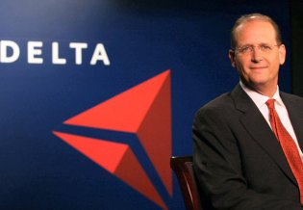
Richard H. Anderson & DELTA ILLUMINATI PYRAMID
The current CEO of Delta Airlines is Richard H. Anderson, former 2007 CEO of UnitedHealth- Ingenix.[42] Ingenix is the data crunching unit of UnitedHealth. Ingenix has an annual revenue of $1.6 billion, and is poised to establish a national (Global) digital clearinghouse to ensure the accuracy of medical payments and provide a centralized service for checking the credentials of physicians.
In 2007, UnitedHealth was poised to profit from (Global) health reform. Its decade-long series of acquisitions has made the company a coast-to-coast Leviathan enmeshed in the lives of 70 million Americans. United’s AmeriChoice unit is the largest government contractor administering state Medicaid programs for the poor and federally sponsored plans for children.[43]

Britain’s Simon Stevens leads UnitedHealth Group’s international businesses and U.S. health reform groups. As chairman of both the UnitedHealth Center for Health Reform and Modernization and the Optum Institute, Mr. Stevens also directs the company’s work on U.S. health care modernization and implementation of the new President Barrack Obama’s Affordable Care Act. He previously served as CEO of UnitedHealth Group’s Medicare company, serving one-in-five older Americans nationwide.
Mr. Stevens has had a varied career as an executive leading major hospital systems, primary care, and payer organizations in the United States and internationally. Previously he was British Prime Minister Tony Blair’s health policy director at 10 Downing Street and the U.K. Department of Health, where he led the high profile reform of the British National Health Service (NHS).[44]
UnitedHealth’s largest employer clients is DELTA Air Lines.[45]Lucia, Ronald Davis and Jordan‘s DELTA Airlines healthcare provider is UnitedHealth directly under the control of at least two of Tony Blair’s ILLUMINATI Global New World Order/ILLUMINATI stooges, Richard H. Anderson, and Simon Stevens of the British Crown.
Tony Blair’s FAITH FOUNDATION is covert arm of the British Crown and the Vatican to control a One World Religion for a New World Order with LUCIFER as god.
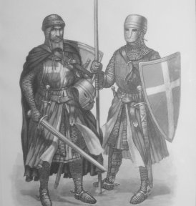
“For more than 80 years, Catholic international organizations and the the Sovereign Military Hospitaller Order of Saint John of Jerusalem of Rhodes and of Malta (Knights of Malta) have promoted Catholic solidarity (Counter-Reformation agendas) within the Community of Nations, first at the League of Nations (the precursor to the United Nations) and later at the United Nations (UN) and its global UN agencies.”[46]
Tony Blair’s FAITH FOUNDATION ties directly into a Global clearing house controlled by global commuter and monitoring systems being created and dominated by UnitedHealth that would move to insure that each and every child is tied into compulsory education Faith and Globalization mind control indoctrination as part of a total healthcare package.
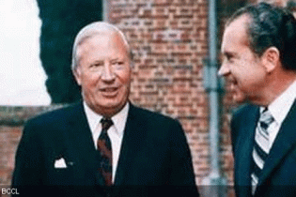
It will be Dr. Arnold Hutshnecker’s Plan repackaged. Dr. Hutschnecker proposed mandatory testing all, particularly Black and Brown children, for “anti-social” tendencies as part of America’s overall national healthcare package through the U.S. Department Health, Education and Welfare under President Richard Milhous Nixon.[47] Dr. Hutschnecker was an actually confessed Nazi/SS Knight of the Black Sun of the THIRD REICH implanted in America. Dr. Hutschnecker’s final recommendation to the highest elected office of this country- the establishment of government camps for incorrigible teen-age boys, “For the severely disturbed, the young hard-core criminal, there may be a need to establish camps with group activities under the guidance of counselors, under the supervision of psychologists, who have empathy (most important) but also firmness.”[48]
Dr. Hutschnecker’s plan was stopped only by public exposure and outrage. Those children that don’t pass muster with Blair’s Faith and Globalization indoctrination will be subjected to be drugged, placed in government camps, or liquidated.
Out of Lucia‘s mouth, Jordan Davis went through Tony Blair’s FAITH FOUNDATION (one think) experimental educational children’s indoctrination program through her employer’s healthcare program, UnitedHealth.
When Jordan Davis didn’t adjust to the program, he was psychologically wounded through behavior modification programs like hypnotism, forced drug therapy or aversion punishment, and most likely blamed his parents; and began to act out. Like Trayvon Martin, Jordan Davis was sacrificed as a much bigger picture to further divide and confuse the masses, races; and demonize Black Youth for a final and clandestine solution of the ILLUMINATI!
Next, we get into Michael Dunn and how it relates to MK ULTRA, Gangster Rap, Satanic Jay’s Holy Grail, Magna Carta

[1] http://www.whale.to/b/monarch_q.html
[2] http://en.wikipedia.org/wiki/Project_MKDELTA
[3] http://polioforever.wordpress.com/dr-marys-monkey/
[4] http://www.ncbi.nlm.nih.gov/pmc/articles/PMC3096388/
[5] http://www.ncbi.nlm.nih.gov/pmc/articles/PMC3116750/
[6] http://www.ncbi.nlm.nih.gov/pmc/articles/PMC3116750/
[7] https://groups.google.com/forum/#!msg/alt.conspiracy.jfk/WJps6unLEio/0rOT7D0Dxz8J
[8] http://archive.org/stream/danielhalfwillia013550mbp/danielhalfwillia013550mbp_djvu.txt
[9] http://en.wikipedia.org/wiki/Alton_Ochsner
[10] http://doctormarysmonkey.com/More/Gambit/DrO.pdf
[11] http://visupview.blogspot.com/2013/06/dr-cameron-or-how-we-learned-to-stop_29.html
[12] http://www.assassinationweb.com/roseb1.htm
[13] http://doctormarysmonkey.com/More/Gambit/DrO.pdf
[14] https://groups.google.com/forum/#!msg/alt.conspiracy.jfk/WJps6unLEio/0rOT7D0Dxz8J
[15] http://www.godlikeproductions.com/forum1/message2115406/pg1
[16] http://quixoticjoust.blogspot.com/2011_11_01_archive.html
[17] http://www.gftpln.org/Article.do?orgId=353&articleId=1518
[18] http://www.spartacus.schoolnet.co.uk/JFKholt.htm
[19] http://www.deltamuseum.org/explore/history/leaders/chairmen-ceos-presidents
[20] http://www.city-data.com/elec2/…/elec-NEW-ORLEANS-LA-82.htm
[21] http://guncontrolnowusa.wordpress.com/2014/01/11/the-nra-working-for-an-america-where-gun-death-is-normal-and-usual/
[22] http://guncontrolnowusa.wordpress.com/2014/01/11/the-nra-working-for-an-america-where-gun-death-is-normal-and-usual/
[23] http://guncontrolnowusa.wordpress.com/2014/01/11/the-nra-working-for-an-america-where-gun-death-is-normal-and-usual/
[24] http://www.jetmag.com/news/standing-our-ground/
[25] http://guncontrolnowusa.wordpress.com/2014/01/11/the-nra-working-for-an-america-where-gun-death-is-normal-and-usual/
[26] http://guncontrolnowusa.wordpress.com/2014/01/11/the-nra-working-for-an-america-where-gun-death-is-normal-and-usual/
[27] http://www.rollingstone.com/culture/news/jordan-davis-stand-your-grounds-latest-victim-20130425
[28] http://lucius.wikia.com/wiki/Lucifer
[29] http://www.prnewswire.com/news-releases/moms-demand-action-for-gun-sense-in-america-announces-lucy-mcbath-as-national-spokesperson-221478541.html
[30] http://www.thesleuthjournal.com/just-another-accidental-activist-sandy-hook-gun-control-mouthpiece/
[31] http://www.thesleuthjournal.com/just-another-accidental-activist-sandy-hook-gun-control-mouthpiece/
[32] http://www.thesleuthjournal.com/just-another-accidental-activist-sandy-hook-gun-control-mouthpiece/
[33] http://www.veteranstoday.com/2014/01/07/top-ten-reasons-sandy-hook-was-an-elaborate-hoax/
[34] http://www.larouchepub.com/other/2009/3634blair_evil_obama.html
[35] http://www.biblebelievers.org.au/33rd.htm
[36] http://www.biblebelievers.org.au/kmlst1.htm
[37] http://www.prisonplanet.com/wearechange-proves-tony-blair-lied-to-parliament-about-bilderberg.html
[38] http://www.worldviewweekend.com/worldview-times/article.php?articleid=8331
[39] http://en.wikipedia.org/wiki/Fabian_Society
[40] http://www.rodjenkins.com/new_world-order_origins.htm
[41] http://www.tonyblairfaithfoundation.org/page/advisors
[42] http://investing.businessweek.com/research/stocks/people/person.asp?personId=331864&ticker=DAL
[43] http://www.businessweek.com/magazine/content/09_33/b4143034820260.htm
[44] http://www.unitedhealthgroup.com/Newsroom/Profile/SimonStevens.aspx
[45] http://www.businessweek.com/magazine/content/09_33/b4143034820260.htm
[46] http://thegodpress.blogspot.com/2013/12/the-counter-reformation-and-faith.html
[47] http://mindcontrolblackassassins.com/tag/charles-garry/
[48] http://mindcontrolblackassassins.com/tag/charles-garry/
Comments : 11 Comments
Tags: aliyah harris, Allen Dulles, alton ochsner, arnold hutschnecker, daniel hale williams, delta airlines, ewen cameron, faith foundation, igenix, Illuminati, illuminati sacrifice, jordan davis, josef goebbels, josef mengele, knight templars, Knights of Black Sun, knigths of malta, lucia kay mcbath, lucia mcbath, mda, michael dunn, mind control, mind control frequencies, mk delta, MK-ULTRA, moms demand action for gun sense in america, new orleans, operation paperclip, richard h. anderson, richard nixon, richard w. freeman, ron davis, ronald davis, sandy hook false flag, shannon watts, simon stevens, tony blair, trayvon martin, unitedhealth
Categories : allen dulles, Barack Obama, Black Manchurian Candidates, brain entrainment, Dr. Josef Mengele, Extremely Low Electrical Frequencies, Geobbels Method, george michael zimmerman, george zimmerman, Hauptsturmfuhrer SS Dr. Josef Mengele, Heinrich Himmler, illuminati, illuminati sacrifice, imperium, J. Edgar Hoover, jonestown, jordan davis, Josef Mengele, Knight of Malta, Knights Hospitaller, Knights of the Black Sun, Knights Templar, lucifer's servants, MK DELTA, MK-ULTRA, monarch child, monarch program, new age religion, nwo, oakland, oakland police department, Operation PAPERCLIP, Paperclip Project, Paul Josef Goebbels, peoples temple, Reichsfurhrer SS-1 Heinrich Himmler, RONALD REAGAN, satan, Satanism, Schutzsteffel, SS, Stanford University, trauma-based mind control, Tulane University

PHARRELL WILLIAMS- HOLLYWEIRD’S LITTLE LUCIFER, A MASTER OF DECEPTIONS AND ILLUSIONS
20022014
We Shall Not be Moved
The British Empire & Caliban Plan
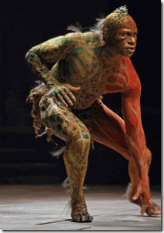
The old Anglo-Saxon British Empire is the New World Order shock troops that intend to emerge as the final conquers and rulers on the frontier of the entire Black Music and Entertainment Industry in America through a campaign of merciless murder and terror, the art of Deception and ILLUSIONS that out of pure evil intend to push the Black Masses, particularly- back before the Stone Age.
There is a battle waging across the world. It is classic battle that dates from the very beginning of human civilization Gods versus Gods, Lucifer against God, brother against brother, Set versus Osiris- Good against Evil. The forces of evil are embolden to advance the battle to unprecedented levels through the mastery of science and technology. They are advancing on what historically have been the people’s first line of defense at its very core, the Classical Ageless Children of the Good- the African descendants of Osiris- Isis and Horus.
Classic Black Spirituals, Blues, Jazz and R&B have been targeted to be virtually phased out of public domain as an inspiration, consciousness and will of the people. These forms of art tends to enrich “Goodness”, and “Humanize” the people. The ancient people of Kemet credited one of their gods Hathor with the invention of music which Osiris in turn used as part of his effort to civilize the world.
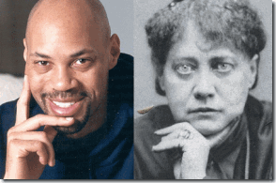
However, popular mass media ILLUMINATI projects like 12 Years a Slave, the Help and the Butler have been used to plant ILLUSIONS of backwardness, ignorance, subservience and the lack of ability to ascend to higher human intellectual levels. One of the inspirations behind 12 Years a Slave, screenwriter John Ridley, above, boldly tells the world that if what I describe as “Ridley’s Niggers” lingering and locked in “post-traumatic slave syndromes” do not ascend into notions of preceded and wickedly conceded higher forms of humanity (veiled eugenics), they will be liquidated.[1] It is a proclamation absolutely consistent with Satanists ( Helena Petrovna Blavatsky- Secret Doctrine) and Luciferian SS Knights of the Black Sun bloodshed pseudo race theories.
Satanic Jay’s so called music is designed by the ILLUMINATI to demonize people of color. In his white Knights Templar warrior’s song, Holy Grail, Magna Carta, he tells the planet and confirms the paranoia of the race bigoted George Zimmermans and Michael Dunns of the world that he (a black man) represents universal “Evil”, and he is the thug and evil “Nigga” that menace, corrupt, and poison the atmosphere of the entire world of the good and uplifting.[2]
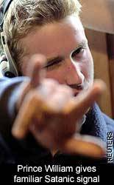
The power and art of music is currently be shut down in urban schools and closed off from the masses. The access to the Black Folk traditional forms of music is intended to become under tighter controls by ILLUMINATI masters like Clive Davis. As you can plainly observe, Pharrell Williams, a Master of ILLUSIONS is being prop up by the ILLUMINATI and British Empire to be one of the major catalysts and prime moving forces designed to dynamically and radically change the face of the entire music and entertainment industry to reduce the people to a mindless mass of controlled cybernetic robots with Lucifer as god, and the British Crown (Prince William) as the reigning World Anti-Christ straight out of the contrived Book of Revelation.

If you believe the hype, Pharrell Williams, the strange little dude with the Smokey the Bear Hat, has to be the biggest popular music icon discovery since the invention of the automobile. According to the ILLUMINATI’s mass media build up of him, he has already taken home an Oscar for “ Happy”.
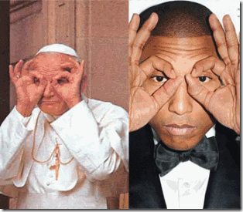
However, Pharrell is not to be dismissed with the randomness and playfulness of a cartoon character. He is a very wicked, intelligent, sophisticated and trained ILLUMINATI counterculture change agent of the British Empire. If you are influenced by his alien and strange “punk” fashion notions, pay in full to the order of the British Crown. Pharrell’s hat is available through the Vivienne Westwood Worlds End boutique in London.[3] The Worlds End boutique is owned by Dame Vivienne Westwood.[4]

In 2013, Vivienne Westwood had been directed to design and issue a jewel-encrusted purple royal crown for Satanic Jay and Beyonce’s 17 month old daughter Blue Ivy to authenticate the ILLUSION that they belong to the remote British Crown’s Royal French Bloodlines.[5] Satanic Jay and Beyonce even went so far with the ILLUSION that they have been anointed the British Crown’s Hip Hop Royalty of America that they hired a French nanny for the baby.[6]

Pharrell Williams, Punk-anated, emasculated by British Counterculture Specialists and in Trance
For service to British Crown, Master Mason Westwood was awarded a Knight/Damehood to the Excellent Order of the British Empire (OBE) which she collected from Queen Elizabeth II at Buckingham Palace in 1992.[7]

“There’s certainly no ignoring the flame-haired, devil-horn-wearing (and often panty-less) protopunk designer—” – Vivienne Westwood[8]
Pharrell’s style and fashion is most likely the design concept of the masterminds and counterculture specialists that created the British Punk/New Wave Pop Subculture.
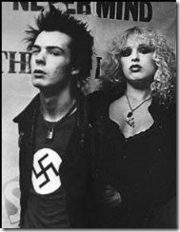
The late Sid Vicious (1957-1979), English bass guitarist and vocalist most famous as a member of the influential punk group the Sex Pistols.[9]
The Godparents and architects of the British Punk Subculture, Malcolm McClaren and Vivienne Westwood, owned a clothing and bondage apparel store on King’s Road in London called “SEX.” They sold tee- shirts and jackets adorned with swastikas. They also sold SS-1 Henrich Himmler’s SS- Knights of the Black Sun officer’s caps.[10] They were also influenced the resurgence of the Edwardian Teddy Boy Movement during the 1970s.[11]
The Punk Subculture, the Gnosis & Satanism
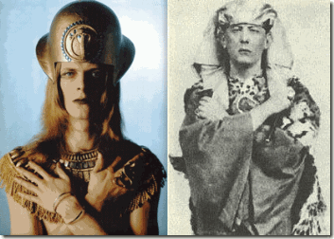
I’m closer to the Golden Dawn
Immersed in Crowley‘s uniform of imagery.
–David Bowie, 1971 song “Quicksand”[12]
New Wave is the longest-lived sub-genre of music. New Wave’s roots can be traced back to 1969, when David Bowie first released the song “Space Oddity”. In 1973, when Bowie re-released “Space Oddity”, the precursor to New Wave, punk rock was born. Throughout the mid-1970’s, Punk bands such as The Sex Pistols were among the leaders.[13] If the New Wave’s roots are traced back to David Bowie, then the underlining philosophy of its roots is Aleister Crowley the Great BEAST’s Satanism, and the “Gnostics.”[14]

On November 25, 1995, David Bowie finally admitted that in 1976 “My overriding interest was in cabbala and Crowleyism. That whole dark and rather fearsome never–world of the wrong side of the brain. … And more recently, [in 1995 he stated] I’ve been interested in the Gnostics”.
In Aldous Huxley’s Brave New World (1946), it delineates what the perfect dictatorship would look like. It would have the appearance of a democracy, but would basically be a prison without walls in which the prisoners would not even dream of escaping. It would essentially be, as Aldous Huxley tells us, a system of slavery where, through entertainment and consumption the slaves “would love their servitude”.[15]

McLaren realized in the 1970s that a new youth style was needed, and largely initiated the punk movement as a mass diversion for the youth, to which he and Vivienne Westwood supplied the fashions. In the summer 1975, McLaren created the Sex Pistols (sexy young assassins) to appeal to the young to promote the New Wave Movement.[16]

Vivienne Westwood- Secret Societies and Freemason motto is “Ordo Ab Chao“ meaning Order Out of Chaos
In autumn 1976, the Sex Pistols was subsidized and financed by the Columbians thru a multi-national conglomerate, EMI (EMI Group Limited- Columbia Gramophone Company ),[17] up to a million dollars that critics claimed, could not play.[18]
At the time, Sir Joseph Lockwood was EMI’s chief executive officer. Sir Lockwood was MI-6.[19] The Secret Intelligence Service (SIS), commonly known as MI6 (Military Intelligence, Section 6, is the British intelligence agency which supplies the British Government with foreign intelligence. It operates under the formal direction of the Joint Intelligence Committee (JIC) alongside the internal Security Service (MI5), the Government Communications Headquarters (GCHQ) and Defense Intelligence (DI).[20]
After WWII, EMI (Harry Walter Legge)[21] was used as a “ratline” to harbor and subsidize Nazis out of Germany. One of their flagship artists had been Austrian conductor Herbert von Karajan, a major figure in 20th-century classical music. In 1933, he had joined the Nazi Party. It was far from a random act. Nazi Propaganda Chief Josef Goebbels intervened personally to stop a probe into his mother’s, Anita Guetermann, Jewish origins in order to clear the way for her marriage to his father.[22]
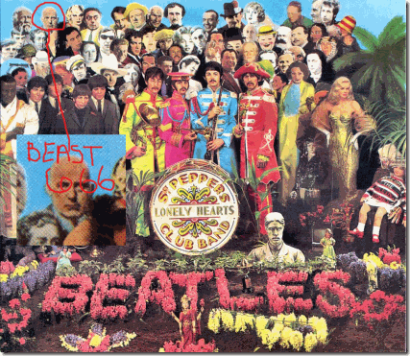
Sir Joe had been charged by the British Crown with the covert promotion of the “Re-Emergence of British Empire“ via the Frankfurt School to veil a mass social engineering population control program through popular entertainment means for a New World Order.[23] Their most successful mass population control project through Sir Lockwood, EMI and popular music was the British Rock Invasion, Aleister Crowley & the “BEATLES.”[24]
“Modern electronic-rock music, inaugurated in the early 1960s, is, and always has been, a joint enterprise of British military intelligence and Satanic cults. Modern electronic-rock music, inaugurated in the early 1960s, is, and always has been, a joint enterprise of British military intelligence and Satanic cults. On the one side, the Satanists control the major rock groups through drugs, sex, threats of violence, and even murder. On the other side, publicity, tours, and recordings are financed by record companies connected to British military intelligence circles. Both sides are intimately entwined with the biggest business in the world, the international drug trade.”[25]

Hugo has the Masonic Checkerboard Scarf & flash Vulcan Hand Symbol
In 1990, Pharrell started out in the heavily fortified military-intelligence complex city of Virginia Beach, Virginia with a R&B group called, “The Neptunes.”[26]The Neptunes developed in a duo group, Pharrell and Charles Edward “Chad” Hugo. Hugo was Pilipino descent along with Pharrell, half Pilipino. Hugo’s father was a U.S. Naval Officer, and his mother worked at a laboratory. Pharrell and Hugo met at a special summer camp for the “Gifted and Talented” kids.[27]
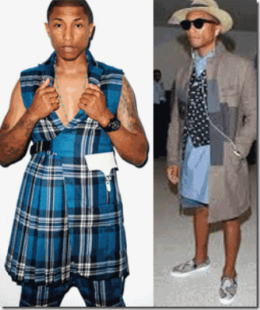
Pharrell Williams & Trans-Sexual Punk Fashions
Virginia Beach is home to the large Naval Air Station Oceano that support the Navy’s Atlantic and Pacific Fleet Force of Strike-Fighter Aircraft & Joint/Inter-Agency Operations.[28] Even though, Pharrell has been appointed as an ILLUMINATI pop culture darling not much is really known about his background other than his father, Pharaoh, is a handyman, and his mom, Carolyn, is a teacher.[29]

However, the Neptunes is an awfully strange name for a punk/R&B/rap group. Neptune is a very extremely complex and important god of the sea of great antiquity. He figures prominently behind the veiled mythologies of Satanic Jay’s Magna Carta-Holy Grail- Alpheus and Arethusa- ancient Greek and Roman river and ocean spirits.
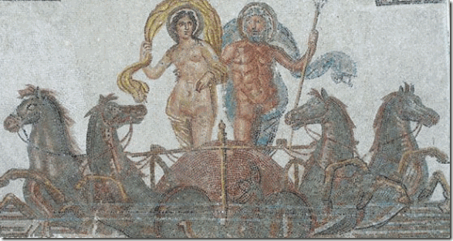
Ancient Greek Neptune & Amphitrite
Neptune is an extremely central Olympian God connected to the stars, Kemetic Goddess Neith,[30] and the Lost Continent of Atlantis.[31] He is the counterpart of the Kemetic God Sobek,[32] Greek God Poseidon. Neptune was the brother of Jupiter and Pluto, each of them presiding over the realms of Heaven, our earthly world, and the Underworld, respectively. Amphitrite was his consort.[33]
It is apparent that for some reason Pharrell had been exposed and deeply immersed in the occult and Egyptian/Greek– Roman mythology at an early impressionate age. Special summer camps for gifted, intelligent and talented kids was a prime recruiting grounds for CIA/MK ULTRA.[34]
Pharrell Williams & the Medieval Cult of the Angels
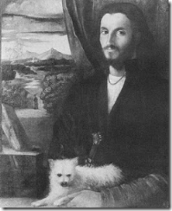
Pharrell Williams’ role model – 14-15th century genius Leonardo Da Vinci. Pharrell says, “I like a lot about him. He was an Aries, like me, so I can relate to a lot of things he got into. ” [35]
SOME OF THE THINGS THAT LEONARDO DA VINCI GOT INTO
Da Vinci- Necromancy & Enochian Magic

Dr. John Dee (July 13, 1527 – 1608 or 1609), above, was a “Renaissance Man” that also followed the things that da Vinci (April 15, 1452 – May 2, 1519) got into such as the Occult, Necromancy (commutations with the dead) and the secret “Enochian Tradition“ (angelic language). Enochian is a name often applied to an occult or secret angelic language revealed in the private journals of Dr. Dee and his colleague Edward Kelley in late 16th-century England. The men claimed that the language was revealed to them by angels. The language is integral to the secret practice of Enochian Magick, an lost art of magic that existed during times of Adam and Eve.[36]
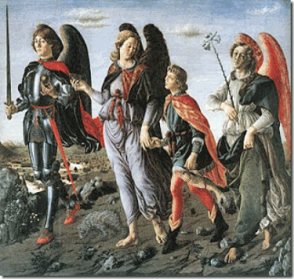
Young Leonardo is said to have modeled as Archangel Michael with the sword for this painting with his white dog at his feet, Tobias and the Angels, by Andrea del Verrocchio (1467-1469).[37]
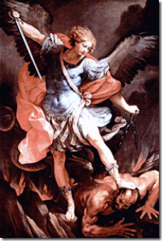
Dr. Dee had frequent communications with Archangel Michael (“Strength of God”), the guardian of Jacob and Israel, who first appeared to Dee on March 14, 1582. Michael would weigh human souls at the Last Judgment and wielded his sword of justice. Trithemius claimed Michael was guardian of the sun and Agrippa considered him guardian of the metal quicksilver. Both equated him with the planet Mercury in alchemy.[38] The angel, above, holding Tobias’ hand with a fish to heal his father’s blindness (Enochian Magick) is Angel Raphael.[39] Raphael, (“It is God who heals”, “God Heals”, “God, Please Heal”) is an archangel of Judaism and Christianity, who in the Judeo-Christian tradition performs all manners of healing.[40] As recorded by Dr. Dee in his diary, Angel Raphael appeared to him on Thursday 15th March 1582. However, Dee had been allegedly in communications with Angels Raphael and Michael regularly at least 12 years prior.[41]
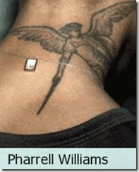
Above, Angel Michael‘s sword of justice (fire) strike at the spine of Pharrell. “The mysteries of Kundalini, the supreme magical power symbolized by the sleeping Fire Snake at the base of the spine which, after its awakening, activates the subtle power-zones in the human body.”[42]

In the Enochian Tradition, the term “Enochian” comes from Dee‘s assertion that the Biblical Patriarch Enoch had been the last human to know the language.[43]
Enoch 66:14-15 has Michael explaining to Enoch that the evil spirits [demons] shall bear witness against those of the flesh who supported them. Yet Enoch is told that Michael holds a secret oath so that the elect shall not perish by their knowledge like the sinners. Enoch 68:20-22.[44]
I believe Pharrell’s tattoo of Archangel Michael frees the Great BEAST Aleister Crowley 666’s Satanic Kundalini, the Coiled Snake in the spine, from “the sword of fire” with the secret name.
Da Vinci, Dee, Kelley & Angel Uriel
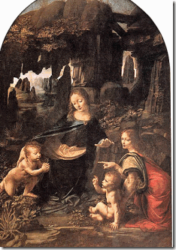
Angel Uriel on the right with baby John the Baptist- both Display the John the Baptist ( I AM) Gesture
Leonardo da Vinci’s 1483-1486 Virgin of the Rocks (sometimes the Madonna of the Rocks) show the Madonna and Child Jesus with the infant John the Baptist and Angel Uriel, in a rocky settling which gives the painting its usual name.[45]
Uriel (“light of God”) was the first angel to speak with Dee after Kelley started scrying for him. In cabalistic lore, Uriel gave humanity knowledge of the cabala and alchemy. During a spiritual conference in Bohemia, in 1587, Kelley told Dee that the angel Uriel had ordered the two men should share their wives.[46] Dr. Dee reportedly had a young and attractive 23 year old wife, widow Jane Fromon. [47] In 1582, he had a vision of a young angel floating outside his window, holding a crystal egg. Dr. Dee believed this to be Uriel.[48]
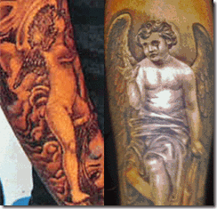
Pharrell’s arm Tattoos and a Young Angel Uriel?
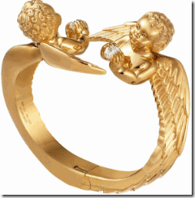
However, I would definitely identify the young angels as Uriel holding diamonds on Pharrell’s $32,000 specialty designed Gold Bracelet by Carmille Miceli and Pharrell
DA VINCI- ILLUSIONS, DECEPTIONS & PEDERASTY
The Mona Lisa & The Devil- the Salaì ILLUSION and Deception

“My job is to come in and create all of the artists that I work with, like you know, the way da Vinci was looking at Mona Lisa.” -Pharrell Williams [49]
“I’m a producer. I’m a musician. And my job is to come in and you know, put — you know, I treat all of the artists that I work with, like, you know, the way da Vinci was looking at Mona Lisa, you know, there’s an interesting backdrop.” -Pharrell Williams [50]
The Mona Lisa has become known as a half-length portrait of a woman by Leonardo da Vinci which has been acclaimed as “the best known, the most visited, the most written about, the most sung about, the most parodied work of art in the world.“[51]
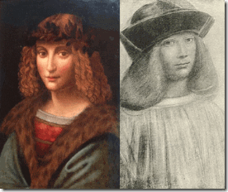
Gian Giacomo Caprotti da Oreno, better known as Salaì (“The Devil”, lit. “The little unclean one”) was a pupil and boy- lover of Leonard da Vinci. Salai entered Leonardo’s household at the age of 10.[52]
And this is the way that da Vinci actually looked at the Mona Lisa.

Salaì, the Devil, was actually the Mona Lisa.[53]
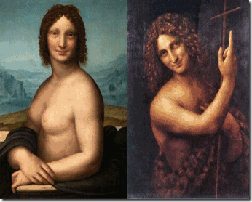
Salaì, the Devil, was actually Da Vinci’s John the Baptist with his Hand Symbol
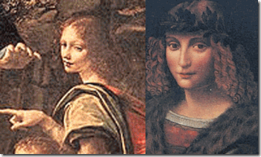
Salaì, the Devil, even looks like da Vinci’s Angel Uriel with the John Gesture on the Rocks
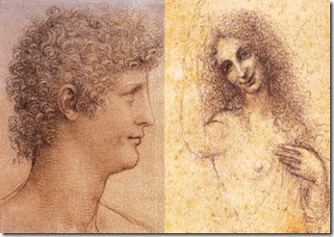
Da Vinci looked at the Mona Lisa as Salaì, the Devil- “the little unclean one” with the John Gesture. Likewise, Pharrell works by ILLUSIONS and Deceptions along side the Devil and “unclean ones.”
Leonardo da Vinci, Pharrell Williams and John Gesture
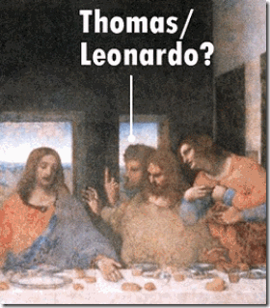
Leonardo da Vinci covertly inserted the John Gesture by Thomas to challenge Jesus’ claim as the Messiah in the infamous painting, The Last Supper. At the heart of the secret John Gesture is the Johannite or Mandaean heresy that denounced Jesus as a “false prophet” and in his place recognized John the Baptist as the true Messiah. Two early Grand Masters of the Priory of Sion that included Leonardo da Vinci along with Sir Isaac Newton are said to have had overwhelming Johannite tendencies. One theory maintains that da Vinci covertly inserted his own actual image as Thomas in the Last Supper to personally challenge Jesus as the Messiah. The famous founder of the Knights Templars, Hughes de Payens, had also been accused by the Vatican of being a Johannite.
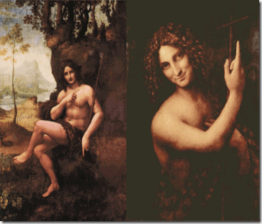
The John Gesture appears throughout da Vinci’s works.(John Gesture) in da Vinci’s St. John the Baptist in the Wilderness (1510-1515) and Salaì (John Gesture) in da Vinci’s St. John the Baptist (1515).
Pharrell Grammys, the John Gesture, 2014

Satanic Jay 2014 Grammy’s, The John Gesture, “Drunk in Love.” Pharrell calls him, “Leonardo Carter”
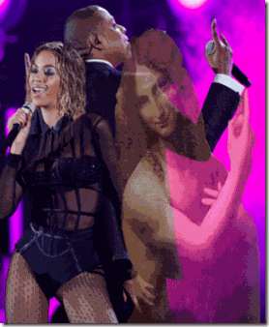
Below, The John Gesture “He is the One”, Pharrell Performs “Get Lucky” in Brooklyn April 2013

A Coincidence, Pharrell and the John Gesture, Check out the beginning of Pharrell Performance of “Happy” 2013 the Ellen Show, Frames 22-26
Pharrell Performs Happy Opening with the John Gesture
Pharrell, The John Gesture Mass Deception (2014 NBA All Star Game)- Covertly Challenging Christ the Messiah like his Medieval Master/Spirit of ILLUSIONS, Leonardo da Vinci

Da Vinci & Dee- Masters of the Rosicrucian
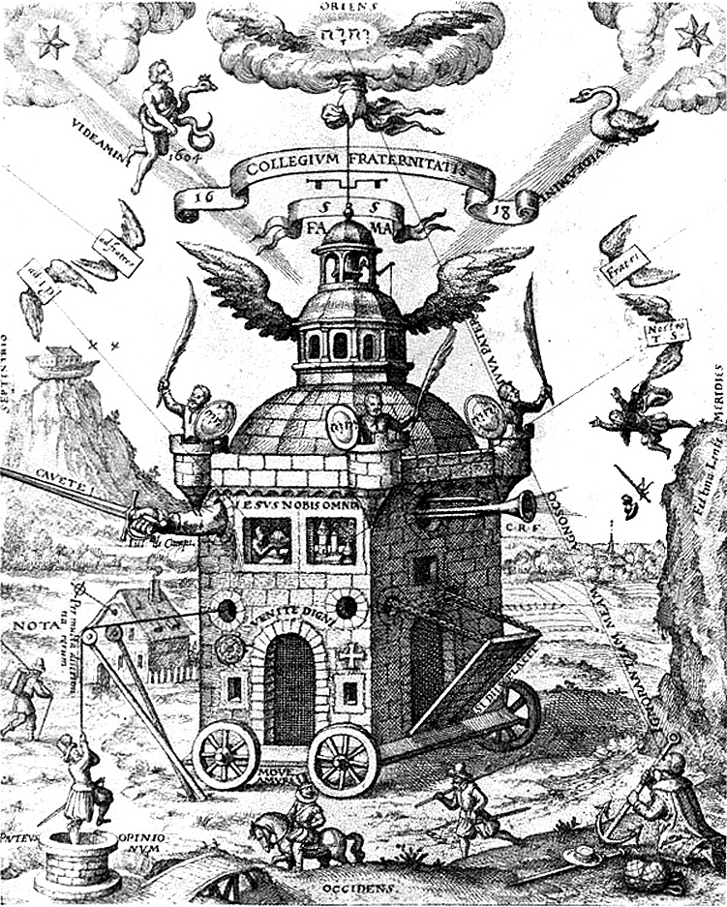
Freemasons claim that their secret medieval masters included Rosicrucians Leonardo da Vinci [54]and Dr. John Dee.[55]
Pharrell and the Vulcans
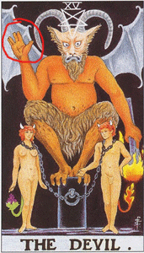
The DEVIL and the Kabbalah Vulcan Hand Gesture
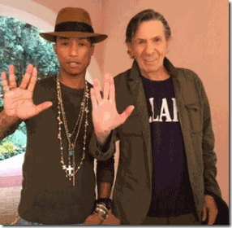
Pharrell & Dr. Spock- the Vulcan Hand Symbol
HollyWeird Actor Leonard Nimoy– Dr. Spock, the Vulcan of the television series introduced and popularized the Vulcan Hand Gesture. The Vulcans were white-skinned superior extraterrestrial beings that originate from the planet Vulcan. They are noted for superior intellect, paranormal abilities, and their attempt to live by reason and logic with no interference from emotion [56] just like SS-1 Reichsfuhrer Heinrich Himmler’s Knights of the Black Sun, the Schutzstaffel (SS).
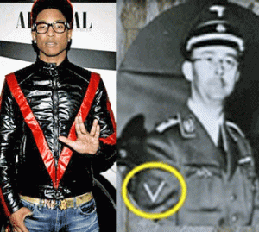
Pharrell is still uncommonly fascinated, obsessed and Tranced (MK ULTRA) by the television series Star Trek, Vulcans, Dr. Spock and its Symbolism. The Vulcan Hand Gesture has been given to him, and an elite Political and HollyWeird and Satanic Subculture Cell as is a sign of their allegiance to a larger and more powerful secret global cabal of Lucifer’s Servants like the late former Prime Minister of Great Britain, Winston Churchill, and U.S. President Barack Obama.
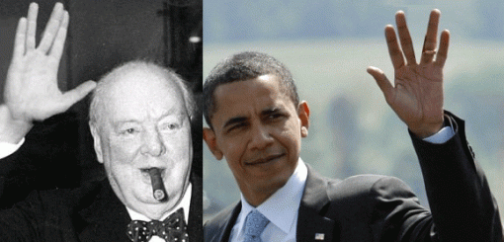
Before Nimoy exposed it to the masses, the Vulcan Hand Gesture was a secret ancient Jewish Kabbalistic Symbol.

Kabbalism is a system of Jewish mysticism and magic and is the foundational element in modern witchcraft. Virtually all of the great witches and sorcerers of this century were Kabbbalist. — William J. Schnoebelen, The Dark Side of Freemasonry[57]
The Hebrew Cabala is a series of occultic writings that are as demonic as any incantation ever uttered in witchcraft. Webster’s Dictionary tells us the Cabala (sometimes spelled Kabbala) is “an occult religious philosophy developed by certain Jewish rabbis…” — James Lloyd, The Apocalypse Chronicles, (Vol. VII, No. 1, 2005) [58]
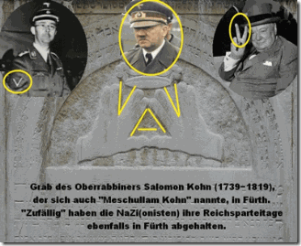
It is believed by Jewish scholars that the Vulcan hand sign is a secret reference to verses in the Song of Songs (2.8- 9). The verses that God “peeks through the cracks in the wall.” In other words, God watches over and protects the protects the Jewish people even when he is hidden.[59] The Vulcan Hand Gesture is yet another type of ILLUMINATI/Luciferian All-Seeing Eye hand gesture appropriated from great antiquity for absolute evil and Satanic purposes.
The Vulcans & the 9-11 Inside Job
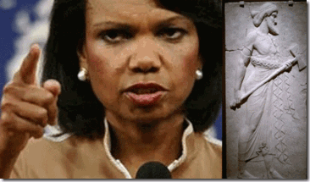
The Vulcans were also a Republican Presidential candidate George W. Bush’s foreign policy advisory team assembled prior to the 2000 U.S. presidential election led by the High Priestess/Witch Condoleezza Rice and included Richard Armitage, Robert Blackwell, Stephen Hadley, Richard Perle, Dov S. Zekheim (High Kabbalistic Rabbi Priest), Robert Zoellick and Paul Wolfowitz, and Wolfowitz protégé, Scooter Libby.[60] Rice’s Vulcans were a secret super cell planning group or key sub cell in the 9-11 Inside Job and Deception that brought down the twin towers, and building 7 and sacrificed thousands of lives as a ruse to invade Iraqi, and institute a virtual police state in America.[61]

Pharrell’s Masculinity- The BBC Virtually Has Him by the Balls
On September 11th 2001, the BBC announced the collapse of World Trade Centre Building Seven (The Salomon ([King Solomon] Brothers Building) at least 23 minutes before it was detonated by explosives. BBC has proven over and over again that it is nothing more than the propaganda arm of the British Empire,[62] and the ILLUMINATI.
“Unknown to the public, Reith [Lord John Reith, founder of the BBC] had been the prime minister’s speech writer. Ambitious to become Viceroy of India, he ensured the BBC became an evangelist of imperial power, with “impartiality” duly suspended whenever that power was threatened. This “principle” has applied to the BBC’s coverage of every colonial war of the modern era: from the covered-up genocide in Indonesia and suppression of eyewitness film of the American bombing of North Vietnam to support for the illegal Blair/Bush invasion of Iraq in 2003 and the now familiar echo of Israeli propaganda whenever that lawless state abuses its captive, Palestine.”[63]
Vulcan is also a mythological Roman Sun Deity who was associated with fire, thunderbolts, and light. The festival in honour of him was called the Vulcania in which human sacrifices were offered. “According to Diel, he bears a family relationship to the Christian devil.’ It is fascinating to know that he married Venus, another name for Lucifer or the devil. What is even more interesting is that Vulcan is adored in Masonry under the name of Tubal Cain. In the Masonic Quiz Book the question is asked: “Who was Tubal Cain?” The answer is: “He is the Vulcan of the pagans.” In Masonry, Tubal Cain is the name of the password for the Master Mason (or third) degree. Listen to what occultist and Mason, Manly Palmer Hall, has to say:
“When the Mason learns that the key to the warrior on the block is the proper application of the dynamo of living power, he has learned the mastery of his craft. The seething energies of Lucifer are in his hands and before he may step onward and upward, he must prove his ability to properly apply energy. He must follow in the footsteps of his forefather, Tubal-Cain, who with the mighty strength of the war god hammered his sword into a ploughshare.”[64]
Pharrell Williams believes that he is among the superior Vulcans. He appears to be among the most (MK ULTRA/MONARCH) prominent entertainment industry promoters of the Kabbalistic Vulcan Heresy, and the New World Order. He is a master of ILLUSIONS and Kabbalistic-Satanic deception.
Pharrell Williams, The Master of ILLUSIONS- Transhumanism and the Satanic Grammy’s

“… Satan is the adversary, not of God, but of mankind; i.e., the angel charged by God with the task of proving that mankind is an unworthy creation. In the transtopian context, Lucifer represents ambition, rebellion, rational enlightenment, and the dark side of Transhumanism.”[65]

Pharrell turned out to be a big surprise hit at the 2014 Satanic 56th Annual Grammy Awards in HollyWeird. He received seven nominations and took home at least three that included Best Song and Producer of the Year.[66] The Transhumanist Daft Punk, a robotic dance music duo steeped deeply in ILLUMINATI symbolism scored the 2014 Grammy’s Album of the Year and Record of the Year accepted by Pharrell Williams.

A pyramid stage at a Daft Punk show. The artists are symbolically over the base (representing the masses) but under the apex (representing the elite).[67]

Daft Punk sets the ILLUMINATI agenda to turn the music entertainment industry into a faceless cyborg control system conditioning the masses to turn into robots dancing and listening to scientifically (MK ULTRA/MONARCH) mind control sounds, rhythms, beats and melodies.
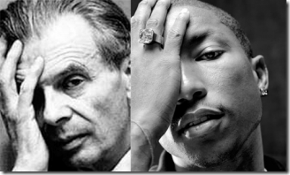
” It seems to me that the nature of the ultimate revolution with which we are now faced is precisely this: we are in process of developing a whole series of techniques which will enable the controlling oligarchy who have always existed and presumably always will exist, to get people actually to love their servitude.” -Aldous Huxley, [68]
At the basis of Transhumanism- “improving the species” and “improving human genetic qualities” is “veiled eugenics” (pseudo race science) that inspired the Greatest Racial Mass Murderers in History, the Nationalist Socialist State of Nazi Germany to create the Genetic Superior Race of Aryans to dominate the world; and eradicate the so called lower races by the millions.
“The term ‘Transhumanism‘ was coined by biologist Julian Huxley in 1957, who defined it as “man remaining man, but transcending himself, by realizing new possibilities of and for his human nature.”[69]
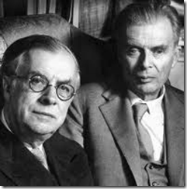
The British Crown’s Julian Sorell Huxley (1887-1975), brother of Aldous Huxley (British Godfather of CIA/MK ULTRA) was a Life Fellow of the Eugenics Society from 1925, its President 1959-62.[70] According to Huxley, “Transhumanism is an Illuminati inspired movement based upon the re-engineering of mankind using advanced technology. It seeks to improve the human body beyond its natural capabilities. It seeks to improve human intelligence using biochips along with the merging of mind with machine.”[71]
“Because that, when they knew God, they glorified him not as God,” Romans 1:21.

At the 2014 Grammy’s, Daft Punk, Little Lucifer- Pharrell Williams, and Nile Rogers upstaged the legendary musical genius of Stevie Wonder.
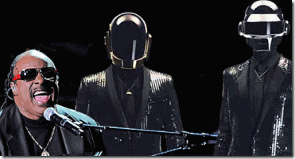
The fearful and spineless Stevie Wonder was forced to join and submit in a veiled praise tribute performance “Get Lucky” to their father- LUCIFER. In November 2012 due to public pressure, Stevie Wonder had been forced by the people and global mass conscious to back away and cancel a tribute performance to another notorious state sponsored group of racial mass murderers and ILLUMINATI/LUCIFERIANS, the Zionist Israeli Defense Forces.[72]
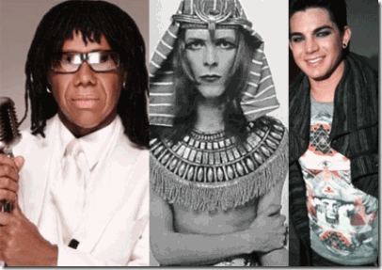
Niles Rogers, co-founder of the popular 70s band, Chic, is another story. Along with Pharrell, he also featured prominently in Daft Punk’s “Get Lucky.” He has submitted to the ILLUMINATI and Will of Lucifer. He worked and taught music to the ILLUMINATI and Satanists like Crowley(es) David Bowie, and American Idol Adam Lambert.
Pharrell, Daft Punk: Get LUCIFER
“Get Lucky” featuring Pharrell Williams and Niles Rogers
“Like the legend of the phoenix
All ends with beginnings
what keeps the planet spinning…
We’ve come too far to give up who we are
So let’s raise the bar and our cups to the stars…
I’m up all night to get lucky…” Daft Punk[73]
The Phoenix is a symbol of resurrection as well as the coming antichrist kingdom. William Schnoebelen, in his book, Satan’s Door Revisited , p. 4. “This Phoenix destroys itself in flames and then rises from the ashes. Most occultists believe that the Phoenix is a symbol of Lucifer who was cast down in flames and who … will one day rise triumphant. This [belief] also relates to the raising of Hiram Abiff, the Masonic ‘Christ’.”[74]
Often, blessings of God are given to Luck. There is a popular urban legend that “Luck” is derived from “Lucifer.” [75] The word “luck” dates to the 15th century and comes from the Middle Dutch word “luc” (short for “gheluc”), which means “happiness” or “good fortune.”[76]
The Dutch people referred to as Netherlanders, are an ethic native to the Netherlands.[77] The Frisians are a Germanic ethic group that occupied the coastal parts of the Netherlands (low countries) and Germany in antiquity.[78] When the Romans entered the low countries in the 50s AD, the people of the low countries were wild Druidic heathens and pagans preferred to as- “the savage people of Germania“.[79]
Get Lucky- Get “Loki”- Get LUCIFER

“The common saying ‘One for luck’, is probably just a continuation of the old pagan Nordic expression, ‘One for god and one for Wod (Wodin or Wodan) and one for Lok’, of which we read of in Karl Helm, Altgermanische Religionsgeschichte, p. 265. Please remember that the above quoted Netherlands dictionary stated that luck, luk and lok are different spellings for the same word. Forlong, Encyclopedia of Religions, vol. 2, p. 463, says that Luk is an ancient root for ‘light’ and related to Loki... Jacob Grimm, Teutonic Mythology, reveals more of the obscure origin of this mysterious deity. The names Logi and Loki were merged in times of old. 225 He further points out the apparent roots for these names to be: lucere, luken. 226 He also reveals that Locke was the Danish for the burning sun, and the Jutland’s Lokke was the heat of the sun, and that Loki, is by turns taken … for the sun, fire, giant or DEVIL.’ 226 Luka was also known as the fire-diety, as read on p. 242. Jacob Grimm on p. 82, vol. 1, of his Deutsche Mythologie, says that Lokki could be taken as an abbreviation of LUCIFER‘!”[80]


1 Corinthians 6:9
King James Version (KJV)
⁹ Know ye not that the unrighteous shall not inherit the kingdom of God…
What do you do with a brother like Pharrell that is so much a master of ILLUSIONS and Deceptions like his father, LUCIFER?

“The enemy has only images and illusions behind which he hides his true motives. Destroy the image [ILLUSIONS] and you will break the enemy.” Shaolin Abbot to Bruce Lee, Enter the Dragon (1973)

[1] http://www.esquire.com/features/essay/ESQ1206BLACKESSAY_108
[2] http://rapgenius.com/Jay-z-holy-grail-lyrics
[3] http://www.latimes.com/fashion/alltherage/la-ar-grammys-2014-pharrell-vivienne-westwood-hat-20140127,0,5230793.story#axzz2tOiwWdL9
[4] http://en.wikipedia.org/wiki/Vivienne_Westwood
[5] http://celebritybabies.people.com/2013/06/28/blue-ivy-carter-wears-crown-beyonce-jay-z/
[6] http://bossip.com/835698/parlez-vous-francais-humpback-hov-and-beyawnsay-looking-to-hire-euro-nanny-to-teach-blue-ivy-to-speak-french-43081/
[7] http://en.wikipedia.org/wiki/Vivienne_Westwood
[8] http://www.vogue.com/voguepedia/Vivienne_Westwood
[9] http://en.wikipedia.org/wiki/Sid_Vicious
[10] http://www.illuminati-news.com/Articles/42.html
[11] http://www.edwardianteddyboy.com/
[12] http://www.parareligion.ch/bowie.htm
[13]http://www.urbandictionary.com/define.php?term=new%20wave
[14] http://www.parareligion.ch/bowie.htm
[15] http://www.egs.edu/library/aldous-huxley/biography/
[16]http://en.wikipedia.org/wiki/Malcolm_McLaren
[17] http://en.wikipedia.org/wiki/EMI
[18] http://www.canada.com/vancouversun/story.html?id=77bed197-a77e-4696-b0ad-2b001250a2da&k=31178
[19] http://www.positive-feedback.com/Issue22/cjdiaries_lennon.htm
[20] http://en.wikipedia.org/wiki/Secret_Intelligence_Service
[21] http://en.wikipedia.org/wiki/Walter_Legge
[22] http://www.israelnationalnews.com/News/News.aspx/163206#.Uv_q-fldXZI
[23] http://www.positive-feedback.com/Issue22/cjdiaries_lennon.htm
[24] http://en.wikipedia.org/wiki/Frankfurt_School_conspiracy_theory
[25] http://100777.com/node/151
[26] http://en.wikipedia.org/wiki/The_Neptunes
[27] http://en.wikipedia.org/wiki/Chad_Hugo
[28] http://www.cnic.navy.mil/regions/cnrma/installations/nas_oceana.html
[29] http://www.complex.com/music/2013/08/what-were-rappers-parents-jobs/pharrell-williams
[30] http://shedrums.com/Medusa.htm
[31] http://www.pantheon.org/articles/a/atlantis.html
[32] http://kanechronicles.wikia.com/wiki/Sobek
[33] http://en.wikipedia.org/wiki/Neptune_(mythology)
[34] http://www.whale.to/b/ross3.html
[35] http://www.contactmusic.com/news-article/pharrell-im-just-like-da-vinci_08_03_2006
[36] http://en.wikipedia.org/wiki/Enochian
[37] http://en.wikipedia.org/wiki/Andrea_del_Verrocchio
[38] http://www.deliriumsrealm.com/john-dee/
[39] http://en.wikipedia.org/wiki/Andrea_del_Verrocchio
[40] http://en.wikipedia.org/wiki/Raphael_(archangel)
[41] http://www.jwmt.org/v1n10/angelic.html
[42] http://www.tomegatherion.co.uk/achiddengod.pdf
[43] http://en.wikipedia.org/wiki/Enochian
[44] http://religion.wikia.com/wiki/Michael_(archangel)
[45] http://www.lairweb.org.nz/leonardo/rocks.html
[46] http://en.wikipedia.org/wiki/John_Dee
[47] http://www.mysteriousbritain.co.uk/occult/john–dee.html‎
[48] http://www.cctv.bz/spirituality/10-Interesting-Facts-about-Archangel-Uriel_42461/
[49] http://transcripts.cnn.com/TRANSCRIPTS/1312/20/ta.01.html
[50] http://transcripts.cnn.com/TRANSCRIPTS/1312/20/ta.01.html
[51] http://en.wikipedia.org/wiki/Mona_Lisa
[52] http://en.wikipedia.org/wiki/Sala%C3%AC
[53] http://www.nydailynews.com/news/world/mona-lisa-leonardo-da-vinci-male-lover-salai-gian-giacomo-caprotti-claims-expert-article-1.133138
[54] http://unamsanctamcatholicam.blogspot.com/2010/04/was-dante-rosicrucian.html
[55] http://www.johndee.org/DEE.html
[56] http://en.wikipedia.org/wiki/Vulcan_(Star_Trek)
[57] http://www.bibliotecapleyades.net/sociopolitica/codex_magica/codex_magica21.htm
[58] http://www.bibliotecapleyades.net/sociopolitica/codex_magica/codex_magica21.htm
[59] http://firstlightforum.wordpress.com/2009/02/11/leonard-nimoy-alias-dr-spock-insights-into-a-hollywood-jew/
[60] http://en.wikipedia.org/wiki/The_Vulcans
[61] http://www.911truth.dk/first/en/faq.htm
[62] http://www.indymedia.ie/article/100404?userlanguage=ga&save_prefs=true
[63] http://johnpilger.com/articles/as-gaza-is-savaged-again-understanding-the-bbc-s-historical-role-is-vital
[64] http://www.whale.to/b/vulcan_salute.html
[65] http://vigilantcitizen.com/musicbusiness/transhumanism-psychological-warfare-and-b-e-p-s-imma-be
[66] http://en.wikipedia.org/wiki/2014_Grammy_Awards
[67] http://vigilantcitizen.com/latestnews/heavy-illuminati-symbolism-in-australian-ad-for-the-love-of-music/
[68] http://www.globalistagenda.org/technology.htm
[69] http://vigilantcitizen.com/musicbusiness/transhumanism-psychological-warfare-and-b-e-p-s-imma-be/
[70] http://www.galtoninstitute.org.uk/Newsletters/GINL9912/julian_huxley.htm
[71] http://johnthewitness.wordpress.com/2012/10/16/transhumanism-agenda-is-satans-counterfeit-ye-shall-be-as-gods/
[72] http://www.blackagendareport.com/content/stevie-wonder-disgraces-himself-concert-israeli-military
[73] http://www.azlyrics.com/lyrics/daftpunk/getlucky.html
[74] http://www.whale.to/b/phoenix_s.html
[75] http://wiki.answers.com/Q/Is_luck_a_derivative_of_Lucifer
[76] http://www.etymonline.com/index.php?term=luck
[77] http://en.wikipedia.org/wiki/Dutch_people
[78] http://en.wikipedia.org/wiki/Frisians
[79] http://en.wikipedia.org/wiki/Mythology_in_the_Low_Countries
[80] http://iahushua.com/ST-RP/christ.htm
Comments : 8 Comments
Tags: 12 years a slave, 9-11 deception, 9-11 inside job, adam lambert, aldous huxkey, Aldous Huxley, Aleister Crowley, angel michael, angel uriel, bbc, beatles, Beyonce, Blue Ivy, british empire, bruce lee, building 7, caliban, Condoleezza Rice, daft punk, david bowie, dr. spock, edward hugo, edward kelley, enochian language, get lucky, holy grail, horus, Illuminati, isis, jay z, john dee, john gesture, john ridley, john the baptist, Julian Huxley, kabbalah, Knights of the Black Sun, knights templar, kundalini, leonard nimoy, Leonardo da Vinci, loki, lord john reith, Lucifer, Lucifer's Servants, magna carta, mahalia jackson, mona lisa, Nazis, neptune, neptunes, niles rogers, Osiris, pharrell williams, prince william, priory of sion, punk counterculture, Reichsfurhrer Heinrich Himmler, Salaì, Satanism, sex pistols, sid vicious, SS, stevie wonder, transhumanism, twin towers, vivenne westwood, vulcan, vulcan hand symbol, wodin
Categories : 2014 Grammy Awards, 9-11, african american satanic cult, Aleister Crowley, ALL SEEING EYE, Aryan Supremacy, Barack Obama, beyonce, black christianity, clive davis, cyberneticist, cybernetics, cyborg, cyborgs, daft punk, david bowie, edward kelley, george michael zimmerman, george zimmerman, Hip Hop, holy grail, Horus, illuminati, Iraq, israel, jay z, jay-z, jesus christ, Jewish Defense League, john dee, john the baptist, justin timberlake, Knights of the Black Sun, leonardo da vinci, lucifer's servants, luciferians, mind control, MK-ULTRA, monarch program, new age religion, OLYMPIANS, Paul Josef Goebbels, pharrell williams, POST-HUMAN RENAISSANCE, queen elizabeth, racial mass murder, Rose-Croix, Rosicrucian, Rosicrucianism, rosy cross, Satanism, Secret Doctrine, SS, ZIONIST

Go to..
http://www.energyenhancement.org

For 34 Free..
- On Sign-Up - Energy Enhancement Books and Energy Enhancement Against Satanism Books.

To defeat Evil, you need to up your game.

Learn the Energy Enhancement Meditation Course by Video or Live in Iguazu.

ENERGY ENHANCEMENT MEDITATION
ENERGY ENHANCEMENT MEDITATION LEVEL 1 POWER UP!! GAIN SUPER ENERGY http://www.energyenhancement.org/Level1.htm
ENERGY ENHANCEMENT MEDITATION LEVEL 2 ELIMINATE ENERGY BLOCKAGES http://www.energyenhancement.org/Level2.htm
ENERGY ENHANCEMENT MEDITATION LEVEL 3 CLEAN KARMA BLOCKAGES AND PAST LIFE KARMA BY TRANSMUTATION http://www.energyenhancement.org/Level3.htm
ENERGY ENHANCEMENT MEDITATION LEVEL 4 MASTER ENERGY CONNECTIONS AND RELATIONSHIPS http://www.energyenhancement.org/Level4.htm













