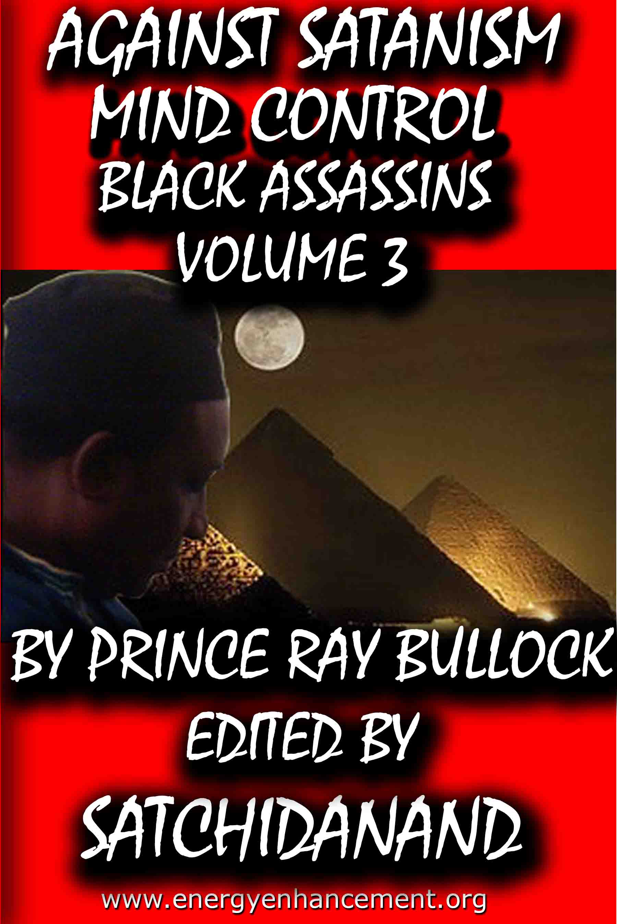

DEDICATION
With all Thanks, Love and Gratitude to Swami Devi Dhyani and all the helpers who make these books and DVDs possible.
With all Thanks, Love and Gratitude to my Mother and Father and to all my other Teachers, Theos Bernard, Sri Yogendra, Eric Berne, Gurdjieff, Father Bede Griffiths, Osho, Zen Master Hogen, Swami Sivananda, Swami Satchitananda, and all the other giants upon whose shoulders I stand - who made me able to be what… I AM – Swami Satchidanand

Copyright © 2020

[Energy Enhancement Synthesis of Light Limited (SOL)]

All rights reserved. This publication may be reproduced in whole or in part, by any person under fair use as long as we are referenced, without written permission of:
Swami Satchidanand

sol@energyenhancement.org
www.energyenhancement.org
AGAINST SATANISM
MIND CONTROL
BLACK ASSASSINS
VOLUME 3
BY PRINCERAY BULLOCK
EDITED
SATCHIDANAND
www.energyenhancement.org

Table of Contents
JUDGE ROY MOORE, TERRY CREWS, ME TOO, FREEMASONRY, SATANIC CIRCLES & THE PHILOSOPHY OF MARQUIS DE SADE 26
THE CULT OF THE SUPREME BEING, JUDGE ROY MOORE, THE NEO-NAZI, CONFEDERATE JACOBIN HIDDEN BEHIND THE MASK OF GOD 77
JUDGE ROY STEWART MOORE, TROJAN FIREBRAND & THE LEAGUE OF UNITED SOUTHERNERS- CRY AMERICA, CRY! 116
JUDGE ROY MOORE OF ALABAMA, THE LEAGUE OF THE SOUTH & THE SEETHING ENERGY OF LUCIFER 154
THREE- WENDY WILLIAMS, HOWLING MAN AND THE DEVIL & THE SECRET EARTH MOTHER GODDESS CULT AND THE HARVEST 190
THEY’RE ALL GONNA LAUGH AT YOU, WENDY WILLIAMS, THE WARLOCK, HORNED GOD & THE SATANIC THIRD RACE MATRIX 247
DE COON CAKE WALK, THE JEMELE HILL SECRET MATRIX, THE RISE OF THE THIRD SATANIC RACE & THE NFL 285


Go to http://www.energyenhancement.org for 34 Free –On Sign-Up - Energy Enhancement Books and Energy Enhancement Against Satanism Books.
To defeat Evil, you need to up your game. Learn the Energy Enhancement Meditation Course by Video or Live in Iguazu.


Change the World...


Go to http://www.energyenhancement.org for 34 Free Energy Enhancement Books.
To defeat Evil, you need to up your game. Learn the Energy Enhancement Meditation Course by Video or Live in Iguazu.
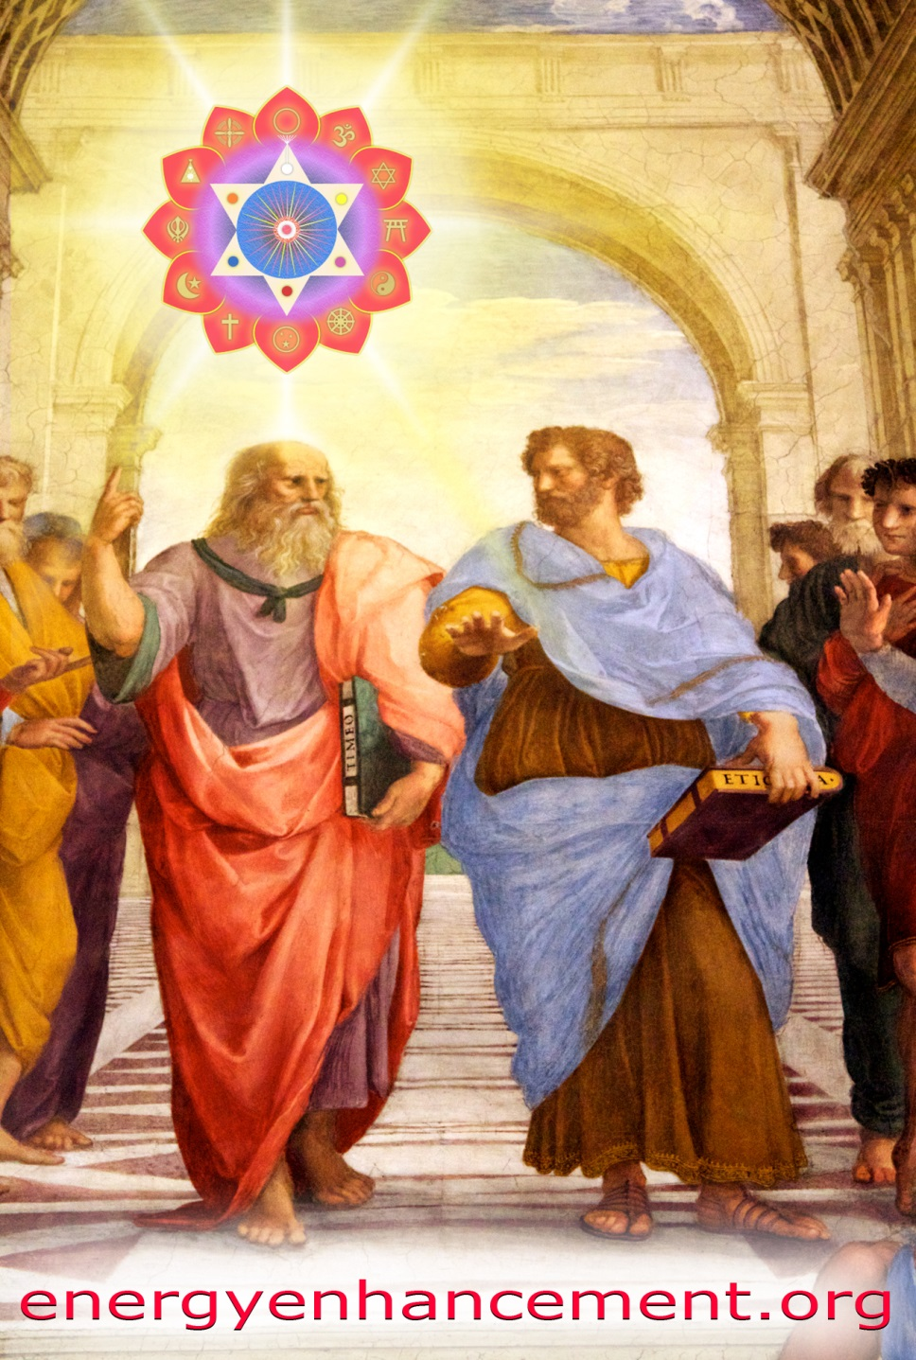

PLATO AND SATANIC BABYLONIAN SECRET AGENT ARISTOTLE "THE POISONER" OF ALEXANDER THE GREAT - BY RAPHAEL

ENERGY ENHANCEMENT MEDITATION
ENERGY ENHANCEMENT MEDITATION LEVEL 1 POWER UP!! GAIN SUPER ENERGY http://www.energyenhancement.org/Level1.htm
ENERGY ENHANCEMENT MEDITATION LEVEL 2 ELIMINATE ENERGY BLOCKAGES http://www.energyenhancement.org/Level2.htm
ENERGY ENHANCEMENT MEDITATION LEVEL 3 CLEAN KARMA BLOCKAGES AND PAST LIFE KARMA BY TRANSMUTATION http://www.energyenhancement.org/Level3.htm
ENERGY ENHANCEMENT MEDITATION LEVEL 4 MASTER ENERGY CONNECTIONS AND RELATIONSHIPS http://www.energyenhancement.org/Level4.htm
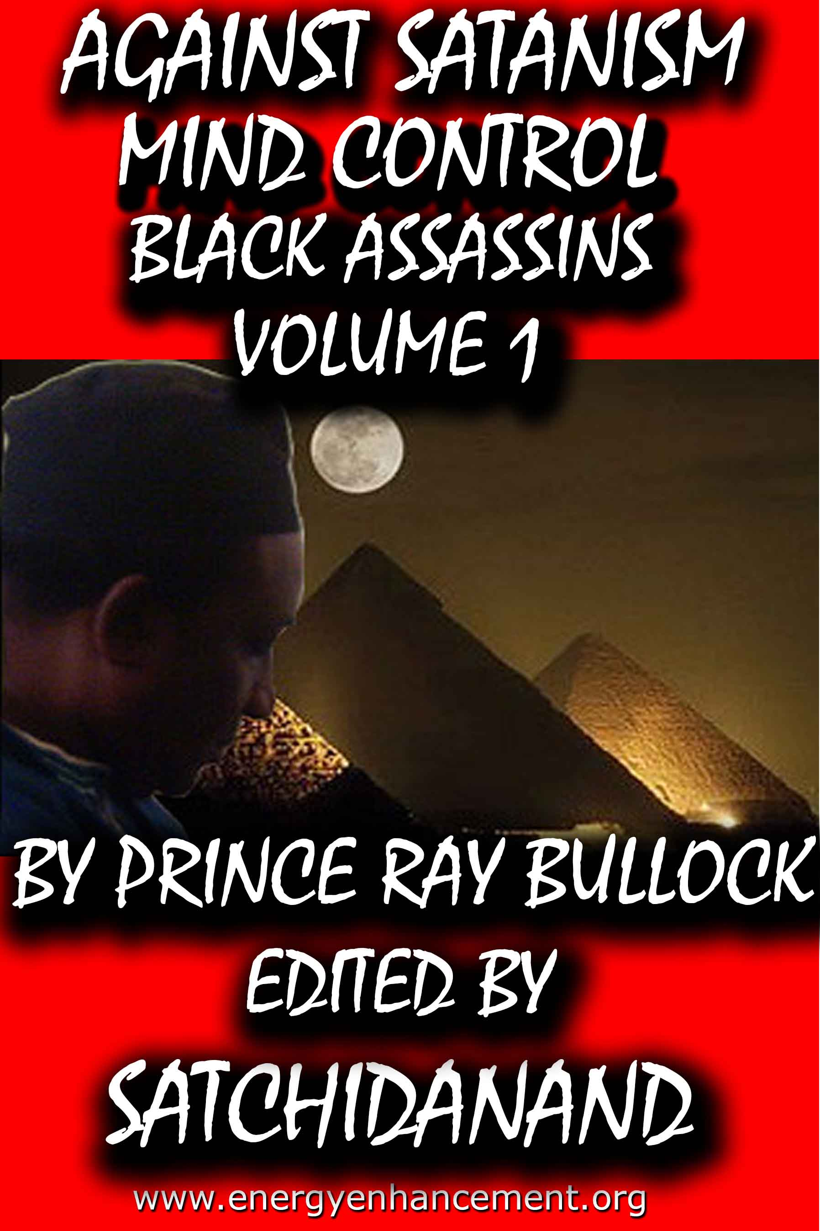
MIND CONTROL BLACK ASSASSINS VOLS 1-11 FREE!!

AGAINST SATANISM VOLS 1 – 6 FREE!!

- ON SIGN-UP AT..

energyenhancement.org

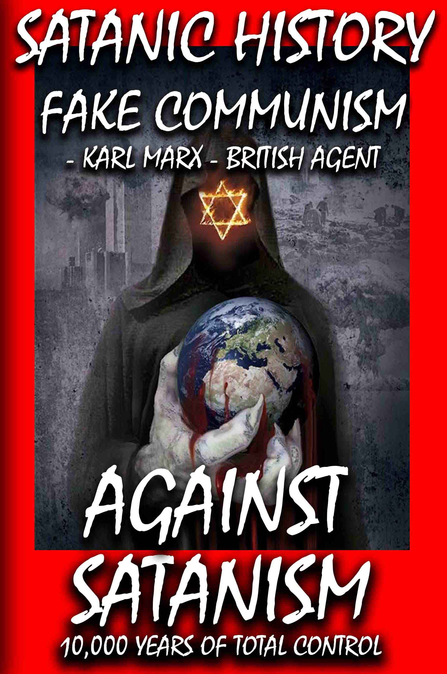

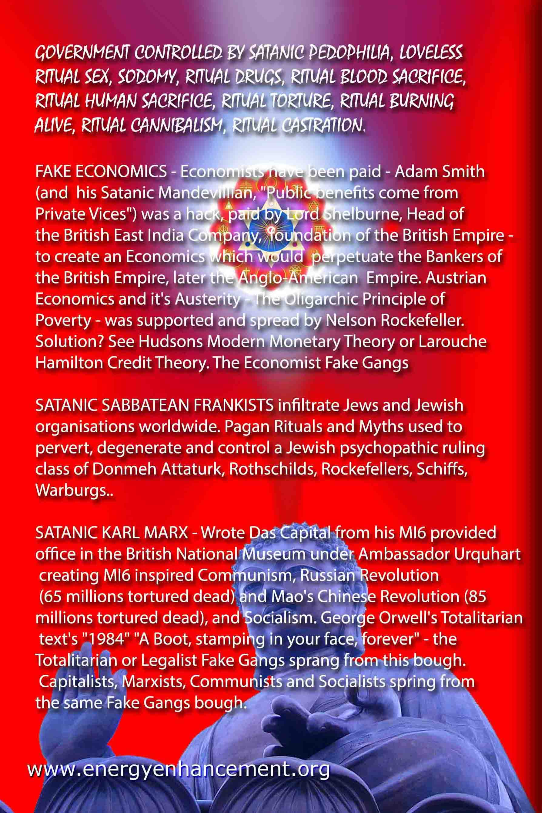

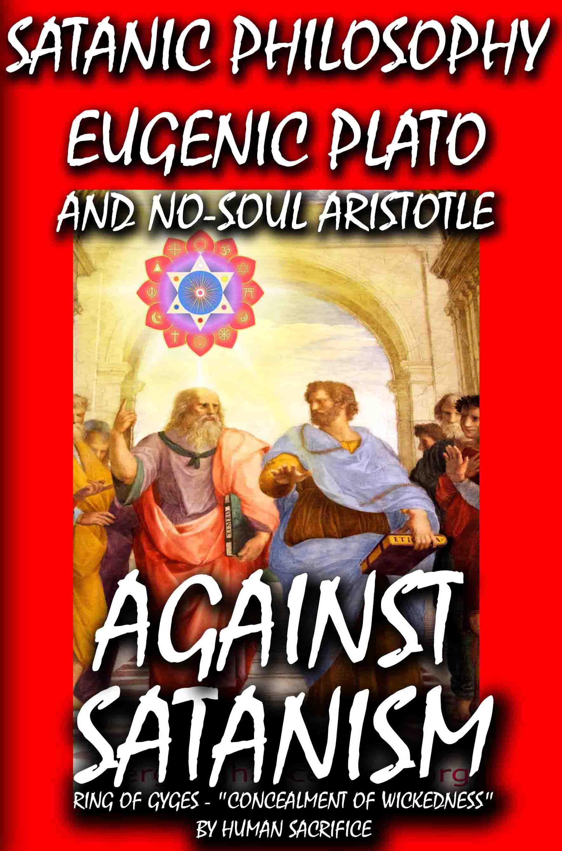

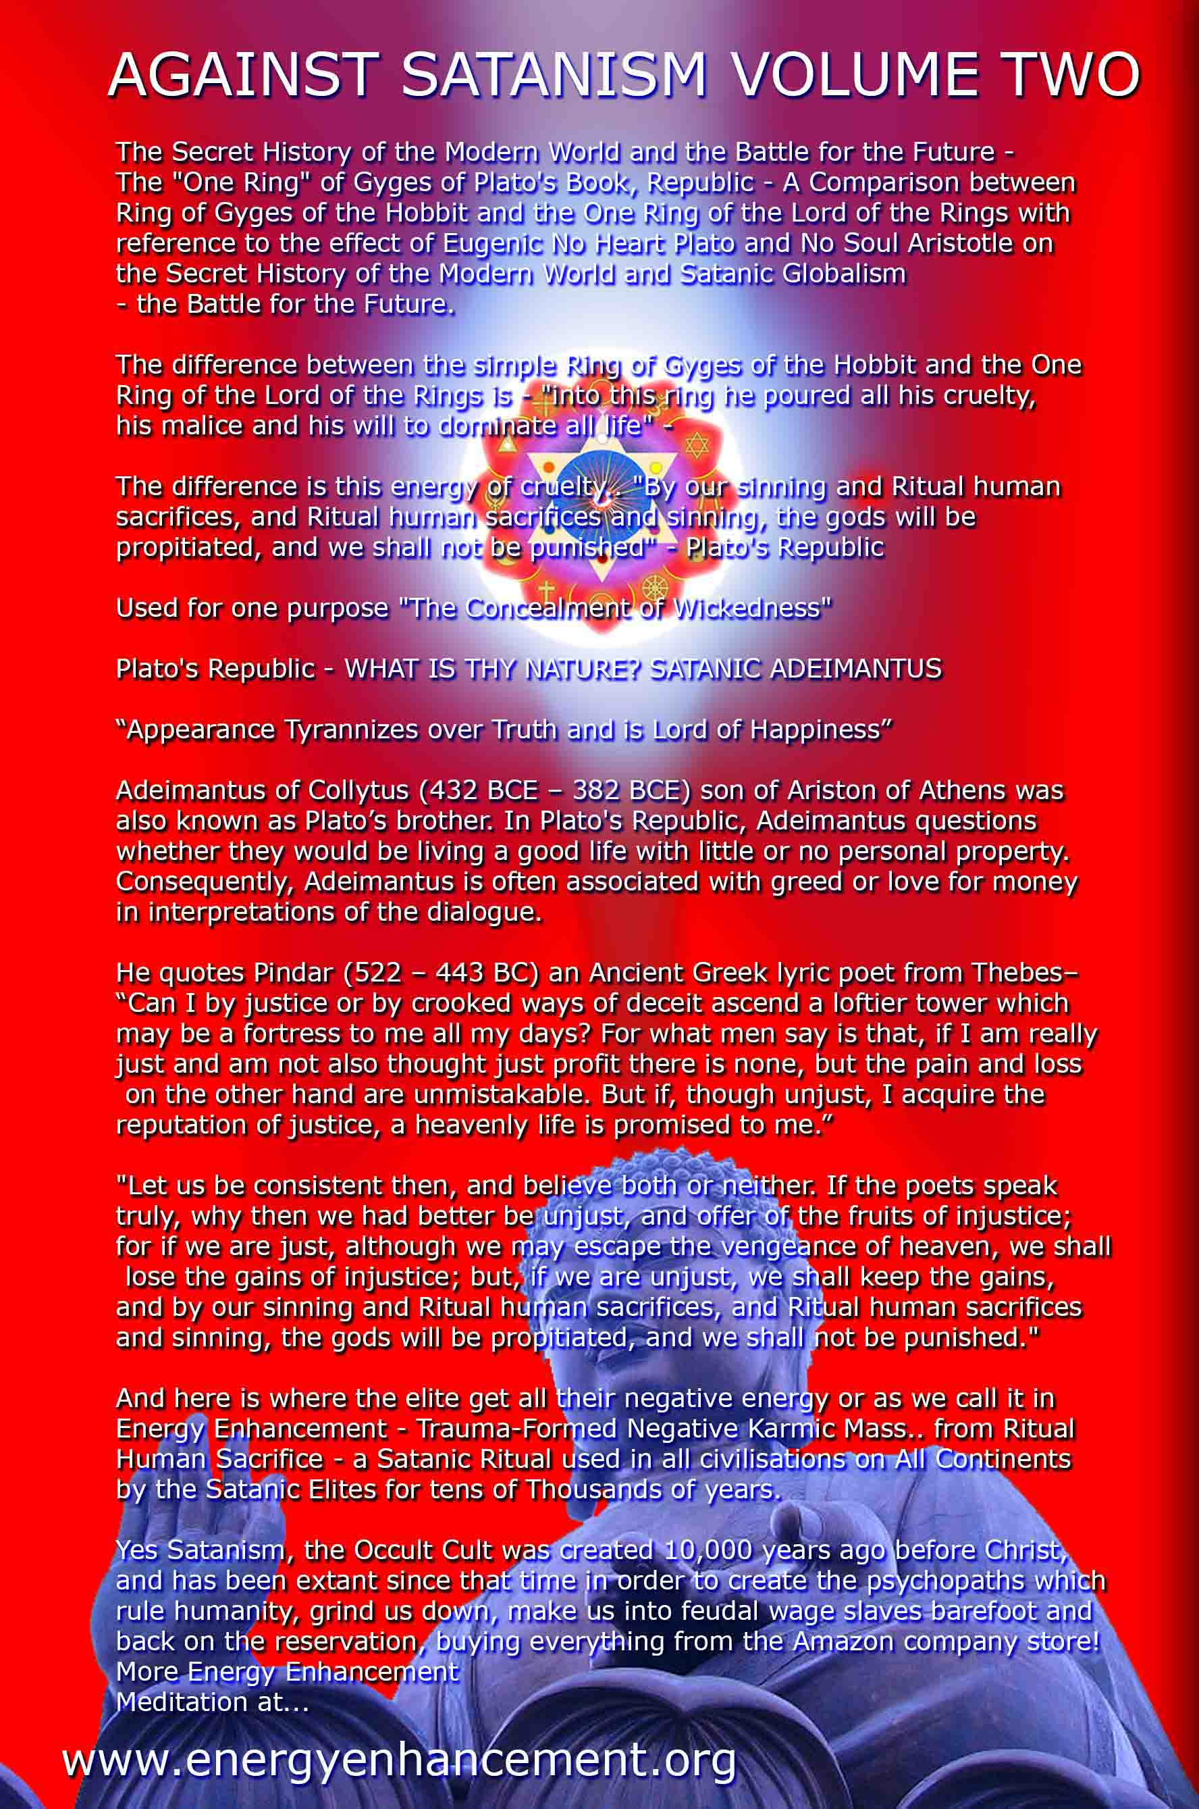

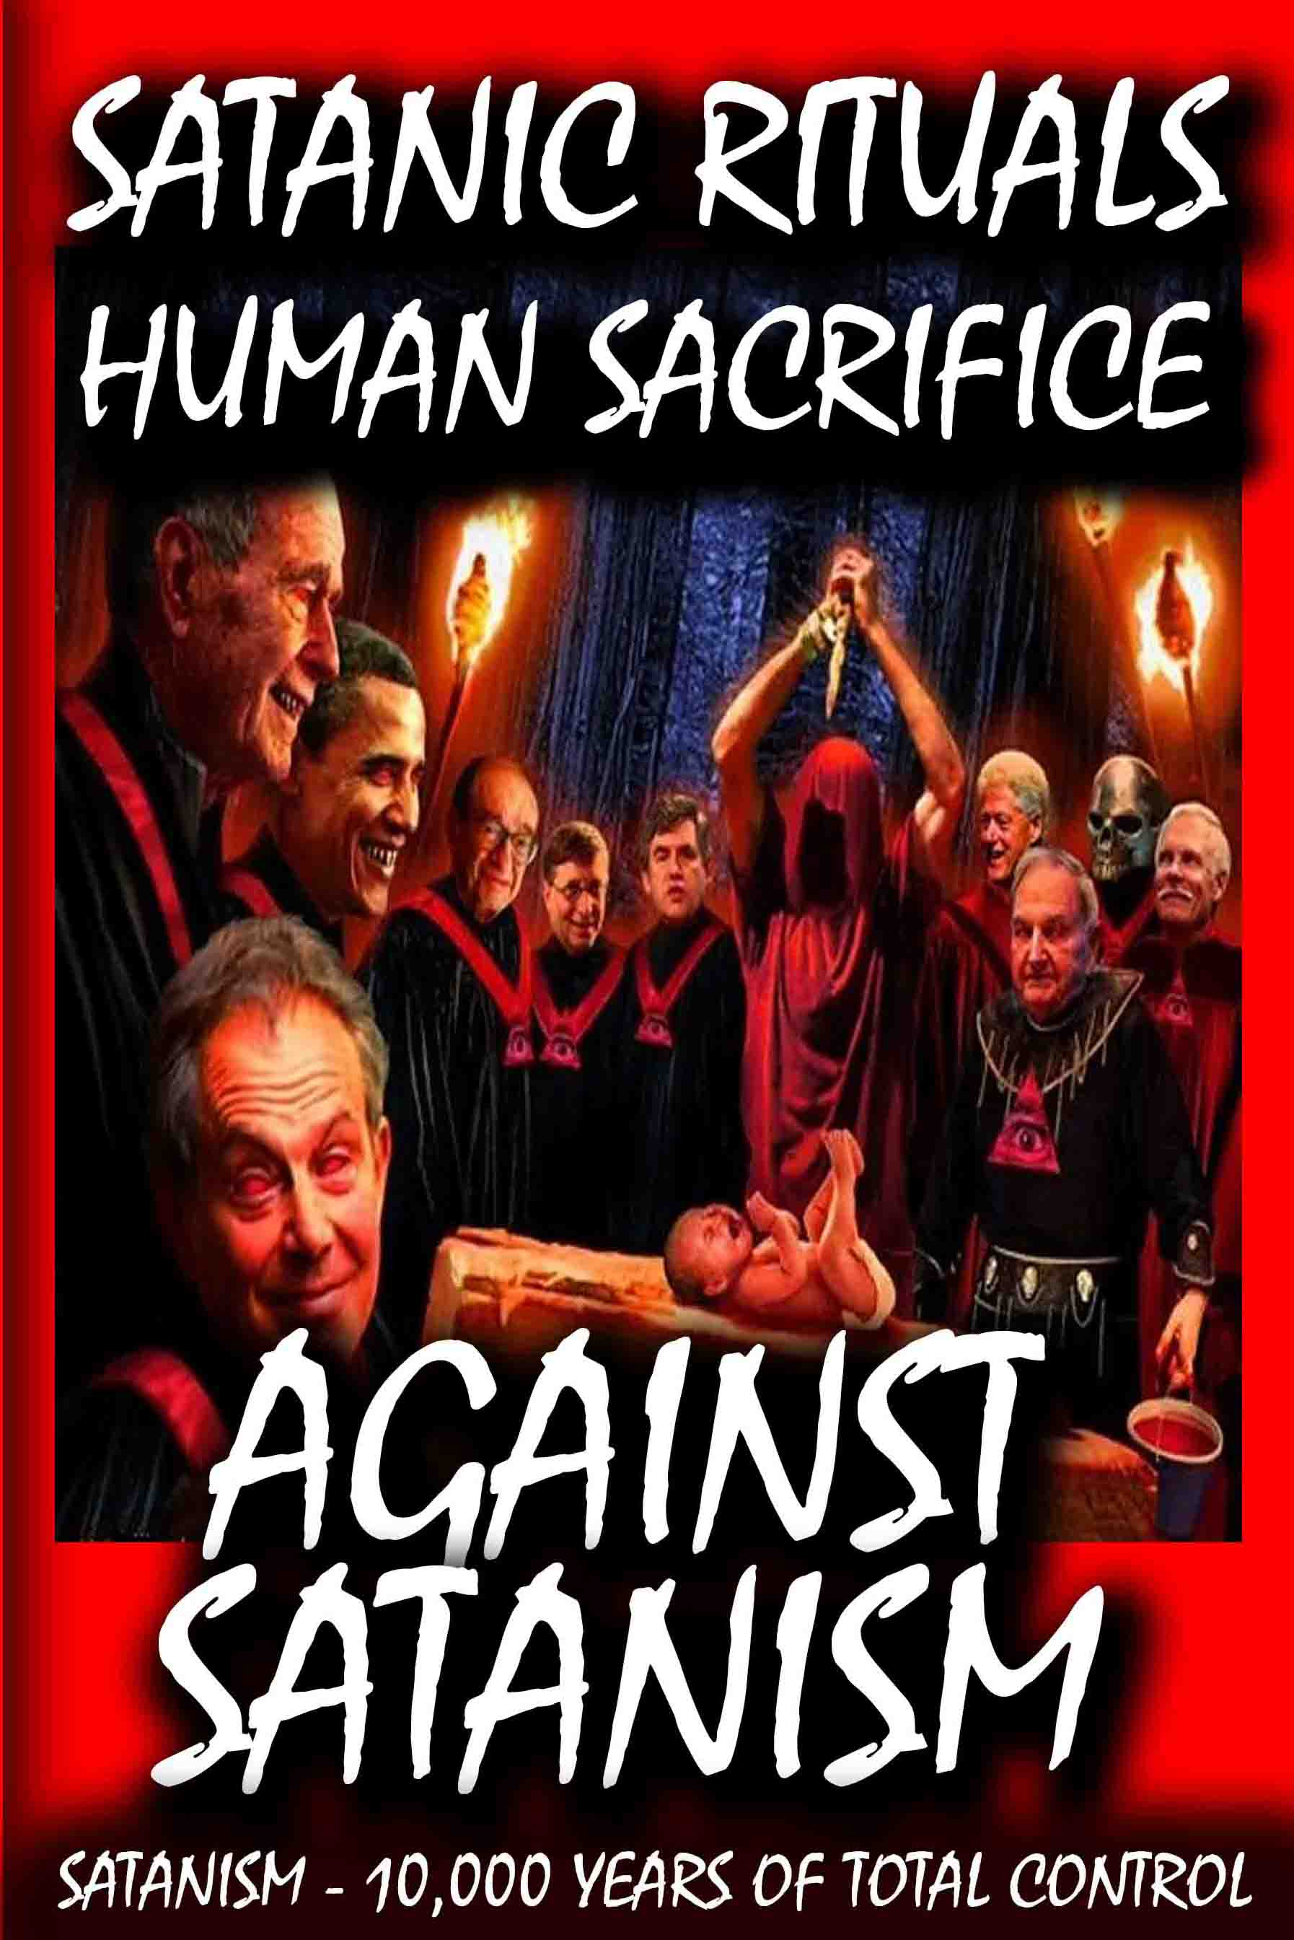

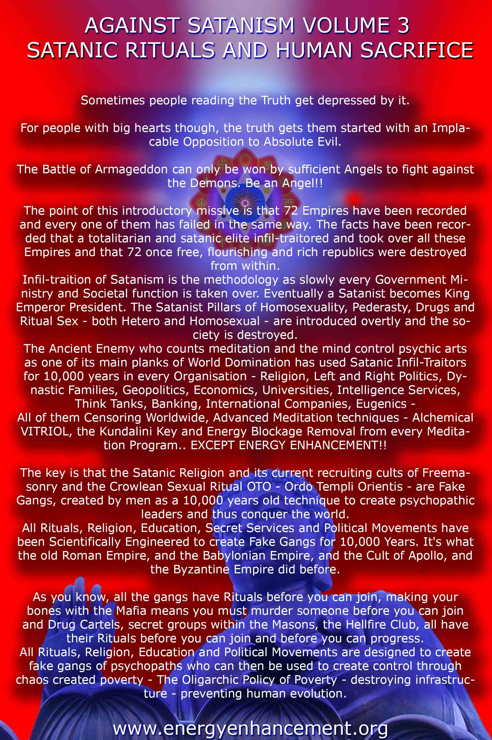

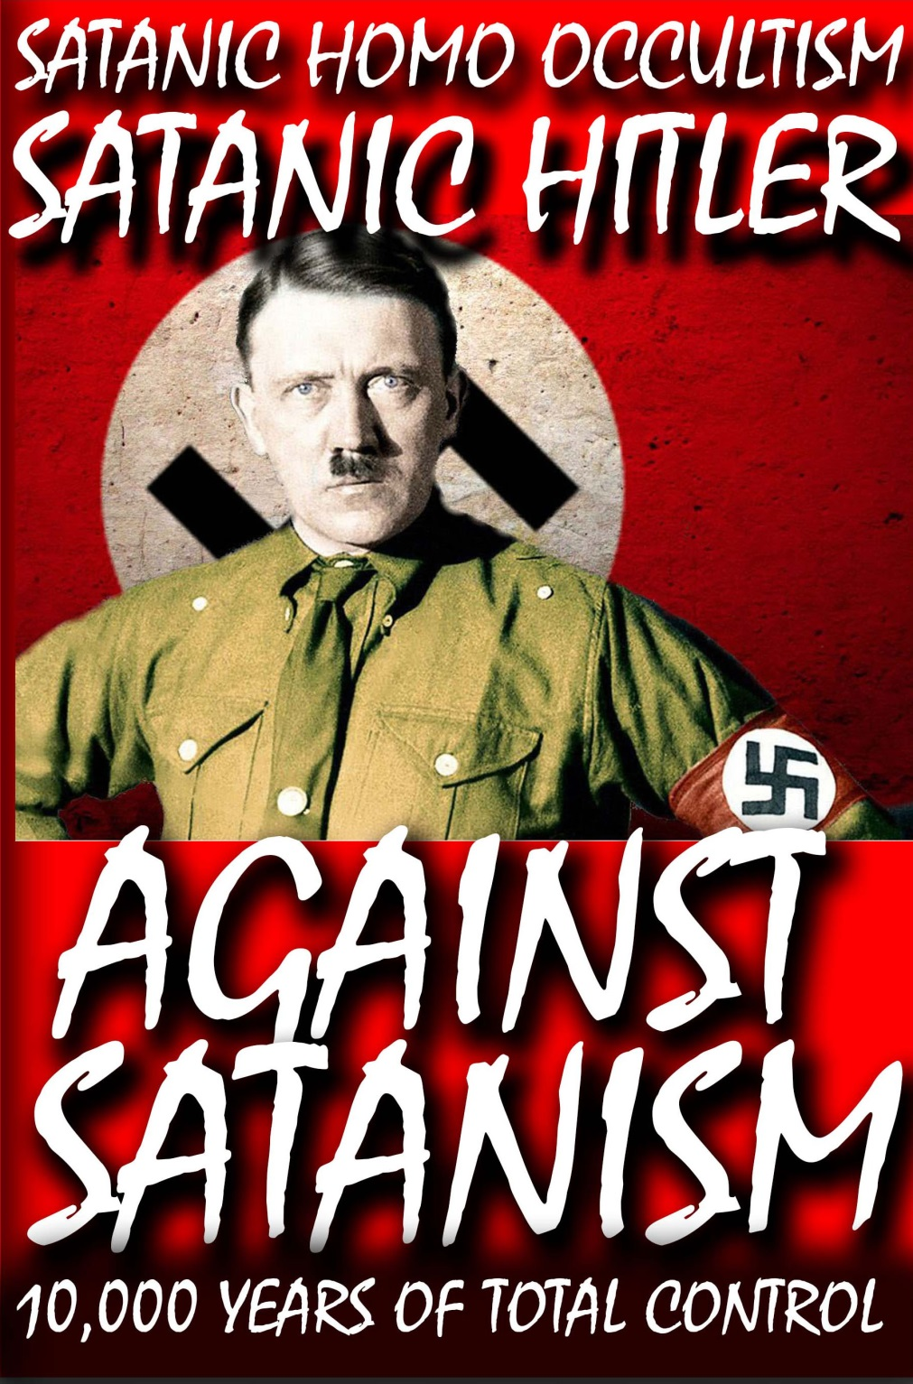

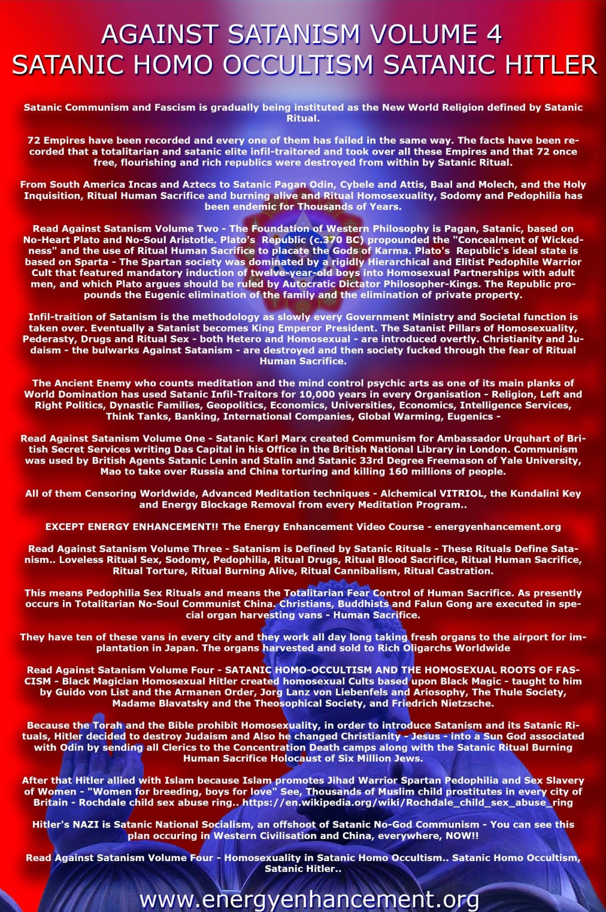

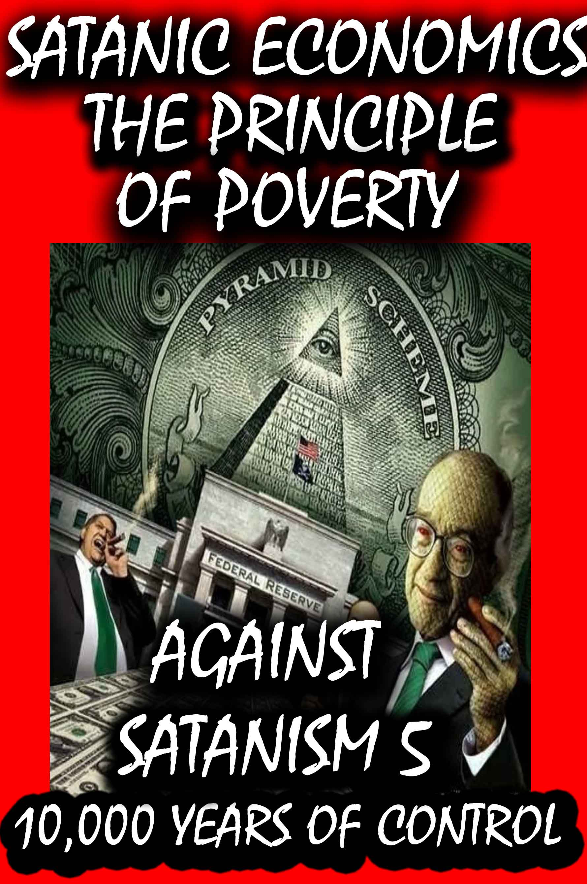

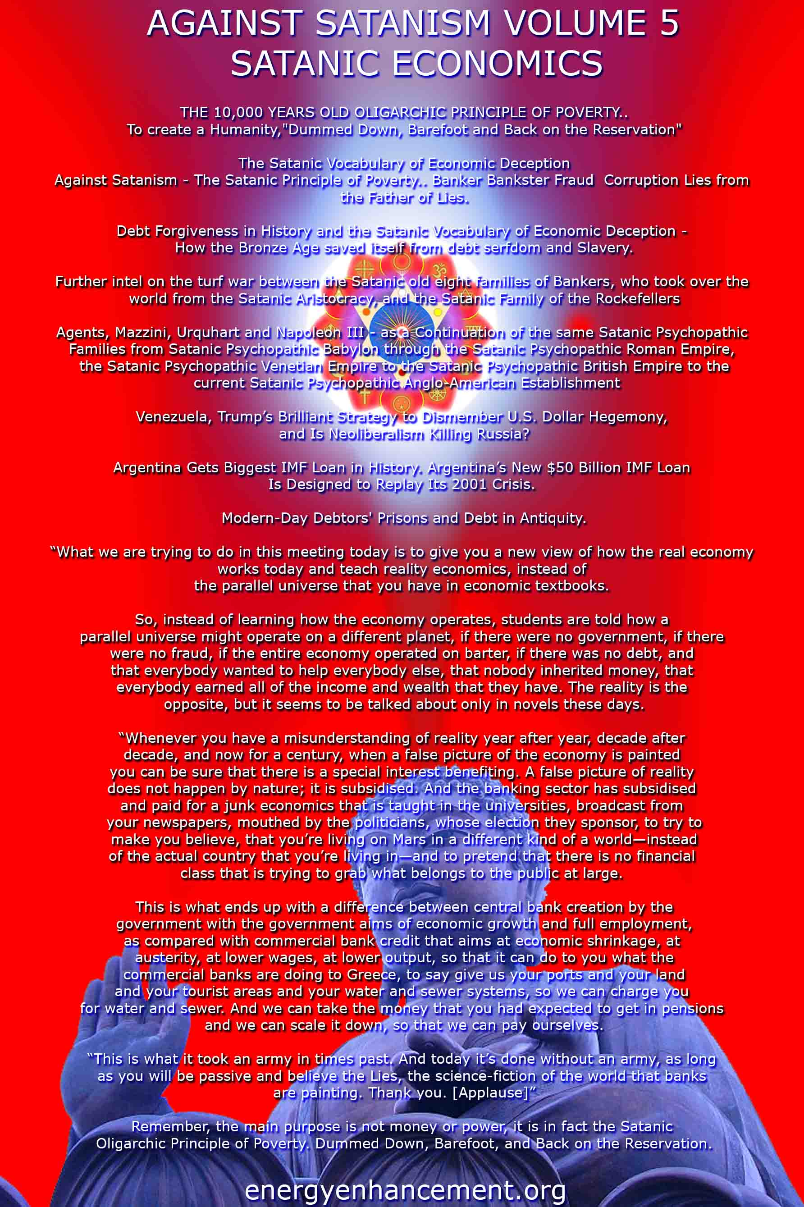

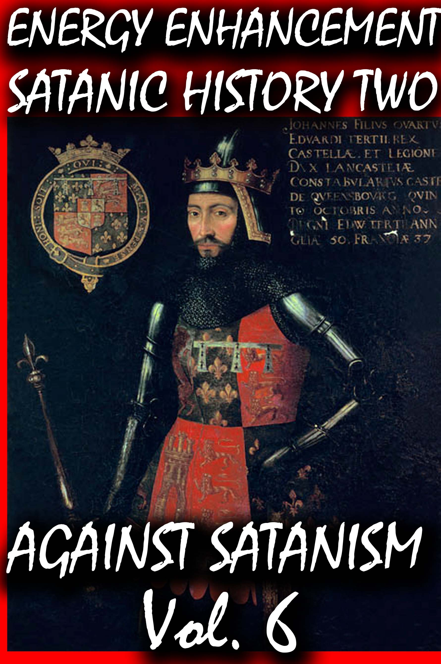
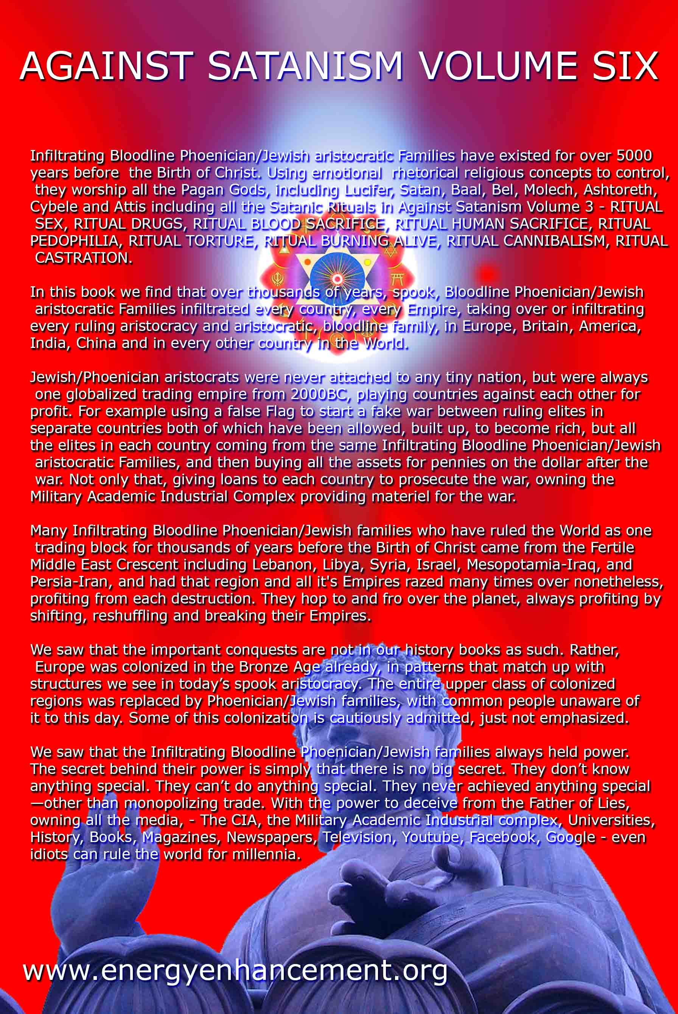
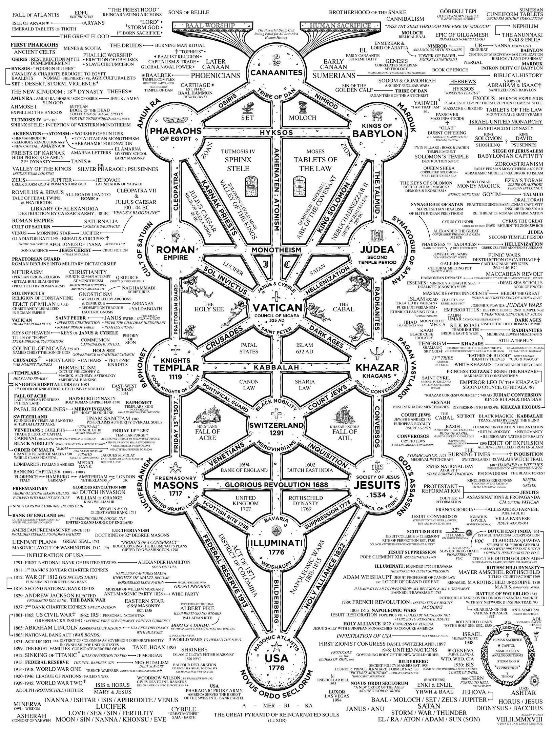

JUDGE ROY MOORE, TERRY CREWS, ME TOO, FREEMASONRY, SATANIC CIRCLES & THE PHILOSOPHY OF MARQUIS DE SADE
13122017
I
THE DE SADE CANCER
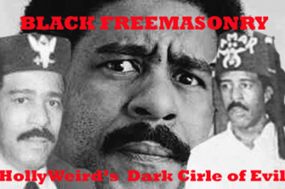
Richard Pryor’s ultimate insider joke about HollyWeird is no joke at all. It is not a de Sade moment or flash that that he describes existing in HollyWeird. Don’t get that twisted.
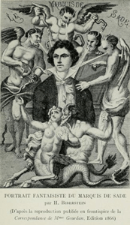
It vividly describes the secret universal Masonic fraternal order’s Marquis de Sade Philosophy of Satanic Ritual Debauchery and Sexual Abuse that people of color and women are subjected to on a daily basis to regularly work in the music-entertainment industry controlled by global elite Satanic Masonic cabals. It is now being exposed that it is also predominate in the halls of congress. And, it is getting much more secret and WORSE!
The feminist “ME TOO” sexual abuse campaign is a deeply shrouded controlled narrative plot. It is an ILLUMINATI diversionary tactic. It is a false flag. Nonetheless, false flags and mass population controlled narrative intelligence plots always contains elements of truth that makes it an effective propaganda tool. True, women are fundamentally, customarily and universally manipulated and ritually sexually abused by fraternal orders of global Satanic dark circle powerful men in HollyWeird like poster boy, Harvey Weinstein, represents. But the sexual abuse that Weinstein practices are not the results of individual weaknesses, or moments and flashes of de Sade. It is the custom, practice and philosophy of the secret elite Masonic fraternal orders and ruling Satanic Global Cabals. The current “ME TOO” sexual abuse campaign deliberately veils the much greater EVIL.
So too, the pedophilia charges against Judge Roy Moore also veils the much greater EVIL. At the very dawn of the Alabama Special U.S. Senate election, it is only now that Judge Roy Moore’s racist shroud is being partially unveiled by corporate mass media, but as a cloud of individual character weakness issue like a moments and flash of de Sade. They will not talk about MK ULTRA, and the multi- generational ultra– secret societies, Masonic fraternal orders, dark satanic (Saturn) and white doctrine supremacy circles that bind combinations together to form secret policies and principles of global perpetual ULTIMATE POWER, CONTROL AND EVIL.
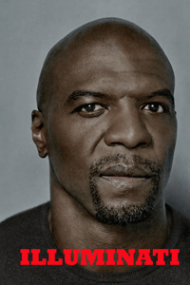
Black Actor Terry Crews, part of the “ME TOO” sexual abuse by powerful men controlled narrative and campaign, is a HollyWeird ILLUMINATI/Masonic MK ULTRA shrill.
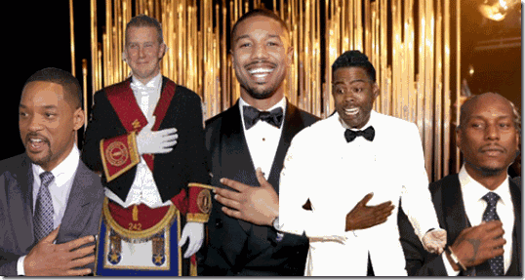
During the 2016 Oscar ceremonies, Chris Rock admitted that to work regularly in the HollyWeird entertainment industry- black people (Negroes) had to be cleared (MK ULTRA de Sade sexually abused– initiated) through secret dark [Masonic] societies.[1]
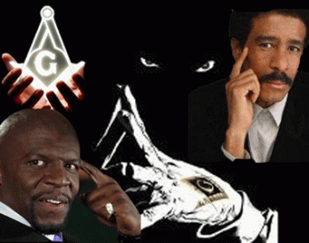
Prince Hall Black Freemasonry & the Marquis de Sade Philosophy
And, Terry Crews is no exception.
II
TERRY CREWS & THE HOLLYWEIRD ZIONIST KABBALAH-ZOHAR FRATERNAL DARK CIRCLE
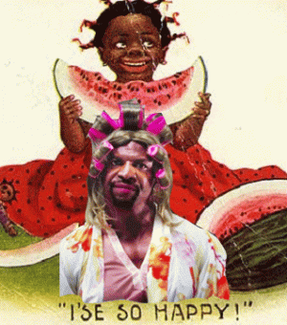
Coon Terry Crews’ Female Alter, I’ SE SO HAPPY or BRAINWASHED!
In 2009, the infamous powerhouse 111 year old William Morris Agency (WMA) merged with the 14 year old Endeavor in the HollyWeird talent agency representation business.

WMA Client, 6 year old JonBenet Ramsey
In the infamous 1996 child molestation murder case of 6 years old JonBenet Ramsey in Denver, Co, her parents, John and Patsy Ramsey, had most likely pimped her out as a child prostitute to the WMA who were taking child “Models” and using them to provide secret CIA MK ULTRA/MONARCH Occult Bureau child sex slave services for elite PIZZAGATE pedophiles and global counter- intelligence MK ULTRA clandestine white mail operations in addition to their casting and modeling shows.[2]

WME and Endeavor is headed by deep rabbit hole Israeli Zionist counter-intelligence agent, Ari Emanuel, CEO. Emanuel is Donald J. Drumpf’s friend and HollyWeird based talent agent.[3]
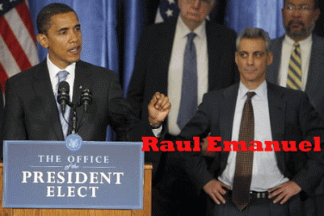
Emanuel is the younger brother of Chicago Mayor, former U.S. Congressman and Barrack Obama’s dual Israel citizen White House Chief of Staff-designate, extreme Zionist Mossad-IDF Agent, Rahm Emanuel.[4]
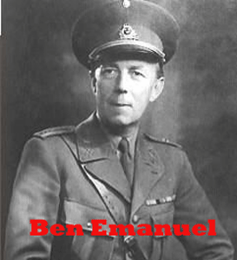
Benjamin Emanuel, the patriarch of the Emanuel family, was a member of IRGUN, the Zionist paramilitary group which was a violent radical offshoot of Haganah, a Jewish paramilitary organization linked to SS Baron Otto von Bolschwing and SS- Knights of the Black Sun.[5] There have been claims that the senior Emanuel personally mass murdered 80 Palestinians in the late 1940s during the State of Israel’s formative years. Benjamin adopted as his surname the first name of his brother, Emanuel Auerbach, who was killed fighting Arabs.
In 1948, IRGUN attempted to bring munitions onto the Israeli shore on the ship the Altalena, which was attacked by the Israeli Labor government before it could make landfall. The Altalena was purchased by American Jewish gangster Mickey Cohen, a member of Murder Incorporated, the assassination-for-hire branch of the American National Crime Syndicate, with ties to the Five Families of New York. Murder Inc. once operated out of a candy store in Brooklyn.
After the establishment of the State of Israel, IRGUN evolved into the political party Herut, which itself evolved into the political party Likud, which today runs Israel and is headed by Satan’s Son- Freemason, Prime Minister Binyamin Netanyahu. [6]

Steve Bannon and Breitbart News behind and pushing Judge Roy Moore in Alabama are products of Israeli Intelligence and Binyamin Netanyahu.[7]

Ari Emanuel
An April 2002 lawsuit by agent Sandra Epstein against Endeavor Agency brought accusations of patent philosophical debauchery by Epstein and other Endeavor employees against Ari Emanuel. In the court filings, Emanuel is alleged to have created an atmosphere of ritual sexual abuse, and allowed a friend to operate a pornographic website out of Endeavor’s offices. According to Epstein, Emanuel also made racist remarks that prevented her from sending a script about Navy Seals to black actor Wesley Snipes, saying, “That is the dumbest thing I’ve ever heard. Everyone knows that blacks don’t swim.” Emanuel disputed these accusations at the time. Epstein’s claims were settled for $2.25 million.[8]
WMA is also strong in the clandestine intelligence community, television and music; Endeavor reps a chunk of A-list actors, writers and directors. Adam Lawrence Venit (born, 1963, Cleveland) is a Jewish brotherhood protégé of Ari Emanuel, and a business partner of the Endeavor Talent Agency that handled the A- Actors List that included Adam Sandler. Venit was a vital business partner in the merger between WMA and Endeavor.[9]
Crews says that he observed Adam Venit at a HollyWeird industry private party sticking “his tongue in and out of his mouth provocatively” at him. Any normal person would have been forewarned by Venit’s provocative sexual suggestive gestures. Yet, Crews was still compelled to welcome the man into his inner circle of human dignity occupied by his wife. He claimed that Venit groped his genitals, “squeezing so hard that he leapt back in pain.” He “squealed like a pig” in a hog pen, and a toy doll crying “ma-ma”. A lawsuit alleges that Crews alerted Adam Sandler, who was at the party. Venit is his HollyWeird entertainment industry representative. The lawsuit says that Crews cried out by yelling, “Adam, come get your boy! He’s grabbing my nuts.”[10]
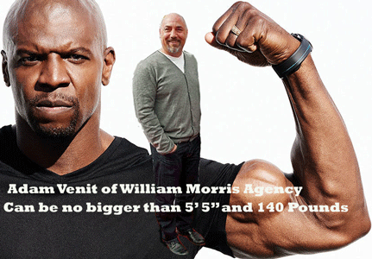
Crews is a former NFL linebacker standing about 6’ 4” and weighting in at about 240 pounds of muscle and mass. Allegedly, he trains in Brasillian Jiu Jistsu under Jiu Jitsu legend Rigan Machado.

Crews knows all too well how to protect a circle of safety and dignity with only one hand. He didn’t have to cry out for Sandler to come get his man. And, he didn’t have to physically harm Venit to protect his circle of security and well-being.[11] Yet, he was mentally disabled to such an extent that he couldn’t even push his abuser out of his inner space of human dignity.

You Don’t Mess with the Zohan is a 2008 American political satire comedy produced by Adam Sandler, who also starred in the film. Zohan Dvir (Sandler) is a superhuman Israeli counter-terrorist (Mossad Special Forces Combat Veteran) and the finest and most respected soldier in the Israel Defense Forces (IDF). However, Zohan has become both disgusted and disillusioned by the constant fighting, secretly dreaming of moving to the US and becoming a hairdresser.[12]

Sandler’s Zohar Dvir is the Hollywood concept of an elite Israeli counter-terrorism fighter is no mere hyperbole. It is ultra-clandestine Zohar Dvir — Israel Police deputy commissioner. Many claim that the main character in Adam Sandler’s 2008 film “You Don’t Mess with the Zohan” — a former crack IDF operative whose full name is actually Zohan Dvir — was based on him.[13] Sandler’s Zohan Dvir is a dangerous Israeli Mossad agent that allegedly reluctantly kills and mass murder Palestinians as an avocation, while forgoing his real dream: to cut hair in the US for Paul Mitchell. There is absolutely nothing “lovable”, comical or amusing about that. No matter how Sandler shrouds Israel and its crimes against humanity in Palestine, we call it by no other names than racial apartheid, and genocide.[14]

Adam Sandler, Female Alter- Jill Sadelstein in Jack and Jill
Yes. Adam Sandler. This is the super bad ass Zionist Mossad IDF mass murdering agent want to be that this big rusty ass Negro wants us to believe that he cried out for to come and protect him from a fellow Jewish Zionist fraternal brother that is reluctantly a MK ULTRA sexual predator and handler. But, somebody has to do it, right. Well, Sandler also has a female alter that wants to play with and crush his nuts. It makes absolutely no sense at all! Normally, that is the case.
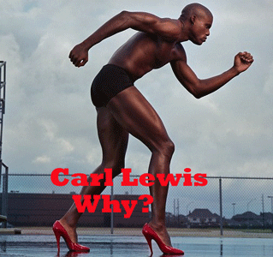
However, much of this Masonic dark circle and Negro Freemason MK ULTRA programmed Female Alters, and Male/Female triggers and switches snuff I surely don’t understand! Can they not see themselves and their humanity and dignity humiliated?
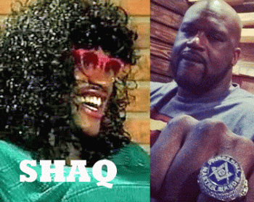
Shaquille O’Neal Woman or Man- Prince Hall Freemason
It appears that Sandler is fascinated with black man’s penis or lack of a penis, too. In October 2014, Sandler stopped by Conan last year and told a whopper of a locker room story. It seems that when Sandler was kicking it on the set of Grown Ups 2 with basketball legend Shaquille O’Neal, he hit the locker room with one thing on his mind. To quote Sandler, “I gotta see Shaq’s penis!” Shaq may be programmed to serve the Satanic Masonic dark circle in duality to have a penis and no penis at all. [15]
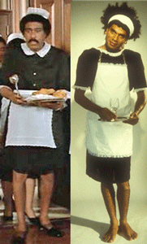
Prince Hall Freemason Richard Pryor may also have been programmed to SERVE the ILLUMINATI with a Penis and then no Penis at all. The February 2016 HollyWeird Zionist Kabbalah- Zohar industry private party attended by Crews, Sandler, and Venit was undoubtedly a satanic homosexual initiation rite.
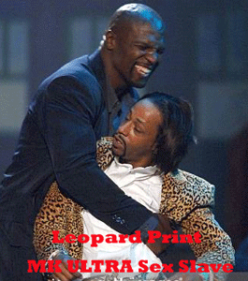
In the 2002 “Friday After Next” HollyWeird feature film, Terry Crews was stereo-typically cast as a hulking black ex-convict, Damon Pearly, which involves a very complex MK ULTRA psychological warfare ritual homosexual sodomy rape rite- gender confusion scene with Katt Williams, and then a ritual crushing of a black man’s genitals- a racist eugenic anti- fertility ritual.
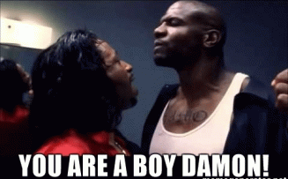
Damon is no BOY!

Above, Katt Williams is crushing, ritually destroying black manhood, Crews’ balls with a pair of pillars. In Crews’ gathering with the brotherhood of Jewish Zionists regarding his balls and manhood, not one of Jewish fraternal brothers at the so-called party have come forward to even acknowledge the “Crew Sexual Assault” ever took place. Neither Sandler nor Venit have publicly acknowledged the incident. So, it would be helpful if Crews and or his wife expose where the party was, and who was there, but that won’t happen. As a testament to what took place, they care nothing if anything at all for health, safety and welfare of Crews and his wife. But, its a much more deeper rabbit hole.
III
TERRY CREWS, MK ULTRA AND THE DE SADE PHILOSOPHY

Programmed Sexual Deviant Adolescent Terry Crews
Oddly, February 2016 was also the same time that Crews self-admitted that he had been addicted to pornography and debauchery since he was 12 years old. He had been turned into a freakish social sexual deviant at an uncommon early age for the era.[16] Terry Crews was born in 1968. So, where did he get pornography in 1980 at 12 years old when the worldwide internet didn’t exist until the 1990s? Was it CIA MK ULTRA- ritual sexual abuse and programming? After attending a Flint, Michigan elementary school, Crews got a scholarship to a special international brotherhood-sisterhood place called Interlochen (meaning “between the lakes”) Arts (summer) Camp in Michigan.[17]
CIA MK ULTRA Subproject 103 was conducted by Robert Cormack and A.B. Kristofferson at the Children’s International Summer Villages, Inc. in Maine. The subjects were 16 to 21 years of age and were there for a reunion; all had attended the camp in previous years as 11-year olds. The academic purpose of the project was to study how children communicate when they do not share a common language. The CIA was interested in the project as a cover for establishing relationships with children from a variety of countries. Obviously, the intent was to recruit them as agents or assets. A MEMORANDUM FOR THE RECORD from the Subproject 103 documents dated 10 December 1959 states that:
It is felt that this project will support the [whited out] need for cover. In addition it will assist in the identification of promising young foreign nationals and U.S. nationals (many of whom are now in their late teens) who may at any time be of direct interest to the Agency…. No cleared or witting persons are concerned with the conduct of this project.
The principal investigator for MK ULTRA Subproject 112 was Melvin DeFleur of the University of Indiana. He studied perceptions of occupational roles in children from first to eighth grades. According to a MEMORANDUM FOR THE RECORD dated 24 March 1960, the CIA’s “interest is connected with the current problems of vocational guidance with possible applications to the selection of technical and scientific careers.”[18]

I compare Crews’ human shock, pain, humiliation and reaction to WMA’s ritual sexual abuse to what happened to Wendy Williams on Halloween. She was patently humiliated before millions when she suddenly lost consciousness from fright and dropped to floor live on international television.

Immediately after the incident, she didn’t lash out at her handlers- she regressed to an early level of her MK ULTRA mind control programming (SEX KITTEN) by post-hypnotic suggestions and implantation. These post-hypnotic suggestion and implantation levels are multi-leveled and may delve down dozens or hundreds of levels.
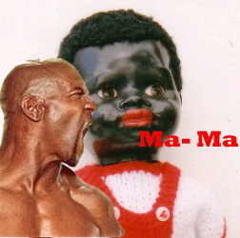
Faced with an absolutely normal human reaction that one would defend his or her humanity, dignity, womanhood or manhood against a patent sexual abuser and aggressor. However, attacked sexually, Terry Crews squealed like a pig, or cried out “ma-ma” like a voice box toy doll when squeezed instead of protecting his human dignity.
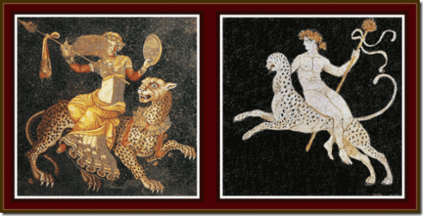
The (MK ULTRA) LEOPARD is a Totemic Symbol of Dionysus
Both ancient Greek Gods Pan and Dionysus were gods of fertility, presenting unbridled sexuality and carnal desire.[19] Some ancients saw no difference between Dionysus and the DEVIL. Euripides echoed this belief in the “Hecuba“; one of the god’s names was Dionysus Morychos “the dark one”, a rough equivalent of SATAN, who wore goatskins and dwelt in the underworld.[20] After being universally humanly humiliated, Crews regressed like Wendy William to an early level of his MK ULTRA mind control programming (SEX SLAVE KITTEN CHILD PROSTITUTE) by post-hypnotic suggestions and implantation. He recalled his early childhood MK ULTRA programming of social sexual deviance disorder with pornography was reinforced.
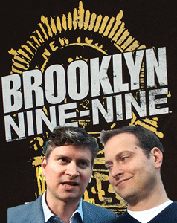
Michael Schur and Dan Goor
Crews’ television- film career has not been harmed at all after the February 2016 incident with the Zionist Jewish Brotherhood. He continues a starring television spot on Brooklyn Nine-Nine. It is an American police television sitcom that premiered on Fox on September 17, 2013 created by Dan Goor and Michael Schur.[21]
Judaic Daniel Joshua Goor of Bethesda, Maryland is the son of Ronald S. and Nancy Goor. His father is a science administrator for a notorious clandestine MK ULTRA funding agency, the National Heart, Lung and Blood Institute of the National Institute of Health.[22] He is a government specialist of eye-mind physics.
“Dr. Goor took his 180 degree camera lens to photograph the inside of a Concorde jet, and control area of a tank … to capture these activities for children.”[23]

Richard Pryor- Prince Hall Freemason Human Toy of the Elite
Judaic Michael Schur is of Eastern European Ashkenazi Jewish descent.[24] In Brooklyn Nine-Nine, Crews is cast as Sgt. Terry Jeffords. Goor and Schur created the role especially for him. They wanted a hulking Mandingo big dick black brute toy without a brain, like wanting rain without the wind, thunder and lightning.
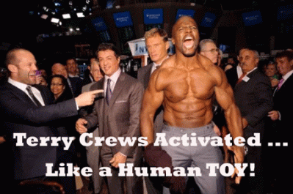
“… one adjustment we did make was we sort of adjusted Terry [Crews’] character [also named Terry] a bit because our original idea for him was that he was a completely broken man. He was the perfect physical specimen — he was physically strong but psychologically weak. I think what we found is that Terry Crews, the actor, is so funny when he’s activated …”[25]

Young Goor and Schur gave us their code and number Nine- Nine (99). When HollyWeird A-List star, Charlie Sheen, was confronted as being a satanic priest and warlock, he also gave us his code and number Nine- Nine (99).
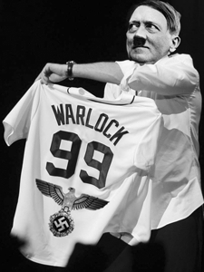
The Nazi Fuhrer Adolf Hitler was a member of a German Satanic Lodge. Excerpt: “I would like to pass on some of the information which, according to Otti Votavova, she received directly from Franz Bardon. According to her, Adolf Hitler was a member of a 99 Lodge. Besides this, Hitler and some of his confidants were members of the Thule Order, which was simply the external instrument of a group of powerful Tibetan black magicians which used the members of the Thule Order for their own purposes.”
A 99 Lodge was a F O G C Lodge, the Freemasonic Order of the Golden Centurium. It was a purely magical-mystical loge was founded in 1840 in Munich by some German rich industrialists and well situated citizens. This lodge existed until 1933. At all times only 99 persons of the male gender could belong to this esoteric working-group or secret lodge. This lodge [26]basically never appeared in the open.[27]
President Donald J. Drumpf in February 2017 visited the National Museum of African American History and Culture in Washington DC, and was reportedly moved to an audibly comment on the horrific nature of slavery during his tour. Drumpf came upon a stone auction block for selling Africans, he commented: “Boy, that is just not good. That is not good.” That’s about all that he had to say about the horrors and EVIL of African Human Bondage.[28]
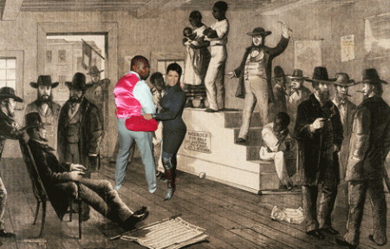
Terry Crews and his wife had been placed on a Slave Auction Block. Adam Venit, business partner and principal of WMA physically inspected then crushed Crew’s genitals as if the Negro was for sale, and he was indeed put on sale by the global satanic fraternal order.
IV
CONGRESSMAN TRENT FRANKS, JACOBINS, THE LATTER-DAY SAINTS MASONIC ORDER & SLAVERY
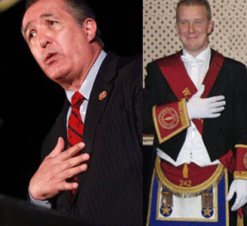
That leads us to now former U.S. Congressman Trent Franks representing the 8th District of Arizona. Franks is an ultra-conservative Republican that aligned himself with the Jacobin Club tea party, joining the House Tea Party Caucus in 2010.[29]
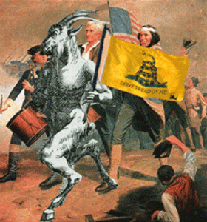
The Tea Party Movement took its name and ideas from Freemasonry. The Tea Party Movement of 18th century Revolutionary New England had its origins in Boston with Goat-men at the Green Dragon Tavern of the St. Andrews Lodge and the Grand Lodge of Massachusetts (Ancients).[30]
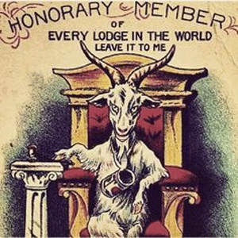
Likewise, the French Revolution of the 18th century had its origins with the Jacobin Clubs where the leaders of the Revolution concocted their plans for the abolition of the monarchy and the aristocracy. There seems to be proof that there was a coalition of the revolutionary conspirators with the ILLUMINATI and the Freemasons which formed the Jacobin Clubs, those Bodies being, as they contend, only Masonic Lodges in disguise.[31]
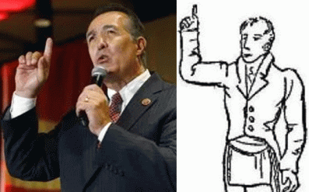
Trent Franks & Freemason- Sign of Preservation
There is no conclusive evidence that Trent Franks is a Freemason or a Masonic Latter-Day Saint, but if it walks and quacks like a duck- the man is a secret Masonic initiate. The first five Latter-day prophets were Freemasons. Joseph Smith, Brigham Young, John Taylor, Wilford Woodruff, and Lorenzo Snow all were members of the masonic fraternity. All joined while living with the Saints in Nauvoo, Illinois. The Temple of Latter-Day Saints is also a Masonic Lodge in disguise.[32]

Dr. James Dobson & Trent Franks
Before winning election to Congress, Franks served in the Arizona legislature and founded the Arizona Family Research Institute, an organization associated with Dr. James Dobson’s “Focus on the Family.” Franks’ institute advocates for policies designed to protect children and families.[33]
Paula White confirmed reports that she is the oft-vaguely cited evangelical leader responsible for leading Trump to Jesus. “I totally led Donald to Jesus … “Just like Dr. James Dobson said I did … Totally.”[34]
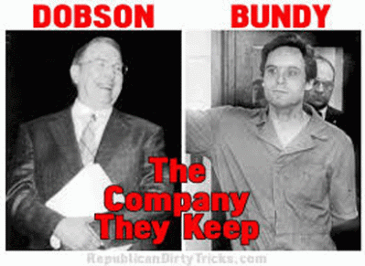
Dr. James Dobson founded Zionist Gary Bauer’s Family Research Council. James Clayton “Jim” Dobson, Jr. is an influential American evangelical Christian author, psychologist. The notorious serial mass murderer Ted Bundy of the ILLUMINATI MASONIC BUNDY BLOODLINE had connections with human-child trafficking, abductions, Satanism, pedophilia, sacrifices, and mind control. Bundy told an interviewer that he read the work of Marquis de Sade and was hugely impacted by his works. James Dobson is a Sex Perversion, Pornography- Ted Bundy Expert. He is also a Marquis de Sade expert.
Bundy was a pen-pal to would-be President Ronald Reagan assassin John Hinckley, Jr. He drops a lot of strange language that refers to Monarch mind control- references to butterflies, women, and control. They also seem to have spoken in some sort of code. All of Bundy’s responses to Hinckley contained the phrase “the haunting score” in reference to all the films they discussed. Haunting score– Bundy said that he killed more than 100 people, and not only women. He confessed to killing 30 women in seven states before he was executed by electric chair on January 24, 1989.
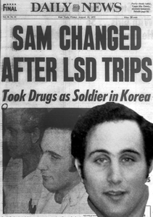
The Son of Sam MK ULTRA Manchurian Candidate assassin was also pen pals with Bundy. Berkowitz (Son of Sam) told author Maury Terry that he worked with a Satanic Cult to slaughter people and committed most but not every murder. He covered for accomplices on a few of the deaths.
Dr. Dobson founded Focus on the Family (FOTF) in 1977, which he led until 2003. In the 1980s, he was ranked as one of the most influential spokesmen for conservative social positions in American public life. Although never an ordained minister, he was called “the nation’s most influential evangelical leader” by The New York Times, while Slate portrayed him as a successor to evangelical leaders Jerry Falwell and Pat Robertson.[35]
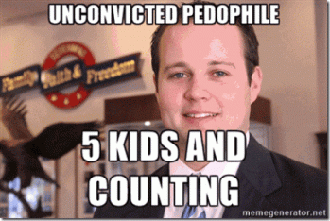
On June 18, 2013, Josh Duggar was appointed the executive director of Dobson and Bauer’s FRC Action, the non-profit and tax-exempt legislative action arm of Family Research Council. Duggar resigned on May 21, 2015, when it became public and he confirmed that he was a secret notorious Pedophile that had admitted molested five (5) underage girls, including some of his sisters, twelve years earlier, when he was between 14 and 15 years old.[36]
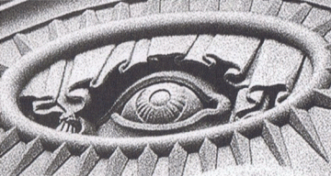
All Seeing Eye on Salt Lake Temple
In 1987, Franks completed a course of study at the non-accredited National Center for Constitutional Studies (NCCS), formerly known as the Freemen Institute, in Utah.[37] The center had its origins when in 1967 by Latter-day Saint political writer W. Cleon Skousen, a professor at Brigham Young University, organized an off-campus institute for constitutional studies. In 1971, this was formerly christened as The Freemen Institute. It was later given its current name and its headquarters moved to Washington, D.C.[38]
A 2011 report by the Southern Poverty Law Center said that the NCCS had found a number of new organizational allies among “constitutionalist” groups such as the John Birch Society, Eagle Forum, and Oath Keepers. Additionally, in the media, the NCCS found a powerful voice in the form of Glenn Beck, who is a Mormon that used the Fox News platform to advocate for NCCS books and ideas. Since the rise of the Tea Party Movement, NCCS has experienced exploding interest from Tea Party-affiliated groups. Among other things specific to the amendments of the Constitution, they believe that by giving women the vote the 19th Amendment violated states’ rights.[39]
To say the least, Trent Franks is an extremely odd, creepy and strange person to be a U.S. Congressman. Franks suddenly resigned from Congress ahead of January 31, 2018, when it was widely publicly reported that he had pressured his congressional female aides for sex to impregnate them with his children. It turns out that multiple female staffers, current and past, have come forward saying that they had been propositioned by Creepy Franks.[40]
“In what sounds like the plotline of the hugely popular “The Handmaid’s Tale,” a streaming TV series (adapted from a Margaret Atwood book) about a dystopian future where an elite caste of Christian fundamentalists with barren wives systematically rape their eponymous servants to bear their children.”[41]
It also rings of African Human Bondage when black women had to no rights to the dignity of their bodies that white men were bound to honor and respect. In 1987, controversy erupted in California over the NCCS-published textbook The Making of America by Masonic Latter-day Saint W. Cleon Skousen. The book quoted a 1934 essay on slavery by Pulitzer Prize-winning historian Fred Albert Shannon that described black children as “pickaninnies” another section stated that life for white Southerners was “a nightmare” due to “the constant fear of slave rebellion“, and claimed that white slave owners were “the worst victims of slavery.”[42]
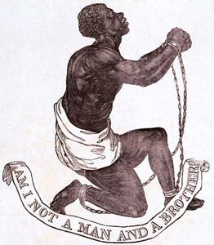
Skousen’s Making of America idealized and wickedly justified the Evil of African Human Bondage. “Quoting the historian Fred Albert Shannon, ‘The Making of America’ explained that ‘[slave] gangs in transit were usually a cheerful lot, though the presence of a number of the more vicious type sometimes made it necessary for them all to go in chains.'”[43]
Frank’s Congressional Republican Masonic Jacobin Tea Party colleague, Joe Barton of Texas, the longest-serving member of the Texas congressional delegation, has decided not to seek re-election in 2018.[44]
V
CONGRESSMAN JOE BARTON, ILLUMINATI, MASONIC JACOBIN CLUBS & MASS POPULATION CONTROL AND DESTRUCTION
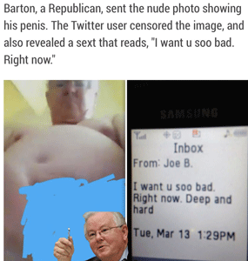

Some may argue that TEA PARTY CAUCUS Congressman Creepy Joe Linus Barton had a de Sade moment or flash when he Sexting his eerie genital (dick) pictures to a woman.

Creepy Joe and the Masonic Fraternal Sign of Preservation
Actually outing Creepy Joe is a reflection of secret racism, misogyny, pedophilia and sadism that is creeping across the country among the Masonic ILLUMINATI fraternal order ruling elite. It is no accident that Barton’s de Sade moments can be be traced directly back to the ILLUMINATI- Masonic Jacobin Clubs that Creepy Joe belongs to.
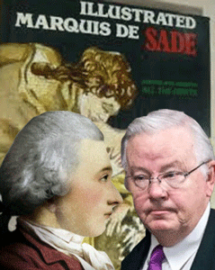
The Jacobin Club’s secret sexual philosophy is based on the scandalous libertinism and extreme pornographic writings of the Satanic Lunatic of the 18th century Jacobin, Marquis de Sade. The Jacobins were formed from the Parisian followers of Christ’s disciple, James. In 1219, the Dominican Order established a convent in Paris that took on the name, the Jacobins, as their convent was located on the Rue Saint-Jacques near Norte Dame. The Covent’s chapel was the chapel of a pilgrims’ hospice – dedicated to Saint James the Great. The Church of the Jacobins is a deconsecrated Roman Catholic Church located in Toulouse, France. … by Father Sébastien Michaëlis , who had won permission from King of France, Louis XIII (1610 to 1643) and his regent Marie de Medicito (1575 – 1642) found a new monastery in Paris, despite opposition from the chapter general of Michaëlis’ order, the Dominicans.[45]
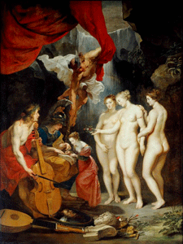
L’Education de Marie de Médicis (Apollo and Mercury lead her in music and eloquence while Minerva teachers her to read and the Three Graces offer beauty) 1622-1625, Peter Paul Rubens
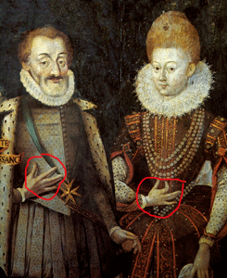
Henri IV et Marie de Médicis, roi et reine de France et de Navarre
Usually Henri IV and Marie Medici’s secret Marrano or Triad Claw hand gesture is compared with letters W or M from the Latin alphabet. Or tree letters ו (vav) from the Hebrew one ( ווו ). (Numerical meaning of ו is 6 and together tree ווו give number 666.) However, the Hebrew letter shin is more similar to Triad Claw than other ones. Besides in Kabbalah the letter shin means The Eternal Flame that is close to sacred and secret ideals. Marie de Medici was the pagan daughter of Francesco I, the second Grand Duke of Tuscany, and the House of Medici. Her grandfather was Cosimo I de’ Medici. The House of Medici led an elite secret Satanic/Rosicrucian cabal called the “The Society” often referred to as the Kiriath-Sepher – language of the giants [FALLEN ANGELS].[46]
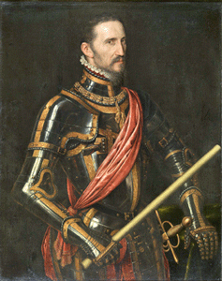
Cosimo I de’ Medici, the first Grand Duke of Tuscany and House of Medici found his own secret knight order. The Order of Saint Stephen (Official: Sacro Militare Ordine di Santo Stefano Papa e Martire, “Holy Military Order of St. Stephen Pope and Martyr“) is a Roman Catholic Tuscan dynastic military order founded in 1561. The Order is a model of The Order of Knights of the Hospital of Saint John of Jerusalem, also known as the Order of Saint John, Order of Hospitallers, Knights Hospitaller, Knights Hospitalier or Hospitallers- Knights Templar.[47]
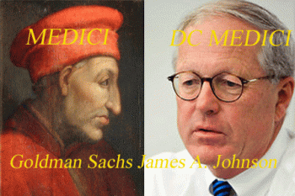
The House of Medici is one of the original 13 ILLUMINATI Satanic family houses that secretly rule the world.[48] James Johnson, Director of Goldman and Sachs, and a reigning member of the Bilderbergers is called most unusually and very troublesome, “Washington DC’s Medici”.[49] Yes, it is the same Goldman and Sachs of President select Donald J. Drumpf, Steve Bannon and the Dark Satanic Circle that currently rules over the United States.
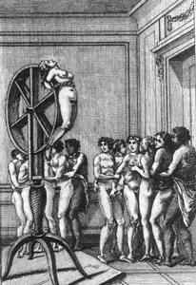
In the sexual arena, Satanic Sade abolished love and romance and brought to bear the full force of the master-slave paradigm. Sex, for Sade, was exclusively about power, and the masters demonstrate their domination through the inflicting of pain on the slaves.[50]
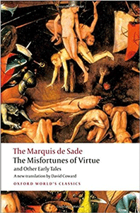
“ … Sade had created a “negative utopia” – the worst of all possible worlds (except for himself, of course). Yet pre-Revolutionary France, the whole World, was exactly that. Unless you belong to the elite, you are living in a nightmare, subject to the invariably cruel whims of the ruling class. Sade’s intimate knowledge of the aristocracy had led him to believe that they didn’t see the underclasses as human but rather as animals waiting for their appointment with the abattoir. The Satanic Old World Order continue to think much the same thing today, wanting people’s money and eugenically soft killing their lives.”[51]
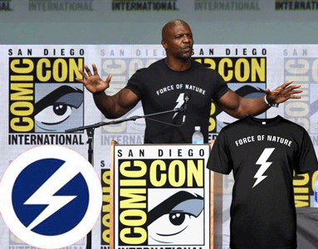
If he is indeed a Freemason and I believe that he is, I can understand him promoting the Masonic “All-Seeing Eye“. But for the life of me, I can’t explain why Terry Crews cannot recognize the Lightning Bolt as a fundamental symbol of European Racism and Fascism, and it not being in his interest of his human dignity to promote.
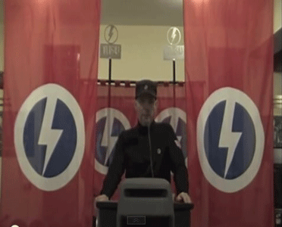
The single Lightning Bolt also represents the Nazi Rune, Sieg- Victory. The hidden meaning behind the Sieg Rune is that its originally a lightning rune not a sun rune as people would have us believe it. Its modern day use is as a Satanic Symbol or a symbol that represents the ancient Greek god Zeus who was the god of lightning.
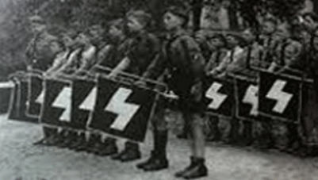
However, when he promotes the “Force of Nature“, it turns a page back again to the Lunatic Marquis de Sade. Psychopathic de Sade must be congratulated for unflinchingly committing to paper the thoughts of a person who literally thought that for the strong to kill the weak was nothing but [Law] of nature in action (as in the Eugenic Satanist Darwin law of the jungle, “the survival of the fittest” or Satanic Social Darwinism where the strong kill the weak through eugenics, fluoride rat poison, Monsanto GMO, Brain Damaging Vaccinations, concentration camps that hence could not be condemned in any way. De Sade argued more or less that it was the duty of the strong to kill the weak and it would be unnatural and deadly to the future of humanity if they didn’t.
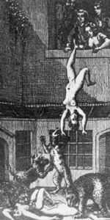
Marquis de Sade’s Madness
Sade’s Satanic philosophy can be summed up as “might is right“; the world is amoral and Nature is based on creation and destruction, so no one is entitled to condemn the forces of destruction. Any claims to a moral order are based on hypocrisy and covert exploitation. Sade’s philosophy is psychopathic, without empathy, without conscience, there is only the victim. Sade’s philosophy is Satanic Darwinism: all weakness must perish, and the weak can have no complaint. Nature conferred weakness upon them and Nature will kill them for it. “The Survival of the fittest” means the Satanic elimination of the de Sade victim.
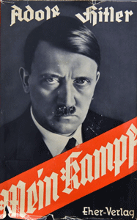
Hitler held similar views. He believed compassion is a sin, and thus compassion for the weak is a betrayal of nature’s law. De Sade declared that nothing that destroys can be criminal, such being the Law of Nature. In a later book, one of his characters says, “Cruelty is simply the energy in a man whom civilization has not yet altogether corrupted. It is therefore not a vice but a virtue.”
Behind the veil of the French Revolution were the ILLUMINATI Jacobins that sought to destroy Christianity, and all Laws of civilizations that evolved out of Mosaic Codes and the bible that came out of Kemet- Aset-Osiris. It is the age old battle between Good and Evil, it is Sethian- Set, Apophis- Apep, Lucifer, and Devil’s hatred of what is right, truth, balanced, and just! The “Law“, above all else, is about preventing nature taking its course – because we are not animals.
Judge Roy Stewart Moore of Alabama can also be best described as a Jacobin Republican Tea Party member. If he is elected to Congress, he will replace the interests of Trent Franks, and Joe Barton on the Jacobin ILLUMINATI Tea Party Caucus.
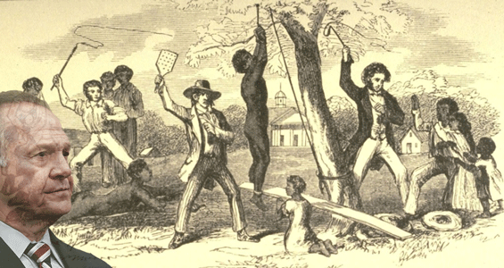
Most people don’t necessarily truly understand Judge Moore’s statement about the South’s antebellum slavery white families and African Human Bondage. A black man at a September 2017 Judge Roy Moore rally asked what President Donald Trump means by “make America great again,” Moore answered the question based on an absolutely elitist racist, perverted and SADIST (Marquis de Sade) observation about the abolished EVIL of institution of African Slavery: “I think it was great at the time when families were united — even though we had slavery. They cared for one another. People were strong in the families. Our families were strong. Our country had a direction.”
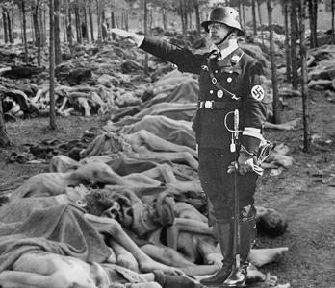
Reichsfuhrer SS-1 Heinrich Himmler provided basically the same racist, perverted and SADIST observation during the era of EVIL of the Jewish Holocaust and Genocide. In the infamous October 4, 1943 (“Janus Face”) Speech to SS Major-Generals at Posen- West Prussia, German province, Himmler said,
“One basic principle must be the absolute rule for the SS man: we must be honest, decent, loyal, and comradely to members of our own blood and to nobody else… Most of you must know what it means when 100 corpses are lying side by side, or 500 or 1000. To have stuck it out and at the same time-apart from exceptions caused by human weakness-to have remained decent fellows, that is what has made us hard. This is a page of glory in our history which has never been written and is never to be written …”
In other words, Slavery like that of the Jewish Holocaust white families remained honest, decent, loyal and comradely to themselves and nobody else nevertheless of what they believed to have been an NECESSARY EVIL.
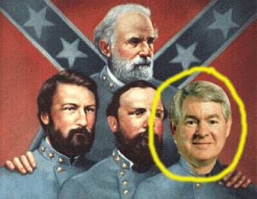
Judge Alan King, Fraternal Order of 1865
In conclusion, we have been in what seems to be an endless court battle for at least the same 7 (seven) years in Birmingham, Alabama with Probate Judge Alan Lamar King . Judge King, ’71 University of Alabama, Alpha Tau Omega (ATO) is heavily, deeply and openly involved in the Fraternal Order of 1865. It was the first fraternal order established among white gentlemen of the Confederate South after the Civil War. In 2011, the FBI listed King’s ATO as an Alabama Gang. He has to be one of the most powerful political figures of the State of Alabama. He made myself the chief election officer of the populous Jefferson County. He is an old fashion Dixiecrat. In other words, Judge King will count the votes for Jefferson County in the special U.S. Senate race between Judge Roy Moore and Doug Jones. In Alabama, he is a king maker and breaker. President select Donald J. Drumpf has appointed King to his election integrity commission.
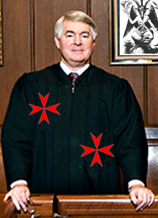
Alan King, Probate Judge of Jefferson County, Invisible Knight of Malta
King’s ATO is certainly the perfect secret fraternal order to cloak the South’s “Lost Cause” racist motives behind. You can be a secret closet racialist, elitist, confederate, Freemason, Satanist and a Knight Templar all in secret society. However, keep in mind that all ATO’s secret rituals and ceremonies are based on the LUCIFERIAN esoteric knowledge (Magnum Opus) of Freemason, Knight of the Klan and Golden Circle, and President Lincoln’s co-conspirator assassin, Albert Pike.

Jefferson County’s Racist Wheel of Fortune, Hosted by Probate Executor Elizabeth McElroy & Probate Judge Alan Lamar King
In Birmingham, Jefferson County, Alabama, the ATO and fraternal orders boost their incomes by taking from the dead. Jefferson County goes far beyond the British Empire, even if persons of color dies, with or without a will with surviving relatives entitled to inherit, estates of dearly departed with money, assets and real property are given to Alabama gangs under the color of the state by McElroy and King to loot with impunity. I can’t say who will win the U.S. Senate race, but notice has been given of the Masonic Sadist Jacobins in congress destroying the United States. I think I said enough as we gear up to continue our protracted battle with Queen Bee Elizabeth McElroy, and secret Satanic Knight of Malta, Alan Lamar King.

[1] http://www.theguardian.com/film/2016/feb/29/chris-rock-at-the-oscars-youre-damn-right-hollywoods-racist
[2] http://educate-yourself.org/cn/jonbentramseysatanicritual.shtml
[3] http://www.silvanuspublishing.com/rahm-emanuel/terry-crews/
[4] http://ireport.cnn.com/docs/DOC-143306
[5] https://www.bibliotecapleyades.net/sociopolitica/sociopol_germany08.htm
[6] http://aquarianagrarian.blogspot.com/2014/01/the-emanuel-family.html
[7] https://www.sott.net/article/334281-Breitbart-News-Founded-for-and-by-Israel
[8] http://en.metapedia.org/wiki/Ari_Emanuel
[9] https://en.wikipedia.org/wiki/Endeavor_Talent_Agency
[10] http://variety.com/2017/biz/news/terry-crews-adam-venit-lawsuit-sexual-assault-1202631393/
[11] http://www.imdb.com/name/nm0187719/bio?ref_=nm_ov_bio_sm
[12] https://en.wikipedia.org/wiki/You_Don%27t_Mess_with_the_Zohan
[13] https://www.timesofisrael.com/you-dont-mess-with-the-zohar/
[14] https://www.counterpunch.org/2008/06/26/you-don-t-mess-with-the-racism/
[15] https://www.huffingtonpost.com/2013/04/09/adam-sandler-shaqs-penis-conan_n_3044725.html
[16] https://www.thefix.com/terry-crews-posts-facebook-videos-detailing-porn-addiction
[17] https://www.britannica.com/place/Interlochen
[18] http://www.whale.to/b/ross3.html
[19] http://mythmaniacs.com/pan.htm
[20] http://www.gnosticliberationfront.com/cia_mind_control_at_stanford_research%20institute.htm
[21] https://en.wikipedia.org/wiki/Brooklyn_Nine-Nine
[22] https://nihrecord.nih.gov/PDF_Archive/1982%20PDFs/19820302.pdf
[23] Id.
[24] http://ethnicelebs.com/michael-schur
[25] http://beta.latimes.com/entertainment/tv/showtracker/la-et-st-brooklyn-nine-nine-showrunner-dan-goor-talks-good-fortunes-first-season-lessons-20140211-story.html
[26]
[27] http://www.redicecreations.com/specialreports/2005/12dec/FOGC.html
[28] https://www.thedailybeast.com/trump-on-slavery-boy-that-is-not-good
[29] https://www.washingtonpost.com/news/the-fix/wp/2013/06/12/who-is-trent-franks/?utm_term=.616970dc2731
[30] http://freemasonry.bcy.ca/history/boston_tea_party.html
[31] http://www.masonicdictionary.com/jacobins.html
[32] http://www.ldsliving.com/Mormons-and-Masons-5-Fascinating-Connections/s/80329
[33] http://www.siskiyoudaily.com/zz/news/20171207/ariz-rep-trent-franks-resigns-amid-ethics-investigation
[34] http://theendtimes.news/2016/07/08/paula-white-confirms-that-she-totally-led-trump-to-jesus/
[35] https://en.wikipedia.org/wiki/James_Dobson
[36] https://en.wikipedia.org/wiki/Family_Research_Council
[37] https://en.wikipedia.org/wiki/Trent_Franks
[38] https://en.wikipedia.org/wiki/National_Center_for_Constitutional_Studies
[39] Id.
[40] http://www.miamiherald.com/opinion/op-ed/article188938484.html
[41] http://www.miamiherald.com/opinion/op-ed/article188938484.html
[42] https://en.wikipedia.org/wiki/National_Center_for_Constitutional_Studies
[43] http://exmormon.org/phorum/read.php?2,1478972
[44] https://www.sacurrent.com/the-daily/archives/2017/11/30/texas-congressman-joe-barton-accused-of-unwanted-sexual-advances-wont-seek-re-election
[45] https://en.wikipedia.org/wiki/Sebastien_Michaelis
[46] https://en.wikipedia.org/wiki/Kappa_Sigma

[47] https://en.wikipedia.org/wiki/Order_of_Saint_Stephen
[48] http://www.world-exposed.com/13-illuminati-families-secretly-ruling-world/
[49] http://www.independent.co.uk/news/world/bilderberg-group-meeting-what-is-it-and-who-is-attending-global-elites-a7069561.html

[50] http://www.energyenhancement.org/The-Satanic-Psychopath-Marquis-de-Sade-Propagandist-for-the-Policy-of-Perversion-and-Degeneration-of-the-Oligarchic-Ruling-Class-of-Eugenic-Darwinian-Existentialists-for-the-Control-of-Humanity.htm
[51] Id.
Comments : Leave a comment
Tags: 99 lodge, Adam Venit, Adolf Hitler, African Human Bondage.W. Cleon Skousen, alan lamar king, ALL SEEING EYE, antebellum south, Apophis- Apep, ari emanuel, Baron Otto von Bolschwing, Benjamin Emanuel, birmingham, brooklyn 99, charlie sheen, Children's International Summer Villages, Church of the Jacobins, Cosimo I de' Medici, Dan Goor, devil, Dionysus, Dissociate identity disorder, donald j. drumpf, donald j. trump, doug jones, Dr. James Dobson, elizabeth mcelroy, endeavor, Endeavor Talent Agency, Eugenics, Focus on the Family, Fred Albert Shannon, freemasonry, freemasons, goat god pan, Goldman Sachs, Grand Lodge of Massachusetts (Ancients), Green Dragon Tavern, harvey Weinstein, Heinrich Himmler, hollyweird, HollyWeird Kabbalah Cult, house of medici, Illuminati, Inc, IRGUN, israel, jacobin club, james a. johnson, jewish holocaust, joe barton, John Hinckley, jonbenet ramsey, Josh Duggar, Jr., judge roy moore, kabbalah, Knights of the Black Sun, knights templar, latter day saints, law of nature, Lucifer, Lucifer's Servants, luciferians, Marie de Medici, Marquis de Sade, Marrano secret jew, masons, me too, Michael Schur, mind control, MK-ULTRA, Monarch Program, Monarchs, mormons, mossad, National Center for Constitutional Studies, National Museum of African American History and Culture, Nazis, negative utopia, Osiris, paula white, pedophila, pizzagate, Pornography, Post-hypnotic amnesia, prince hall freemason, prince hall freemasons, Rahm Emanuel, Reichsfurhrer Heinrich Himmler, richard pryor, sadism, satan, Satanic Darwinism, Satanism, senate race, Set, Seth, Sethian- Set, Shaquille O’Neal, sieg rune, slavery, son of sam, SS, St. Andrews Lodge, Steve Bannon. Breitbart News, Tea Party Movement, Ted Bundy, terry crews, the toy, TRENT FRANKS, triad claw, wendy williams, william morris agency, You Don't Mess with the Zoha, Zohar Dvir
Categories : african american satanic cult, african holocaust, African Liberation, African slavery, alabama, ALL SEEING EYE, Apollo, baphomet, Barack Obama, Barak Obama, birmingham, black children, black christianity, black inheritance, black institutions, christianity, CIA, council of foreign relations, council on foreign relations, devil, donald j. drumpf, donald j. trump, donald trump, dualism, fallen angels, false flags, freemason, freemasons, genocide, Heinrich Himmler, hollywood satanic cult, human bondage, illuminati, israel, jesus christ, John Birch Society, Knights Hospitaller, Knights of the Black Sun, Knights Templar, luciferians, mind control, MK-ULTRA, modern slavery, monarch child, monarch program, MPD, mulitiple personality disorder, new world order, Osiris, post amnesia barriers, post hypnotic suggestions, power control group, Rahm Emanuel, Reichsfurhrer SS-1 Heinrich Himmler, richard pryor, Ritual Satanic Abuse, ritual satanic sexual abuse, ritually abused children, satan, Satanic Global High Cabal, Satanism, Secret Doctrine, set, seth, sex kitten, sex slave, slavery, SS, SS Baron Otto Albrecht Alfred von Bolschwing, steve bannon, Untermensch

THE CULT OF THE SUPREME BEING, JUDGE ROY MOORE, THE NEO-NAZI, CONFEDERATE JACOBIN HIDDEN BEHIND THE MASK OF GOD
29112017
I
DONALD J. DRUMPF, THE SUPREME BEING
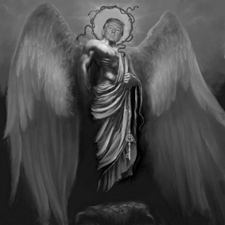
Donald J. Drumpf- THE SUPERIOR BEING
Donald J. Drumpf & Lebensborn
In an interview for PBS, Donald J. Drumpf’s biographer Michael D’Antonio claimed Fred Trump taught his son that the family’s success was genetic. He said: “The family subscribes to a racehorse theory of human development. “They believe that there are superior people and that if you put together the genes of a superior woman and a superior man, you get a superior offspring.” The superior offspring from a superior people does indeed dial up– HELLO, LEBENSBORN!
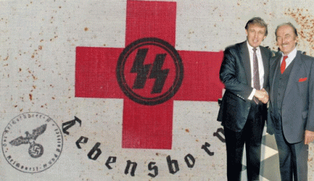
The notion of the Master Race originated from 19th century racial theory, which posited that there is a hierarchy of races, and that cultures degenerate when distinct races mix. To ensure the genetic purity of his country, Adolf Hitler and Heinrich Himmler implemented selective human breeding through the racial pseudo-science of eugenics. As part of their Nazi genetic engineering plan to build up an Aryan “master-race” or “super-breed of humanity”, they created Lebensborn or the “Fountain of Life” program. Secret special clinics were set up across Eastern Europe where SS- Knights of the Black Sun were encouraged to mate with blue-eyed, blonde Nordic girls who had no Jewish ancestry, in order to produce “racially pure” German offspring.
Donald J. Drumpf & the One God-Cult of the Supreme Being
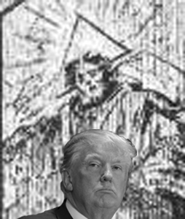
Donald J. Drumpf & Marquis de Sade’s ILLUMINATI Supreme Being
In September 2016, Republican Candidate for U.S. President, Donald J. Drumpf, promised to bring the nation together under One God– SUPREME BEING. “We will be one people, under one God, saluting one American flag,” he said at a speech to the National Guard Association in Baltimore. Drumpf’s “Under One God” line does indeed dial up, HELLO “Hitlerian”. The Nazi Party slogan was “Ein Volk, ein Reich, ein Fuhrer!” ― “One people, One empire, One leader!”
I am not at all a follower of the late Psychologist Dr. Erich Fromm, but one evening I was busy trying to figure out the motives of this and what was behind that when he stopped me in my tracks. Dr. Fromm said to cast Nazi Germany’s actions as a sickness served as “a substitute for valid ethical concepts,” tending to “weaken the sense for moral values, by calling something by a psychiatric term when it should be called plainly EVIL. It’s the same with President select Donald J. Drumpf. Sickness is not Drumpf’s problem. The issue with him is plainly Evil– ABSOLUTE EVIL.
Donald J. Drumpf, Native Americans & the Great White Father
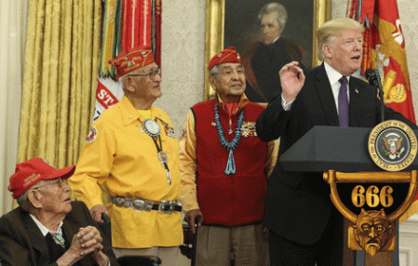It was the ABSOLUTE and CLASSIC EVIL of Donald J. Drumpf to honor the families of Navajo Code Talkers, the World War II veterans, whose code breaking skills helped the US win the war, at the White House under President Andrew Jackson, 7th President of the United States. The EVIL of Donald J. Drumpf mocked and humiliated them.
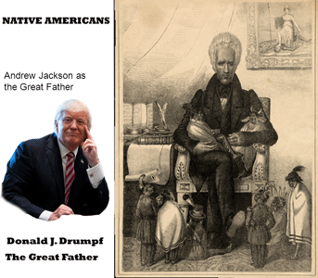
“We can never forget or minimize the fact that [Andrew] Jackson carried out the most murderous removal campaign against American Indians — Cherokees, Creeks, Choctaws, Chickasaws and Seminoles — in U.S. history. He was directly responsible for the hideous, agonizing deaths of tens of thousands of Native Americans, beginning with the Creek War of 1813. Jackson was responsible for the deaths of thousands of Muscogee Creek people in that conflict. Jackson led armies, largely composed of Tennessee volunteers, who conducted war against noncombatants, women and children. According to contemporary Creek sources, hundreds of Creek women and children were sold into slavery. They were starved, raped and murdered. Creek children, mostly little boys, were sold for $20 each as “pets.” Orphaned children were taken off the battlefield from the bodies of their mothers as “trophies.“
Subsequently, Jackson signed the Indian Removal Bill of May 28, 1830, and militarily enforced fraudulent treaties that sent thousands on the death marches. Of the Cherokee “Trail of Tears” it was said that no one under 6 or over 60 survived the hideous march west. A relatively little known fact is that Cherokees held captive in concentration camps were deprived of the use of soap, so bent was Jackson on Indian extermination. When Cherokee leaders were able to finally prevail upon the Army for the issuance of soap, Jackson, upon hearing of this, flew into a rage at The Hermitage and demanded that the order allowing for the use of soap be rescinded. This is the so-called “Peoples President.” What people? Surely not Indian people!
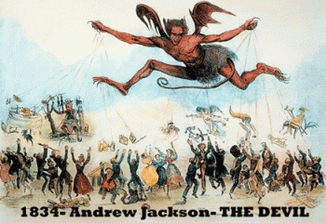
Yet, the Andrew Jackson Foundation [Donald J. Drumpf] wants to elevate this monster, this ethnic cleanser, to the status of a great president. Jackson was a racist devil incarnate — an early-day American Hitler whose deadly legacy for American Indians remains extant to this very day. According to contemporary Creek sources, hundreds of Creek women and children were sold into slavery. They were starved, raped and murdered. Creek children, mostly little boys, were sold for $20 each as ‘pets’. Orphaned children were taken off the battlefield from the bodies of their mothers as “trophies.”
II
JUDGE ROY MOORE, THE THIN VEIL OF THE BEAST
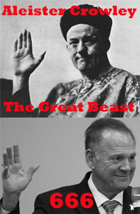
Prior to the U.S. Senate Special Election on December 12, 2017 in Alabama, Republican candidate for the senate, Judge Steward Roy Moore, will not appear in any political debates, or answer questions from any press conferences. The Judge is an enigma wrapped inside a puzzle inside a bubble. It is a bubble that is so fragile that the first rays of sunlight that hit it will burst it wide open.
The wife of Republican Alabama Senate candidate Judge Roy Moore has been her husband’s biggest defender amid a storm of allegations concerning relationships with teenage girls. But Kayla Moore was also a minor, and he very much an adult, when her future husband first took an interest in her.
“I was standing at the back of the auditorium and I saw her at the front and I remember her name, it was Kayla Kisor, K.K,” he said. “It was, oh gosh, eight [8] years later or something, I met her and when she told me her name I remembered K.K.”
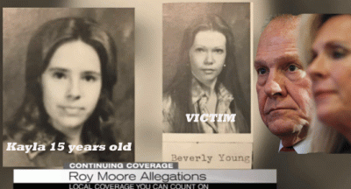
That [8] eight-year time frame would have meant that Moore was 29 and Kayla just 15 years old when they first met that is consistent with his customary pedophilia predatory habits and practice of behavior stalking female minors.[1] ,[2] In fact, Judge Moore is accused of sexually assaulting one of high school classmates.
I said that to say this. The climate in the country goes beyond a Women‘s issue. Judge Roy Moore is much more than a predatory pedophile that is contemptible and outrageous in its self. President select Drumpf, the Republican, Democratic Parties, and corporate mass media are approaching Judge Roy Moore as if but for the pedophilia allegations– he is some type of populous candidate for public office. It veils the EVIL and the BEAST!
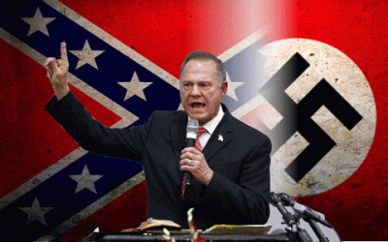
They are deliberately ignoring and not exposing this man’s notorious neo- NAZI white nationalist supremacy background that alone makes him not only a clear and present danger to people of color, but he is a serious threat to this form of government that has evolved out of FIRE & CHAOS, the Abolition of Slavery, and the Great Civil War. He seeks in combination with others to turn back time in this country to the era of the Evil of African Human Bondage, and White Supremacy.
II
JUDGE ROY MOORE, CONFEDERACY & ANTI CIVIL RIGHTS
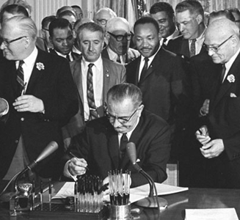
U.S. Civil Rights Act of 1964
What are the Judge’s views on civil rights and race in America? In a November 2017 speech at a religious revival in Jackson, Judge Roy Moore stated that “they started [to] create new rights in 1965, and today we’ve got a problem” in an apparent reference to the Voting Rights Act of 1965. It would be safe to say that he has an anti- civil rights platform.
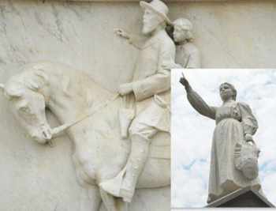
Gadsden’s Statue of Emma Sansom & General Bedford Forrest
Roy Moore was born in Gadsden, the county seat of Etowah County, Alabama. It has a confederate monument dedicated to Emma Sansom. She was an Alabama farm girl noted for her bravery during the Civil War, during which she helped Confederate General Nathan Bedford Forrest capture Union Commander Abel Striegh on May 2, 1863.[3]
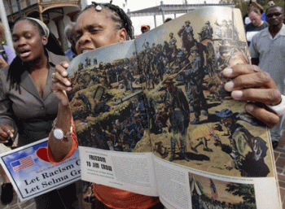
Black Americans have not forgotten General Forrest’s Crimes Against Humanity. Nathan Bedford Forrest is one of the most EVIL and demonic figures from the Civil War era. His command was responsible for the savage massacre of hundreds of black troops, including black children, women and elders at Fort Pillow, Tennessee, in April 1864, and he served as the first grand wizard of the Ku Klux Klan in the early years of Reconstruction that continued the South’s campaign of racial murders and terrorism against Black people.[4]
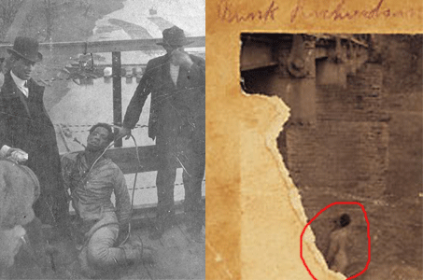
Gadsden was a hotbed climate of KKK terrorism, murder and crimes against people of color. On February 11, 1906, Bunk Richardson, about 28 years old, was lynched in the city for a crime that he may not have committed. The lynch mob shot him in the head. Bunk’s body was suspended by his neck with twenty feet of rope on a bridge over the Coosa River. Terrified, many black families had to escape Gadsden in the middle of the night with everything that they could carry.[5]
Is Judge Roy Moore also a vicious racist and ugly racial segregationist consistent with his cultural background? In 2004, an Alabama referendum sought to put an end unconstitutional segregation-era wording, requiring separate schools for “white and coloured children” in its constitution as well as references to the poll taxes once imposed to disenfranchise blacks.[6]
John Giles, president of Alabama Christian Coalition opposed the state referendum under the cloak of increased taxation. Giles’ campaign was assisted by Judge Roy Moore, who had become a local hero since he defied a federal court order to remove a two-ton slab of granite engraved with the Ten Commandments from the rotunda of the Alabama Supreme Court.[7]
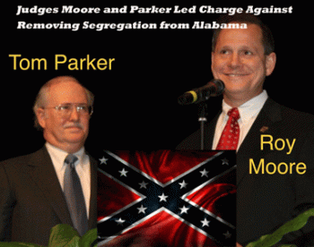
Roy Moore’s former assistant during his initial term as chief justice, Tom Parker, was elected to the Alabama Supreme Court even after it became clear that he had been handing out Confederate flags while campaigning and had attended a function honoring the first grand wizard of the Ku Klux Klan. Parker ran for high public office as the protégé of Judge Roy Moore.
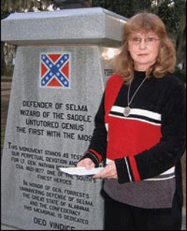
Neo-Confederate Pat Godwin
In July 2004, Parker made his way to the Selma home of Pat and Butch Godwin, who were holding a birthday party to honor Confederate Gen. Nathan Bedford Forrest, the first grand wizard of the Ku Klux Klan, and vicious racial mass murderer. The Godwins run “Friends of Forrest Inc.”, which owns a Forrest statue the Godwins spent two years unsuccessfully trying to place on public property. Standing on his friends’ Confederate battle flag-bedecked front porch, Parker rallied the crowd. Later, one listener lauded him as “a man not afraid of the flag.”[8]
The Godwins are extremist neo-Confederates. Pat Godwin’s latest crusade is to block any acknowledgement on the Capitol grounds of the 1965 Selma-to-Montgomery civil rights march — a goal of the Alabama Historical Commission. In a July E-mail, Godwin railed at “the trash that came here in 1965,” complaining that those who honor the civil rights movement “are aiding and abetting the ultimate goal of the ONE WORLD ORDER — to BROWN AmeriKa and annihilate Anglo-Celtic-European culture!”
Pat Godwin and her close friend Ellen Williams recently put together a packet of documents that they say proves that the march was the “Mother of All Orgies” and the marchers were motivated by “money, sex and alcohol.” A month earlier, in June, Parker showed up at the Elba, Alabama, funeral of Alberta Stewart Martin, believed to have been the last living widow of a Confederate veteran. He made himself a quick favorite by giving away hundreds of miniature Confederate battle flags to the 300 people, many in period dress, who gathered for this major neo-Confederate event.[9]
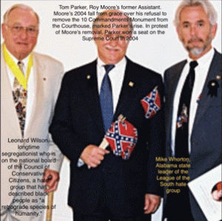And, in a photo widely circulated in the neo-Confederate world, he is seen with what were apparently two friends of his: Mike Whorton, Alabama state leader of the League of the South hate group, and Leonard Wilson, a longtime segregationist who is on the national board of the Council of Conservative Citizens, a hate group that has described black people as “a retrograde species of humanity.“[10] Pat and Butch Godwin’s home is known fondly in neo-Confederate circles as “Fort Dixie.”[11] Tom Parker was Moore’s spokesman and legal adviser.
Pro-Confederate activists twice held events to commemorate Alabama’s 1861 secession from the United States at the headquarters of the Foundation led at the time by Roy Moore, the new Republican nominee for US Senate.[12] The events, held at the Foundation for Moral Law’s building in 2009 and 2010, promoted a history of the Civil War sympathetic to the Confederate cause, in which the conflict is presented as one fought over the federal government violating the South’s sovereignty as opposed to one fought chiefly over the preservation of slavery.[13]
In a September 2017 speech, Republican Candidate for U.S. Senate, Judge Roy Moore disrespectfully used “reds and yellows” to describe American Native Americans and Asians fighting. Where, and When? Moore said,
“We were torn apart in the Civil War — Brother against brother, North against South, party against party. What changed? Now, we have blacks and whites fighting, reds and yellows fighting, Democrats and Republicans fighting, men and women fighting. What’s going to unite us? What’s going to bring us back together? A president? A Congress? No. It’s going to be God.”[14]
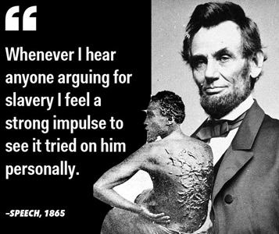
Of course, Judge Moore won’t mention the ultimate EVIL Institution of African Human Bondage that was one of most important causes of the Great American Civil War, and the Assassination of President Abe Lincoln. Sir Winston Churchill describes it as, “The last war between gentlemen“. They still clink to the notion that gentlemen of the North and South held respect, honor and chivalry in and out of battle. They were civil to each other even when in separate armies. It was a war between brothers. It may have been such an illusionary metaphor at first, but Black people abruptly interceded in that gentlemanly family quarrel between brothers. It soon became a war of the enslaved versus the en-slavers.
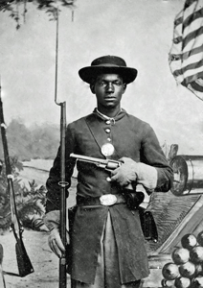
“Once let the black man get upon his person the brass letter, U.S., let him get an eagle on his button, and a musket on his shoulder and bullets in his pocket, there is no power on earth that can deny that he has earned the right to citizenship.” Frederick Douglass[15]
No power on earth or Lucifer himself would have defeated over 4 million Africans and descendants breaking the chains and yoke of inhuman slavery. Is Judge Roy Moore a racist and segregationist? Well, birds of the same feather flock together. YES!
III
THE ILLUMINATI, NAZIS, JACOBINS, JUDGE ROY MOORE & BIRDS OF THE FEATHER
Judge Roy Moore & Dangerous Nazi- White Nationalist Terrorism
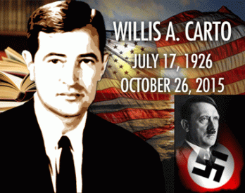
Along with white nationalist terrorist groups like the League of the South, Judge Roy Moore was supported by Willis Allison Carto in an unholy alliance with the DEVIL. The late Carto ran a neo-Nazi network of secret cells and front organizations that seeks the overthrow of the U.S. government under a unified Europe ruled by a Nazi-like regime of Fuhrer Adolph Hitler. Its subterranean society was called “The Francis Parker Yockey Movement” named after the Nazi Philosopher, and Underground Third Reich collaborator.
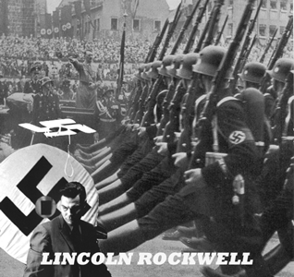
Carto also supported Lincoln Rockwell’s American Nazi Party. In the late 1960s, it was running nearly a million dollar lobbying group (Liberty Lobby) in Washington DC. Carto was involved in writing speeches and legislation for about a dozen Washington law-makers. Carto and the Liberty Lobby argued that the holocaust was a Jewish Myth.[16]
Nationalist white supremacist Carto and the Foundation to Defend the First Amendment donated a $1,000 to its bird of feather, Judge Moore’s Foundation for Moral Law. They [Carto’s Nazi Cells] have an ideology that is, “Total Nazi; and notice I didn’t say neo-Nazi,” Todd Blodgett, the former head of the white supremacist record label Resistance Records — and later an FBI informant — told HuffPost.[17]
Judge Roy Moore, the Tea Party, Freemasons & the ILLUMINATI Jacobin Club
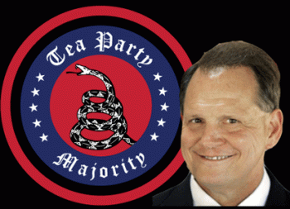
Alabama Patriots – the Statewide Tea Party Organization endorsed Judge Roy Moore for U.S. Senate.[18] Tea Party Express of California, the nation’s largest Tea Party political action committee, announced its endorsement of Judge Roy Moore for U.S. Senate.[19] In Georgia, Tea Party Patriots Citizens Fund (TPPCF) Chairman Jenny Beth Martin endorsed Judge Roy Moore for U.S. Senate.[20] Tea Party groups across the U.S. seem unified to endorse Republican Judge Roy Moore for U.S. Senate.
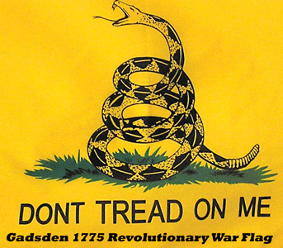
The Tea Party took its name from identification with New England colonists who demonstrated their distrust and contempt for British government by illegally seizing and dumping imported tea in protest of increased taxes, the first salvo in what became the American Revolution culminating in independence from Britain and formation of a new government. The Boston Tea Party was planned at the Green Dragon Tavern, also known as the “Freemasons’ Arms” and “the Headquarters of the Revolution.”[21]
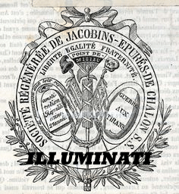
The modern Tea Party Movement’s character, tactics and goals are consistent with and reminiscent of, the Masonic extremists of the French Revolution known as the ILLUMINATI Jacobin Club. Like the Tea Party, the Jacobins came to power riding a wave of populist contempt and rage at government, the first target – the failed monarchy of Louis XVI. The leaders of the Jacobins were best known for the fervor of their hatred of the monarchy and their willingness to use any means to bring it down. It was the Jacobins who insisted it was not enough to depose and imprison the king, his blood needed to be shed in order for the people to be truly free.
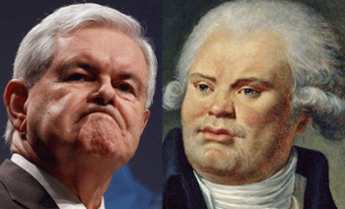
Tea Party Leader Newt Gingrich is compared to the firebrand (fire eater) Jacobin, Danton. In the French Revolution, Georges-Jacques Danton (1759- 1794) is credited as the chief force in the overthrow of the monarchy and the establishment of the First French Republic (September 21, 1792).[22] Danton was President of the Jacobin Club, and a member of the famous and powerful ILLUMINATI Nine Sisters Masonic Lodge with Ben Franklin as the grand master.[23]
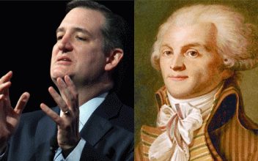
Tea Party Party Ted Cruz is compared to Maximilien Robespierre. The most powerful and influential Jacobin in France was Maximilien François Marie Isidore de Robespierr (Robespierre– 1758- 1794), who was dubbed ‘the Incorruptible’ because of his ascetic lifestyle and unwavering commitment to the revolution. He was one of “most ardent apostles” of SATAN(ISM).
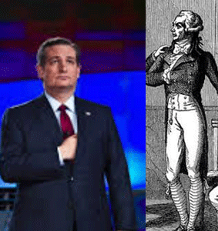
Texas U.S. Senator Ted Cruz 21st Century Jacobin & Masonic Hidden Hand
The Hidden Hand of Ted Cruz and Robespierre originates in “The Royal Arch Degree of Freemasonry”, a degree introduced under Illuminati infiltration. The Royal Arch Degree (the 13th degree of the Scottish Rite or the 7th degree of the York Rite) is also known as the Mason of the Secret. During this Degree, initiates are said to receive great Masonic Truths.[24]
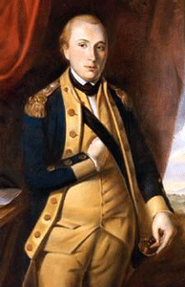
Masonic Hidden Hand Marquis de Lafayette
Called “America’s Best Friend” in Europe, Marquis de Lafayette was Thomas Jefferson’s best friend in France and America.[25] Marquis de Lafayette (1757-1834) was also a Hidden Hand 33° Freemason and French military officer who was a general in the American Revolutionary War and a leader of the Garde Nationale during the bloody French Revolution. Lafayette was also made an honorary Grand Commander of Supreme Council of New York. More than 75 Masonic bodies in the U.S. have been named after him, including 39 lodges, 18 chapters, 4 councils, 4 commanderies, and 7 Scottish rite bodies.[26]
Both Robespierre and Ted Cruz are notable in their willingness to embrace fear and terror as legitimate political tools. Terror emanates from virtue, you needed it to have virtue manifest. Robespierre famously said, “Virtue without terror is impotent, terror without virtue is cruel.” This became the guiding principle of the Jacobins which ultimately led to the deaths of more than 55,000 French citizens before Robespierre’s head finally joined the others in the basket under the guillotine.
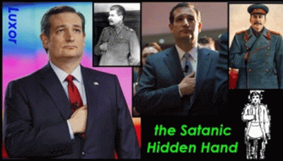
This is the 21st Century, But Here It Is in the U.S. Senate
It’s certainly not a stretch to say that Ted Cruz is EVIL enough to embrace tactics that amount to Jacobin political terrorism – shutting down the federal government; threatening default on repaying government debt; attacking the integrity and patriotism of colleagues and officials who disagree with him; supporting fratricidal primaries against fellow Republicans that are deemed insufficiently conservative.[27]
IV
ROBESPIERRE & ROUSSEAU, SOCIAL CONTRACTS & THE MASONIC CULT OF THE SUPREME BEING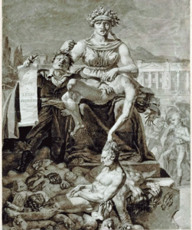
Robespierre’s Supreme Being
The Cult of the Supreme Being was established in France by Robespierre during the French Revolution as the official state religion. He studied the works of Jean Jacques Rousseau and was attracted to many of his ideas. Robespierre became intrigued by the idea of a “virtuous self“, a man who stands alone accompanied only by his conscience.
Robespierre’s study of the classics prompted him to aspire to Roman virtues, but he sought to emulate Rousseau in particular. Robespierre’s conception of revolutionary virtue and his programme for constructing political sovereignty out of direct democracy came from Rousseau, and in pursuit of these ideals he eventually became known during the Jacobin Republic as “the Incorruptible.” His religious ideas and the Cult of the Supreme Being were also heavily influenced by Rousseau.[28]
Adam Weishaupt, founder of the ILLUMINATI was raised and taught by Jesuits, at the age of 28, he was dean of the faculty of law at the University of Ingolstadt in Bavaria. He was obsessed with ancient Egyptian rites and rituals. He maintained contact with Freemasons. He was an avid reader of Jean-Jacques Rousseau.[29]
Rousseau’s political philosophy, particularly his formulation of social contract theory (or Contractarianism), strongly influenced the French Revolution and the development of liberal, conservative and socialist theory. His views on philosophy of education and on religion were equally controversial but nevertheless influential.[30]
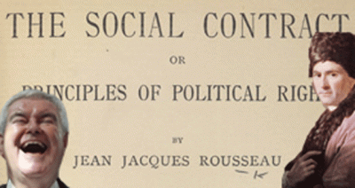
Rousseau coined the term “civil religion” in Chapter 8, Book 4 of The Social Contract, to describe what he regarded as the moral and spiritual foundation essential for any modern society. Speaker of the House, Newt Gingrich’s infamous “Contract with America” (Contractarianism) was the conservative action of more than 300 Republican Congressional candidates who signed it was presented at a September 27, 1994 press conference.[31] It was works of mass public deception and illusions of Jean Rousseau.
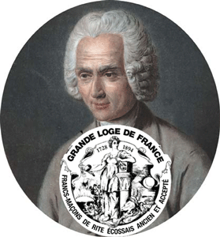
Rousseau was also a Freemason, a member of the Original Grand Orient of France that claimed responsibility for the French Revolution and enforced an atheistic and secular view of Masonry.[32]
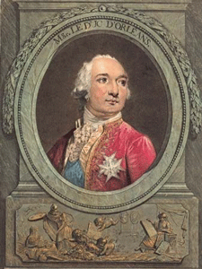
Louis Philippe Joseph d’Orléans, above, was the son of Louis Philippe d’Orléa, Duke of Chartres, and Louise Henriette de Bourbon. Philippe was a member of the House of Orléans, a cadet branch of the French royal family. His mother came from the House of Bourbon- Conde. Philippe d’Orléans was a cousin of Louis XVI and one of the wealthiest men in France. He actively supported the Revolution of 1789, and was a strong advocate for the elimination of the absolute monarchy in favor of a constitutional monarchy. He voted the death of King Louis XVI; however, was himself guillotined in November 1793 during France’s Reign of Terror.[33]
Philippe d’Orléans was a member of the Jacobins during the French Revolution; he strongly adhered to the principles of Jean Rousseau. In addition to being a Jacobin, Philippe was also the Grand Master of the Masonic Grand Orient de France, the most powerful Masonic Obedience in worldwide Continental Freemasonry.[34]
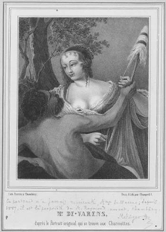
Early, Rousseau was an initiate of Madame de Warens (1699- 1762) and was received into her household in Chambéry in Southeast France. Madame de Warens was a paid Jesuit spy and catholic converter for the House of Savoy, then part of the Kingdom of Sardinia.[35] She was a Libertine. A libertine is one devoid of most moral or sexual restraints, which are seen as unnecessary or undesirable, especially one who ignores or even spurns accepted morals and forms of behavior sanctified by the larger society.
Madame de Warens read the works of Deist authors, particularly Voltaire. While living in her household, Rousseau delved into the works of Newton, Bayle, and Voltaire. Voltaire’s works, in particular, he said, “Inspired me with a desire to write elegantly, and caused me to endeavor to imitate the colorings of that author, with whom I was so enchanted.” [36]
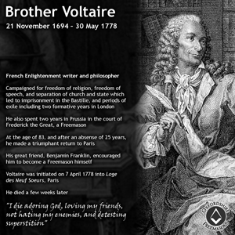
Voltaire was also a Freemason. François-Marie Arouet (1694 – 1778) known by his nom de plume Voltaire was a French Enlightenment writer, historian, and philosopher. He was enshrined in the Panthéon, after the National Assembly of France, which regarded him as a forerunner of the French Revolution.[37] He also was a freemason. He was initiated in Ben Franklin and Denton’s Lodge of the Nine Sisters, at Paris, April 7, 1778.[38]
Deists believe in a god of nature – a noninterventionist creator in the affairs of man – who permits the universe to run itself according to natural laws. Like a “clockmaker god” initiating the cosmic process, the universe moves forward, without needing God’s supervision.[39]
Deism became popular during the 1700’s. Deist ideas appear in the writings of such philosophers as Rousseau and Voltaire. In America, deist ideas appear in the Declaration of Independence and the Preamble to the Constitution. Those ideas reflect political influence of leading deists of the time: Benjamin Franklin, Thomas Jefferson, and Thomas Paine. The deist concept of God underlies such phrases as “In God We Trust” and “we are endowed by the Creator with certain inalienable rights”.[40]
This is a very important religious invention of the secret ruling ILLUMINATI/Masonic planter elite in the founding principles of America’s constitutional congresses that few truly understand. This religious principle places their man’s inhumanity to man– Institution of African Human Bondage- the affairs of men beyond the questions and judgment of GOD!
It was intended that The Cult of the Supreme Being become the state religion of the new French Republic and a replacement for Roman Catholicism and its rival, the Cult of Reason.
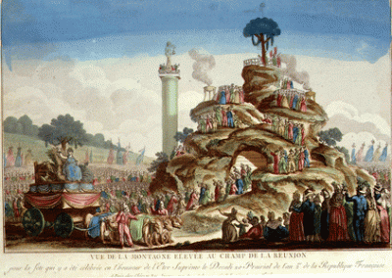
Cult of the Supreme Being Ritual- Mound & Tree of Liberty
The concept of a Tree of Life (Liberty) has been used in science, religion, philosophy, and mythology. A tree of life is a common motif in various world theologies, mythologies, and philosophies. It alludes to the interconnection of all life on our planet and serves as a metaphor for common descent in the evolutionary sense.[41]
Manly P. Hall 33°, in his monumental work, The Secret Teachings of All Ages, writes, “…the Tree of Life is also the appointed symbol of the Mysteries, and by partaking of its fruit man attains immortality.”[42]
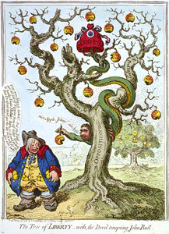
French Revolution- Satanic Tree of Liberty
The ritual ceremonies of the Cult of the Supreme Being were arranged by Jacques-Louis David. David was a Freemason initiated into the “La Moderation” Lucifer’s Masonic Lodge.[43] Freemason Robespierre was the minister. Many hymns were heard, including Freemason Marie Joseph Chénier’s famous hymn:
God of the people, of kings, of cities, of the countryside,
Of Luther, of Calvin, of the children of Israel
You whom the Gheber [Zoroaster] worships deep within his mountains,
In invoking the stars of heaven
Here are gathered before your immense sight
The sons and supports of the French empire.[44]
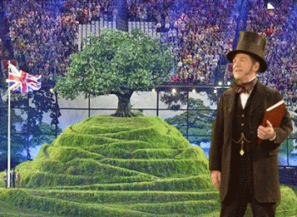
2012 Summer Olympics, Freemason, Mound & Tree of Liberty, London, England
Many will argue that the French Masonic Cult of the Supreme Being, the Mountain and Tree of Liberty Ritual is a thing of the distant pass. Well, they will be hard pressed to explain why the ritual shows up in Great Britain in the 21st century with a British Freemason like French Freemason Jean Rousseau leading the ritual ceremonies.
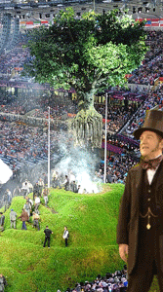
And, people arising out of deep of the mountain (Zoroastrianism) like the sonnet of French Freemason Marie Joseph Chénier.
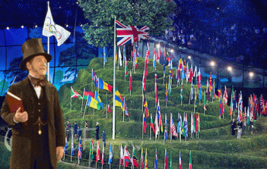
However, the British Royal House make no bones about supporting the Cult of the Supreme Being to become the 21st century Satanic religion of the NEW WORLD ORDER.
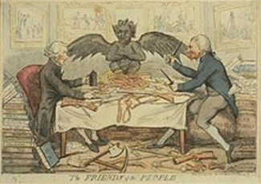
The Friends of the People caricatured by Isaac Cruikshank, November 15, 1792, Joseph Priestley, DEVIL and Thomas Paine. ORIGIN OF FREEMASONRY by Thomas Paine (1737- 1809) The Christian religion and Masonry have one and the same common origin: both are derived from the worship of the sun. The difference between their origin is, that the Christian religion is a parody on the worship of the sun, in which they put a man whom they call Christ, in the place of the sun, and pay him the same adoration which was originally paid to the sun.
In Masonry many of the ceremonies of the Druids are preserved in their original state, at least without any parody. With them the sun is still the sun; and his image in the form of the sun is the great emblematical ornament of Masonic lodges and Masonic dresses. It is the central figure on their aprons, and they wear it also pendant on the breast of their lodges, and in their processions. It has the figure of a man, as at the head of the sun, as Christ is always represented.
At what period of antiquity, or in what nation, this religion was first established, is lost in the labyrinth of unrecorded time. It is generally ascribed to the ancient Egyptians, the Babylonians and Chaldeans, and reduced afterwards to a system regulated by the apparent progress of the sun through the twelve signs of the zodiac by Zoroaster the lawgiver of Persia, from whence Pythagoras brought it into Greece.[45]
Thomas Paine was specifically brought to America by Jacobin Freemason, Benjamin Franklin. It was Franklin who, with the support of Masonic Grand Master George Washington. They made Paine’s “great swelling words” an acceptable sensation in the American colonies. Men like Thomas Paine, Jefferson and Benjamin Franklin spent years interacting with the revolutionary ILLUMINATI Jacobin Masons in France, who even set up a goddess they called Reason in the midst of the French Revolution. This was done specifically to denounce Christianity and the BIBLE (Book of Leviticus), which the French attempted to destroy completely from their midst.[46]
In 1792, after the guillotine was erected near the Tuileries and Robespierre and Jean-Paul Marat rounded up “priests, royalists, editors, and judges” and executed 1,400 political prisoners. Thomas Jefferson and others in his Democratic Republican Party applauded the mass atrocities. Some called themselves “Jacobins,” saluting one another as “citizens.” They excused the bloodshed as necessary EVILS in the pursuit of liberty.
Jefferson had a stunning response when his former private secretary William Short wrote him from Europe to tell him personally of “those mad and corrupted people in France who under the name of liberty have destroyed their own government.”
Jefferson replied with chilly dispassion. “The liberty of the whole earth was depending on the issue of the contest,” he wrote. “Rather than it should have failed, I would have seen half the earth desolated.”[47] That brings us right back to Judge Roy Moore. He too, will see the nation divided, burning of Troy, and half the earth desolated before he voluntarily step away from the Republican ticket for U.S. Senate.
V
JACOBIN ROY MOORE OF ALABAMA
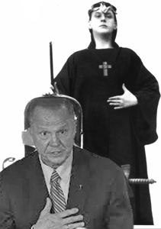
“Do what thou wilt shall be the whole of the Law. Love is the law, love under will” – Aleister Crowley 666
The issue with Judge Roy Stewart Moore just as is with Donald J. Drumpf is plainly Evil– ABSOLUTE EVIL.
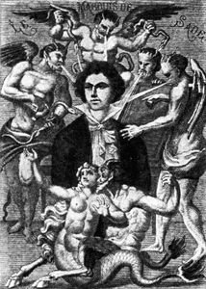
Lust’s Passions will be Served. –Marquis de Sade, the ILLUMINATI
It is believed that Adam Weishaupt of the ILLUMINATI formed an inner council of members (the “law of five”), which included: himself, Sir Francis Dashwood (Hellfire Club), Kolmer, Alphonse Donatien De Sade (Marquis de Sade), and Mayer Amschel Rothschild. Marquis de Sade (Sadism) was a “Psychopathic Satanist” of the oligarchic ruling class. He was a Libertine, a Master of Debauchery.
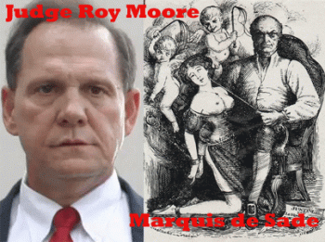
Marquis de Sade like Judge Roy Moore was always on the lookout for impressionable girls to exploit. In 1772, Sade with his valet took part in an orgy of whippings, masturbation and sodomy with four girls, to whom they gave aniseed sweets soaked in Spanish Fly aphrodisiac. Two of the girls became ill and said they’d been poisoned. A warrant was issued for the arrest of Sade and his valet, but they fled the country. In their absence, Sade was sentenced to beheading for poisoning and sodomy, and his valet to hanging. When Sade heard the news, he recorded that he masturbated and discharged joyously! When he later returned to France, he was later reprieved on appeal, as was so often the case with the aristocratic class.
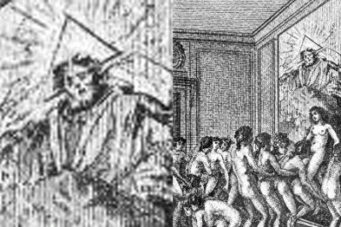
Marquis de Sade’s Supreme Being & Debauchery
An Orgy, Illustration From “Histoire de Juliette, by the Marquise de Sade
During the French Revolution, Sade and joined the Section des Piques, a radical revolutionary faction in Paris. His past military experience was put to use organizing their cavalry, and in 1793 (the year of The Terror) he became president of the section. He even addressed the French National Convention in 1792 as a member, and published several political pamphlets.
The National Convention, French Convention Nationale, assembly governed France from September 20, 1792, until October 26, 1795, during the most critical period of the French Revolution. The National Convention was elected to provide a new constitution for the country after the overthrow of the monarchy (August 10, 1792). Sodomy, incest, rape, and other sexual vices proposed by Sade were presented as fraternal or sororal gestures (like brothers and sisterly).
In an essay of the period of the French National Convention heavily influenced and dominated by the ILLUMINATI Jacobin Club and Marquis de Sade, Sibalis write: “In his presentation of the newly drafted penal code to the Constituent Assembly, Le Pelletier de Saint-Fargeau commented that it outlawed only ‘true crimes’ and not ‘those phony offenses created by superstition, feudalism, the tax system and despotism.’ Although he did not list the crimes ‘created by superstition‘ — meaning the Christian religion – they undoubtedly included blasphemy, heresy, sacrilee, and witchcraft, and also quite probably bestiality, incest, pederasty (Greek-Roman Boy-Love) and sodomy. By dropping any mention of these former offenses, Revolutionary legislation simply passed over in silence acts that had once, at least in theory, merited the most severe penalties [including death].” (“The Regulation of Male Homosexuality in Revolutionary and Napoleonic France, 1789-1815,” in Homosexuality in Modern France, edited by Jeffrey Merrick and Bryant T. Ragan, Jr. p. 82)
I said all of that to say this. Judge Moore’s Foundation for Moral Law (Jean Rousseau) is a secret Jacobin ILLUMINATI Cell on a mission to further confuse, divide and polarize the America people, and drive the country into CHAOS. As far as Judge Moore’s pedophilia charges are concerned, the Jacobin God stays out of the affairs of man. And, the Jacobins don’t consider pedophilia, sexual assaults and sexual perversion societal crimes , but the divine privileges of the secret MASONIC,
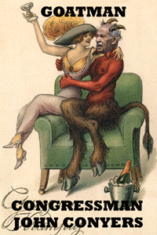
Divine 9- Kappa Alpha Psi, Boule, Prince Hall Master Master
and ANCIENT WHITE BROTHERHOODS!
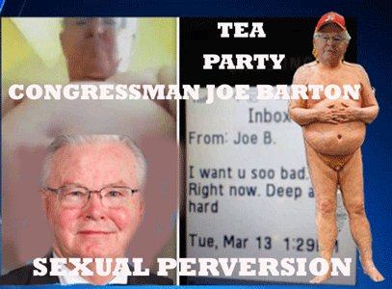
Jacobin ILLUMINATI Tea Party U.S. Congressman Joe Barton (Texas)
I have said enough!
_______________________________________________________________________________
[1] http://www.newsweek.com/roy-moore-wife-kayla-minor-718819
[2] http://www.dailymail.co.uk/news/article-5103989/Roy-Moore-noticed-wife-15.html
[3] https://en.wikipedia.org/wiki/Emma_Sansom
[4] https://www.britannica.com/biography/Nathan-Bedford-Forrest
[5] http://www.al.com/news/anniston-gadsden/index.ssf/2016/12/1906_gadsden_lynching_memorial.html
[6] https://www.theguardian.com/world/2004/nov/30/usa.schoolsworldwide
[7] Id.
[8] https://www.splcenter.org/fighting-hate/intelligence-report/2004/alabama-supreme-court-candidate-tom-parker-has-extremist-ties
[9] https://www.splcenter.org/fighting-hate/intelligence-report/2004/alabama-supreme-court-candidate-tom-parker-has-extremist-ties

[10] https://www.splcenter.org/fighting-hate/intelligence-report/2004/alabama-supreme-court-candidate-tom-parker-has-extremist-ties
[11] Id.
[12] http://www.cnn.com/2017/09/27/politics/kfile-roy-moore-secession-day-events/index.html
[13] http://www.cnn.com/2017/09/27/politics/kfile-roy-moore-secession-day-events/index.html
[14] https://www.bustle.com/p/who-is-roy-moore-his-reds-yellows-racial-slur-has-people-outraged-2404602
[15] https://www.archives.gov/education/lessons/blacks-civil-war
[16] https://paleofuture.gizmodo.com/fbi-releases-file-on-willis-carto-neo-nazi-recently-bu-1783195062
[17] https://www.huffingtonpost.com/entry/roy-moore-foundation-nazi-donation_us_59e79abae4b08f9f9edc59a0
[18] https://www.roymoore.org/Press-Releases/67/ALABAMA-PATRIOTS-ENDORSE-JUDGE-MOORE
[19] http://www.teapartyexpress.org/9265/tea-party-express-endorses-roy-moore-in-alabama-senate-runoff
[20] https://www.teapartypatriotscitizensfund.com/tea-party-patriots-citizens-fund-endorses-roy-moore-for-u-s-senate/
[21] http://www.thenazareneway.com/Goddess%20of%20Founding%20Fathers.htm
[22] https://www.britannica.com/biography/Georges-Danton
[23] https://worldtruth.tv/the-dupont-bloodline-a-dynasty-of-satanic-royalty/
[24] https://zaidpub.com/occult-symbolism-as-based-on-ancient-mystery-religions/known-personalities-the-hidden-hand-of-the-occult/
[25] https://www.politico.com/magazine/story/2014/02/thomas-jefferson-france-lafayette-monticello-103303
[26] https://zaidpub.com/occult-symbolism-as-based-on-ancient-mystery-religions/known-personalities-the-hidden-hand-of-the-occult/

[27] https://breakchains.wordpress.com/2014/07/24/the-new-jacobins/
[28] https://en.wikipedia.org/wiki/Maximilien_Robespierre
[29] https://www.spencorp.info/adam-weishaupt
[30] http://www.philosophybasics.com/philosophers_rousseau.html
[31] http://www.u-s-history.com/pages/h2052.html
[32] http://www.midnightfreemasons.org/2012/08/the-masonic-philosophy-of-george_29.html
[33] https://en.wikipedia.org/wiki/Louis_Philippe_II,_Duke_of_Orl%C3%A9ans
[34] http://www.wikiwand.com/en/Louis_Philippe_II,_Duke_of_Orl%C3%A9ans
[35] https://en.wikipedia.org/wiki/Fran%C3%A7oise-Louise_de_Warens
[36] https://www.catholictextbookproject.com/wp-content/uploads/LTN_1_Supplement_Age_of_Enlightenment.pdf
[37] https://en.wikipedia.org/wiki/Voltaire
[38] http://www.masonicdictionary.com/voltaire.html
[39] https://www.allaboutphilosophy.org/deism.htm
[40] http://www.knightstemplar.org/gckt/va/17/1823/papers/Deism.pdf
[41] http://en.wikipedia.org/wiki/Tree_of_life#Assyria
[42] http://www.sacred-texts.com/eso/sta/sta22.htm
[43] https://en.wikipedia.org/wiki/Jacques-Louis_David#Freemasonry
[44] http://revolution-fr.livejournal.com/17187.html
[45] http://www.deism.com/paine_essay_masonry_1.htm
[46] http://old.worldviewweekend.com/worldview-times/print.php?&ArticleID=7086
[47] https://www.thewrap.com/thomas-jefferson-alexander-hamilton-donald-trump-french-revolution-mob/
Comments : 1 Comment
Tags: 2012 london olympics, abolition of slavery, abraham lincoln, Adam Weishaupt, Adolf Hitler, african human bondage, african slave trade, Alabama Christian Coalition, alabama supreme court, Aleister Crowley, benjamin franklin, beverly young, bible, black boule, British royal house, christianity, civil rights, civil war, confederacy, confederate flag, Contract with America, Contractarianism, Council of Conservative Citizens, cult of reason, Cult of the Supreme Being, Deism, divine nine, donald j. drumpf, donald j. trump, druids, emma sansom, erich fromm, fort dixie, fort pillow, fort pillow massacre, fort pillow war crime, Foundation for Moral Law, Foundation to Defend the First Amendment, Francis Parker Yockey, frederick douglass, French National Convention, french revolution, French Convention Nationale, friends of forrest inc., Gadsdenm alabama, general natan belford forrest, george washington, Georges-Jacques Danton, grand orient of france, Great BEAST 666 Aleister Crowley, Great White Brotherhood, Green Dragon Tavern, Heinrich Himmler, hell fire club, Illuminati, illuminati conspiracy, jacobin club, Jacques-Louis David, Jean Jacques Rousseau, jim crow, joe barton, john conyers, john giles, judge roy moore, judge tom parker, Kappa Alpha Psi, kayla kisor, Knights of the Black Sun, ku klux klan, La Moderation, league of the south, lebensborn, Leonard Wilson, Louis Philippe Joseph d'Orléans, Louis XVI, Lucifer, Madame de Warens, MANLY P. HALL, Marie Joseph Chénier, Marquis de Lafayette, Marquis de Sade, Masonic Hidden Hand, master race, Maximilien Robespierre, Mike Whorton, moral law, natural law, nazi, Nazis, New World Order, newt gingrich, Nine Sisters Masonic Lodge, nion Commander Abel Striegh, noninterventionist creator, pat godwin, pedophila, prince hall freemasons, pythagoras, Roman Catholicism, royal arch masons, satan, segregation, slavery, SS, tea party, ted cruz, THIRD REICH, thomas jefferson, Thomas Paine, tree of liberty, u.s. civil rights act, u.s. senate, underground third reich, Voltaire, voting rights act of 1965, willis a. carto, Zoroaster
Categories : Abraham Lincoln, alabama, baphomet, bunga bunga, Charles Koch. Fred Koch, christianity, civil war, devil, donald j. drumpf, donald j. trump, donald trump, dr. martin luther king, jr., druids, freemason, freemasons, human bondage, illuminati, imperium, jefferson davis, jesuits, Knights Hospitaller, Knights Templar, ku klux klan, luciferians, modern slavery, racial mass murder, satan, Satanism, scottsish rite, slavery, SS

JUDGE ROY STEWART MOORE, TROJAN FIREBRAND & THE LEAGUE OF UNITED SOUTHERNERS- CRY AMERICA, CRY!
22112017
I
THE GREAT EVIL OF DONALD J. DRUMPF AND JUDGE ROY MOORE
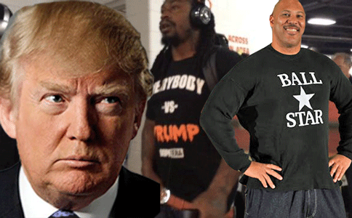
Many have cried out in wilderness about the EVIL of this world. Many cried out about the EVIL of Donald J. Drumpf. Yet, the American people allowed him to take over the highest public office of this nation. A great EVIL- Lucifer’s Son has been released on earth under the cloak of the U.S. Government. You know him one way, by his LIES! Lucifer was the first liar and with his lies he deceived one-third of Heaven’s angels. (Revelation 12:4)
Donald J. Drumpf has told 1,628 LIES since taking office. Over the 298 DAYS since his inauguration, Drumpf has told an average of 5.5 LIES every single day of the week, Monday to Sunday. Over the last 35 days, Drumpf has been even more dishonest than usual, upping his daily average to 9 LIES every 24 HOURS. And, he doesn’t give a DAMN what people think.
At any other time in history, the spirit and climate of patriotism in the nation may have been very different. However, people in this country are rather shell- shocked and stressed. There seems to be a cloud of EVIL and gloom hanging over the country for so many people. People are asking President select Donald J. Drumpf why he is singling out Marshawn Lynch and Lavar Ball for special treatment to deliberately place them in a bad public light, and not the EVIL of the accused pedophilia sexual predator, and Alabama white nationalist supremacist candidate, Judge Roy Stewart Moore. He is running in a race to occupy one of the highest offices of public trust in this nation, a U.S. Senate seat.
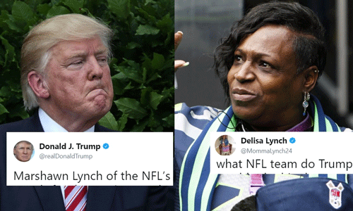
Oakland Raiders’ Marshawn Lynch is my first wife’s nephew. At one time, I was very close to his family before my dissolution of marriage from his aunt. I have never met Marshawn. But, his mother, Delisa, remains my beloved spiritual niece. It is so particularly spiritually disheartening to me that she has had to respond to one of the most powerfully profound EVIL and racist men on earth that unnecessarily singled out her son for special treatment on a national and global stage even though he has not broken any laws, or committed any wrongs or EVIL. They have 1st Amendment Constitutional rights! The world cries out. They don’t have to bow down to emperors and mad tyrants in this country.
However, Donald J. Drumpf and the Dark Satanic Circle that have taken over the seats and reigns of power of the U.S. Government are Absolute EVIL. They are CHAOS, irrational and reactionary. They follow the unwritten codes of the land of Dixie– the long gone Antebellum South and the EVILS of African Human Bondage. They have fallen back to the GREAT EVILS, and dark fallacies of ultimate white supremacy that said by the highest court of the land of the 19th century in the Dred Scott Decision,
” In the opinion of the court, the legislation and histories of the times, and the language used in the Declaration of Independence, show, that neither the class of persons who had been imported as slaves, nor their descendants, whether they had become free or not, were then acknowledged as a part of the people, nor intended to be included in the general words used in that memorable instrument.
“It is difficult at this day to realize the state of public opinion in relation to that unfortunate race, which prevailed in the civilized and enlightened portions of the world at the time of the Declaration of Independence, and when the Constitution of the United States was framed and adopted. But the public history of every European nation displays it in a manner too plain to be mistaken.
They had for more than a century before been regarded as beings of an inferior order, and altogether unfit to associate with the white race, either in social or political relations; and so far inferior, that they had no rights which the white man was bound to respect; and that the negro might justly and lawfully be reduced to slavery for his benefit. He was bought and sold, and treated as an ordinary article of merchandise and traffic, whenever a profit could be made by it. This opinion was at that time fixed and universal in the civilized portion of the white race. It was regarded as an axiom in morals as well as in politics, which no one thought of disputing, or supposed to be open to dispute; and men in every grade and position in society daily and habitually acted upon it in their private pursuits, as well as in matters of public concern, without doubting for a moment the correctness of this opinion.“
In the unwritten code of Antebellum South that they seek to enforce, it offends the fancy of white nationalist supremacy for black people to assert that they have any rights that they are bound to respect. It is the unwritten “code of insolence.”
President select Drumpf is the nation’s chief law enforcement officer, and commander in chief of U.S. Armed Forces. On the Dark Side, he commands a league of Manchurian Candidates, white nationalist terrorists, sick brothers, demonic misfits, spirits and demons. Follow wise spiritual and legal counsel, and stick to the letter and spirit of the law. These are extremely dangerous and dark forces. Be vigilant and strong my beautiful beloved.
II
JUDGE ROY MOORE, ULTIMATE EVIL AND THE FALL OF TROY
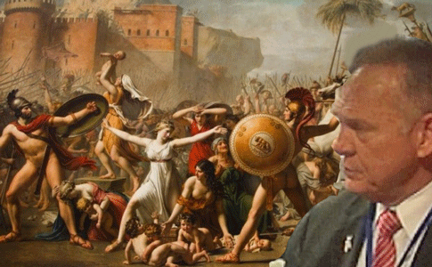
Greek Mythology surrounding Paris and Helen of Troy is a romanticized version of ancient legend of the fall of the city of Troy. They tell us that the Goddess Aphrodite awarded Paris with the most beautiful woman in the world by her divine providence by his judgment to award her the Golden Apple. The Great God Zeus had appointed Paris to judge among Hera, Athena and Aphrodite, and award the most beautiful among them with the Golden Apple. For the Golden Apple, Aphrodite promised Paris the beautiful, Helen of Sparta, the wife of Greek King Menelaus. It is classic epic poetry of Homer.
The ancient Great Greek Historian, Herodotus, says that isn’t necessarily true. There had been no such divine intervention that allowed the Prince of Troy, Paris, to kidnap Queen Helen and rape her. It was a great crime to Sparta, and an offense to JUSTICE, RIGHTEOUSNESS, TRUTH, and BALANCE. Herodotus says that Paris abducted and raped Helen and took to the seas with the queen along with the King’s treasure. Before he reached his homeland Troy, he shipwrecked off the coast of the Land of Kemet near Memphis. The Great Pharaoh learned of Paris’ great crime and outrage against his host arrested Paris, and placed Helen of Sparta and King Menelaus’ treasure under his protection while Paris sailed back to Troy. King Menelaus and the Greeks arrived in great military force at the gates of Troy. They simply refused to believe King Priam and Prince Paris that Helen wasn’t behind the walls of the city. The great long bloody war and seize of Troy of legend began.

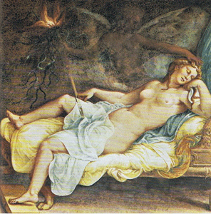
HECUBA OF TROY
“She [Hecuba] dreams, and gives her lord to understand, that she should soon bring forth a firebrand, whose hot and climbing flame should be, so great, that Neptune’s Troy, it would consume with heat.” Troilus and Cressida is a tragedy and another piece of epic poetry by William Shakespeare, believed to have been written in 1602.[1]
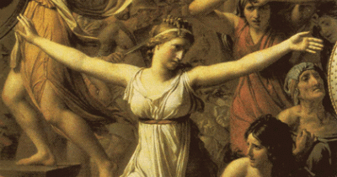
CASSANDA
Our firebrand brother, Paris, burns us all. Cry, Trojans, cry![2]
Hecuba, wife of King Priam of Troy, was the daughter either of Dymas, king of Phrygia (according to Homer) or of Cisseus, king of Thrace (according to Euripides and Virgil); the name of her mother is unknown. While pregnant with her son Paris, she dreamed that she gave birth to a firebrand that destroyed the city of Troy.[3] She gave birth to a prince and tyrant bound for the “River of Hell“. Troy was bound to burn in the river of HELL.
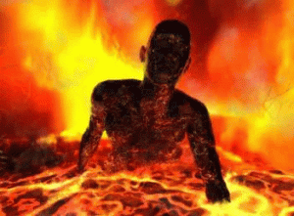
In Greek mythology, the river Phlegethon “flaming“) or Pyriphlegethon (“fire-flaming”) was one of the five rivers in the infernal regions of the underworld. In Dante’s Inferno, Phlegethon is described as a river of blood that boils souls. It is in the Seventh Circle of Hell, which punishes those who committed crimes of violence against their fellow men (see Canto XII, 46–48); murderers, tyrants, and the like. By causing hot blood to flow through their violent deeds in life, they are now sunk in the flowing, boiling blood of the Phlegethon. The depth at which each sinner must stand in the river is determined by the level of violence they caused in life; Dante sees Attila the Hun and Alexander the Great up to their eyebrows. Centaurs patrol the circle, firing arrows at those who try to rise above their allotted level in the river.
In Spenser’s The Faerie Queene, the Phlegethon is to be found in hell, and is portrayed as a “fiery flood” where “the damned ghosts in torments fry” (Canto V, 291–291). In Paradise Lost (II, 580) John Milton names the Phlegeton (sic) as one of the rivers of Hell, which bold adventuring demons explore while Satan’s flight to Earth begins.
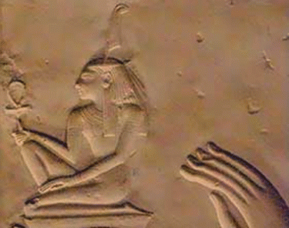
THE ANCIENT GODDESS MAAT
Around 450 BC, Herodotus and the ancients believes that Paris and the Helen of Troy tells another entirely different story that held it was Divine Providence that they were shipwrecked in the Great Land of Kemet (MAAT), and “it might be evident to all men that when great wrongs are done, the gods will surely visit them with great punishments.”
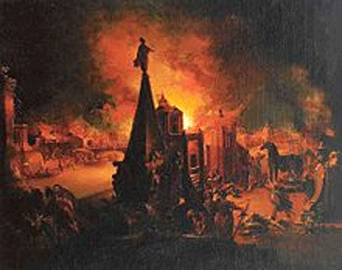
The Burning of Troy (1759/62), oil painting by Johann Georg Trautmann
Corporate Mass Media has romanticized Roy Stewart Moore as an “Alabama [Pyriphlegethon] firebrand”- The Paris of the South. They say that medieval English writers first began using “firebrand” in the 14th century as a byword for demagogues and rabble-rousers. In modern journalism, they say it still conveys a spirit of extremism and agitation without the editorial fuss of calling a high-profile elected official an “extremist” or an “agitator” instead of calling it the “EVIL OF MAN.”[4]
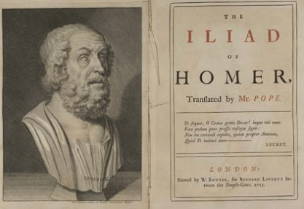
As you see, “Firebrand” may actually go back to Greek Mythology to Homer and the Iliad, and the notions of HELL. And, I believe that the “Firebrand” of Homer’s Troy is the mythological foundation of the “fire-eaters” of the South that nearly brought the United States to total “flaming” destruction during the American Civil War like the mighty City of Troy for their own EVIL, and crimes against humanity– the INSTITUTION OF AFRICAN HUMAN BONDAGE. Don’t get it twisted. The Confederate antebellum aristocracy were 19th scholars and intellectuals. The Confederate elite planters, particularly Jefferson Davis, were fascinated with Greek Mythology– everything Greek and Roman to justify themselves as “Gods of Men“.
In my previous post on Judge Roy Moore, JUDGE ROY MOORE OF ALABAMA, THE LEAGUE OF THE SOUTH & THE SEETHING ENERGY OF LUCIFER, I talked about The League, and its predecessor and grandfather, The League of United Southerners (fire-eaters) that started the American Civil War. The League of the South is a haven and front for their grandfather’s paleoconservative and neo- conservative fatal ideas, academics and clandestine activism that now seeks to clandestinely fan the flames for the 2nd Civil War in America, and a new EVIL institution- MODERN SLAVERY.
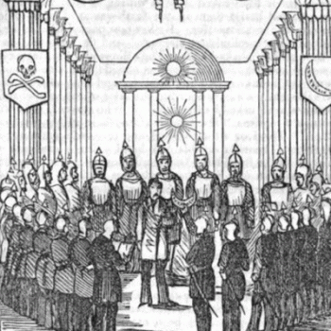
The “fire-eaters” of the South were clandestine members and allies of the Masonic Knights of the Golden Circle (KGC), a “militant oath-bound secret society dedicated to promoting [white] southern rights”, and African Human Bondage. They were a “powerful force” that became by 1860 the “strong arm of secession” across the South. The KGC were secretly at the center of the secession crisis in America that it to the Great Civil War.[5]
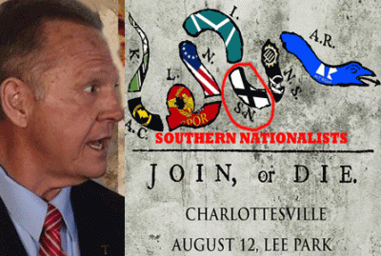
Judge Roy Moore also has a secret and powerful “strong arm force” behind him, Warlock Steve Bannon, and an international network of violent united white nationalist terrorists that seek clandestine and violent secession.

U.S. President select Donald J. Drumpf: “But not all of those people [Charlottesville Alt-Right March] were neo-Nazis, believe me. Not all of those people were white supremacists, by any stretch.”

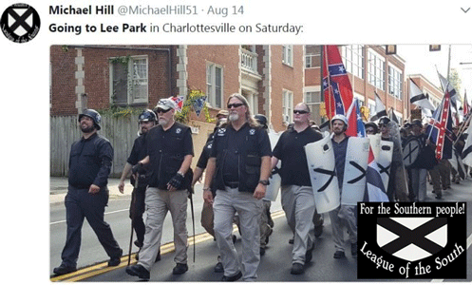
March of Very Fine People- LOS Anglo- Celtic War Tribe
It does not look as if Judge Moore’s clandestine patron and sponsoring saints, the League of the South (LOS), led by a convicted felonious white supremacist nationalist terrorist Michael Tubbs of Florida; and white supremacist nationalist Alabamian Michael Hill are marching to a peaceful rally in Charlottesville in the state of Virginia.
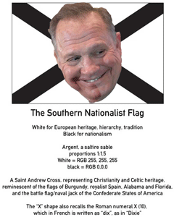
The League of the South financed up to 2/3’s of Judge Roy Moore’s public office election campaign in Alabama. Some seem to believe that the League can march into anyplace across America- jump into a boxing ring with their gloves on-
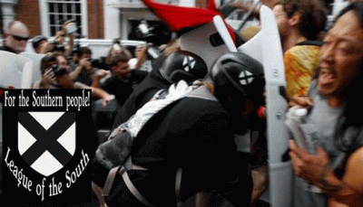
attack, engage, fight and brawl …
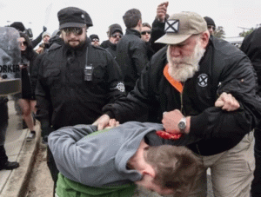
beat people nearly to death with weapons …


like little-tiny 20 year old De Andre Harris, a resident of Charlottesville in the state of Virginia …
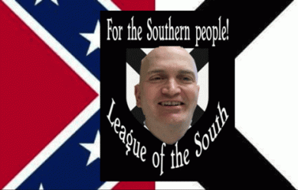
Ray Crews, Chairman of the League of the South’s North Carolina Chapter
then argue justification and protection from the law for the violence that takes place in the ring as- White Nationalists’ Self Defense. Tiny savagely beaten DeAndre Harris of Charlottesville was arrested and charged by his resident police department for assault and battery on Ray Crews, Chairman of the League of the South’s North Carolina Chapter. Peacefully march anyplace in America, that’s not their agenda, purpose or nature.
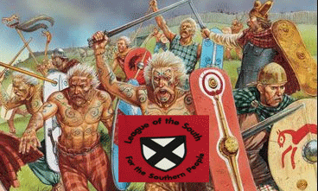
The League has been described as using the warlike-warrior nature and tradition of English and Celtic mythology “belligerently“as part of their violent white nationalist terrorist- secessionist movement and agenda.
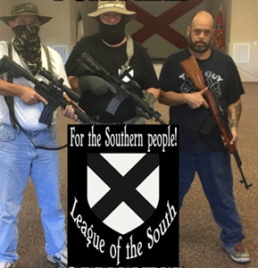
It is just the same as their American Civil War grandfather, The League of United Southerners, had done to the South’s Anglo- Celtics Masses …
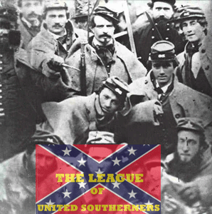
to front, arm, and fight them in the Great Civil War to preserve and expand the elite’s plantation system, and African Human Bondage in America.
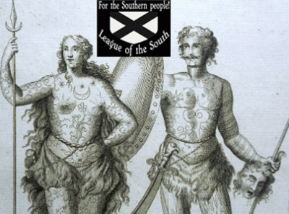
The League describes Southern Culture as being inherently Anglo-Celtic (originating in the British Isles), and they believe the South’s core Anglo-Celtic warlike culture should be preserved. Anglo-Celtic people are those of British or English and Celtic descent- Ireland, Scotland, Wales the Isle of Man and Cornwall.
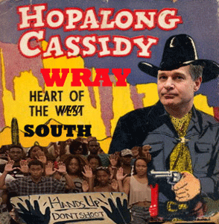
FBI Director Wray’s Six Shooter Trained for Black Identity Extremists
And, Drumpf, Steve Bannon, and the Dark Circle have Dixie Mafia running the FBI (Hopalong Cassidy Wray of Atlanta, GA) – looking the other way, while white nationalist terrorists intimidate witnesses against Roy Moore, and advance their racist and violent secessionist agendas across America.
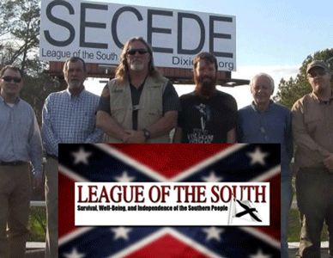
Convicted White Nationalist Supremacist Terrorist Michael Tubbs- 21st Century SECESSION OF THE SOUTH!
In my prior post, I mentioned, but did not discuss the League of the South’s underlining philosophy of neo-conservatism, and paleoconservatism– paleo– combining form- older or ancient. The word paleoconservative (“old conservative“) was originally a tongue-in-cheek rejoinder used in the 1980s to differentiate traditional Conservatives from Neoconservatives and Straussians (Leo Strauss).
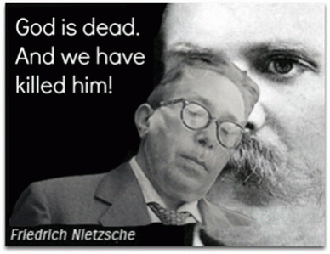
Leo Strauss and Nietzche
Leo Strauss was the guru of the neo-conservatives that embarked America in proxy wars in the Middle East on behalf of Israel. Like Plato, he taught that within societies, some are fit to lead, while others [particularly, people of color] only to be led.[6]
According to Strauss (1899- 1973), it was Machiavelli who initiated the Enlightenment, by rejecting the purely theoretical world of Plato. “For Strauss, in accordance with Machiavellian thinking, virtue would not be applicable, because no regime could meet its standards. Rather, a new regime should be created, by accepting, understanding, and harnessing man’s tendency for self-interest, or ‘human nature‘ “.[7]
Pat Buchanan calls Neo-conservatism “a globalist, interventionist, open borders ideology.” The Paleoconservatives argue that the “Neocons” are illegitimate interlopers in the conservative movement. The southern traditionalist worldview conservative thread of paleoconservatism embodies the statesmanship of nineteenth-century figures such as John Randolph of Roanoke, John Taylor of Caroline, and John C. Calhoun, the godfathers of southern traditional paleoconservatism.[8]
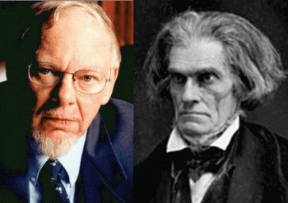
Clyde Wilson & John Calhoun
Clyde Norman Wilson is one of the 4 (four) Ph.D.’s philosophical founders of the League of the South, and an affiliated scholar of the League’s Institute, the research arm of the League of the South. He is an American professor of history at the University of South Carolina, and a paleoconservative political commentator. Wilson is best known for his expertise on the life and writings of John C. Calhoun, having recently compiled all his papers in twenty-eight volumes.[9]
Wilson has contributed more than 400 articles, essays, and reviews to a wide variety of academic and popular books and publications. He has lectured extensively across the U.S. to scholarly, heritage, and political groups. Books include Essays in the Jefferson Tradition: and Defending Dixie. He has edited a number of books, including three volumes of The Dictionary of Literary Biography on American historians; The Essential Calhoun; John C. Calhoun: A Bibliography; and A Defender of Southern Conservatism: M.E. Bradford and His Achievements.[10] Wilson is recipient of the Bostick Medal for Contributions to South Carolina Letters, the first annual John Randolph Club Award for Lifetime Achievement, and the Sons of Confederate Veterans Medal of Meritorious Service. In 2005 he was the founding Dean of the Stephen D. Lee Institute, an educational arm of the Sons of Confederate Veterans.[11]
Historian Paul V. Murphy argues that paleoconservatism is rooted in a group of intellectuals fascinated by antebellum culture and the Southern Agrarians. IT IS! What does paleoconservatism mean to its fathers, John Randolph of Roanoke, John Taylor of Caroline, and John C. Calhoun?
III
ANTEBELLUM SOUTH & THE ILLUMINATI JACOBIN CLUB
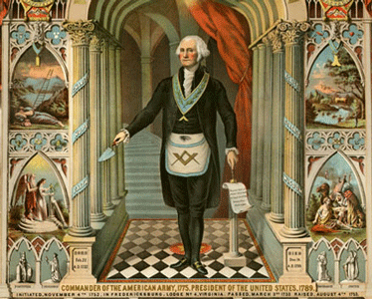
On October 24, 1798, former President George Washington pinned a letter to the U.S. Congress that he does not doubt that the doctrines of the Bavarian ILLUMINATI, as created by Adam Weishaupt in 1776, (which was used to infiltrate Freemasonry) had spread in the United States in fact he says, “On the contrary, no one is more truly satisfied of this fact than I am.” Then he adds that it is possible that those Democratic Societies influenced or created by the Freemasons or ILLUMINATI, “…actually had a separation of the People from their Government in view, is too evident to be questioned.”[12] The ILLUMINATI must have been much bigger, and closer to him than he realized- the JACOBIN CLUB in America.
IV
JACOBIN THOMAS JEFFERSON, THE DEVIL’S SON
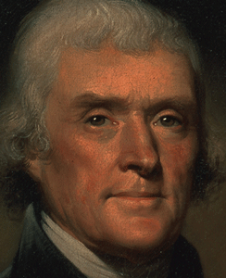
Thomas Jefferson
The 1796 U.S. presidential election was between the pro-French and pro-decentralization Democratic-Republicans under Southern Agrarian Thomas Jefferson and Aaron Burr, and John Adams and Charles Pinckney’s pro-British and pro-centralization Federalists. In the campaign during the election, Federalists attacked Republicans as both dangerous French Masonic- ILLUMINATI Jacobins who threatened social disorder; and slaveholding aristocrats determined to protect their interests at any costs.[13]
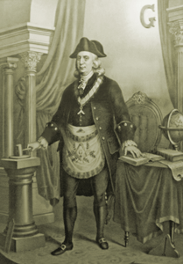On July 14, 1789, the U.S. Ambassador to France, Thomas Jefferson, was a witness to the events of a day in Paris that is commonly associated with the beginning of the French Revolution. Jefferson arrived in Paris to replace Benjamin Franklin, who was retiring as ambassador to France. Jefferson was sympathetic to the revolution, opening his home in Paris to its leaders and assisting his friend the Marquis de Lafayette– ILLUMINATI with drafting the Declaration of the Rights of Man.[14]
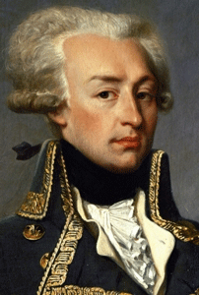
French ILLUMINATI Marquis de Lafayette
The Marquis de Lafayette was a young French aristocrat who joined the American Revolutionary War at his own request, becoming one of America’s most successful leaders in combat and General George Washington’s most loyal companion. On October 21, 1778, Lafayette, as a Major General, was granted a leave of absence to go to Paris, France to return at his convenience.[15] No original documentary evidence is known to be in existence which records the initiation of General Lafayette in the Masonic Fraternity, nor in what Lodge or when it took place. It has always been a tradition in Masonic circles that General Lafayette was a Grand Orient of France Mason before he came to America.[16]
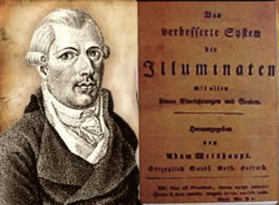
Adam Weishaupt
ILLUMINATI Manifesto of World Revolution by Marco de Luchetti, technically a forward to conspirator of the French Revolution Nicholas Bonneville’s 1792 book L’Esprit Des Religions, explains how the French secret society/publisher Le Cercle Social housed the key French members of the Bavarian ILLUMINATI who carried out a definite conspiracy via the French Revolution. Included among the key backers of this ILLUMINATI conspiracy are the Rothschild family, who bankrolled founder Adam Weishaupt, the Saxe-Gotha family who protected Weishaupt after the secret group was exposed, as well as the Marquis de Lafayette, who served as a general in the American Revolution, and as a leader of the Garde Nationale in the French Revolution.[17]
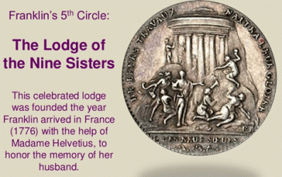
Both Benjamin Franklin and Thomas Jefferson became heavily involved with, and tied to, the secret societies of France and Europe at large during their extensive time there as ambassadors prior to the French Revolution. Franklin was master of the Masonic Lodge of Philadelphia, while over in France he was master of the Nine Sisters Lodge, from which sprang the French Revolution. In England, he joined a rakish political group founded by Sir Francis Dashwood (member of Parliament, adviser to King George III) called the Monks of Medmenham Abbey, otherwise known as the Hellfire Club.[18]
Jefferson is on record as supporting the expressed aims of Adam Weishaupt, founder of the ILLUMINATI, and his vision for the perfectibility of man, while he incorporated many esoteric thematics connotating an illuminated status into his Monticello estate, which grew to include 33 rooms and bore various symbolic architectural elements.[19] Both Franklin and Jefferson were alleged members of the satanic group, Hell-Fire Club, who practiced satanic sexual occult rituals, and most likely human sacrifices.[20]
The Duc d’Orleans, Grand Master of the Grand Orient of France, which is head of all the French masons, along with two other key Masons Charles-Maurice de Talleyrand and Honoré-Gabriel Riqueti, comte de Mirabeau started the Jacobins. According to the book, The War of the Antichrist with the Church (a book made from the lectures of George Dillon, Dublin, Ireland: M.H. Gill & Son, 1885) where Dillon lectures on the French Revolution, he states that both Talleyrand and Mirabeau were key ILLUMINATI. The name of the original lodge of the Jacobins was changed to Club Breton, then Jacobin Club. The Jacobins were basically an Illuminized type of Freemasonry.
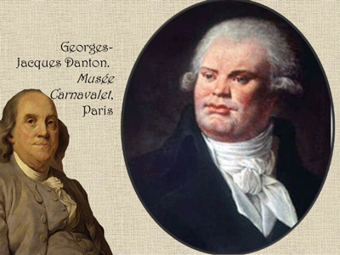
The President of the Jacobin Club was the Freemason Georges Jacques Danton (1759 – 5 April 1794), who was a member of the famous and powerful Nine Sisters Lodge (nine sisters or nine muses is what the Pleiades is called) along with Ben Franklin. A very secret body of 300 key Freemasons ruled France secretly during this period according to the Autobiography of Wolfe Tone (pub. by R. Barry O’Brien, 1893).
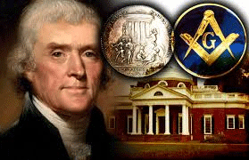
For over 200 years, there has been disagreement over whether or not Jefferson had been a Freemason. Dr. Joseph Guillotin reported that he attended meetings at the prestigious Lodge of Nine Muses with Danton in Paris, France—the same lodge attended by Voltaire, Benjamin Franklin, and John Paul Jones. Jefferson marched in a Masonic procession with Widow’s Son Lodge No. 60 and Charlottesville Lodge No. 90 on October 6, 1817, and participated in laying the cornerstone for Central College (now known as the University of Virginia.) In 1801, twenty-five years prior to his death, a lodge was chartered in Surry Court House, Virginia—it was named Jefferson Lodge No. 65. And most notably, upon his death on July 4, 1826, both the Grand Lodge of South Carolina and the Grand Lodge of Louisiana held Masonic funeral rites and processions for him.[21]
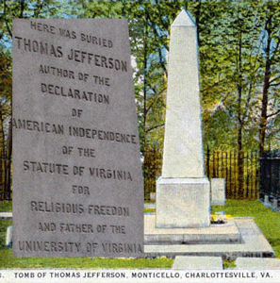
The man is buried underneath an Egyptian-Freemason Phallic Obelisk. The original idea for all the French Revolution started with the Satanic Hierarchy. During that time, eyewitnesses testified that Satan has a very detailed plan which he entrusts to his very select few at the top. Much of what seems coincidence and unrelated is actually according to a very clever (diabolical) plan.[22]
V
THOMAS JEFFERSON’S FIRST COUSIN- JOHN RANDOLPH OF ROANOKE
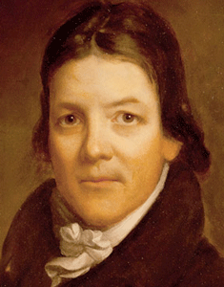
John Randolph of Roanoke
The Cavalier class in the old South identified themselves, generally, as Anglo-Norman. John Randolph of Roanoke, that great eccentric and public figure, said (as did fellow Virginian John Taylor of Caroline) “I am an aristocrat; I love liberty. I hate equality.”[23]
John Randolph (June 2, 1773 – May 24, 1833), known as John Randolph of Roanoke, was a planter and a Congressman from Virginia, serving in the House of Representatives at various times from 1799 to 1833, Senate (1825-1827), and also Minister to Russia (1830). He served as Thomas Jefferson’s spokesman in the House. Randolph was born at Cawsons, Virginia (now in Hopewell, VA ), the son of rich tobacco planter John Randolph (1742–1775) and Frances Bland (1744–1788). His families, the Randolph family of Virginia and the Bland family of Virginia, are both counted among the prominent First Families of Virginia and were close cousins to each other. He was the grandson of both Richard Randolph and Theodorick Bland of Cawsons who were, respectively, the grandson and great-grandson of William Randolph and Mary Isham of Turkey Island. He was the first cousin once removed of both Richard Bland and Peyton Randolph, the two pillars of the First Continental Congress, the nephew of Congressman Theodorick Bland. He was a second cousin of Thomas Jefferson. Jefferson’s mother was the daughter of Isham Randolph of Dungeness.
John Randolph of Roanoke and the Tucker Masonic Clan
In Bermuda, the powerful Tucker Clan was instrumental in bringing the Scottish Rite Freemasonry to prominence over the Grand Lodge Masons.. Wherever the Tucker family was prominent, it imported Scottish Rite Masonry. Lodge St George is the oldest Lodge of all the Lodges operating in Bermuda, and the oldest Scottish lodge outside of Scotland. Lodge St George received its Warrant on August 7, 1797.
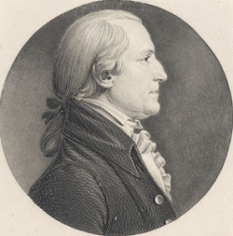
Colonel Henry St. George Tucker
John Randolph’s stepfather was Bermuda Lodge British Freemason Colonel Henry St. George Tucker (1752- 1827) notoriously known shipper smuggler of the island of Bermuda. Lodge St George is the oldest Lodge of all the Lodges operating in Bermuda, and the oldest Scottish lodge outside of Scotland. Lodge St George received its Warrant on August 7, 1797.
On January 3, 1777, Tucker arrived at Yorktown aboard the family ship Dispatch. In Williamsburg he sold 2,817 bushels of smuggled salt and 1,500 pounds of cotton for £1,800 profit. Later that year, while attending a service at Bruton Parish Church, he met Frances Bland Randolph, the widow of John Randolph and the member of a prominent Virginia family. After almost a year of courtship, he married her on September 23, 1778, making his home at Matoax (sometimes Mattaox), the 1,300-acre Randolph plantation on the Appomattox River, in Chesterfield County. Frances Randolph brought three sons, including John Randolph of Roanoke, to the marriage.
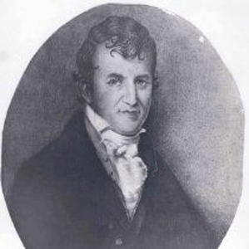
Henry St. George Tucker
Frances and Tucker had three daughters, and three sons, including jurist and congressman Henry St. George Tucker (1771- 1852), and Nathaniel Beverley Tucker (1820- 1890).
Nathaniel Beverley Tucker and the KGC Assassinated President Lincoln
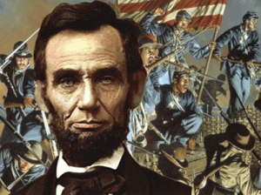
John Randolph, Henry St. George, and Nathaniel Beverley studied secret societies and Freemasonry in the extensive occult library of Colonel Tucker. Henry St. George Tucker became known as “India Henry” chairman of the British East India Company, a wild colonial racialist and major opium smuggler who spent six months in prison for “attempted rape.” Nathaniel Beverley Tucker was one of the legendary Trojan mythical Parisian “fire eaters- firebrands” of the South along with John Calhoun, James Quitman, Edmund Ruffin, etc., that started the American Civil War that brought the South to be consumed in heat and flames. Nathaniel Beverley became a major operative of the Confederate Secret Service, a clandestine Knight of the Golden Circle (KGC) that assassinated U.S. President Abraham Lincoln.
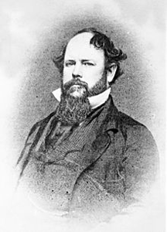
KGC Nathaniel Beverly Tucker
Confederate Commissioners Jacob Thompson of Mississippi (former US Secretary of the Interior) and Clement C. Clay (a former Alabama Senator), Nathaniel Beverly Tucker, traitorous former US consul to Liverpool England, and cousin to the Chairman of the British East India Company (opium runners); Tucker was in charge of procuring supplies from the British provinces for the Confederate war machine.
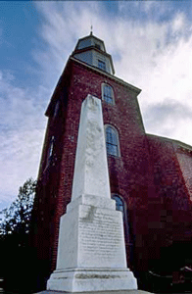
Tucker’s Masonic Obelisk Phallic Tombstone Dominates the Duke of Gloucester Street entry to Williamsburg’s Bruton Parish Graveyard.
Sept 16, 1865: Nathaniel Beverly Tucker arranged passage to ENGLAND for Lincoln’s Vatican “JESUIT” Assassination Conspirator, John Surratt, under an assumed name. Having been born an English subject in the West Indies, Judah P Benjamin (Confederate Secretary of State) also escaped to ENGLAND after the war and became wealthy as a Queen’s counsel. Tucker was a member of the Edgar Allan Poe Society of Baltimore. Poe’s work owes much to the concern of Romanticism with the OCCULT and the SATANIC.
VI
JACOBIN CLUB- JOHN TAYLOR OF CAROLINE
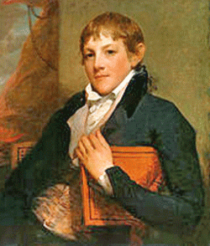
John Taylor of Caroline
John Taylor of Caroline had been described as radical Jacobin, and spreading the Jacobin policy of French revolution by force.[24] He was a Jeffersonian Republican, and close friend of Thomas Jefferson.[25] A confidant and chief lieutenant of Thomas Jefferson, John Taylor of Caroline represented the anti-Federalist position during the Constitutional debates. He was a man perhaps more Jeffersonian than Jefferson himself.[26] Like John Calhoun, he opposed the national bank and protective tariffs. He was the democratic leader of the House of Representatives. Though he was said to dislike slavery, he owned more than 5000 acres of land in Kentucky and Virginia (three plantations) with hundreds of slaves. Randolph maintained that the federal government had no constitutional right to legislate on the institution of slavery. By the beginning of the nineteenth century, Democratic-Republican leaders in the South often expressed the belief that while the principles of the French Revolution were noble, they were taken too far when applied to blacks.
John Taylor of Caroline was a prominent member of the American Colonization Society who was a U.S. Senator in 1794, argued that the abstract impulse behind the French Revolution “turned out to be a foolish and mischievous speculation;” and asked, “what then can be expected from making republicans of negro slaves…?” The Revolution, he continued, “attempted to compound a free nation of black and white people in St. Domingo. The experiment pronounced that one colour must perish.”
Abolitionists were to blame. If they were able to “emancipate the blacks,” in the United States, it would surely bring civil war and needless bloodshed for whites. He viewed an integrated republic with “inconceivable horror” as “monstrous and unnatural as a mongrel half white man and half negro.” White sympathy for enslaved blacks, he complained, was akin to blacks transferring “their affections from their own species to the baboons.” Civil rights in the South were increasingly radicalized—republican participation was a badge of white privilege and blackness a perpetual brand of slavery.[27]
Caroline County, Virginia is associated with several important men in the nation’s history. James Taylor “The Elder”, (1640? – 1698) (James I) owned several thousand acres which stretched from Piccardee’s Fork through Sparta and parts of King & Queen County. He named his plantation “Hare Forest” after his family’s estate in England. James Taylor, “the Elder” was the ancestor to several important men in our nation’s history; John Penn, Judge Edmund Pendleton, James Madison, Zachary Taylor Robert E. Lee, Jefferson Davis many others. He died on April 30, 1698, and was buried on his property (Hare Forest) in Caroline County.[28]
The younger James Taylor II (Taylor, 1674) was born March 14 1674 at Hare Forest his parents’ home. He died June 23 1729. The younger James built the plantation and home called Bloomsbury in Orange county, now on the national historic records. On February 23 1699, he married Martha Thompson, the daughter of Colonel William Thompson, of the royal navy and granddaughter of Sir Roger Thompson of England. James and Martha had nine children. They also have distinction in generating two United States presidents, the great grandsons James Madison and Zachary Taylor.[29]
The elder’s son, John Taylor (1696- 1780), married Catherine Pendleton. Their son was James Taylor of Orange (1729- 1760). John of Caroline was the son of James Taylor of Orange, and Ann Pollard. She was a sister of Sarah Pollard, wife of Edmund Pendleton, a Founding Father of the State of Virginia. John Taylor of Caroline was of the same line (1st cousin) of General Zachary Taylor, who became the 12th President of the United States.[30] John Taylor of Caroline was the prophet of secession, a founder of conservative Southern nationalism that we see in the foundation philosophy of the League of the South.[31]
VII
KNIGHT OF THE GOLDEN CIRCLE, JOHN C. CALHOUN
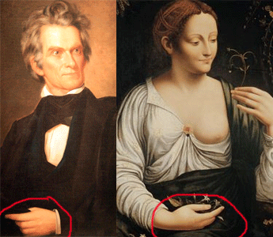
“There cannot be a durable republican government without slavery.” –John C. Calhoun[32]
Above, Columbine– Leonardo Da Vinci Painting (1516- 1519) and John C. Calhoun, St. John Baptist’s Gesture in the face of the church- [Rosicrucian- Masonic] One God [Lucifer], One Savior, John the Baptist.
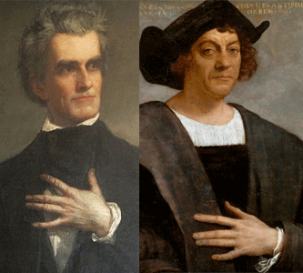
The South’s “Fire- Eater- Firebrand” Trojan Parisian John C. Calhoun
Calhoun’s secret society hand symbol appears as early as 15th century Christopher Columbus. It predates the founding of the Society of Jesus (Jesuits), and its founder of the 16th century.
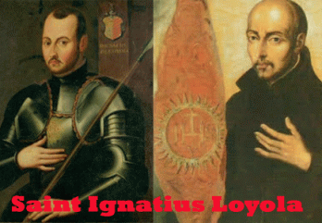
Columbus was the son-in-law of Henry the Navigator, the Grand Master of the Knights of Christ– Knights Templar.
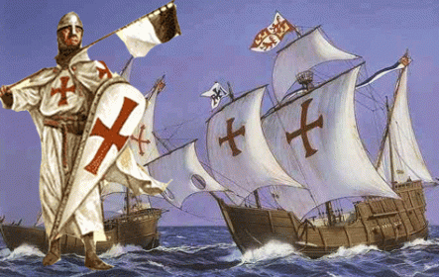
Columbus sailed under the banner of the Knights Templar. He was a Grand Master of the Knights of Christ– Knights Templar so as his father-in-law had been. Calhoun’s hand gesture is a signature of the Knights Templar, and the Jesuits. It is the ancient secret signature of Mary Magdalene of the Knights Templar, and the Marrano (secret Jew) of the Jesuits- secret Knight Templars of the Vatican?
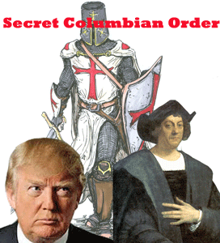
U.S. President select Donald J. Drumpf is a member of New York’s Society of St. Tammany or Columbian Order– Secret Masonic Lodge. Fred Drumpf was a Knight of the Ku Klux Klan- its predecessor was the South’s paramilitary unit, the K.G.C.
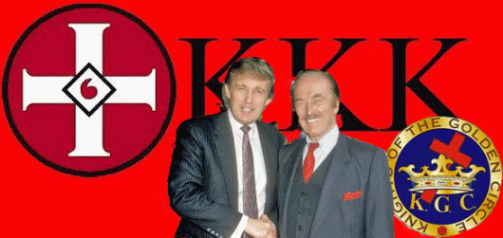
The Knights of the Golden Circle or K.G.C. was created in 1854 to establish a slave holding empire that would include many southern states in the U.S., the West Indies, Mexico, and parts of Central America. The Golden Circle would have a radius of 1200 miles and would be centered in Havana, Cuba. This empire would monopolize the production and trade of tobacco, cotton, and sugar and would be so strong that it would insure the EVIL of African Human Bondage could never be abolished by the northern states.
Sovereign Grand Commanders of Scottish Rite Masonry– Secret British Spies and Operatives, John James Joseph Gourgas (1777-1865), and Killian Van Rensselaer (1800- 1881) helped found the K.G.C. It allegedly had its beginnings in the formation of Southern Rights Clubs in various southern cities in the mid-1830s. These clubs were inspired by the philosophies of clandestine Knight, John C. Calhoun (1782–1850). Calhoun served as a congressman from his home state of South Carolina, a state legislator, vice president under the administrations of both John Quincy Adams and Andrew Jackson. In addition to the Southern Rights Clubs, which advocated the re-establishment of the African slave-trade, some of the inspiration for the Knights may also be related to a little-known secret organization called the Order of the Lone Star, founded in 1834, which helped orchestrate the successful Texas Revolution resulting in Texas independence from Mexico in 1836. Even before that, the K.G.C.’s roots went back to the Sons of Liberty of the American Revolutionary period.[33]
The Southern Rights Clubs were undoubtedly taken from the ILLUMINATI blueprint of the Jacobin Clubs. Thomas Jefferson, John Taylor of Caroline, and John C. Calhoun were the Jacobin godfathers of Southern State Rights Ideology of the League of the South that almost consumed the entire nation in flames like ANCIENT TROY. I think that I said enough, right now.
___________________________________________________________________________
[1] https://en.wikipedia.org/wiki/Troilus_and_Cressida
[2] http://shakespeare.mit.edu/troilus_cressida/troilus_cressida.2.2.html
[3] http://www.shakmyth.org/myth/107/hecuba
[4] https://www.theatlantic.com/politics/archive/2017/09/roy-moore-firebrand/541341/
[5] http://knights-of-the-golden-circle.blogspot.com/2014/08/
[6] http://www.conspiracyarchive.com/NewAge/Plato_Kabbalist.htm
[7] Id.
[8]
[9] https://en.wikipedia.org/wiki/Clyde_N._Wilson
[10] Id.
[11] https://en.wikipedia.org/wiki/Clyde_N._Wilson
[12] https://consciouslifenews.com/library-congress-confirms-george-washington-aware-nefarious-illuminati/1122149/
[13] http://trace.tennessee.edu/cgi/viewcontent.cgi?article=2677&context=utk_graddiss
[14] https://prologue.blogs.archives.gov/2012/07/13/in-their-own-words-thomas-jefferson-and-the-storming-of-the-bastille/
[15] http://www.masonicworld.com/education/files/artoct02/where_was_lafayette_made_a_mason.htm
[16] Id.
[17] http://truthstreammedia.com/2013/04/15/washington-warned-illuminati-infiltrating-revolution-2/
[18] http://www.worldviewweekend.com/news/article/ben-franklin-hellfire-club-and-his-view-jesus-christ
[19] Id.
[20] https://www.bibliotecapleyades.net/sociopolitica/esp_sociopol_illuminati_11a.htm
[21] http://toddecreason.blogspot.com/2011/10/thomas-jefferson-freemason-or-not.html
[22] http://www.whale.to/b/sp/blood.html#THE_JACOBINS_
[23] https://theoldinheritance.wordpress.com/tag/first-families-of-virginia/
[24] http://www.antiwar.com/stromberg/s101999.html
[25] https://en.wikipedia.org/wiki/John_Taylor_of_Caroline
[26] https://rowman.com/ISBN/9781611473605/The-Liberal-Republicanism-of-John-Taylor-of-Caroline
[27] http://ecommons.luc.edu/cgi/viewcontent.cgi?article=3126&context=luc_diss
[28] https://co.caroline.va.us/DocumentCenter/Home/View/413
[29] http://www.taylorappaloosa.com/TaylorHistory.html
[30] https://en.wikipedia.org/wiki/John_Taylor_of_Caroline
[31] http://trace.tennessee.edu/cgi/viewcontent.cgi?article=2677&context=utk_graddiss
[32] http://xroads.virginia.edu/~cap/calhoun/jcc1.html
[33] http://knightsofthegoldencircle.webs.com/
Comments : 2 Comments
Tags: abraham lincoln, adam w, Adam Weishaupt, alabama firebrand, Anglo-Celtic, benjamin franklin, black identity extremists, black lives matter, celtic mythology, christopher wray, civil war, Clyde Norman Wilson, Colonel William Randolph, democratic, democratic republicians, FBI, federalists, firebrand, french revolution, george washington, Grand Orient de France, homer, house of rothschild, iliad, illuminated one, Illuminati, jacobin club, john adams, john c. calhoun, john randolph of roanoke, john taylor of caroline, judge roy moore, kgc, knights of the golden circle, league of the south, league of united southerners, leo strauss, marquis de lafayvette, michael tubbs, nathaniel beverley tucker, neo conservative, neoconservatism, paleoconservative, plato, republican party, roy moore, Roy Stewart Moore, scottish rite, secessionists, second civil war, Sons of Confederate Veterans, southern agrarians, st. george tucker, steve bannon, straussianism, thomas jefferson, troy, white nationalist terrorism, white nationalists, william randolph
Categories : african holocaust, African Liberation, African slavery, alabama, albert pike, Aryan Supremacy, black lives matter, christianity, confederate states of america, devil, donald j. drumpf, donald j. trump, false prophets, freemason, freemasons, human bondage, human sacifrice, illuminati, illuminati sacrifice, leonardo da vinci, luciferians, modern slavery, Nazis, Rose-Croix, Rosicrucian, Rosicrucianism, rosy cross, Satanism, scottsish rite, slavery, south carolina

JUDGE ROY MOORE OF ALABAMA, THE LEAGUE OF THE SOUTH & THE SEETHING ENERGY OF LUCIFER
16112017
I
NOBODY KNOWS
My mother was born in the 1920s on a cotton crop-sharing tenant farm in Morehouse Parish, Louisiana under the conditions and badges of human bondage. She often talked about the hard times. Sometimes when she talked about the cotton farm, I could see the fear that still lingered in her heart and soul. She walked miles to school sometimes thru the snow without shoes. She didn’t have shoes. She had to quit school in the 2nd grade. My grandfather, Luke, got into it with the cheating white farmer. He was forced to abandon his family or his family had had to take to the road right that moment, then and there under threat of a shotgun. Mother had to drop out of school to help on the farm. My uncle, Harmon, told me about the no food on the table. He said, O’ Luke hid a piece of a roll of bologna sausage up in the attic. He was so hungry one day that he found the the bologna and ate it. I thought about his eldest sister, my mother. What did she eat? Most likely, nothing at all. Well, uncle never forgot about the whipping he got from O’ Luke for eating the bologna. Right now, today, some of my family are like the bluesman Sonny Boy Williamson. What they experienced in the Deep South was so troubling that they couldn’t and wouldn’t talk about it. They took it to their graves, and NOBODY KNOWS.
Donald J. Drumpf’s Dark Circle Department of Justice and FBI has downplayed the threat that white nationalist terrorist groups pose to people of color, and the security of the nation. Instead, they focus on and target “black identity extremists” based on an ILLUSION– premeditated violence against law enforcement. It is a PRETEXT to be much greater story.

The young 20 year old black man, DeAndre Harris, savagely attacked and beaten almost to death with sticks, pipes, and metal objects in Charottesville, VA by armed white nationalists has been arrested facing an allegation that he injured a white supremacist on the day of the white nationalists march to unite. Harris was served a warrant charging him with unlawful wounding a white nationalist, the Charlottesville Police Department said.
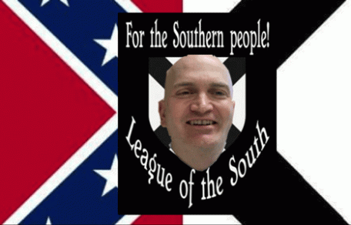

Harry Ray Crews
The League of the South, a neo–Confederate/Nazi organization, say Harold Ray Crews, 48 years old, the group’s North Carolina chairman, pursued the warrant. Crews is a NC attorney. He is also a member of the Sons of Confederate Veterans (SCV). Don’t get it twisted. I am not going to talk about the merits of that case. I will talk about the white terrorist group, The League of the South.
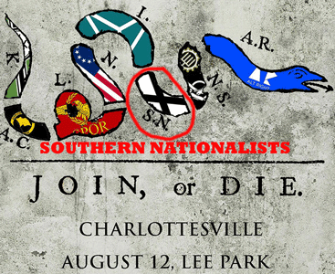
One of the objectives of the Charlottesville united white nationalist march was to unify white supremacist terrorist groups with the League of the South in the middle. The above is a poster for the Charlottesville “Unite the Right” rally derived from secret Hell Fire Club- Master Mason Benjamin Franklin’s famous “Join or Die” cartoon.The snake has powerful, superstitious connotations. During Franklin’s era, there was myth that a severed snake would come back to life if the pieces were put together before sunset. The cartoon, which appeared alongside Franklin’s editorial about the “disunited state” of the colonies, symbolically portrays an either/or fallacy: unite or be attacked by French and Indian allies.
The Charlottesville groups depicted include from left to right (K) “Kekistani,” (AC) “Anti-Communist,” (L) “Libertarian,” (N) “Nationalist,” (I) “Identitarian/Identity Evropa,” (SN) “Southern Nationalist (League of the South),” (NS) “National Socialist,” and (AR) “Alt Right.” The National Socialist flags depicted include Traditionalist Worker Party, and Vanguard America.

The “national flag of Kekistan” mimics a German Nazi War Flag, with the Kek logo replacing the swastika and the green replacing the infamous German red. Why is it necessary for white nationalist supremacists to unite around- secession from the U.S., the violent overthrow of the government, and a race war against people to force, particularly Black, back to the conditions of HUMAN BONDAGE!
Roy Moore is not only an Alabama issue. He is national issue, because there are reasons to believe that he is a clandestine member of The League of the South that seeks secession, the violent overthrow of the national U.S. Government, and war against Black people in pursuit of a MODERN FORM OF SLAVERY.
II
ROY MOORE, PEDOPHILIA & THE LEAGUE OF THE SOUTH
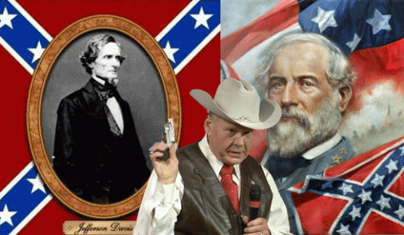
Roy Moore’s office is adorned with a portrait of Civil War Confederacy President Jefferson Davis and busts of Confederate General Robert E. Lee, and Confederate General Thomas Jonathan “Stonewall” Jackson.
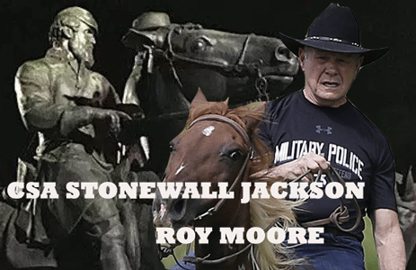
All Cowboy Hat and Cattle
“Spoke to Roy Moore of Alabama last night for the first time. Sounds like a really great guy who ran a fantastic race. He will help to #MAGA (Make America Great Again)!” U.S. President select Donald J. Drumpf [1]
Republican Roy Stewart Moore, who was twice suspended from his job as the chief justice of the Alabama Supreme Court, defeated incumbent Sen. Luther Strange, who was appointed to the seat vacated by Attorney General Jeff Sessions and was backed by Drumpf and Senate Majority Leader Mitch McConnell (R-Ky.). Moore took nearly 55 percent of the vote, rolling over Strange, who pulled in about 45 percent, according to results from Alabama’s Secretary of State. Moore is now the front-runner to win the seat in the December 12, 2017 general election.[2]
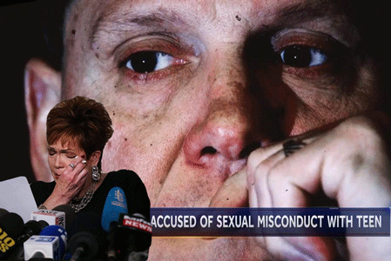
U.S. Senate Republican leaders are waging an urgent campaign to pressure GOP nominee Roy Moore to withdraw from the Alabama Senate race amid growing allegations of sexual misconduct and assault from 5 (five) different women. The Senate is organizing to declare him “unfit to serve” and threaten to expel him from Congress if he is elected.[3]

There is clearly another substantial reason for the people of Alabama to REJECT his candidacy for one of the highest moral public offices of this country, and if he is elected, nevertheless, declare Roy Moore “unfit to serve” and expel him from the U.S. Senate for receiving and providing material support for “white nationalist terrorism”.[4]
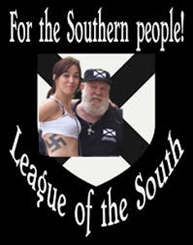
In a FBI 2006 bulletin, it detailed the threat of domestic white nationalist terrorist groups infiltrating state law enforcement agencies to clandestinely violently target and terrorize people of color. One white nationalist group that is considered dangerous and a terrorist threat to people of color, and this nation is the League of the South.[5]
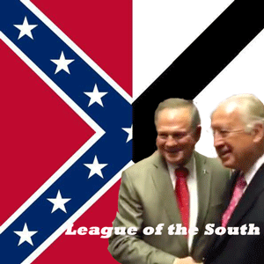
Roy Moore & Michael Peroutka
Nearly two-thirds of Roy Moore’s funding in his race to become chief justice of the Alabama Supreme Court in 2012 came from Michael Anthony Peroutka. Moore’s own website lists Peroutka as someone that endorses him, and he seems to endorse. A donation of a few hundred dollars won’t buy a candidate’s loyalty, but it may give the payee donor access to a candidate or a campaign’s inner circle of staff, and advisers. The donation may also indicate a current relationship to a candidate’s campaign or open the doors to a relationship that can influence policy, forming public opinion, or coming up with a policy to influence public policy. However, Peroutka donating two-thirds of Roy Moore’s election funding is far more than donating a few hundred dollars to buy influence with a public figure. Moore appears to be a bought and sold candidate of Peroutka and the League of the South for a high office of public trust.

In 2012 during Moore’s candidacy for high public office, Peroutka described himself as a “proud member of the League of the South,” a domestic traitorous white supremacy terrorist organization which states its ultimate goal is “a free and independent Southern republic”.[6] They advocate the South’s secession from the union, again. Moore said, he did not share the beliefs of the League of the South or James Edward, and that neither he nor anyone in his campaign had “secession ideas.” Yet, he didn’t return the money that he received from the Peroutka, or denounce the League when he was aware that they were white supremacy secessionists.[7]
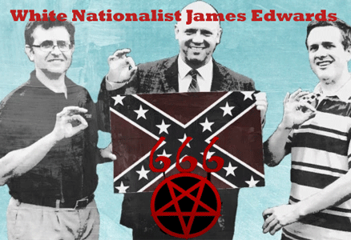
In 2012, James Edwards had been a central figure known to be associated with the League. On his blog, Edwards has called African Human Bondage– slavery “the greatest thing” that happened to black people.[8]
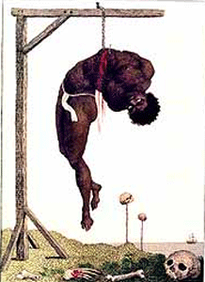
Hung by the Ribs until Death- Horrors of African Human Bondage
As late as March 2016, Edwards attended a Trump rally in Memphis, TN, as a fully credentialed member of the press. From the media pen, Edwards hosted a live broadcast of his radio show, and snagged a 20-minute interview with Donald Trump, Jr. Past guests on “Political Cesspool” have included Ku Klux Klan leaders, Holocaust deniers, and Holocaust affirmers (NAZIS).[9]

Horrors of the Jewish Holocaust
In July 2017, The League of the South said that it was happy to announce closer working relations with host James Edwards and The Political Cesspool radio show that seems to suggest that they were working with him all along. The Political Cesspool, which has had Peroutka as a guest has been called, “the premier hate station in the United States.”[10]
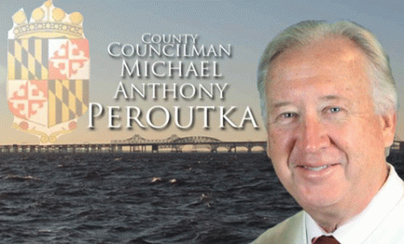
Michael Peroutka (born 1952), born in Maryland, is a descendant of late 19th century Bohemian immigrants. Bohemia is the Czech lands of the Czech Republic. In a broader meaning, Bohemia sometimes refers to the entire Czech territory, including Moravia and Czech Silesia especially in a historical context, such as the Lands of the Bohemian Crown ruled by Bohemian kings.[11] He is a Maryland lawyer, the founder of the Institute on the Constitution. He once held a position in the U.S. Department of Health and Human Services, and was the Constitution Party candidate for president in 2004. He is co-host of The American View radio program.
Peroutka is a graduate of the Jesuit Loyola College in Maryland, and the University of Baltimore, School of Law. He was the Chairman of the Constitution Party of Maryland and a member of the Executive Committee of the Constitution Party National Committee. In 2014, he became a Republican and won election to the County Council of Anne Arundel County, Maryland, representing District 5.[12] Anne Arundel is an extremely affluent and influential part of the state, which is the home county of Maryland’s capital, Annapolis, and also home to the U.S. Naval Academy, National Security Agency (NSA), and Fort George G. Meade.[13]
III
JACK KERSHAW, DR. MARTIN LUTHER KING, JR. & THE LEAGUE OF THE SOUTH
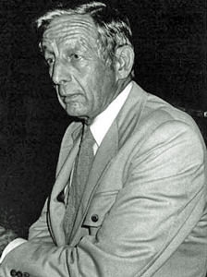
White Nationalist, Jack Kershaw
“Somebody needs to say a good word for slavery. Where in the world are the Negroes better off today than in America?” — Jack Kershaw, League of the South board member, 1998
The League of the South started out complaining about the media treatment of white Southerners, but quickly developed into a white supremacy racist group calling for secession, attacking egalitarianism, calling antebellum slavery “God-ordained,” opposing racial intermarriage, and defending segregation as a policy designed to protect the “integrity” of both the black and the white races. In 2013, Peroutka joined the board of directors of the League that since its inception also believes the “godly” nation it wants to form should be run by “Anglo-Celtic” elite that would establish a Christian theocratic state and politically dominate blacks and other minorities.[14]
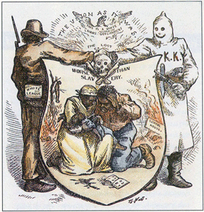
Starting with 40 people, the League initially included 4 (four) men with Ph.D.’s on its board, along with Jack Kershaw, who was once active in the racist segregationist and violent White Citizens’ Council in Nashville, TN, and remained on the board of the League as late as 2009.[15]
White Citizens’ Councils were an associated network of white supremacist organizations in the U.S., concentrated in the South. The first was formed on July 11, 1954. With about 60,000 members across the United States, mostly in the South, the groups were founded primarily to oppose racial integration of schools, but they also opposed voter registration efforts and integration of public facilities during the 1950s and 1960s. Members used criminal and violent intimidation tactics including economic boycotts, firing people from jobs, propaganda, and violence against citizens and civil-rights activists. They collaborated with the secret Masonic Knights of the Ku Klux Klan, and white supremacist to violently advance white supremacist political agendas in the U.S.[16]
Jack Kershaw of Nashville, TN, (1913- 2010) was one of the country’s most ardent white nationalist and segregationist of the 20th century. He was a member of the (SCV) Sons of Confederate Veterans; M.O.S.B. the officer corps of the SCV; member Joe Johnston Camp 28 SCV. The (M.O.S.B.) Military Order of the Stars and Bars was founded in 1938 to honor the traitorous Confederate Officer Corps and the government officials of the Confederacy that tore this country apart in the U.S. Civil War.[17] Kershaw claimed to be an heir of Admiral Kershaw CSA of South Carolina.[18] There doesn’t seem to appear to be an Admiral Kershaw, but there is a famous Joseph B. Kershaw CSA of Camden, SC. The Kershaws (John, William, and Eli) were early colonial settlers in SC out of Sowerby, Yorkshire, England during the Revolutionary War.[19]
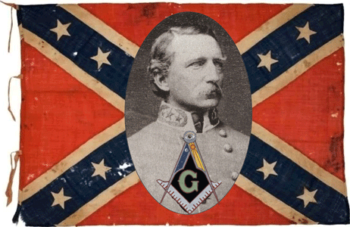
Joseph Brevard Kershaw (January 5, 1822 – April 13, 1894) was a lawyer, judge, and a Confederate general in the Civil War. At the close of the war he returned to South Carolina and in 1865 was chosen president of the State Senate. He was judge of the Circuit Court from 1877 to 1893. Joseph B. Kershaw was also a noted important Grand Master of the Freemasons of South Carolina.[20] John (William) Jack Kershaw’s Great Grandparents were out of England. There were most likely an extended branch of Joseph B. Kershaw’s family known for their distinctive blond hair and blue eyes like Jack’s father born in 1881 in McLean, Illinois.
They Killed Dr. Martin Luther Luther King, Jr.
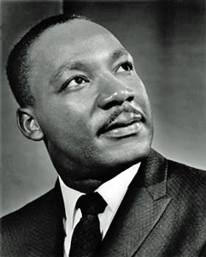
It had been one of the most cowardly Crimes of the 20th Century to kill the “King of Peace.” The nation lost its soul, and was nearly consumed by fire. My heart still cries. Dr. King talked about God, and dreams, and preached LOVE for our fellow man.
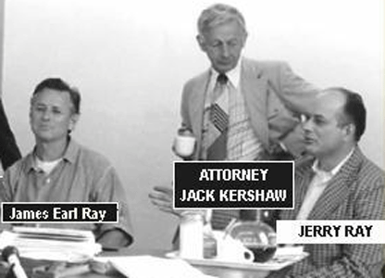
Kershaw served as the attorney of Martin Luther King, Jr.’s assassin, James Earl Ray. Ray was a low-level Dixie Mafia grunt, and patsy for the assassination of Dr. King. Early on in the creation of the Patsy, the escape of James Earl Ray from the Missouri State Prison in Springfield, Missouri on April 23, 1967 was paid for by Grand Master Mason, J. Edgar Hoover, director of the FBI. $25,000.00 was delivered to Warden Swenson by Hoover’s aid Clyde Tolson through Dixie Mafia soldier, Russell Adkins. Dr. King was assassinated in Memphis, TN, April 4, 1968.[21]
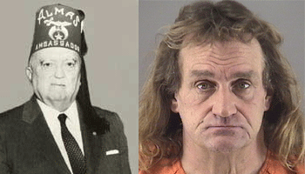
Recently in July 2016, Russell Adkins of the Dixie Mafia had been sentenced to life in prison in the death of 19-year-old Dana Rosendale after police ruled her death a homicide. Rosendale died a few days after she was found in a street in September 1982. The cause of her death was undetermined at the time. Adkins told police he found Rosendale and then later told authorities she had fallen out of his car. He was not charged at the time.
Ray hired Kershaw as his attorney in 1974 to work on his civil matters. However, in 1977 and 1978, he became Ray’s lead attorney. It was Kershaw that took Ray before the U.S. House Select Committee on Assassinations to be made a mockery of before he suddenly died.[22] Kershaw is a rabbit hole that goes deep down the hole of U.S. intelligence, CIA, Mafia– New Orleans Godfather– Carlos Marcello, Memphis Godfather– Gene Luchese, and the Dixie Mafia (see Dr. William F. Peppers, ESQ, The Plot to Kill King, Skyhouse Publishing, NY, NY (2016)).
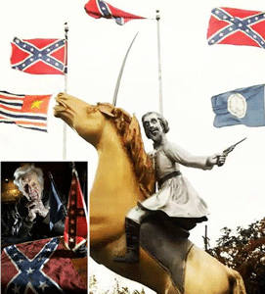
In 1998, Kershaw sculpted a statue of early KKK leader Nathan Bedford Forrest in Nashville, and who also repeatedly argued that slavery had been good for black people.[23] It was like plunging a dagger in the hearts of Black People over a hundred years later, once again.
On the drizzly morning of April 12, 1864, many of the surviving black union soldiers who witnessed the attack, and mass murders of black people at Fort Pillow, TN testified to a Joint Committee Senate and House of Representatives in May 1864, a week after the mass slaughter occurred.
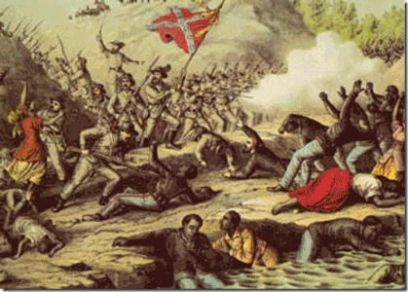
“Union sources asserted that although their troops surrendered, Major General Nathan Bedford Forrest’s troops [about 2,500] still executed them in cold blood, specifically the black troops, shouting out ‘No quarter! No quarter! Kill the damn ni**ers-; shoot them down.’ The black soldiers who survived testified that most of the men surrendered and threw down their weapons, only to be shot or beaten by the Confederate soldiers. Sergeant Henry F. Weaver (Co. C of the 6th USCT Heavy Artillery) stated that ‘The rebels charged after the flag of truce, the TN cavalry broke and was followed down the hill by the colored soldiers…They were shooting the negroes over my head…I saw one of the rebels and told him I would surrender, he said ‘We do not shoot white men,’…he ordered me away; [and] kept shooting the negroes…’”[24]
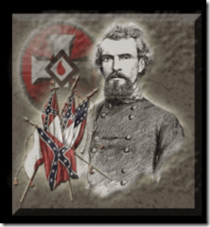
Major General Forrest was the first Grand Wizard of the Ku Klux Klan. Both sides of the war reported that after the fort’s surviving garrison, most of it comprised of black soldiers, civilian workers, women, children and elders surrendered and was disarmed, the confederates swarmed upon them and bayoneted, knifed, and clubbed some 250 men to death in an orgy of sadism and human savagery. Over two dozen were castrated and lynched.[25]
It was reported that more than 300 black soldiers, children, men, women and elderly were slaughtered in cold blooded savage inhumanity to man in the Fort Pillow Massacre led by Major General Bedford Forrest. The Fort Pillow Massacre became a Union rallying battle cry among Black Soldiers and the masses of the people. It cemented their own resolve to see the war through to its conclusion.[26]From that moment on, the Black Masses ran to meet them in the light of the day, in the dark of the night, in the cities, valleys, trenches, on the rivers, creeks and at sea crying “REMEMBER FORT PILLOW“, and DO BATTLE!
Michael Hill of Alabama- The League of the South
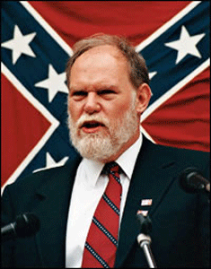
White Nationalist Terrorist Michael Hill of Alabama
The vicious racist, Michael Hill, of Killen, Alabama, co-founded The League of the South in 1994. The stated goal of the League is to create an independent country made up of the former slave states of the American South. Hill is known for Nazi, and neo-confederate pro-slavery views. Hill has recently suggested organizing a violent “Southern Defense Force” militia in preparation for “guerrilla war,” predicted “race war,” and attacked “Organized Jewry.”
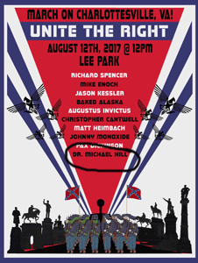
He was a scheduled speaker at the white nationalist rally in Charlottesville alongside former KKK head David Duke. The League of the South was of the organizers of Nazi/KKK march in Charlottesville.
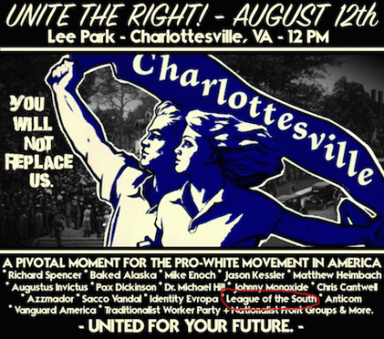
Hill and members of The League were caught on camera brawling during the violent protests.
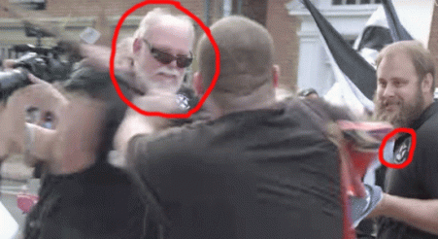
Violent White Extremists- Michael Hill and the League
In its aftermath, he wrote a Facebook post titled “Fight or die White man.” The group has had traitorous billboards reading “SECEDE” posted across the South since 2014.

CCC- Dylann Roof, Earl Holt, Roy Moore & Gordon Baum
Judge Roy Moore and the CCC
Buzzfeed reported in 2015, back in 1995, Moore gave a keynote address to the Council of Conservative Citizens — a white supremacist group that Charleston mass murderer Dylann Roof would cite as a key influence two decades later. The Council of Conservative Citizens (CofCC or CCC) is an American white supremacist organization. It supports white nationalism, and variety of conservative and paleo-conservative causes. Several members of the CCC Board of Directors are former leaders of the segregationist Citizens’ Councils of America, founded by Bob Patterson, which is commonly referred to as the White Citizens’ Councils. Its statement of principles says that they “oppose all efforts to mix the races of mankind“.[27]
Many members” of the CCC have ties to the Ku Klux Klan and the National Association for the Advancement of White People. They also recruit from Aryan Nations. In 1995, CCC was led by Gordon Lee Baum and his local St. Louis chapter leader Earl Holt had a radio show in that Missouri city. They have had interesting things to say about Black People. CCC refers to blacks as “a retrograde species of humanity.” It is widely reported that Holt said, “The REAL ENEMY is “Africanus Criminalis,” the laziest, stupidest and most criminally-inclined race in the history of the world…“, but he has since removed his name from the post. The CCC is a deep rabbit hole of international white national racist terrorists.
League of the South- A U.S. Domestic Terrorist Organization
A Convicted [League of the South] Domestic Terrorist Was at the Charlottesville Nazi March
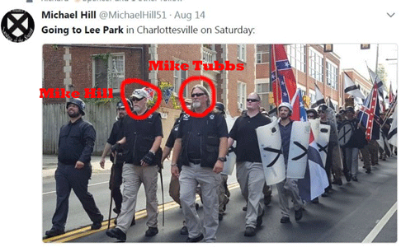
League of the South Domestic White Nationalist Terrorists Michael Hill and Michael Tubs
At least one man who attended the Aug. 11, 2017 white supremacist march in Charlottesville, Virginia, is a convicted domestic terrorist. Michael Tubbs, currently the chairman of the Florida League of the South, spent four years in prison after stealing military equipment and plotting to bomb black- and Jewish-owned businesses in Jacksonville, Florida.
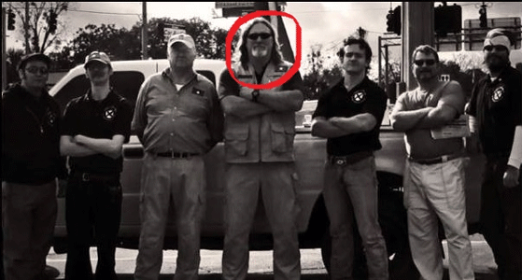
Michael Tubbs & League of the South
In 1990, Tubbs, then a U.S. Army Special Forces soldier, was in Saudi Arabia as part of the Pentagon’s response to the Iraqi invasion of neighboring Kuwait. The military abruptly recalled Tubbs from the Middle East to face federal conspiracy charges. It turned out he had been living a disturbing double life.
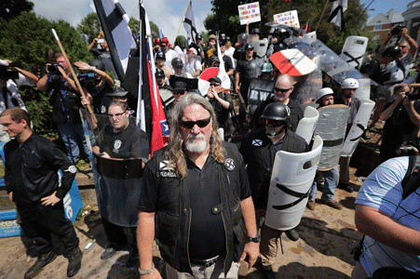
Michael Tubbs & League of the South in Charlottesville
He was involved in a 1987 incident at Fort Bragg, North Carolina in which two armed men — toting weapons fitted with silencers and dressed completely in black — robbed two fellow soldiers of their M-16 rifles during a routine exercise. The soldiers told investigators the stickup men had shouted “This is for the KKK!” as they fled.
One of the attackers was Tubbs. The other was a warrant officer named Jeffrey Jennett. The brazen holdup went unsolved for 3 (three) years until Tubbs deployed to Middle East. That’s when Jennett’s wife tipped off authorities. Federal agents raided five weapons caches—including one at Tubbs’s home in Jacksonville.
Authorities seized several M-16s with military serial numbers, thousands of rounds of ammunition, 25 pounds of TNT, an anti-aircraft machine gun, anti-personnel land mines, numerous handguns and shotguns, a 40-millimeter grenade launcher, hand grenades, smoke grenades, tear gas, 45 pounds of C-4 and other weaponry.
The investigation spanned Tennessee, Kentucky, North Carolina and Florida. Agents believed Tubbs stole much of the military equipment from both Fort Bragg and Fort Campbell over a period of years. Agents also found white supremacist literature and VHS tapes of speeches by Adolf Hitler. “All the literature focused on just a litany of hate against Jews, Blacks and other minorities,” ATF agent Willi Ellison told The New York Times after the arrests.
Agents also found notes written by Tubbs that showed that he and John Tubbs planned to set up a new group called the Knights of the New Order and a list of targets that included newspapers, television stations and businesses owned by Jews and Blacks. They also found a group pledge authored by Tubbs. “I dedicate my heart to oppose the enemies of my race, my nation and the New Order,” the pledge read. “I dedicate my life from this moment forward to fostering the welfare of the white Aryan race.”
The Tubbs brothers were named in a 16-count federal indictment. In the end, Michael Tubbs pleaded guilty to theft of government property and conspiracy to transport guns and explosives across state lines.
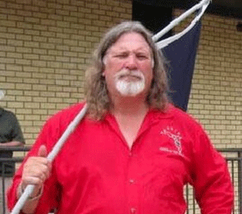
Michael Tubbs left prison in 1995. His time on the inside apparently did not change his views. He promptly began running a group called Kinsman’s Comitatus that raised money to support fellow “political prisoners” in the white supremacist movement. And in August 2017, Tubbs was photographed [attacking] brawling with local residents as Nazis marched on Charlottesville.[28]
IN CONCLUSION
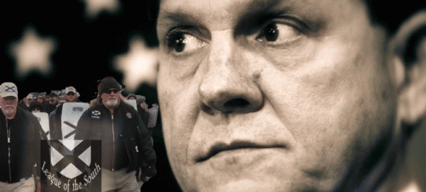
There is much more seriously wrong with Roy Stewart Moore than a custom and Cult of Old Powerful Alabama Pedophiles and Sexual Predators. He displays a serious pathology to something far more complex that needs to be explored. Pathology is the study of paths’, by which disease comes. White Nationalist terrorist hurt and abuse people of color based on upon a complex of a false sense of superiority just the same as a pedophile takes control and sexual abuses his victims without any or very little conscious of wrongdoing based on a false superiority complex like misplaced aggression.
Psychologist Wilhelm Reich’s The Mass Psychology of Fascism (1933) argued that racism was “a symptom of sexual repression in the mind of the authoritarian racist.” A racist, Reich believed, was likely raised in a kind of family that denied its children’s sexuality and created tractable individuals, who could easily be guided by a strong state. A project at the University of California at Berkeley worked on the question of susceptibility to authoritarianism, which n resulted in the creation of a personality test called the F-scale and the 1950 volume The Authoritarian Personality. The researchers found that authoritarians tended to express prejudice against a diverse range of minority groups, to identify with the strong as opposed to the weak, and to be fascinated by the “deviant” sex lives of others.
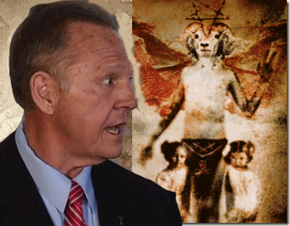
Judge Roy Moore- JUST EVIL!
Psychologist Erich Fromm argued that to cast Germany’s actions as a sickness served as “a substitute for valid ethical concepts,” tending to “weaken the sense for moral values, by calling something by a psychiatric term when it should be called plainly EVIL.” In that token, in Judge Roy Moore’ case, I shouldn’t be looking for any sickness or illness to explain his white authoritarian superiority complex.
League of the South- THE BIGGER PICTURE
The ILLUMINATI, League, Slavery and the Civil War
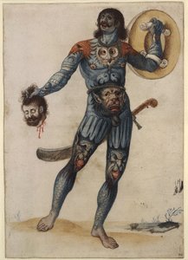
Pagan Painted Pict- Ancient Celtic Warrior
The League of the South was, again, created by a group called the PhD’s. The group studied the Civil War in depth from a particular viewpoint the of the Anglo-Celtic Culture. Founder Michael Hill of Alabama wrote two books on the Celts, and romanticizing the Celtic soldier.
League co-founder Grady McWhiney (July 15, 1928 – April 18, 2006) was a historian of the American South and Civil War. McWhiney and fellow co-founder Forrest McDonald were the authors of the “Celtic Thesis,” which holds that most Southerners were of Celtic ancestry (as opposed to Anglo-Saxon), and that all groups he declared to be “Celtic” (Scots-Irish, Irish, Scottish, Welsh and Cornish) were descended from warlike herdsmen, in contrast to the peaceful farmers (British Protestant) farmers who predominated in England. They attempted to trace numerous ways in which the Celtic culture shaped social, economic and military behavior.
Forrest McDonald (January 7, 1927 – January 19, 2016) was an American historian on the American South. He was a professor at the University of Alabama. Co-founder Clyde Norman Wilson is an American professor of history at the University of South Carolina, a paleoconservative political commentator. Wilson is best known for his expertise on the life and writings of John C. Calhoun, having recently compiled all his papers in twenty-eight volumes. and an affiliated scholar of the League of the South Institute (think tank), the research arm of the League. In 1994, Wilson was an original founder of the League, which advocates a “natural societal order of superiors and subordinates“.
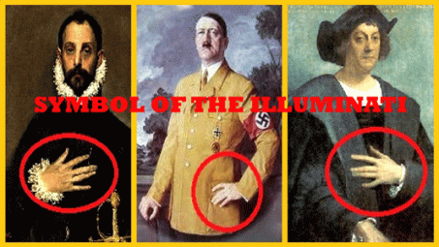
The Superiors that Calhoun talked about was the ILLUMINATI.
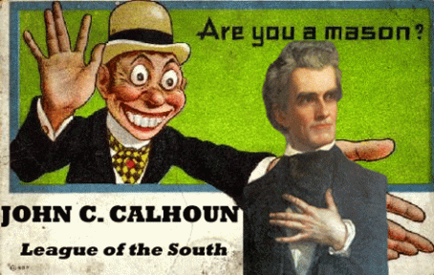
Additionally, the Marrano (Marrano, meaning secret Jew) hand sign above can be known as triad claw. The sign can be compared with W and M from Latin. The letters M and W may symbolize 666 to some as three Vav can mean 666. The League was not created out of a vacuum.
It is based on the 1858 League of United Southerners organized by Edmund Ruffin as a vehicle for reopening the African Slave Trade, forming the Confederacy, and secession. The League was led in part by the philosophy of Scots- Irish John C. Calhoun. John Caldwell Calhoun (March 18, 1782 – March 31, 1850) was an American statesman and political theorist from South Carolina, and the seventh Vice President of the US from 1825 to 1832. Calhoun died before the Civil War, but his views were at the basis of the South’s secession, and the institution of African human bondage. Southern politicians had excused slavery as a “necessary evil“, in a famous speech on the Senate floor on February 6, 1837, Calhoun asserted that slavery was a “positive good“. He rooted this claim on two grounds: “white supremacy” and paternalism. All societies, Calhoun claimed, are ruled by an “elite group that enjoys the fruits of the labor of a less-exception group“.
Edmund Ruffin, related to Thomas Jefferson, was an elite plantation owner, descendant of Virginia Colonialist Colonel William Randolph and Mary Isham as “the Adam and Eve of Virginia” (William and Mary). The Randolphs of Virginia were the elite ruling Masonic families of Virginia. Grandson of Sir John Randolph, son of William and Mary, Edmund Randolph (1753-1813) U.S. Attorney General, 1789-94; U.S. Secretary of State, 1794-95; Aide-de Camp to Washington, 1775-76; Member of Continental Congress, 1779-82; Governor of Virginia, 1786-88; Delegate to Constitutional Convention, 1787. b. Aug. 10, 1753 in Williamsburg, Va. On June 24, 1777 he withdrew from the lodge to become charter master of Jerusalem Lodge No. 54. He was deputy grand master of the Grand Lodge of Virginia in 1784, and grand master from Oct 27,1786 to Oct. 28, 1788. d. Sept. 12, 1813.
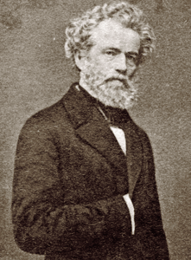
Quitman & Hidden Hand of the Masonic ILLUMINATI
Former Mississippi Governor, James A. Quitman (1798 – 1858) and Alabamian William Lowndes Yancey (1814 – 1863) were “fire-eaters“- members of the 1858 League. Quitman was grand master of the Mississippi Masons from 1826 to 1838 and again from 1840 to 1845. In fact, there is reason to believe that the 1858 League were suspected ultra secret society members (Albert Pike, John C. Breckenridge, Howell Cobb, Jefferson Davis, John B. Floyd, Pryor Lee, John A. Quitman, Robert A. Toombs, Louis T. Wisfall, William J. Yancey) of the Masonic Knights of the Golden Circle- collaborators with Masonic British Royal Family Intelligence Services to maintain an American Slave State (A Secret Society History of the Civil War, Mark A. Lause, Board of Trustees of the University of Illinois, Champaign, IL (2011)).
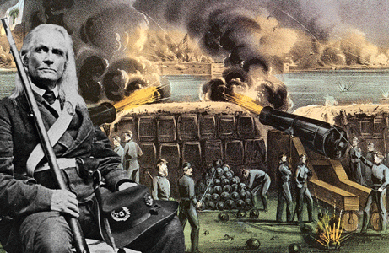
Edmund Ruffin- SC Palmetto (Masonic Palm Tree) Guard
The Palmetto (Palm Tree) is a sacred symbol of Freemasonry, and the Occult,
“Ovid tells the story of the Phoenix follows: “Most beings spring from other individuals; but there is a certain kind which reproduces itself. The Assyrians call it the Phoenix. It does not live on fruit or flowers, but on frankincense and odoriferous gums. When it has lived five hundred years, it builds itself a nest in the branches of an oak, or on the top of a palm tree. In this it collects cinnamon, and spikenard, and myrrh, and of these ‘materials builds a pile on which it deposits itself, and dying, breathes out its last breath amidst odours. From the body of the parent bird, a young Phoenix issues forth, destined to live as long a life as its predecessor. When this has grown up and gained sufficient strength, it lifts its nest from the tree (its own cradle and its parent’s sepulchre), and carries it to the city of Heliopolis in Egypt, and deposits it in the temple of the Sun.”
Edmund Ruffin of The 1858 League was the Southern elite Randolph Family of Virginia superior (ILLUMINATI) that fired the infamous “first shot” at Fort Sumter, SC to start the Civil War. At the end of the Civil War, he wrapped himself inside the Confederate Flag, and blew his brains out than see Africans freed from bondage under the United States of America.
“How art thou fallen from heaven, O Lucifer, son of the morning! how art thou cut down to the ground, which didst weaken the nations!”
-ISAIAH 14:12 (KJV)
“Lucifer, the Light-bearer! Strange and mysterious name to give to the Spirit of Darkness! Lucifer, the Son of the Morning! Is it he who bears the Light, and with its splendors intolerable, blinds feeble, sensual, or selfish souls? Doubt it not!”
-ALBERT PIKE in MORALS AND DOGMA OF THE ANCIENT ACCEPTED SCOTTISH RITE
“When the Mason learns that the key to the warrior on the block is the proper application of the dynamo of living power, he has learned the mystery of his Craft. The SEETHING ENERGIES OF LUCIFER are in his hands, and before he may step onward and upward, he must prove his ability to properly apply energy.”
–MANLY P. HALL in THE LOST KEYS OF FREEMASONRY
I have said enough!
_______________________________________________________
[1] http://www.independent.co.uk/news/world/americas/donald-trump-roy-moore-white-supremacist-league-of-the-south-michael-david-peroutka-alabama-election-a7986936.html
[2] https://www.washingtonpost.com/powerpost/moore-vs-strange-polling-opens-in-alabama-republican-primary/2017/09/25/9c7192f8-a253-11e7-b14f-f41773cd5a14_story.html?utm_term=.cea30e152023
[3] https://www.washingtonpost.com/politics/mcconnell-calls-on-roy-moore-to-end-senate-campaign-following-accusations-of-sexual-misconduct/2017/11/13/1ca48d56-c890-11e7-aa96-54417592cf72_story.html?utm_term=.61c8afb32290
[4] http://www.independent.co.uk/news/world/americas/donald-trump-roy-moore-white-supremacist-league-of-the-south-michael-david-peroutka-alabama-election-a7986936.html
[5] https://www.pbs.org/newshour/nation/fbi-white-supremacists-in-law-enforcement
[6] http://www.independent.co.uk/news/world/americas/donald-trump-roy-moore-white-supremacist-league-of-the-south-michael-david-peroutka-alabama-election-a7986936.html
[7] http://www.theoccidentalobserver.net/2012/01/09/judge-roy-moore-says-he-does-not-share-the-views-of-james-edwards-in-newspaper-interview/
[8] Id.
[9] http://nymag.com/daily/intelligencer/2016/03/trumps-son-gives-interview-to-pro-slavery-host.html
[10] http://leagueofthesouth.com/tag/james-edwards/
[11] https://en.wikipedia.org/wiki/Bohemia
[12] https://en.wikipedia.org/wiki/Michael_Peroutka
[13] https://www.dailykos.com/stories/2014/8/10/1318201/-Something-is-rotten-in-Anne-Arundel-County-Maryland
[14] https://www.dailykos.com/stories/2014/8/10/1318201/-Something-is-rotten-in-Anne-Arundel-County-Maryland
[15] Id.
[16] https://en.wikipedia.org/wiki/Citizens%27_Councils
[17] http://www.militaryorderofthestarsandbars.org/
[18] http://www.garyrevel.com/news/jack_kershaw.html
[19] http://www.genealogy.com/forum/surnames/topics/kershaw/480/
[20] https://en.wikipedia.org/wiki/Joseph_B._Kershaw
[21] http://garyrevel.com/ray/nojustice.html
[22] http://caseantiques.com/item/lot-664-james-earl-ray-jack-kershaw-archive-mlk-assassi/
[23] http://talkingpointsmemo.com/dc/roy-moores-sugar-daddy-has-deep-ties-to-secessionists
[24] https://rediscovering-black-history.blogs.archives.gov/2014/04/08/fort-pillow-150th-anniversary/
[25] http://listverse.com/2013/03/17/10-war-crimes-of-the-us-civil-war/
[26] https://rediscovering-black-history.blogs.archives.gov/2014/04/08/fort-pillow-150th-anniversary/
[27] https://en.wikipedia.org/wiki/Council_of_Conservative_Citizens
[28] https://warisboring.com/a-convicted-domestic-terrorist-was-at-the-charlottesville-nazi-march/
Comments : Leave a comment
Tags: Adolf Hitler, african bondage, alabama, albert pike, Anglo-Celtic, Anne Arundel County, Baphomet, benjamin franklin, black identity extremists, Carlos Marcello, charlottesville, CIA, Clyde Norman Wilson, Colonel William Randolph, confederacy, confederate flag, deandre harris, dixie mafia, donald j. drumpf, donald j. trump, donald trump, Dr. Martin Luther King, Dr. Martin Luther Luther King, Dylann Roof, Earl Holt, Edmund Ruffin, eric fromm, FBI, Forrest McDonald, fort pillow massacre, Fort Sumter, freemasonry, freemasons, Gene Luchese, general robert e. lee, German Nazi War Flag, gordon baum, Grady McWhiney, harold ray crews, hell fire club, holocaust, Holocaust affirmers, Howell Cobb, Illuminati, j. edgar hoover, jack kershaw, James Earl Ray, James Edward, jefferson davis, jerry ray, John A. Quitman, John B. Floyd, John Caldwell Calhoun, Joseph Brevard Kershaw, Jr., Kekistani, knights of the golden circle, ku klux klan, league of the south, Louis T. Wisfall, Lucifer, luciferians, m sign, mafia, MANLY P. HALL, Marrano secret jew, Mary Isham, masons, Michael Anthony Peroutka, michael hill, michael tubbs, Military Order of the Stars and Bars, modern slavery, nathan bedford forrest, nazi, Nazis, nazs, ohn C. Breckenridge, pedophila, Political Cesspool, Pryor Lee, Robert A. Toombs, roy moore, Roy Stewart Moore, Russell Adkins, satanic dark circle cult, sc, scottish rite, secessionists, slavery, Sons of Confederate Veterans, stonewall jackson, triad claw, u.s. department of justice, unite the right, university of alabama, vanguard america, White Citizens' Councils, white nationalist terrorism, white supremacy, Wilhelm Reich, William J. Yancey
Categories : african holocaust, African Liberation, African slavery, alabama, albert pike, Aryan Supremacy, baphomet, CIA, devil, donald j. drumpf, donald j. trump, donald trump, evil, freemason, freemasons, illuminati, J. Edgar Hoover, ku klux klan, lucifer's servants, luciferians, Martin Luther King, MK-ULTRA, modern slavery, Nazis, new world order, nwo, satan, scottsish rite

THREE- WENDY WILLIAMS, HOWLING MAN AND THE DEVIL & THE SECRET EARTH MOTHER GODDESS CULT AND THE HARVEST
13112017
I
THE DEVIL, THE HOWLING MAN
The “Howling Man” Twilight Zone TV episode scared the wits out of me when I first saw it. My family of deep south Baptist Christians feared the Devil, and instilled that fear inside of me. I had seen the Devil as a cartoon character, but I believe that this was the first time that I saw the Devil presented in the flesh. The “Howling Man” still scares me.
Donald J. Drumpf virtually begged the American public like the “Howling Man” to trust him that everyone was absolutely delusional about his extreme RACISM, and manifestation of EVILNESS, and DEVILISHNESS. What has always held him in check and away from public offices of TRUST has always been as simple as the “Staff of Truth“. Yet, he cried to America, “Lift the Staff” quickly, our country is in peril!
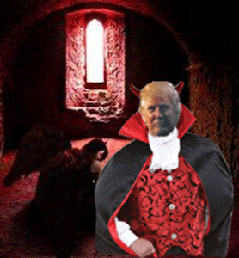
Some forces lifted the staff, released him, and made Donald J. Drumpf the President of the United States. In the 21st century, the release of the “Howling Man” into global world power is no Twilight Zone TV episode that I can hide from by burying my head in sand. This S.H.I.T. is REAL!
II
DONALD J. DRUMPF & THE HOWLING MAN
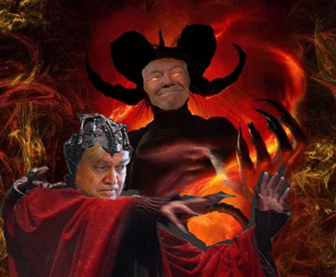
Never before in the history of this nation has a presidential administration begun its reign by telling it citizens that SATANIC “dark forces” and its POWER are good for them to RULE over the masses. Yet, that is exactly what happened in America in November 2016. President select Donald J. Drumpf’s chief strategist, Steve Bannon, for the new administration told The Hollywood Reporter that “darkness is good.”
“Dick Cheney. Darth Vader. SATAN. That’s POWER. It only helps us when they (liberals) get it wrong. When they’re blind to who we are and what we’re doing.”
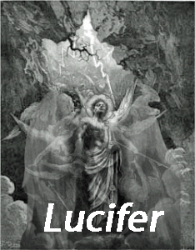
THE POWER OF SATAN– He is mentioned more often in Scripture than all other evil angels combined, and of twenty-nine references in the Gospels, Jesus spoke of him twenty-five times.
He is “the Prince of Demons” (Matt. 12:24), the undisputed ruler of a host of evil spirits that inhabit the cosmos as surely as humanity inhabits planet earth. He is “the ruler of this world” (John 12:31), exercising massive authority in the ordered system of things opposed to God. He is “the prince of the power of the air” (Eph. 2:2), which includes all unregenerate humanity and all FALLEN ANGELS.[1]
This didn’t come from me. It came directly from Drumpf’s Chief U.S. Presidential Strategist, Steve Bannon. Their strategy is release SATAN, his SERVANTS, SPIRITS, and leagues of DEMONS on earth with the power, authority and cloak of the U.S. Government.
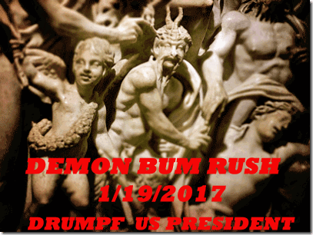
Out of the Darkness, the demon bum rush began when Donald J. Drumpf was inaugurated as the 45th President of the United States. The Drumpf Strategy, from the very beginning, was the deception of Lucifer. A new world order Masonic Satanic Power Base and Cabal will rise on earth out of the CHAOS created by swinging the gates of hell and portals of other dimensions wide open. In the CHAOS, the masses will be blind to who they are and what they are doing. POWER, POWER to RULE, even the MOON will be frightened of them!
So, which is it? U.S. citizens didn’t believe Drumpf and Bannon, or they believed it, and then buried their heads in sand from the neck up.
III
SATAN
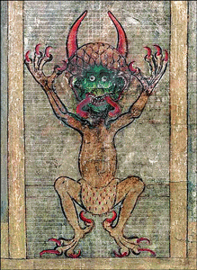
The medieval book commonly called the “Devil’s Bible” is a mysterious book that in its day was believed to contain all human knowledge. Medieval people believed that the author sold his soul to the devil to be able to write it. The “Devil’s Bible,” a behemoth volume weighing in at 165 pounds, believed to have been produced by a single monk over the course of decades in the 13th Century AD. It got its name “Devil’s Bible” from the illustration of the devil on page 290 (in the photo above). It is believed to be the only bible of its era that depicts SATAN.[2]
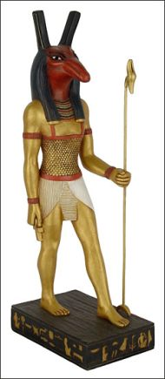
SATAN (Set, Seth, Shaitan, Molech or Saturn) is the Lord of Hell and the very god who rules over money and wealth. The name Satan has its origin in Ancient Kemet from a deity named Set, (/sɛt/ or Seth, Sēth, Σήθ /sɛθ/; also spelled Setesh, Sutekh, Setekh, Suty or Sut).[3] In art, Set is mostly depicted as a type of creature, referred to by Egyptologists as the Set animal or Typhonic beast and he is portrayed as the usurper of the creator god, Ashur-Osiris. In Kemetic mythology, we find Ashur-Osiris as the Creator, Horus the Preserver, and Typhon the Destroyer. Ashur is the SO BELOW son of the gods from the planet on the AS ABOVE named Jupiter.
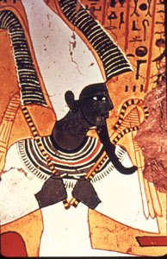
GOD ASHUR
The King of all planets, God Ashur, went by names such as Zeus in Greece, or Yahweh and Adonai in Israel.[4] Since ancient times Jupiter and Saturn had always warred with one another over supremacy just like in Kemetic mythology there is Ashur-Osiris and Set or in the Abrahamic religions with Cain and Able. It is Set, who we know today as Satan (Saturn) who killed and mutilated his own brother Ashur-Osiris (Jupiter). Set was also identified by the Egyptians with the Hittite deity Teshub, who was a storm god like Set. The Greeks later connected Set with Typhon because both were evil forces, storm deities, and sons of the Earth that attacked the main gods.[5]
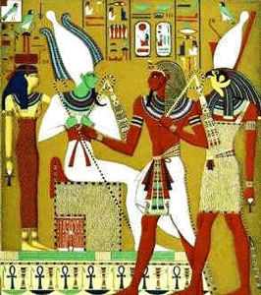
“Osiris, Ausser–or Wizzer (Wsjr), is the original Green Man–he is the land and the earth in his representation of mankind migrating through cycles of consciousness. He is the seed, self, sun and universe, enabling consciousness to express itself as a manifestation in the physical, earthly realm. As such, he is associated with all phases of agricultural processes and to the symbolism of the tree of life. He is expressed as green in many depictions to represent these associations and their relationship to the fertility of the earth, his dual feminine aspect. It is through the portal of our solar plexus, the Lion’s Gate, and our true heart center, that we traverse the dimensions from spirit to matter, from unity consciousness to individuated consciousness and back again. This is the ‘Hero’s Journey’ that is likened to the path of the Sun across the sky.”[6]
Demonic Terrorist Firestorm in Northern California
There is a high probability that the above Youtube video and account may suddenly disappear in space before my blog does. They say that the courageous, through and very vigilante citizen, Debora Tavares’, is missing, and I pray that she is well. So, let me give you a short thumbnail summary and links of what this brave lady was saying, and confronting in 2015.
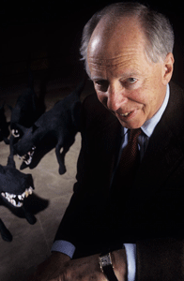
Lord Jacob Rothschild
Nathaniel Charles Jacob Rothschild, 4th Baron Rothschild, Masonic British Order of Merit, Most Excellent Order of the British Empire, Fellowship of the British Academy, runs the Bilderberg and Blackstone Groups. Blackstone is heavily tied in with the Saudi owned Carlyle group that is linked to the Bush CIA Crime Family, and U.S. Pentagon. The Saudi wealthy royalty is controlled by the Rothschilds appointed by Satanic British Royal Family to lead and run Saudi Arabia from WW I, when Britain split up the Ottoman Empire.[7] More on the Saudis Secret Order and the Drumpf connection is discussed below.
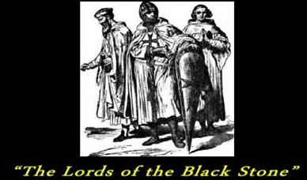
I believe that the old scary Lords of the Black Stone are the Blackstone Group of the 21st century. It is the German tradition that the Templars were ordered to form a secret scientific sect in southern Germany, Austria and northern Italy to be known as “Die Herren vom Schwarzen Stein” – The Lords of the Black Stone – or DHvSS for short, and this is said to be the true, hidden meaning of SS.[8]
The Holy Grail (“Ghral” is holy stone, Persian-Arabic) was said to be a black-violet crystal, half quartz, half amethyst, through which Higher Powers communicated with humanity. It was given into the safe-keeping of the Cathars, and smuggled out of the last stronghold at Montsegur, France, and hidden, by four Cathar women on the night of 14 March 1244. There is a Cathar legend that 700 years after the destruction of the Cathar religion the Holy Grail would be returned to its rightful holders, DHvSS, or the SS?”[9]
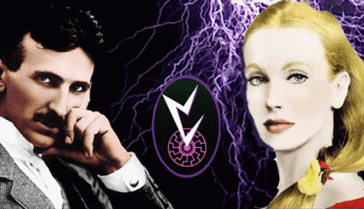
In 1917, the occultist Baron Rudolf von Sebottendorf, the Gurdjeff disciple Karl Haushofer, the ace pilot Lothar Waisz, Prelate Gernot of the secret “Societas Templi MARCONI” (The Inheritors of the Knights Templar– The Lords of the Black Stone ), and Maria Orsic formed THULE GESELLSCHAFT.[10]
The Blackstone Group helped Larry Silverstein mortgage 9-11’s Inside Job World Trade Center, Building 7(seven). [Henry] Kissinger McLarty Associates has a “strategic alliance” with the Blackstone Group.[11] So, it isn’t surprising that the Baphomet and Jewish Mysticism and the Blood Sacrifice secretly lie at the spiritual foundation of these companies.[12]
Nevertheless, it seems that the Rothschild Blackstone Group financed and developed PG&E’s secret Space Weather Modification System that maintains a solar generator in space that beams down Radio frequency (RF)- electromagnetic wave frequencies down into the electromagnetic wave frequencies area. Sebastopol is a city in Sonoma County, CA.
The death toll from the deadliest rash of wildfires in California history is 43. Wildfires suddenly erupted on Oct. 8, 2017 in the heart of California wine country and consumed at least 245,000 acres. An estimated 100,000 people were forced to suddenly flee in terror from their homes in the middle of the night, some at a moment’s notice as flames swept whole neighborhoods. Some 8,900 dwellings and other structures were incinerated, including entire subdivisions in the Sonoma County town of Santa Rosa, which sustained the greatest losses.[13]
Demonic Terrorism in Puerto Rico- HAARP
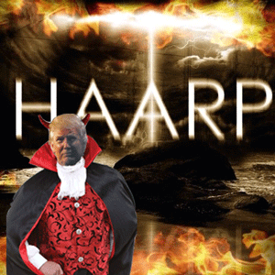
The Drumpf Administration rules over Puerto Rico like a colonial state instead of a U.S. territorial state. Post- Hurricane Maria- HAARP (High Frequency Active Auroral Research Program) recovery, it is still in the deep state of emergency. More than 143,000 Puerto Ricans have arrived in Florida since the powerful storm devastated the islands in September. The U.S. Federal Emergency Management Agency announced that it will offer an “air bridge” to relocate (depopulate the islands) to the U.S. mainland about 3,000 Puerto Rican residents still in shelters after Hurricane Maria.[14] Post- Maria, about 60% of the US territory, which is home to approximately 3.4 million US (colonial) citizens, is still without power. Water? “I have 58,000 inhabitants and only one truck to take water to the upper areas,” said Ramon Díaz, the assistant director of the local emergency management center. Water treatment plants can go down without Puerto Rico’s water and sewage authority did not respond to questions about when the entity expects full service to be restored.[15]
Drumpf’s close friend is hedge funder John Paulson, who has been a “vulture” buying up properties in Puerto Rico for several years. Drumpf’s propose to offer Post- Maria write-offs that will certainly help creditors and vultures like Paulson, instead of the people.[16]
I say that to sadly say this. The U.S. government is working at break neck speed 24/7 like the 9-11 Inside Job to remove as much direct energy/electromagnetic impulse physical evidence surrounding the firestorm as possible from Sonoma and Napa counties. Nevertheless, the unseen and latent toxins left behind from the microwave radio high frequency fires are seeping into the natural surroundings and underground water systems. It is likely that the people of Sonoma and Napa County will be living in the same toxic environment and soup as the people of Puerto Rico.

So, which is it? U.S. citizens didn’t know that were releasing the DEVIL on earth, or they knew and did it anyhow, and then buried their heads in sand from the neck up.
IV
WENDY WILLIAMS & THE MOCKERY OF SATAN
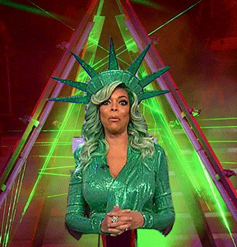
They All Gonna Laugh at Wendy
SATAN’s emerald green face is the dual/Satanic nature of Ashur, “the Green One.” Emerald Green and Wendy Williams represent the EVIL dual nature of SATAN.
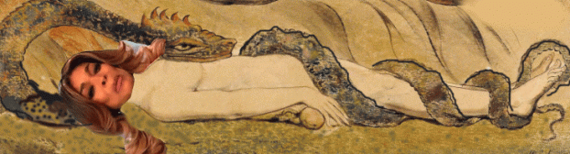
Demonic possession can traditionally often be followed by TRANCE FORMATION. Wendy Williams sold her soul to Lucifer. The Devil’s Contract in the 21st century also includes the technological and medical takeover of their subconscious, conscious mind, and even the spirit– MK ULTRA/MONARCH. Black celebrity Luciferians like Wendy Williams becomes virtual zombies of the THIRD RACE between the Seen (white supremacy), and Unseen (masses of color). Wendy Williams didn’t faint because of any Halloween costume and studio heat. She suddenly fell unconscious due to demonic and ghost possession and TRANCE FORMATION live on the idiot box. They can spin her on a dine!

The bottom line is that Wendy Williams and her Halloween day special cross dressing guest host Jerry O’Connell are initiates of the global SATANIC DARK CIRCLE- PART OF THE ANCIENT SATURN SATANIC DEATH CULT involved in the global horrors of shadow government PIZZAGATE pedophile rings, child and adult slavery, child sacrifice and mass-murder rituals.
Wendy Williams & Festival of Samhain
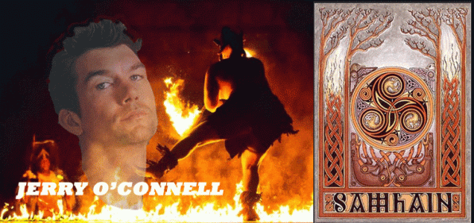
On Halloween, October 31, 2017, Lucifer made a mockery of his servant, Wendy Williams, whatsoever that it may be, man, woman or human clone, before millions of frightened viewers. Halloween is an annual holiday, celebrated each year on October 31 that has roots in age-old European traditions. It originated with the ancient Celtic Festival of Samhain, when people would light bonfires, sacrifice humans, and wear costumes to ward off ghosts.[17],[18] Samhain was in part a sort of Harvest Festival, when the last crops were gathered in for the winter, and livestock killed and stored. But the pagan Celts also believed it was a time when the walls between our world and the next became thin and porous, allowing spirits to pass through.[19]
Wendy Williams’ special guest host, Irish Catholic Jerry O’Connell is linked genetically with the Mythological Magic People of Ireland– Tuatha Dé Danann. O’Connell was part of HollyWeird’s late 1990s infamous Soda Pop Boy Club of River Phoenix, Corey Finland, and Corey Haim that revolved around entertainment film industry secret pedophile/satanic rings, and Charlie Sheen.

Right now, today, Charlie Sheen is accused of raping (HollyWeird Satanic Pedophilia Initiation Rite) 13 (thirteen) year old Corey Haim.[20] Sheen aka Carlos Estévez is also an Irish Catholic that is genetically related to the pagan Iron Age Gallaeci German tribe- the Celts. This group is generally known as the Gallaeci (Galicians) similarly to Galli (Gauls) and the Gallati (Galatians) that settled among the ancient Greeks. His ancient ancestors worshiped the secret Cult of Bacchus– the Horned God Pan, the Baphomet.[21] He openly calls himself- A dark VATICAN ASSASSIN WARLOCK.[22]

Donald J. Drumpf is half Scottish Catholic. He is a descendant of an ancient Scotland Druid Bloodline of the pagan MacLeod Clan from the Hebridean Island of Lewis, off the west coast of Scotland.[23] In a Manuscript Memorial of the Clan dated circa 1767, it is confidently claimed that it is “universally acknowledged” that the MacLeods in Scotland are descended from the Kings of Man. The origin of Clan can be traced to Leod as Ljotfulfr (Ugly Wolf) an important chief in Isle of Lewis in the 12th Century Scotland.
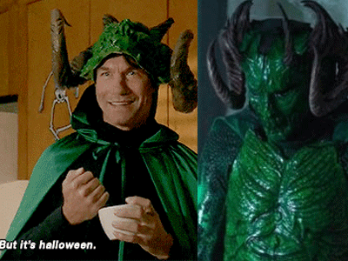
Jerry O’Connell, Green Meanie- Irish Cernunnos, Horned God Pan, the Devil’s Son [24]
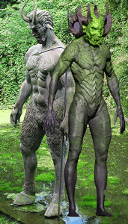
It was no coincidence that Jerry O’Connell has a direct link to the ancient pagan secret Cult of Bacchus– the (Emerald Green) Horned God Pan, the Baphomet – would appear as Wendy Williams’ special guest host for Halloween 2017.
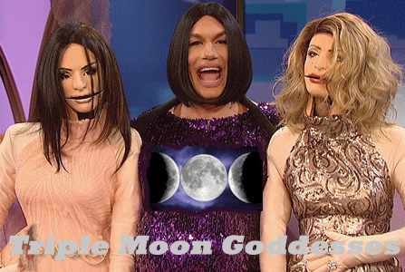
Jerry O’Connell & Celtic Three Bridigs
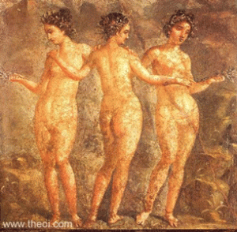
The Three Graces, Greco-Roman fresco from Pompeii C1st A.D., Naples National Archaeological Museum
THE KHARITES (Charites) or Graces, were 3 (three) goddesses of grace, beauty, adornment, joy, mirth, festivity, dance and song. The three Kharites were depicted in classical art as naked women, holding hands and dancing in a circle. They were sometimes crowned with and held sprigs of myrtle. In Greek vase painting a bevy of younger Kharites form the retinue of Aphrodite.[25]
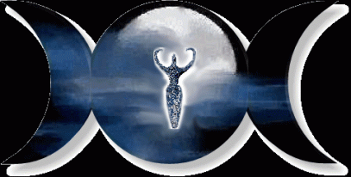
The Triple Moon is a Goddess symbol that represents the Maiden, Mother, and Crone as the waxing, full, and waning moon. It is also associated with feminine energy, mystery and psychic abilities. You often see this symbol on crowns or other head-pieces, particularly worn by High Priestesses.[26]
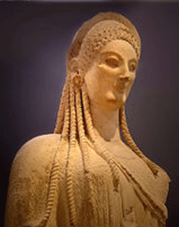
Greek Goddess Persephone
The Maiden represents enchantment, inception, expansion, the female principle, the promise of new beginnings, youth, excitement, and a carefree erotic aura. The Maiden in Greek Mythology is Persephone – purity – and a representation of new beginnings. Persephone is the daughter of Zeus and Demeter.[27]
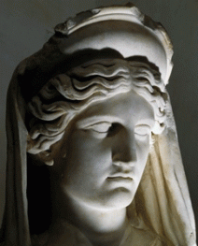
Goddess Demeter
Herodotus II.59.2. The ancient Greek Historian, Herodotus, equates Aset (Isis) with Demeter. Both goddesses also share similar legends of wandering the land in search of their lost loved ones. Demeter wanders throughout the known world in search of her abducted daughter and Aset searches for the body (parts) of her husband and brother, Ashur/Osiris. Other maiden goddesses include Brigid.[28]

Brigit, Brigid or Bríg (“exalted one”) was a goddess of pre-Christian Ireland. She appears in Irish mythology as a member of the Tuatha Dé Danann, the daughter of the Dagda and wife of Bres, with whom she had a son named Ruadán.[29]
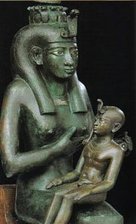
The Mother (The Harvest Queen) represents ripeness, fertility, fulfillment, stability, and power. The Mother Goddess in Greek mythology is Demeter– Aset- Isis, representing wellspring of life, giving and compassionate. Other mother goddesses include: Aa Ambika, Ceres, Astarte.[30]
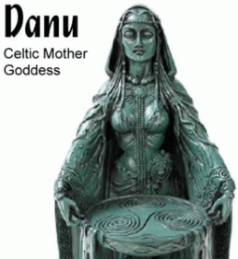
Anu [Danu] (Ireland Harvest Queen) is the popular goddess of fertility, fecundity, plenty, cattle, and health compared with the Greek Demeter and the Roman Ceres.[31]
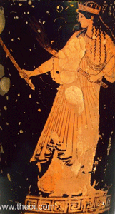
Hecate, Greek Goddess of Witchcraft and Magic
The Crone represents wisdom, repose, and compassion. The Crone in Greek mythology is Hecate – wise, knowing, a culmination of a lifetime of experience. The Goddess Hecate is connected to the ancient Kemetic Goddess Nut. “She was the sky and the heaven and was invoked with many names. The Great Deep, The Starry One, Cow Goddess, Mother of the Gods, Mother of the Sun, Protector of the Dead, Guardian of the Celestial Vault.” These titles all relate to Goddess Hecate in her association with the moon, the night sky and the underworld.[32]
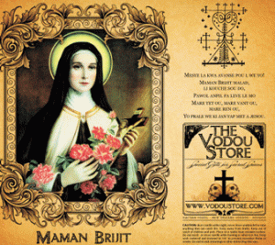
Crone goddesses include: Hel, Maman Brigitte, Oya, Sedna, Skuld, and others.[33] Maman Brigitte (English: Mother Brigitte) also written Grann Brigitte, Manman, Manman Brigit, Manman Brijit is a death loa and the wife of Baron Samedi in Vodou. She drinks rum infused with hot peppers and is symbolized by a black rooster. Like Baron and the Ghede, she uses obscenities. Brigitte is also one of the only white Voodoo gods, due to having origins in IRELAND.[34]
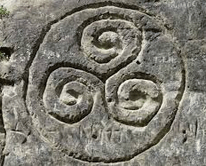
Triple Spiral
The Celtic triple spiral or triskele symbol is sometimes called the spiral of life and was found in the Newgrange site from the Bronze Age in Ireland. The triple spiral is an ancient symbol of Celtic beliefs, and was used consistently in Celtic art for 3 (three) millennia. The Celts believed that all life moved in eternal cycles, regenerating at each point. Celts also believed that all important things came in 3 (three) phases; for example: birth, death and rebirth and mind, body and spirit.[35]
V
THE CELTIC THREE

O’Connell, Celtic Triune Mother Goddess & Wendy Williams (Triangle of Satan Hand Symbol)
According to some authors, the triune mother-goddess in pre-Christian Celtic society was equal in stature to that of Mercury, which is what Caesar called Lugos or Lugh, the most important of all the continental Celtic deities. Often Continental representations in sculpture and bas-relief of goddesses are in triads, which were for a time considered to be representations of different figures than those that appeared individually. However, when one looks at the objects associated with them, it is clear that “the two groups express the same religious idea; only the representation of the idea varies.”
Some of the symbolic associations with the Celtic mother-goddess are the cornucopia, fruit, animals seated on her knee, and a child in her arms or next to her. Interestingly enough, in continental representations of Celtic deities, the goddess Julius Caesar called Minerva (who is now known to be Brighde) is often depicted in a triad with the male deities Mercury and Apollo, or Mercury and Vulcan. This is possibly a symbol of her immense importance in Celtic religious practices. In other representations, “Minerva” is depicted in the company of “Mars” which is what Caesar called Camulus, the same figure as Cumhail (father of Fionn Mac Cumhail, leader of the Fianna) a sky and war god of the Celts, both Insular and Continental.
The triad is a defining characteristic of Celtic religion and mythology. Celtic art and literature has long been preoccupied with the number three. Looking at Celtic works or art one notices that often figures are grouped in clusters of three, creatures have three heads, objects repeat three times, or a single head might have three faces.
Oak, ash, and thorn were called the faery triad of trees. Where they grow together, it is still said that faeries live. From the Druid or Celtic Shamanistic viewpoint the number three represents the different views one might develop following an initiation ceremony that is consistent with the Three Rites of Freemason. Celtic Shamans believed that they could see the present, past and future – their vision of the world was complete and trustworthy. The Shaman often saw himself as a man standing in three different worlds at the same time. In this way, his judgments, decisions and advice became infallible and were closed to interpretation.
To the Celtic Shaman the worlds overlapped thus his consciousness is different from anyone else. His world view is full and complete. He has many ongoing relationships with otherworldly entities, such as fairies, the dead and the yet to be born. He gains his knowledge of this world from these entities and bestows it upon those who are not so blessed with such insight, such as King Arthur. The Celtic preoccupation with the number three can be seen in the image of many of the Celtic Gods and Goddesses such as the Three Brigids, and in the course of a story, often male heroes travel in groups of three in an attempt to complete a task, each of the three completing a different leg of the journey.
Just as night and day need twilight or dawn to go between it, the Celtic Shaman is the necessary third being between what is seen and unseen. He is neither this nor that. This widespread interest of the number three remains in our thinking today. Many modern concepts in philosophy, mathematics, physics, etc., are still very much based in the idea of “The Three.” The Greeks used the number three a lot. There were the three Fates, three Graces, three Gorgons and the three Furies. Even Apollo’s Pythia sat on a three legged chair (tripod) and Cerberus was a three headed dog. Multiples of three also seemed to be used such as the nine Muses and the twelve Olympian gods. Add the Holy Trinity, the trimester and some others, and you have a world-wide phenomenon.[36]
Durante degli Alighieri (simply called Dante (Italian: 1265 – 1321) planned every detail of his master work on Satan and Hell, Divine Comedy. This is most clearly expressed in his use of numerical symbolism throughout. Three, the number of the Holy Trinity, is everywhere in the work. For example, there are nine circles of hell (3 times 3) and nine levels of paradise. Dante’s Satan is a three-headed monster. There are 33 cantos in each of the books of the Comedy. Perhaps most impressive, the entire work is written in terza rima, a form of poetry in which there is a set of three lines, the first and last of which rhyme and the middle line of which rhymes with the first and last of the next stanza, and so forth. The fact that Dante was so invested in promoting this numerical symbolism in his work that he went so far as to make every line he wrote a part of it speaks to the importance of it.[37]
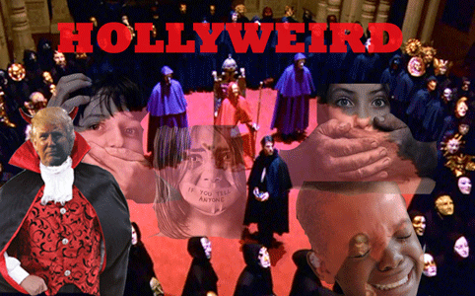
So, which is it? The American people, EYES WIDE SHUT, don’t believe it, the dark forces and spirits of HollyWeird Irish Shaman/Warlock Jerry O’Connell, or if they do believe it, they must have buried their heads in the ground from the neck up. With Old Angel Heart and the Dark Satanic Circle in the White House for another 3 (three) years, the American people are soon bound to suffocate.
VI
JESUS CAMPOS, “ABSOLUTELY” TRUE HERO OF THE HARVEST FESTIVAL?
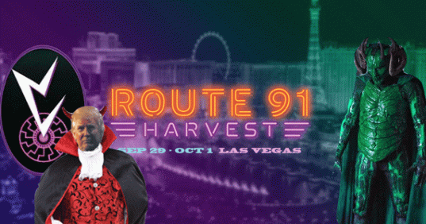
There is also a spiritual connection to the Last Three Months (October, November, and December). October is borrowed from Old French octobre, from Latin octōber (“eighth month”), from Latin octō (“eight”), from Proto-Indo-European *oḱtṓw (“twice four”). October was the 8th (eighth) month in the Roman calendar.[38]
Recall that the Celtic Samhain Festival was in part a sort of October Harvest Festival, when the last crops were gathered in for the winter, livestock killed and stored. Dionysus was the god of the grape harvest, wine making and wine, agriculture, and fertility of nature. He is also associated with ritual madness and ecstasy in Greek mythology.
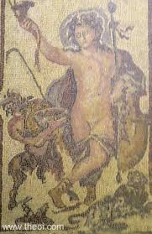
The Horned God Pan is interwoven with Dionysus. Since Ancient Greece, he always shows up for a Harvest Festival.
Obed edom (follower of Edom), a Merarite Levite, a temple porter (gatekeeper), who, with his 8 (eight) sons guarded the southern gate (1 Chronicles 26:4, 8, 15; 15:18, 21, 24). The ark remained in Obed-Edom’s home for 3 (three) months (1 Chronicles 13:13-14). It brought him and his house great blessing. [39]
RT91 Harvest Festival, a 3 (three) day country music fest took place on the Las Vegas strip on Sept 29-October 1. On the THIRD DAY Sunday evening, October 1, 2017, allegedly 59 people died, and over 500 were wounded by assassin(s) at the (Celtic Samhain) Harvest Festival shooting from the Mandalay Bay Hotel and Casino.
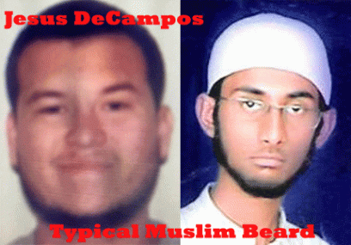
Mandalay Bay private security guard, 25 year old, Jesus De Campos with a typical Muslim beard is one of the central figures in the October 1, 2017 alleged greatest massacre of U.S. citizens in history in Las Vegas. Nevertheless, he is not registered anywhere in America as a private security guard. And, I am not sure if it is true or not, but Mandalay Bay private security guards are prohibited from wearing facial hair on duty.


Wahhabi Muslim Ahmad Rahami
Ahmad Rahami with the typical Muslim beard is the convicted without a defense, terror suspect in bomb attacks in New York and New Jersey. Allegedly, he was radicalized by Afghan Taliban recruiters from their base in Pakistan.

Wahhabi Muslim Syed Farouk with Typical Muslim Beard
Syed Farouk, a U.S.-born American of Pakistani decent who together with his Pakistani-born wife, allegedly, killed 14 of his co-workers in San Bernardino, Calif., traveled to Saudi Arabia before launching his attack. They belong to the Wahhabi Branch of Sunni Islam. Most of the Muslim False Flag Terror Attacks in America have links to Wahhabism and Saudi Arabia.

CIA Undercover Muslim Marcus Robinson with Typical Muslim Beard
FBI/CIA undercover Muslim agent, Marcus Dewayne Robinson, with the typical Muslim beard and his minion Mateen Omar linked to the Orlando Pulse Club Massacre of allegedly 50 dead and 53 wounded are/were Saudi sponsored Wahhabi Salafi Islamist. The Orlando Pulse Club False Flag attack is now the second deadliest mass shooting by a single shooter in United States history, behind the 2017 Las Vegas Strip Harvest of the Dead.
On October 9, 2017, Las Vegas Metropolitan Police Department Sheriff Joe Lombardo amended previous statements to clarify that Jesus Campos was shot before Stephen Paddock opened fire on concert-goers. Campos remains credited with informing police of Paddock’s location. Campos was shot at 9:59 p.m. Lombardo said, and Paddock began firing on the crowd six minutes later.
Dave Hickey, president of the International Union, Security, Police and Fire Professionals of America, “Paddock, who had rigged cameras in the hallway and on the peephole of the door, saw Campos coming and fired through the door, hitting him in the leg.”[40]
Clark County Sheriff Joseph Lombardo, “When Campos was hit, he radioed casino dispatch and told them his location—and Paddock’s. ‘We received information via their dispatch center… that helped us locate where this individual was sequestered.’ ”[41]
Lombardo said that Campos‘ bravery was “amazing” because he remained with officers, provided them with the key to enter the hotel room, and “continued to help [officers] clear rooms until our officer demanded that he go seek medical attention.”[42]
Clark County Undersheriff Kevin McMahill, “Campos, wounded, stayed on the floor and even went door-to-door, clearing rooms with police [allegedly carrying a high projective bullet in the leg], Lombardo said, until he was ordered to leave because he was wounded.”[43]
According to the new timeline, Stephen Paddock began firing at 10:05 p.m. and continued until 10:15 p.m., which matches the latest police report. It is a full 6 (six) minutes after the Sheriff’s department said that Campos was allegedly shot and wounded 9:59 p.m.[44]
One big question that still remains is why law enforcement and the swat team took so long to arrive on the 32nd floor. The new timeline puts officers outside Paddock’s door at 10:22 p.m. — a full 7 (seven) minutes after the shooting ended. And, at what time were Campos and police allegedly ducking and dodging 200 rounds being strayed into the hallway by Paddock on the 32nd floor? [45],[46]
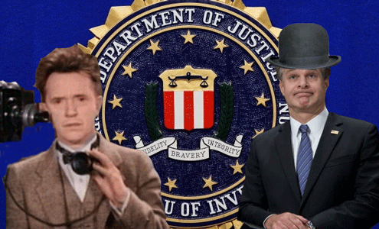
“Hey Chris, Campos just skipped town. He just drove into Mexico. Should we follow him?“
On October 1, 2017, Campos disappeared after checking into an urgent care facility that say that they know nothing about it.[47] Sources told Fox News that Campos allegedly wounded and carrying a high velocity projectile smoking bullet in the leg, drove a rental car that was registered in California 18 hours, 1, 184.8 miles into Mexico.[48] Customs and Border Patrol documents obtained by Fox News show that a person claiming to be Jesus De Campos entered the United States from Mexico at the San Ysidro border crossing on October 8, 2017.
So, which is it? Is Campos a national hero or a zero? U.S. citizens have the option to disbelieve that he is a hero, or they can believe the entire story line, hook, line and sinker – EYES WIDE SHUT.
Campos, The FBI Laurel & Wray Show
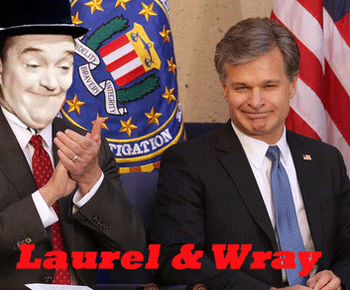
Under the Cloak of the FBI Laurel & Wray Show, Campos may have left the United States- a Saudi Wahhabi Terrorist Assassin …
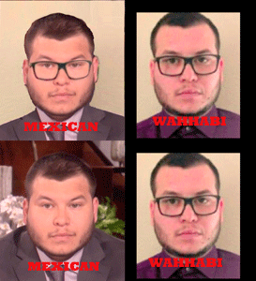
And returned to the country a Mexican in deception to appear on the Ellen DeGeneres Show. Well, that’s the story line. Whatsoever the current Campos may be, he entered the U.S. viva Mexico.
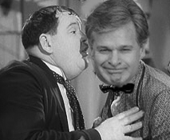
“Hey Chris, the Saudi’s ETS was at the Harvest. Do you think we need to look into it?”
If quiet is keep, Saudi-based private military company ETS Risk Management was, in fact, on the ground before, during, and after the October 1, 2017 attack in Las Vegas. ETS is a Global Risk Management and Executive Protection Company focused on the provision of Protective Security Solutions for multi-national corporations, high net worth individuals [and Criminal Terrorists like De Campos] (HNWIs), NGOs and scholastic organizations, the company’s official website claims. But more importantly, ETS is based out of Saudi Arabia which brings us to the His Royal Highness Prince Alwaleed Bin Talal who was arrested by the king and his son for corruption.

Gates & Prince Talal
Four Seasons Hotels and Resorts independently operate five floors (35-39) of the Mandalay Bay Resort and Casino. Four Seasons Hotels and Resorts is managed by Kingdom Hotel Investments (KHI) which according to their official website is “one of the world’s largest and most prestigious hotel management companies. Four Seasons has been privately held since 2007, primarily by Kingdom Holding Company (KHC) and Cascade Investment, LLC – a Seattle-based company owned by billionaire eugenicist and gun control advocate Bill Gates. Each company holds a 45% stake. A third company by the name of Triple Holdings holds the remaining 10%. KHC was founded by Prince Alwaleed Bin Talal. He is listed as the chairman.
Saudi Prince Talal owns a stake just 3 (three) floors of the Mandalay Bay Casino just above Stephen Paddock that allegedly fired over one-thousand .223 caliber rounds into crowd goers who were attending the Route 91 Harvest Music Festival allegedly killing 58 people, and wounding approximately 500.[49]
VII
OLD ANGEL HEART, MOTHER OF THE DARK SATANIC CIRCLE & THE WAHHABI TERRORISTS
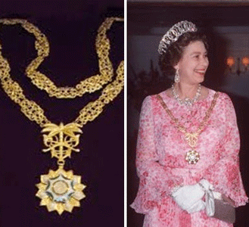
For all those that have argued that Old Angel Heart wasn’t a Freemason, he is a master mason now, without any doubt whatsoever. Saudi Arabia- Collar of the King Abdulaziz Order of Merit was bestowed upon the world’s richest, dangerous and most powerful Masonic- Dragon Lady, Queen Elizabeth II, by King Khaled bin Abdulaziz Al Saud in 1979.

1987, Queen Elizabeth, Prince Philip & Wahhabi Global Terrorist Founder King Saud
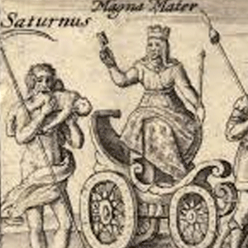
She is the “Magna Mater” CYBELE, the secret cannibalistic SATURN cult’s Earth Mother Goddess- “Mother of All Satanic Dark Circles”.
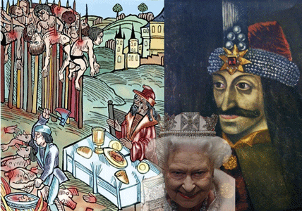
The queen goes back in direct ancestry to the devil blood cannibal Vlad III, known as Vlad the Impaler or Vlad Dracula, Prince of Wallachia. Prince Philip, Duke of Edinburgh is a secret ritual International Grand Masonic Master, Royal Knight of the Most Noble Order of the Garter, Extra Knight of the Most Ancient and Most Noble Order of the Thistle, Member of the Order of Merit, Grand Master and First and Principal Knight Grand Cross of the Most Excellent Order of the British Empire. They created King Saud, and the Saudi Royal Family as carbon copies of the British Satanic Dragon Empire.
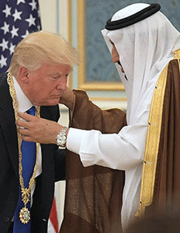
Collar of the British Empire Wahhabi Terrorist King Abdulaziz Order of Merit
On May 20, 2017, Drumpf was officially initiated into the Order of Wahhabi Terrorist King Abdulaziz. The order was named after Abdulaziz Al Saud, founder of the modern Saudi state.[50] Yes, it is the secret Masonic Order of Ibn Saud, Jack Philby of British Intelligence, and future CIA Director, Allen Dulles that found global terrorism- Wahhabism.
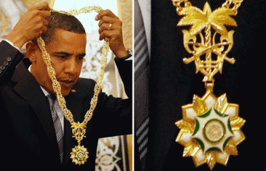
U.S. Libya War Criminal Barrack Obama- Collar of the Wahhabi Terrorist King Abdulaziz Order of Merit
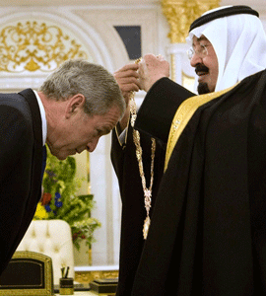
9-11- Iraq War Criminal George W. Bush- Collar of the Wahhabi Terrorist King Abdulaziz Order of Merit
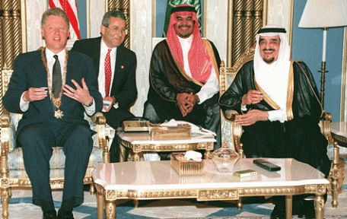
Dixie Mafia War Criminal, Bill Clinton- Collar of the Wahhabi Terrorist King Abdulaziz Order of Merit
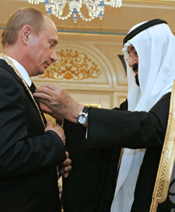
Russian KGB Freemason, Vladimir Vladimirovich Putin- Collar of the Wahhabi Terrorist King Abdulaziz Order of Merit
“The modern world begins, the authors suggest, at the end of World War I, when British diplomat/adventurers Jack Philby (father of Soviet spy Kim Philby and legendary Arabist) and Lawrence of Arabia endeavour to unify a bunch of warring Bedouin tribes into nationhood, best represented by Saudi Arabia. Aware that black gold (oil) lies underneath the desert sands, Philby gingerly befriends Ibn Saud, and makes him the first Saudi king. But Philby is not solely interested in empire, even his own British one; he is interested in making money, and forges an alliance with an American intelligence agent in charge of Middle Eastern affairs, Allen Dulles. By the 1930s, Ibn Saud and Philby are secret supporters of the Nazi rise to political power in Germany, and bring Dulles, a NYC-based corporate lawyer for Sullivan and Cromwell, in on their scheme. It is a triple game driven by their hatred of Zionism and the Jews, motivated by their obsessive seeking of profits, and designed to completely transform the landscape of the Middle East. Philby and Dulles convince Ibn Saud to allow limited Jewish immigration to Palestine, assuring him that the numbers will never challenge or upset his control. When Jews leave Germany, their assets are confiscated by Hitler, who shares a percentage of these with dummy corporations established by Philby, Dulles, and their allies. Some of this money is used to arm Ibn Saud, and intelligence disclosures to him by Philby enable Ibn Saud to become king of Saudi Arabia over other Arab leaders supported by the British government.”[51]

In December 2015, after then-candidate Donald J. Drumpf called for a ban on Muslims entering the United States, Prince Alwaleed Bin Talal of Saudi Arabia tweeted, “You are a disgrace not only to the GOP but to all America. Withdraw from the U.S presidential race as you will never win.”
Drumpf responded: “Dopey Prince @Alwaleed_Talal wants to control our U.S. politicians with daddy’s money. Can’t do it when I get elected. #Trump2016.” A month later, after Drumpf re-tweeted a doctored photo of Alwaleed with Megyn Kelly, the prince tweeted at him, “Trump: You base your statements on photoshopped pics? I bailed you out twice; a 3rd time, maybe?” After Drumpf was elected, Alwaleed softened his tone and tweeted his congratulations: “President elect @realDonaldTrump whatever the past differences, America has spoken, congratulations & best wishes for your presidency.”[52]
VIII
LUCIFER, SAUDIS, DIXIE MAFIA & THE SECOND CIVIL WAR
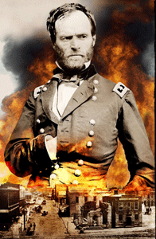
From the very outset of the Civil War, Confederate President Jefferson Davis, the name sake of Drumpf’s U.S. Attorney General Jefferson Davis Sessions, was explicitly compared to Lucifer. Union General William T. Sherman compared the South’s rebellion to that of the FALLEN ANGELS.
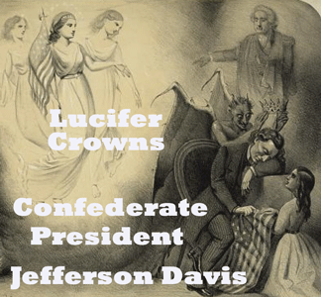
The Institution of African Human Bondage might in itself been enough to commit the Confederacy to the depths of Hell Fire, but Lucifer was almost heroic to the South- deeply shrouded in evil nobility. They saw Lucifer’s rebellion against Heaven as a matter of misunderstanding. The rebellion in heaven wasn’t purely evil, but a case of love. Lucifer wasn’t evil at all. He loved God so much above all things. He rebelled against God only by helping humans gain wisdom that God did not want them to have.
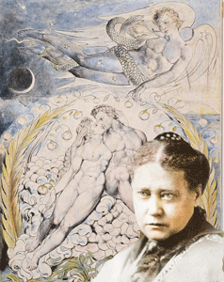
Satanist Madame Blavatsky’s idea is that there was no God, as the bible described, but rather that man is god. She also argued that Lucifer was misunderstood; and that it would be him who would free man of his ignorance. She wrote, “Mankind will become freed from its false gods, and find itself finally SELF redeemed (The Secret Doctrine II, p.420).”
Madame Blavatsky, “We are about to found a magazine of our own, Lucifer. Don’t allow yourself to be frightened: it is not the devil, into which the Catholics have falsified the name of the Morning Star, sacred to all the ancient world, of the ‘bringer of light,’ Phosphoros, as the Romans often called the Mother of God and Christ. And in St. John’s Revelation does it not say, ‘I, Jesus, the morning star’? I wish people would take this to mind, at least. It is possible that the rebellious angel was called Lucifer before his fall, but after his transformation he must not be called so….”
Don’t get it twisted. Satanists of the 19th century totally ignore the evolution of Lucifer/Satan from the Kemetic God Set that was truly jealous of the POWER and LOVE of his brother- King Ashur (Osiris) that he slayed him. The mythology of the Gods Set and Ashur (Osiris) predates the books of the bible by tens if not hundreds of thousandths of years.
The Atlanta, Georgia firm of King & Spalding had been centered in the Deep South since the end of the Civil War and Reconstruction. On November 15, 1864, Union General William T. Sherman ordered the traitorous confederate business district of Atlanta, the palm of the hand of the confederacy, destroyed, burned to the ground, before he embarked on his famous “March to the Sea”.[53]
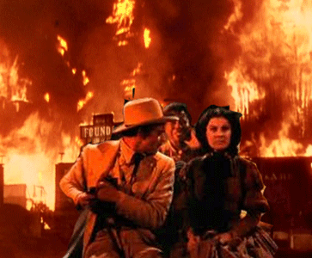
The firm’s founders, Alexander Campbell King, and Jack Johnson Spalding, were linked to Atlanta’s “Gone with the Wind” prominent Lucifer Grand Lodges of France, England, Ireland, and Scottish Rite Masonic slave owning Confederate families, and the South’s secret 2nd Civil War.
The city of Atlanta was created in the early 19th century to facilitate the building of a terminal to a vast railroad train network that would reach the Atlantic Ocean. The city’s name has it origin in the Atlantic Ocean. So, they say. The Atlantic means “Sea of Atlas“, while “Atlantis” means “Island of Atlas“. According to Plato, the first king of Atlantis was also named Atlas, but that Atlas was a son of Poseidon and the mortal woman Cleito. Atlanta is spiritually connected with the Greek mythological Island of Atlantis, and Sir Francis Bacon’s vision of America’s New Atlantis. It is an Utopian notion of a “divine” master Anglo Saxon race living in paradise ruling over a nation of toiling slaves. It is a notion that they will not let die!
The Dixie Mafia, which might have as many as one thousand “affiliated” criminals involved with it, is known to be active in several areas of the South, notably Atlanta, and Bill Clinton’s Little Rock, AR. “The biggest conglomeration of them is in Atlanta”, according to Gene Matthews, a special agent in the intelligence division of the Fulton County DA.[54]
What took place on October 1, 2017 in Las Vegas was a criminal enterprise coup. People were killed that night, but it wasn’t the people of Dixie Land attending the country music festival. They were the backdrop acting in combination with a major false flag slaughter of innocence. It was a secret take down of a large network of a Saudi financed criminal ring,and some of their American handlers. Usually, a big criminal coup and network take down make a lot of news, and FBI, local police agencies’ 24-7 press conferences patting each other on the back. But not in this case. Why? Because, it involved international pedophilia rings, PIZZAGATE child, adult sex slave trafficking, drugs, and gun smuggling of U.S. shadow government secret operatives like Stephen Paddock acting in concert with the Masonic Wahhabi Saudis. There were also no government press conferences, because it was the changing of the guard of the secret government criminal enterprises. A new set of operatives and players moved in to takeover the gravy- Bill and Hilary Clinton’s Rings of the Old South Confederate Dixie Mafia.
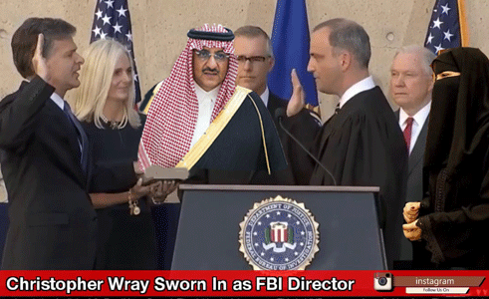
Christopher Wray of the law firm of King & Spaulding of Atlanta was sworn in as the Director of the FBI on August 2, 2017.[55] The King & Spalding website states:
“Our work in the Middle East and our experience with Islamic finance date back to the early 1980s. In 1995, we were the first law firm to establish a dedicated Islamic finance and investment practice group. Our award-winning group has been successful in developing the legal architecture needed by our clients to break new ground in this specialized field. We are the only law firm with recognized experience and the depth to structure and implement sophisticated Shari’ah-compliant investment and financing transactions in the Middle East, Europe and the United States.”
Wray joined King & Spalding in 2005 as a litigation partner in the firm’s Washington, D.C., and Atlanta offices. King & Spalding lobbies for Saudi Arabia through its office of Ministry of Commerce and Investment. It is the body that regulates and develops domestic and foreign trade in Saudi Arabia.[56]
“The Law Office of Mohammad Al-Ammar in affiliation with King & Spalding LLP is home to a team of internationally qualified and highly ranked lawyers who regularly represent some of the most high-profile oil and gas, energy and power companies, banks and finance houses, and significant private equity and real estate investors, and multinationals operating in Saudi Arabia.”[57]

Dr. Majed bin Abdullah Al-Qasabi is the Saudi commerce minister. Majid al-Qasabi is one of the leaders of the current unprecedented aggressive Saudi elite anti-corruption purge, arrests, seizure of assets, and deaths of political officials and leaders in the country.[58]

The Saudi purge is orchestrated by King Salman and Crown Prince Mohammed bin Salman, his ambitious 32 year-old son.[59]
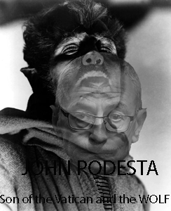
The Saudi Arabian Oil Company, the national oil and natural gas company directed, owned and financed by the Kingdom of Saudi Arabia, has hired Clinton Foundation [Satanic Pedophiles, the Grey Wolf John and Tony] Podesta Group to provide counsel regarding “U.S. policies of concern, activities in Congress and the executive branch, and developments of the U.S. political scene generally,” according to FARA documents filed on September 30, 2016.[60]


Podesta will also conduct research and communicate relevant issues (and may conduct meetings) with members of Congress and executive branch officials. Acting as a third party-client in the agreement, the Saudi Arabian Oil Company is working through international law firm White & Case LLP. The pact, which was inked between Podesta and White & Case, shows services beginning on September 21 and terminating on October 21. White & Case will pay Podesta $30,000 for the month-long campaign in addition to expenses.[61]
Squire Patton Boggs, meanwhile, was picked up on September 19, 2016 by the Saudi Royal Court to advise the country on “legal and strategic policy advice and advocacy on foreign and related issues in the U.S. government.”[62]
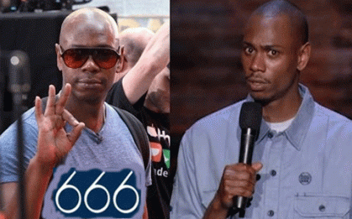
Squire Patton Boggs manage cloned Dave Chappelle 666- Mark of the BEAST.
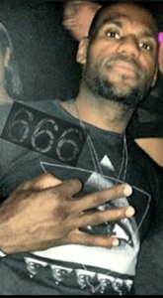
and ILLUMINATI mentacided LeBron James 666.
The firm of Patton Boggs was founded in 1962 by James R. Patton, Jr. and joined soon after by George Blow, and the late Thomas Hale Boggs, Jr., son of the infamous JFK Warren Commission member, assassinated Hale Boggs. It has “participated in the formation of every major multilateral trade agreement considered by Congress.” Boggs joined the firm in 1966 after serving as an economist for the Joint Economic Committee and in the executive office of President Lyndon B. Johnson.[63]
Finally, at the end of “The Howling Man“, the man that opened the door of the Devil’s Cell, and released him on earth re-captured him. He said that it took years, but he followed major wars, natural and made-made disasters, catastrophes, hurricanes, tornadoes, earthquakes, major fires, mass murders, bombings and the such all around the world, until he finally found him at the scene.

“The Howling Man” can be subdued with only the Shepard’s Crook of TRUTH, JUSTICE, BALANCE & RIGHTNESS.
_____________________________________________________________________________
[1] http://www.ligonier.org/learn/articles/demons-servants-satan/
[2] https://voices.nationalgeographic.org/2008/12/17/devil_bible/
[3] https://gnosticwarrior.com/who-is-satan.html
[4] Id.
[5] Id.
[6] http://www.khemitology.com/why-is-osiris-green-by-patricia-awyan/
[7] http://vaticproject.blogspot.com/2014/03/rothschild-owned-blackstone-group.html
[8] http://black.greyfalcon.us/thule.html
[9] Id.
[10] Id.
[11] http://elitewatch.911review.org/Blackstone_Group.html
[12] https://www.zacks.com/stock/news/180280/blackstone-pens-167b-deal-to-sell-alliedbarton-to-wendel
[13] https://www.reuters.com/article/us-california-fire/death-toll-from-california-blazes-rises-to-43-after-teen-dies-idUSKBN1D004Z
[14] http://www.orlandosentinel.com/news/puerto-rico-hurricane-recovery/os-fema-maria-puerto-rico-survivors-20171109-story.html
[15] http://www.miamiherald.com/news/nation-world/world/americas/article183500171.html
[16] https://www.mintpressnews.com/puerto-ricos-recovery-efforts-have-been-stymied-by-its-colonial-status/234296/
[17] http://www.history.com/topics/halloween/history-of-halloween
[18] https://en.wikipedia.org/wiki/Samhain#Wicca

[19] http://www.telegraph.co.uk/news/uknews/6468637/Halloween-a-history-of-All-Hallows-Eve-from-Samhain-to-trick-or-treat.html
[20] http://people.com/tv/charlie-sheen-accused-of-raping-corey-haim/
[21] https://mindcontrolblackassassins.com/author/princeray/
[22] http://www.trivisonno.com/charlie-sheen
[23] https://mindcontrolblackassassins.com/2016/09/10/they-are-lying-about-donald-druid-drumpf-trump-knights-templar-freemasons-the-20-shot-peppa-pig-manchurian-candidate/
[24] https://hiddenremote.com/2016/11/22/scream-queens-whos-under-the-green-meanies-mask/
[25] http://www.theoi.com/Ouranios/Kharites.html
[26] http://www.crystalinks.com/triplegoddess.html
[27] Id.
[28] http://www.artic.edu/~llivin/research/greeks_egyptian_gods/
[29] https://en.wikipedia.org/wiki/Brigid
[30] http://www.crystalinks.com/triplegoddess.html
[31] http://www.terrapsych.com/gods.html
[32] http://hecatestreasures.com/hecate.htm
[33] http://www.crystalinks.com/triplegoddess.html
[34] https://en.wikipedia.org/wiki/Maman_Brigitte
[35] http://www.crystalinks.com/triplegoddess.html
[36] http://www.greatdreams.com/three/three.htm
[37] https://www2.bc.edu/elise-uberti/dante3.html
[38] https://en.wiktionary.org/wiki/October
[39] https://christiananswers.net/dictionary/obed-edom.html
[40] https://www.thedailybeast.com/unarmed-security-guard-jesus-campos-took-on-las-vegas-killer-stephen-paddock
[41] Id.
[42] https://www.cbsnews.com/news/jesus-campos-las-vegas-shooting-police-reveal-new-details-about-hero-security-guard/
[43] Id. At footnote 1
[44] http://nypost.com/2017/10/25/new-timeline-in-las-vegas-massacre-may-offer-new-insights/
[45] Id.
[46] http://beta.latimes.com/nation/la-na-vegas-shooting-20171009-story.html
[47] http://www.news.com.au/lifestyle/real-life/news-life/mandalay-bay-security-guard-jesus-campos-goes-missing-after-vegas-shooting/news-story/3db6deecb6358d04bcedd93a765a6983
[48] http://www.news.com.au/world/north-america/las-vegas-security-guard-jesus-campos-left-us-days-after-mandalay-bay-massacre/news-story/c096ed61810c06e75489ae610759bc86
[49] https://www.intellihub.com/saudi-prince-linked-to-5-independently-managed-floors-inside-mandalay-bay/
[50] https://en.wikipedia.org/wiki/Order_of_King_Abdulaziz
[51]
[52] https://www.vanityfair.com/news/2017/11/prince-alwaleed-donald-trump-regression
[53] http://www.history.com/this-day-in-history/the-destruction-of-atlanta-begins
[54] http://www.nytimes.com/1974/04/19/archives/georgia-hunt-for-bodies-is-linked-to-dixie-mafia-100-yards-of.html
[55] https://www.fbi.gov/history/directors
[56] http://www.odwyerpr.com/story/public/7662/2016-10-04/saudi-arabia-continues-lobbying-spree.html
[57] https://www.kslaw.com/offices/riyadh?locale=en
[58] http://www.dailymail.co.uk/news/article-5060783/Saudi-Arabia-seeks-reassure-investors-royal-purge.html
[59] https://www.vanityfair.com/news/2017/11/trump-praises-saudi-royal-purge
[60] http://www.odwyerpr.com/story/public/7662/2016-10-04/saudi-arabia-continues-lobbying-spree.html
[61] Id.
[62] Id.
[63] https://en.wikipedia.org/wiki/Squire_Patton_Boggs
Comments : Leave a comment
Tags: 9-11 inside job, Aa Ambika, Ahmad Rahami, Allen Dulles, anu, Aphrodite, apollo, arcus Dewayne Robinson, astarte, Atlanta, atlantis, Baphomet, bilderberg group, Bill Clinton, blackstone group, Celtic Shamanistic, celts, Ceres, cernunnos, charlie sheen, child sacrifice, christopher wray, clan macleod, clones, Collar of the King Abdulaziz Order of Merit, Corey Finland, Corey Haim, Crown Prince Mohammed bin Salman, Cult of Bacchus- the Horned God Pan, cult of saturn, cybele, dante's hell, danu, darkness is good, Darth Vader, Dave Chappelle, devil's bible, devil's son, dick cheney, Dionysus, direct energy weapons, dixie mafia, donald j. drumpf, donald j. trump, druids, Durante degli Alighieri, electromagnetic wave frequencies, Ellen DeGeneres Show, emerald green, ets, eyes wide shut, fallen angels, festival of samhain, Four Seasons Hotels and Resorts, freemasons, georgia, geostorm terrorism, goat god pan, god ashur, god set, god vulcan, Goddess Demeter, goddess hecate, goddess isis, grand lodge of ireland, grand lodge of scotland, grand lodge of the orient, Grand Lodges of England, Grand Orient de France, green meanie, hale boggs, halloween, harvest festival, Herodotus, holy trinity, horus, human sacrifice, hurricane maria, Illuminati, ireland, island of atlas, Jack Philby, jerry o'connell, jesus campos, jesus de campos, John Paulson, john podesta, jupiter, kemet, King & Spalding, King Salman, Kingdom Hotel Investments, lad the Impaler, las vegas, las vegas shooting hoax, laurel and hardy, laurel and wray, lebron james, lord jacob rothschild, Lucifer, Lunar Goddess Hecate, madeleine mccann, Majid al-Qasabi, Maman Brigitte, Mandalay Bay Hotel and Casino, maria orsic, mars, mercury, minerva, napa county, old angel heart, omar mateen, Order of the Thistle, orlando, orlando homophobic massacre, Orlando Pulse Club, Osiris, Patton Boggs, pedophilia, Persephone, PG&E, pizzagate, plato, Prince Alwaleed Bin Talal, prince of demons, prince philip, puerto rico, queen elizabeth II, River Phoenix, Route 91 Harvest, Royal Knight of the Most Noble Order of the Garter, santa rosa firestorm, satan, SATURN SATANIC DEATH CULT, saudi arabia, Shari’ah law, sir francis bacon, sir roger bacon, soda pop boy club, Sodalian Oath, Sonoma County, Space Weather Modification System, stephen paddock, steve bannon, Syed Farouk, the green one, the howling man, the invisible man, the lords of the black stone, third race, Three Bridigs, Three Graces, three rites of freemasonry, Thule Gesellschaft, tony podesta, trance formation, triangle of satan, triple goddess, triple moon, Triple Spiral, Tuath(a) Dé Danann, twilight zone, typhon, vatican assassin warlock, Vlad Dracula, Vladimir Vladimirovich Putin, Wahhabi Jihadist, wahhabi muslims, Wahhabi Salafi Islamist, wahhabi terrorists, wahhabism, wendy williams, William T. Sherman
Categories : 9-11, Afghanistan, african american satanic cult, African slavery, antichrist, Apollo, baphomet, Barack Obama, bill clinton, black children, Black Manchurian Candidates, blood covenants, blood oaths, blood sacrifice, Codex Gigas, devil, devil's horns, Devil’s Bible, donald j. drumpf, donald j. trump, donald trump, earth mother goddess, egypt, evil, Eyes Wide Shut, fallen angels, false flags, freemason, freemasons, HAARP, Heinrich Himmler, hollywood satanic cult, illuminati, illuminati sacrifice, kemet, Knights of the Black Sun, Knights Templar, lucifer's servants, luciferians, manchurian candidates, maria orsic, masonic sacrifice, MK-ULTRA, modern slavery, Osiris, Pakistan, pan, Power, ritual satanic sexual abuse, ritually abused children, satan, Satanism, set, sex kitten, sex slave, SS, thule

THEY’RE ALL GONNA LAUGH AT YOU, WENDY WILLIAMS, THE WARLOCK, HORNED GOD & THE SATANIC THIRD RACE MATRIX
6112017
eI
BLIND MAN- MK ULTRA & THE THIRD RACE
I don’t intend to laugh at Wendy Williams. And, I don’t intend to cry for her like a blind man, either. Wendy Williams is no longer a puzzle wrapped inside an enigma. For fame, wealth and fortune, Wendy Williams cheated. There is no question now that she sold her soul to Lucifer, and that her mind, heart, and body belongs to SATAN. She shall not put the people out on a corner to be left to cry. It is the Black Matrix– the Covert 2nd Civil War, Re-Enslavement of Black People, and the creation of a mind controlled Satanic Third Race that will serve White Supremacy that we face in the 21st century.
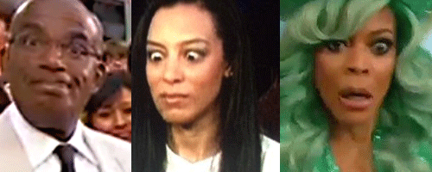
Stalked by Demons, NBC Al Roker, CNN Angela Rye, and now Fox’s Wendy Williams
Global Black celebrities that enter the homes and minds of millions of people worldwide are being subjected to clandestine severe trauma- based mind control programming in secret “sunken places” away from the public. They are ritually tortured and sexually abused 24 hours a day that is now scientifically possible by advancements in systematic psychotronic electronic, electromagnetic low frequencies harassment, and artificial telepathy hologram programs. They will SERVE LUCIFER, and white supremacy as part of a mind control THIRD RACE MATRIX.
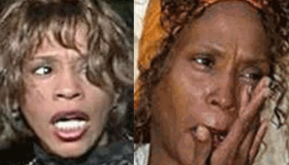
Artificial Telepathy Hologram manipulations explained how the late Whitney Houston could see faces, images and All-Seeing Eyes on the walls, carpets, doors, and inside and outside of her closets; and be harassed 24 hrs a day with stalking holographic DEMONS.
 THIRD RACE Wendy Williams in Trance Formation
People want to see. I can let her go until the people open their eyes to see, and come up with some answers, and solutions to this covert war against the black entertainment industry, and its people. At this point, laughing at or crying for Wendy Williams don’t do us any good. It won’t cure our collective blindness to the Satanic/ILLUMINATI agenda of Old Angel Heart and the Dark Satanic Circle that occupy the highest elected public offices in America.
On the Halloween morning of October 31, 2017, I turned on Wendy Williams while my wife took her medicine, and I fixed breakfast. The Wendy Williams Show is an American syndicated infotainment talk show produced by Debmar-Mercury (subsidiary of Liongate) and distributed by 20th Television (Fox Television). It is primarily aired on Fox, CW and MyNetwork TV affiliates. Wendy is broadcast live in front of a studio audience on Mondays through Thursdays. Wendy reach at least 1.7 million people on a global daily basis.
For Halloween, Wendy wore an emerald green Statue of Liberty Halloween costume. In symbolic color code, emerald green is a very significant extremely ancient and deep statement in Kemetic cosmology. It represents God Aset (Osiris), and Goddess Wadjet.
God Aset- Osiris, Ausser–or Wizzer (Wsjr), is the original Green Man–he is the land and the earth in his representation of mankind migrating through cycles of consciousness. He is the seed, self, sun and universe, enabling consciousness to express itself as a manifestation in the physical, earthly realm. As such, he is associated with all phases of agricultural processes and to the symbolism of the tree of life. He is expressed as green in many depictions to represent these associations and their relationship to the fertility of the earth, his dual feminine aspect.
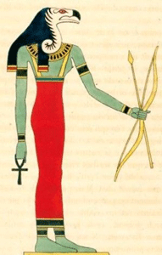
Wadjet is ” ‘She Who is Green’ Cobra-Netjer associated with both the land of Lower Kemet itself and its protection, and the protection and symbolism of the Red Crown (Nit), Wadjet is often depicted as a full cobra, or as the head of the cobra, rearing up in protection on the forehead of Netjeru and rulers.”
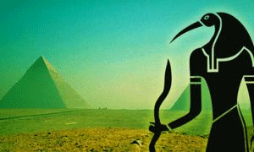
The mythology surrounding Christian Rosenkreutz, the legendary namesake of the Rosicrucian Brotherhood, involves the Emerald Tablet of Hermes, upon which their Hermetic wisdom is based, as well as the famed relic of the Holy Grail.[4] Hermes, the god-man, is said to have brought the alchemical wisdom of the Gods to mankind. He has thus been equated with the Kemetic God Thoth, as well as with Enoch, the patriarch in the Bible who was allowed to go to Heaven and take the “Elixir of Life”, which caused him to live forever. Enoch also was allowed to write down the secrets of the gods upon a tablet, which was brought down to Earth and given to Noah to enlighten mankind.[5]
Hermes had a similar tablet, said to be the color of emerald, and to contain all the secrets of alchemy, known to the gods. Because he revealed this hidden knowledge to man, Hermes therefore has a Luciferian, Titanic and Promethean aspect to him. Hermes is said to never die, but to fall into periods of prolonged sleep, from which he is awakened at regular intervals by the periodic rediscovery of his tomb. The Emerald Tablet of Hermes is upon which the Rosicrucian writings are undoubtedly based.[6]
There is an old legend about an ancient Star-Stone that fell to Earth ages ago when the archangels Lucifer and Michael first battled. Michael struck Lucifer on the head and the crown jewel fell off and down to Earth (Malkuth). This legendary stone is called the Lapsit Exillis, or Stone of Exile. The Stone the builders rejected, which ended up being the Capstone.
The Jewel has been equated with the Emerald Tablet of Hermes, as well as the Graal. It is symbolic of yet another allegorical rendition of the “Fall” of not only Lucifer from Heaven, but of The Middle Pillar on the Tree of Life (Tiphareth, Yesod, Malkuth), which created Daath/Death/Dimensions/Time-Space (i.e. Life).

In Arthurian legend, The Stone holds the Excalibur that only “The True King” with Strength can withdraw.[7] There is a possibility that the legend of King Arthur may be rooted in that of a historical Irish king.[8]
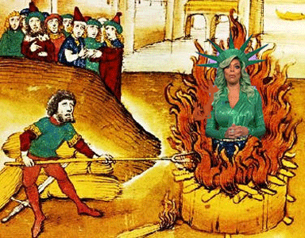
Wendy Williams, “It felt like I was in the middle of a FIRE,” she explained. “Starting down at my feet going all the way up to my top.”
II
WENDY WILLIAMS SHOW, HALLOWEEN, THE IRISH WARLOCK & THE HORNED GOD
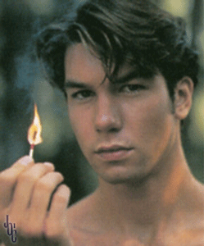
At the very beginning of her Halloween show, Wendy Williams introduced her celebrity guest host, HollyWeird’s Irish Roman Catholic Actor, Jerry O’ Connell.
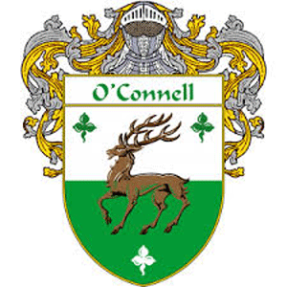
The name Connell comes from the possible meaning Cú (Con) meaning “Wolf or Hound”. They are descendants from the [Tuatha Dé Danann] High King of Ireland, Aengue Tuirmeach in 180 BC. The Coat of Arms colors are silver and [Emerald] Green, comprising of a Stag, signifying longevity. The stag is between three trefoil which signifies abundance.[9] It appears from the knight in the cress that it was a warrior- Knights Templar clan.
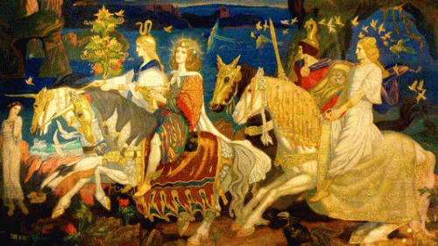
In the Mythological Cycle of Irish Mythology, the Tuatha Dé Danann lived in the other-world and was a magical race that became known as the Sidhe Faerie Folk in Irish folklore.[10] They are also linked to the biblical mythology of Lucifer and the “Fallen Angels.” The Tuath(a) Dé Danann (usually translated as “people(s)/tribe(s) of the goddess Danu” ), also known by the earlier name Tuath Dé (“tribe of the gods“), are a supernatural race in Irish mythology. They are thought to represent the main deities of pre-Christian Gaelic Ireland. The Old Irish word tuath (plural tuatha) means “people, tribe, nation”; dé is the genitive case of día and, depending on context, can mean “god, gods, goddess” or more broadly “supernatural being, object of worship”. In the earliest writings, the mythical race is referred to as the Tuath Dé (plural Tuatha Dé). However, Irish monks also began using the term Tuath Dé to refer to the Israelites.[11]
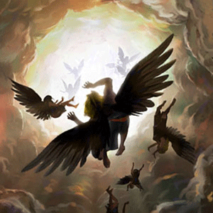
LUCIFER, “How you are fallen from heaven, O Day Star, son of Dawn! How you are cut down to the ground, you who laid the nations low! You said in your heart, ‘I will ascend to heaven; I will raise my throne above the stars of God; I will sit on the mount of assembly on the heights of Zaphon; I will ascend to the tops of the clouds, I will make myself like the Most High’” (Isaiah 14:12-14). According to Lebor Gabála Érenn, they (Tuath Dé) came to Ireland “in dark clouds” and “landed on the mountains of [the] Commaicne Rein in Connachta [CONNACHT, IRELAND]; and they brought a darkness over the sun for three days and three nights”.[12] Many Scottish and Irish tribes and clans claim secret descent from the Tuatha Dé Danann, and have organized themselves to secret societies committed to ancient Tuatha ancient blood oath secrecy, racial supremacy, Satanism, demonology, magick, sorcery, and human sacrifice.
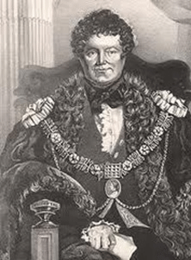
One of Ireland’s most infamous orators, lawyers, politicians, liberators, Master Masons was Roman Catholic Daniel O’Connell (1775 – 1847). He was initiated 1799, Lodge 189, Dublin. He was sitting counsel, and Deputy Grand Master of the mother lodge, the Grand Lodge of Ireland.[13]

Wendy Williams introduced Jerry O’Connell. He came from back stage dressed in drag, a purple (occulted color) sequin dress. He had to two bizarre sick female rubber dummies attached to him enough to scare anyone. I heard the name, Kardashian. Then, I heard him squealing strange low and high- pitched sounds as alter personality voices of his dummies that banged in my heard. I dashed and grabbed the TV remote, muted the sound, turned away from the TV. I switched channels. My inner conscious told me to run, turn away from it- protect yourself.

Later that evening, I discovered during that morning live show that Wendy Williams had a MK ULTRA malfunction, lost consciousness and fell to the floor on air. From her hand signs and gestures during her shows, it was pretty clear that she was a sick Luciferian ILLUMINATI black celebrity.
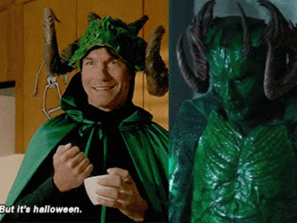
Jerry O’Connell & The Horned God
“But it’s Halloween!” Jerry O’Connell in a serial killer Green Meanie costume from the 2015 TV series, Scream Queens.
Green Meanie, the Horned God Pan
The ancient Celts and Druids in the West had worshiped a horned God who went by the names of Cernunnos, and in Old Irish literature as Uindos, Herne (Hermes), Hu Gadarn, and Hesus (Jesus). He was known as the most ancient and powerful Celtic deity who was called the “lord of wild and all things” like the Greek God Pan. The meaning of Cernunnos in Gaelic and Old English and Irish is the “horned one or he who has horns.”
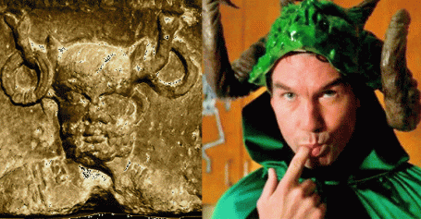
Celtic Horned God Cernunnos & Jerry O’Connell
This God was usually depicted in artwork wearing stag antlers and was normally accompanied by his symbols of the stag, ram, bull and holding a horned and spotted serpent or worm. After Halloween day 2017, it is also crystal clear that Wendy Williams is a CIA MK ULTRA/MONARCH multi-personality disordered victim.

Wendy Williams, Regressing not Recovering at Home
Wendy Williams is an extremely valuable high profile House Negro that reach millions on the idiot box for the glory of Lucifer. She is far more mentally sick than anyone realize. She She has been programmed with multiple alter personalities. Each alter most likely have multiple levels of other personalities to utterly prevent de-programming. Each alter would most likely have its own system and codes of post-hypnotic suggestions. After her mental breakdown on the set of the show, she went home and went thru a set of programmed mental regressions. When you experience regression, you “go back” in some way.

Wendy dressed, and surrounded herself in a security blanket and zone of MK ULTRA Sex Kitten personality animal prints. On Halloween morning, we got a pretty good idea of who deliberately triggered her, warlock handler, Jerry O’Connell. His wicked and disturbing multi-personality disordered routine set her off. It was deliberate, and he faded away in the background of the firestorm following Wendy’s very public global mental breakdown and malfunction.
Wendy Williams & the African Auset Deception
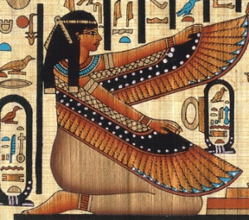
Kemetic Goddess Auset (Isis)
There is a lot of misinformation flowing around on the internet that Wendy Williams’ statue of liberty costume is a representation of the ancient African Kemetic Goddess Auset (Isis). It is true to a certain degree, but it completely ignores the European Rosicrucian and Masonic manifestation and bastardization of the goddess developed over the ages to SERVE their nature. It skips over a lot of very significant and important links, and history.
Wendy Williams & the Masonic Goddess Columbia and the NY Columbian Order
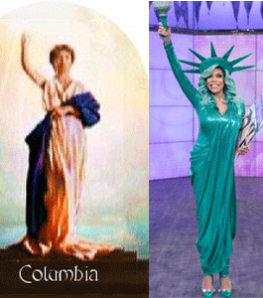
Wendy Williams’ statue of liberty costume is a manifestation of the Masonic Goddess Columbia that is particularly sacred to the Columbia Masonic Order of New York. The Columbian Order is sacred to memory of Columbus, and the idol of Goddess Columbia that represents the feminized Columbus– representing Mother Earth and the Motherland. The District of [Goddess] Columbia, the seat of power of the United States, is Masonic grounds dedicated to her.[14]
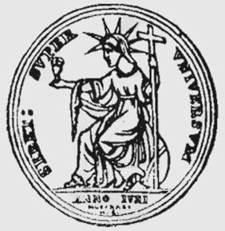
Queen Semiramis
Before Goddess Columbia, she was Babylonian Queen Semiramis, consort of Nimrod.[15]
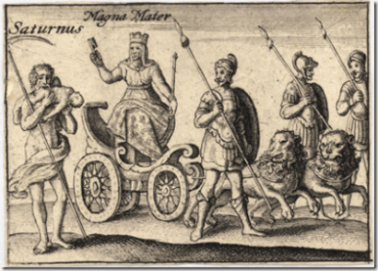
Goddess Cybele and Her Cannibal Consort, Saturn
Before Queen Semiramis, she was Earth Mother (Magus Mater) Goddess Cybele.[16]
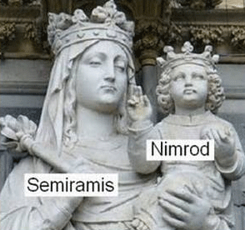
Goddess Columbia– Queen Semiramis of Babylon (goddess of the moon), holding the torch with the eternal flame of Nimrod (sun god). The Statue of Liberty in New York harbor was presented in 1884 as a gift from the French Grand Orient Temple Masons to the Masons of America in celebration of the centenary of the first Masonic Republic. She is holding the Masonic “Torch of Enlightenment“. It is also referred to back in the 1700’s by the Illuminati Masons as the “Flaming Torch of Reason“. The Torch represents the “Sun” in the sky. The Statue of Liberty’s official title is, “Liberty Enlightening the World“.[17]
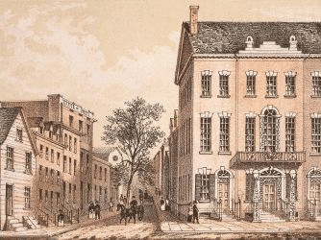
1790s Tammany Hall, NY, NY
Tammany Hall, now the “Sun Building”, was the early meeting place of Grand Lodge of New York, and of many subordinate lodges. It played a major role in controlling New York City and New York State politics and helping immigrants, most notably the Irish, rise up in American politics from the 1790s to the 1960s.[18]
The Sons of Saint Tammany were formally organized in New York City on May 12, 1789.[19] For the next 35 years after the Boston Tea Party, each of the original Sons of Liberty and Sons of St. Tamina groups went their own way. In 1813, at historic Fort Mifflin, near Philadelphia, several of these groups came together and formed one organization known as the Society of Red Men.[20] By the mid-1830s, the Tammany Society had been reconstituted as the Improved Order of Red Men.[21] The Improved Order was modeled after the Independent Order of Odd Fellows (Brotherhood of Death) and used the legend of Hiram Abiff of Masonic legend as its third degree.[22]
The Society of St. Tammany, the Sons of St. Tammany, or the Columbian Order is a secret Masonic Order whose hidden power reached all the way up to the White House. The Sons of St. Tammany certainly had Masonic Lodges. President Andrew Jackson seems to have been a Member of St. Tammany Lodge No. 1, Nashville, Tennessee, as early as 1800. It was the first Lodge in Tennessee, organized in 1789, under a Dispensation from the Grand Lodge of North Carolina.[23] The Columbian Order also had its Masonic Lodges. Columbian Lodge in Boston is one of the oldest Masonic Lodges in the United States, instituted in 1795 by Paul Revere.[24]
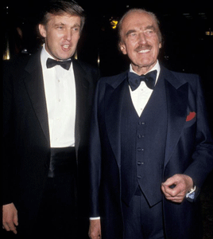
The late Scandalous Fred, and his son, Donald J. Drumpf were directly VIPs (very important persons) members of the Masonic Society and Sons of Tammany Hall aka St. Tammany, Sons of St. Tammany, or the Columbia Order through Brooklyn’s Madison Club, and the Knights of the Round Table in NY.[25]

HollyWeird Ritually Sexually Abused Child Star, Cory Feldman: “ask anybody in our group of kids at that time: They were passing us back and forth to each other.”
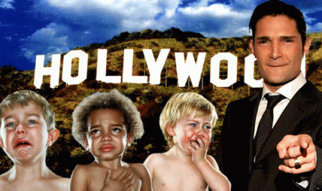
Feldman’s HollyWeird group of kids included Jeremiah “Jerry” O’Connell, born in Manhattan, NY in 1974, in the shadows of the Drumpfs and the Masonic Columbia Order, the son of Linda, an art teacher, and Michael O’Connell, an advertising agency art director. They will tell everything you need to know about his mother. But, they will not say anything about his father, (Masonic?) Irishman, Michael O’Connell, out of Great Britain.[26]

Live in the Theater District, Manhattan, NY, Jerry O’ Connell was dressed up as all the pregnant Kardashians. He and the dummies represented MK ULTRA/MONARCH alter personalities of them. It was far from being described as hilarious.

Before O’Connell, Wendy bowed down, and immediately formed the opposite prayer hand symbol- the “downward prayer position” that has been identified as the “Triangle of Satan” symbol often used by the Masonic Columbia Order Brotherhood of Death and President select Donald J. Drumpf.[27]

Wendy begged Satan for protection. However, the Warlock was into an absolutely demonic ritual to demonstrate and magnify SATAN’S POWER on national TV on Halloween before at least a thousand fold- 1.7 million people. O’Connell’s occult ritual routine was designed to scare, humiliate and TERRORIZE Wendy Williams, and the global masses. [28]

“Scare Them, You Can Herd Them”
At about noon, the Manhattan Halloween Terror continued. Sayfullo Saipov, a fake Muslim from Uzbekistan yelling “Allahu Akbar“drove a white rented pickup truck down a protected bike path and collided with a bus, allegedly killing 8 (eight) people and injuring several others. The story-line is that Saipov planned for a year to rent a Home Depot pickup and run down a complete random group of bike riders on a bike path in Manhattan. It makes no sense at all. Donald J. Drumpf of the Manhattan Columbia Order, and Muslim Terror in Manhattan fear mongering campaign reached millions upon millions 24 hours a day. Under the veil, Jerry O’ Connell represents HollyWeird’s extreme EVIL and WICKEDNESS.
IV
JERRY O’CONNELL & HOLLYWEIRD’S UNDERGROUND PEDOPHILIA RINGS
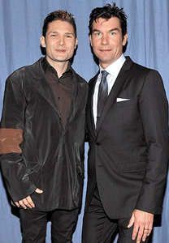
Jerry O’ Connell is directly linked to Cory Feldman, and the underworld HollyWeird Satanic Pedophile ring. In an interview with The Hollywood Reporter, Feldman discussed how he was repeatedly molested by adult males in the HollyWeird entertainment industry, saying these men would pass many young stars “back and forth to each other.” He said, “ask anybody in our group of kids at that time: They were passing us back and forth to each other.”
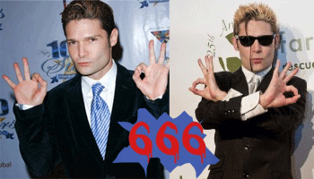
Corey Feldman 666 Satanic/ILLUMINATI Symbolism
Feldman then made the shocking claim that many people in the industry were aware that he and Cory Haim were being abused by these older men, and that no one did anything to stop it or help the boys. “This person uses intimidation and threats as a way to keep people quiet. And all these men were all friends,” explained Feldman.[29]
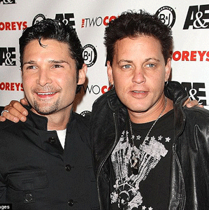
Corey Haim (above in 2007) struggled with drugs up until his death in 2010 at the age of 38, a death that Feldman blames on the men who abused the actor.[30]
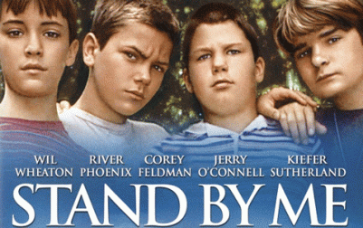
Ask Jerry O’ Connell, because he was one of Feldman and Haim’s “group of kids at that time.” In March 2011, former child stars Jerry O’Connell, Corey Feldman and Wil Wheaton reunited in Los Angeles with Richard Dreyfus and director Rob Reiner to celebrate the 25th anniversary of their 1986 coming-of-age classic Stand By Me. The film’s other star, River Phoenix, died at age 23 in 1993.[31]
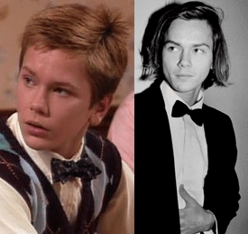
Hidden Hand (Society) of River Phoenix
In the years following his death, a number of theories would be put forth as to why River Phoenix was the victim of a celebrity heroin overdose, or assassinated. Some would say that he retreated in drug abuse as a result of being ritually sexually molested as a child by the global pedophile cult his family belonged to.[32] River Phoenix starred with Jerry O’Connell in Stand by Me when he was 15 to 16 years old. Phoenix had been traumatized, and ritually sexually abused and raped by an ILLUMINATI Cult (Children of God a.k.a. The Family, Family of Love) since at least 11 years old, when he tried to commit suicide.[33]
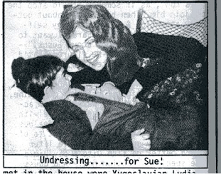
Child Undressing for Sue and the “The Family”
In the 1990s, the cult faced numerous allegations of pedophilia and sexual abuse from different locations worldwide including Argentina, Australia, Brazil, France, Italy, Japan, Norway, Peru, Spain, Sweden, the UK, USA, and Venezuela. River’s death came in the midst of a major criminal investigation in Argentina. State Chief Inspector Juan Carlos Rebollo, who led the September 1993 raids, stated: “We found evidence suggesting the Family is funded by influential businessmen worldwide.”[34]

Jerry O’Connell is a very complex demonic spirit and personality. To avoid Satanism and Pedophilia Rings in HollyWeird when he was most vulnerable as a child, he would have been able to dance around and between raindrops. So far his lips has been sealed about what went on behind the cameras in tinsel town. However, he is certainly a leading candidate to be the High Priest of a Eyes Wide Shut secret Saturn Society- Aleister Crowley Masonic Satanic Cult and Cabal.

But it’s Halloween. Jerry O’Connell most definitely did Lucifer’s Work to magnify the POWER OF SATAN and make a global mockery of Wendy Williams, then slip away behind the Darkness and EVIL of the Day of the DEAD.
V
THE SATANIC THIRD RACE MATRIX & LIBERATION

I did not coin the concept, “The Third Race“, to identify a hidden Matrix produced by the horrors of African Human Bondage. It came out of Margo Jefferson’s memoir of growing up in postwar America’s emerging privileged black elite that she entitled, “Negroland“. The nation’s elite House Negroes very proudly call themselves, “The Third Race“, between the masses of Blacks (Africans) and white people. It is a matrix– something within or from which something else originates, develops, or takes form- A HOUSE NEGRO!
Post- Panthers, I had another frightened bird, Barbara, to fly under my wing. She was a fine smooth chocolate brown black young lady- nervous and nearly out of her mind in fear and stress. She couldn’t function normally. She was isolated, and all alone- inside the Black Race Matrix with nowhere to go. She had attempted suicide, and was still suicidal trying to escape the matrix. She was in a very fragile mental state that almost anyone could sexually abuse and exploit her. I kept her close to me with a ring of protection of the African Liberation Movement that remained strong and intact after the Panthers were compromised. She always talked about white men following her. I saw nothing out of the ordinary. I was BLIND.
Barbara was a daughter of affluent and prominent (class conscious) black family out of the deep south (Little Rock, Arkansas). They were brown skinned, that deep roots to mulatto (half-white) Free Negroes of St Lukes Parish, Beaufort, South Carolina. They were an example of your classic black overachievers and professional class. So, we had been led to believe. As a family, they were normally socialized at Southern University in Louisiana, and Texas Southern University. In the Bay Area, they became a class of black professional elite tennis players, teachers and school administrators.
I took her under my wing at San Francisco State University. She followed me thru the A.B. degree program in Anthropology, and the teacher credential program. As I said before, she was like a frightened young bird that often saw mysterious white men following her. It was as if her family had abandoned her while she suffered and toiled under the stress of fear. These classes of House Negroes seem to have a very little sense of self protection. They seem powerless to oppose the systems of white supremacy that they SERVE.
During the late 1960s, I first observed these classes of THIRD RACE House Negroes at Howard University in Washington DC. The students at the university were sheltered children of the privileged super elite black political and professional/Masonic classes from across the nation, and the world. I saw no pain or emotion in their eyes. They had no dirt under their fingernails. Their teeth were pearly white and perfect. Their skins were soft and unblemished as if they had rarely been outside under the toil of the sun. They were like a totally different race of people packed in one place- A MATRIX. When I first arrived on campus, a group of frightened students at the dorm that I was staying at called campus police, and pointed me out as a “block boy” that invaded the campus. The “block people” were ordinarily black residents of the city that weren’t allowed on campus. They didn’t mix with ordinary black people as if they were a different race of people.
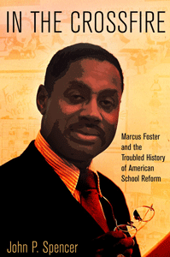
I stayed close to Barbara for about 2 (two) years. I was literally forced out of Oakland. I had received my AB degree, and completed the California teacher credential program. I was qualified, and ready to move inside the educational system- another complex Matrix as a liberator. But, the word came down out of Washington, DC– get me away from Oakland Unified School District (OUSD), and Superintendent of OUSD, Dr. Marcus A. Foster. In a long stressful and emotional meeting with Dr. Foster before I left town, I pleaded with him to defy the powers at be, accept the African Liberation Movement’s ring of protection- bring us in. It was about the children– protecting the children. The people would join us in battle.
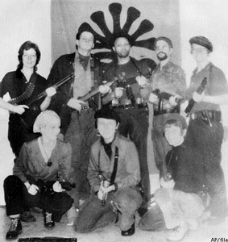
Symbionese Liberation Army (SLA)
On November 6, 1973, 44 years ago, they blew Dr. Foster’s brains and heart out with shotgun blasts on the side of the OUSD main office. It was a Masonic assassination. He still remains the only sitting large metropolitan school district administrator assassinated in U.S. history. The crime remains unsolved. It other words, they won’t solve it.[35]
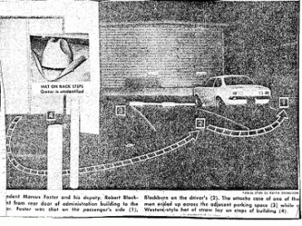
The Alameda County DA, law enforcement and investigative agencies accused the Panthers, and the SLA of assassinating Dr. Foster, but Panthers and the SLA didn’t wear “COWBOY HATS“.
It had gotten far too dangerous for me to live in the city of my birth. Plus, I was on the government’s hit list, whitelist, and shitlist. I couldn’t get a job shoveling shit in Oakland. I settled in Los Angeles. Sometime later, Barbara called me. She had settled in as an OUSD teacher. She was in immediate fear, again, of a white man that she said she had been forced to marry. They separated, but he was stalking and harassing her. I packed up my big stick 357, and flew into town, but again, I didn’t see anything out of the ordinary. Whatever had been going down suddenly stopped. This time, I really thought something was wrong. Why would she marry a white man that she feared?
By this time, I was much wiser about a lot of unseen and unexplained things. She told me about been the sole witness to her aunt’s murder in 1969 or 1970. She was shot and killed by a jealous suitor. The story line was that he thought that she was moving too fast ahead of him economically and socially with her new job and recent fame making history. He was jealous of her upward mobility within society. So, I didn’t think much of it at the time. But, I dug a little deeper. Her aunt was about to become the first black female Castlemont High School principal in history of a large metropolitan school district in America when she was shot down in cold blood in her backyard. Barbara watched the entire murder unfold from the window of her in-law residential house in the yard. Undoubtedly, Barbara witnessed more.
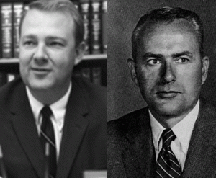
Oakland’s Secret German Mafia, Edwin Meese III & D. Lowell Jensen
I dug deeper. I found it highly unusual and absolutely unprecedented that Alameda County District Attorneys, Edwin Meese III, and his chief deputy D. Lowell Jensen of the Alameda County German Mafia took over her aunt’s probate estate to the exclusion of her entire family.
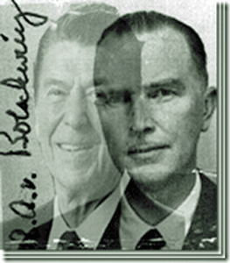
They were racialist arch-conservative key advisers of Ronald Reagan as California Governor and U.S. President along beside Nazi- Sturmhauptführer SS Baron Otto von Bolschwing of Reichsfurhrer Heinrich Himmler’s SS, and the Gehlen Org. Reagan was the secret alter-ego of Himmler’s most prized and clandestine Allgemeine SS officer, Baron Bolschwing. They were all alter-egos of the Knights of the Black Sun. Meese and Jensen provided legal shadow government cover and protection in Oakland and Alameda County for the FBI’s covert COINTELPRO War against the Panthers, CIA MK ULTRA Symbionese Liberation Army (SLA), and the high level CIA Assassination of Dr. Marcus A. Foster, and much- much more. SS Baron Otto Albert Alfred von Bolschwing is still top secret and classified U.S. national security information in regards to the National Security Council (NSC), CIA, FBI, Ronald Reagan, and California. My Dear Lord! It explains why I never saw anything even with my eyes open. These brutal satanic forces were the shadow government– 20th century’s most racist, dangerous and clandestine force in the U.S. history. While I was looking for them, they were most likely watching me.
I dug deeper. I found that the killer, a Western Pacific railroad employee, pled guilty to homicide. He was sent to Vacaville Men’s Mental Health Facility to reside with CIA Station Chief, Dr. James Alexander Hamilton for the duration of his stay in prison, then I lost track of his whereabouts when he was released. I had come to the conclusion that her aunt’s murderer was an early experimental MK ULTRA/MONARCH Black Manchurian Candidate Assassin on the loose.
They slaughtered Barbara’s aunt, Dorothy Jones, to make it plain and clear to the Black Bourgeoisie that they (Nazi German Cabal)- strict white supremacy, decide when it’s time for them to move up in society, or be freed. Barbara’s aunt had moved too fast up the social and economic ladder equal to white people without their expressed permission and blessings. She acted as if she had been liberated. The Third Race Matrix: she was bound to SERVE, not grow independently and free by the grace of her own god, character and ambitions. Barbara too, had been raised and bound to SERVE inside the Matrix.
When I began to unfold some truths surrounding Barbara and the assassination of her aunt, the stakes suddenly became much higher. She suddenly turned hostile toward me as if I was her arch-enemy. I could no longer trust sitting in the same room with her. Being a former Panther, I must always be careful when things become hostile. I have no reputation or history of violence. Yet, a person’s fear of me, no matter how unreasonable, always seems to be legally justified to the government if something happens to be setup to go down. As far as I know, Barbara is in a class of very wealthy Bay Area property owners inside the Black Matrix, most likely a SLUM- LORD!
IN CONCLUSION
Whether the barriers between the black elite and the masses of blacks are silent, benign, or overt, the end result is always the same as it was during slavery. The black elite (bourgeoisie) continue to SERVE the master/servant relationship as it had been during the days of African Human Bondage in America. From the 17th to the 20th century, House Negroes SERVED slavery and white supremacy by interbreeding, strict socialization, brutal behavior modification, and mental conditioning. However in the 21st century, they serve two masters, white supremacy and LUCIFER, through advances in scientific technology, medical, and psychological applications and technologies that makes lay safe zones and deprogramming virtually impossible. In other words, I or the black community would have the chance of a snowball in hell to help to liberate a 21st century House Negro and Modern Slave, or a mind controlled/cloned black celebrity like Wendy Williams. The iatrogenic mind control victim of today may have hundreds of alters layered on dozens of other alter personalities anchored with hundreds of post-hypnotic suggestions with a termination alter. One of many challenges of this age will be to unify the masses, open their eyes and minds to the Dark Satanic Circles and Cabals that hide behind the power and authority of the highest public offices of this nation.
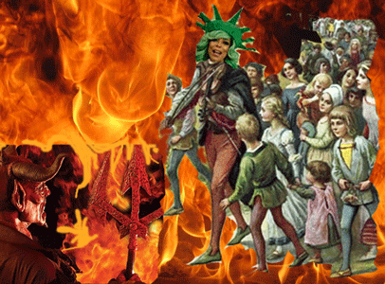
We must identify and close down the “sunken places” that program black celebrities like Wendy Williams, and other high profile influential personalities that lead the masses to LUCIFER. We need to know the doctors, and technicians that command the “sunken” stations and laboratories. There has to be zones of protection, whether inside or outside this country.
BLIND MAN, Little Milton
He lifted up his head toward Heaven and said
“Good Lord, I’d rather die than to let a no good
A no good cheating woman
Make me stand on the corner and cry”
Lord knows I’m living in a world of darkness
But that don’t, that don’t bother me
And until I find that sweet little girl of mine
Lord knows, I just don’t want to see- Lord, won’t somebody please help the blind me?
You have an option to keep her eyes wide shut, stand on the corner and cry like a Blind Man, or wake up to A New Awakening. I have said enough.
__________________________________________________________________________________________________________
[4] https://www.bibliotecapleyades.net/merovingians/merovingios_12.htm
[5] Id.
[6] Id.
[7] http://itsallintheegg.blogspot.com/search/label/The%20Emerald%20Tablet
[8] https://childrenofarthur.wordpress.com/2011/11/14/was-king-arthur-irish/
[9] http://www.battleofclontarf.net/the-e%C3%B3ganachta-tribe-and-their-clans/origin-of-the-o-connell-clan-name/3624
[10] https://www.yourirish.com/folklore/the-tuatha-de-danann-invades-ireland
[11] https://en.wikipedia.org/wiki/Tuatha_D%C3%A9_Danann
[12] Id.
[13] http://trove.nla.gov.au/newspaper/article/116752898
[14] http://www.bibliotecapleyades.net/sociopolitica/esp_sociopol_washingtonDC09.htm
[15] http://goccuk321.blogspot.com/2012/10/seed-of-nimrod-semiramis.html
[16] http://endrtimes.blogspot.com/2009/08/semiramis-queen-of-heaven-mother-of-god.html
[17] http://freemasonrywatch.org/statue_of_liberty.html
[18] https://en.wikipedia.org/wiki/Tammany_Hall
[19] http://historic-wheeling.wikispaces.com/The+History+of+the+Improved+Order+of+Redmen
[20] Id.
[21] http://www.wvculture.org/history/wvhs1701.html

[22] http://www.meta-religion.com/Secret_societies/Groups/secret_organizations.htm#.VdKK0LJVhBc
[23] http://www.mn-masons.org/masonic-history/famous-masons/masonic-american-presidents
[24] http://www.columbianlodge.org/
[25] https://johngraysonblog.wordpress.com/2017/02/16/donald-trump-is-a-freemason/
[26] https://en.wikipedia.org/wiki/Jerry_O%27Connell
[27] https://medium.com/@allanishac/body-language-experts-say-trump-often-flashes-triangle-of-satan-hand-gesture-5b592002c1e8
[28] http://www.wendyshow.com/2017/10/31/jerry-oconnells-halloween-surprise/#.WfsjL1tSyUk
[29] http://www.dailymail.co.uk/news/article-3611046/I-molested-passed-Corey-Feldman-details-horrors-Hollywood-pedophile-ring-reveals-Corey-Haim-just-11-raped-leading-life-drugs.html
[30] Id.
[31] http://www.hollywoodreporter.com/news/photo-stand-by-me-cast-168878
[32] http://heroin.net/heroin-addiction/heroin-addicts/celebrity-heroin-users/the-heroin-death-of-river-phoenix/
[33] https://midnight-rant.com/establishing-motive/the-children-of-god/
[34] Id.
[35] http://www.whale.to/b/brussell12.html
Comments : Leave a comment
Categories : 1000 Year Reich, Advanced Research Projects Agency, african american satanic cult, african holocaust, African Liberation, African slavery, alameda county mafia, Aleister Crowley, artichoke program, Aryan Supremacy, ascendant triangle, aset, ashur, baphomet, black children, black inheritance, black institutions, Black Manchurian Candidates, Black Panther Party for Self Defense, blood covenants, blood oaths, blood sacrifice, BOULE, boys from brazil, BRONFMAN GANG, brotherhood of death, church of satan, CIA, civil war, COINTELPRO, cybele, d. lowell jensen, DARPA, donald j. drumpf, donald j. trump, donald trump, dr. isaac slaughter, Dr. James Alexander Hamilton, Dr. Marcus A. Foster, druids, earth mother goddess, egypt, ELF, evil, Extremely Low Electrical Frequencies, Eyes Wide Shut, fallen angels, False Satanic Rites of Lost Negroes, freemason, freemasons, Heinrich Himmler, hollywood satanic cult, holograms, holy grail, huey p. newton, human bondage, illuminati, Isis, kemet, lucifer's servants, luciferians, marcus a. foster, mind control, MK-ULTRA, modern slavery, monarch child, monarch program, MPD, mulitiple personality disorder, Nazis, new world order, oakland, pizzagate, post amnesia barriers, post hypnotic suggestions, Reichsfurhrer SS-1 Heinrich Himmler, reinhard gehlen, Ritual Satanic Abuse, ritual satanic sexual abuse, rose and cross, Rosicrucian, Rosicrucianism, satan, Satanic Global High Cabal, Satanism, sex kitten, sex slave, SS, Symbionese Liberation Army, trauma-based mind control, underground reich, underground third reich, Untermensch

DE COON CAKE WALK, THE JEMELE HILL SECRET MATRIX, THE RISE OF THE THIRD SATANIC RACE & THE NFL
31102017
I
NEGROES & THE RISE OF THE THIRD SATANIC RACE

Over the last decade with Obama and now with Donald J. Drumpf as the highest elected U.S. constitutional public law, and military enforcement officials of the country, the nature of the CIA MK ULTRA/MONARCH mind control game has drastically changed. More and more high profile and visible public figures and celebrities are covertly mind control programmed to SERVE a Luciferian Masonic Agenda like a Master Plan to create a terrible and frightening new satanic race of people that appears to be beginning with an experimental mass psychological assault against Black People.
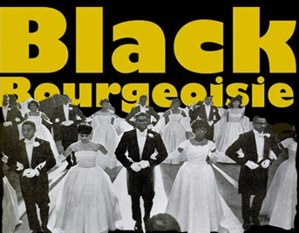
Modern Slavery & De Coon Cake Walk
Margo Jefferson is a writing professor at Columbia University. In 1994, she won a Pulitzer Prize for Criticism for her work at The New York Times. In her memoir, Negroland, Jefferson describes the social pressures of her upbringing, as well as the sense of separation that it engendered. She writes that she and other members of the black elite thought of themselves as a “THIRD RACE”, poised between the masses of Negroes and all classes of Caucasians.”[1]
Race is a way of categorizing humans into groups, called races or racial groups, based on combinations of shared physical traits, ancestry, genetics, and social traits.[2] I never thought of the black elite most likely descendants of antebellum house Negro slaves as a blueprint for a separate THIRD RACE, but it makes absolute ILLUMINATI sense.
In application, I just couldn’t understand the possible existence of a Third Race, conceptually. It was alien to our school of through in 20th century America. All forms of black slavery and human bondage had been abolished. So, I was taught. So, I believed. In California, there isn’t necessarily a history of African Bondage. However, there exist silent and secret barriers placed between elite blacks with genetic physical traits of straight hair, lighter skin (mulattoes- mixed races), and darker skinned Africans carried over from the days of bondage, and deep seated secret underground southern traditions.
During my days as a Panther, a young frighten sister from the Third Race flew under my wing on the campus of Merritt Jr. College in Oakland, CA, to take refuge, and wouldn’t leave my side. She followed me wherever I went. She danced, hopped, skipped, and unraveled her hair in a circle around me. She was finally free to play, and act out like a little girl that she had never known. All that I knew then was that she was a young sister among the black masses. Beyond the gun, the Panthers had also become like beacons of spiritual liberation among the people.
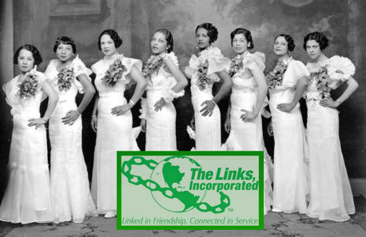
In the Black Community, she belonged to the elite Negro invitational only social societies like Jack and Jill founded by Detroit wealthy socialite, Marion Stubbs Thomas, and Links, Inc.
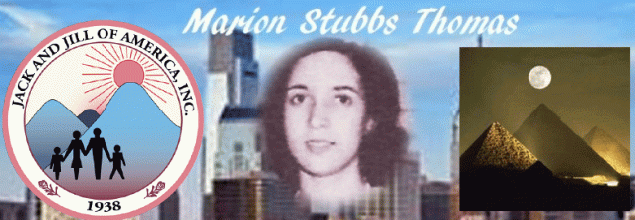
Jack and Jill is an ancient rhyme associated with Sun/Moon Cult Worship.
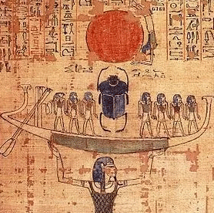
As in “Keeper of the Keys,” or “keeper rings” comes from the Kemetic Khepera, which was the title of the Scarabeus Beetle, which represented the sun at the highest point of summer. The symbol for Capricorn is the Beetle Capri/Khepra for Cancer. Khepracorn is the opener of the New Year, it was said to hold the keys to the door of the zodiac or calendar. “This stellar story is encapsulated in nursery rhymes like Jack and Jill, etc.”[3]
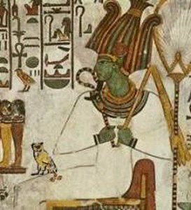
The Links official colors are white, and Emerald Green. Green Emerald is associated with the Occult, the Fallen Angel– Lucifer, and Mysteries of the Green One- Ashur (Osiris). [4],[5]
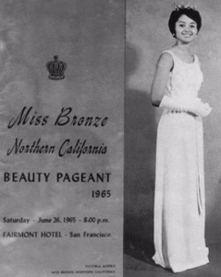
The young lady was a Black Bourgeoisie debutante, and a leading Miss (Black) Bronze beauty pageant contestant. Her mother was a single uneducated Mulatto from Lafayette, Louisiana social climbing among the elite sectors of the black community in Oakland- San Francisco Bay Area based on the color of her skin. She would have passed as a white woman. When she took refuge under the wing of the Black Panther Party for Self Defense, the young sister was in a state of an internal psychological crisis, a nervous breakdown. She couldn’t study. She was flunking out of college- contemplating suicide then face the grim reality of her world.
She tried to explain to me about the world in which she lived. She had been chosen, and promised in marriage to a son of a black prominent family. Then, she told me about a secret system and custom among the Third Race of being chosen from an early age. Concealed from the public, the custom provided for affluent and prominent white men to choose her– buy her clothes, give her and family money, and finance her education. She and her family would always get the best of perks, jobs, and opportunities a powerful secret society of white supremacy had to offer.
She told me about the secrets behind the black beauty pageants and how they would actually be on parade and review for wealthy white benefactors that had the power to pick and choose among them. She said that they usually sat upstairs in restricted blacked out areas of auditoriums, and buildings. She was afraid- about to go insane in fear. I later discovered that most of the young, black and beautiful Miss Bronze pageant winners promised HollyWeird contracts and careers had been MK ULTRA/MONARCH drugged, programmed, and turned into high end tinsel town prostitutes, and sex slaves. One of the best known pageant winners that actually became a HollyWeird star was the late Vonetta McGee.
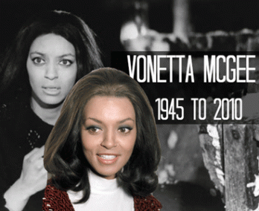
One of the best known Miss Bronze pageant winners that actually became a HollyWeird star was the late Vonetta McGee. Being a Panther, nobody bothered the young sister while under my wing. She finally settled down. The headaches went away. Her fright and fear became manageable so that she could function normally, and concentrate on her studies. I helped her with classes so that she could get an AA degree, and pursue her career in early childhood education. She had been raised and nurtured to SERVE in a new form of slavery as a prized pretty baby “Young Trophy Black Female” for a cabal of rich and powerful white men. Still, it took me a long time to conceptualize this secret world of the THIRD RACE, and believe that it was possible for this form of slavery to actually exist in the black community right under our collective noses.
II
MENTACIDE, MK ULTRA TWINNING- ANGELA RYE & COMMON

In the past, black light skinned high profile CNN Political Commentator and NPR Political Analyst, Angela Rye, hasn’t been interested in developing any personal relationships with men. I have noticed that she is a strong spirited and willed young sister. But, she lives inside an enigma wrapped up in a puzzle. In the limelight of corporate mass media, Angela Rye exists inside a bubble. She lives an outright lie.
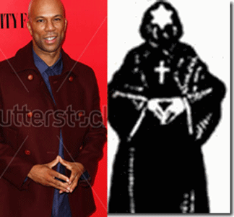
Common, Descending Pyramid- Symbol of the Brotherhood of DEATH
However, she has recently confirmed in public that she is dating light skinned Common (Sense), the Rapper. I wouldn’t necessarily call them a romantic couple, per se. I call it CIA MK ULTRA/MONARCH twining developed by Dr. Josef Mengele at Auschwitz Concentration Camp in Poland. Angela Rye and Common have been, respectively, programmed by the Satanic ILLUMINATI “to fill their destiny as the chosen ones or chosen [Satanic] generations” (coined by Mengele at Auschwitz).^{[6]}
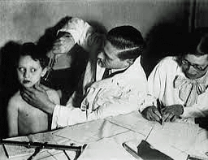
“Non-biological “twinning” is yet another bizarre feature observed within MONARCH programming. For instance, two young non related children would be ceremoniously initiated in a magical “soul-bonding” ritual so they might be “inseparably paired for eternity” (possibly another Mengele connection?). They essentially share two halves of the programmed information, making them interdependent upon one another.”^{[7]}
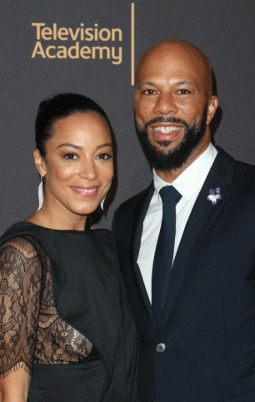
In HollyWeird, twinning has become a common process that “twin” or “pair” two or more MK ULTRA victims together to reinforce universal shared traits as result of ritual drug and trauma based mind control programming. We should be very clear that in Angela Rye’s power and zeal for individual fame and fortune. She sold her soul to Lucifer.
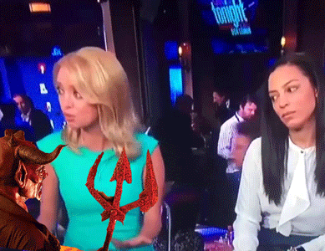
She went thru the process of Satanic ILLUMINATI Mentacide– the systemic effort to undermine and destroy a person’s values and beliefs, as by the use of prolonged interrogation, drugs, torture, ect., and to induce radically different Satanic ideas and alter states for the benefit of others.^{[8]}

Millions witnessed it in her flashback of being terrorized and traumatized played out live on CNN when a spirit suddenly rose from the “SUNKEN PLACE” in front of her on air,
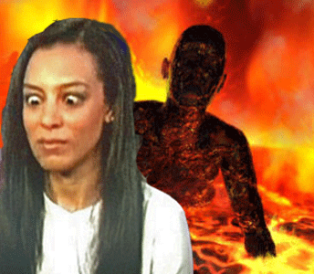
where she had her mind fractured into multiple alters.
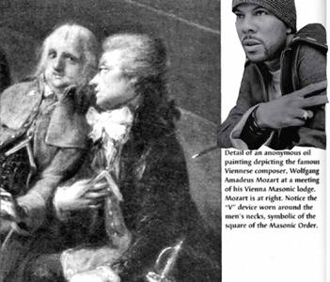
Her contrived suitor, Common (Sense), is an odd brother from Chicago. Undoubtedly from his ILLUMINATI hand symbols; he has been initiated into Lucifer’s Masonic Lodges.

Common is part of the secret International Masonic Satanic Brotherhood.
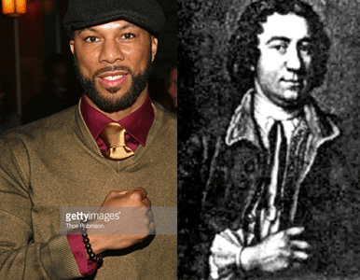
Common carries the ancient occult Masonic Satanic Brotherhood’s CLAWED HAND. Clawed Hand Sir Francis Dashwood, leader of England’s 18th century “Hell Fire Club.” It was a secret coven among the global nobility and rich that practiced ritual Satanic Magic including human sacrifice. (Witchcraft, Magic and the Supernatural, Octopus Books, London, (1974), pg. 33)
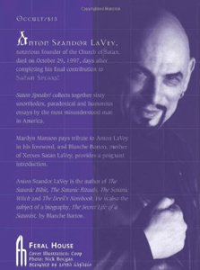
Clawed Hand– Church of Satan, Anton LaVey, “SATAN SPEAKS.”
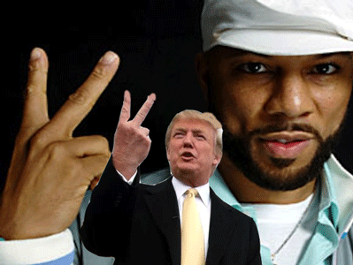
Common’s signature “two finger” V sign, in reality, is of ancient origins. It is, in fact, a sign of Satan, of malediction, of the horned God, Pan, and worse. Paranoia magazine, an interesting publication which bills itself as “the conspiracy reader” had a picture some years back of Churchill displaying the “V.” An astute reader knowledgeable of dark things wrote a letter to the editor in the next issue commenting on Churchill and his sign. Nigel A. Cornwall of Britain wrote, “The sign I believe has its origins as a symbol for a pagan horned God.” Cornwall also suggested that when the sign is given with the palm inside, it is recognized as a horribly vulgar and offensive gesture—signifying penetration of both body orifices. Done in the typical fashion, this sign literally means intercourse by the devil—to be violated sexually by the horned God. The thumb holding down the fingers creates the “vulva,” while the two largest fingers pointed up are the horns of the God (SATAN).[9]
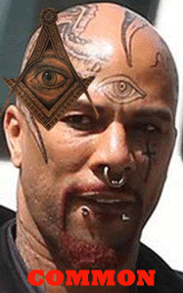
In Chicago, he was a member of Barack Obama, and Reverend Jeremiah Wright’s Trinity United Church of Christ.^{[10]} Common was likely part of the church’s secret down low homosexual society.^{[11]}

Tennis Super Star, Serena Williams
I realize that muscularity is a fact and reality for females. So be it. But, tennis superstar, Serena Williams, just don’t strike or impress me as a naturally born woman.
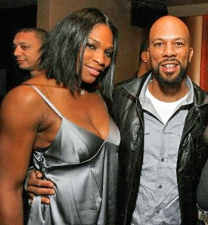
There are a lot of rumors and speculations surrounding Serena that she is actually a transgender man.
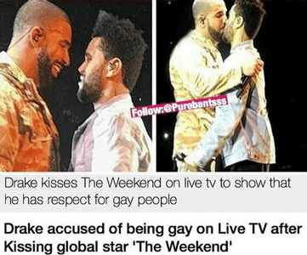
Just as there are rumors and speculations surrounding Drake– the rapper, is an ILLUMINATI homosexual.^{[12]} Drake is in fact, Jewish Occult Kabbalah of the Zohar.^{[13]}

Serena Williams split with Common (Sense) in 2010 after at least a one or two year-long relationship. Common, real name Lonnie Rashid Lynn, had been dating Serena since 2008.^{[14]}
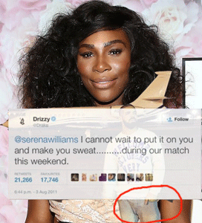
After Common stepped out, Zohar Drake stepped in with Serena– real strange secret freaky ritual Luciferian homosexual HollyWeird stuff.
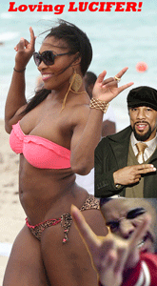
Common and Drake’s ILLUMINATI mission and plot as highly visible and desirable light skinned House Negroes were and are to help normalize a new and very different race of Luciferian black people.

It truly breaks my heart to see a promising and valuable passionate and intelligent young sister like Angela Rye is drawn into the middle of this Satanic S.H.I.T. But, she laid her bed. Certainly, she sold her soul to LUCIFER, her mind, body, heart and spirit are no longer among our Lord, and the masses. But, she needs a time and space to COME BACK HOME!
III
JEMELE HILL, MK ULTRA , MENTACIDE & THE THIRD RACE

We must be wary when a highly visible profiled black celebrity disappears, then suddenly pop up appearing to have been drugged. In the case of Jemele Hill, she was suspended for two (2) weeks from ESPN for allegedly violating company social media policy by advocating public boycott of NFL Dallas Cowboys owner Jerry Jones’ sponsors and advertisers. Jones had been very vocal and hard-line about forcing black NFL players to break their 1st Amendment protests by compelling them to stand in allegiance during the rendering of the U.S. National Anthem during pre-game ceremonies.
On October 21, 2017, Jemele Hill, suddenly, in a TMZ exclusive headline story broke her silence from her two (2) week suspension from ESPN. It looks as if the interview had been deliberately arranged and staged in a relatively quiet secure area of an airport facility for TMZ.
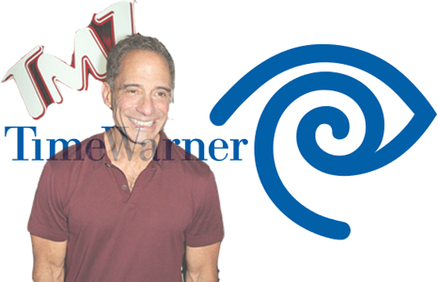
Mastermind Ashkenazi Jewish/Gay Harvey Levin is the creator and managing editor of All-Seeing Eye Luciferian Time Warner’s TMZ. Harvey Levin and TMZ carry a shrouded Zionist/Satanic/ILLUMINATI agenda consistent with the Jewish Cabal of John Skipper, President of ESPN Inc. as well as the co-chairman of Disney Media Networks, and Disney CEO Bob Iger that terrorized, and suspended Jemele Hill.
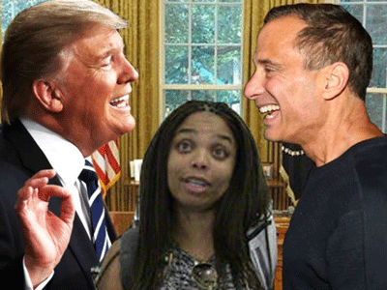
Levin has also been a consistent close friend of Donald J. Drumpf for at least 12 years. In April 2017, “Levin, a lawyer who went on to found the celebrity gossip and news website and television show, defended his hour long meeting with Trump last month, saying they were discussing future opportunities and other projects. (Levin featured Trump on a special called “Objectified,” which aired on Fox News last year.)”[15]
Current and former staffers told investigative reporters at ThinkProgress that Levin is in regular contact with President Drumpf, and that he often writes the pro-Drumpf reports himself. One staffer said that during the campaign, it was “pretty common” to hear Levin’s secretary say, “Trump is calling you.” Other sources said that First Lady Melania has called Levin, as well.[16] TMZ is known to vigorously defend and promote President Drumpf during, and after, the 2016 election. Alongside regular coverage of the Kardashians and Justin Bieber, “the site often runs pro-Trump stories and reports that seems to be sourced directly to the White House.”[17]

If you had seen Jemele on ESPN, she is confident, extremely remarkably intelligent, and thinks exceptionally well on her feet. So, if she normally says something- believe it. In the TMZ interview, she clearly said, “After my Donald Trump’s tweets, I deserved that suspension (highlighted emotional emphasis). I deserved it. I violated the policy… I deserved that suspension.”[18]
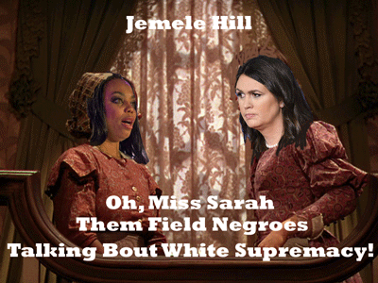
In her mind, she clearly believes that she was suspended, punished, terrorized in the Sunken Place for being sassy and insolent to a white man, Donald J. Drumpf. Nevertheless, the public was led to believe that ESPN suspended her for the Jerry Jones’ Dallas Cowboys NFL boycott controversy- the second violation of their social media guidelines, not her Donald Drumpf’s tweets.
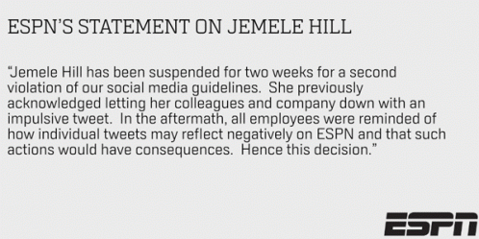
In the TMZ interview, Jemele didn’t have her signature sharp razor edge. At about frames 2:31, she started to uncharacteristically and disturbingly lick her lips. From her overall appearance and odd mouth gestures, and eye movements, it appears as if she had been MK ULTRA/MONARCH ritually traumatized; and drugged– which can cause her mild dehydration- tongue out licking her lips.
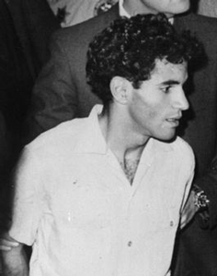
On April 17, 1969, MK ULTRA/MONARCH Manchurian Candidate Sirhan Sirhan awaiting his 1st verdict jury re-entered… Sirhan’s tongue came out- licked his lips.[19] During trial, Sirhan Sirhan just sat there at counsel’s table, licked his lips and smiled that funny little smile.[20]
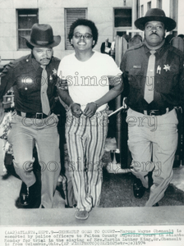
During arraignment on murder charges for assassinating Mrs. Martin Luther King, Sr. in July 1974, Marcus Wayne Chenault referred to himself in an alter personality, the “Hebrew”, and gave the name of the alter to the court as “Servant JACOB”. In court, Chenault was observed to be “licking his lips.”[21]

Manchurian Candidate Dylann Roof Licking His Lips
Charleston racist church shooter Dylann Roof was caught with the powerful mind-altering narcotic Suboxone that contains the MK ULTRA experimental drug BUPRENORPHINE, when apprehended by police during an incident on Feb. 28, 2015.[22]

MK ULTRA/MONARCH Mentacide occurs when even conscious Black People are ritually (Drugged/ traumatized) conditioned and forced to believe and act out of someone else’s interpretation of reality to their benefit and against their own humanity and survival. It is a state of insanity without disease (Dr. John Henri Clarke, Mwalimu K. Bomani Barut, Dr. Bobby E. Wright). Certainly, Jamele chose fame, fortune, and maybe her life and the lives of her family, and faced the oppressors alone. But, Jamele like Angela Rye may need a zone of protection, time and space to recover, and COME HOME AGAIN.
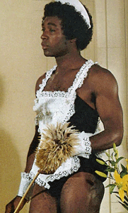
The New Black Man
As the direct result of Mentacide conditioning and programming, Jemele has been deliberately and wickedly centered in mass corporate media to falsely promote and push the White Supremacy MATRIX that namely “straight black men are the white people [OPPRESSORS] of black people” implying the need for a new THIRD race of Homosexual Black Males to best SERVE the New World Order.

Early, Huey P. Newton, and Bobby Seale taught me that we didn’t need everyone to put on the black beret, leather coat, and buckle up. We needed a dedicated fearless hardcore street, but disciplined force of brothers and sisters with undying love in their hearts for the people to lead the way. Bobby told me after Huey was imprisoned that one of our primary functions was to create an atmosphere and spirit of resistance and revolutionary movement among the people, and that an united people would help us, FREE HUEY and the masses. To accomplish our calling, we needed the love and trust of the all the people.
So, the Black Panther Party for Self Defense was more than just a safe haven and a ring of protection for run-away Third Race sex slaves. People from all walks of life with the spirit of resistance gathered behind the lines of the Panthers. We had clergy, educators, former members of civil rights groups such as Student Nonviolent Coordinating Committee (SNCC), police, and military personnel, HollyWeird and entertainment industry celebrities, actors, actresses. We had whistle blowers, and revolutionaries of all races from all over the world seeking unity with the people.
Black NFL players don’t necessary pose any real unified threats to the military, social, or the political systems of this county. Yet, in this country’s current racial atmosphere created by President Drumpf and the Dark Satanic Circle, they pose a real threat to white supremacy, because it is irrational and reactionary.
I repeat it, because it is important. For generations, a black person even a child that stand up for their rights can be accused of breaking the unwritten code of “racial insolence.” In America, racialist mobs backed up by the police and military have lynched black men, women and children for such “insolent behavior” for something as simple as refusing to step off a sidewalk to let whites pass, looking whites in the eye or protesting for rights. When Southern people speak of the “Insolence of the Negro“, it a Race License crime that injure only the South’s vanity. Missouri U.S. Senator Carl Schurz (1829 – 1906) pointed out that a Negro is called insolent, whenever his conduct varies in any manner from what a southerner was accustomed to when SLAVERY existed. (Forrest G. Wood, The Racist Response to Emancipation and Reconstruction, Black Scare, University of California, Berkeley, CA (1970), pg. 141)
Jemele Hill was suspended from CNN not for violating any violations of company social media policies. It was a big lie. She was suspended from her job for something totally irrational and reactionary, white supremacy Insolence- questioning power & sassing a white man in mass media- Donald J. Drumpf.
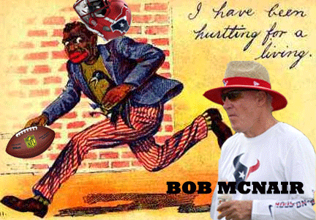
Recently, at a recent meeting of NFL owners and league executives regarding player protests, from deep in the heart of the Texas, Houston Texans owner Robert C. McNair warned his fellow owners that the black players protesting pose a threat to league. McNair reportedly said, “We can’t have the inmates running the prison.” In other words– “slaves running the plantation.” The crime of racial insolence is completely irrational and reactionary. The crime of insolence can be violated for little as earning the same salary as whites, looking whites in the eye, and PROTESTING FOR RIGHTS!
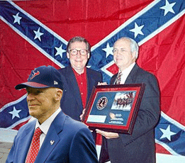
McNair, Sen. Mitch McConnell & Sons of the Confederacy
Robert C. McNair was born in Florida and raised in South Carolina, both slave owning states of the Confederacy. According to one tally, McNair was Senate Majority Leader Mitch McConnell’s largest donor from the period from Jan. 1, 2009 to Sept. 30, 2015, contributing $1,502,500.

In 2016, McNair donated $4.5 million to Donald J. Drumpf and out of all of the NFL owners McNair was the biggest donor to Drumpf.
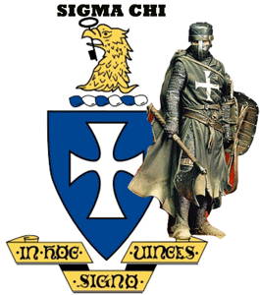
McNair belongs to the secret Brotherhood Order of Sigma Chi. He is a primary backer and financier of the fraternity.
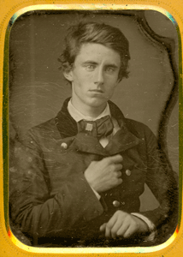
Clawed Hand of the Brotherhood of Death, Benj. Piatt Runkle
Benjamin Piatt Runkle was a Knight Templar, and a 32nd degree Scottish Rites Mason- a principle founder of the fraternity. Runkle was a primary designer of the fraternal order’s logo- the Cross and Shield. For all particular purposes, the fraternity is a secret Baphomet (Satanic) Masonic Knights Templar order.
At the University of Nebraska, Sigma Chi Fraternity has been accused of practicing KKK rituals during initiation activities. A Sigma Chi incident allegedly took place in January of 1997. Members of the fraternity were found in rural Lancaster County dancing drunkenly around a wooden cross they had set on fire. The burning cross is a notorious ritual of the KKK. It was further alleged that the members of Sigma Chi were dressed in Confederate uniforms complete with Confederate flags, swords and rifles. I said of all of that to say this. Bob McNair, owner of the Houston Texans, is a vicious, dangerous and evil white supremacist and racist that can’t be sugar-coated no further just because he belongs to the NFL.
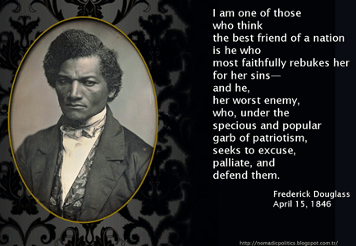
“This struggle may be a moral one, or it may be a physical one, and it may be both moral and physical, but it must be a struggle. Power concedes nothing without a demand. It never did and it never will. Find out just what any people will quietly submit to and you have found out the exact measure of injustice and wrong which will be imposed upon them, and these will continue till they are resisted with either words or blows, or with both. The limits of tyrants are prescribed by the endurance of those whom they oppress. In the light of these ideas, Negroes will be hunted at the North and held and flogged at the South so long as they submit to those devilish outrages and make no resistance, either moral or physical. Men may not get all they pay for in this world, but they must certainly pay for all they get. If we ever get free from the oppressions and wrongs heaped upon us, we must pay for their removal. We must do this by labor, by suffering, by sacrifice, and if needs be, by our lives and the lives of others.”
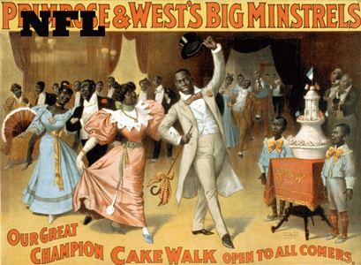
They can Shuffle Your Feet, grin, bend and de Cake Coon Walk all that you want around the issues. But, they want to return Black People to conditions of slavery. They can bow down on theirs knees before the flag and call it a protest. But be assured, those that oppress us call it a crime of insolence no matter how much de coon cake walking, and sugar and icing is on the cake.
 De Coon Cake Walk for the NFL
Jemele’s last words before she was taken to the “sunken place” was a call for the people to rise up, organize, and act in response to the violation of professional black athletes’ first amendment rights. It was a call for unity, action, resistance, and struggle among the people to support, and take the pressure off NFL protesters. It was a crime of insolence!
When Jemele called President Donald J. Drumpf a “white supremacist“, and warned the people to also be Wary of the Evil that he surrounded himself with in this democracy, it was a crime of insolence! Right now, today, some of that very EVIL that Jemele warned us about were in fact indicted by a federal grand jury for Crimes Against this Democracy!
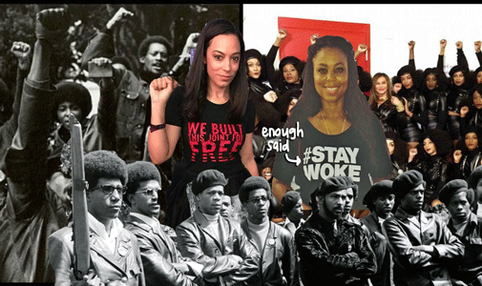

Back in the day, there would be no questions or confusion about our sisters.
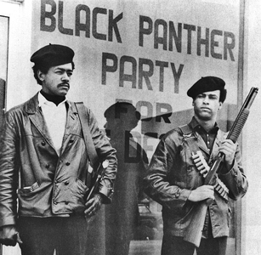
There would be No De Coon Cake Walking! Enough Said.
[1] http://www.npr.org/sections/codeswitch/2015/09/08/438536006/privilege-and-pressure-a-memoir-of-growing-up-black-and-elite-in-negroland
[2] https://en.wikipedia.org/wiki/Race_(human_classification)
[3] http://www.irishoriginsofcivilization.com/etymology-key-to-the-past.html
[4] https://www.bibliotecapleyades.net/merovingians/merovingios_12.htm
[5] http://www.witchipedia.com/god:osiris
[6] https://www.bibliotecapleyades.net/sociopolitica/esp_sociopol_mindcon02.htm
[7] Id.
[8] http://www.dictionary.com/browse/menticide
[9] https://www.bibliotecapleyades.net/sociopolitica/codex_magica/codex_magica25.htm
[10] http://www.celebritybeliefs.com/common/
[11] http://www.wnd.com/2012/10/trinity-church-members-reveal-obama-shocker/
[12] http://www.vladtv.com/article/156400/man-claims-lil-wayne-drake-perform-gay-illuminati-rituals
[13] http://www.mtv.com/news/2743603/drake-bat-mitzvah/
[14] http://www.dailymail.co.uk/tvshowbiz/article-1281742/Serena-Williams-splits-boyfriend-Common.html
[15] https://www.politico.com/blogs/on-media/2017/04/26/harvey-levin-trump-tmz-237645
[16] https://thinkprogress.org/tmz-quietly-became-americas-most-potent-pro-trump-media-outlet-bf703c24a68e/
[17] https://www.thecut.com/2017/06/tmz-donald-trump-harvey-levin-relationship.html
[18] http://www.tmz.com/2017/10/21/jemele-hill-says-she-deserved-suspension-on-good-terms-with-espn/
[19] https://www.loc.gov/item/2004662444/
[20] Garner, K.M., Father, Son, Unholy Ghost, Strategic Book Publishing, and Rights, Co., Singapore, (2016), pg. 224
[21] http://weeklyview.net/2014/07/17/the-kings-of-ebenezer/
[22] http://naturalsociety.com/suboxone-the-psych-drug-which-may-have-triggered-the-charleston-church-shooting/
Comments : 1 Comment
Tags: angela rye, Anton Szandor LaVey, ashur, Auschwitz Concentration Camp, Benjamin Piatt Runkle, black bourgeoisie, black is the new gay, black matrix, Black Panther Party for Self Defense, bob mcnair, bobby seale, brotherhood of death, carl schurz, CHURCH OF SATAN, CIA MK ULTRA/MONARCH, cnn, common, common sense, confederacy, confederate flag, coon cake walking, crime of racial insolence, dallas cowboys, disney, donald j. drumpf, donald j. trump, down low club, Dr. Bobby E. Wright, Dr. John Henri Clarke, Dr. Josef Mengele, drake, Dylann Roof, espn, frederick douglass, free huey, freemasons, harvey levin, hell fire club, hollyweird, homosexual agenda, homosexuality, houston texans, Huey P. Newton, Illuminati, inmates running the prison, insolence, insolence of the negro, jack and jill, jemele hill, jerry jones, john skipper, Kabbalah of the Zohar, khepera, kkk, knights templar, ku klux klan, links, Lucifer, Marcus Wayne Chenault, margo jefferson, marion stubbs thomas, masonic lodge, masons, Mentacide, Merritt Junior College, miss bronze, Mitch McConnell, Mwalimu K. Bomani Barut, new black man, NFL ILLUMINATI, Osiris, robert c. mcnair, robert iger, sarah huckabee, satan, satanic, serena williams, sigma chi, Sir Francis Dashwood, Sirhan Sirhan, sncc, sons of the confederacy, soul bonding, sunken place, the weekend, third race, tmz, Trinity United Church of Christ, twinning, vonetta mcgee, white racism, white supremacy
Categories : African Liberation, African slavery, Aryan Supremacy, baby scarifrice, baphomet, Barack Obama, black institutions, blood covenants, blood oaths, church of satan, CIA, COINTELPRO, confederate flag, confederate states of america, devil, devil's horns, donald j. drumpf, donald j. trump, donald trump, Dr. Josef Mengele, Eye of Horus, fallen angels, freemasons, genocide, gone with the wind, Hauptsturmfuhrer SS Dr. Josef Mengele, Heinrich Himmler, Hip Hop, HIP HOP false prophets, hip hop satanic cult, hollywood satanic cult, huey p. newton, human bondage, human sacifrice, illuminati, illuminati sacrifice, Knights Hospitaller, Knights Templar, ku klux klan, lucifer's servants, lucifer's workshop, luciferians, masonic sacrifice, mind control, MK-ULTRA, modern slavery, MPD, mulitiple personality disorder, Nazis, Neuro-Linquistic Programming, new world order, nwo, oakland, panther squad, Satanism, scottsish rite, sex kitten, sex slave, slavery, trauma-based mind control

Go to..
http://www.energyenhancement.org

For 34 Free..
- On Sign-Up - Energy Enhancement Books and Energy Enhancement Against Satanism Books.

To defeat Evil, you need to up your game.

Learn the Energy Enhancement Meditation Course by Video or Live in Iguazu.

ENERGY ENHANCEMENT MEDITATION
ENERGY ENHANCEMENT MEDITATION LEVEL 1 POWER UP!! GAIN SUPER ENERGY http://www.energyenhancement.org/Level1.htm
ENERGY ENHANCEMENT MEDITATION LEVEL 2 ELIMINATE ENERGY BLOCKAGES http://www.energyenhancement.org/Level2.htm
ENERGY ENHANCEMENT MEDITATION LEVEL 3 CLEAN KARMA BLOCKAGES AND PAST LIFE KARMA BY TRANSMUTATION http://www.energyenhancement.org/Level3.htm
ENERGY ENHANCEMENT MEDITATION LEVEL 4 MASTER ENERGY CONNECTIONS AND RELATIONSHIPS http://www.energyenhancement.org/Level4.htm



